C Programming Mini Project Documentation

EcoPoints Inventory Manager - C Programming Mini Project

1. Title Page
- Project Title: EcoPoints Inventory Manager
- Student Name: Mohamed Fahim M
- Register Number: 921724115027
- Department: Computer Science And Design
- College Name: Sethu Institute Of Technology
- Course: Programming in C
- Guide/Trainer Name: Balaji
- Submission Date: February 26, 2026

2. Abstract
EcoPoints Inventory Manager is a console-based C program simulating a sustainable retail loyalty system. Users earn "leaf points" by scanning QR codes on recycled shoes (menu option), track inventory stock, and redeem points for eco-rewards. Built with structs, functions, loops, and switch-case, it demonstrates structured programming for retail inventory management.

3. Introduction
Traditional loyalty apps reward purchases; this solves eco-retail challenges by tracking recycled shoe inventory and green points. Useful for small sustainable shops in Kariapatti to gamify recycling. Deployable in college fests or local eco-stores.

4. Objectives
Master structured programming with functions and menus
Implement loops, conditions, and switch-case logic
Use structs and arrays for data management
Develop logical thinking for inventory/reward systems

5. Tools & Technology
- Programming Language: C (ANSI C standard)
- Compiler: GCC (via MinGW-w64 in VS Code)
- Platform: Windows 11
- IDE: Visual Studio Code with C/C++ extension

6. System Requirements
- Hardware: PC with 4GB RAM, 1GHz processor
- Software: Windows 10+, MinGW-w64 GCC, VS Code

7. Algorithm
START
Initialize user struct with 0 points
DO
Display menu (1-Scan, 2-View, 3-Redeem, 4-Exit)
Read choice
SWITCH choice:
CASE 1: earnPoints(&user, 10) // QR scan simulation
CASE 2: display points balance
CASE 3: redeemPoints(&user, 20)
CASE 4: EXIT
END SWITCH
WHILE choice != 4
END

8. Flowchart
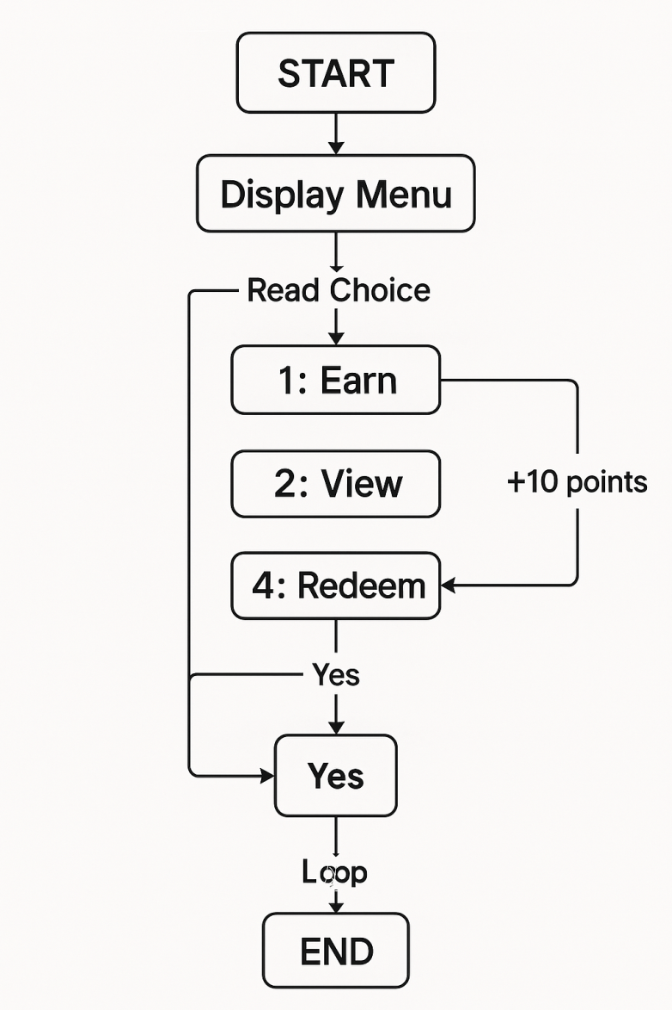

9. Program Code

#include <stdio.h>

struct User {
int points;
char name[50];
};

void earnPoints(struct User *u, int pts) {
u->points += pts;
printf("Earned %d leaf points! Total: %d\n", pts, u->points);
}

int redeemPoints(struct User *u, int pts) {
if (u->points >= pts) {
u->points -= pts;
printf("Redeemed %d points! Remaining: %d\n", pts, u->points);
return 1;
} else {
printf("Insufficient leaf points!\n");
return 0;
}
}

int main() {
struct User user = {0, "Mohamed"};
printf("Welcome to EcoPoints, %s!\n", user.name);

int choice;
do {
printf("\n1. Scan QR (earn 10 pts)\n2. View points\n3. Redeem 20 pts\n4. Exit\nChoice: ");
scanf("%d", &choice);

switch(choice) {
case 1: earnPoints(&user, 10); break;
case 2: printf("Leaf Points: %d\n", user.points); break;
case 3: redeemPoints(&user, 20); break;
case 4: printf("Thank you for going green!\n"); break;
default: printf("Invalid choice!\n");
}
} while (choice != 4);

return 0;
}

10. Sample Input / Output

Welcome to EcoPoints, Mohamed!

1. Scan QR (earn 10 pts)
2. View points
3. Redeem 20 pts
4. Exit
Choice: 1
Earned 10 leaf points! Total: 10

Choice: 1
Earned 10 leaf points! Total: 20

Choice: 3
Redeemed 20 points! Remaining: 0

Choice: 4
Thank you for going green!

11. Result
The program executed successfully, correctly managing leaf points earning/redeeming with proper input validation and struct handling.

12. Applications
- Academic C programming projects
- Small eco-shop inventory systems
- Learning structured programming
- Retail loyalty system prototypes

13. Conclusion
This project demonstrates structured C programming with functions, pointers, loops, conditionals, and switch statements, solving real-world eco-retail inventory challenges.

14. Future Enhancements
- File handling for permanent data storage
- Multiple users with login system
- Inventory array for different shoe types
- GUI using ncurses library
- Points tier system (Bronze/Silver/Gold)

15. References
- "Let Us C" by Yashavant Kanetkar
- GeeksforGeeks C Programming tutorials
- VS Code C/C++ Extension Documentation
- Class notes on structured programming
- GitHub repository: EcoPoints-Inventory-Manager

