**QLoRA - Powerhouses of Efficient Finetuning in Large Language Models**

**“Text Generation Project”**

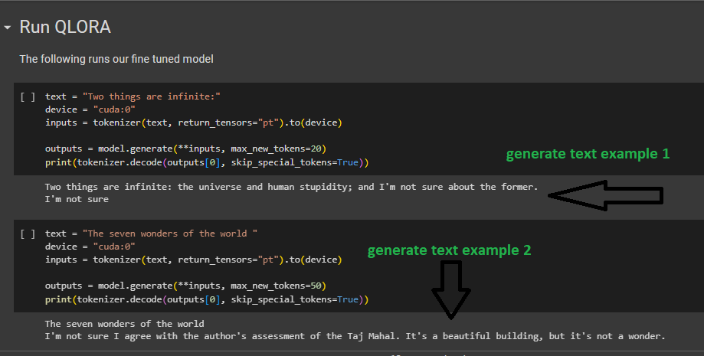**prediction Causal Language Model:**

**Time to train the QLoRA Model !**

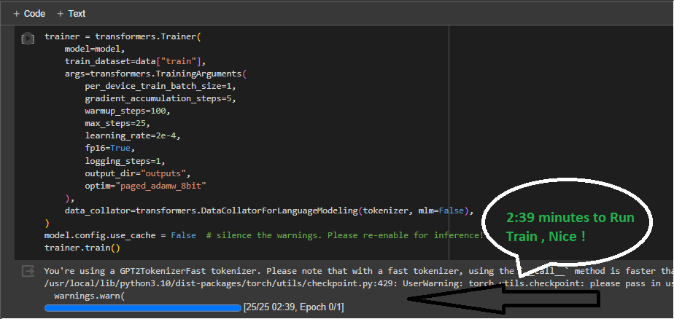

**Quantization 4 bit !**

