**Week 7 Assignment**

## 

**Deadline Thursday 19/10/2023 11:59PM**

## Bank Landing Page

Use what you have learned to build the following web page:

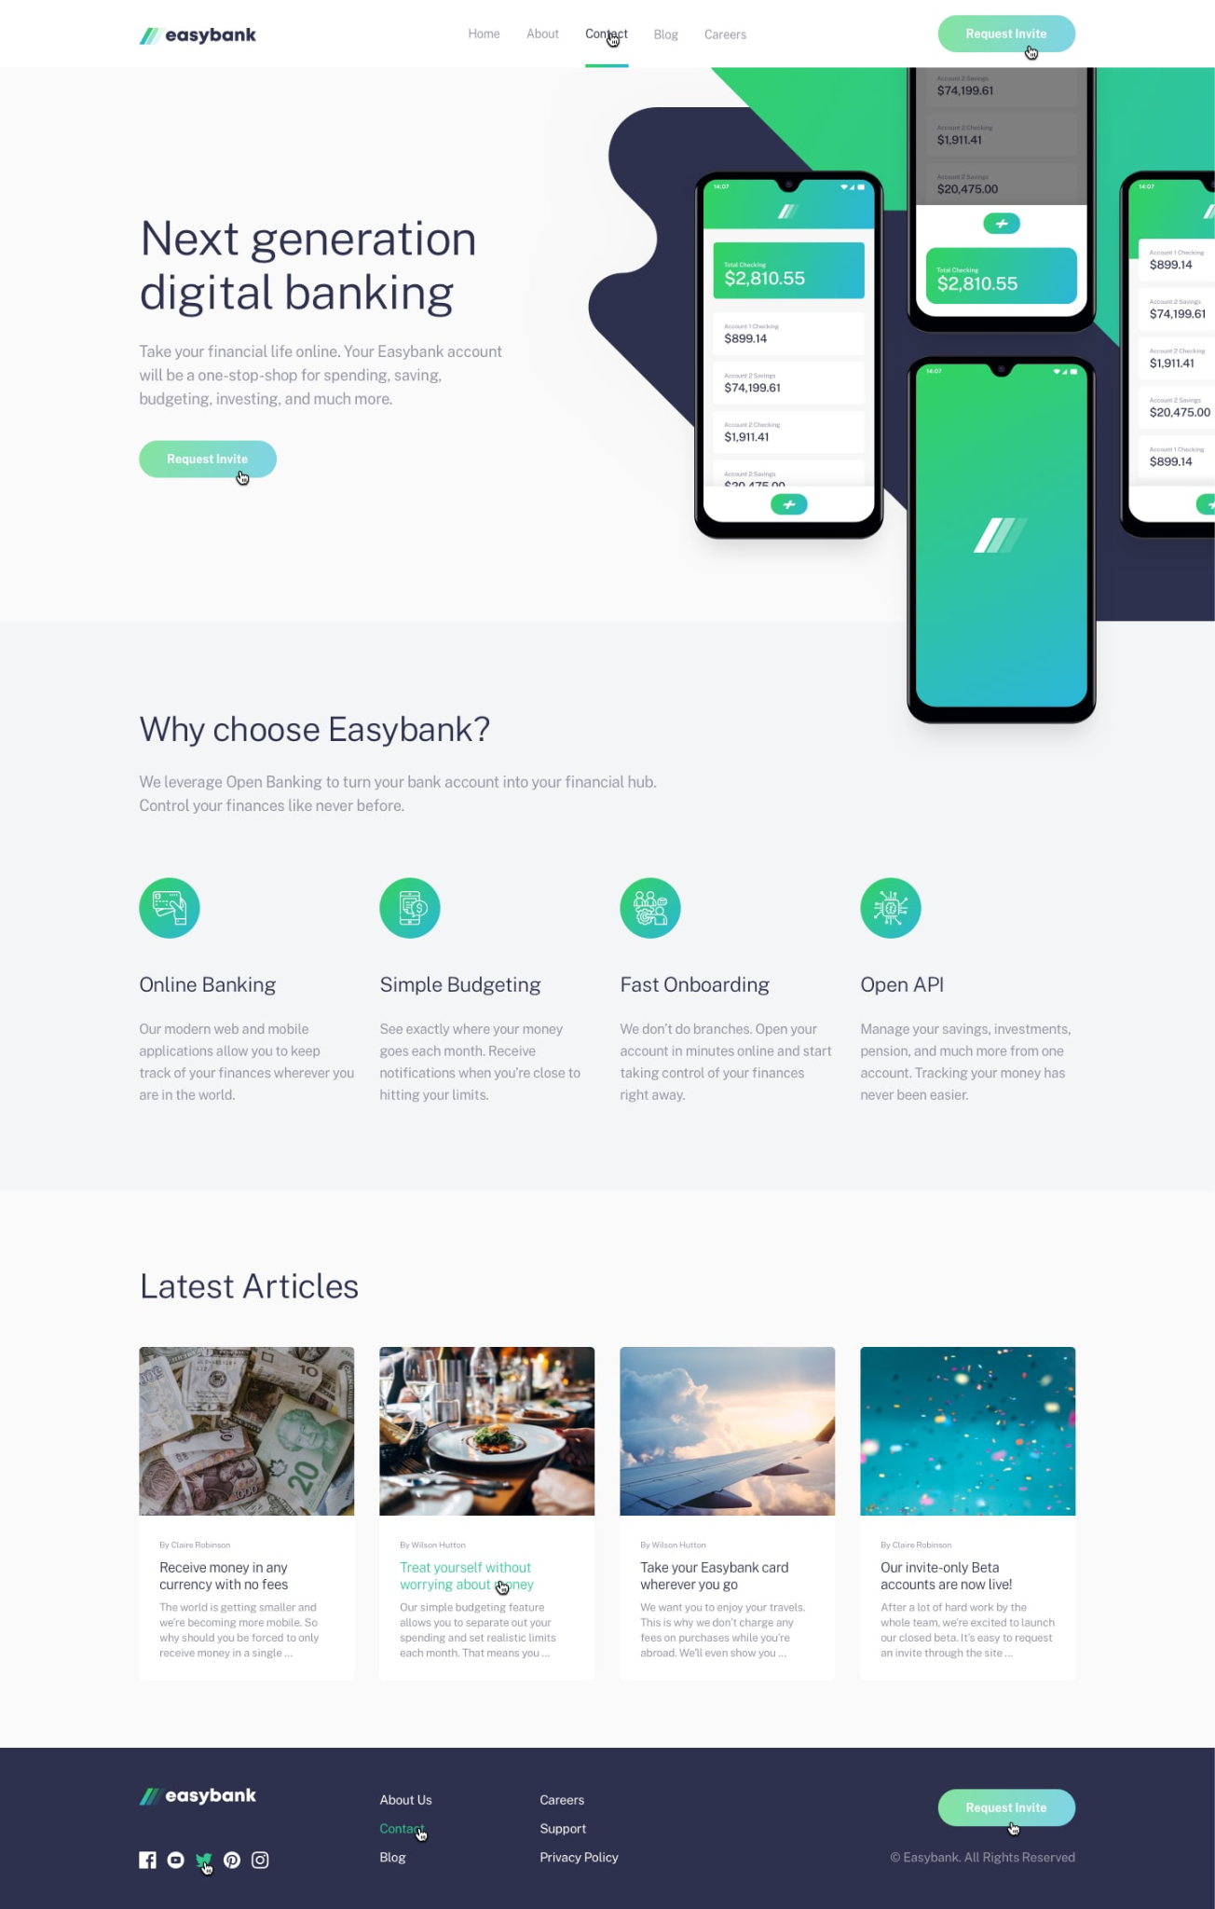

* Use **Flexbox** to layout the items in the page and page sections.
* Use the colors, and fonts mentioned in the **style-guide.md** file and images that exist in the **materials** folder.
* Follow the **active-states.jpg** design to add the needed hovers/animation effects.

**Note:** carefully read and use the materials provided for the task.

**Bonus:**

* You must define all your theme values using **CSS Variables.**
* Use **font-awesome** or **Google** **icons** to add the icons in the footer and other icons to the website.
* Change the layout of the website to follow the **mobile layout mentioned in the materials** for mobile users, using media queries + Flexbox.

## Soundnap Home Page (Remastered)

Use your work in [week 5_assignment](https://docs.google.com/document/d/1kUQ_JkDhmplttKh7WIpU7o-C6wZ7N7_b/edit?usp=drive_link&ouid=112802899325202797131&rtpof=true&sd=true) for the Soundsnap home page and use **Flexbox instead** to lay out the items, navbar, and other elements on the page.

