Cairo University  
Faculty of Computers and Artificial Intelligent

**CS251 - Software Engineering I**

Parking Garage

Software Requirements Specifications (SRS)

Griffin

June & 2022

Contents

Instructions [To be removed] 3

Team 3

Document Purpose and Audience 3

Introduction 3

Software Purpose 3

Software Scope 3

Definitions, acronyms, and abbreviations 3

Requirements 4

Functional Requirements 4

Non Functional Requirements 4

System Models 4

Use Case Model 4

Use Case Tables 5

Ownership Report 6

Policy Regarding Plagiarism: 6

# Team

|  |  |  |  |
| --- | --- | --- | --- |
| **ID** | **Name** | **Email** | **Mobile** |
| 20200693 | Mohammed Ahmed Saleh | not.m7mdd@gmail.com | 01141835675 |
| 20200149 | Hossam Hassan Farouk | darkknghit40@gmail.com | 01012447770 |
| 20200437 | Mohammed Gamal Ragab | mohamed6688745@gmail.com | 01119899140 |
| 20200086 | Akram Mohammed Hassan | am58627939@gmail.com | 01158627939 |

# Document Purpose and Audience

* This document description for Parking Garage application.
* This document describes the functions of the system and what the system should to do and
* the Requirements and System Models.
* This document tries to write everything the customer asks for.

# Introduction

## Software Purpose

## This application manages a parking space for a configurable maximum number of vehicles this application helps the garage owner to find empty parking slot for vehicle and Make things easier for a Garage owner.

## Software Scope

* The Application has some stakeholders such as: Garage owner and vehicle drivers.
* The application gives garage owner two option to parking vehicles and garage owner chose one option.
* And the system calculate time when vehicle is parking automatically.
* And when he's wanting to park out the system calculate the payment fees and notifies Garage owner with it.
* The application displays all vehicle in slot and display the available slot.
* The application displays the total income in any given point.
* the application must display error massage for exception behavior.

# Requirements

## Functional Requirements

* **The application must handle the following functions:**
  + **Park-in** function that marks the arrival time of a vehicle if there is an available slot.
  + The application shall **capture** such time automatically from the system.
    - park-in function the application shall pick a free slot based on the active **slot configuration**. There are two configurations:
      * first come first served slot, use first free slot.
      * Find slot with minimum dimension to hold vehicle.
  + **Park-out** function that marks the departure time of a vehicle from the garage. The application shall capture such time automatically from the system.
  + **Parking fees** base one time of stay hourly rate of 5 EGP.
  + The application should Calculate the total income as well as **the total number of vehicles** that used the parking garage at any given point in time.
  + The application must **Display** the available parking slots.
  + If there any **exceptions** that can happen by user interaction the application must display error massage for exception behavior.

## Non Functional Requirements

* **Non-functional requirements describe how the system works**
  + **Availability**: Expected system availability is 24x7
  + **Reliability**: Parking overview should display slot at any time.
  + **Usability**: The owner Garage should be able to use the system with ease within 5min.
  + **Reliability**: All the data of the car parking system should be saved
  + **Usability**: A user should be able to use the system with ease within30 min.
  + **Usability**: The system must check if there's an available slot or not and inform the user.
  + **Integrity**: The system display error message for exceptional can happen during user interaction.
  + **Availability**: Expected system availability is 24x7.

# System Models

## Use Case Model

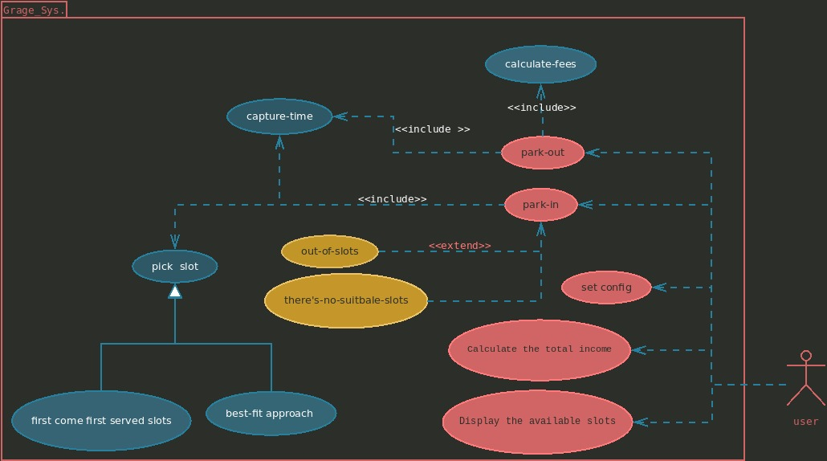

## Use Case Tables

|  |  |  |
| --- | --- | --- |
| Use Case ID: | UC1.1 | |
| Use Case Name: | Park in | |
| Actors: | Admin | |
| Pre-conditions: | Enter to the garage. | |
| Post-conditions: | Park in has done successfully | |
| Flow of events: | **User Action** | **System Action** |
| 1-Admin choose to park in |  |
|  | 2-System display available slots |
|  | 3-system pick suitable slot to the vehicle, based on two configuration(,FirstCome,BestFit) |
|  |  | 4-System Add vehicle in this slot |
|  |  | 5-system Capture the time ,Give the vehicle arrivalTime |
|  |  | 6-After adding Vehicle The system send Success message to admin |
| Exceptions: | **User Action** | **System Action** |
|  | 2- out of slots |
|  | 3-System notify admin |
|  | 3-There is no suitable slot |
| Includes: |  | |
| Notes and Issues: |  | |

|  |  |  |
| --- | --- | --- |
| Use Case ID: | UC1.2 | |
| Use Case Name: | Park out | |
| Actors: | Admin | |
| Pre-conditions: | Park in first | |
| Post-conditions: | Park in has done successfully | |
| Flow of events: | **User Action** | **System Action** |
| 1-Admin choose to park out |  |
|  | 2-cupture time |
|  | .3- calculate total time that the vehicle stay in garage |
|  |  | 4- calculate fees |
|  |  | 6-retrun calculated fees |
|  |  | 7-remove vehicle from garage |
| Exceptions: | **User Action** | **System Action** |
|  |  |
|  |  |
|  |  |
| Includes: |  | |
| Notes and Issues: |  | |

|  |  |  |
| --- | --- | --- |
| Use Case ID: | 1.3 | |
| Use Case Name: | Display Available Slots | |
| Actors: | User | |
| Pre-conditions: | Display available slots | |
| Post-conditions: | Display available slots in Garage successfully | |
| Flow of events: | **User Action** | **System Action** |
| 1-User select to display available slots |  |
|  | 2-Stystem check there available slots or not. |
|  | 3- System open list of available slots Id |
| Exceptions: | **User Action** | **System Action** |
|  | 2- Not found available slots |
|  | 3-system notifies User |
| Includes: |  | |
| Notes and Issues: |  | |

|  |  |  |
| --- | --- | --- |
| Use Case ID: |  | |
| Use Case Name: | Calculate the total income. | |
| Actors: | Admin | |
| Pre-conditions: | Park-in | |
| Post-conditions: | Get total income of the garage | |
| sFlow of events: | **User Action** | **System Action** |
| 1- Admin choose total Income |  |
|  | 2-System get Total time for each vehicle |
|  | 3-System Calc total fees for each vehicle |
|  | 4- System return to Admin the Sum of total fees for each vehicle |
|  |  |
| Exceptions: | **User Action** | **System Action** |
|  |  |
|  |  |
| Includes: | UC1.1 | |
| Notes and Issues: |  | |

# Ownership Report

|  |  |
| --- | --- |
| **Item** | **Owners** |
| Document Purpose and Audience | *Mohammed Ahmad* |
| Introduction | *Mohammed Ahmed* |
| Requirements | *Mohammed Ahmed* |
| System Models: Use Case Model | *Hossam Hassan* |
| System Models: Use Case Tables, Class and sequence Diagram | *Hossam Hassan*  *Mohammed Gamal*  *Akram Mohammed* |