Cairo University  
Faculty of Computers and Information



**CS251**

**Software Engineering I**

GOFO

Software Design Specifications

Version 2.0

Contents

Team 3

Document Purpose and Audience 3

System Models 4

I. Class Diagram(s) 4

II. Class Descriptions 5

III. Sequence diagrams 6

Class - Sequence Usage Table 12

# Team

|  |  |  |  |
| --- | --- | --- | --- |
| **ID** | **Name** | **Email** | **Mobile** |
| 20180218 | Mohamed Gamal Diab | Mohamed.gamal2052000@gmail.com | 01122485062 |
| 20180350 | Youssef Maher Maher | youssefmaher.yh@gmail.com | 01113453457 |
| 20180167 | Ali Mohamed Fathy | ali.mohamed.65666@gmail.com | 01153395569 |
| 20180051 | Alamir Hassan Younis | alamirhassan8@gmail.com | 01127171631 |

# Document Purpose and Audience

* This document includes SRS description for GoFo football playground booking system. It describes the functions of the system and the uses cases.
* It is meant for all stakeholders, especially the client to understand what features will in the system.
* It also serves as the basis for the contract between the company and the client.
* It serves as a guide for the developers to understand what they will develop.

# System Models

## I. Class Diagram(s)

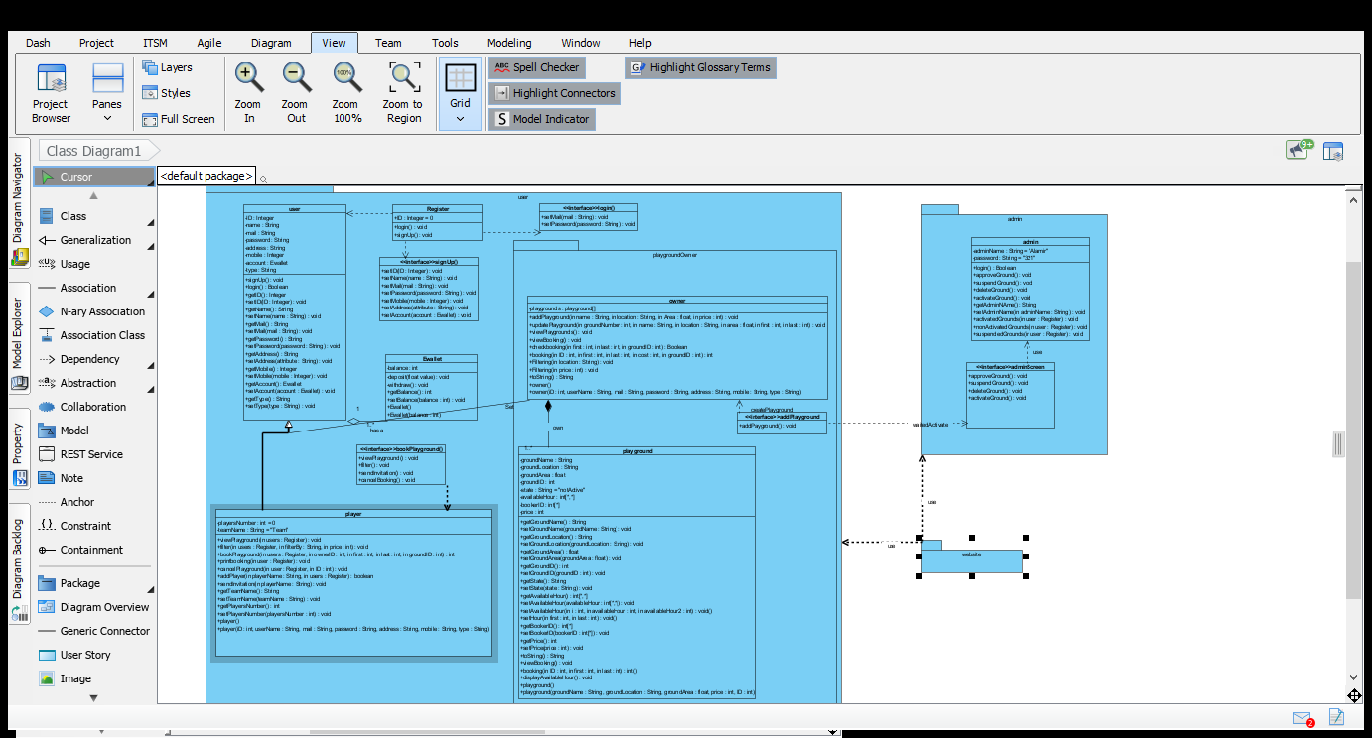

## II. Class Descriptions

| **Class ID** | **Class Name** | **Description & Responsibility** |
| --- | --- | --- |
| 1. F1 | User | User is parent of two classes’ owner and player.  This class has 8 attributes (name, mail, password, ID, type, phone, address, account)  , have setter and getter for this attribute And 2 important function (login, signup, transaction). |
| 2. F2 | Player | Player is child of class user. This class for player who wanted book playground. Player has 2 attributes name of team and player of this team.  Class has setter & getter of this attributes, and has 6 function (view Playground, book playground, filter playground, cancel booking, send invitation, create team). |
| 3. F3 | Owner | Owner is child of class user. This class for playground owner. Player has 1 attribute list of owner’s playground.  Class has setter & getter of this attributes, and has 5 functions (add playground, update playground, view booking, check ewallet, create profile). |
| 4. F4 | Playground | Playground has 4 attributes (ID, name, location, area) this attribute has setter and getter.  This class is important for owner it has all data about playground of owner. |
| 5. F5 | Account | Every user should have account in ewallet to make transaction between player and owner. This class has 2 attributes (ID, balance), and 2 function (withdraw, deposit). |
| 6. F6 | Admin | This class for admin he response on reliability between owner and player by 5 functions (login, approve ground, activate ground, suspend ground, delete ground). |
| 7. F7 | GOFO simulation | This class is interface for user has two functions. Login for user registed before, signup to create account on GOFO. |
| 8. F8 | Login | This class is interface for user. User enter his mail and password and system check and return true or false. |
| 9. F9 | Signup | This class is interface for user. He talks the data from user and the system create his mail. |
| 10.F10 | Book playground | The player use it to view playgrounds, filtered it, book it and send invitation to his team or other player and make transaction. |

## III. Sequence diagrams

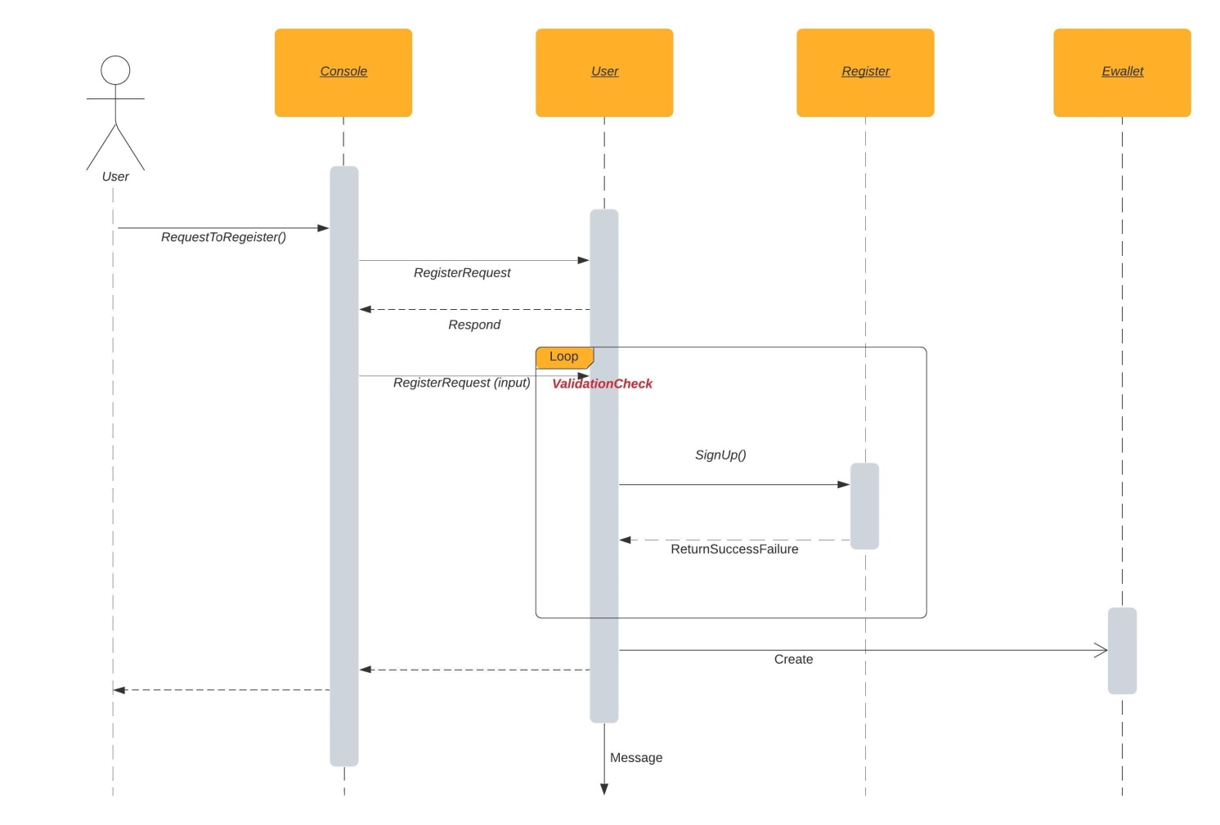

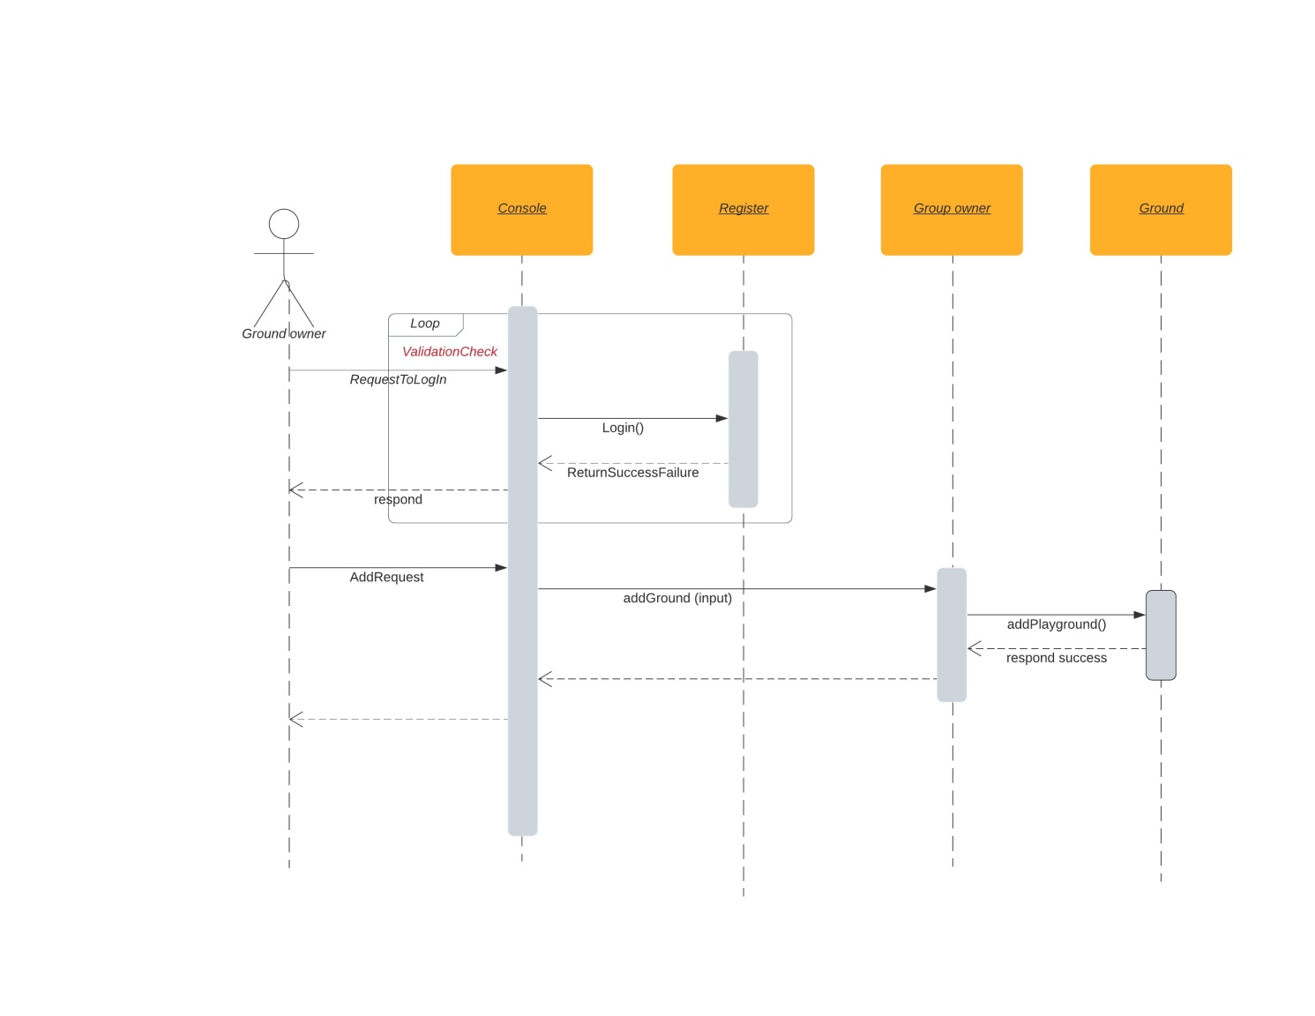

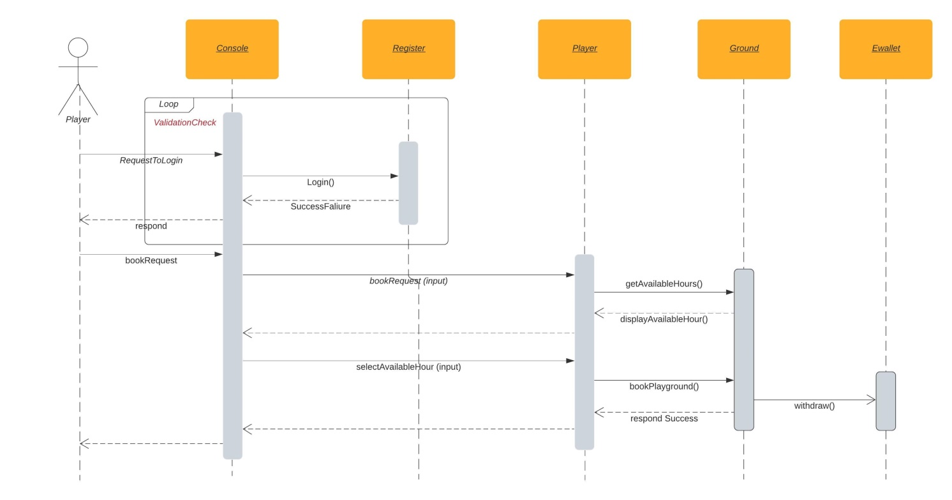

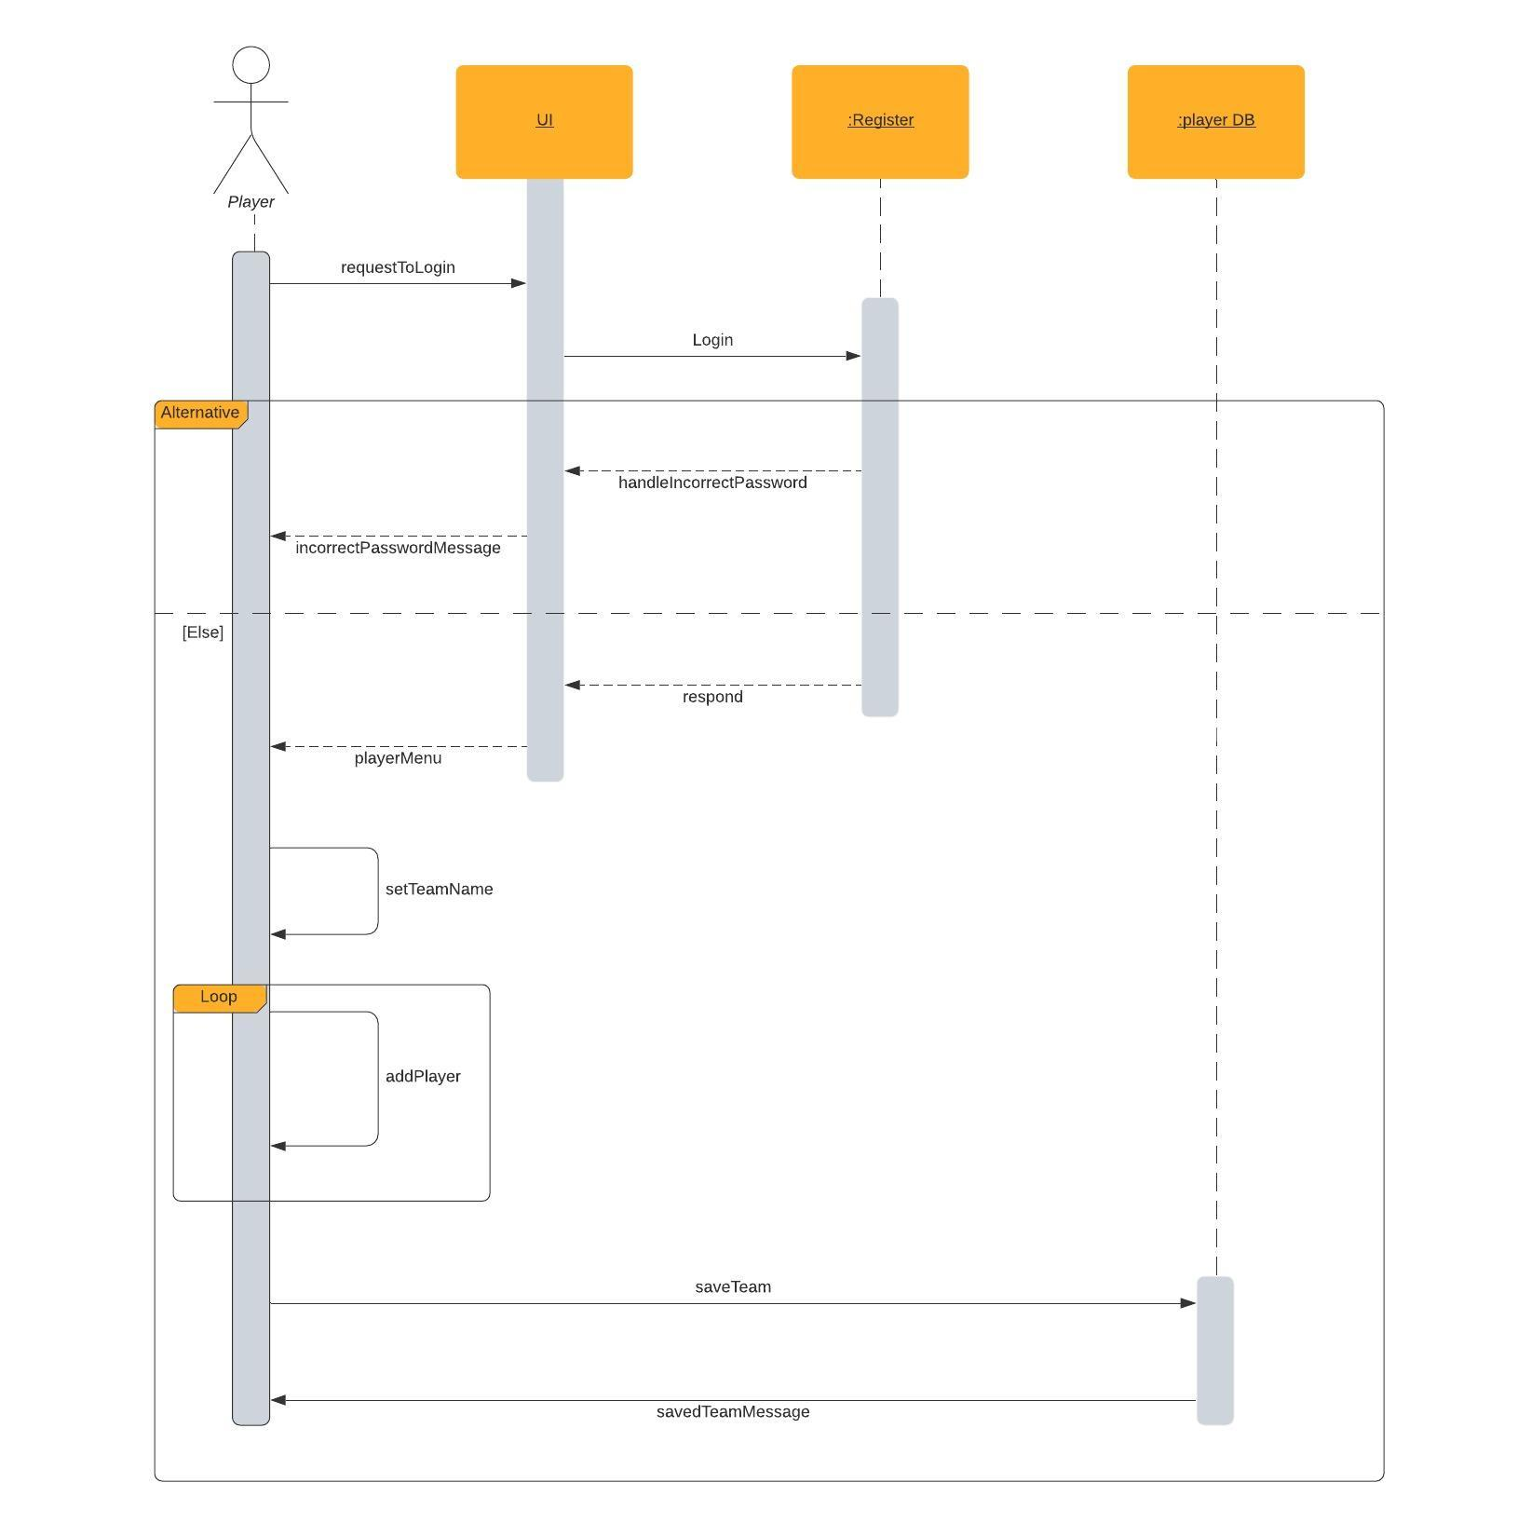

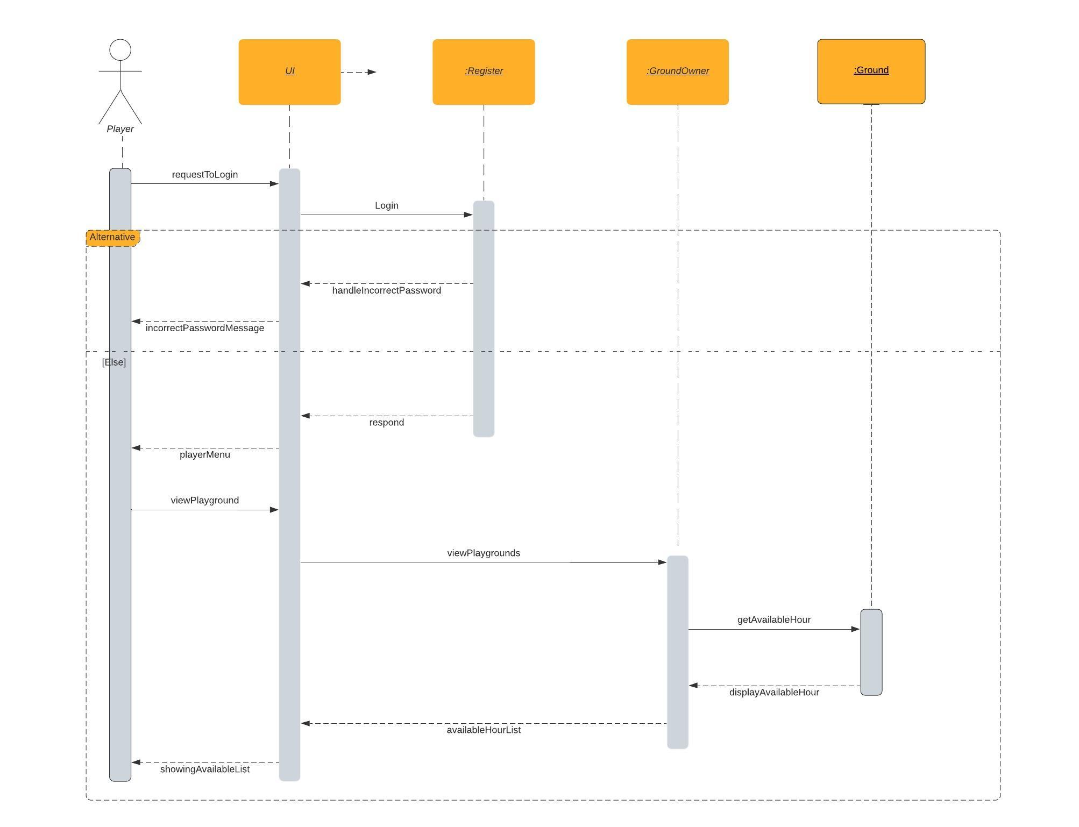

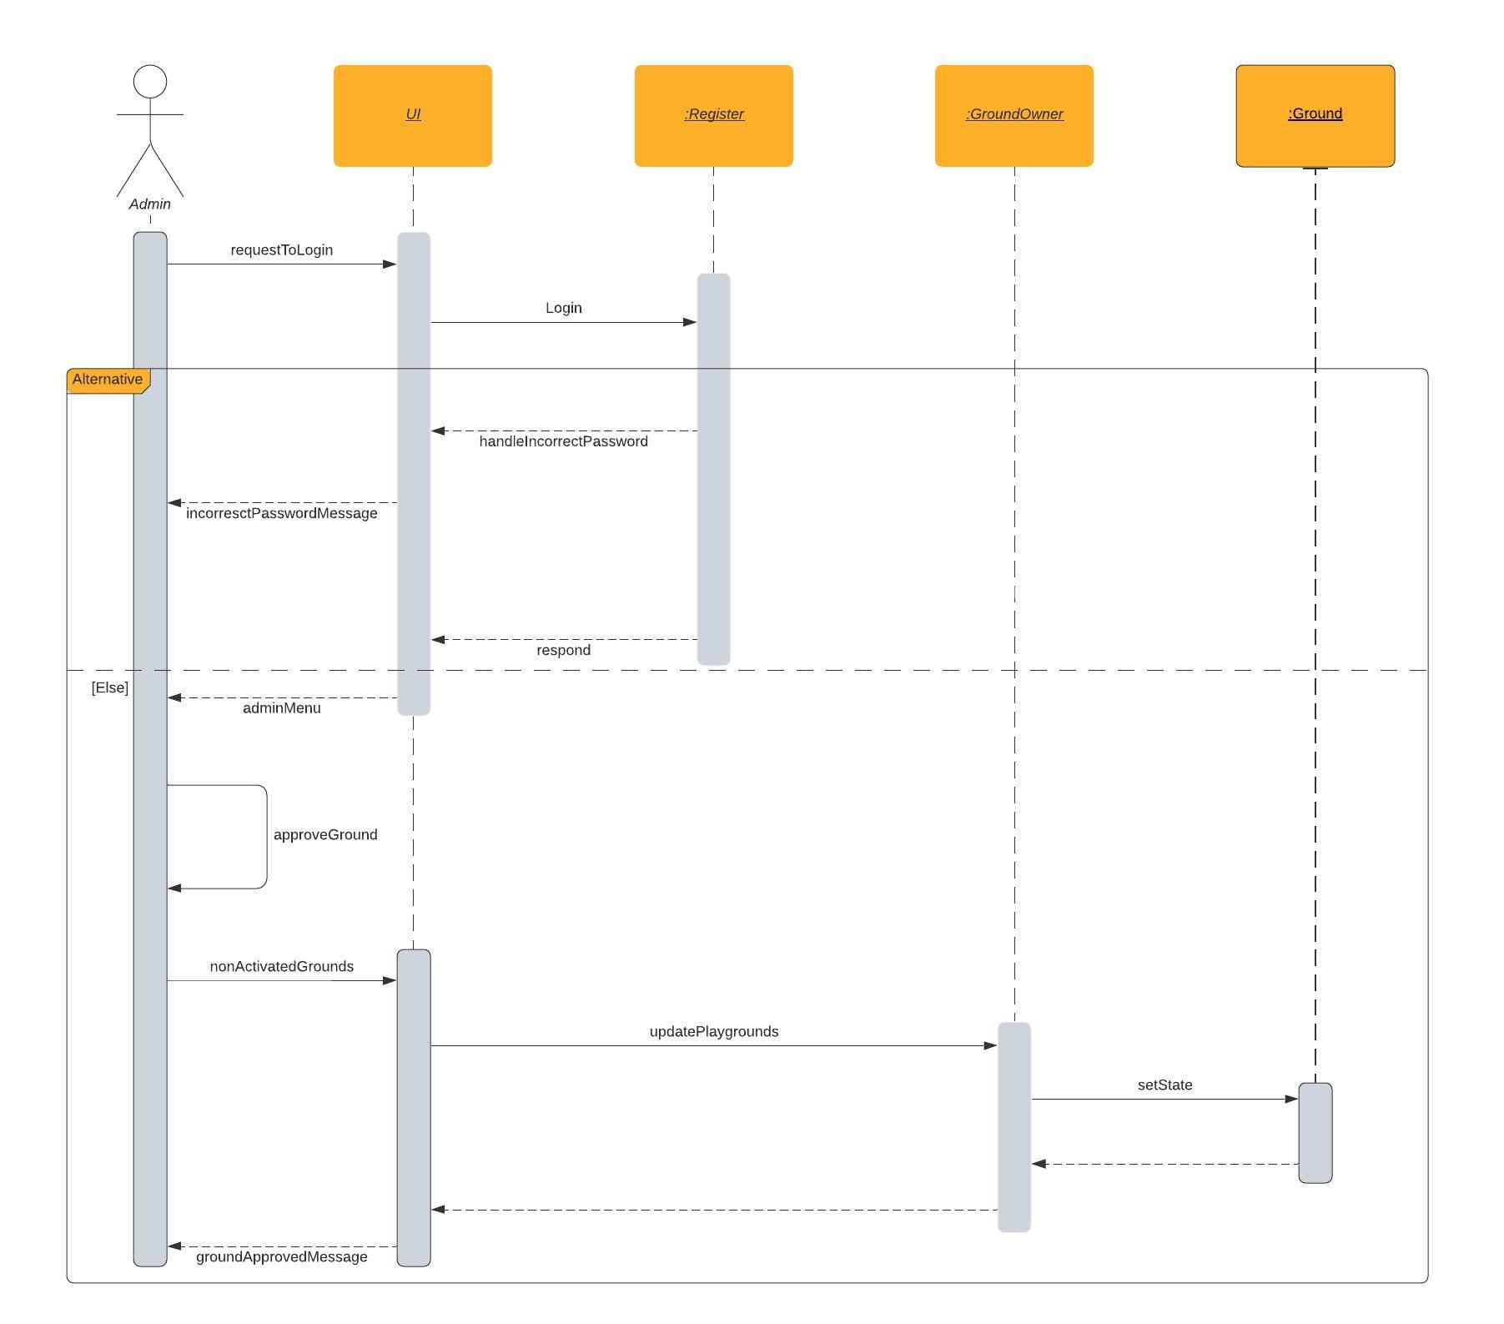

### 

### Class - Sequence Usage Table

| **Sequence Diagram** | **Classes Used** | **All Methods Used** |
| --- | --- | --- |
| 1. Sign up | Class user  Class Player  Class owner | 1. signUp(String name, String mail, String password, String address, String mobile, String type) |
| 1. Add Playground | Class owner | 1. addPlayground(String name, String location, **float** Area, **int** price) |
| 1. Book playground | Class Player | 1. bookPlayground(Register users, **int** ownerID, **int** first, **int** last, **int** groundID) 2. withdraw(**int** valueWithdraw) 3. booking(**int** ID, **int** first, **int** last, **int** cost, **int** groundID) 4. checkbooking(**int** first, **int** last, **int** groundID) |
| 1. Create team | Class Player | 1. addPlayer(String playerName, Register users) |
| 1. view playground hour | Class Player | 1. viewPlayground(Register users) 2. viewPlaygrounds() |
| 1. Approve playground | Class Admin | 1. nonActivatedGrounds(Register user) 2. approveGround(Register user, **int** id) 3. setState(String state) |