

**Faculty of Computers and Artificial Intelligence**

**Cairo University**

**Final Assessment Project**

**Course Title: Introduction to Database Systems (IS211)**

**Semester: Second Semester Date: May 2020**

**Instructors: Dr. Iman Hassan & Dr. Amani Hassan**

Online Recruitment Project

**Prepared by:**

|  |  |
| --- | --- |
| Student Name | Student ID |
| Mohamed Gamal Diab | 20180218 |
| Youssef Maher Maher | 20180350 |
| Alamier Hassan Younis | 20180051 |
| Abd-elrahman Esmat Mohamed | 20180154 |
| Mohamed Ahmed Abd-elrahman | 20180214 |

**Contents**

Chapter 1: Introduction 3

1.1 Description of the project idea 3

1.2 Technology and tools used 3

Chapter 2: Analysis 4

2.1 DB Conceptual ERD 4

2.2 DB Physical ERD 5

2.2.1 Create database 5

2.2.2 Create tables 5

2.2.3 Set C.V 5

2.2.4 Set Applicant 6

2.2.5 Set Employer 7

2.2.6 Set Vacancy 7

2.2.7 Apply for 8

Chapter 3: SQL Queries + screenshots of the results 9

References 11

# Chapter 1: Introduction

## Description of the project idea

Our idea is a system for employing applicants for jobs published in the system. First thing first, the employer, who has free positions in his company, offers the jobs by recording them into the system. Second thing second, the applicant who searches for a new job or a new free position apply for this job by introducing his CV or Resume to the employer. Third thing third, after many applicants apply for the job, the employer, then, could contact the best choices for his job and offer them an interview. These steps are the main operations for the system we are working on. This idea will ease the operation of hiring or employing new employees, it won’t make it easier for the employer only, but for the applicant as well.

## Technology and tools used

Microsoft SQL Server 2014 Management Studio.

<https://erdplus.com/standalone>

# Chapter 2: Analysis

## DB Conceptual ERD

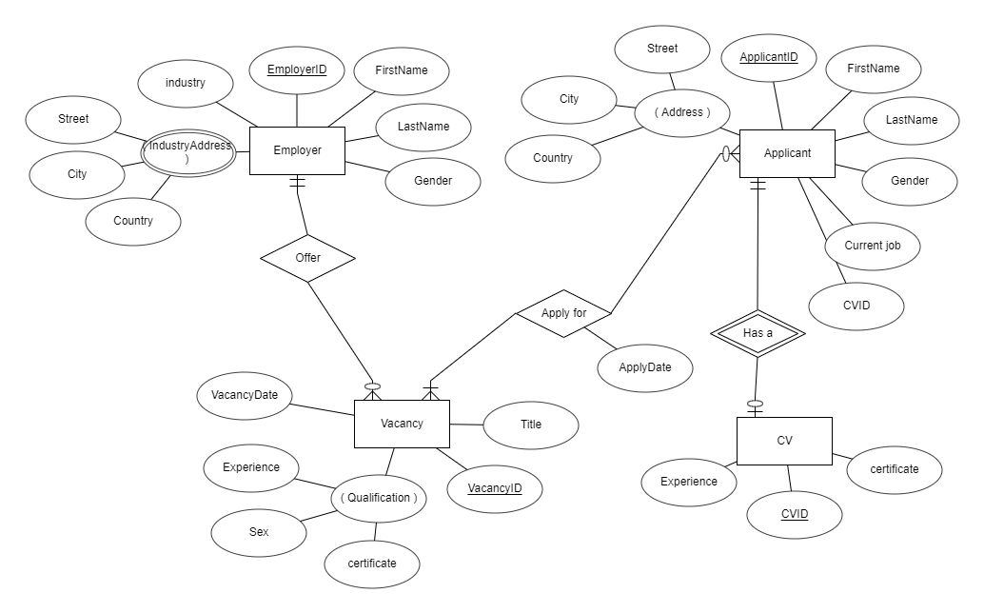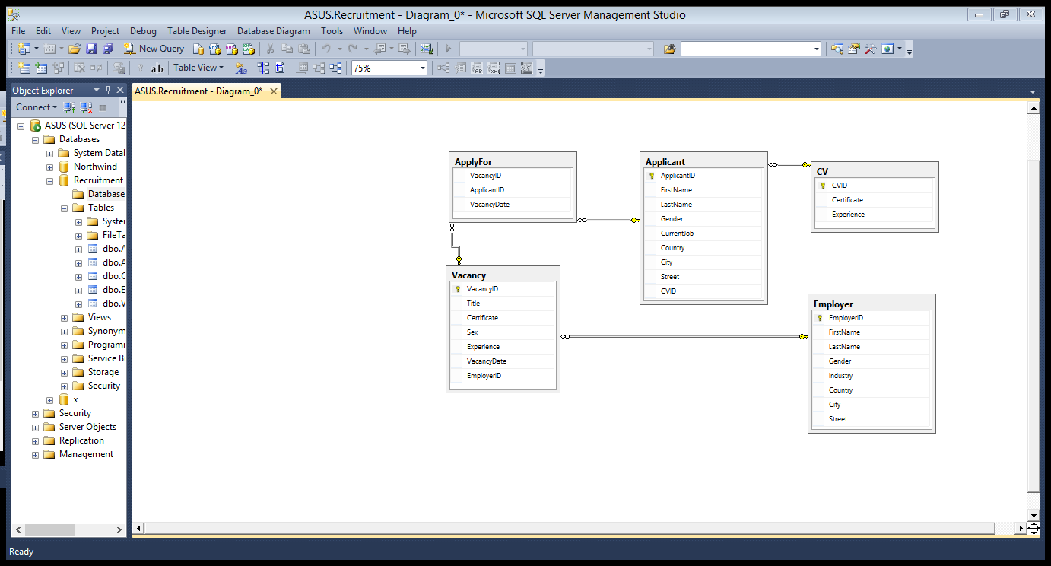

## DB Physical ERD

### Create database

CREATE DATABASE Recruitment;

### Create tables

CREATE TABLE Employer (

EmployerID int NOT NULL PRIMARY KEY IDENTITY,

FirstName varchar(25) NOT NULL,

LastName varchar(25) NOT NULL,

Gender varchar(10) NOT NULL CHECK (Gender = 'male' or Gender = 'female'),

Industry varchar(25) NOT NULL,

Country varchar(25) NOT NULL,

City varchar(25) NOT NULL,

Street varchar(25) NOT NULL,

);

CREATE TABLE CV (

CVID int NOT NULL PRIMARY KEY IDENTITY,

Certificate varchar(100),

Experience varchar(100),

);

CREATE TABLE Applicant (

ApplicantID int NOT NULL PRIMARY KEY IDENTITY,

FirstName varchar(25) NOT NULL,

LastName varchar(25) NOT NULL,

Gender varchar(10) NOT NULL CHECK (Gender = 'male' or Gender = 'female'),

CurrentJob varchar(25) NULL DEFAULT 'non-working',

Country varchar(25) NOT NULL,

City varchar(25) NOT NULL,

Street varchar(25) NOT NULL,

CVID int FOREIGN KEY (CVID) REFERENCES CV(CVID)

);

CREATE TABLE Vacancy (

VacancyID int NOT NULL PRIMARY KEY IDENTITY,

Title varchar(25) NOT NULL,

Certificate varchar(100),

Sex varchar(10) NOT NULL CHECK (Sex = 'male' or Sex = 'female' or Sex = 'Both') DEFAULT 'Both',

Experience varchar(100),

EmployerID int FOREIGN KEY (EmployerID) REFERENCES Employer(EmployerID) NOT NULL,

VacancyDate date DEFAULT GETDATE() NOT NULL,

);

CREATE TABLE ApplyFor (

VacancyID int NOT NULL FOREIGN KEY (vacancyID) REFERENCES Vacancy(vacancyID),

ApplicantID int FOREIGN KEY (ApplicantID) REFERENCES Applicant(ApplicantID) NOT NULL,

VacancyDate date DEFAULT GETDATE() NOT NULL,

);

### Set C.V

SET IDENTITY_INSERT CV ON

insert into CV(CVID,Certificate,Experience)

values(1,'c++ language','three programms');

insert into CV(CVID,Certificate,Experience)

values(2,'front end','2 websites');

insert into CV(CVID,Certificate,Experience)

values(3,'English language','2 years in school');

insert into CV(CVID,Certificate,Experience)

values(4,'nothing','3years in alahly bank');

insert into CV(CVID,Certificate,Experience)

values(5,'public relationship','1 year in company');

insert into CV(CVID,Certificate,Experience)

values(6,'public relationship','4 years in hotel');

insert into CV(CVID,Certificate,Experience)

values(7,'civil enginner','built house and cinema');

insert into CV(CVID,Certificate,Experience)

values(8,'kitchen','2 years in bakery');

insert into CV(CVID,Certificate,Experience)

values(9,'nursing','4 years in clinic');

insert into CV(CVID,Certificate,Experience)

values(10,'medican in children','2 years in hospital');

insert into CV(CVID,Certificate,Experience)

values(11,'Arabic literature','25 novels');

insert into CV(CVID,Certificate,Experience)

values(12,'cs magester','professor');

### Set Applicant

SET IDENTITY_INSERT Applicant ON

insert into Applicant(ApplicantID,FirstName,LastName,Gender,CurrentJob,Country,City,Street,CVID)

values(1,'mohamed','gamal','male','programmer','Egypt','cairo','maadi',1);

insert into Applicant(ApplicantID,FirstName,LastName,Gender,CurrentJob,Country,City,Street,CVID)

values(2,'youssef','maher','male','web developer','Egypt','cairo','darelsalam',2);

insert into Applicant(ApplicantID,FirstName,LastName,Gender,CurrentJob,Country,City,Street,CVID)

values(3,'alamir','hassan','male','teacher','Egypt','giza','ardalwaa',3);

insert into Applicant(ApplicantID,FirstName,LastName,Gender,CurrentJob,Country,City,Street,CVID)

values(4,'mohamed','elbna','male','security','Egypt','sohag','badrashen',4);

insert into Applicant(ApplicantID,FirstName,LastName,Gender,CurrentJob,Country,City,Street,CVID)

values(5,'abdo','esmat','female','hr','Egypt','asuet','qaz',5);

insert into Applicant(ApplicantID,FirstName,LastName,Gender,CurrentJob,Country,City,Street,CVID)

values(6,'mai','mohamed','female','receptionest','Egypt','aswan','naser',6);

insert into Applicant(ApplicantID,FirstName,LastName,Gender,CurrentJob,Country,City,Street,CVID)

values(7,'toka','ahmed','female','enginner','Egypt','luxor','simple',7);

insert into Applicant(ApplicantID,FirstName,LastName,Gender,CurrentJob,Country,City,Street,CVID)

values(8,'salma','basher','female','baker','Egypt','alex','max',8);

insert into Applicant(ApplicantID,FirstName,LastName,Gender,CurrentJob,Country,City,Street,CVID)

values(9,'batol','mohamed','female','nurse','Egypt','giza','panorama',9);

insert into Applicant(ApplicantID,FirstName,LastName,Gender,CurrentJob,Country,City,Street,CVID)

values(10,'Alaa','fathy','female','doctor','Egypt','cairo','tahrer',10);

insert into Applicant(ApplicantID,FirstName,LastName,Gender,CurrentJob,Country,City,Street,CVID)

values(11,'ahmed','khaleed','male','writer','Egypt','tanta','asd',11);

insert into Applicant(ApplicantID,FirstName,LastName,Gender,CurrentJob,Country,City,Street,CVID)

values(12,'abeer','osama','female','professor','Egypt','sainai','tor',12);

### Set Employer

SET IDENTITY_INSERT Employer ON

insert into Employer(EmployerID,FirstName,LastName,Gender,Industry,Country,City,Street)

values(1,'yasser','abdo','male','library','Egypt','fayoum','soaye');

insert into Employer(EmployerID,FirstName,LastName,Gender,Industry,Country,City,Street)

values(2,'gamal','elwan','male','bank','Egypt','behera','brka');

insert into Employer(EmployerID,FirstName,LastName,Gender,Industry,Country,City,Street)

values(3,'marwa','ezzat','female','hospital','Egypt','domyat','mshbk');

insert into Employer(EmployerID,FirstName,LastName,Gender,Industry,Country,City,Street)

values(4,'wafaa','mahmoud','female','education center','Egypt','sohag','zaitoon');

insert into Employer(EmployerID,FirstName,LastName,Gender,Industry,Country,City,Street)

values(5,'mohab','gamal','male','economist','Egypt','asuet','helwan');

insert into Employer(EmployerID,FirstName,LastName,Gender,Industry,Country,City,Street)

values(6,'nagoa','maoud','female','hotel','Egypt','aswan','kotzika');

insert into Employer(EmployerID,FirstName,LastName,Gender,Industry,Country,City,Street)

values(7,'fatma','hussein','female','programming','Egypt','luxor','thknat');

insert into Employer(EmployerID,FirstName,LastName,Gender,Industry,Country,City,Street)

values(8,'gamal','diab','male','civil company','Egypt','cairo','shohdaa');

### Set Vacancy

insert into Vacancy(VacancyID,Title,Certificate,Sex,Experience,VacancyDate,employerID)

values(1,'librarian','library support staff','both','master of library science','2020/1/20',1);

insert into Vacancy(VacancyID,Title,Certificate,Sex,Experience,VacancyDate,employerID)

values(2,'security','secure','male','four years in international bank','2019/11/23',2);

insert into Vacancy(VacancyID,Title,Certificate,Sex,Experience,VacancyDate,employerID)

values(3,'nurse','nursing assistant','female','nothing','2020/3/3',3);

insert into Vacancy(VacancyID,Title,Certificate,Sex,Experience,VacancyDate,employerID)

values(4,'doctor','ABPS','both','nothing','2020/4/5',3);

insert into Vacancy(VacancyID,Title,Certificate,Sex,Experience,VacancyDate,employerID)

values(5,'teacher','english language','female','1 year in primary school','2019/5/20',4);

insert into Vacancy(VacancyID,Title,Certificate,Sex,Experience,VacancyDate,employerID)

values(6,'Clean Worker','nothing','male','nothing','2019/12/6',4);

insert into Vacancy(VacancyID,Title,Certificate,Sex,Experience,VacancyDate,employerID)

values(7,'Receptionist','Popular Relation','female','2 years in 4stars hotel','2020/5/29',6);

insert into Vacancy(VacancyID,Title,Certificate,Sex,Experience,VacancyDate,employerID)

values(8,'programmer','c++ language','both','3 programs','2020/6/1',7);

insert into Vacancy(VacancyID,Title,Certificate,Sex,Experience,VacancyDate,employerID)

values(9,'web developer','front end','both','4 websites','2020/4/15',7);

insert into Vacancy(VacancyID,Title,Certificate,Sex,Experience,VacancyDate,employerID)

values(10,'enginner','Architecture art','male','bulding 2 houses','2020/5/20',8);

insert into Vacancy(VacancyID,Title,Certificate,Sex,Experience,VacancyDate,employerID)

values(11,'courier','tea maker','female','nothing','2020/2/8',8);

insert into Vacancy(VacancyID,Title,Certificate,Sex,Experience,VacancyDate,employerID)

values(12,'programmer','java language','male','4 programs','2020/3/19',7);

insert into Vacancy(VacancyID,Title,Certificate,Sex,Experience,VacancyDate,employerID)

values(13,'courier','coffe maker','both','nothing','2020/1/24',1);

insert into Vacancy(VacancyID,Title,Certificate,Sex,Experience,VacancyDate,employerID)

values(14,'Accountant','MSI','both','5 years working in national bank','2020/3/17',2);

insert into Vacancy(VacancyID,Title,Certificate,Sex,Experience,VacancyDate,employerID)

values(15,'Clean Worker','Cleaning expert','both','nothing','2019/10/30',3);

### Apply for

insert into ApplyFor(VacancyID,ApplicantID,VacancyDate)

values(11, 11, '2020-02-01')

insert into ApplyFor(VacancyID,ApplicantID,VacancyDate)

values(2, 5, '2019-12-01')

insert into ApplyFor(VacancyID,ApplicantID,VacancyDate)

values(2, 4, '2019-11-30')

insert into ApplyFor(VacancyID,ApplicantID,VacancyDate)

values(3, 9, '2020-04-01')

insert into ApplyFor(VacancyID,ApplicantID,VacancyDate)

values(4, 10, '2020-04-15')

insert into ApplyFor(VacancyID,ApplicantID,VacancyDate)

values(4, 12, '2020-04-10')

insert into ApplyFor(VacancyID,ApplicantID,VacancyDate)

values(5, 3, '2019-05-25')

insert into ApplyFor(VacancyID,ApplicantID,VacancyDate)

values(5, 6, '2019-05-30')

insert into ApplyFor(VacancyID,ApplicantID,VacancyDate)

values(6, 4, '2019-12-25')

insert into ApplyFor(VacancyID,ApplicantID,VacancyDate)

values(6, 5, '2019-12-30')

insert into ApplyFor(VacancyID,ApplicantID,VacancyDate)

values(7, 3, '2020-06-01')

insert into ApplyFor(VacancyID,ApplicantID,VacancyDate)

values(8, 7, '2020-06-17')

insert into ApplyFor(VacancyID,ApplicantID,VacancyDate)

values(8, 1, '2020-06-15')

insert into ApplyFor(VacancyID,ApplicantID,VacancyDate)

values(9, 2, '2020-04-20')

insert into ApplyFor(VacancyID,ApplicantID,VacancyDate)

values(10, 7, '2020-06-01')

insert into ApplyFor(VacancyID,ApplicantID,VacancyDate)

values(8, 2, '2020-06-20')

insert into ApplyFor(VacancyID,ApplicantID,VacancyDate)

values(12, 1, '2019-04-01')

insert into ApplyFor(VacancyID,ApplicantID,VacancyDate)

values(12, 7, '2019-04-30')

# Chapter 3: SQL Queries + screenshots of the results

1. What was the most interesting job “title” that had maximum number of applicants?

SELECT top 1 vacancy.title ,COUNT(ApplyFor.ApplicantID)AS counting

FROM ApplyFor,vacancy

where vacancy.VacancyID =ApplyFor.VacancyID

GROUP BY title

order by counting DESC;

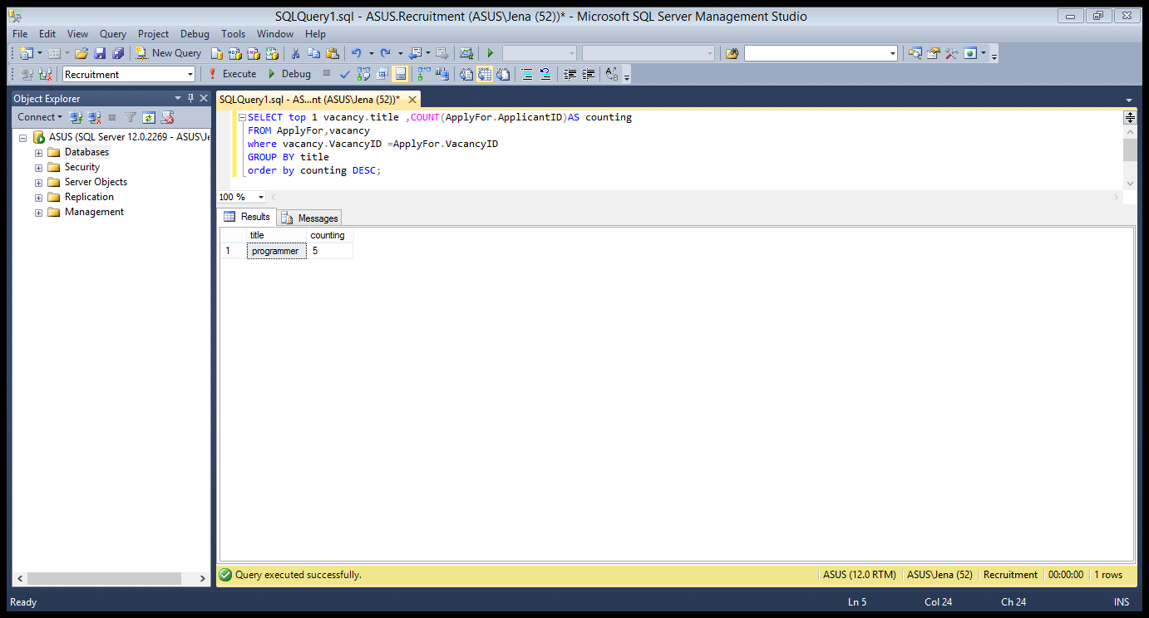

1. What was the announced job “title” that hadn’t any applicants last month?

SELECT *

FROM Vacancy

WHERE Vacancy.VacancyID NOT IN (select Applyfor.VacancyID from ApplyFor where VacancyDate>getdate()-30)

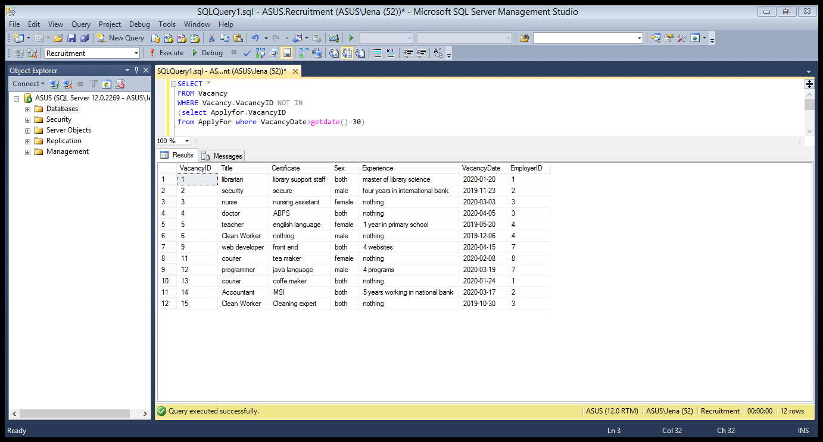

1. Who was the employer with the maximum announcements last month?

SELECT top 1 Employer.EmployerID, Employer.FirstName, Employer.LastName,s.counting

FROM (SELECT COUNT(vacancyID)AS counting, EmployerID FROM vacancy

where VacancyDate>getdate()-30

GROUP BY EmployerID )as s,Employer

where s.EmployerID=Employer.EmployerID

order by s.counting DESC

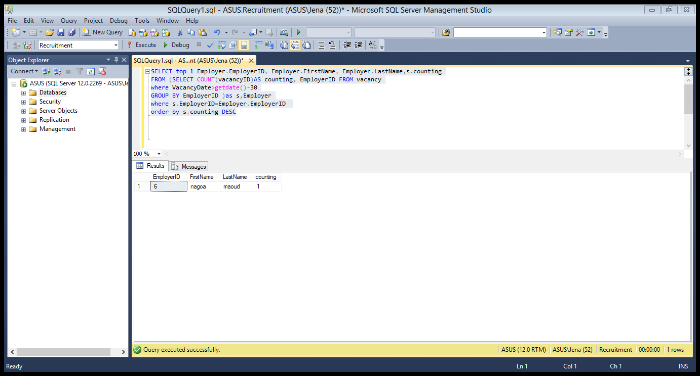

1. Who were the employers didn’t announce any job last month?

SELECT *

FROM Employer

WHERE Employer.EmployerID NOT IN (select Vacancy.EmployerID from vacancy where VacancyDate>getdate()-30)

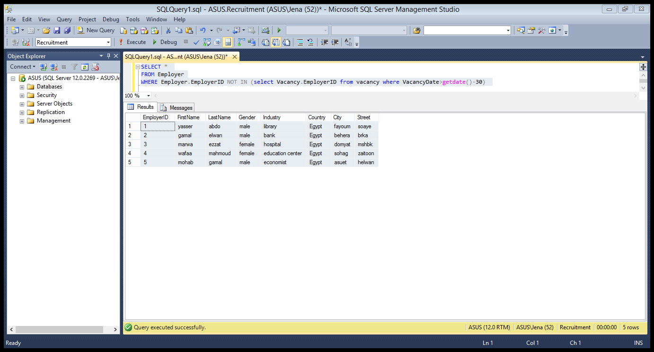

1. What were the available positions at each employer last month?

select *

from Vacancy

where VacancyDate> GETDATE()-30

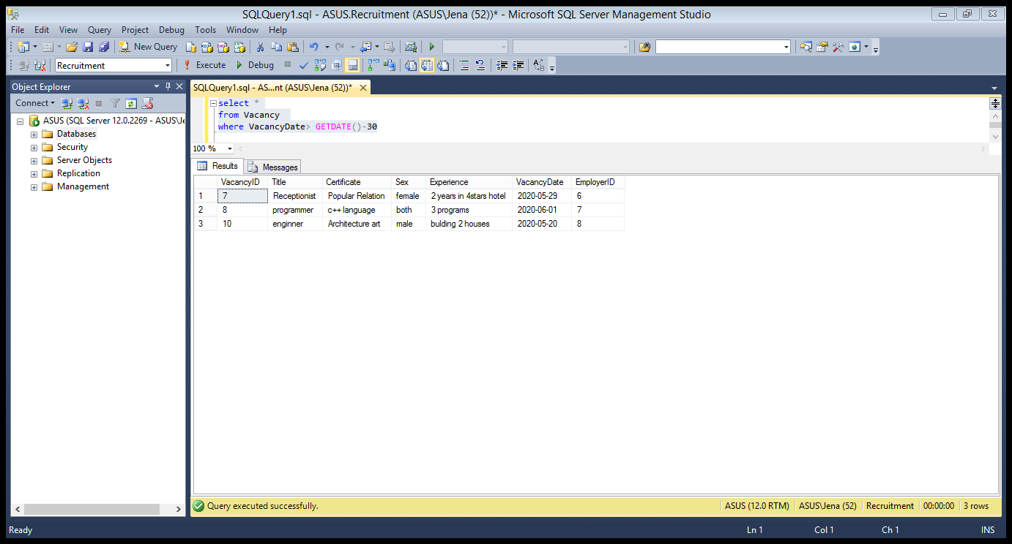

1. For each seeker, retrieve all his/her information and the number of jobs he applied for

SELECT Applicant.ApplicantID, Applicant.FirstName,Applicant.LastName,Applicant.Gender,s.counting

FROM (SELECT Applicant.ApplicantID,COUNT(ApplyFor.VacancyID)AS counting

FROM ApplyFor,Applicant

where Applicant.ApplicantID = ApplyFor.ApplicantID

GROUP BY Applicant.ApplicantID )as s FULL OUTER JOIN Applicant

on s.ApplicantID=Applicant.ApplicantID

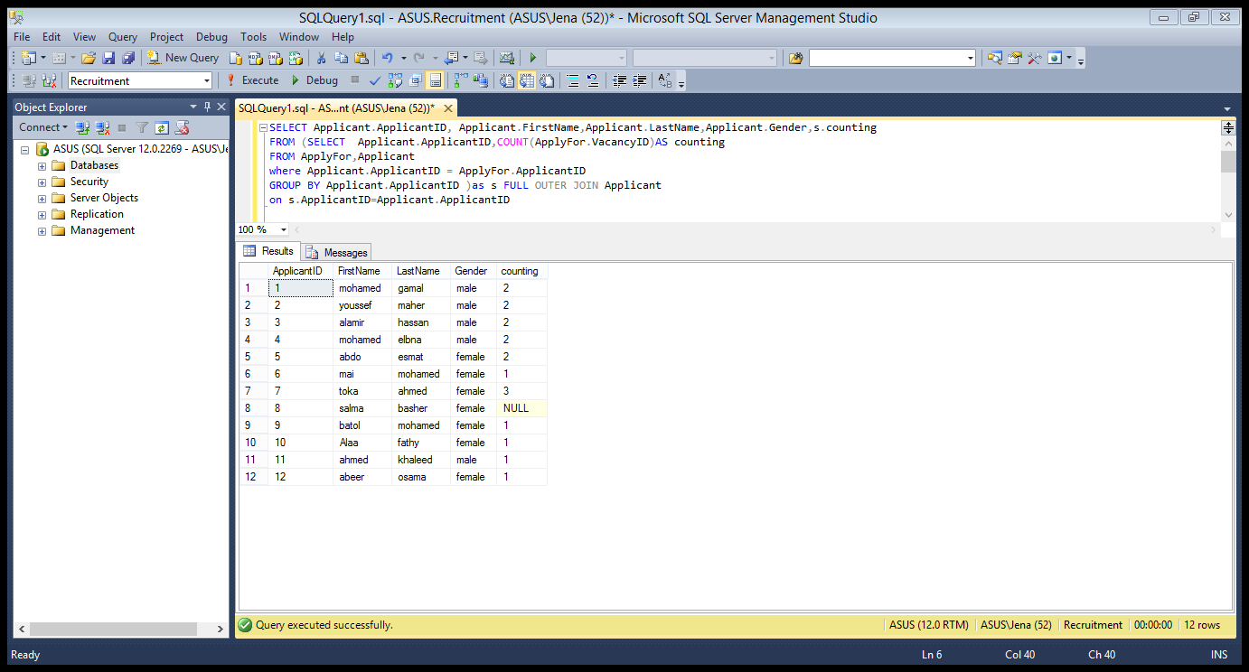

# References

<https://www.w3schools.com/sql/default.asp>