|  |
| --- |
| Compiler Project Report |

|  |  |
| --- | --- |
| **Content** | **Page Number** |
| Introduction | 1 |
| Scanner Definition | 2 |
| Parser Definition |  |
| Semantic Analysis Definition |  |
| Design | 3 |
| Output | 6 |
| Who did what? | 6 |
| Conclusion | 6 |
| References | 6 |

Introduction

1. Scanner is the first phase to create a compiler for the Tiny language. A program in Tiny language has a simple structure as follow:

* A sequence of statements separated by semicolons.
* No procedures and no declarations
* All variables are integers which are declared by simply assigning values to them (like BASIC)
* Only two control statements which may include statement sequences:
  + If statement: has an optional else part and must be terminated by the word end.
  + Repeat statement
* Read and Write statements that perform input/output
* Multiline C comments ( /* */) are used for block comments but comments cannot be nested for simplicity.
* Expressions are limited to Boolean and arithmetic expressions.
* Arithmetic expressions may involve: integer constants, variables, parentheses and any of the three integer operators -, + and * with the usual mathematical properties (precedence and associativity)
* Comparison operators are only: < and =
* The assignment operator :=
* Boolean expressions only appear as tests in control statements (no Boolean variables, assignment or I/O).

And extra works :

* Added Arithmetic operator /.
* Comparison operators >, != , >= and <= .
* Added full number parsing “e.g. 1.2E-3.5”.

|  |
| --- |
| **Reserved Words** |
| If |
| Then |
| Else |
| End |
| Repeat |
| Until |
| Read |
| Write |

1. Parser is the second phase**. Syntax Analysis (Parsing)** is the process of **analyzing a text**, made of a sequence of tokens (for example, words), to determine its **grammatical structure** with respect to a given (more or less) formal grammar.

A program or function which performs syntax analysis is called a **syntax analyzer, or parser**.

EBNF:-

program 🡪 stmt-sequence

stmt-sequence 🡪 statement { **;** statement }

statement 🡪 if-stmt | repeat-stmt | assign-stmt | read-stmt | write-stmt

if-stmt 🡪**if** exp **then** stmt-sequence **[ else** stmt- sequence ] **end**

repeat-stmt 🡪 **repeat** stmt-sequence **until** exp

assign-stmt 🡪 **identifier** **:=** exp

read-stmt 🡪 **read** **identifier**

write-stmt 🡪 **write** exp

exp 🡪 simple-exp [comparison-op simple-exp ]

comparison-op 🡪 **<** | =

simple-exp 🡪 term { addop term }

addop 🡪 **+** | **-**

term 🡪factor { mulop factor }

mulop 🡪 **\***

factor 🡪 **(**exp**)** | **number** | **identifier**

1. **Semantic Analysis** is the phase in which the compiler **adds semantic information** to the parse tree and builds the symbol table.

This phase performs semantic checks, such as:

**Object binding** (associating variable and function references with their definitions).

**Definite assignment** (requiring all local variables to be initialized before use).

**Rejecting incorrect programs or issuing warnings.**

Scanner Design:

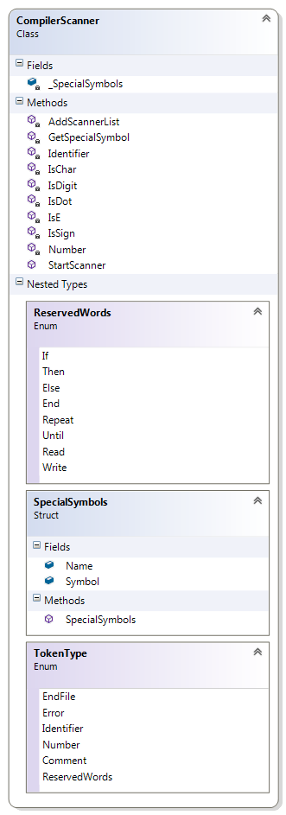

/// <summary>

/// Start Scanner

/// </summary>

/// <param name="FileData"></param>

/// <param name="ScannerData"></param>

public void StartScanner(string[] FileData, ref List<KeyValuePair<string, string>> ScannerData)

-------------------------------------------------------------------------------------------------------------------------------

/// <summary>

/// Check char or not

/// </summary>

/// <param name="ch"></param>

/// <returns>bool</returns>

private bool IsChar(char ch)

-------------------------------------------------------------------------------------------------------------------------------

/// <summary>

/// Check Digit or not

/// </summary>

/// <param name="ch"></param>

/// <returns>bool</returns>

private bool IsDigit(char ch)

-------------------------------------------------------------------------------------------------------------------------------

/// <summary>

/// Check Dot or not

/// </summary>

/// <param name="ch"></param>

/// <returns>bool</returns>

private bool IsDot(char ch)

------------------------------------------------------------------------------------------------------------------------------

/// <summary>

/// Check E or not

/// </summary>

/// <param name="ch"></param>

/// <returns>bool</returns>

private bool IsE(char ch)

-------------------------------------------------------------------------------------------------------------------------------

/// <summary>

/// Check + or - or not

/// </summary>

/// <param name="ch"></param>

/// <returns>bool</returns>

private bool IsSign(char ch)

-------------------------------------------------------------------------------------------------------------------------------

/// <summary>

/// Get Identifier and stop index

/// </summary>

/// <param name="input"></param>

/// <param name="index"></param>

/// <returns>string</returns>

private string Identifier(string input, ref int index)

-------------------------------------------------------------------------------------------------------------------------------

/// <summary>

/// Get Number(with error or not) and stop index

/// </summary>

/// <param name="input"></param>

/// <param name="index"></param>

/// <param name="Error"></param>

/// <returns>string</returns>

private string Number(string input, ref int index, ref bool Error, string output = "",bool E =false,bool Dot=false)

-------------------------------------------------------------------------------------------------------------------------------

/// <summary>

/// Get SpecialSymbol or empty

/// </summary>

/// <param name="current"></param>

/// <returns>string</returns>

private string GetSpecialSymbol(string current)

-------------------------------------------------------------------------------------------------------------------------------

/// <summary>

/// Add Token to ScannerData List

/// </summary>

/// <param name="ScannerData"></param>

/// <param name="output"></param>

/// <param name="result"></param>

private void AddScannerList(ref List<KeyValuePair<string, string>> ScannerData, string output, string result)

Scanner Output:

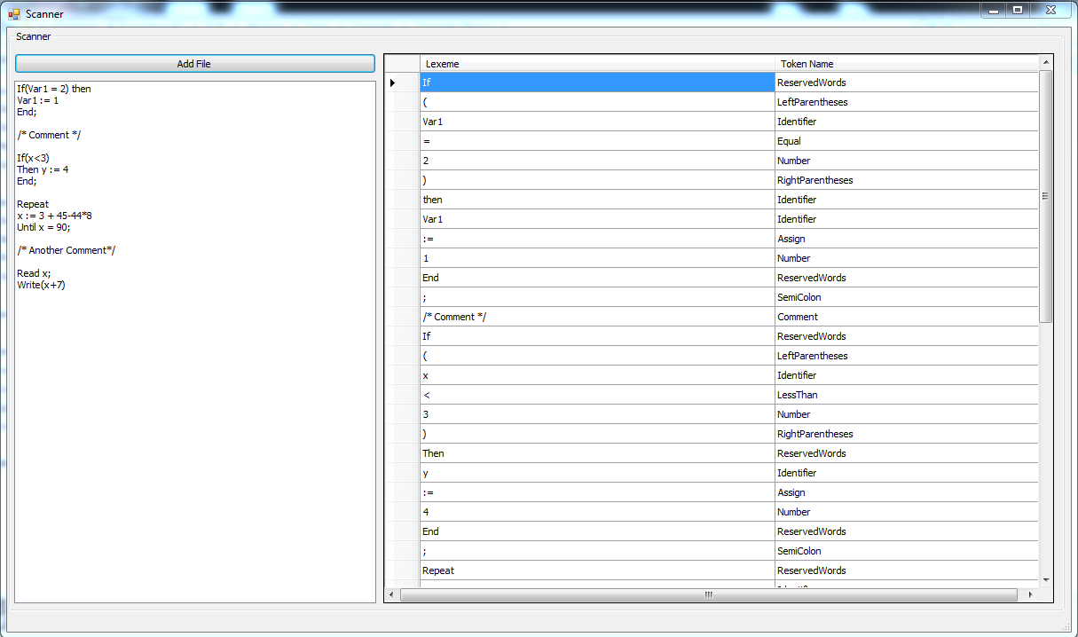

/// <summary>

/// Create Parse Tree

/// </summary>

/// <param name="SD"></param>

/// <param name="ParserTreeView"></param>

public bool CreateParseTree(List<KeyValuePair<string, string>> SD, ref TreeNode ParserTreeRoot)

-------------------------------------------------------------------------------------------------------------------------------

/// <summary>

/// Program ---> StatementSequence

/// </summary>

/// <returns></returns>

private TreeNode Program()

/// <summary>

/// StatementSequence ---> Statement { ; Statement }

/// </summary>

/// <param name="CurrentIndex"></param>

/// <param name="CurrentNode"></param>

/// <returns></returns>

private bool StatementSequence(ref int CurrentIndex, ref TreeNode CurrentNode)

-------------------------------------------------------------------------------------------------------------------------------

/// <summary>

/// Statement ---> IfStatement | RepeatStatement | AssignStatement | ReadStatement | WriteStatement

/// </summary>

/// <param name="CurrentIndex"></param>

/// <param name="CurrentNode"></param>

/// <returns></returns>

private bool Statement(ref int CurrentIndex, ref TreeNode CurrentNode)

-------------------------------------------------------------------------------------------------------------------------------

/// <summary>

/// IfStatement ---> If Expression Then StatementSequence [ Else StatementSequence ] End

/// </summary>

/// <param name="CurrentIndex"></param>

/// <param name="CurrentNode"></param>

/// <returns></returns>

private bool IfStatement(ref int CurrentIndex, ref TreeNode CurrentNode)

-------------------------------------------------------------------------------------------------------------------------------

/// <summary>

/// RepeatStatement ---> Repeat StatementSequence Until Expression

/// </summary>

/// <param name="CurrentIndex"></param>

/// <param name="CurrentNode"></param>

/// <returns></returns>

private bool RepeatStatement(ref int CurrentIndex, ref TreeNode CurrentNode)

-------------------------------------------------------------------------------------------------------------------------------

/// <summary>

/// AssignStatement ---> Identifier := Expression

/// </summary>

/// <param name="CurrentIndex"></param>

/// <param name="CurrentNode"></param>

/// <returns></returns>

private bool AssignStatement(ref int CurrentIndex, ref TreeNode CurrentNode)

-------------------------------------------------------------------------------------------------------------------------------

/// <summary>

/// ReadStatement ---> Read Identifier

/// </summary>

/// <param name="CurrentIndex"></param>

/// <param name="CurrentNode"></param>

/// <returns></returns>

private bool ReadStatement(ref int CurrentIndex, ref TreeNode CurrentNode)

-------------------------------------------------------------------------------------------------------------------------------

/// <summary>

/// WriteStatement ---> Write Expression

/// </summary>

/// <param name="CurrentIndex"></param>

/// <param name="CurrentNode"></param>

/// <returns></returns>

private bool WriteStatement(ref int CurrentIndex, ref TreeNode CurrentNode)

-------------------------------------------------------------------------------------------------------------------------------

/// <summary>

/// Expression ---> SimpleExpression [ ComparisonOperation SimpleExpression ]

/// </summary>

/// <param name="CurrentIndex"></param>

/// <param name="CurrentNode"></param>

/// <returns></returns>

private bool Expression(ref int CurrentIndex, ref TreeNode CurrentNode)

-------------------------------------------------------------------------------------------------------------------------------

/// <summary>

/// ComparisonOperation ---> < | =

/// </summary>

/// <param name="CurrentIndex"></param>

/// <param name="CurrentNode"></param>

/// <returns></returns>

private bool ComparisonOperation(ref int CurrentIndex, ref TreeNode CurrentNode)

-------------------------------------------------------------------------------------------------------------------------------

/// <summary>

/// SimpleExpression ---> Term { AddOperation Term }

/// </summary>

/// <param name="CurrentIndex"></param>

/// <param name="CurrentNode"></param>

/// <returns></returns>

private bool SimpleExpression(ref int CurrentIndex, ref TreeNode CurrentNode) /// -------------------------------------------------------------------------------------------------------------------------------

<summary>

/// AddOperation ---> + | -

/// </summary>

/// <param name="CurrentIndex"></param>

/// <param name="CurrentNode"></param>

/// <returns></returns>

private bool AddOperation(ref int CurrentIndex, ref TreeNode CurrentNode)

-------------------------------------------------------------------------------------------------------------------------------

/// <summary>

/// Term ---> Factor { MultiplicationOperation Factor }

/// </summary>

/// <param name="CurrentIndex"></param>

/// <param name="CurrentNode"></param>

/// <returns></returns>

private bool Term(ref int CurrentIndex, ref TreeNode CurrentNode)

-------------------------------------------------------------------------------------------------------------------------------

/// <summary>

/// MultiplicationOperation ---> *

/// </summary>

/// <param name="CurrentIndex"></param>

/// <param name="CurrentNode"></param>

/// <returns></returns>

private bool MultiplicationOperation(ref int CurrentIndex, ref TreeNode CurrentNode)

-------------------------------------------------------------------------------------------------------------------------------

/// <summary>

/// Factor ---> (Expression) | Number | Identifier

/// </summary>

/// <param name="CurrentIndex"></param>

/// <param name="CurrentNode"></param>

/// <returns></returns>

private bool Factor(ref int CurrentIndex, ref TreeNode CurrentNode)

-------------------------------------------------------------------------------------------------------------------------------

/// <summary>

/// CreateNode

/// </summary>

/// <param name="nodeName"></param>

/// <param name="value"></param>

/// <returns></returns>

private TreeNode CreateNode(string nodeName,string value)

-------------------------------------------------------------------------------------------------------------------------------

/// <summary>

/// AddChildNode

/// </summary>

/// <param name="Parent"></param>

/// <param name="Child"></param>

/// <returns></returns>

private TreeNode AddChildNode(TreeNode Parent,TreeNode Child)

Parser Design:

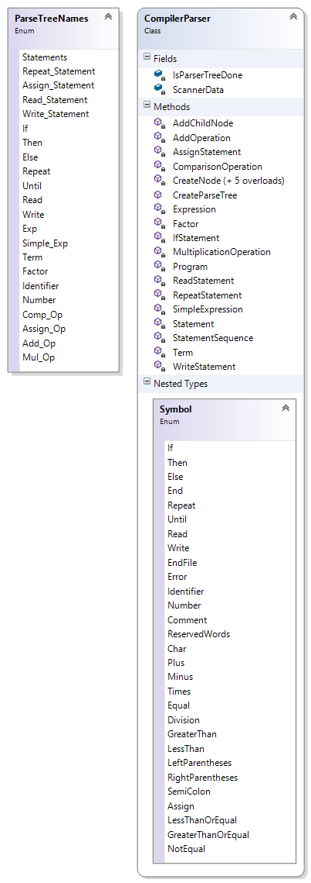

/// <summary>

/// Create Semantic Tree

/// </summary>

/// <param name="ParserTreeRoot"></param>

public void CreateSemanticTree(ref TreeNode ParserTreeRoot)

-------------------------------------------------------------------------------------------------------------------------------

/// <summary>

/// Statements

/// </summary>

/// <param name="node"></param>

private void Statements(ref TreeNode node)

-------------------------------------------------------------------------------------------------------------------------------

/// <summary>

/// If

/// </summary>

/// <param name="node"></param>

private void If(ref TreeNode node)

-------------------------------------------------------------------------------------------------------------------------------

/// <summary>

/// Repeat

/// </summary>

/// <param name="node"></param>

private void Repeat(ref TreeNode node)

-------------------------------------------------------------------------------------------------------------------------------

/// <summary>

/// Assign_Statement

/// </summary>

/// <param name="node"></param>

private void Assign_Statement(ref TreeNode node)

-------------------------------------------------------------------------------------------------------------------------------

/// <summary>

/// Read

/// </summary>

/// <param name="node"></param>

private void Read(ref TreeNode node)

-------------------------------------------------------------------------------------------------------------------------------

/// <summary>

/// Write

/// </summary>

/// <param name="node"></param>

private void Write(ref TreeNode node)

-------------------------------------------------------------------------------------------------------------------------------

/// <summary>

/// Exp

/// </summary>

/// <param name="node"></param>

private void Exp(ref TreeNode node)

-------------------------------------------------------------------------------------------------------------------------------

/// <summary>

/// Simple_Exp

/// </summary>

/// <param name="node"></param>

private void Simple_Exp(ref TreeNode node)

-------------------------------------------------------------------------------------------------------------------------------

/// <summary>

/// Term

/// </summary>

/// <param name="node"></param>

private void Term(ref TreeNode node)

-------------------------------------------------------------------------------------------------------------------------------

/// <summary>

/// Factor

/// </summary>

/// <param name="node"></param>

private void Factor(ref TreeNode node)

-------------------------------------------------------------------------------------------------------------------------------

/// <summary>

/// Compare

/// </summary>

/// <param name="firstTerm"></param>

/// <param name="secondTerm"></param>

/// <param name="Comp_Op"></param>

/// <returns></returns>

private bool Compare(string firstTerm, string secondTerm, string Comp_Op)

-------------------------------------------------------------------------------------------------------------------------------

/// <summary>

/// nodeOfKey

/// </summary>

/// <param name="node"></param>

/// <param name="key"></param>

/// <returns></returns>

private TreeNode nodeOfKey(TreeNode node, ParseTreeNames key)

-------------------------------------------------------------------------------------------------------------------------------

/// <summary>

/// indexOfKey

/// </summary>

/// <param name="node"></param>

/// <param name="key"></param>

/// <returns></returns>

private int indexOfKey(TreeNode node, ParseTreeNames key)

-------------------------------------------------------------------------------------------------------------------------------

/// <summary>

/// editNode

/// </summary>

/// <param name="parent"></param>

/// <param name="child"></param>

private void editNode(ref TreeNode parent, TreeNode child)

-------------------------------------------------------------------------------------------------------------------------------

/// <summary>

/// editNode

/// </summary>

/// <param name="parent"></param>

/// <param name="child"></param>

/// <param name="index"></param>

private void editNode(ref TreeNode parent, TreeNode child, int index)

-------------------------------------------------------------------------------------------------------------------------------

/// <summary>

/// format

/// </summary>

/// <param name="str"></param>

/// <returns></returns>

private string format(string str)

-------------------------------------------------------------------------------------------------------------------------------

/// <summary>

/// split

/// </summary>

/// <param name="str"></param>

/// <returns></returns>

private string[] split(string str)

-------------------------------------------------------------------------------------------------------------------------------

/// <summary>

/// hasAlpha

/// </summary>

/// <param name="str"></param>

/// <returns></returns>

private bool hasAlpha(string str)

Parser Output:

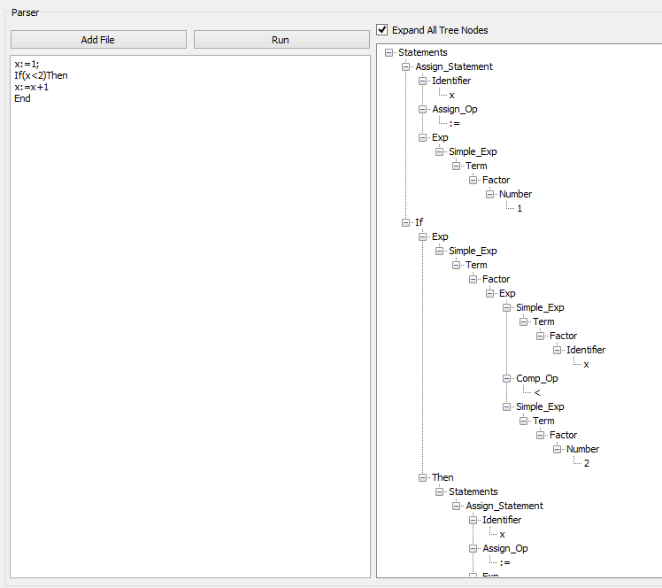 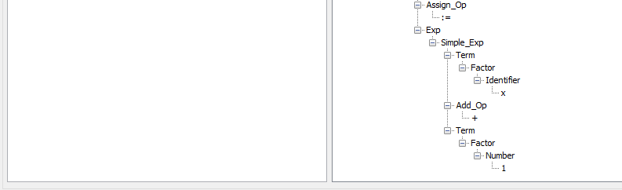

Semantic Design:

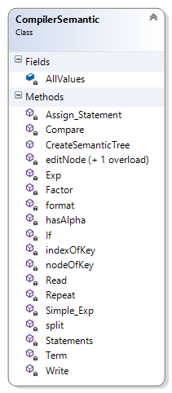

Semantic Output:

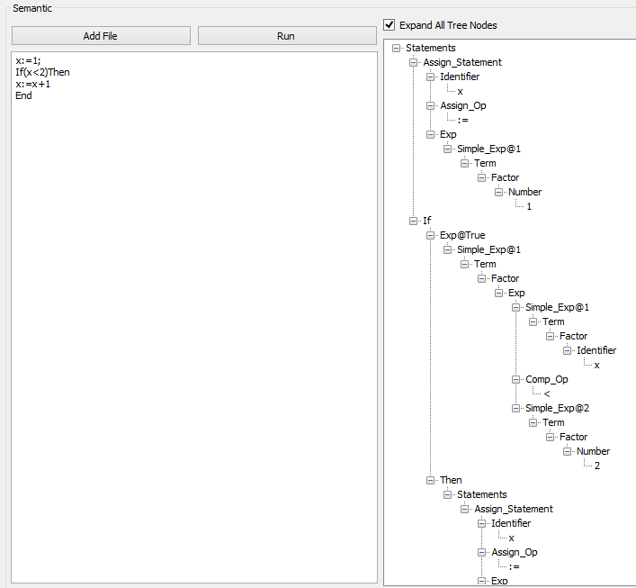 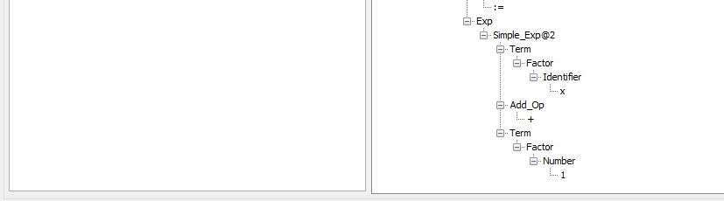

Who did what?

|  |  |  |
| --- | --- | --- |
| Name | Section |  |
| Mohamed Ali Mohamed | 3 | Parser Implementation |
| Mahmoud Khaled Mahmoud | 3 | Semantic Implementation |
| Mahmoud Mohamed Afify | 3 | Scanner Implementation |
| Mohamed Gamal Soliman | 2 | Scanner Implementation |
| Ahmed Hani Ibrahim | 1 | EBNF |

Conclusion:

All phase work with no bugs.

References:

Compiler’s Labs