Decision Trees Case Study
Decision Trees are excellent tools for helping you to choose between several courses of action to take a decision.
Consider the following case study:
“Assume as a factory manager, you want to take a decision either:
(1) to produce a new product or
(2) to consolidate (combine) توطيد the old product of your manufacturing i.e. makes (something) physically stronger or more solid by Combining a number of things into a single more effective or coherent whole”.
Suppose your sales المبيعات, manufacturing التصنيع, production الانتاج and financial departments الادارة المالية feeds you with the date contained in the following table:
شامل
تقوية
Decision | Possibility | Evaluation | Probability |  | Market Reaction | Values of Uncertain Outcomes | Total | Cost | Net Benefit | Final Decision
New Product | Thorough Development | Good | 0.4 | }1 | $ 1,000,000 | ? | ? | $150,000 | ? | Y/N
New Product | Thorough Development | Moderate | 0.4 | }1 | $ 50,000 | ?
New Product | Thorough Development | Poor | 0.2 | }1 | $ 2,000 | ?
New Product | Rapid Development | Good | 0.1 | }1 | $ 1,000,000 | ? | ? | $80,000 | ? | Y/N
New Product | Rapid Development | Moderate | 0.2 | }1 | $ 50,000 | ?
New Product | Rapid Development | Poor | 0.7 | }1 | $ 2,000 | ?
Consolidate Old Product | Strengthen Product | Good | 0.3 | }1 | $ 400,000 | ? | ? | $30,000 | ? | Y/N
Consolidate Old Product | Strengthen Product | Moderate | 0.4 | }1 | $ 20,000 | ?
Consolidate Old Product | Strengthen Product | Poor | 0.3` | }1 | $ 6,000 | ?
Consolidate Old Product | Reap Product | Good | 0.6 | }1 | $ 20,000 | ? | ? | $0 | ? | Y/N
Consolidate Old Product | Reap Product | Poor | 0.4 | }1 | $ 2,000 | ?
الظهور مرة اخري بشكل مغاير

Step 1:

Draw the decision tree for this case study as a structure without data.

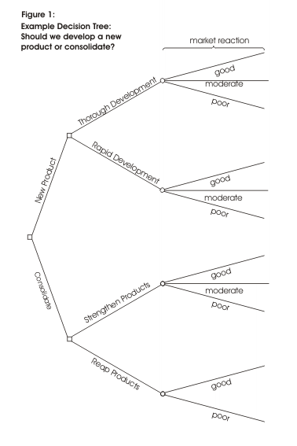

Step 2:

Evaluate your decision tree by putting the table data on your drawing.
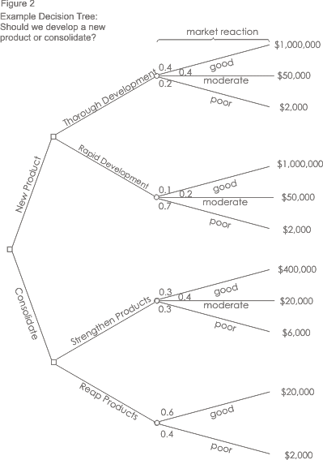

Step 3:

Calculate tree values from right to left.

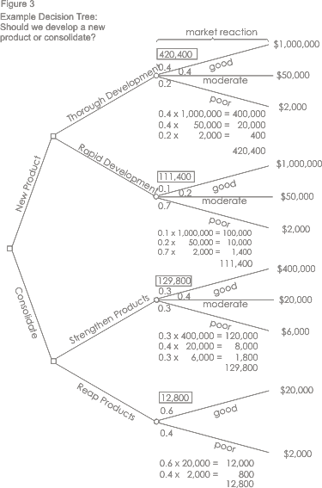

Step 4:

Calculate the value of decision nodes to determine the maximum route by taking into consideration the cost values.

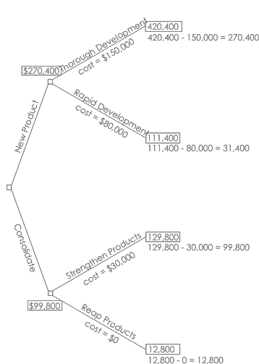

Decision:
By applying this technique, we can see that the best option is to develop a new product (270,400 is higher than 99,800)
It is worth much more to us to take our time (thorough development شامل متأني ) and get the product right, than to rush (rapid development متسرع ) the product to market.

