COVID-19 Impact on Social and Emotional Learning



(855) 297 7575 | info@integrass.com | Integrass.com

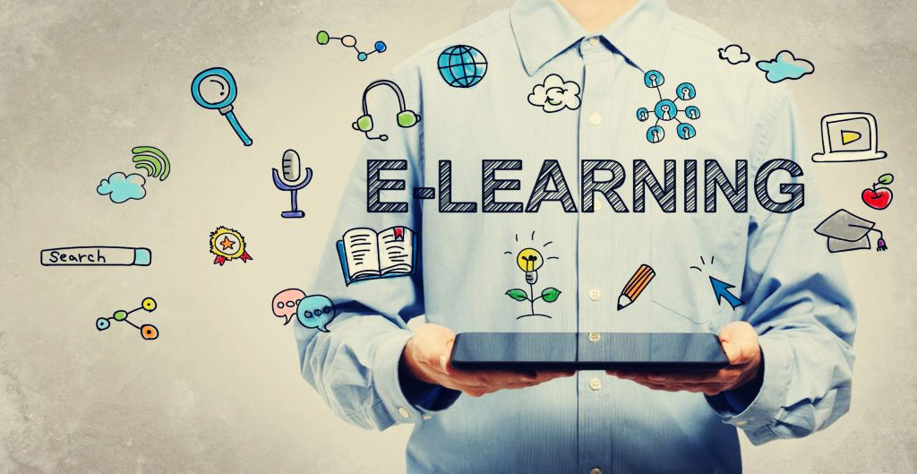

Lorem ipsum dolor sit amet, consectetur adipiscing elit, sed do eiusmod tempor incididunt ut labore et dolore magna aliqua. Ut enim ad minim veniam, quis nostrud exercitation ullamco laboris nisi ut aliquipex ea commodo consequat. Duis aute irure dolor in reprehenderit in voluptate velit esse cillum dolore

**Table of Contents**

**Introduction** 3

**Chapter One: The Situation of Children During COVID** 4

**Domains of Child development** 5

**Role of Learning Management Systems (LMS) in Providing Continous Education** 6

**Future of LMS** 8

**Conclusion** 9

# **Introduction**

The world is going through one of the serious crises, which has impacted globally. On one hand, the Pandemic has caused serious life losses, health crises, and panic. On the other hand, there are massive shut-downs, economic losses, market crashes, loss of jobs, and even financial instability. The aftermath of the crisis has erupted a great psychological effect on people, where they develop serious mental illness, depression, and other mind-related challenges. While focussing on the challenges of children, schools are shut down in most of the world, making it very difficult for the children to continue their education. It is only through virtual learning or through online classes, which bridges the gap between the students and the teachers.

This White Paper aims to elucidate the current scenario around the world, where children below the age of 8 are facing learning challenges during this Pandemic. It is important to understand the importance of learning, especially for young children. This White Paper also aims to bring a solution for continuous learning and development during the crisis, to address the needs of the children.

**Points to be remembered:**

* The ages 0 to 8 are considered highly important for any child, as it is the formative period which is highly crucial for learning and development.
* The child grasps so many things, and it is found that Brain development starts for a child right from the pregnancy.
* A child not only learns through the curriculum but also by observing the people and surroundings.
* A holistic knowledge includes the intellectual, social, and emotional skills of the child, and to gain a comprehensive development, all the facets of education should be developed equally.
* When there is an obstacle in learning, the development of a child lags.
* To meet this issue globally, UNESCO partners with local bodies, LMS content providers, and NGOs to give uninterrupted learning.

# **Chapter One: The Situation of Children During COVID**

****Across the globe, the physical, mental trauma of young children is immeasurable. The structural inequality, financial inequality, the rise in pandemic deaths, and infant mortality rates have caused a serious impact.

Around March 2020, almost 89 percent of the student’s population is of the school and the college. A serious technical and psychological system should be in place to compensate for all the losses of absenteeism in schools and colleges. To give a concrete solution to the phycological and learning needs, the demand for LMS systems has gained enormous popularity.

1. **The Global Education Coalition Program:**

“The Global Education Coalition”, is a welcoming venture of UNESCO, to provide a learning opportunity to children during an unprecedented educational disruption. With the support of local governing bodies, schools, and NGOs, the initiative of giving continual education to children has been on the progress. The aim is to create a sustainable solution and not just an interim solution during COVID alone.



**It is highly alarming to note that:**

* **60.5% of the world’s population is affected by the school’s closure**
* **More than 1.5 billion students are out of school**
* **Almost 109 countries around the world suffer out of school’s closure**

UNESCO has identified websites and other major tools, and other learning management systems, which can address the students, teachers, and other stakeholders directly, and provide continuous knowledge transfer. The directives have been fragmented into several steps, which helps them to achieve their destination of not only reaching the students effectively but to provide interactive and focused content, which makes a distinct impact in the minds of the children.

# **Domains of Child development**

A child needs to go through comprehensive stages of growth and development in all spheres of learning, which are Physical Development, which involves activities like catching, throwing, jumping, and hoping. The phase of Cognitive development is where a child thinks on its own. The next and the most important phase is the Social and Emotional Development, where the child recognizes the emotions and knows how to control it. It is a phase of self-awareness, which enables the child to identify their strengths and weaknesses.

The age below ten is very critical, where emotional, cognitive, and holistic learning happens, and the child begins to get their own identity. They also want to feel important among the group of their peers. Friends, families, and peers form an important part in the development of a child, where a lot of knowledge is imparted through peers.

# **Chapter 2: Role of Learning Management Systems (LMS) in Providing Continous Education:**

Online education, and learning through digital medium always have an advantage and edge over the traditional methods of learning, as it provides a safe environment and enables them to continue the education despite hurdles. In this current scenario, where the schools, colleges, and other educational systems are closed, and the children are learning with the support of the Internet and gadgets. Computers, mobile devices, and other gadgets have become a learning tool. The onus to develop the content which interests the child is vested in the hands of the content creators.

1. **Growth of Learning Management System:**

The process of eLearning hs emerged into LMS during the late 90s, where it delivers training programs and learning programs, which can be easily tracked, documented, automated monitored, and administrated. It first emerged to cater training segment market, and later focussed on identifying the learning and training gaps in all the sectors.

LMS are commonly web-based and was initially designed to locally host it on-premise. Many organizations would purchase and install it on their server. Later, it is provided as SaaS, where the hosting is provided by the vendors.

A perfectly synchronized LMS system could include all types of contents from Videos, Documents, Presentations, and online classes where a teacher can broadcast simultaneously to multiple students.

1. **Properties of LMS:**

The shift from the traditional classrooms to digital medium has raised the demands for the newer mode of learning. It is essential to address the diverse needs of learning, as the requirements vary from among institutions. If the learning management system is orchestrated perfectly, it enables gain in time, cost, and effort.

1. **Comprehensive Platform**:

LMS is a comprehensive platform, which not only delivers the relevant information but also gives a holistic approach to conduct tests, and assessments periodically.

1. **Systematic Organization**

Each lesson is systematically designed into small portions, which enables comprehensive learning through quiz, and games.

1. **Strict Timelines**

Each lesson has fixed timelines to complete and insists the students complete the lesson within the stipulated timeframe.

1. **Interactive Content**

The interactive systems are highly like by children, which enables them to concentrate and not divert their attention. Keeping the mindset of the child, the content would be strategically designed to cater to the needs of the children.

1. **Periodic tests, assignments, and feedback**

There are special features to give Assignments, and the students can give regular feedback. There are also chat facilities, which enable the child to enable and communicate with the peers.

1. **Dashboard**

The dashboard is also present in the system, which helps the child to compare the progress of themselves with others. It is noted that the competitive spirit works best in children, where there are positive motivation and the urge to achieve greater targets.

# **Chapter 3: Future of LMS**

The advent of digital platforms has made a paradigm shift in the way the learning process has been carried out. Learning from the classrooms, and visiting libraries for knowledge updation were not adequate. Newer platforms and content sharing sites with experiments, and practical demonstrations helped them to understand the concepts better.

eLearning has crossed an enormous path and has made significant enhancements over the years. Once it was a tool of advanced learning, and to enhance the knowledge has made a lot of progress to reach to people. Now it has replaced the classrooms and education institutions, paving way for continuous education. Further, the world is going towards a collaborative learning culture, which features learning and sharing the content with its peers online. Tools like Gamification, virtual social networking, productivity tools, and many mobile apps are now focussing on quenching the knowledge quest of the people.

The focus of the content creators or the IT company’s acumen in both the psychological aspect and the technology aspect has to be up to date. The future holds good for all the stakeholders who are focussing on giving content that is up-to-date, interactive, and informative, but to become learner-centric and to focus on adaptive learning and assessment.

# **Conclusion:**

The future of the world lies in the hands of the younger generation, and through the collective effort of all the people and the stakeholders, it is important to provide them with opportunities for their growth and development. Thus to create a sustainable future, it is important to invest in the continuous learning of children. Many companies, organizations, and voluntary groups have stepped forward for this collective cause. Thus, companies like Integrass are focused on creating special education and learning material, created by experts, and customized to cater to children based on their cultural, regional, and demographical diversities.

Thus an enhanced focus is given in the areas of skill focus, teaching strategies, and implementation supports through read-aloud, games, role-play, and music. On the whole, a child gets comprehensive support to develop and grow, even though the time of pandemic and other challenges. Extending further, this model will be implemented for the countries and places, where the children consequently face some hurdles going to school regularly.

With an IT experience over ten years, and have been curating diverse study materials. Our expertise in developing educational solutions, creating interactive, interesting, and informative content had reached through newer horizons. We have a well-equipped team of Subject Matter Experts, Physiologists, and Neuro-Linguistic Practitioners, and Content creators to address the needs of the children. Contact (855) 297 7575, or visit [info@integrass.com](mailto:info@integrass.com) to request a demo.