
KRL Generator
User Manual
Offline path generation for continuous-fiber printing
on the KUKA KR 6 R900 sixx

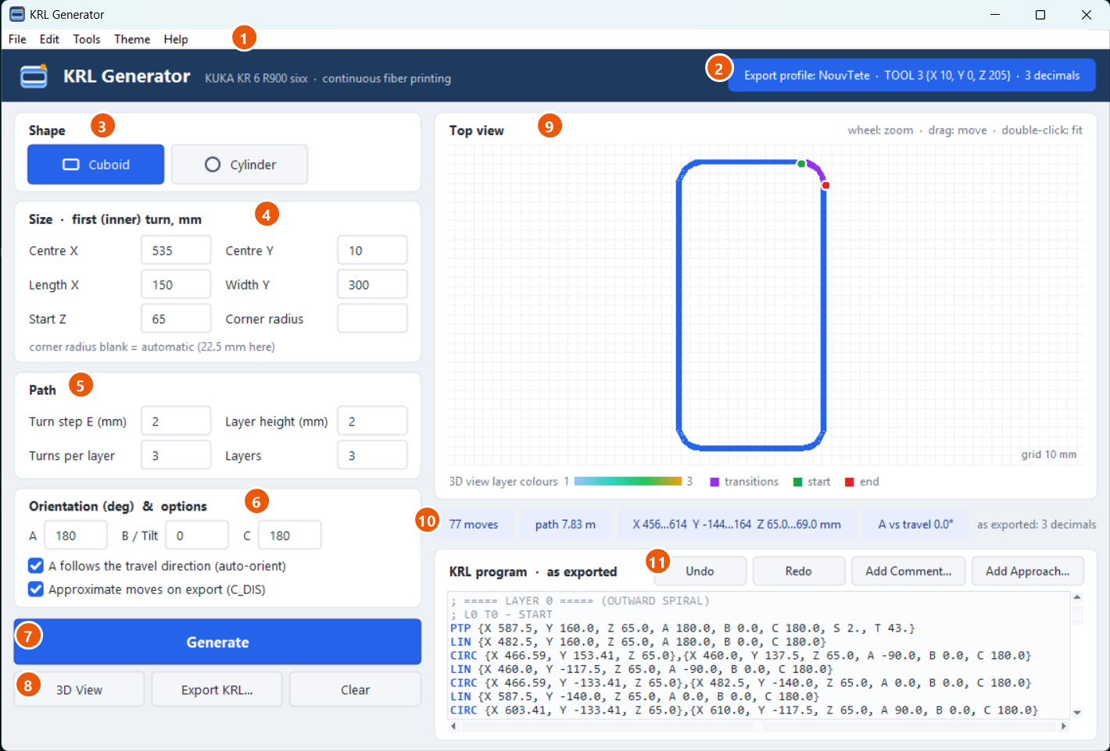

Version 1.0 · November 2026
For lab users and supervisors. No programming knowledge is needed.
Contents
1 Introduction 3
1.1 What you can do with it 3
1.2 About this manual 3
2 Installation and start 4
2.1 What you need 4
2.2 Starting the program 4
2.3 Checking the installation (self-test) 4
3 Quick start: your first program 5
4 The main window 6
5 Choosing and sizing the shape 7
5.1 Cuboid (rounded rectangle) 7
5.2 Cylinder (tube) 8
6 Path settings: turns and layers 10
7 Head orientation and options 11
7.1 The angles A, B and C 11
7.2 A follows the travel direction (auto-orient) 12
7.3 Approximate moves on export (C_DIS) 12
7.4 Helix 12
8 Checking the path 13
8.1 Top view 13
8.2 Information chips 13
8.3 3D view 14
9 The KRL program box 15
9.1 Reading the program 15
9.2 Editing by hand 15
9.3 Add Comment 15
9.4 Add Approach 16
9.5 Undo, Redo and Clear 16
10 Exporting the program to the robot 17
10.1 File name rules 17
10.2 What is in the exported file 17
10.3 On the robot 17
11 Export settings (profiles) 18
11.1 Buttons 18
12 Projects: saving and reopening a print 20
12.1 Messages when opening 20
13 Light and dark theme 21
14 Advanced tools 22
14.1 Manual 11-point editor 22
14.2 Free-form editor (experimental) 22
15 Keyboard and mouse 23
16 Safety and first run on the robot 24
17 Troubleshooting 25
18 Appendix: default values and glossary 26
18.1 Default values 26
18.2 Glossary 26

1 Introduction
KRL Generator creates complete robot programs for continuous-fiber printing on the KUKA KR 6 R900 sixx. You describe the part (shape, size, number of turns and layers, head orientation), the program calculates the whole print path and writes a KUKA program file (.src). You copy that file to the robot controller on a USB stick and run it. Nothing has to be taught on the smartPAD.
The fiber is never cut during a print, so the program always produces one continuous path: neighbouring loops ("turns") are joined by smooth transition moves, and the loops are stacked in height ("layers").
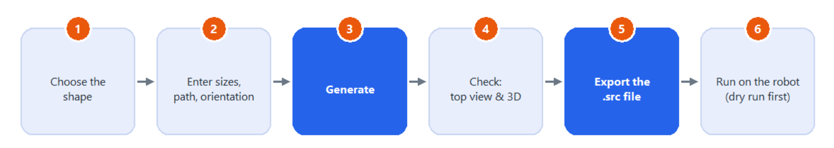
Figure 1. The workflow from the design to the print.

1.1 What you can do with it
- Generate rounded-rectangle walls (cuboids) and tubes (cylinders) with any number of turns and layers.
- Check the path before printing: a top view, a rotatable 3D view and arrows that show where the head points.
- Add your own comments and approach moves to the program.
- Export a ready-to-run .src file with the correct tool, base and speed settings (export profiles).
- Save a print as a project and open it again later to repeat it exactly.

1.2 About this manual
Chapter 3 gives a quick start (a first program in five minutes). The following chapters explain every part of the program in detail. Words in bold are the names you see on the screen. The program itself is in English; the French manual gives the English screen names.
Symbol | Meaning
Tip | A useful shortcut or good practice.
Important | Something that changes the result; read it before you continue.
Safety | Something that protects people, the robot or the part.

2 Installation and start

2.1 What you need
- A PC with Windows 10 or 11 (64-bit). Nothing else has to be installed.
- The two program files, always kept together in the same folder:
- KRL_Generator.exe: the program.
- export_profiles.json: the robot settings (tool, base, speed) written into every exported program.
Important Copy both files. Without export_profiles.json the program still works, but it uses its built-in settings, which may not be the ones your lab uses.

2.2 Starting the program
1 Copy the folder with the two files to the PC (for example to the Desktop or to Documents).
2 Double-click KRL_Generator.exe. The main window opens after about two seconds.
3 The first time, Windows may show "Windows protected your PC". Click More info, then Run anyway. This happens because the program is not signed by a software publisher.
Tip Right-click KRL_Generator.exe and choose Send to > Desktop (create shortcut) to start it from the desktop. Keep the .exe itself next to export_profiles.json.

2.3 Checking the installation (self-test)
The program can check itself and show which robot settings it will write. Open a command prompt in the program folder (in File Explorer, type cmd in the address bar and press Enter) and run:
KRL_Generator.exe --selftest

A window reports whether a test cuboid and a test cylinder were generated and exported correctly, and shows the active tool (TCP), base, speed and rounding. The same report is saved as selftest_report.txt in the program folder.

3 Quick start: your first program
This example produces a rounded-rectangle wall of 3 turns and 3 layers with the default values.
1 Start the program. Cuboid is selected and all fields already contain working values.
2 Enter the size of your part in the Size card (centre, length, width, start height).
3 Set the number of turns and layers in the Path card.
4 Click Generate (or press Ctrl+G). The path appears in the top view and the robot moves appear in the KRL program box.
5 Click 3D View to look at the stack from every side.
6 Click Export KRL..., choose a file name such as Wall_150x300 and save it as .src. Copy the file to the robot with a USB stick.
Safety Run every new program first without fiber and resin, in T1 mode with a low override, and stop at the first point to check that the head is where you expect it (see chapter 16).

4 The main window
Everything is done in one window. The numbers in the picture match the table below.
Figure 2. The main window after Generate (cuboid, 3 turns, 3 layers).
No. | Part | What it does
1 | Menu bar | File (projects, export), Edit (undo, comments, approach moves), Tools (3D view, export settings, advanced editors), Theme (light/dark), Help.
2 | Profile badge | The export profile that will be used: its name, the tool (TCP) and the number of decimals. Change it with Tools > Export Settings (chapter 11).
3 | Shape | Choose Cuboid or Cylinder. Each shape keeps its own values.
4 | Size | Position and size of the first (inner) turn.
5 | Path | Turn step, layer height, number of turns and layers.
6 | Orientation & options | Head angles A, B, C and the options auto-orient, C_DIS (and Helix for the cylinder).
7 | Generate | Calculates the path from the values on the left.
8 | 3D View, Export KRL..., Clear | Open the 3D view, write the .src file, empty the program.
9 | Top view | The path seen from above (zoom and move with the mouse).
10 | Information chips | Number of moves, path length, X/Y/Z range, head direction check, decimals.
11 | KRL program | The robot moves exactly as they will be exported. You can edit them and add lines.

5 Choosing and sizing the shape
Click Cuboid or Cylinder in the Shape card. The Size card changes to the fields of that shape. Switching back and forth keeps the values you typed for each shape.
Important All sizes describe the FIRST, INNER turn. The following turns are built outward from it, so the finished part is larger by about 2 × (Turns − 1) × E.

5.1 Cuboid (rounded rectangle)
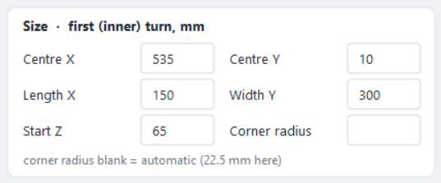
Figure 3. The Size card of the cuboid.
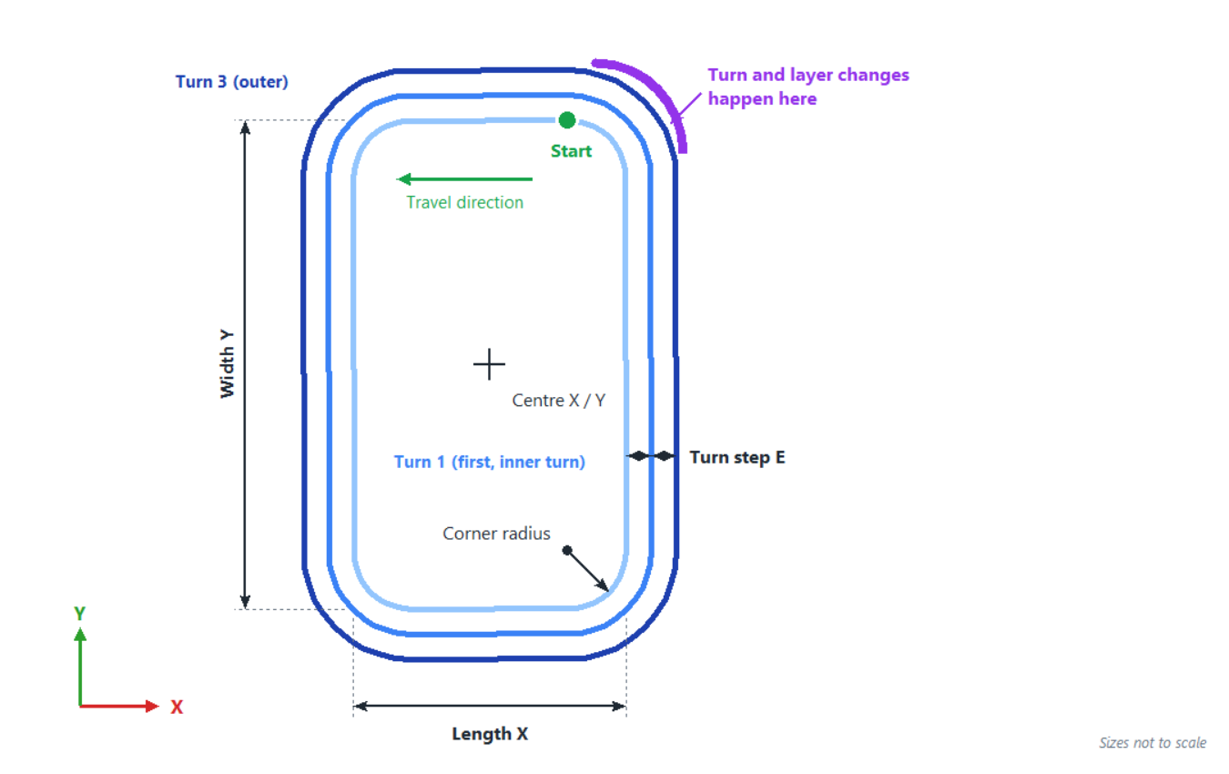
Figure 4. Cuboid: meaning of the size fields, start point and seam.
Field | Meaning
Centre X / Centre Y | Centre of the rectangle in the robot base, in mm.
Length X | Size of the first turn along X, in mm.
Width Y | Size of the first turn along Y, in mm.
Start Z | Height of the first layer (the head height on the bed), in mm.
Corner radius | Radius of the rounded corners of the first turn. Leave it blank for an automatic value: 15 % of the shorter side (at least 2 mm, at most one third of the shorter side). The hint under the fields shows the value that will be used.

The print starts on the top edge next to the top-right corner and runs counter-clockwise (seen from above). The changes from one turn to the next and from one layer to the next all happen at the top-right corner (the seam), as smooth arcs that are tangent to the path. Every outer turn keeps the same corner centres, so its corners stay perfectly round.
Tip The program warns you when a corner radius is below 20 mm, because the head may not follow such a tight curve well. A radius larger than half the shorter side is refused.

5.2 Cylinder (tube)
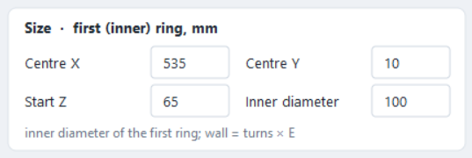
Figure 5. The Size card of the cylinder.
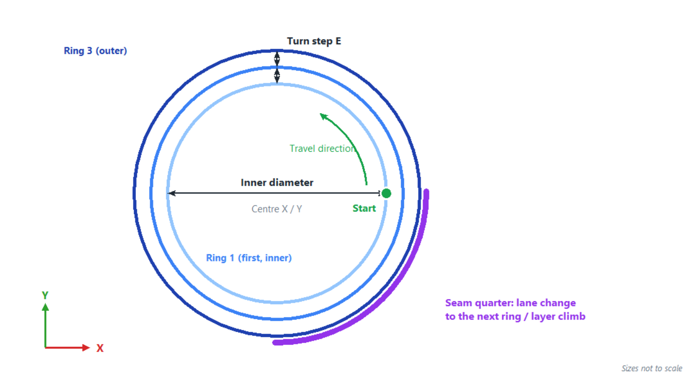
Figure 6. Cylinder: inner diameter, ring step, start point and seam.
Field | Meaning
Centre X / Centre Y | Centre of the tube in the robot base, in mm.
Start Z | Height of the first layer, in mm.
Inner diameter | Diameter of the first (inner) ring, in mm.

Each ring is a full circle made of four quarter arcs, counter-clockwise, starting on the +X side of the centre. The last quarter of each ring is the seam: there the path moves over to the next ring with two smooth arcs, or, on the last ring of a layer, climbs to the next layer.
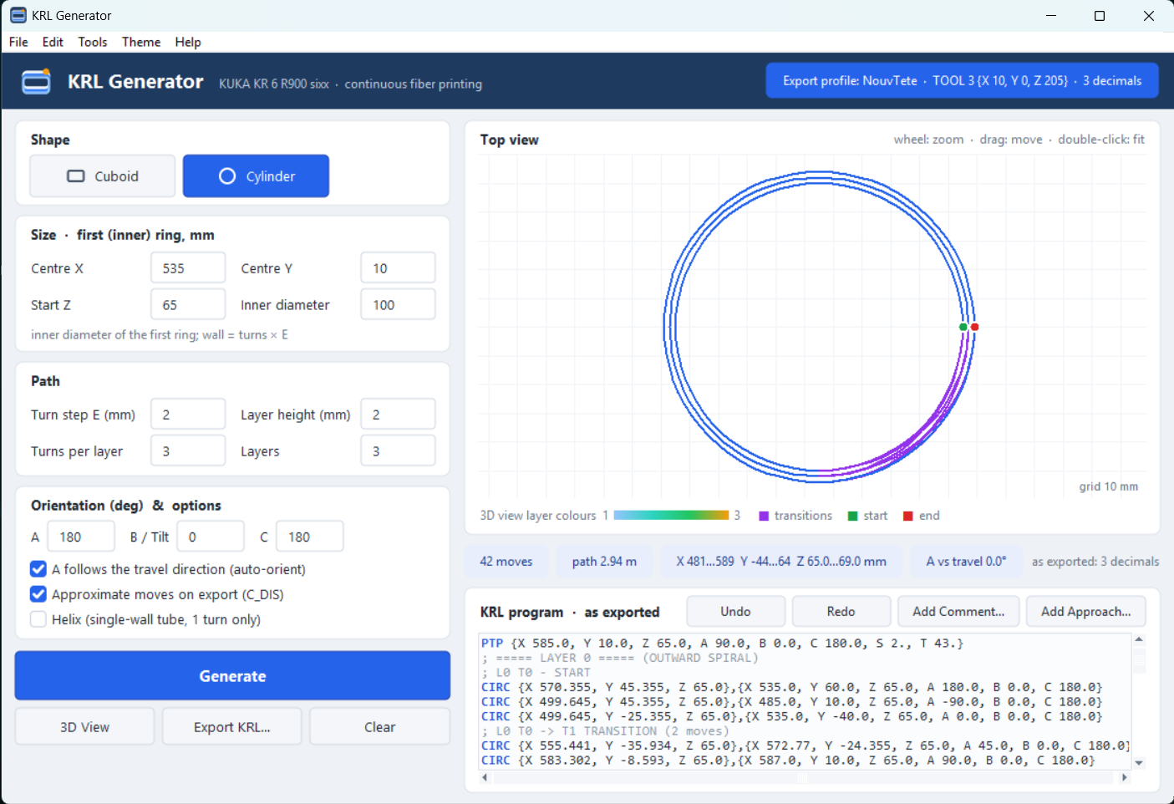
Figure 7. A cylinder with 3 rings per layer (the purple quarter is the seam).
Helix (cylinder only, needs exactly 1 turn per layer): instead of climbing at the seam, the head rises evenly during the whole loop, like a spring. This gives a single-wall tube without a step. The last loop is flat so the top edge is level.
Tip The program warns you when the smallest arc of the path (the inner radius minus about 0.7 × E, at the ring change) is below 20 mm. Diameters of 100 to 200 mm work well.

6 Path settings: turns and layers
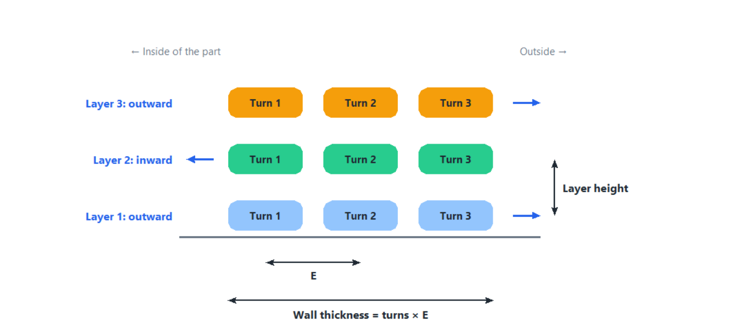
Figure 8. Cross-section through a wall of 3 turns and 3 layers.
Field | Meaning
Turn step E (mm) | Distance between two neighbouring turns (centre to centre). Usually the width of the laid fiber or a little less, for example 2 mm.
Layer height (mm) | Height step from one layer to the next.
Turns per layer | Number of concentric loops in each layer. The wall is about Turns × E wide.
Layers | Number of layers stacked in Z.

The numbers are exact: 3 turns and 3 layers give exactly 3 loops in each of 3 layers. The layers alternate so the fiber never has to jump: the first layer spirals outward (inner turn first), the second spirals inward, the third outward again, and so on.
Tip In the program comments, layers and turns are counted from 0: the first layer is LAYER 0 and its first turn is T0. So layer 1 in the figure above is LAYER 0 in the program.

The total height of the print is Start Z + (Layers − 1) × Layer height. The information chips under the top view show the resulting Z range after Generate.

7 Head orientation and options
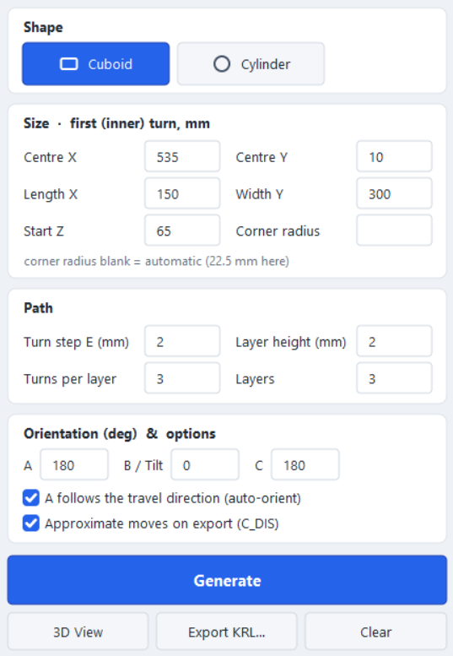
Figure 9. All input cards of the cuboid.

7.1 The angles A, B and C
A, B and C are the KUKA orientation angles of the head in degrees (rotation about Z, then Y, then X).
Angle | Use
A | Turns the head about the vertical axis. With auto-orient (below) it is calculated for you; the value typed here is then only used where no direction exists yet.
B / Tilt | Tilt of the head. It is written to every move exactly as typed (no limits). 0 = the head is upright.
C | Third angle, written to every move as typed (180 for the current head).

7.2 A follows the travel direction (auto-orient)
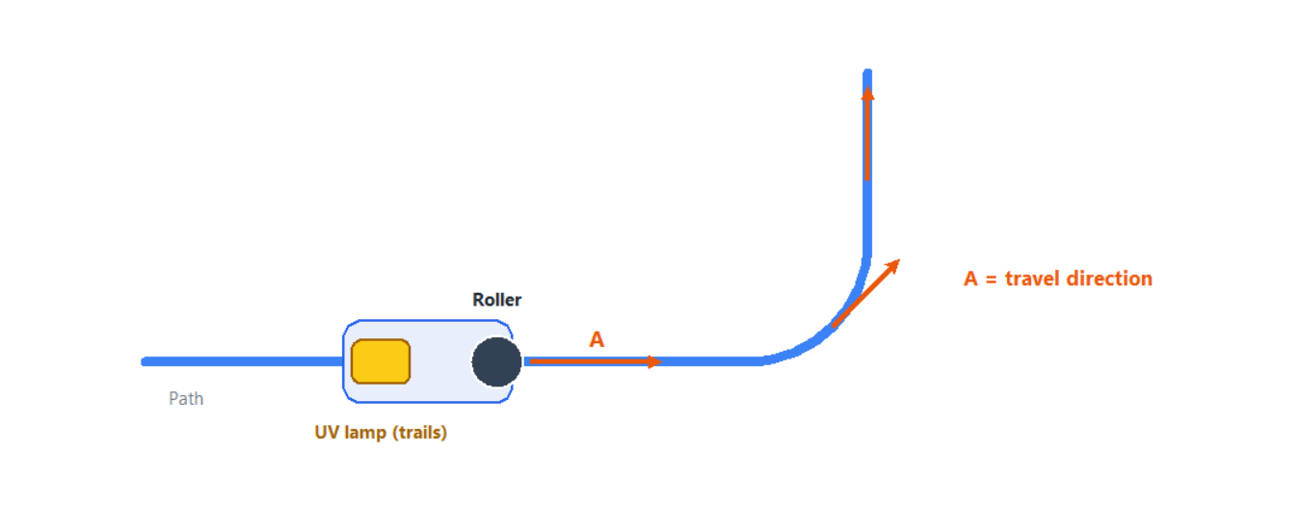
Figure 10. With auto-orient, A turns with the path so the roller leads and the UV lamp trails.
When A follows the travel direction (auto-orient) is ticked (the default), A is set at every move so the head always faces the way it travels: constant along straight edges and turning smoothly through the corners. The roller then presses the fiber straight ahead and the UV lamp always trails behind it.
Untick it only for special tests: then the A, B and C values typed are written to every move unchanged.

7.3 Approximate moves on export (C_DIS)
When ticked (the default), every path move in the exported file gets C_DIS. The robot then blends smoothly from one move into the next instead of stopping at each point. Stops leave resin blobs on the part, so keep this on for printing. The blending distance comes from the export profile ($APO.CDIS, 5 mm).
Important The robot only blends in continuous run. In single-step mode (step by step on the smartPAD) it still stops at every point; that is normal.

7.4 Helix
Only shown for the cylinder; see chapter 5.2.

8 Checking the path
Always look at the path before you export it. Three tools help you: the top view, the information chips and the 3D view.

8.1 Top view
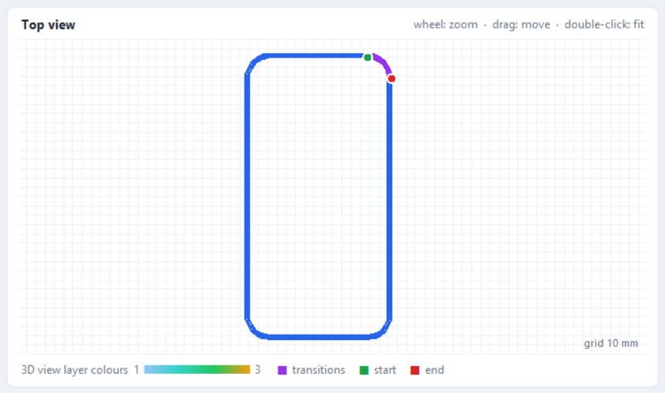
Figure 11. The top view with its legend.
- Mouse wheel: zoom in and out around the mouse pointer.
- Drag with the left mouse button: move the drawing.
- Double-click: fit the whole path into the view again (also Tools > Fit Top View).
- The grid shows 10 mm squares; when you zoom out it becomes coarser and the label at the bottom right tells you the current size.
- Purple lines are the transitions between turns and layers; the green dot is the start, the red dot the end. The colour bar shows the layer colours used in the 3D view.

8.2 Information chips
Figure 12. The information chips.
Chip | Meaning
moves | Number of robot moves in the program.
path | Total length of the path, in metres. Useful to estimate the fiber needed and the print time (length ÷ speed).
X … Y … Z … | Smallest and largest X, Y and Z of the path: compare them with the bed and the robot's working area.
A vs travel | Largest difference between the head direction A and the real travel direction. With auto-orient it should be 0° to 1°.
as exported | The number of decimals used for the coordinates (from the export profile).

8.3 3D view
Click 3D View (or Ctrl+Shift+D) to open the path in a separate window. It shows exactly what is in the KRL program box, including your hand edits.
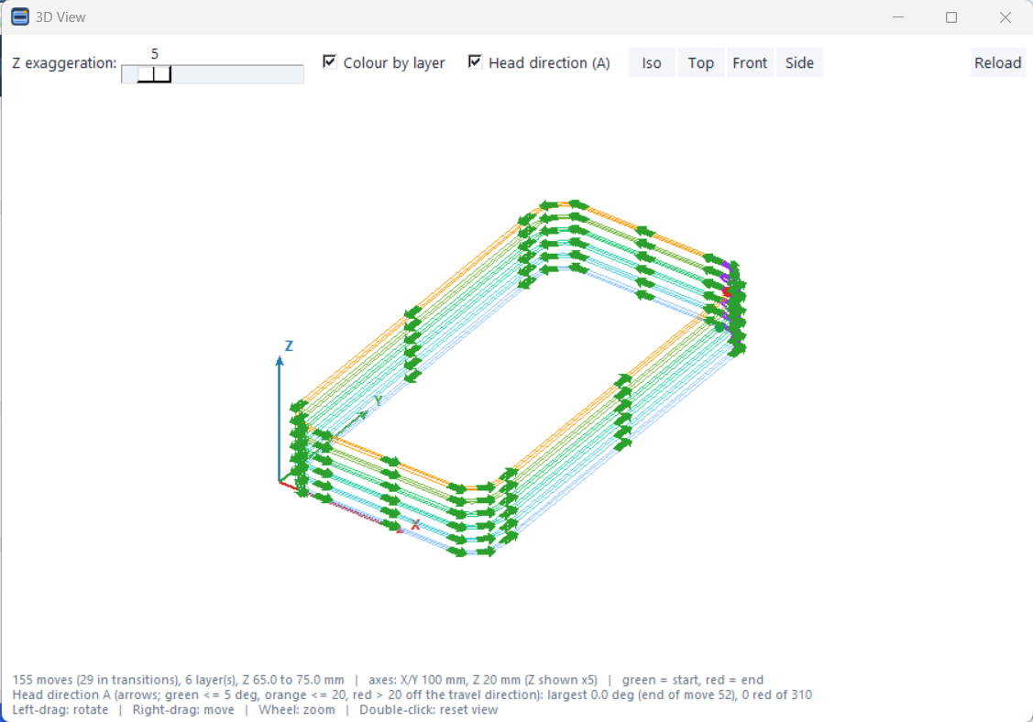
Figure 13. The 3D view of a 6-layer cuboid with the head-direction arrows.
Control | What it does
Z exaggeration | Stretches the height (1 to 40 ×) so that thin layers can be told apart. It does not change the program.
Colour by layer | Each layer gets its own colour (blue at the bottom to orange at the top).
Head direction (A) | Draws an arrow where the head points: green = within 5° of the travel direction, orange = 5° to 20°, red = more than 20°. Red arrows mean the roller would be dragged sideways.
Iso / Top / Front / Side | Standard viewing directions.
Reload | Reads the program box again after a new Generate or a hand edit.
Mouse | Left-drag: rotate. Right-drag: move. Wheel: zoom. Double-click: reset the view.

The line at the bottom gives the number of moves, the layers, the Z range, the axis lengths and the largest head-direction deviation.

9 The KRL program box
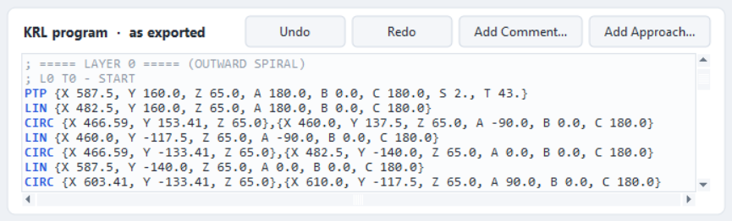
Figure 14. The KRL program box with its buttons.
The box shows the robot moves exactly as they will be exported (the coordinates are already rounded to the profile's decimals). The file header with tool, base and speed is added at export and is not shown here. Keywords are blue, comments grey.

9.1 Reading the program
- ; ===== LAYER n ===== starts a layer and tells you whether it spirals outward or inward.
- ; L0 T1 marks the first layer (L0), second turn (T1): the program counts from 0. TRANSITION lines mark the purple moves.
- PTP is the first move to the start point, LIN a straight move, CIRC an arc through a middle point to an end point.

9.2 Editing by hand
You can type in the box like in a text editor. Whatever is in the box is exported. Ctrl+Z / Ctrl+Y while the cursor is in the box undo and redo your typing.
Important Generate replaces the whole box. Make your hand edits last, after the path is final, and save the project to keep them.

9.3 Add Comment
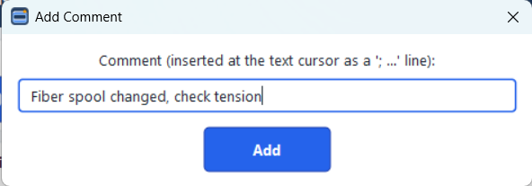
Figure 15. Adding a comment.
Click in the box on the line above which the comment should go, then click Add Comment..., type the text and click Add. It is inserted as a ; comment line. The robot ignores comments; they help the operator (for example "check tension here").

9.4 Add Approach
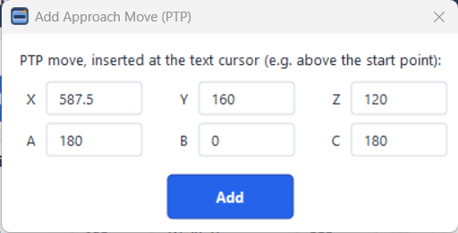
Figure 16. Adding an approach move above the start point.
An approach move is a PTP move to a safe point, typically right above the start point, so the head comes down vertically onto the bed. Put the text cursor on the first PTP line, click Add Approach..., enter X, Y and a higher Z (A, B and C are pre-filled from the orientation fields) and click Add. The move is inserted above the cursor line.
Tip The start point is the first PTP line of the program. Copy its X and Y into the approach move and add 50 mm or more to its Z.

9.5 Undo, Redo and Clear
Undo and Redo (buttons, Edit menu, or Ctrl+Z / Ctrl+Y outside the text box) go back and forward through the last 20 changes: Generate, Clear, comments, approach moves and opened projects, together with the input values. Clear empties the program box (it can be undone).

10 Exporting the program to the robot
1 Click Export KRL... (or File > Export KRL Code, or Ctrl+E).
2 Choose the folder (a USB stick, for example) and type a file name. Keep the type KRL program (*.src); Text file (*.txt) writes the same content for reading or e-mail.
3 Click Save. A message confirms which export profile was used.

10.1 File name rules
The file name becomes the program name on the robot, so the controller's naming rules apply:
- Only letters, digits and the underscore _. No spaces, no dashes, no accents.
- It must not start with a digit, and it can have at most 24 characters.
- Good: Wall_150x300_L3, Tube_D120. Refused: Wall 150x300, 3_layers, tube-01.

10.2 What is in the exported file
The program writes a complete KUKA program: the standard header, the line ; Export profile: <name>, the tool, base, blending, speed and acceleration of the active profile, the first move to HOME, then your moves (with C_DIS when the option is on), and END.
; ===== LAYER 0 ===== (OUTWARD SPIRAL)
; L0 T0 - START
PTP {X 587.5, Y 160.0, Z 65.0, A 180.0, B 0.0, C 180.0, S 2., T 43.}
CIRC {X 466.59, Y 153.41, Z 65.0},{X 460.0, Y 137.5, Z 65.0, A -90.0, B 0.0, C 180.0} C_DIS
LIN {X 460.0, Y -117.5, Z 65.0, A -90.0, B 0.0, C 180.0} C_DIS

10.3 On the robot
1 Plug the USB stick into the controller (or the smartPAD) and copy the .src file into your program folder with the file manager (expert user level may be needed).
2 Select the program and run the dry run described in chapter 16 before the real print.
Important The exported file sets TOOL_DATA and BASE_DATA from the export profile. Running it overwrites those tool and base numbers on the controller. Check the profile (chapter 11) before you export.

11 Export settings (profiles)
An export profile is a named set of robot settings that is written into the header of every exported program. Open it with Tools > Export Settings. The badge at the top right of the main window always shows which profile is active.
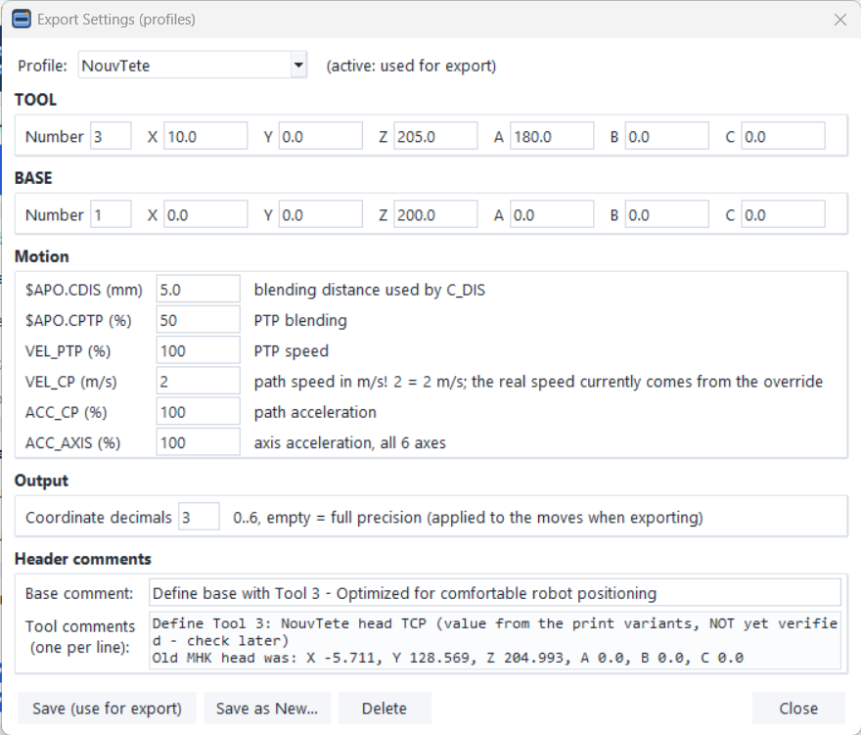
Figure 17. The Export Settings window (profile NouvTete).
Section | Content
Profile | Choose the profile to view or edit. "(active: used for export)" marks the one used by Export.
TOOL | Tool number and the TCP of the print head (X, Y, Z in mm, A, B, C in degrees).
BASE | Base number and the position of the print bed.
Motion | $APO.CDIS: blending distance for C_DIS (mm). $APO.CPTP: PTP blending (%). VEL_PTP: PTP speed (%). VEL_CP: path speed in m/s. ACC_CP / ACC_AXIS: accelerations (%).
Output | Coordinate decimals (0 to 6; empty = full precision). 3 is recommended.
Header comments | Notes written as comments into the header (for example where the TCP value comes from).

11.1 Buttons
- Save (use for export): stores the changes and makes this profile the active one.
- Save as New...: stores the values under a new name, for example for another head or bed.
- Delete: removes the selected profile (the last remaining profile cannot be deleted).
- Close: closes the window without saving.
The profiles are stored in export_profiles.json next to the program, so every PC that has the same file exports the same header. If you change the number of decimals, the program box is updated at once (unless you edited it by hand).
Safety VEL_CP is in metres per second: 2 means 2 m/s, which is far too fast for printing (about 0.01 m/s is intended). Until this value is set for printing, control the speed with the override on the smartPAD and start low.

Important Change TOOL and BASE only with measured values. A wrong TCP moves the whole print in space.

12 Projects: saving and reopening a print
A project file (.json) keeps everything needed to repeat a print: the shape, all input values, the options and the program box (including your comments and hand edits), plus a copy of the export profile that was active.
- File > Save Project... (Ctrl+Shift+S) saves it. The window title then shows the project name.
- File > Open Project... (Ctrl+Shift+O) restores everything. Opening can be undone with Undo.

12.1 Messages when opening
Message | Meaning
The saved output differs from what this version generates | The program box was edited by hand, or the program has changed since. The SAVED text is kept. Press Generate only if you want a fresh path from the inputs.
Profile warning | The project was exported with other settings than the active profile. The active profile is used for the next export; check it.
Old projects | Projects of the earlier cuboid and cylinder programs open too. The title says "from the … app"; Save Project writes the new format (the old file is not changed). A cuboid whose base was made point by point is offered to the manual editor (chapter 14).

Tip Save a project for every real print, with the same name as the .src file. Then you always know which settings produced which part.

13 Light and dark theme
The Theme menu switches between Light and Dark. The choice is remembered for the next start and also applies to an open 3D view.
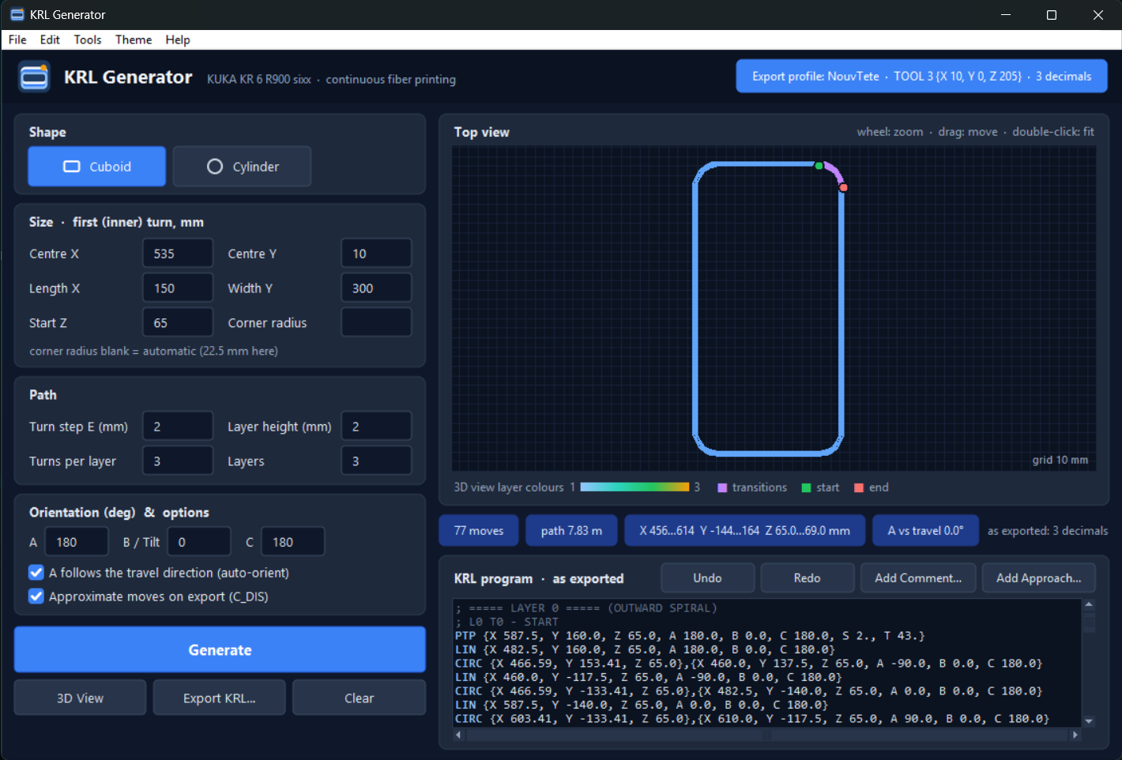
Figure 18. The dark theme.

14 Advanced tools

14.1 Manual 11-point editor
Tools > Manual 11-point editor (advanced) opens the earlier cuboid program. Use it only when a base loop cannot be described by a rounded rectangle: you build the first loop point by point (or import it), then let it generate the turns and layers.
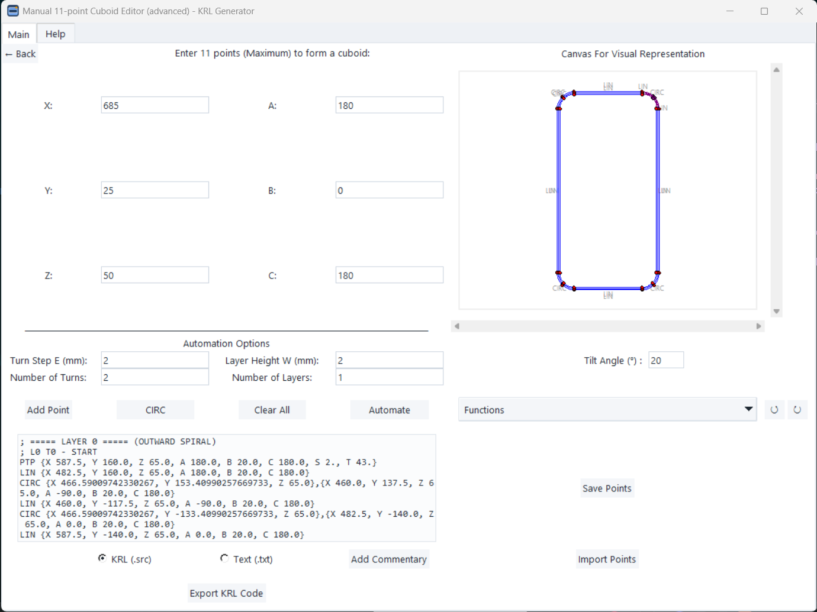
Figure 19. The manual 11-point editor.
1 Build the base loop: enter X, Y, Z, A, B, C and click Add Point (use CIRC for the corner arcs), or use Functions > Auto-Generate Base, or Import Points from a saved points file.
2 Enter Turn Step E, Layer Height W, the number of turns and layers, and the tilt angle.
3 Click Automate: the turns and layers appear in the text box and on the canvas.
4 Click Export KRL Code. The same export profile as in the main window is used.
5 Close the window (or Back) to return to the main window.
Important In the manual editor, the numbers of turns and layers are counted differently: entering N gives N + 1 turns and N + 1 layers. Its B/tilt is limited to 5 to 20°.

14.2 Free-form editor (experimental)
Tools > Free-form editor (experimental) builds a path from single LIN, CIRC and SPLINE moves. It is a test tool: it writes its own header with different tool and base values. Do not use its programs on the robot without checking the header.

15 Keyboard and mouse
Keys | Action
Ctrl+G | Generate
Ctrl+E | Export KRL code
Ctrl+Shift+D | 3D View
Ctrl+Shift+O | Open Project
Ctrl+Shift+S | Save Project
Ctrl+Z / Ctrl+Y | Undo / Redo. Inside the program box: undo / redo your typing.
Wheel / drag / double-click | Top view: zoom / move / fit.
Left / right drag, wheel | 3D view: rotate / move / zoom; double-click resets.

Help in the menu bar repeats the main points: How to use, Current shape and Keyboard and mouse.

16 Safety and first run on the robot
The program calculates the path, but it does not know the real cell. Follow these steps for every new program and after every change of tool, base or size.
1 Check in the program: the X/Y/Z ranges fit the bed, the A vs travel chip is close to 0°, the 3D view shows no red arrows.
2 Check the export profile (badge): correct TOOL and BASE numbers and values.
3 On the robot, select T1, set a low override (for example 10 %) and run without fiber and resin.
4 Stop at the first point (the PTP start) and check the head height above the bed and the head direction.
5 Run one full layer dry, watching the corners, the transitions and the cables and tubes of the head.
6 Only then print with fiber, resin and UV, increasing the override step by step.
Safety Keep the enabling switch and the emergency stop within reach. Never stand inside the cell in automatic mode.

17 Troubleshooting
Problem | What to do
"Input Error: Please enter numbers…" | A field is empty or contains text. Use a dot as the decimal separator (2.5, not 2,5). Only Corner radius may be blank.
"Turns and layers must be whole numbers" | Enter 1, 2, 3 … in Turns per layer and Layers.
"Corner radius must be … at most half the shorter side" | Make the radius smaller or leave it blank.
"The helix option needs exactly 1 turn" | Set Turns per layer to 1 or untick Helix.
"Inner diameter too small for this ring step E" | Increase the inner diameter or reduce E.
Warning "… below 20 mm: the head may not follow it well" | The path was generated, but a curve is tight. Prefer larger radii or diameters.
"… is not a valid KRL program name" | Rename the file (letters, digits, _; no leading digit; max. 24 characters). Nothing was saved.
"Nothing to export yet" | Click Generate first.
Export Settings warning at export | export_profiles.json is missing or damaged; the built-in profile was used. Put the correct file next to the program.
Red arrows in the 3D view | Auto-orient is off, or the program was edited by hand. Tick auto-orient and Generate again.
The robot stops at every point | Check that C_DIS was ticked at export and that the robot runs in continuous mode, not single step.
Windows blocks the program at start | Click More info > Run anyway (chapter 2). An antivirus may scan it the first time; the next starts are faster.
The window looks wrong on another PC | Run KRL_Generator.exe --debug-ui in the program folder and send the file debug_ui.txt to the program's maintainer.

18 Appendix: default values and glossary

18.1 Default values
Field | Default | Note
Centre X / Centre Y | 535 / 10 mm
Start Z | 65 mm
Length X × Width Y (cuboid) | 150 × 300 mm | Corner radius blank = 22.5 mm
Inner diameter (cylinder) | 100 mm
Turn step E / Layer height | 2 / 2 mm
Turns per layer / Layers | 3 / 3 | Exact counts
A / B / C | 180 / 0 / 180°
Auto-orient, C_DIS | On
Export profile | NouvTete | TOOL 3, BASE 1, 3 decimals

18.2 Glossary
Term | Meaning
KRL / .src | KUKA Robot Language; a .src file is a robot program.
PTP | Point-to-point move: fastest way, the path in between is not controlled.
LIN | Straight-line move.
CIRC | Arc move through an auxiliary point to an end point.
C_DIS | Approximation: the robot blends into the next move instead of stopping.
TCP / TOOL | Tool centre point: the point of the head that follows the path.
BASE | The coordinate system of the print bed.
Override | Speed percentage set on the smartPAD.
Turn | One closed loop of the wall in one layer.
Layer | All turns at one height.
Transition / seam | The short arcs that join turns and layers (purple in the views).
Project | A .json file with all inputs and the program, to repeat a print.

