LiveAvatar Platform
Screen-by-Screen Reference Guide

A walkthrough of every screen in the Admin console and the end-user Conversation app, captured from a live, fully-wired deployment (LiveKit + Deepgram + OpenAI + ElevenLabs + bitHuman).

Contents
This guide documents every screen in two applications served by the same platform: the Admin console (operator-facing, /admin) and the Conversation app (end-user-facing, /c/:tenant-slug).

Admin console
1. Sign in — Operator authentication
2. Dashboard — Fleet-wide health and volume at a glance
3. Deployments — List of tenants/agent deployments
4. Agent Builder — Configure and publish a tenant's provider stack
5. Provider catalog — Platform-wide list of supported vendors
6. Provider credentials — Per-tenant API keys/endpoints
7. Sessions list — Every call this tenant has run
8. Session detail — Transcript, latency, and outcome for one call
9. GPU health — Read-only self-hosted GPU worker status
10. Alerts (picker) — Choose a deployment to configure failover
11. Alerts & failover — Fallback LLM, retry policy, degraded-mode message
12. Residency (picker) — Choose a deployment to configure data policy
13. Data residency — Privacy and retention policy for a tenant
14. Accept invite — Invited admin sets their password

Conversation app (end-user)
15. Pre-call — End user grants mic/camera and joins
16. Call — Live conversation with the avatar agent
17. Call summary — Post-call recap and feedback

1. Sign in
Route: /admin/login

Purpose
The Admin console's entry point. Every operator — the person who configures tenants, providers, and agent behavior — authenticates here before reaching any other screen. There is no self-service sign-up: the very first admin account is created once via a one-time bootstrap endpoint (protected by a server-side secret), and every subsequent admin is added through the invite flow (see "Accept invite").

Screenshot
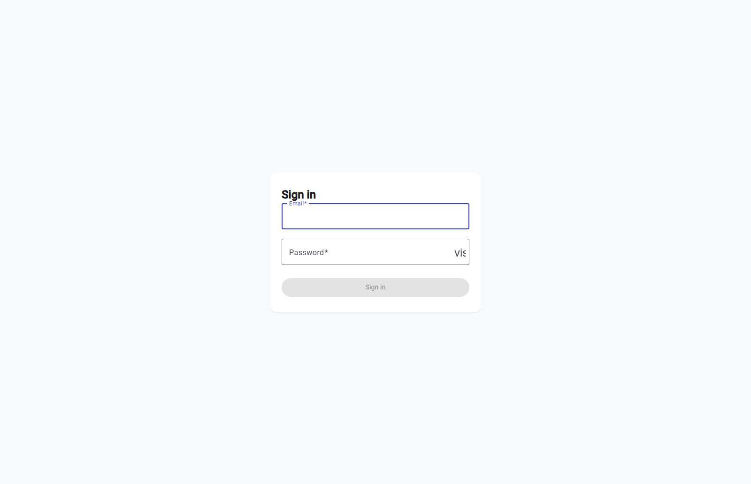

Detailed scenario
- Operator navigates to https://<host>/admin — unauthenticated, they are redirected straight to /admin/login.
- Operator enters their email and password.
- On submit, the API validates the credentials and issues a short-lived access token plus a refresh token.
- On success, the browser is redirected to the Dashboard (or the page the operator originally tried to reach).
- On failure (wrong password, unknown email, or a locked/disabled account), the form shows an inline error and the operator stays on this screen.

Notes
- The password field includes a visibility toggle ("vis..." button, partially visible in the screenshot) to show/hide the typed password.
- This screen has no sidebar navigation — it is the one place in the Admin console shown without the operator being authenticated yet.

2. Dashboard
Route: /admin/dashboard

Purpose
The operator's landing page after signing in. It answers three questions at a glance across the whole fleet (or a single tenant, via the Tenant filter): how many deployments are active, how much call volume happened in the selected window, and whether each provider category (transport, STT, LLM, TTS, avatar) is currently reachable.

Screenshot
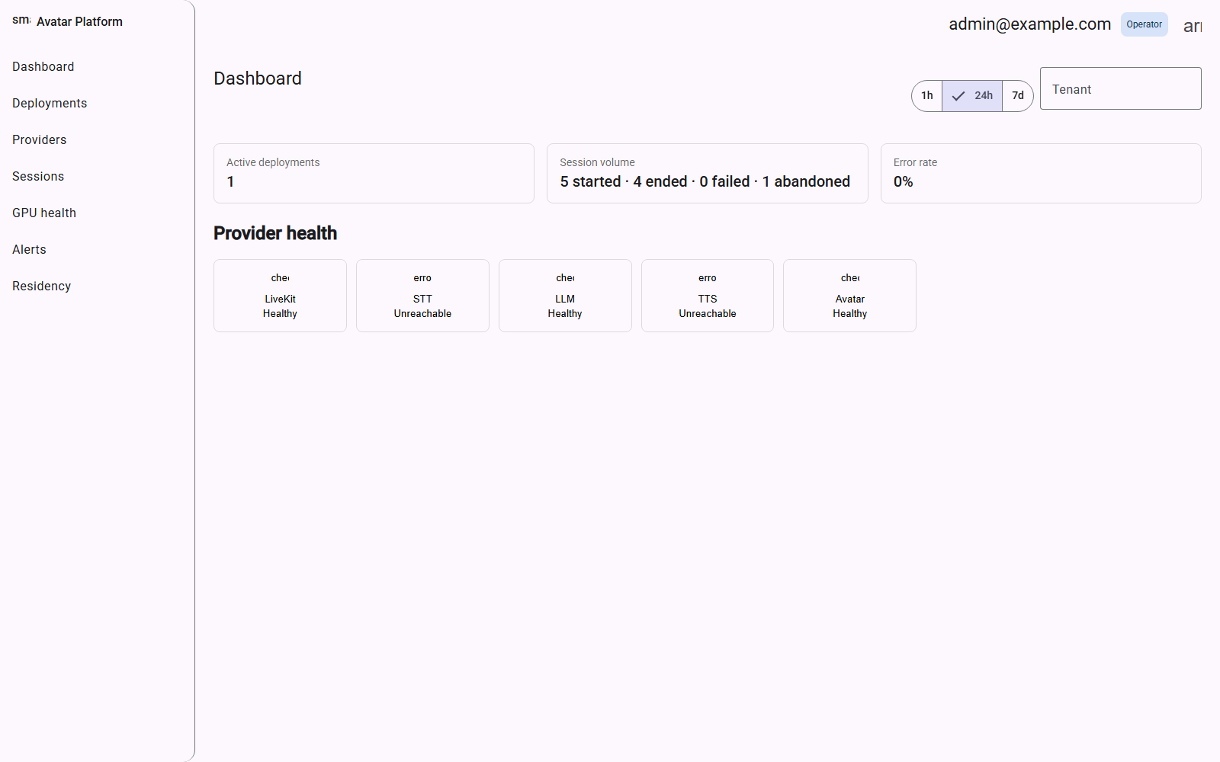

Detailed scenario
- Operator lands here immediately after login.
- Operator picks a time window — 1h, 24h, or 7d — to scope the Session volume and Error rate tiles.
- Operator optionally narrows everything to one tenant using the Tenant filter, top-right.
- Operator scans the Provider health row: each of the 5 categories (LiveKit/transport, STT, LLM, TTS, Avatar) shows Healthy, Degraded, or Unreachable, with a "Checked <time>" timestamp.
- If a tile shows Unreachable, the operator would typically go to Provider credentials to inspect or re-probe that specific credential.

Notes
- "Provider health" here is a live, on-demand check, not a stored historical log — a status can flip between page loads if a vendor blips.
- In this captured example, Session volume already reflects 5 real calls run against this tenant's published config (4 ended normally, 1 abandoned) — proof the full pipeline is live, not a placeholder.

3. Deployments
Route: /admin/deployments

Purpose
The tenant/deployment registry. In this platform, a "deployment" and a "tenant" are the same concept — one row per customer/brand the platform serves, each with its own agent configuration, provider credentials, and call history. This is the jumping-off point to every other tenant-scoped screen (Agent Builder, Provider credentials, Alerts, Residency).

Screenshot
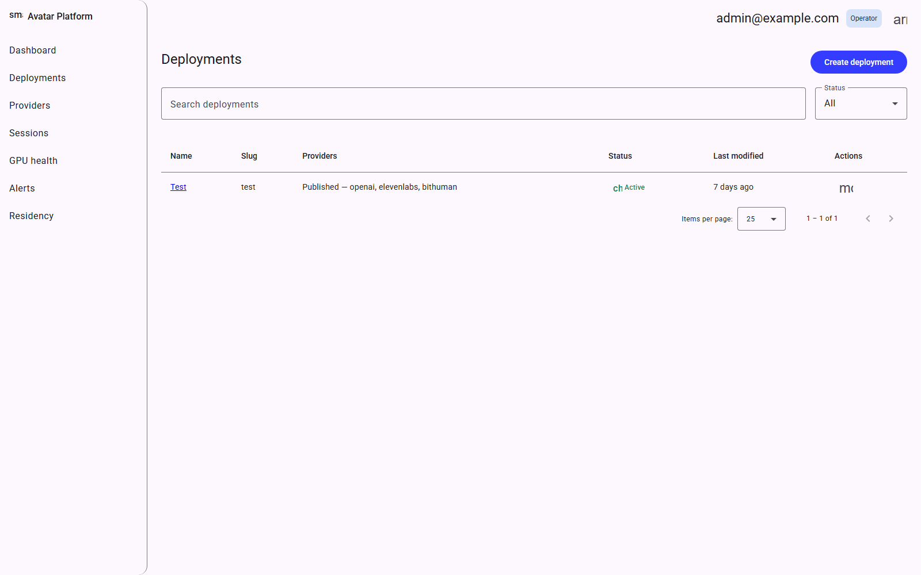

Detailed scenario
- Operator opens Deployments from the sidebar (or lands here after login, since it's the default redirect for the root admin path).
- Operator searches by name or filters by Status (draft vs. published/active) if the list is long.
- Operator clicks a deployment's name (e.g. "Test") to open its Agent Builder and continue configuring it.
- Operator clicks "Create deployment" to onboard a brand-new tenant from scratch.
- The row's "Providers" column summarizes the published stack (e.g. "Published — openai, elevenlabs, bithuman") so an operator can tell a working deployment from an incomplete draft without opening it.

4. Agent Builder
Route: /admin/tenants/:id/builder

Purpose
The heart of the platform: a structured form that assembles one tenant's full agent configuration — transport, speech-to-text, LLM, text-to-speech, avatar, and behavior (system prompt, memory, RAG) — and validates it before it can go live. The right-hand panel mirrors the exact YAML the agent will run, live, as fields change.

Screenshot
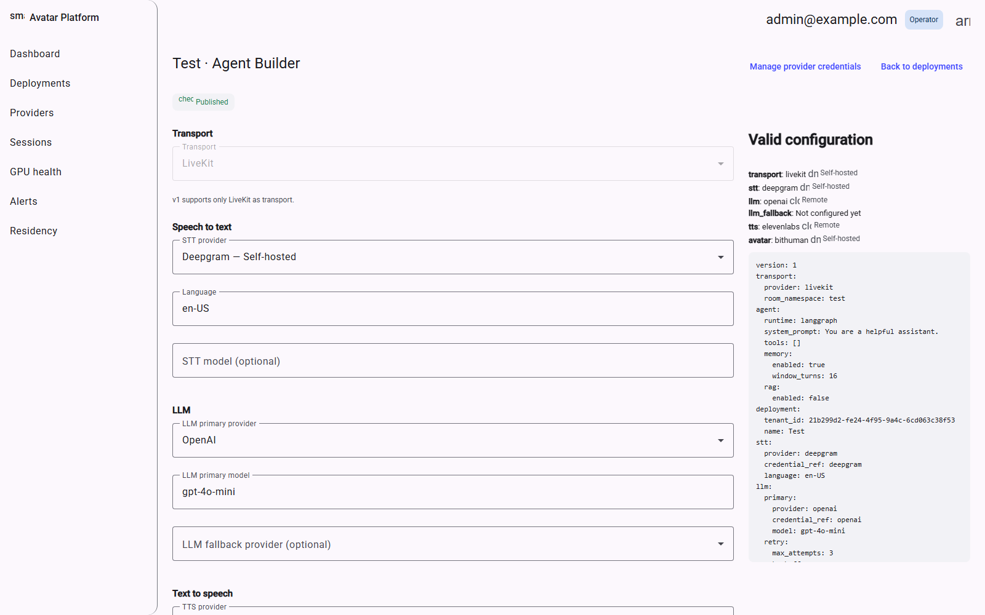

Detailed scenario
- Operator selects a provider in each category (Transport is fixed to LiveKit in v1; STT/LLM/TTS/Avatar are dropdowns).
- A provider only becomes selectable once a matching credential exists for this tenant in Provider credentials — an unconfigured provider shows greyed out.
- Operator fills in provider-specific fields (e.g. LLM model name, TTS voice ID, avatar ID) and the agent's system prompt/behavior settings further down the page.
- The right panel continuously re-validates: it lists exactly which layers are still incomplete (e.g. "avatar: Not configured yet") and shows a live error count.
- Operator saves as Draft at any point — a draft persists even with missing pieces, so configuration can be done incrementally.
- Once every layer resolves with 0 errors, the operator can Publish, which is what actually allows a real call to be dispatched to this tenant.

Notes
- This screenshot shows a fully valid, Published configuration ("Valid configuration" panel, 0 errors) — LiveKit + Deepgram + OpenAI (gpt-4o-mini) + ElevenLabs + bitHuman.
- Publishing re-validates a second, stricter gate (every provider must additionally have a real credential row, not just be selected) — a draft can have gaps a publish cannot.

5. Provider catalog
Route: /admin/providers

Purpose
The platform-wide (not per-tenant) list of every vendor integration the codebase supports, grouped by category — Transport, Speech-to-text, LLM, Text-to-speech, and (below the fold) Avatar. This is a read-mostly reference: it tells an operator what's available to wire up, and lets a platform-level operator (not a tenant admin) disable a vendor fleet-wide.

Screenshot
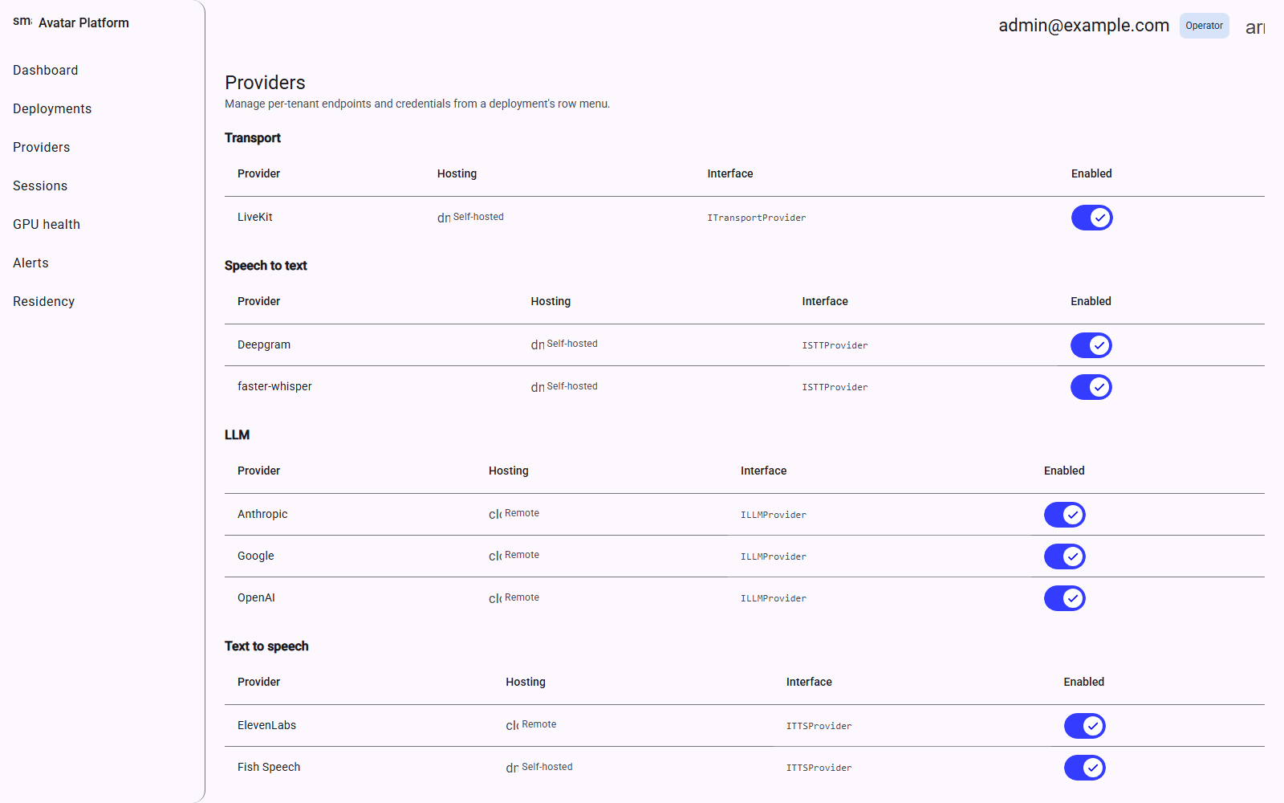

Detailed scenario
- Operator opens Providers to see the full menu of what can be offered to any tenant.
- Each row shows Hosting (Self-hosted vs. Remote) and the internal interface it implements (e.g. ISTTProvider) — useful context for judging integration maturity.
- Operator toggles a provider's Enabled switch off to remove it fleet-wide from every tenant's Agent Builder dropdown (an operator-only action).
- This page does not hold any secrets or endpoints — those live per-tenant in Provider credentials.

Notes
- "Self-hosted" here means the vendor's workload runs on operator-controlled infrastructure (an on-prem GPU worker, or bitHuman's in-process model), not that no network call is ever made.
- faster-whisper and Fish Speech appear as options but need a separate GPU worker this reference deployment does not run — see the Agent Builder notes for the tradeoffs found during setup.

6. Provider credentials
Route: /admin/tenants/:id/provider-credentials

Purpose
The tenant-scoped registry of actual endpoints and secrets: one row per vendor this tenant has wired up. This is where an operator pastes in real API keys (stored as a `credential_ref` pointing to a mounted secret file, never as plaintext in the database) and where the Agent Builder's provider dropdowns get unlocked from.

Screenshot
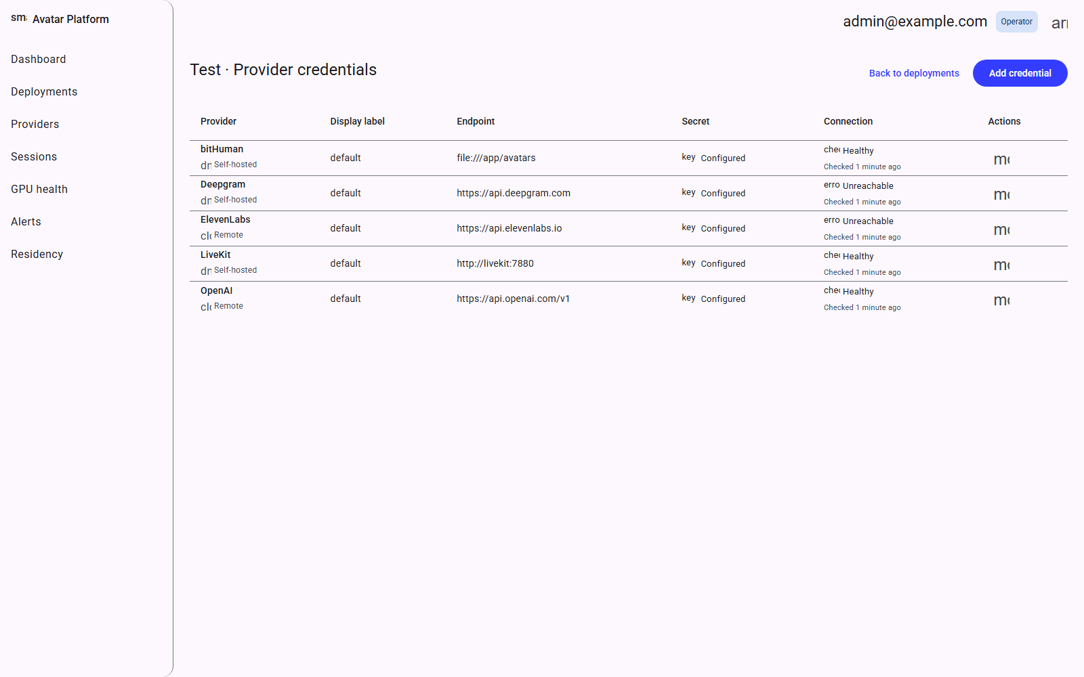

Detailed scenario
- Operator clicks "Add credential", picks a provider from the catalog, and supplies an Endpoint URL and a Display label.
- The actual secret value is never typed into this UI directly — it is placed as a file under the platform's secrets directory ahead of time, and this form only records the credential_ref that names that file.
- Operator uses the row's action menu to re-probe a credential on demand, checking whether the vendor is currently reachable.
- The Connection column shows the live result: Healthy, Degraded, or Unreachable, each with a "Checked <time>" timestamp.
- Once a row exists for a provider, that provider becomes selectable in this tenant's Agent Builder.

Notes
- This screenshot shows 5 real, working credentials for the "Test" tenant: bitHuman (a local file:// path to its model directory), Deepgram, ElevenLabs, LiveKit, and OpenAI.
- "Unreachable" on a credential here reflects a live network probe at that moment — a transient DNS or connectivity blip on the host network can cause a false negative even when the underlying vendor and key are fine.

7. Sessions
Route: /admin/sessions

Purpose
The call log: one row per conversation that was ever started against any of this tenant's (or, unfiltered, the whole fleet's) deployments. This is the first place an operator looks when investigating "a user says the call didn't work."

Screenshot
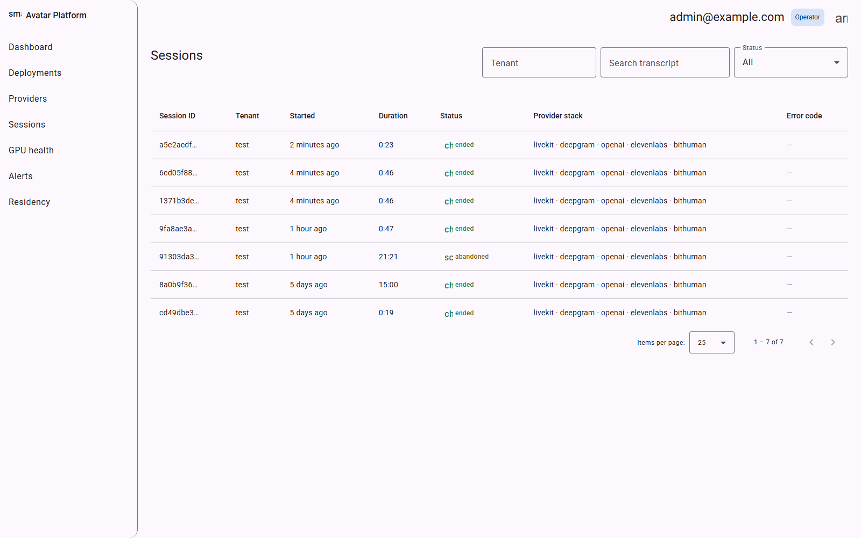

Detailed scenario
- Operator filters by Tenant, searches transcript text, or filters by Status (started/ended/failed/abandoned) using the controls at the top.
- Operator scans the table: Session ID, which tenant it belongs to, when it started, how long it ran, its outcome Status, the Provider stack it used, and any Error code.
- Operator clicks a row to open that session's full detail (transcript, latency breakdown).

Notes
- This is real data from this deployment: 7 sessions across the "Test" tenant — 6 that ended normally and 1 that was abandoned (the caller's browser/network dropped before the agent could finish handshaking) — generated purely by testing the actual join flow, no seed data or mocks.
- The Provider stack column (e.g. "livekit · deepgram · openai · elevenlabs · bithuman") is captured per-session, so switching a tenant's providers later does not rewrite history for past calls.

8. Session detail
Route: /admin/sessions/:id

Purpose
The full record of one call: which room and participants were involved, whether it was recorded, its outcome, the transcript (if any speech was captured), and a latency breakdown per turn (time-to-first-token from the LLM, time-to-first-audio from TTS, etc.) for diagnosing a slow or degraded call.

Screenshot
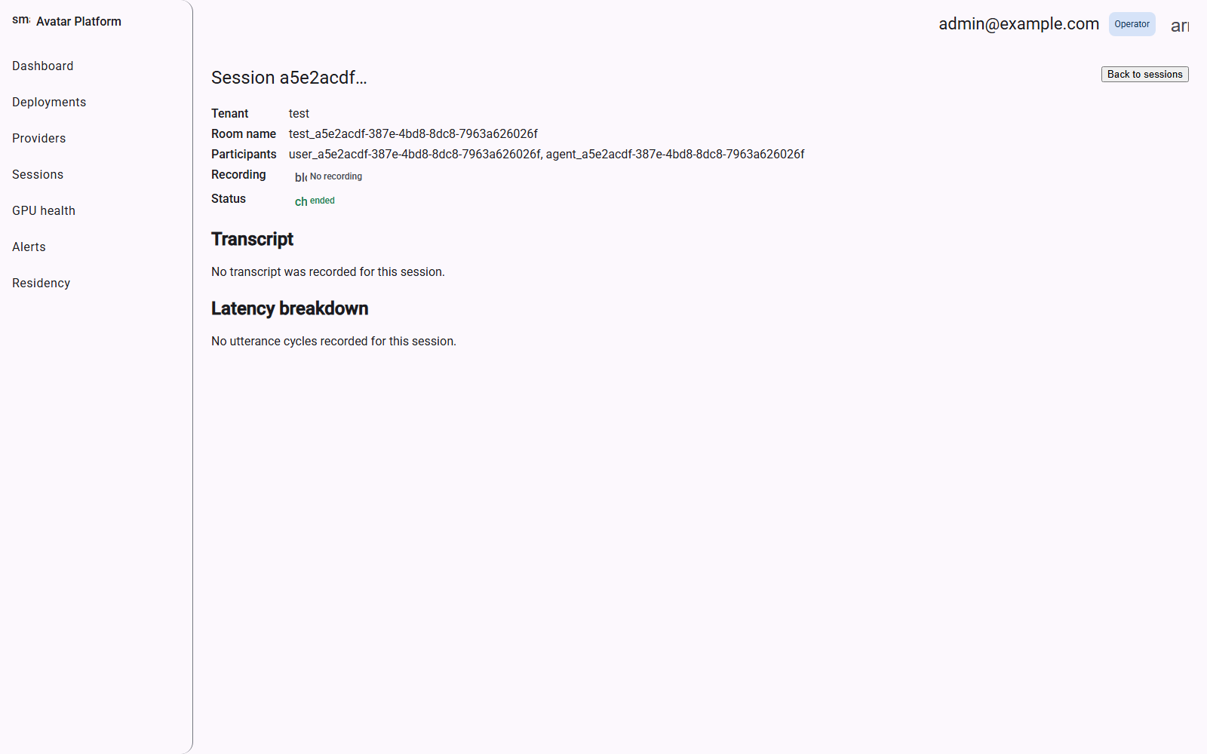

Detailed scenario
- Operator arrives here from the Sessions list by clicking a row, or from a direct link (e.g. shared during an incident investigation).
- Operator reviews the header fields: Tenant, Room name, Participants (the end user's and the agent's LiveKit identities), Recording status, and overall Status.
- Operator scrolls to Transcript to read what was actually said, turn by turn (when speech was captured).
- Operator scrolls to Latency breakdown to see per-utterance timing and spot which leg of the pipeline (STT, LLM, TTS, avatar) was the bottleneck.
- Operator clicks "Back to sessions" to return to the list.

Notes
- This screenshot is a real, automated test call (synthetic silent audio, no real speech) — it shows "No transcript was recorded" and "No utterance cycles recorded" because Deepgram had nothing to transcribe, not because the feature is broken; a real caller's speech would populate both sections.
- A row with a non-null Error code (see the Sessions list) is the fastest way to jump straight to the failure reason for a specific bad call.

9. GPU health
Route: /admin/gpu

Purpose
A read-only status board for self-hosted GPU workers (faster-whisper, Fish Speech, bitHuman, Deepgram-self-hosted) — the infrastructure this platform's own compose/deployment stack deliberately does not provision itself (per the architecture's GPU-autoscaling non-goal). This screen exists to surface whatever an operator has provisioned separately, not to provision or scale it from here.

Screenshot
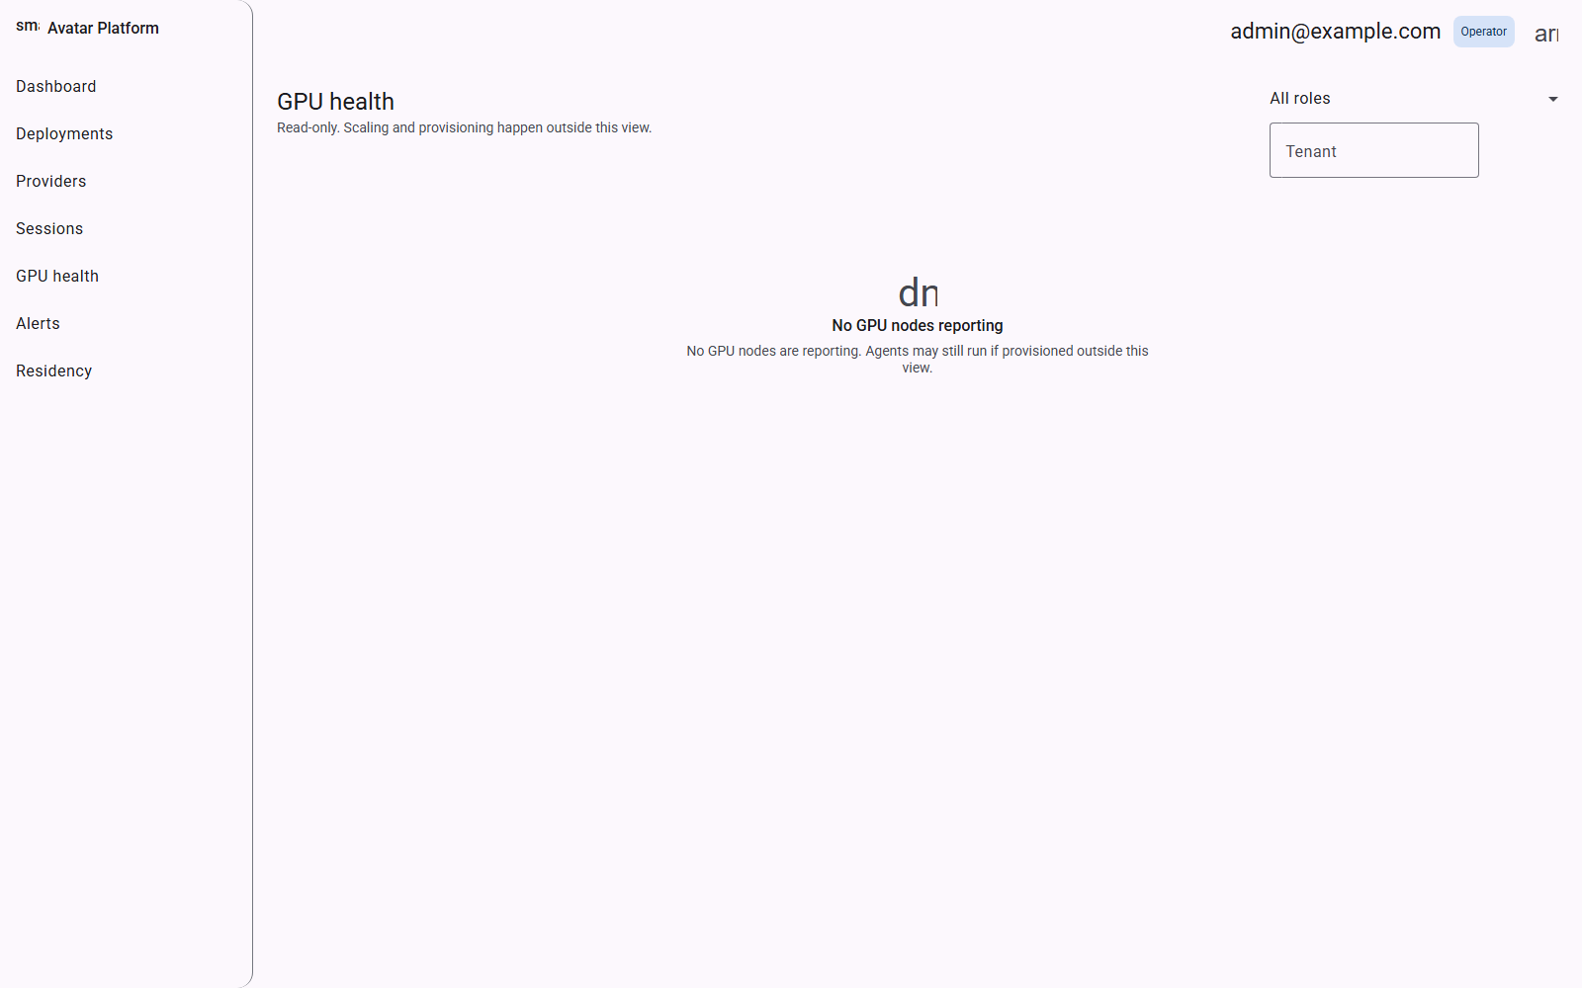

Detailed scenario
- Operator opens GPU health to check whether any registered GPU worker is reporting in.
- Operator filters by Role or Tenant using the controls, top-right, once multiple GPU nodes exist.
- If a node stops heartbeating, it would disappear from (or show as stale in) this list — the operator's cue to check that worker directly.

Notes
- This reference deployment runs no GPU workers at all (bitHuman renders on CPU here), so the page correctly shows "No GPU nodes reporting" — this is expected, not an error.
- The subtitle is explicit that "scaling and provisioning happen outside this view" — this screen is observability only.

10. Alerts (picker)
Route: /admin/alerts

Purpose
A lightweight chooser screen: since fallback/retry/alerts configuration is always scoped to one deployment, this page just lets the operator pick which deployment to configure before landing on the real Alerts & failover screen.

Screenshot
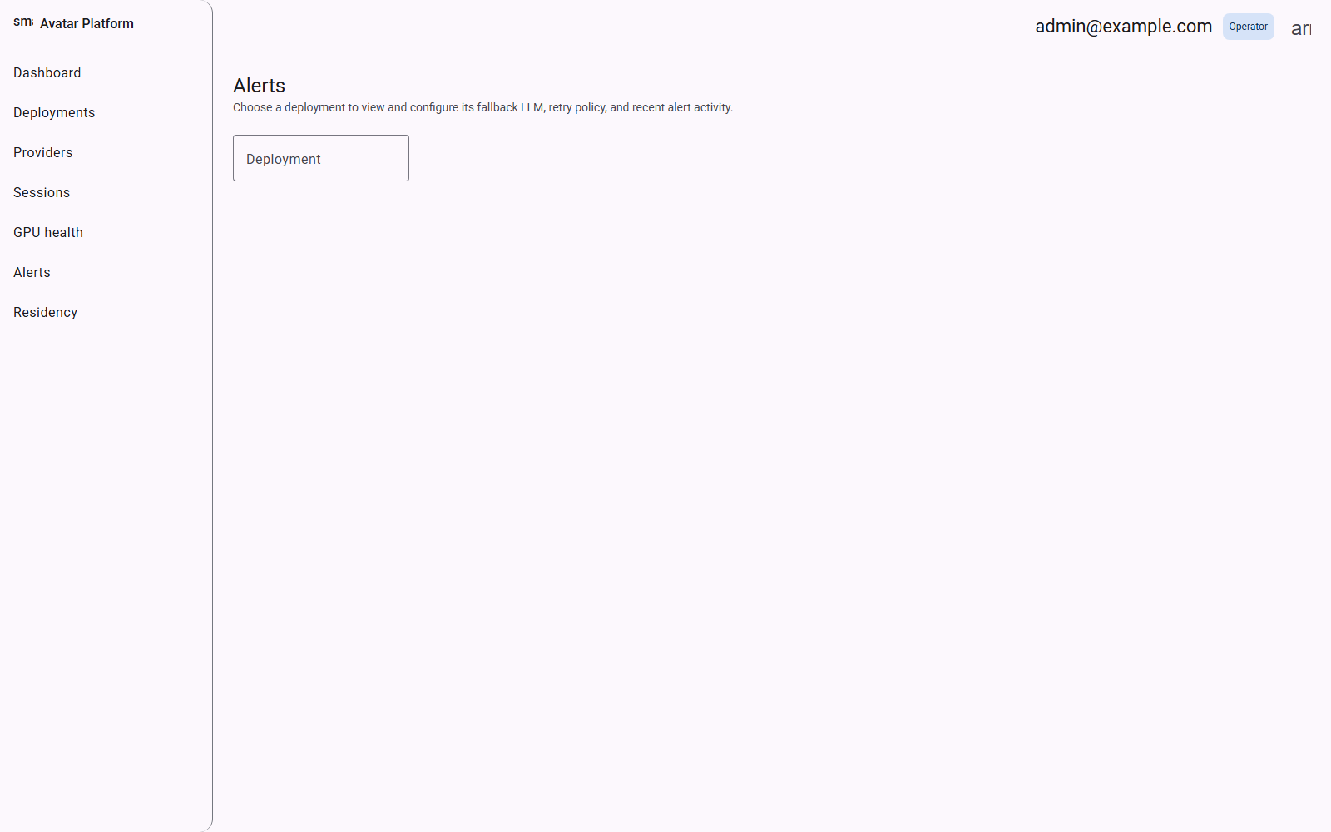

Detailed scenario
- Operator opens Alerts from the sidebar.
- Operator picks a deployment from the Deployment dropdown.
- The app navigates to that tenant's Alerts & failover screen.

11. Alerts & failover
Route: /admin/tenants/:id/alerts

Purpose
Configures what happens when the primary LLM fails mid-call: which model to fall back to, how many retries to attempt and with what backoff, and the exact message the agent speaks to the caller if every attempt is exhausted ("degraded mode"). The bottom section reports how often this has actually triggered in the last 24 hours.

Screenshot
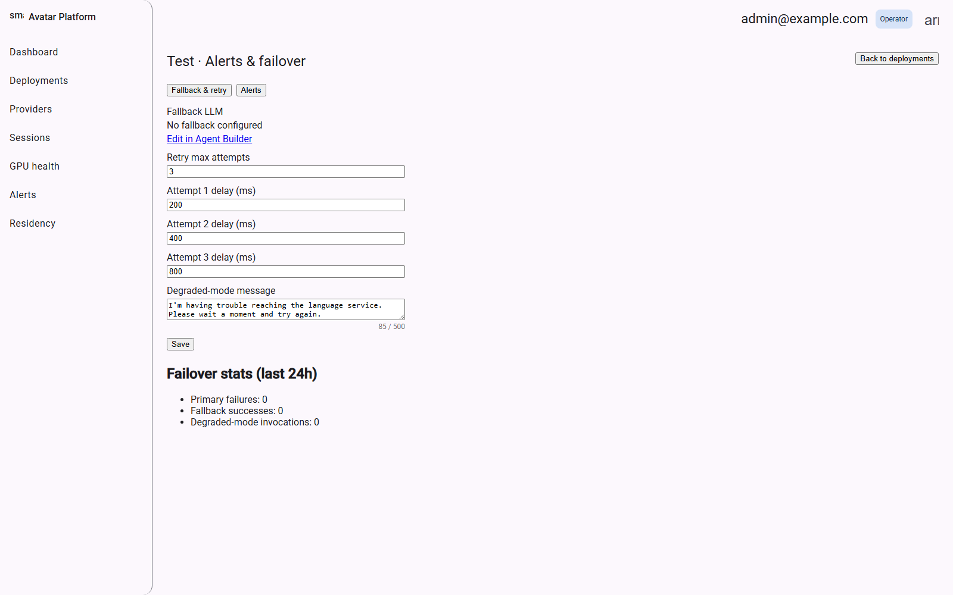

Detailed scenario
- Operator switches to the "Fallback & retry" tab (shown) to set Retry max attempts and a per-attempt delay (ms) — visualized here as 3 attempts at 200/400/800 ms.
- Operator edits the Degraded-mode message — the sentence the agent says instead of silently failing when the LLM is unreachable after all retries.
- Operator clicks the "Alerts" tab to configure notification rules (not shown) for when failovers happen.
- Operator reviews Failover stats (last 24h): Primary failures, Fallback successes, and Degraded-mode invocations, to judge how healthy the LLM path has actually been.
- If no fallback LLM is configured yet, the operator follows the "Edit in Agent Builder" link to set one.
- Operator clicks Save to persist changes.

Notes
- In this example no fallback LLM is configured ("No fallback configured") and the 24h stats are all zero — consistent with a fresh tenant that has only run short test calls, not a production failure history.

12. Residency (picker)
Route: /admin/residency

Purpose
The same picker pattern as Alerts: data-residency and privacy policy is per-deployment, so this screen exists purely to route the operator to the right tenant's Data residency screen.

Screenshot
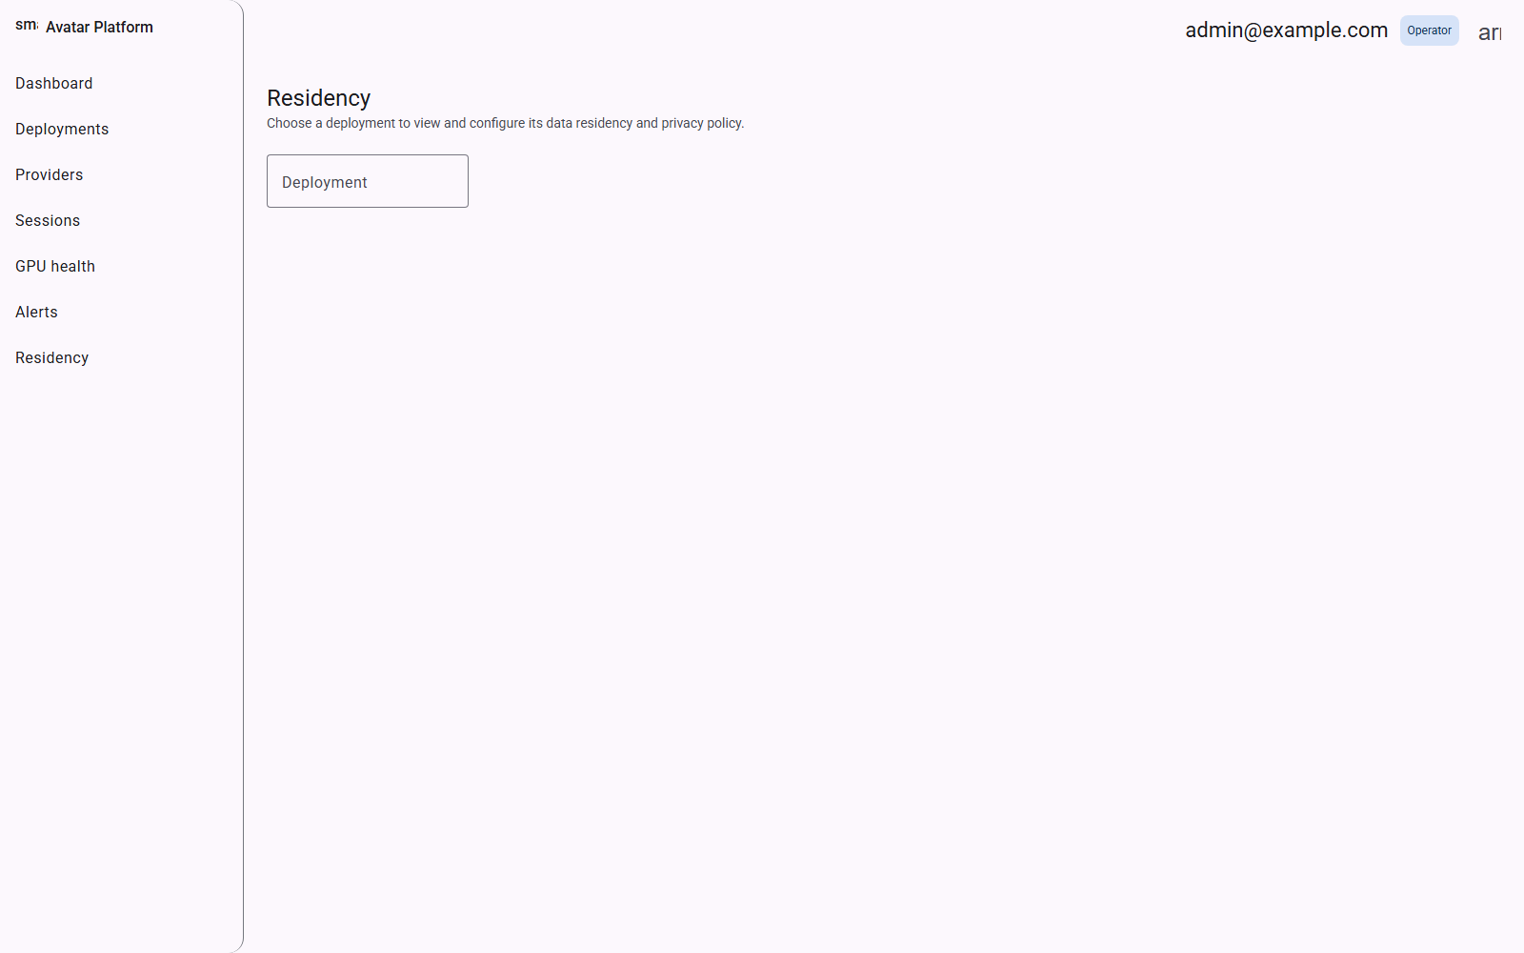

Detailed scenario
- Operator opens Residency from the sidebar.
- Operator picks a deployment from the Deployment dropdown.
- The app navigates to that tenant's Data residency screen.

13. Data residency
Route: /admin/tenants/:id/residency

Purpose
Privacy and data-handling policy for one tenant: exactly what is sent to the remote LLM, how long transcripts are retained before automatic deletion, and whether call recordings are enabled at all. This is the compliance-facing control surface an operator uses to match a customer's contractual or regulatory requirements.

Screenshot
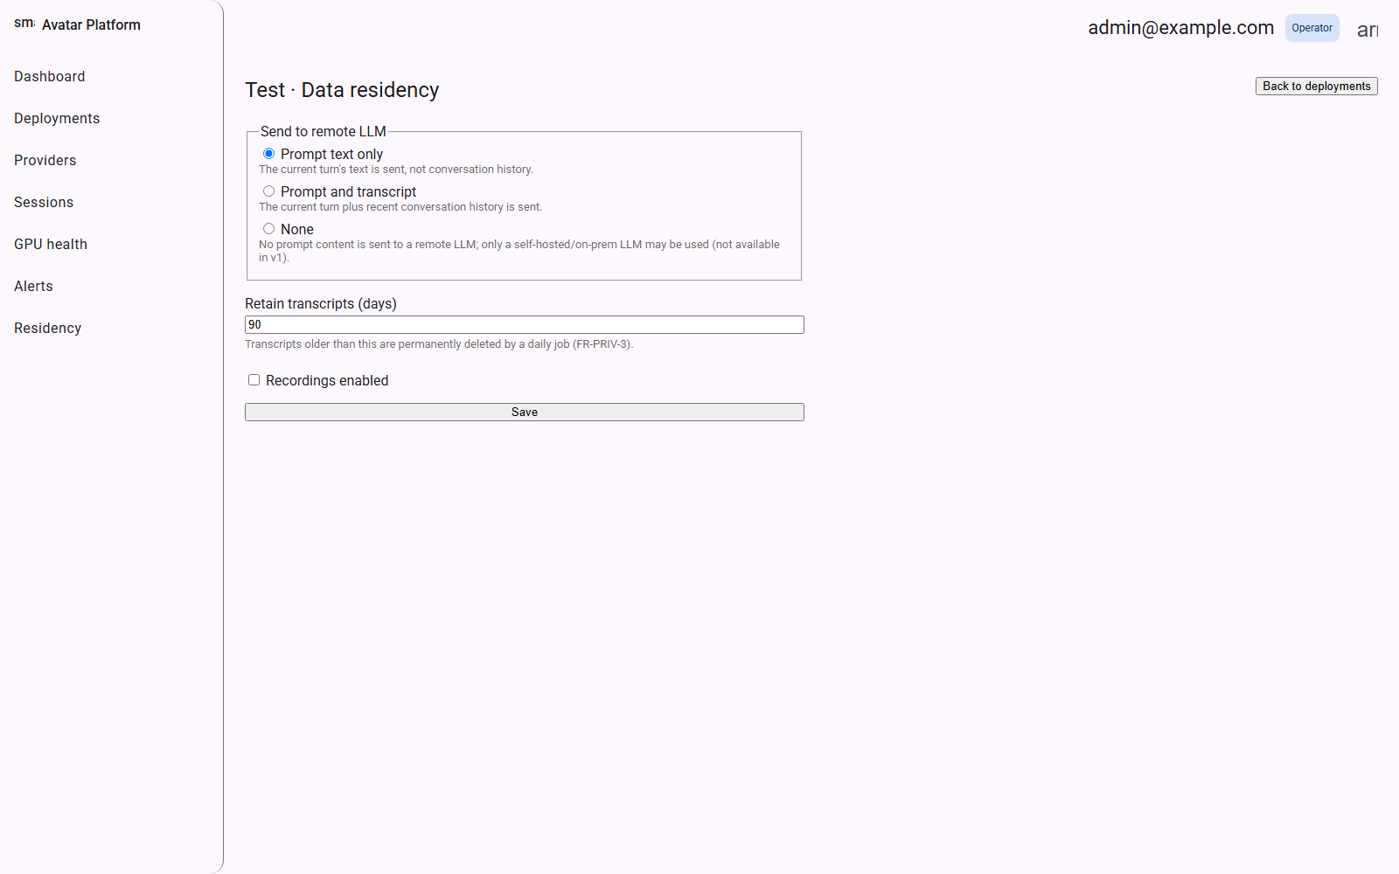

Detailed scenario
- Operator chooses a "Send to remote LLM" mode: Prompt text only (just the current turn), Prompt and transcript (current turn plus recent history), or None (no prompt content leaves the premises at all — requires a self-hosted/on-prem LLM, not available in v1).
- Operator sets "Retain transcripts (days)" — transcripts older than this are permanently deleted by a daily background job.
- Operator toggles "Recordings enabled" if this tenant is contractually allowed to keep call recordings.
- Operator clicks Save.

Notes
- The default and most conservative production-safe option, "Prompt text only," is what this reference tenant uses.
- This screen is the authoritative, per-tenant enforcement point for FR-PRIV-3 (transcript retention) — it is not just a display of a hardcoded policy.

14. Accept invite
Route: /admin/invite?token=...

Purpose
How every admin account after the very first one gets created. An existing operator invites a new admin (from a screen not pictured here, under tenant/user management); the invitee receives a one-time link carrying a token, opens it, and sets their own password on this screen.

Screenshot
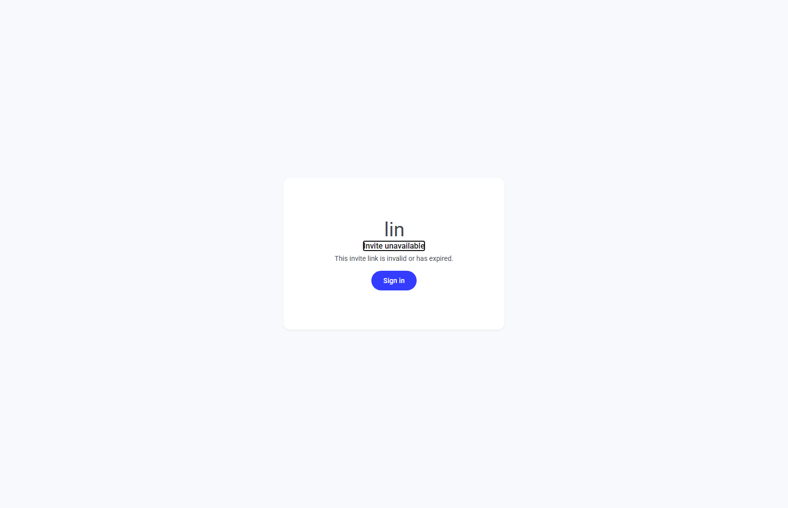

Detailed scenario
- Invitee opens the link they were sent, which includes a `?token=...` query parameter identifying their invite.
- The page validates the token; if valid, it presents a form to set a password and completes account creation on submit.
- If the token is missing, malformed, expired, or already used, the page shows "Invite unavailable" (pictured) instead of a password form, with a Sign in button for anyone who already has an account.

Notes
- This screenshot deliberately shows the invalid-token state (visited with no token at all) — the intended, valid-token flow requires an admin to first issue a real invite from elsewhere in the console.

15. Pre-call
Route: /c/:tenant-slug

Purpose
The end user's entry point — no login required. This is what a customer sees when they click a link to talk to a tenant's avatar agent (e.g. "/c/test"). It requests microphone (and optionally camera) permission up front so the call doesn't fail partway through, and lets the caller optionally give their name before joining.

Screenshot
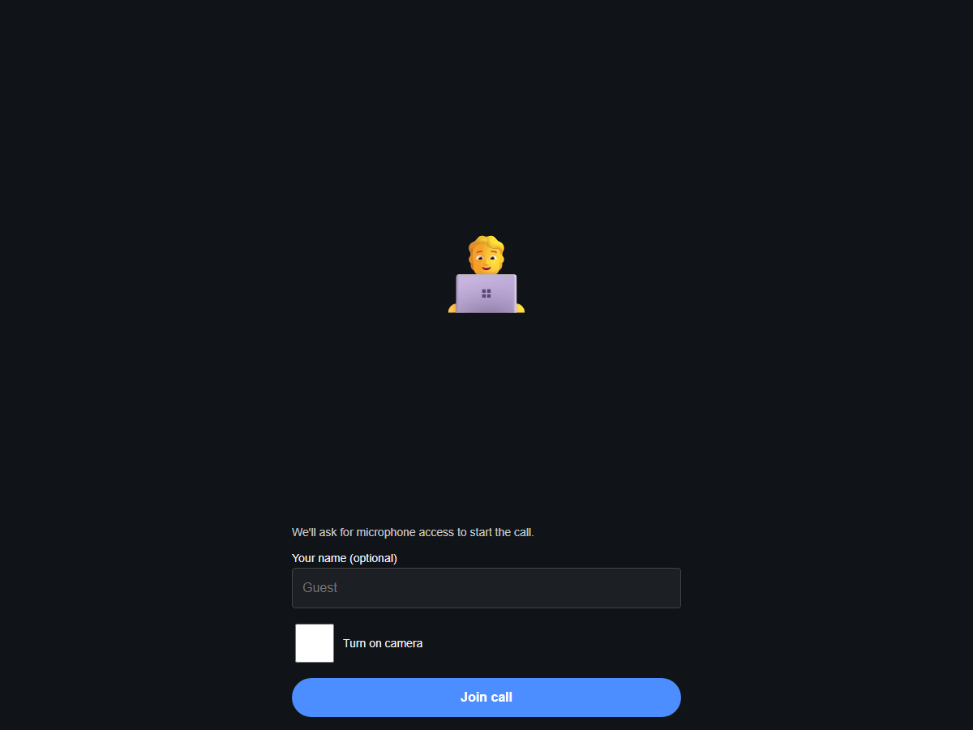

Detailed scenario
- Caller opens the tenant's conversation link — no account or password needed.
- The page immediately requests microphone access; if camera is desired, the caller ticks "Turn on camera" first.
- Caller optionally types a display name (defaults to "Guest").
- Caller clicks "Join call," which requests a session token from the backend and connects to the LiveKit room.
- If the browser denies microphone access, a red banner explains that mic access is required and to retry after allowing it — the call cannot proceed without it.

Notes
- This screen only renders for a valid, published tenant slug — a bare "/c/" or an unpublished/misconfigured tenant does not match any route or fails preflight.

16. Call
Route: /c/:tenant-slug/call

Purpose
The live conversation screen. Once joined, the caller's audio (and video, if enabled) publishes into a LiveKit room; the tenant's dedicated agent worker is dispatched into the same room and runs the full pipeline — Deepgram transcribes the caller's speech, the LLM (OpenAI, in this deployment) generates a reply, ElevenLabs synthesizes it to audio, and bitHuman renders a lip-synced avatar video frame-by-frame back into the room.

Screenshot
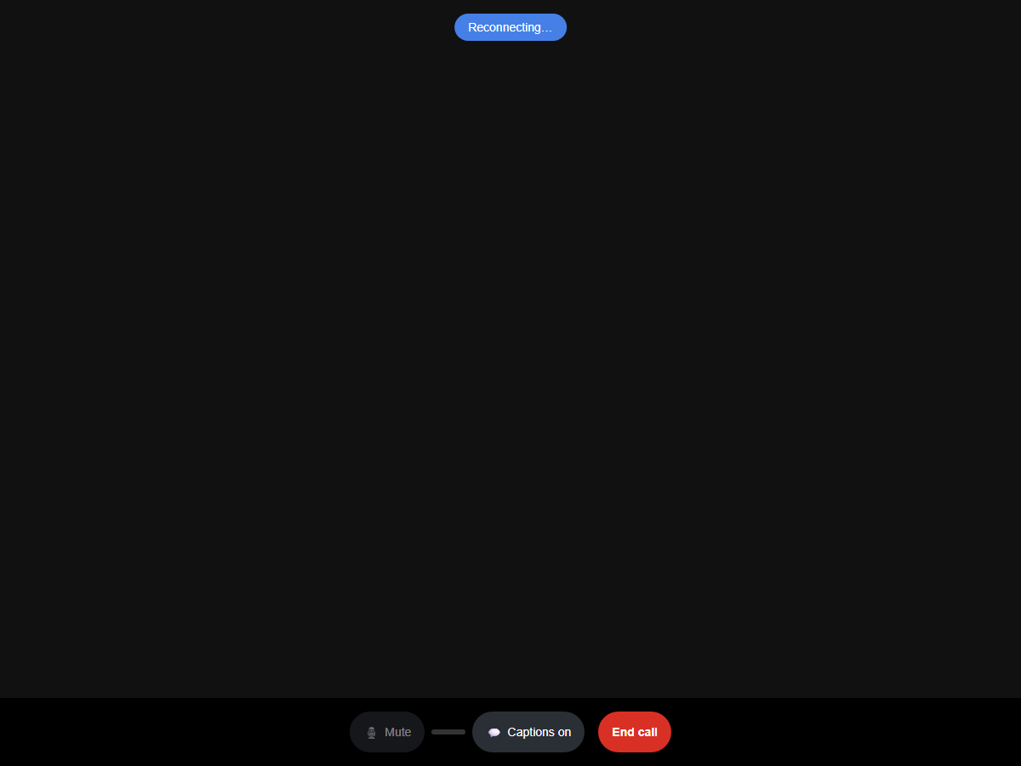

Detailed scenario
- Caller sees the agent's avatar video fill the screen once it starts publishing (rendering can take a few seconds after the agent's own session negotiation completes).
- Caller speaks; live captions can be toggled via "Captions on/off."
- Caller can Mute their own microphone mid-call without leaving the room.
- Caller clicks "End call" when finished, which disconnects from LiveKit and redirects to the Call summary screen.

Notes
- This screenshot was captured moments after a real, live join — controls (Mute, Captions, End call) are fully functional; the video area is still black because the avatar's first rendered frame had not yet arrived at the moment of capture (bitHuman renders on CPU in this environment, absent a GPU, so first-frame latency is higher than a GPU-backed deployment).
- "Captions unavailable" reflects that no STT transcript had streamed back yet at capture time, not a broken feature.

17. Call summary
Route: /c/:tenant-slug/summary/:sessionId/:summaryToken

Purpose
Shown immediately after a call ends. The one-time `summary_token` in the URL is the sole authorization credential for viewing this page — knowing or guessing a session id alone is not enough. It shows an LLM-generated recap of the conversation, the transcript (if one exists), and lets the caller rate the call.

Screenshot
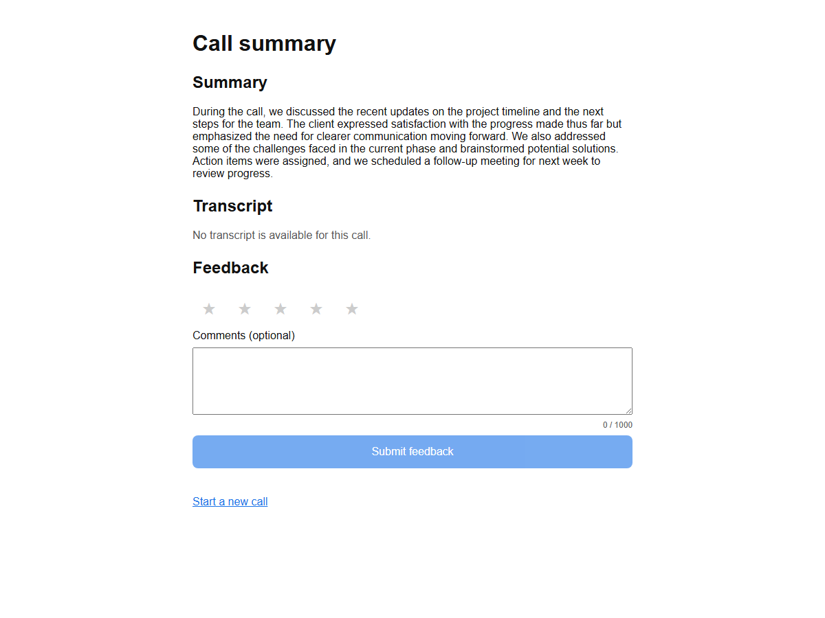

Detailed scenario
- Caller is redirected here automatically after clicking "End call."
- Caller reads the Summary — a short, LLM-generated recap of what was discussed.
- Caller expands Transcript to review the full back-and-forth, if one was recorded.
- Caller optionally rates the call 1–5 stars and leaves a free-text comment, then clicks "Submit feedback."
- Caller clicks "Start a new call" to return to the Pre-call screen and begin again.

Notes
- This screenshot is a genuine, live-generated summary from OpenAI — produced automatically at the end of a real test call against this tenant's published configuration, not placeholder text.
- "No transcript is available for this call" is expected here since the test call used synthetic silent audio with no real speech for Deepgram to transcribe.

