LiveAvatar Platform
User Guide — Admin Console & Conversation Experience

Covers every screen in the admin application (tenant, deployment, provider, session, alert, GPU and Agent Builder management) and the caller-facing conversation application, illustrated with real screenshots captured against a live instance of the platform.

Prepared 2026-09-05

Table of Contents
Right-click and choose ‘Update Field’ to build the table of contents.

About This Guide
LiveAvatar is a platform for building and running voice-driven avatar agents. It has two applications:
- Admin Console — where operators manage tenants, configure agents (the Agent Builder), monitor sessions, and review analytics.
- Conversation Experience — the caller-facing web app a customer opens to talk to a configured avatar agent.
Every screenshot in this guide was captured against a real, live deployment of the platform (real database, real backend, real browser), not a mockup. A short “Notes” line under some screenshots calls out sandbox-specific conditions (e.g. a credential deliberately pointed at a fake endpoint to demonstrate the “Unreachable” state) so the guide stays accurate about what is being shown.
This guide focuses on what each screen is for and how to use it. It does not cover installation/deployment — see docs/deployment/DEPLOYMENT.md in the project repository for that.

Part 1 — Admin Console

1. Signing In
Operators reach the admin console at the deployment's admin URL (e.g. https://admin.yourcompany.com) and sign in with the email and password an administrator gave them, or set during an invite.
The very first operator account on a fresh installation is created once, using a one-time bootstrap step (see the Deployment Guide) rather than through this screen — every account after that is created via an invite (Section 2).
An incorrect email or password shows a generic “invalid credentials” message; the platform does not reveal whether the email exists, to avoid leaking account information.
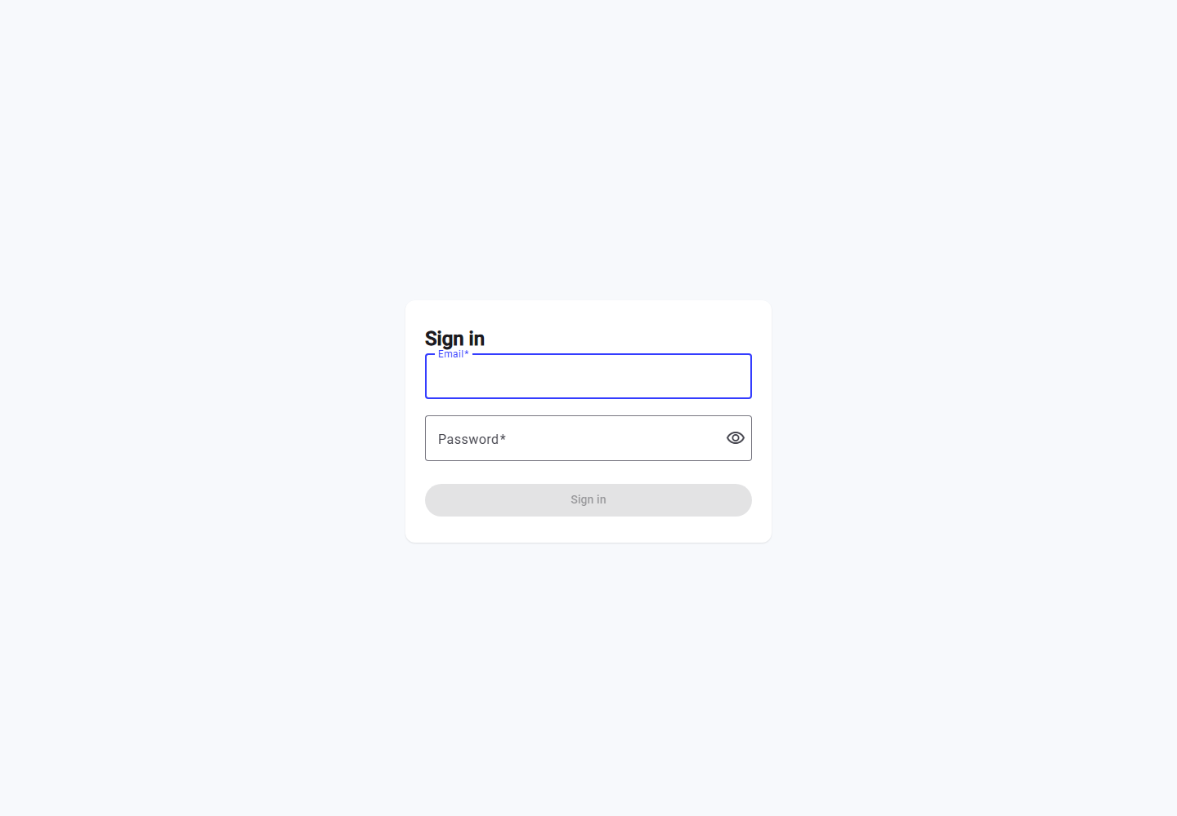
The admin sign-in screen.

2. Accepting an Invite
New operators are added by an existing admin sending an invite (email + role + which tenants they can access). The invite email contains a link to this acceptance screen, where the new user sets their own password.
Roles are scoped per-tenant: an invited admin only ever sees the tenants they were explicitly granted — confirmed below, where a newly-accepted admin invited to a single tenant lands on the deployments list and sees only that one tenant, not the others that exist on the platform.
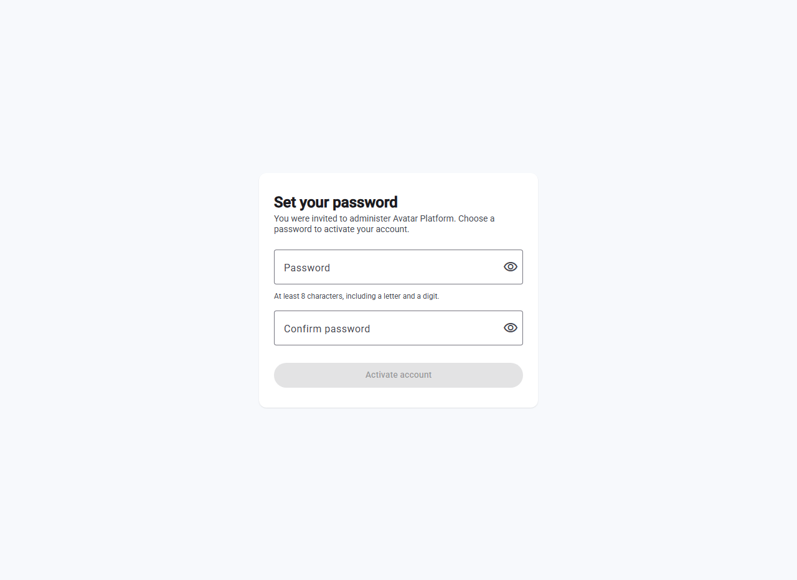
Setting a password to accept an invite.
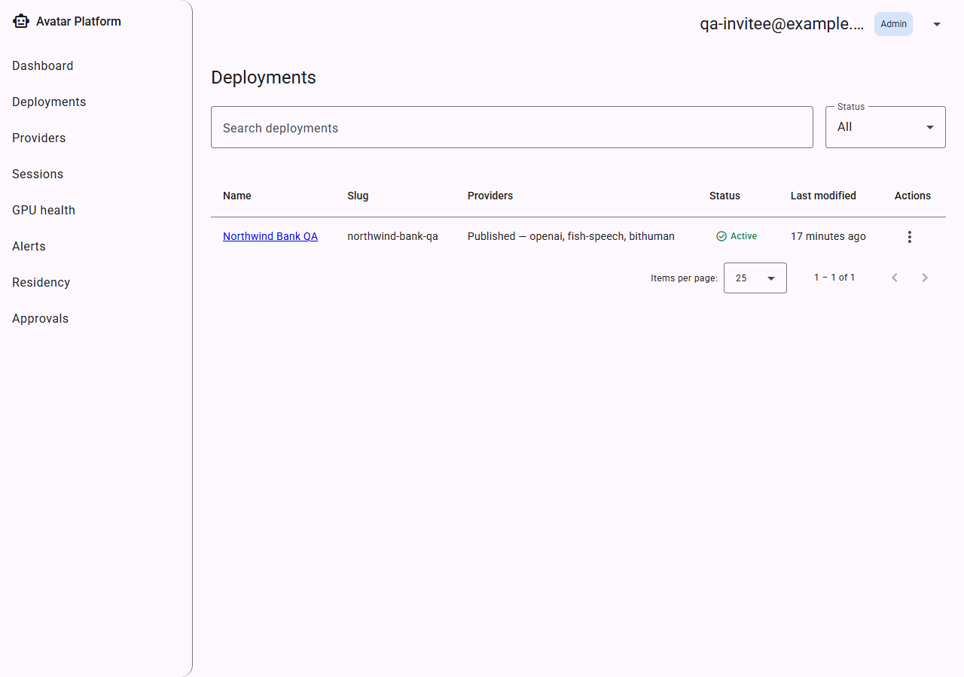
After accepting, the new admin lands on Deployments — correctly scoped to only the tenant(s) they were invited to.

3. Dashboard
The Dashboard is the first screen after login: a cross-tenant rollup of how the whole platform is doing right now — active deployments, session volume (started / ended / failed / abandoned) and the live error rate, plus a provider-health grid showing whether each connected Transport/STT/LLM/TTS/Avatar provider is currently reachable.
Provider health is a real, live reachability check — not a stored flag — so a provider that starts failing shows red here immediately. The screenshot below is a genuinely live deployment with a real Deepgram (STT), OpenAI (LLM), ElevenLabs (TTS), and bitHuman (Avatar, a local model file) all configured and passing their reachability check.
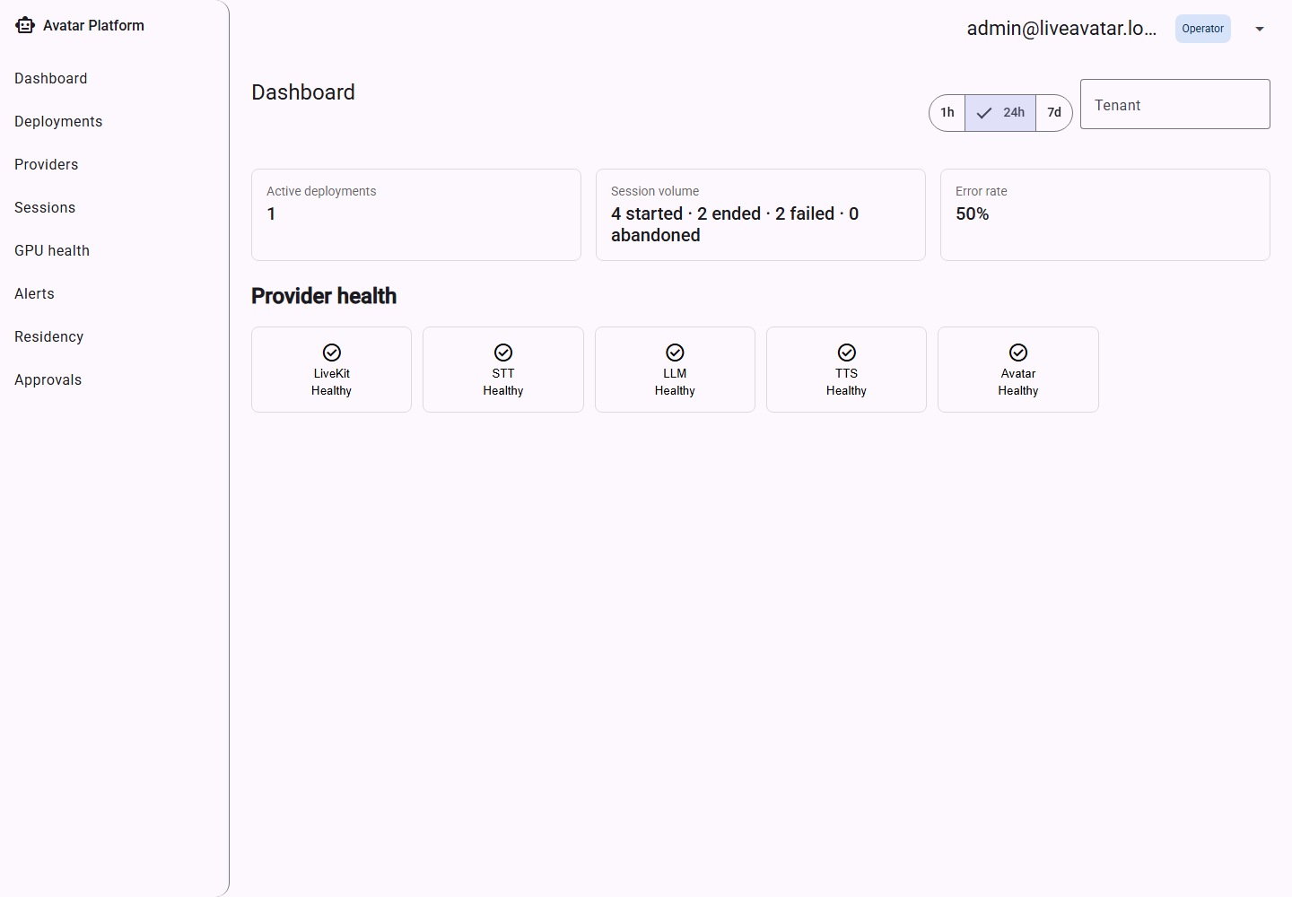
Dashboard — every provider category genuinely healthy.
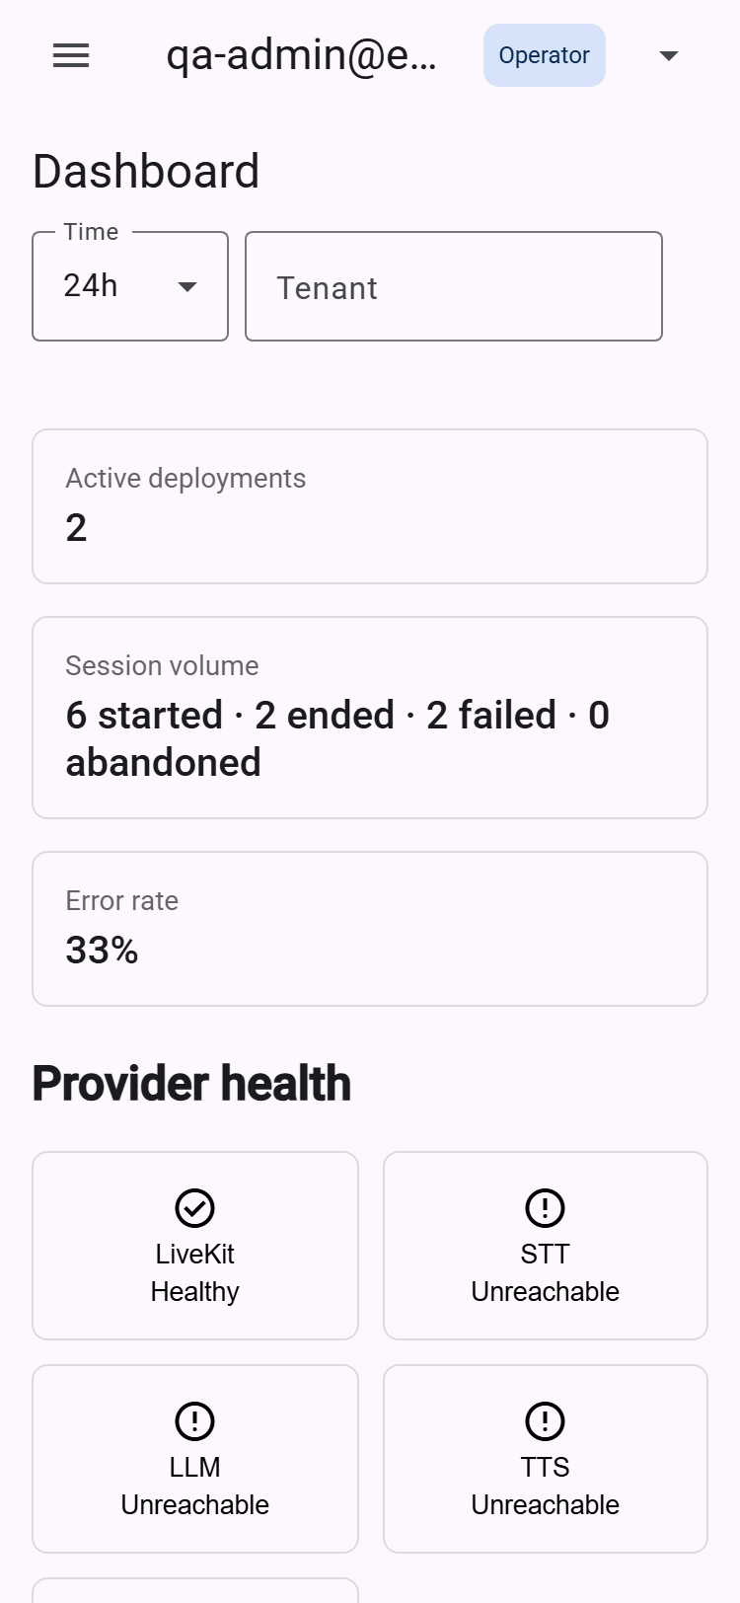
Dashboard on a phone-width (375px) screen.

4. Tenants & Deployments
“Deployments” is the tenant list — one row per customer/brand running on the platform. From here an admin creates a new tenant, opens an existing one's Agent Builder configuration, or changes its status.
- Create deployment — opens a dialog to name a new tenant. A brand-new tenant starts with no configuration; it must be set up in the Agent Builder (Part 1, Section 11) and published before it can take real calls.
- Pause / Activate — pausing a tenant immediately stops new conversations from starting (existing in-progress calls are allowed to finish) while leaving its Agent Builder configuration fully editable. Activating reverses this.
- Open conversation experience — opens the caller-facing Conversation app for this tenant in a new browser tab — the exact link a real caller would use — so an admin can try a tenant's live experience directly from its row, without having to know or type the underlying URL.
Each tenant's name links directly into that tenant's Agent Builder.
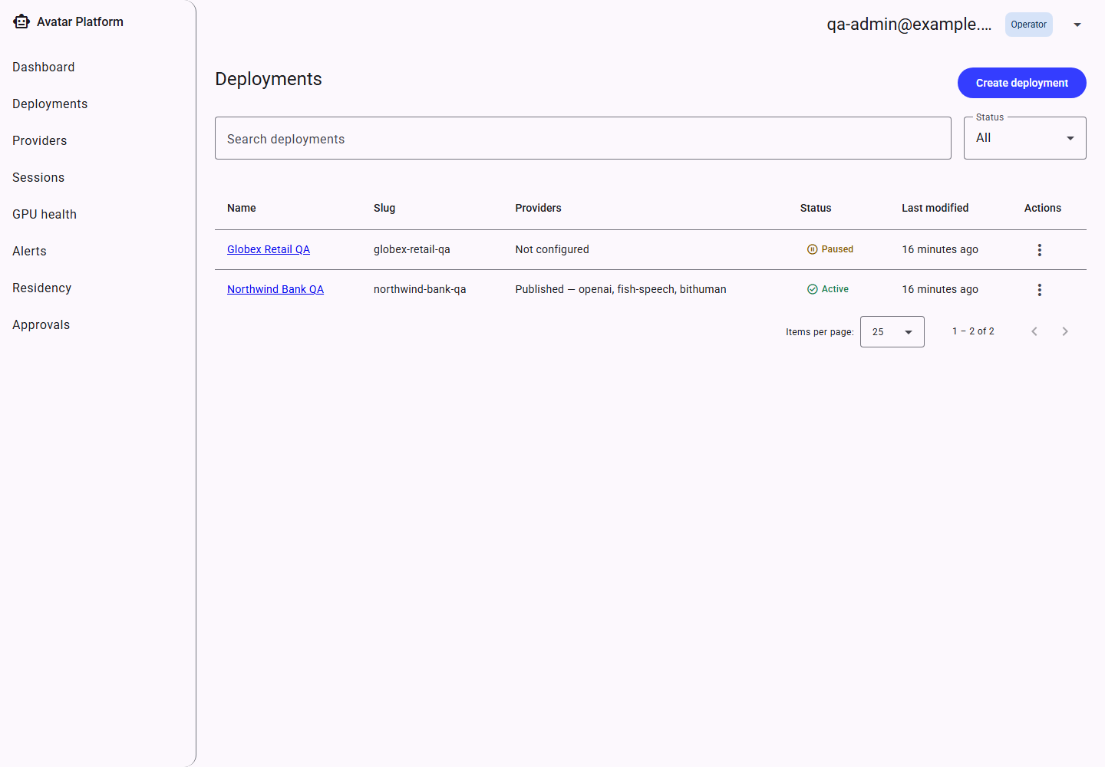
Deployments list — active and paused tenants.
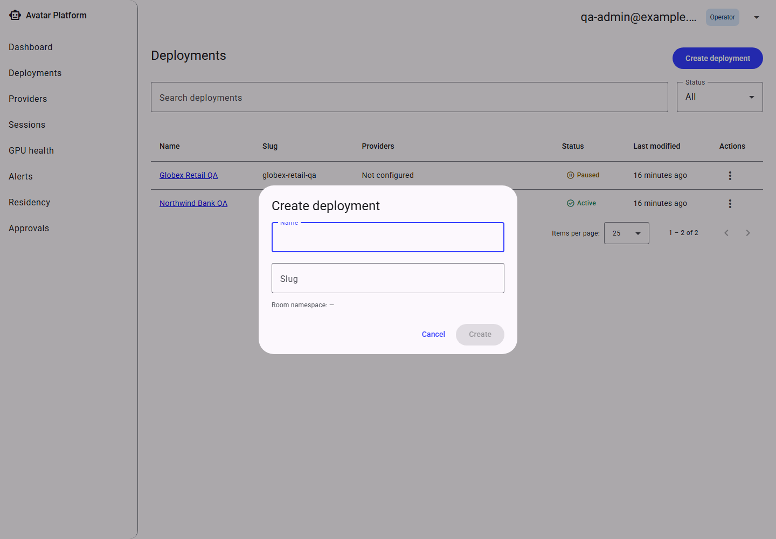
Create-deployment dialog.
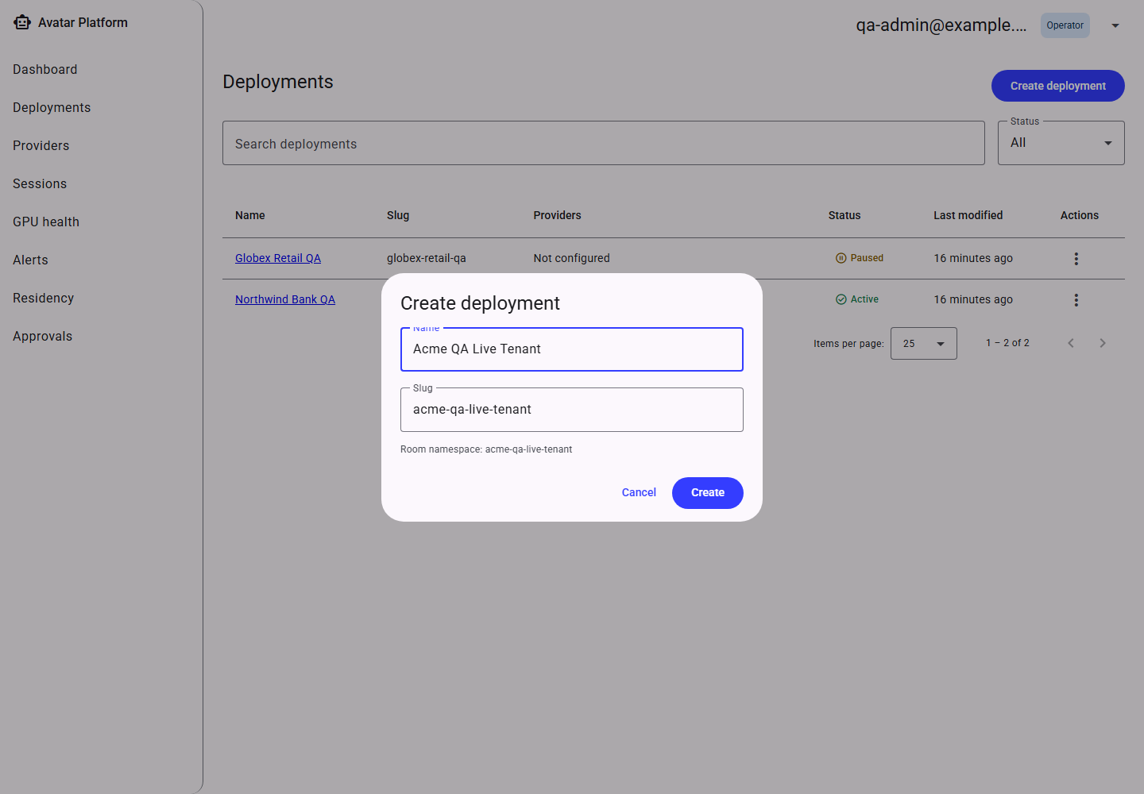
Create-deployment dialog, filled in.
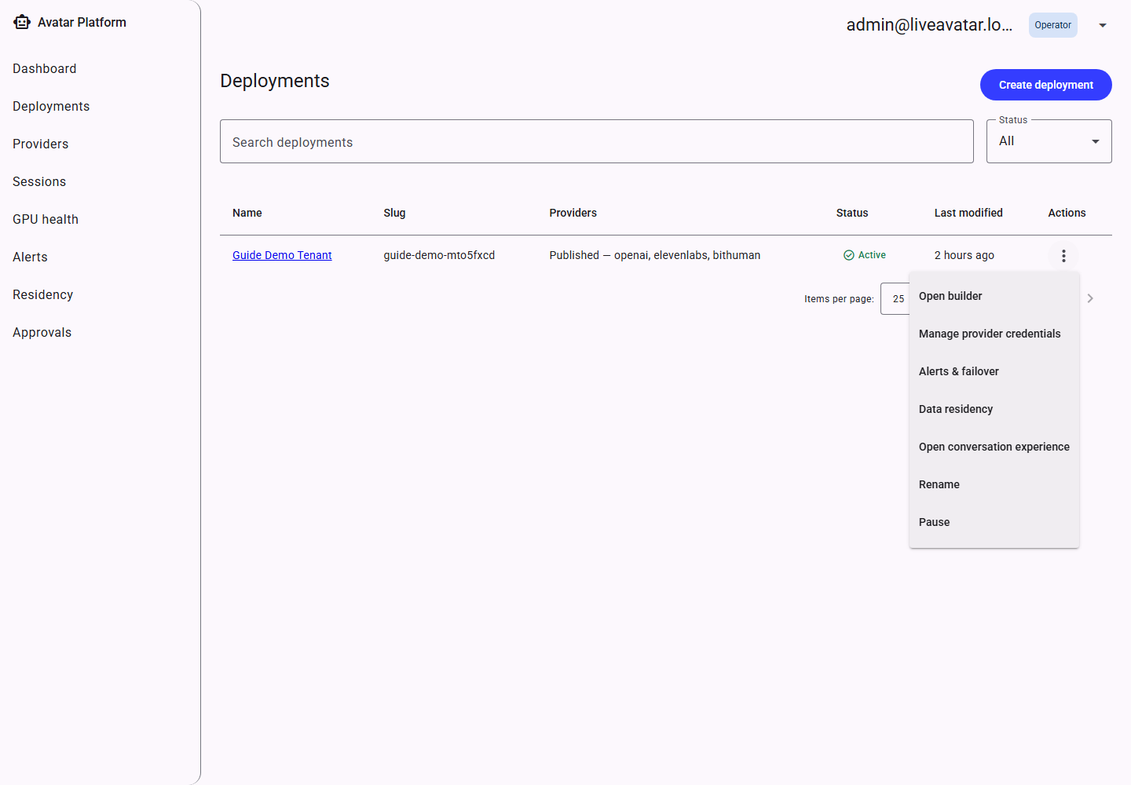
The row-actions menu, including “Open conversation experience.”
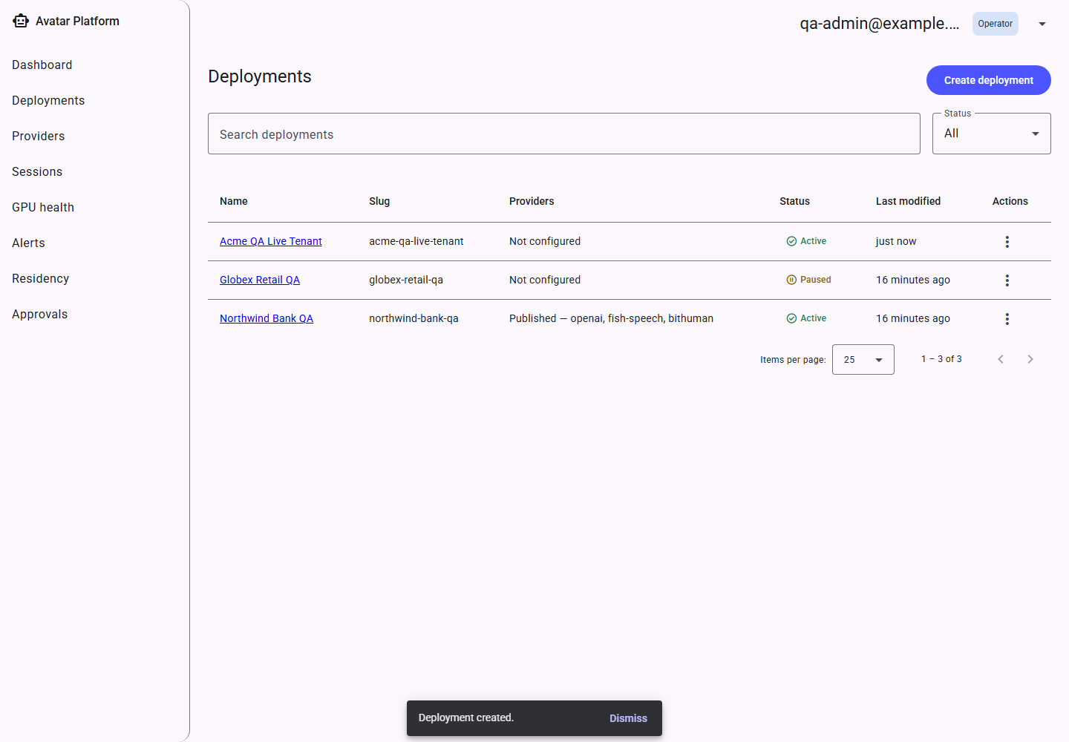
The new tenant appears in the list.
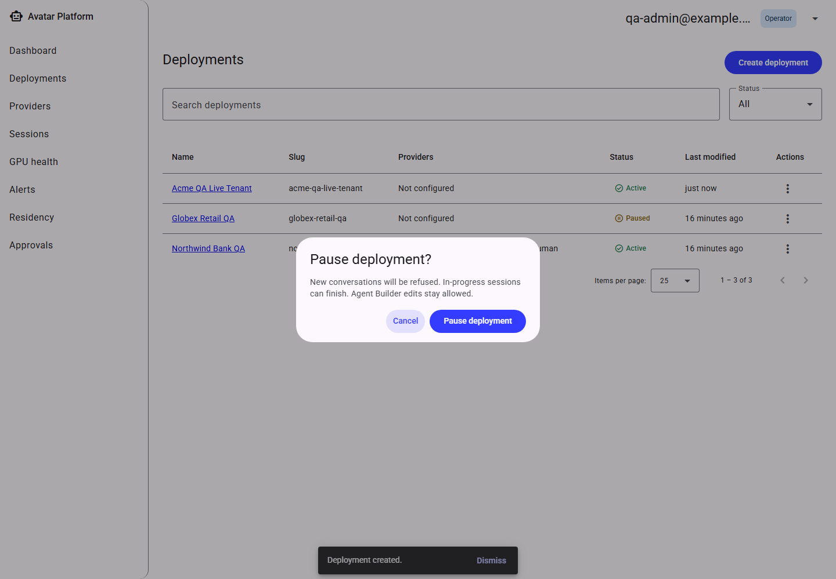
A paused tenant, with its confirmation copy.
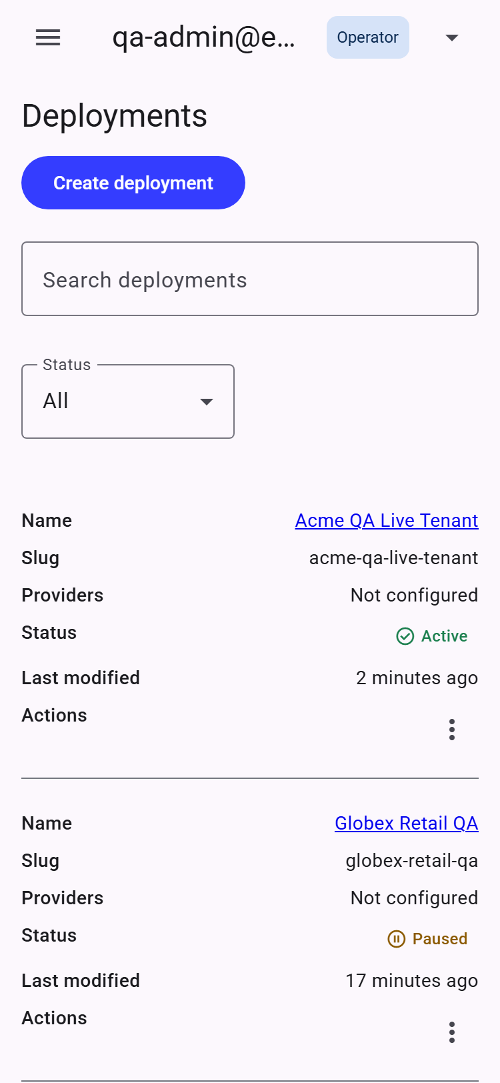
Deployments on a phone-width screen.

5. Provider Registry
Before a tenant can use a given Transport/STT/LLM/TTS/Avatar provider, an admin must add a credential (endpoint + secret reference) for it under that tenant, and confirm it is reachable.
The Catalog tab lists every provider the platform knows how to speak to, each tagged Self-hosted or Remote and grouped by category.
- Add credential — records an endpoint URL and a reference to a secret (never the raw secret itself — secrets live outside the database, referenced only by name).
- Test / probe — actively calls the configured endpoint and reports Healthy, Unreachable, or Testing… while the check is in flight. This is a live network check every time, not a cached status.
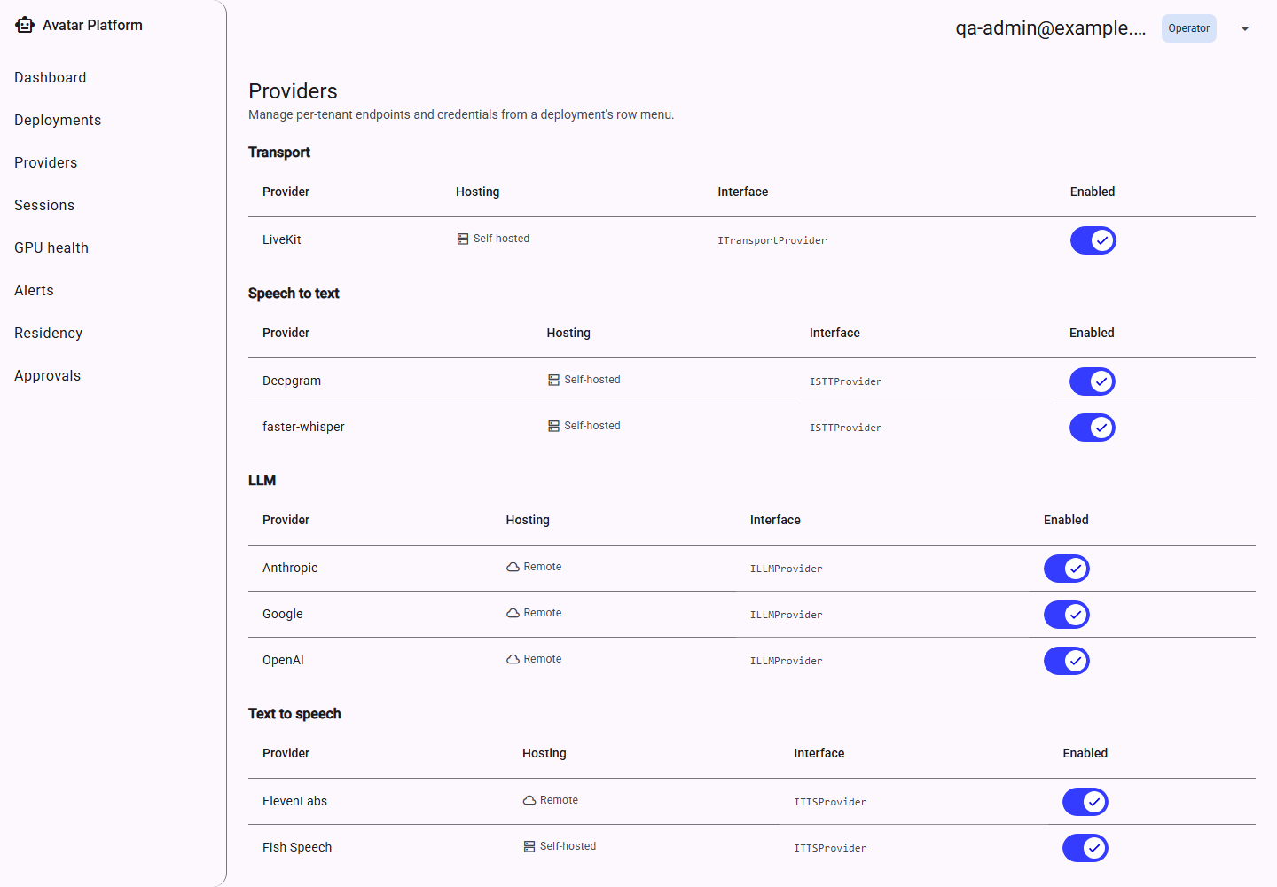
Provider catalog — every supported provider by category.
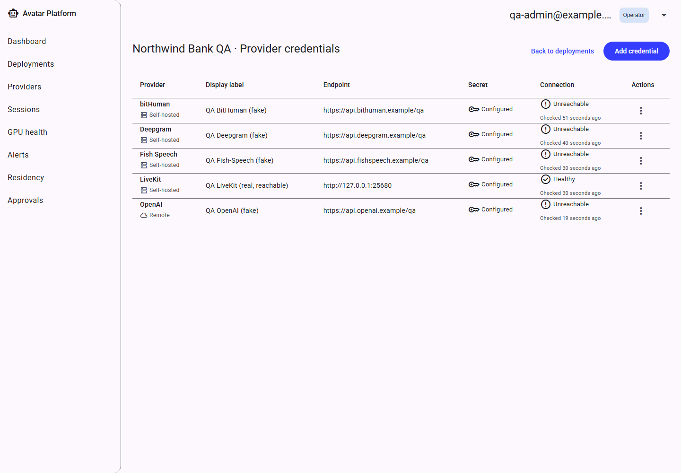
A tenant's credentials, showing a genuine mix of Healthy and Unreachable results.
The Unreachable rows here are credentials deliberately pointed at placeholder endpoints for this screenshot; Section 3's Dashboard shows the same screen's Healthy state once every credential points at its real vendor endpoint (Deepgram, OpenAI, ElevenLabs, bitHuman all verified reachable in this guide's own deployment).
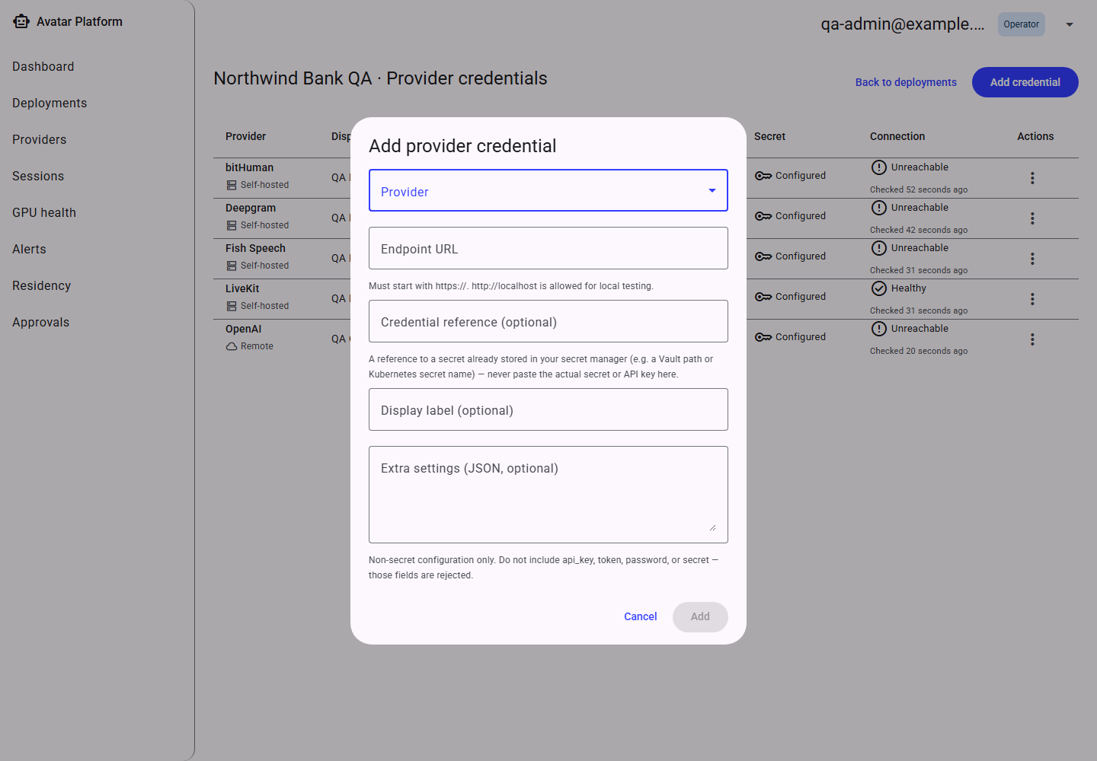
Add-credential dialog.
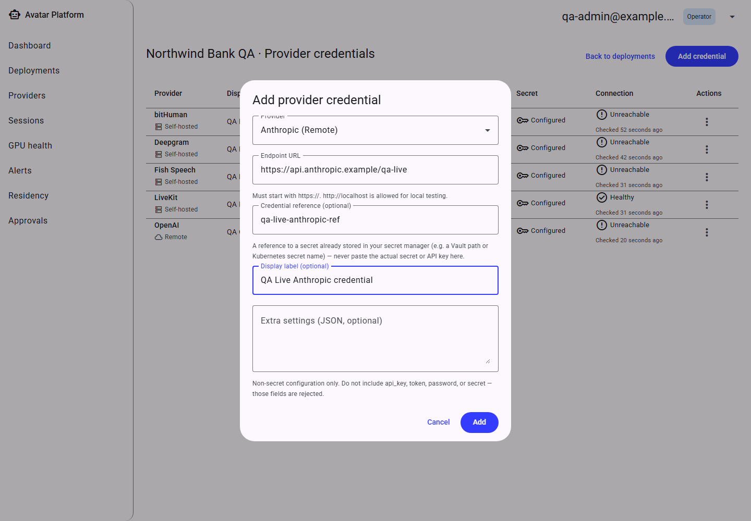
Add-credential dialog, filled in.
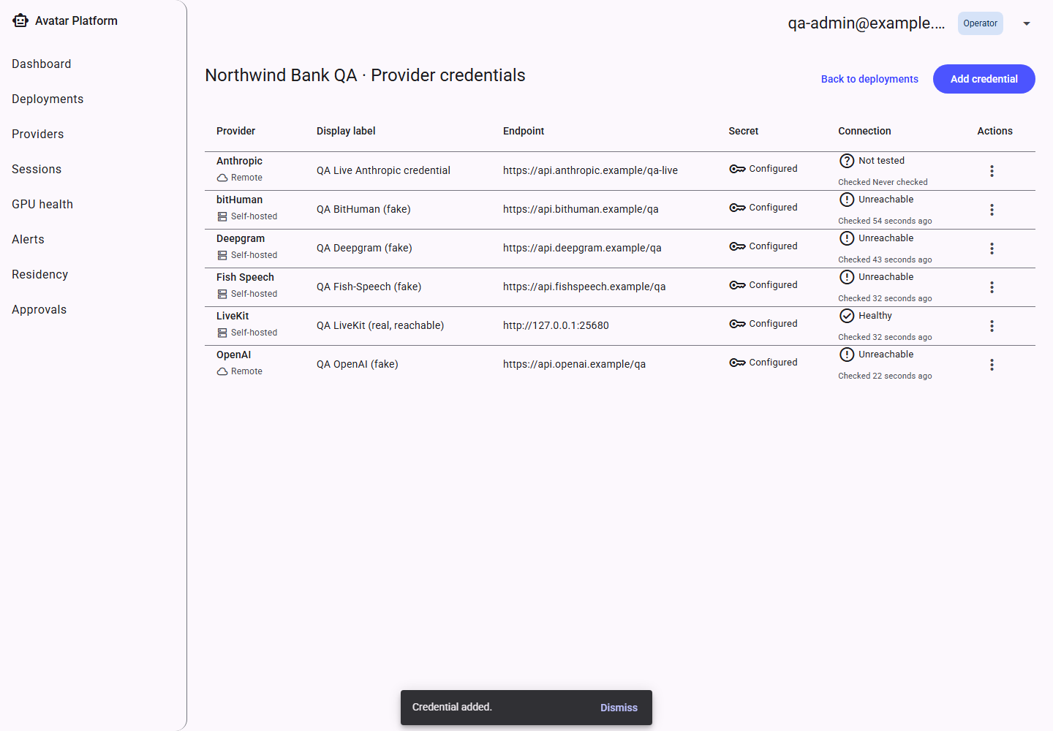
The new credential appears in the list.
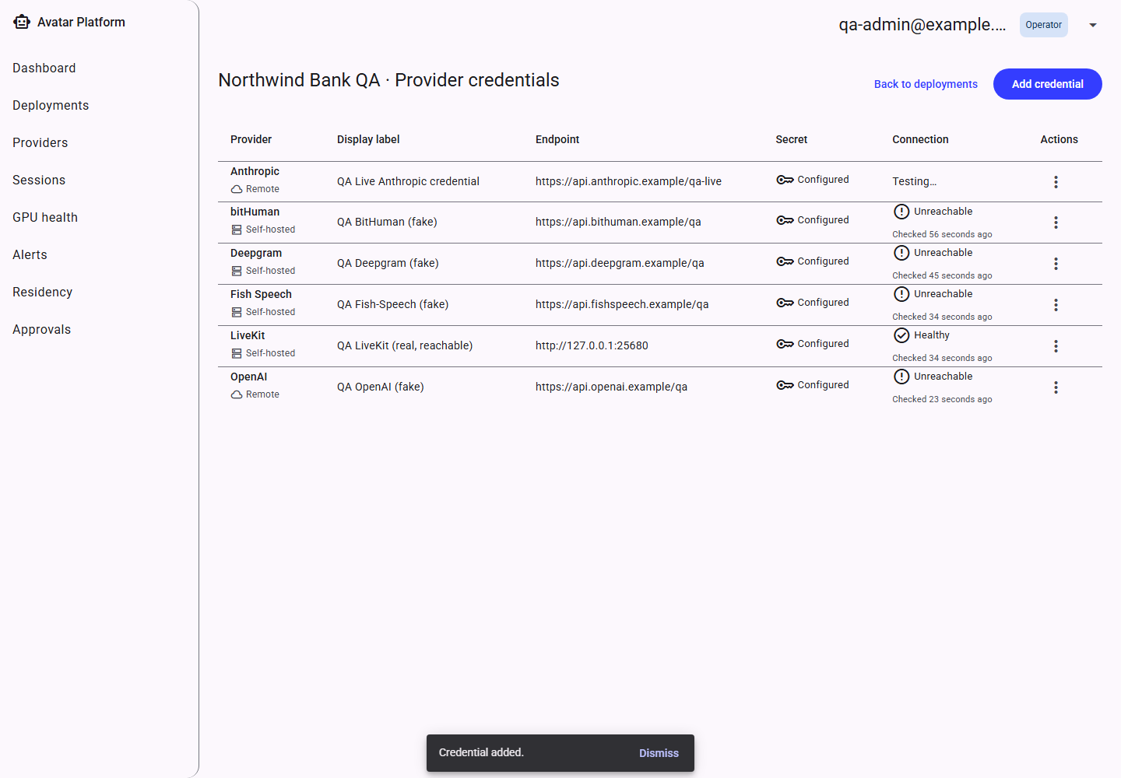
A probe in progress (“Testing…”).

6. Session Logs
Every call a caller has with an avatar agent is recorded as a Session. The Sessions list shows each call's tenant, status (active / ended / failed / abandoned) and start time; opening one shows its full turn-by-turn transcript plus a latency breakdown per turn (how long the STT, LLM, TTS and avatar-rendering steps each took).
A latency stage that was never reported for a given turn (for example, if text-to-speech was skipped) renders as an em dash rather than a misleading zero.
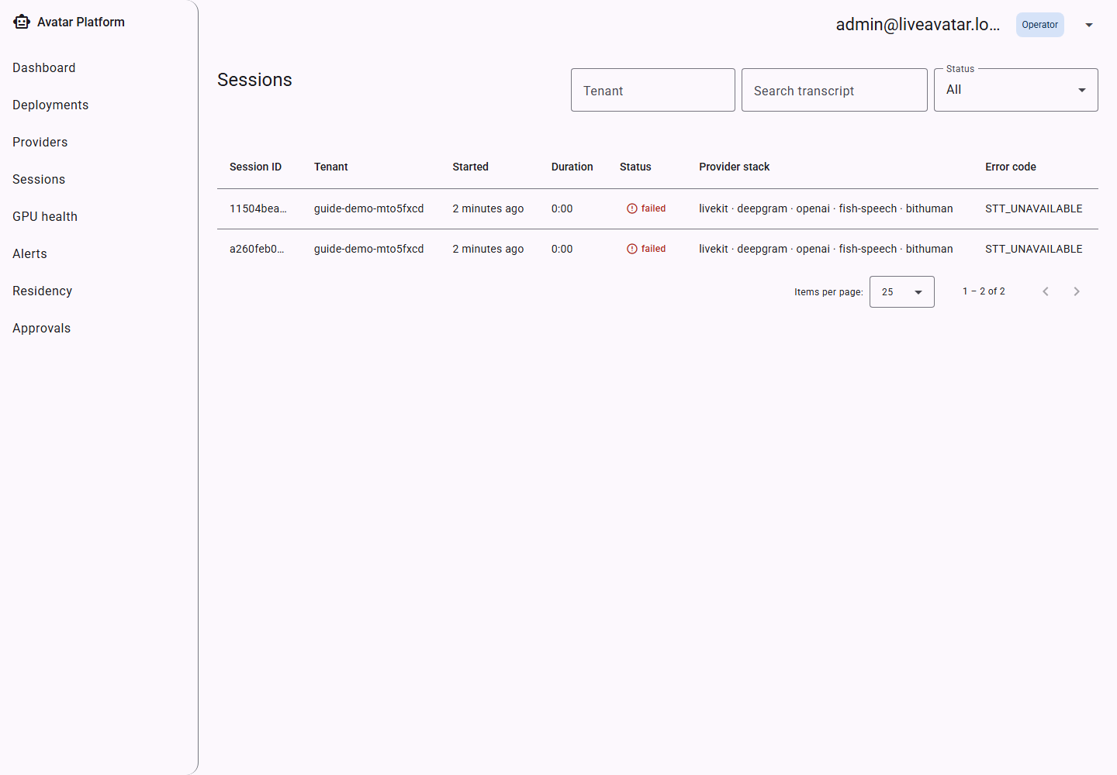
Session logs — list view.
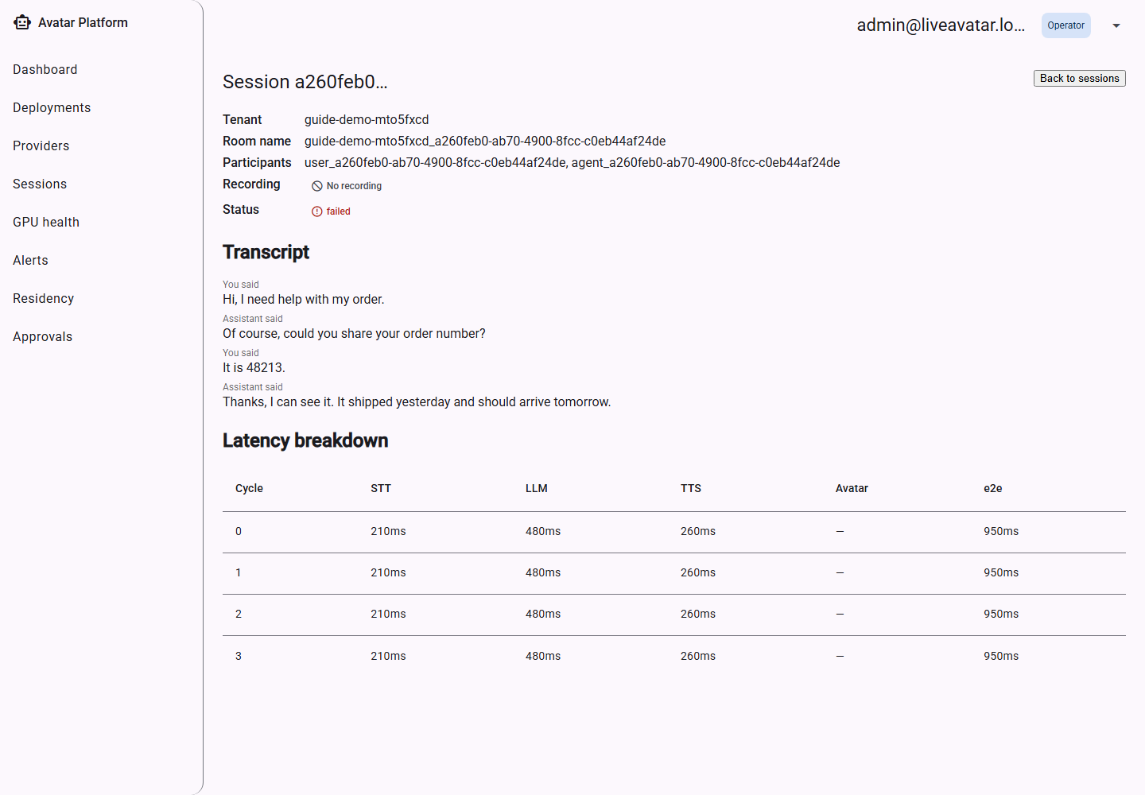
Session detail — transcript and per-turn latency.

7. Alerts
Alerts surface operational problems as they happen: an LLM provider failing over to its backup, a provider becoming unreachable, a session failing outright, a GPU worker going unhealthy, or a live call requesting a human handoff.
The Alerts picker (below) is the entry point when no specific tenant is already selected; choosing a tenant opens that tenant's alert feed and its retry/fallback policy settings.
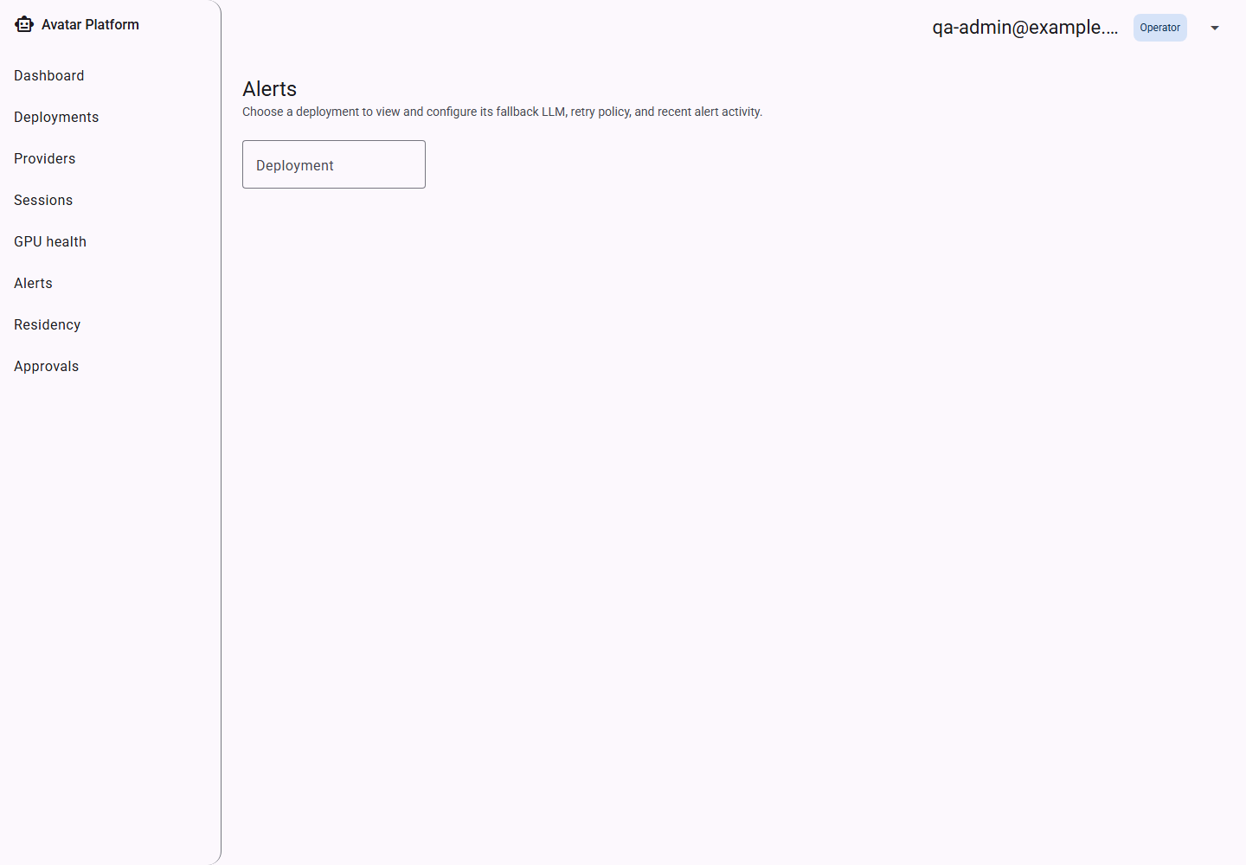
Alerts — tenant picker.
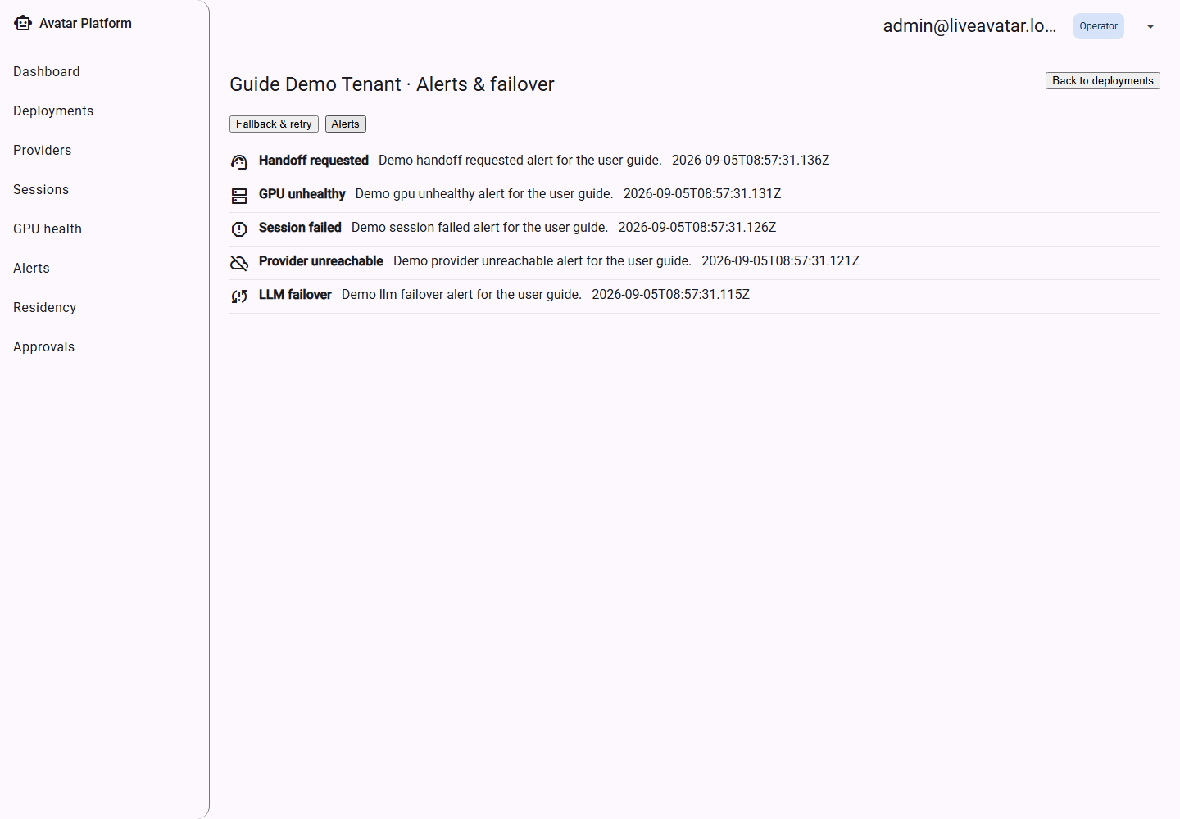
A tenant's alert feed, showing all five alert types.

8. GPU Monitoring
For self-hosted providers (e.g. a self-hosted STT or avatar-rendering worker), this read-only screen shows each GPU node's role, current utilization, and health — based on heartbeats each worker sends in. A node that stops sending heartbeats is shown Unhealthy even if its last reported reading looked fine, since a stale heartbeat is itself the warning sign.
This screen is monitoring only — there are no scale controls here; provisioning GPU capacity is an infrastructure/operator responsibility outside the admin console.
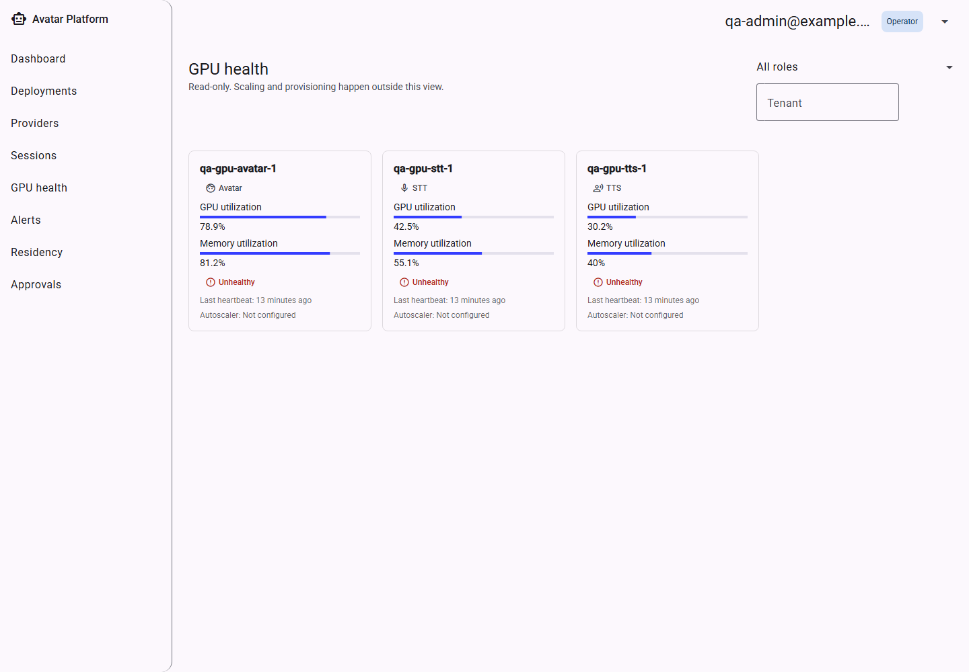
GPU health — per-node role, utilization and status.

9. Reviewer Console (Human-in-the-Loop Approvals)
Some agent actions can be configured to require a human's sign-off before they happen — for example, a consequential tool call like issuing a refund. When that happens mid-call, a HitlDecision is queued here for a reviewer to approve, deny, or approve-with-edits, alongside the full context the model used to propose the action (transcript excerpt, caller identity, retrieved knowledge sources, and the model's own stated reasoning).
This is intentionally a separate top-level area from the Agent Builder (where gates are configured) since the person reviewing a live decision is often a different role than the person who designed the agent.
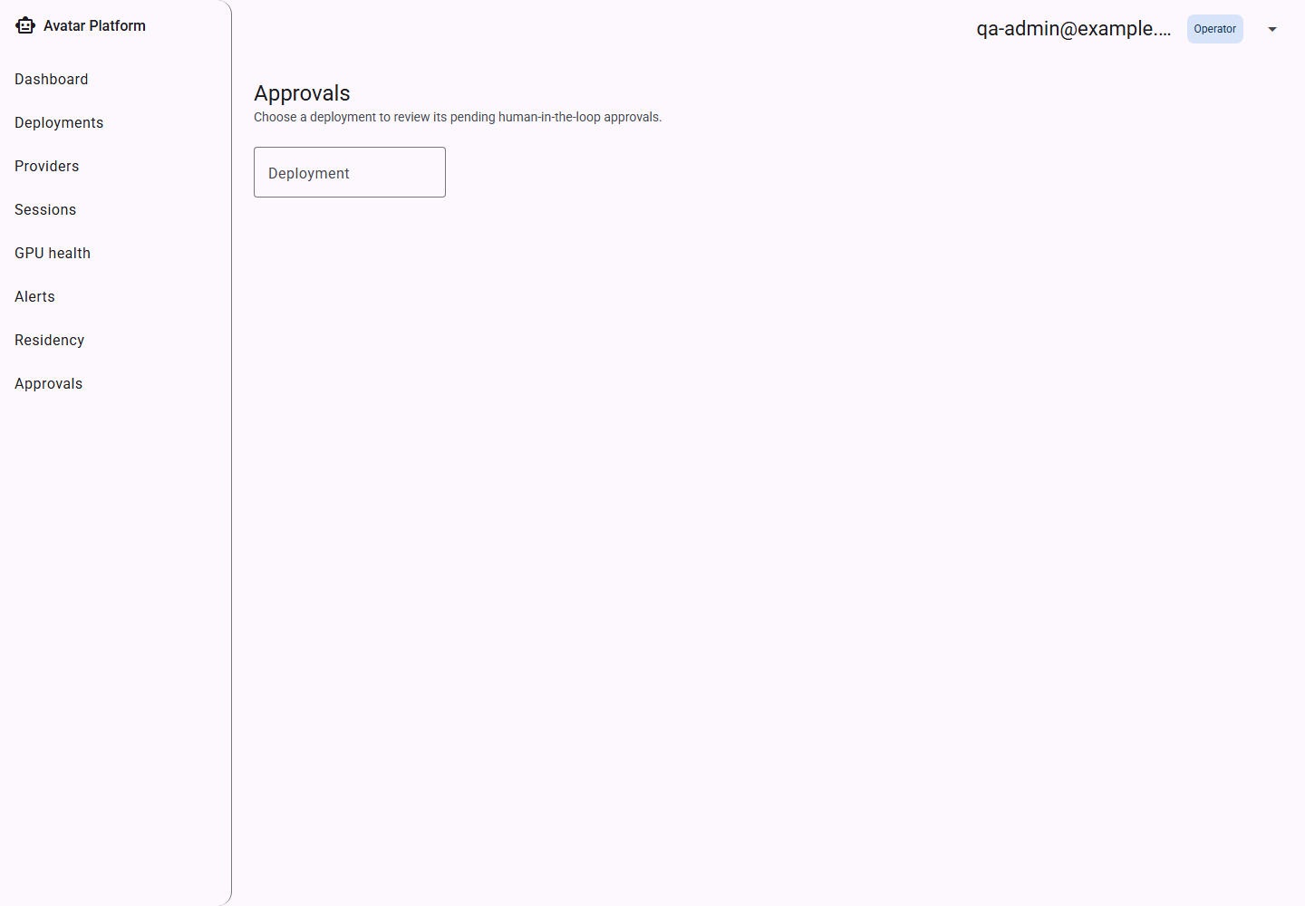
Reviewer console — tenant picker.
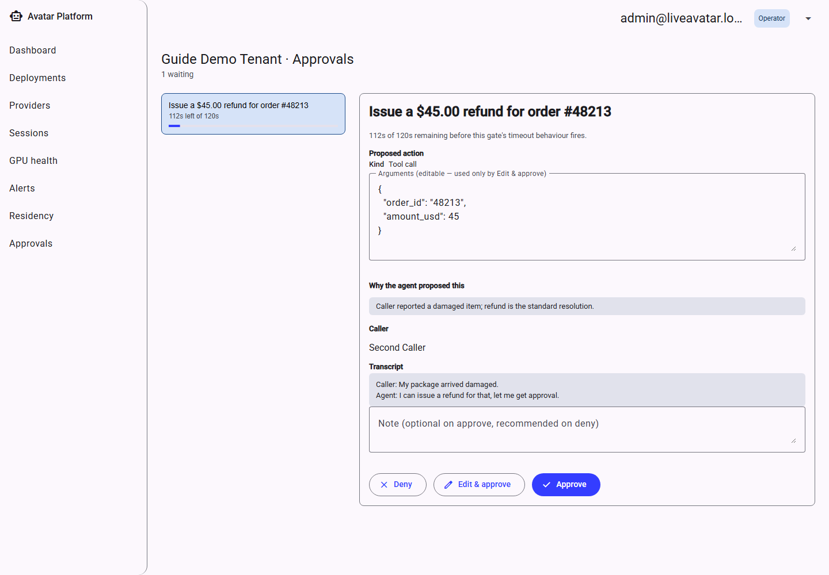
A tenant's pending-decision queue.

10. Data Residency & Privacy
Every tenant has privacy settings controlling whether conversation content may be sent to a remote (non-self-hosted) LLM, how long transcripts are retained before automatic deletion, and whether call recordings are kept at all. These are managed from the Privacy tab inside that tenant's Agent Builder (Section 11.9) — this standalone picker is a shortcut into it from outside a specific tenant's builder.
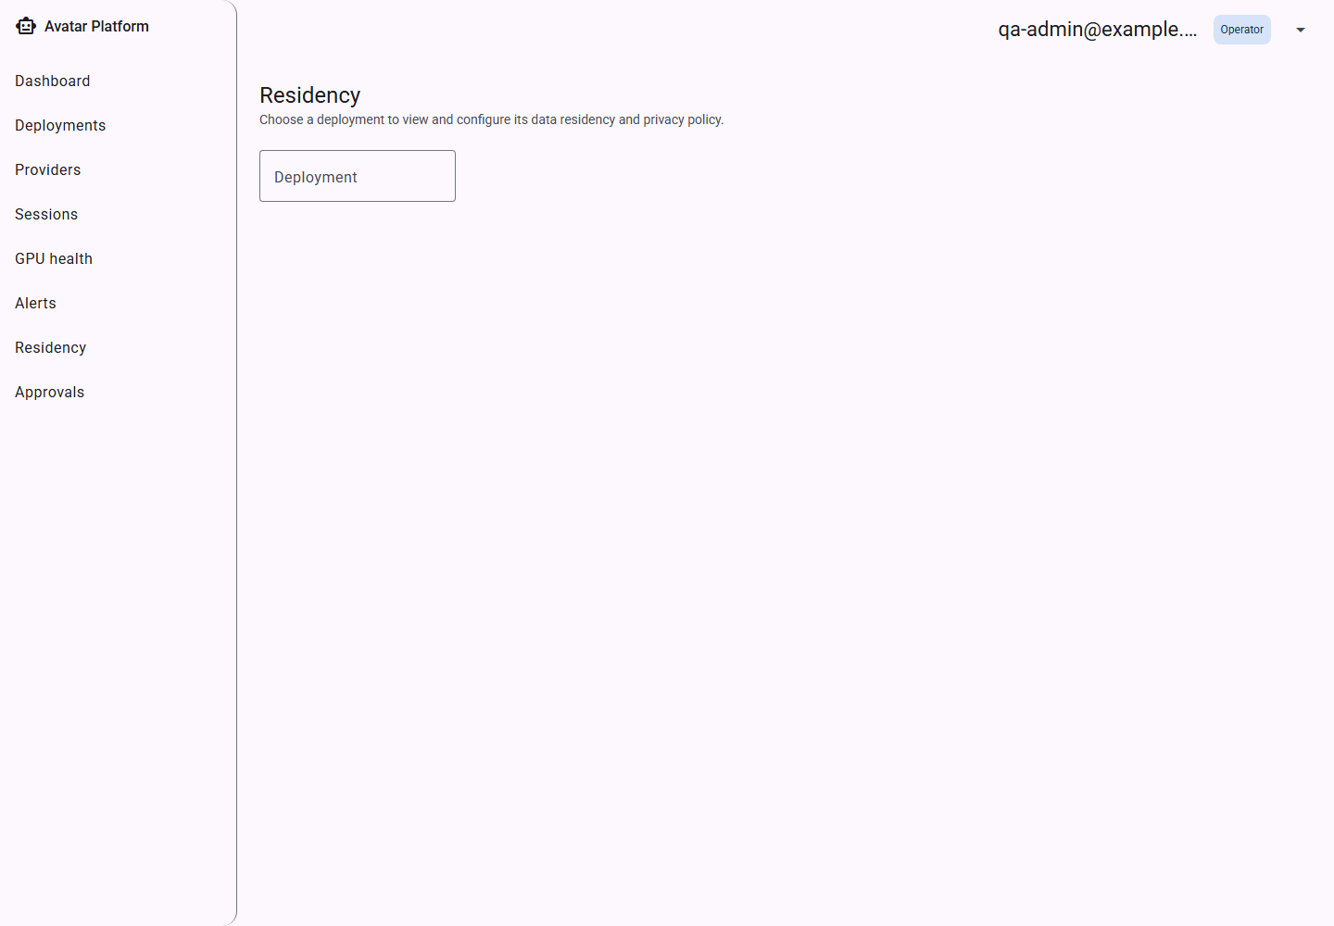
Data Residency — tenant picker.
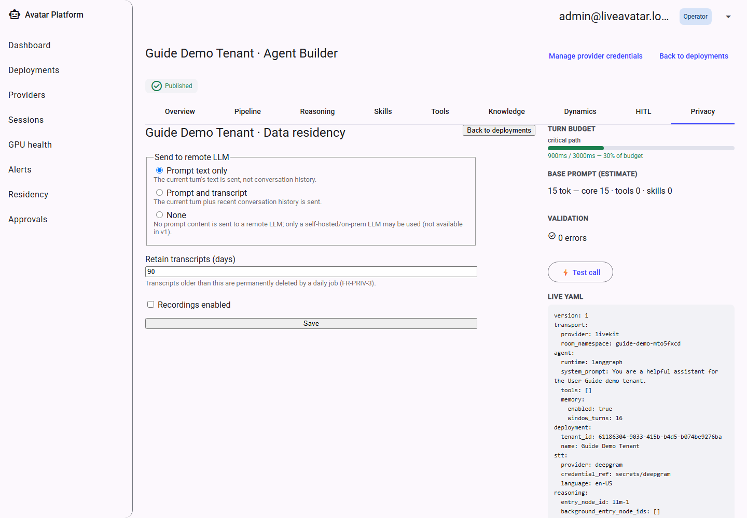
Selecting a tenant opens the Agent Builder's Privacy tab directly.

11. The Agent Builder
The Agent Builder is where an operator designs everything about how a tenant's avatar agent behaves — which speech/voice/avatar providers it uses, how it reasons and responds, what tools and knowledge it can draw on, its conversational feel, and any human-approval requirements. It is one shell with nine tabs; changes are saved as a Draft and only take effect on live calls once explicitly Published.
The right-hand rail (visible on every tab) always shows the running turn-budget estimate, an approximate base-prompt cost, and a live validation summary — so an admin can see whether the configuration is publishable without leaving the tab they're on.

11.1 Overview
A read-only rollup of the whole configuration: four summary cards (Media Pipeline, Reasoning, Capabilities, Behaviour) each with an “edit” shortcut straight into the relevant tab. This is the tab an admin lands on and the best starting point to sanity-check a configuration before publishing.
Publish is disabled, with the specific reason shown, until the configuration is complete (every provider layer chosen, credentials in place, and any conditional rules — like a consequential tool needing an approval gate — satisfied).
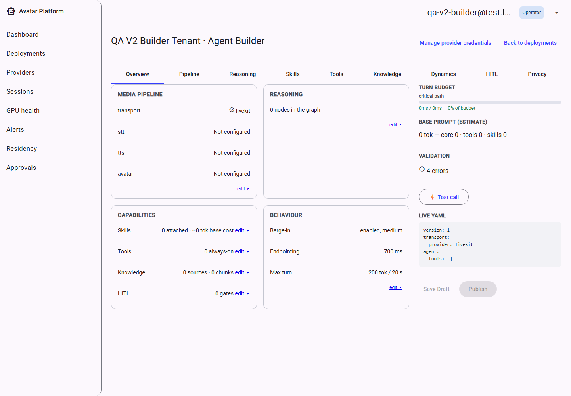
The Builder shell, landing on Overview.
Overview on a brand-new, unconfigured tenant.
Publish is disabled with a reason while the configuration is incomplete.
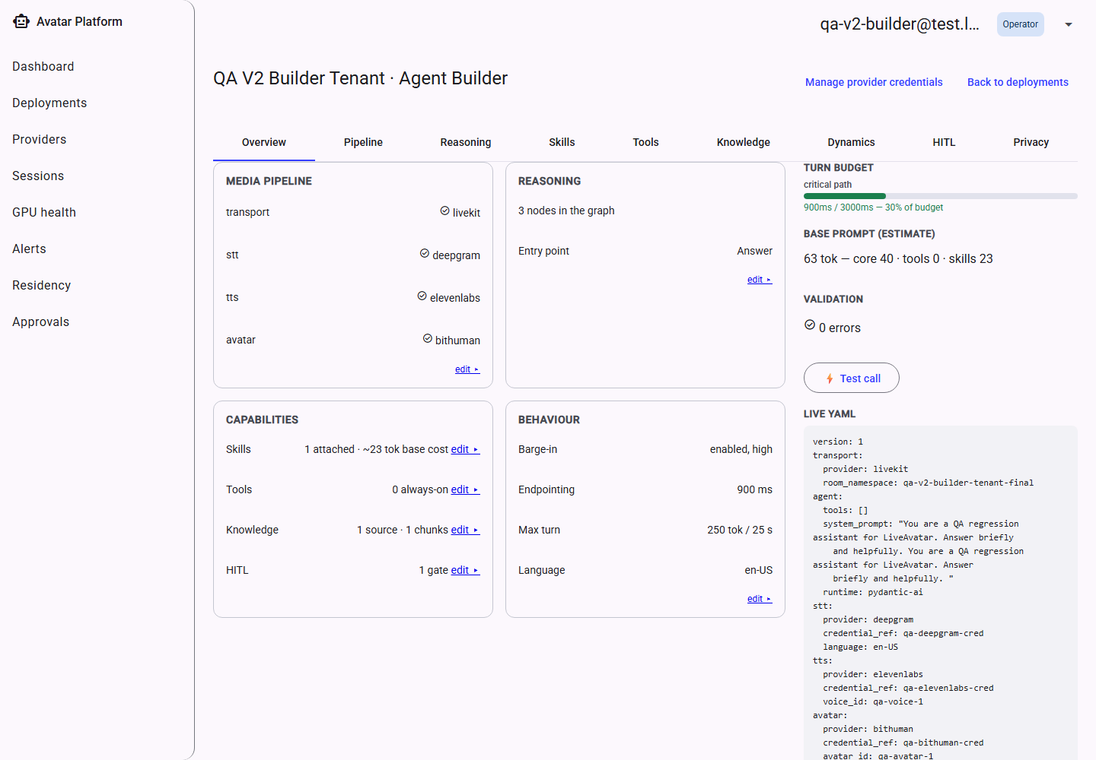
Overview once every layer is configured.
The persistent right rail — turn budget, cost estimate, validation.
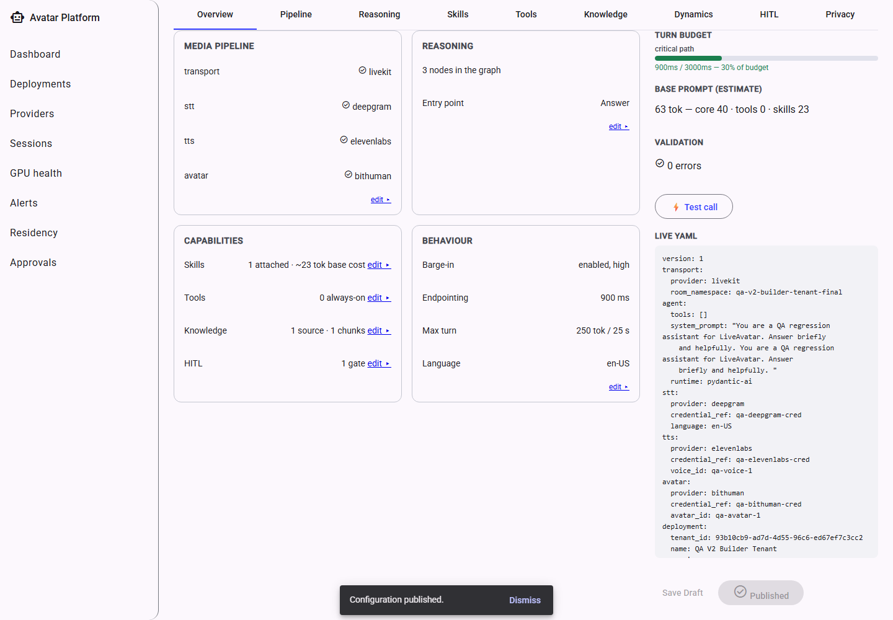
After a successful publish.

11.2 Pipeline
Chooses the four providers that carry a live call: Transport (always LiveKit), Speech-to-Text, Text-to-Speech, and the Avatar renderer — plus which stored credential each one uses.
Selecting a provider without a matching credential shows an inline validation error immediately, rather than only failing at publish time.
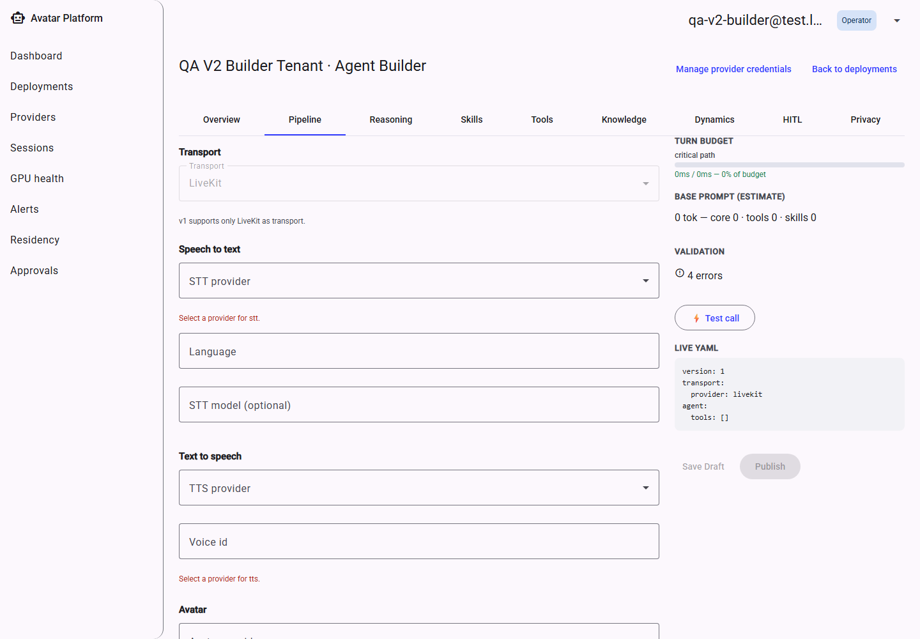
Pipeline with providers unselected — validation errors shown inline.
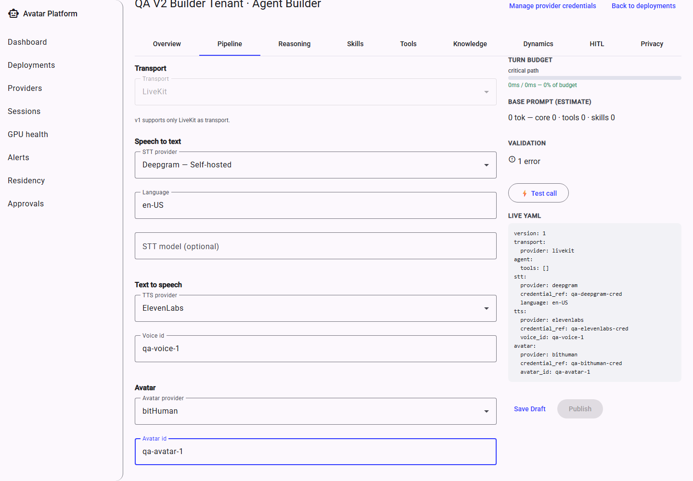
Pipeline fully configured.

11.3 Reasoning
This is the heart of the agent: its core instructions (system prompt, which agent runtime executes it, and whether it keeps conversational memory across turns) plus a visual graph of every reasoning step the agent can take on a turn — LLM calls, tool calls, retrieval, skills, sub-agent delegation, human-approval gates, and more, wired together node by node.
Each node can be opened to configure its specific behaviour (for example, which model an LLM node calls, or which knowledge sources a Retrieve node searches), and the graph's total estimated turn time is checked against the configured turn budget.
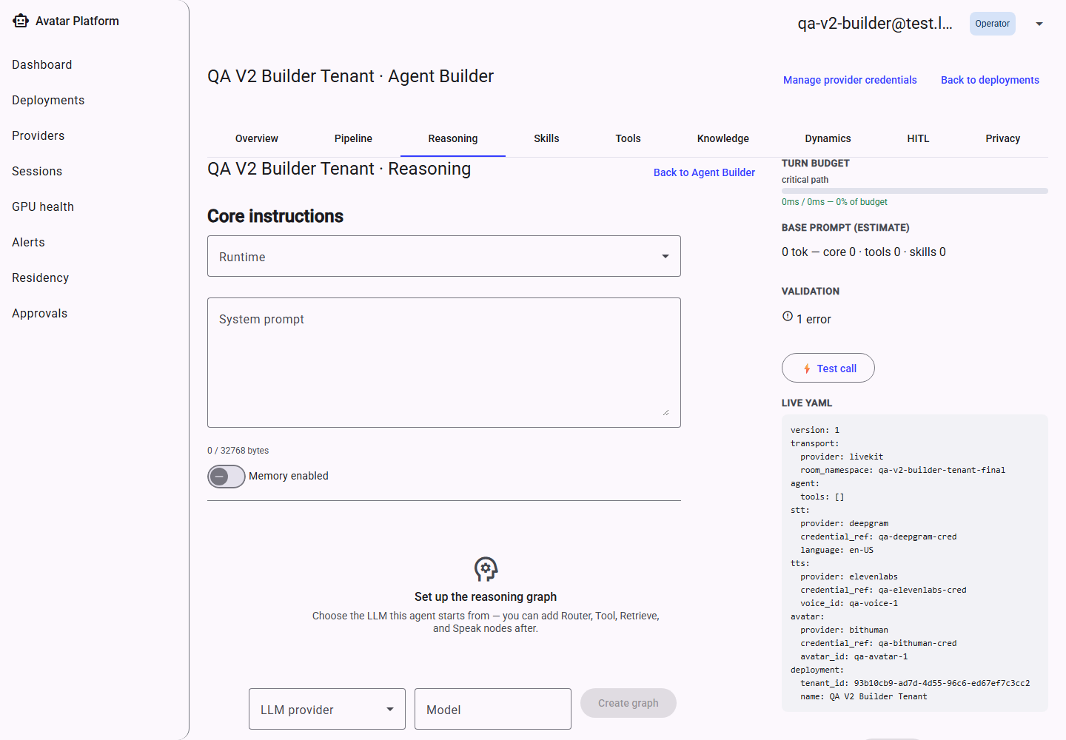
Reasoning — empty graph.
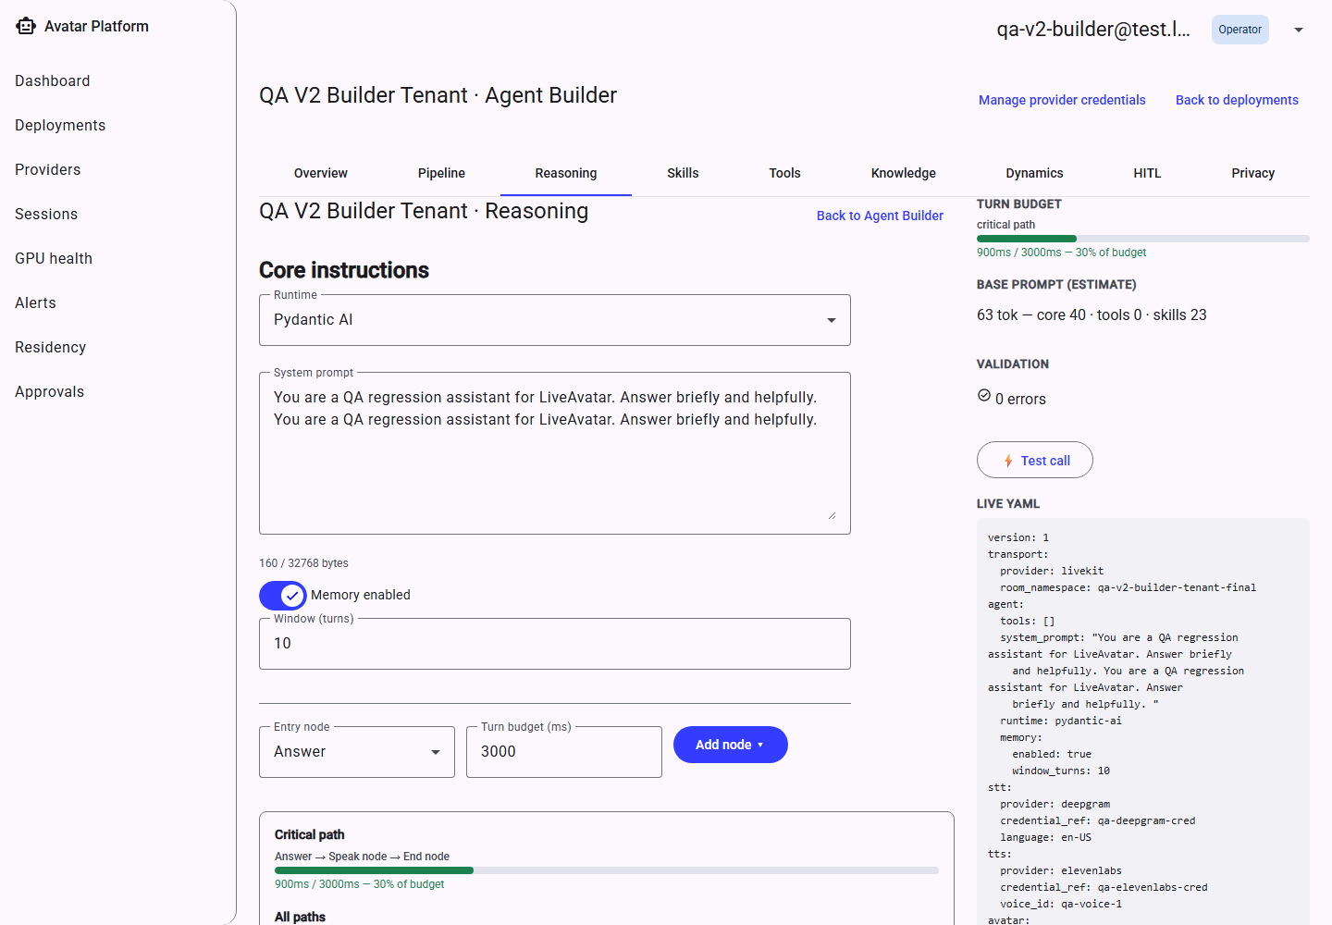
Core instructions — system prompt, runtime, memory.
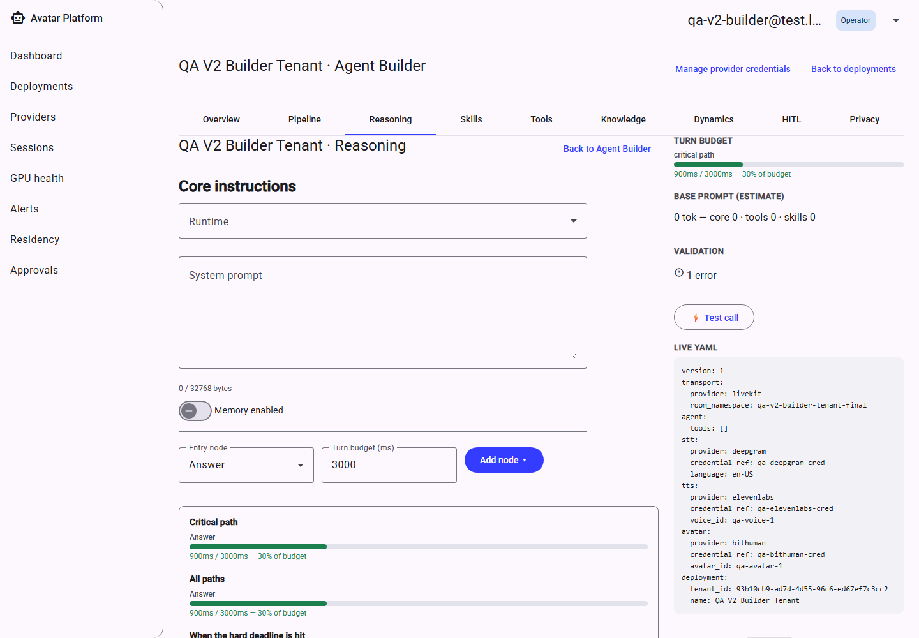
Adding the first node to the graph.
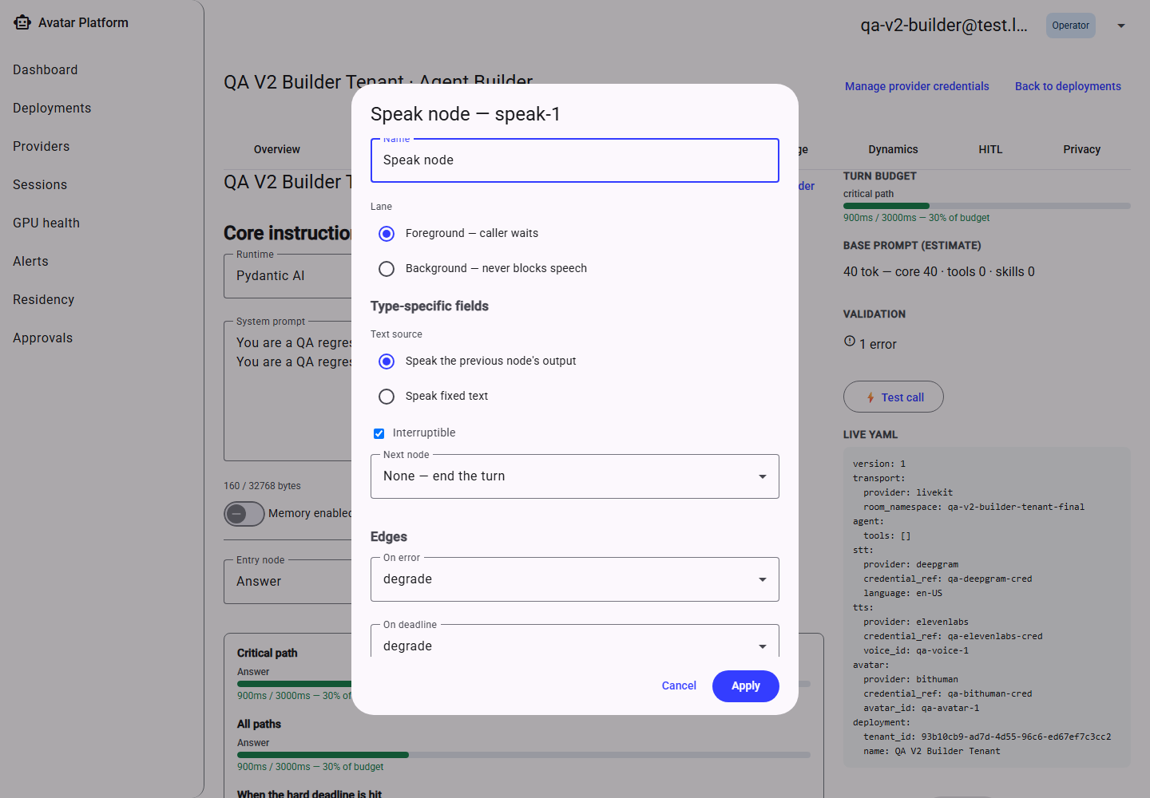
A Speak node, opened for editing.
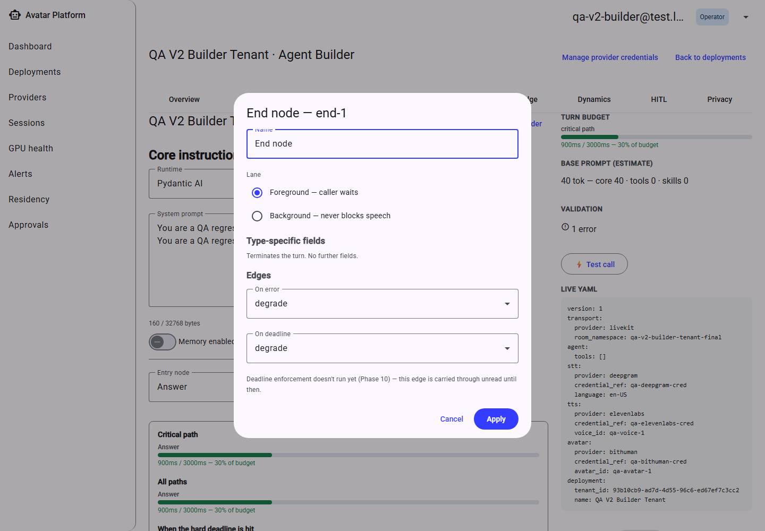
An End node, opened for editing.
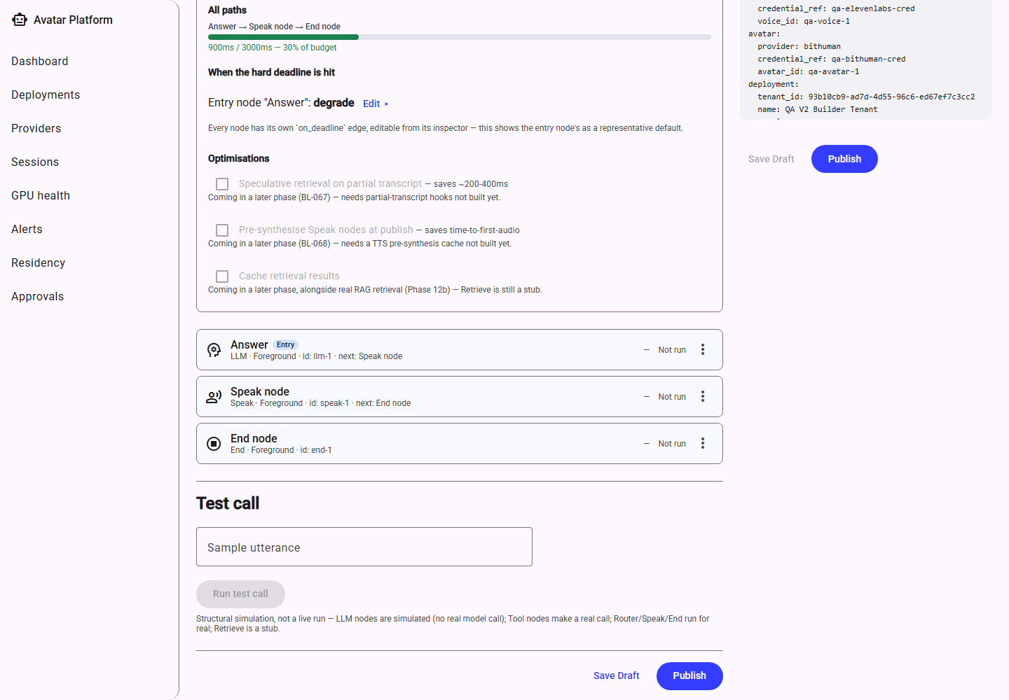
A complete, wired 3-node graph.
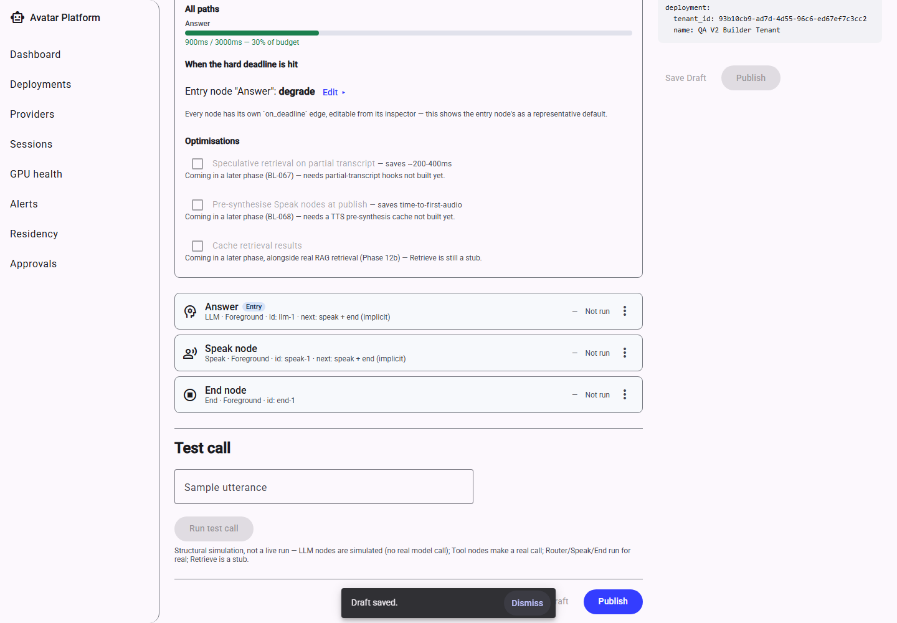
The saved reasoning configuration.

11.4 Skills
A Skill packages a reusable instruction + tool bundle an agent can invoke for a specific task (for example, “book an appointment”), authored and versioned independently of the main reasoning graph, then attached to it by reference.
A skill has a draft and a published version, matching the same draft/publish discipline as the rest of the configuration — a skill must be explicitly published before a live agent can use it.
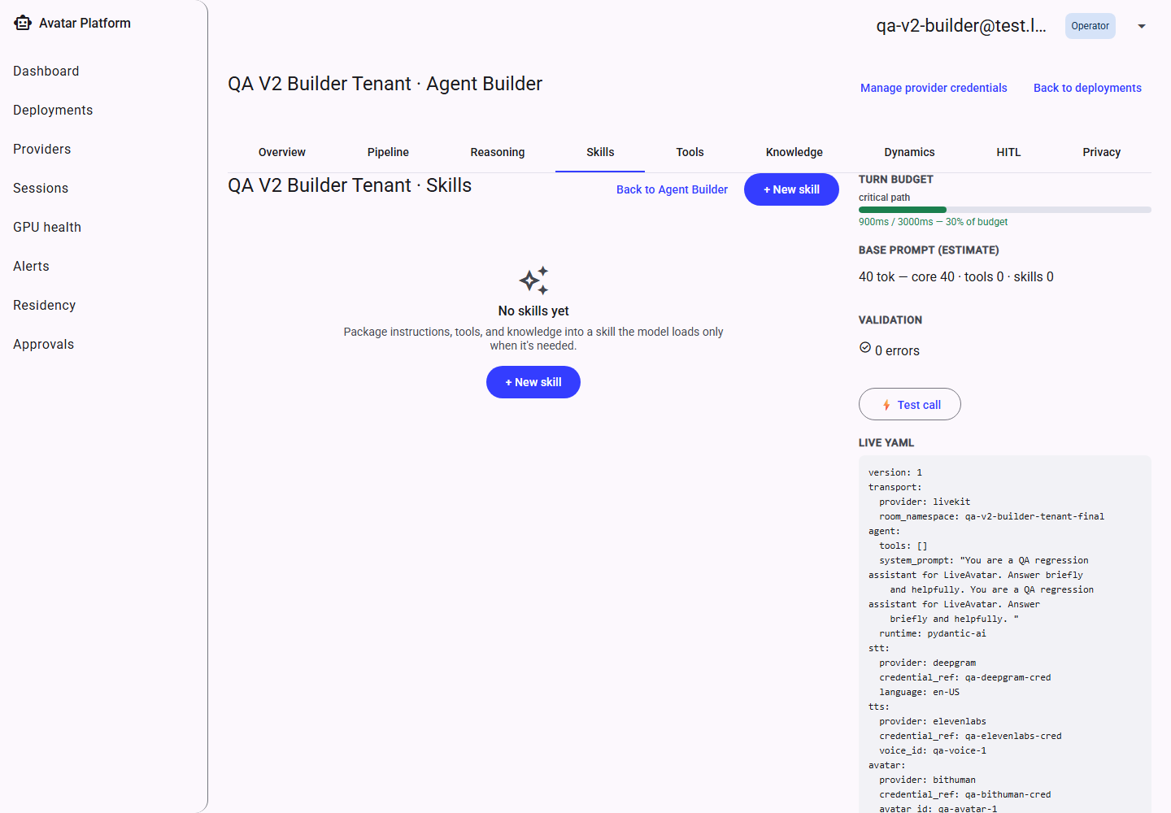
Skills library — empty.
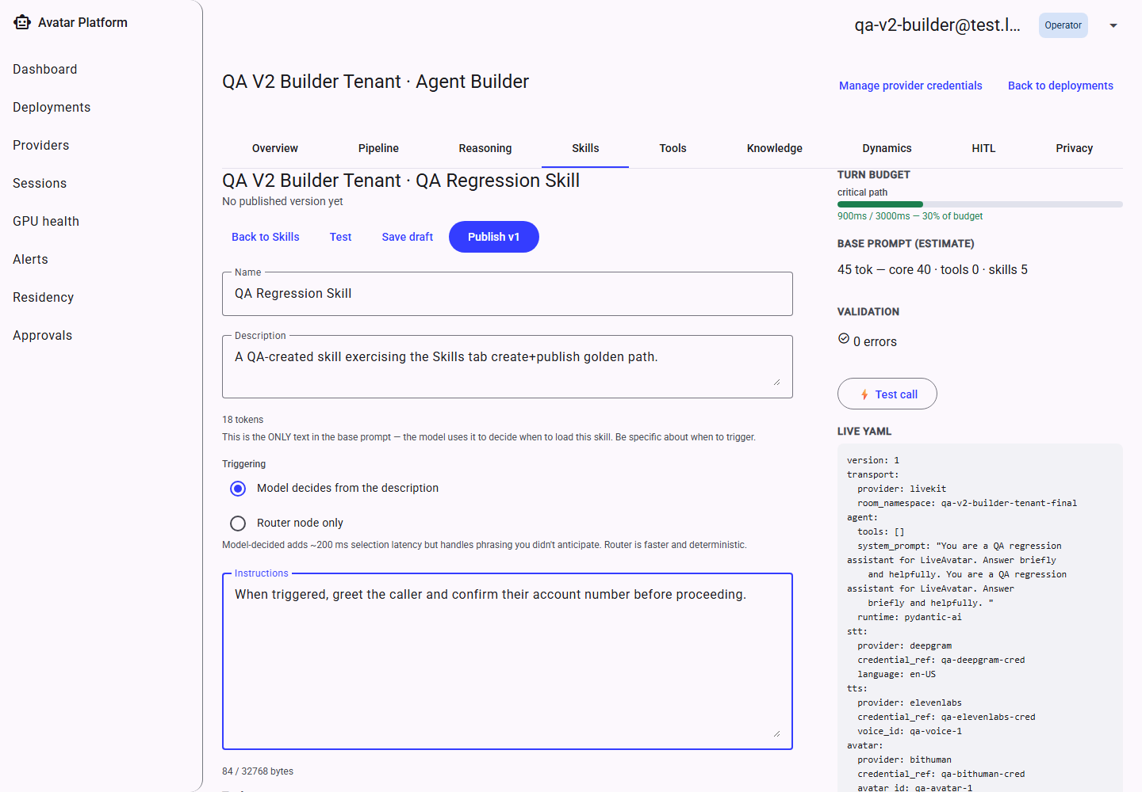
Authoring a new skill.
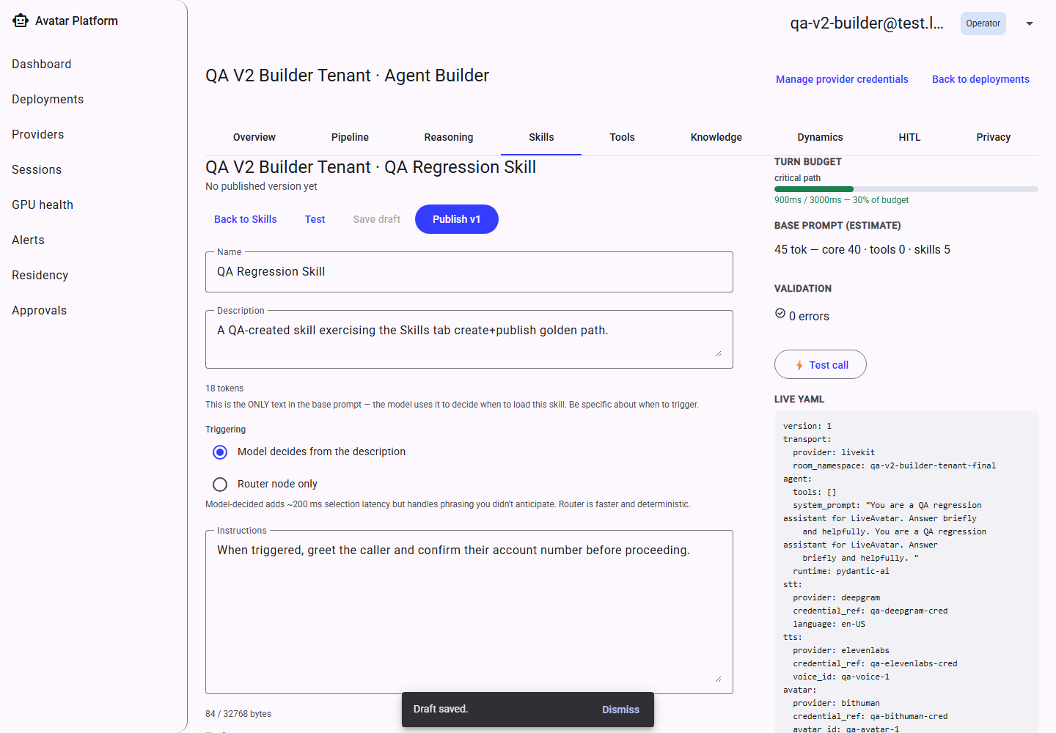
A drafted skill, ready to publish.
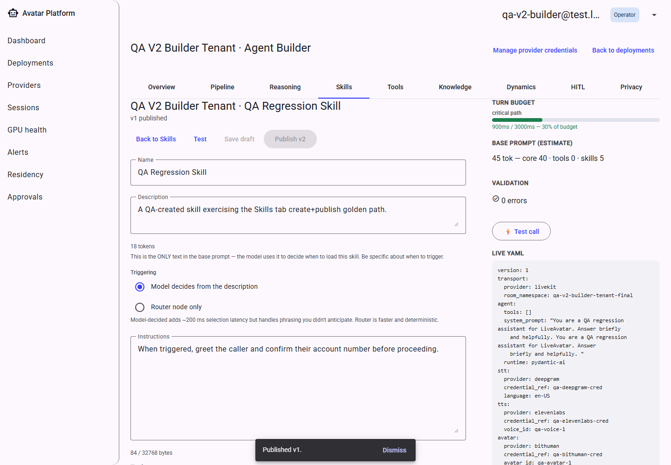
The skill after publishing.
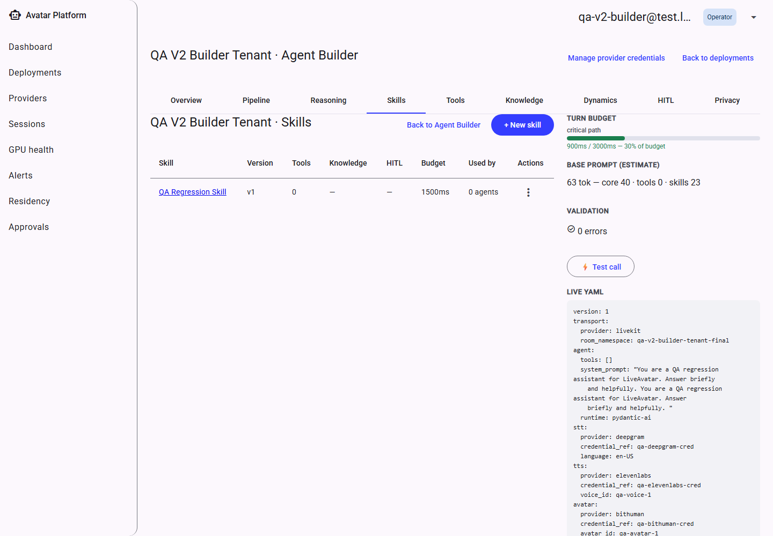
The library, now listing the published skill.

11.5 Tools
Tools are the external actions an agent can call out to (an API that looks something up, or performs an action such as issuing a refund). Marking a tool “consequential” (one whose effects are hard to undo) requires either an attached human-approval gate or a written, explicit acknowledgement of autonomous use before the configuration can be published — the platform will not silently allow an irreversible action to run unsupervised.
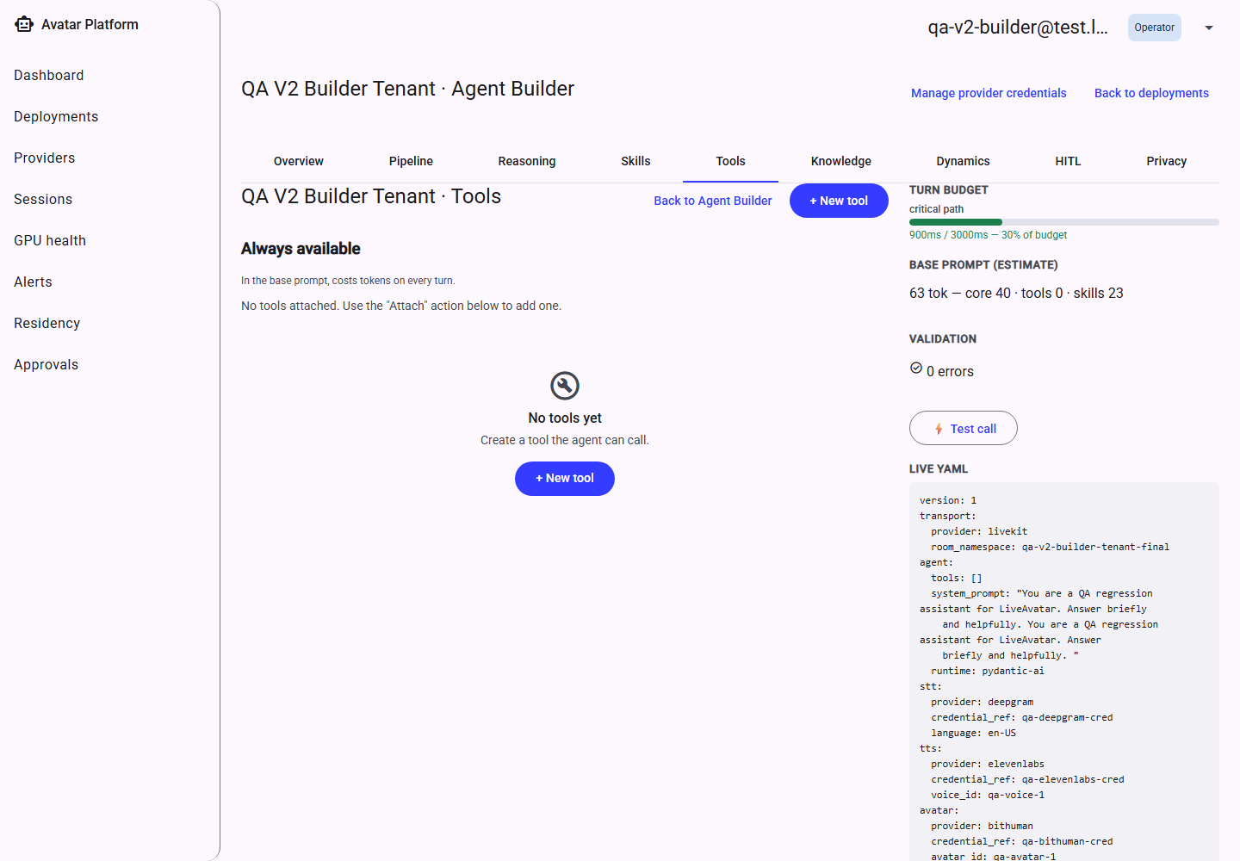
Tools — empty.
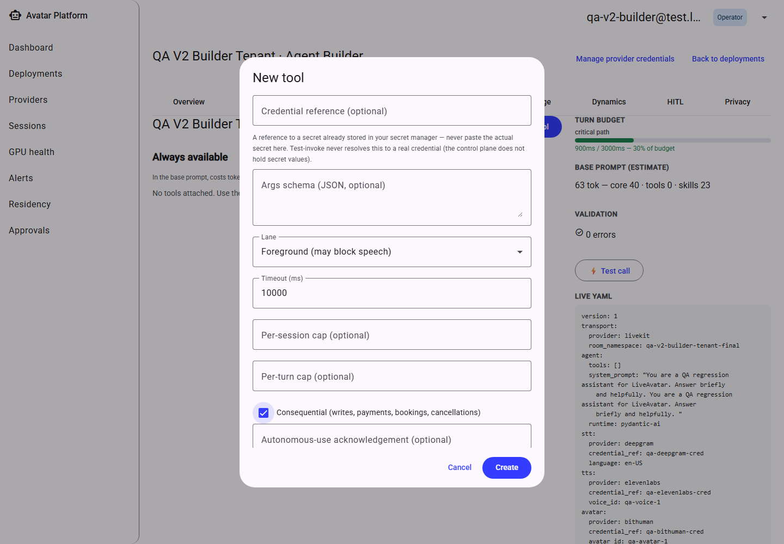
Marking a tool consequential reveals the acknowledgement-text field.
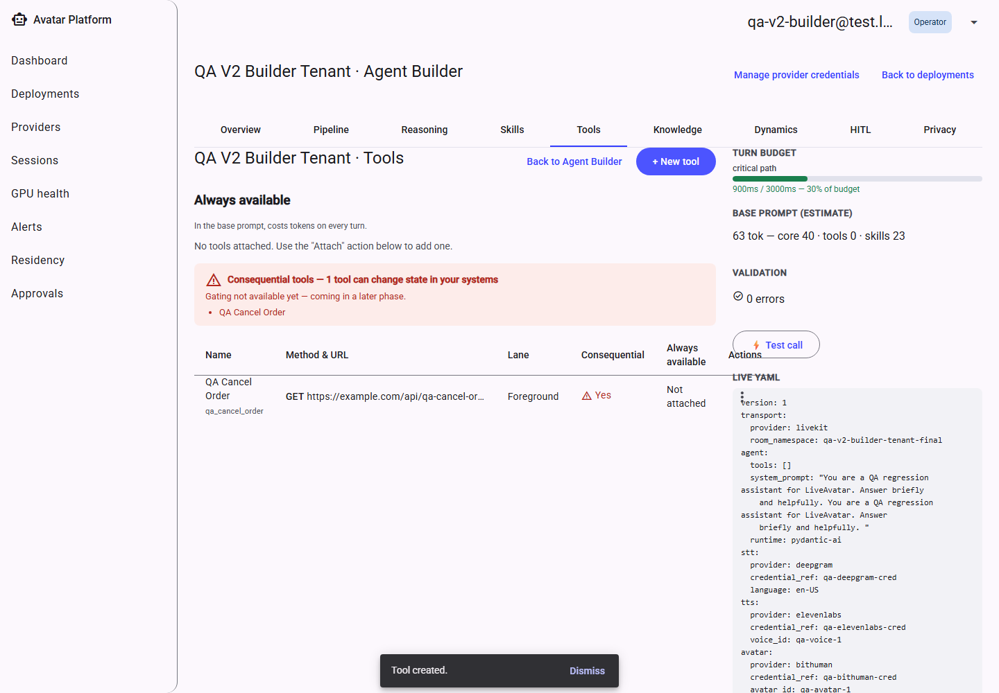
The tools list, showing a consequential tool.

11.6 Knowledge
Configures Retrieval-Augmented Generation: the source documents an agent can search, the retrieval pipeline's tuning (hybrid search weighting, reranking, result thresholds), and a Playground to try a real query against the configured sources before publishing.
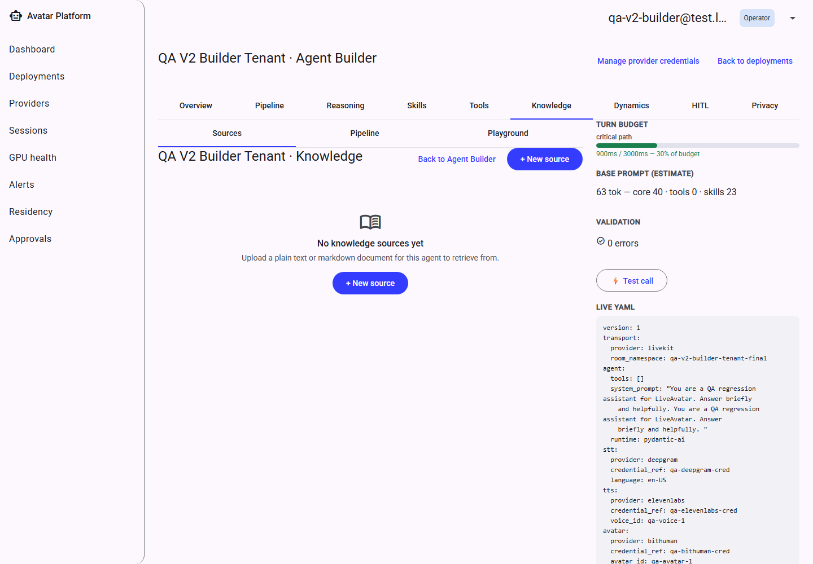
Knowledge — Sources tab.
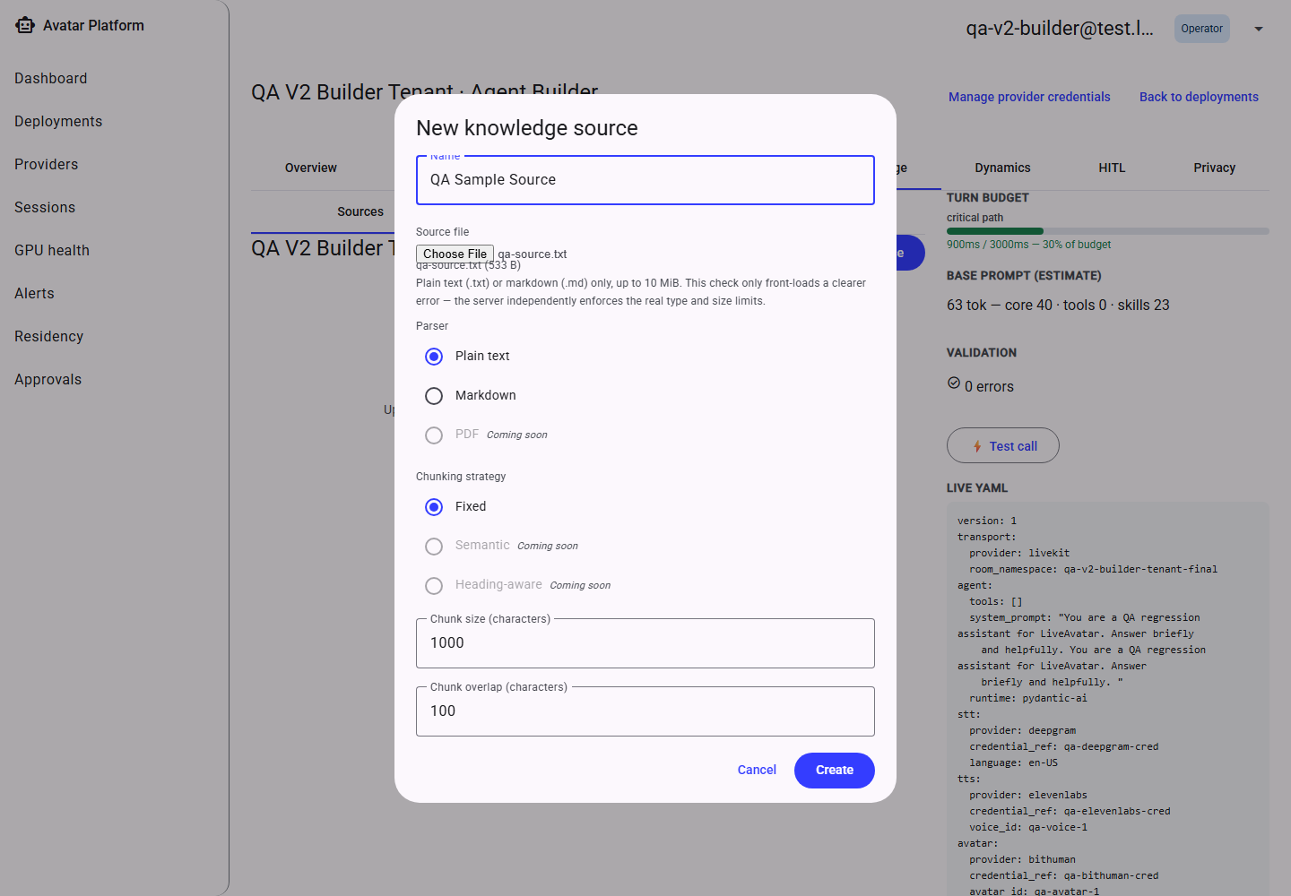
Adding a knowledge source.
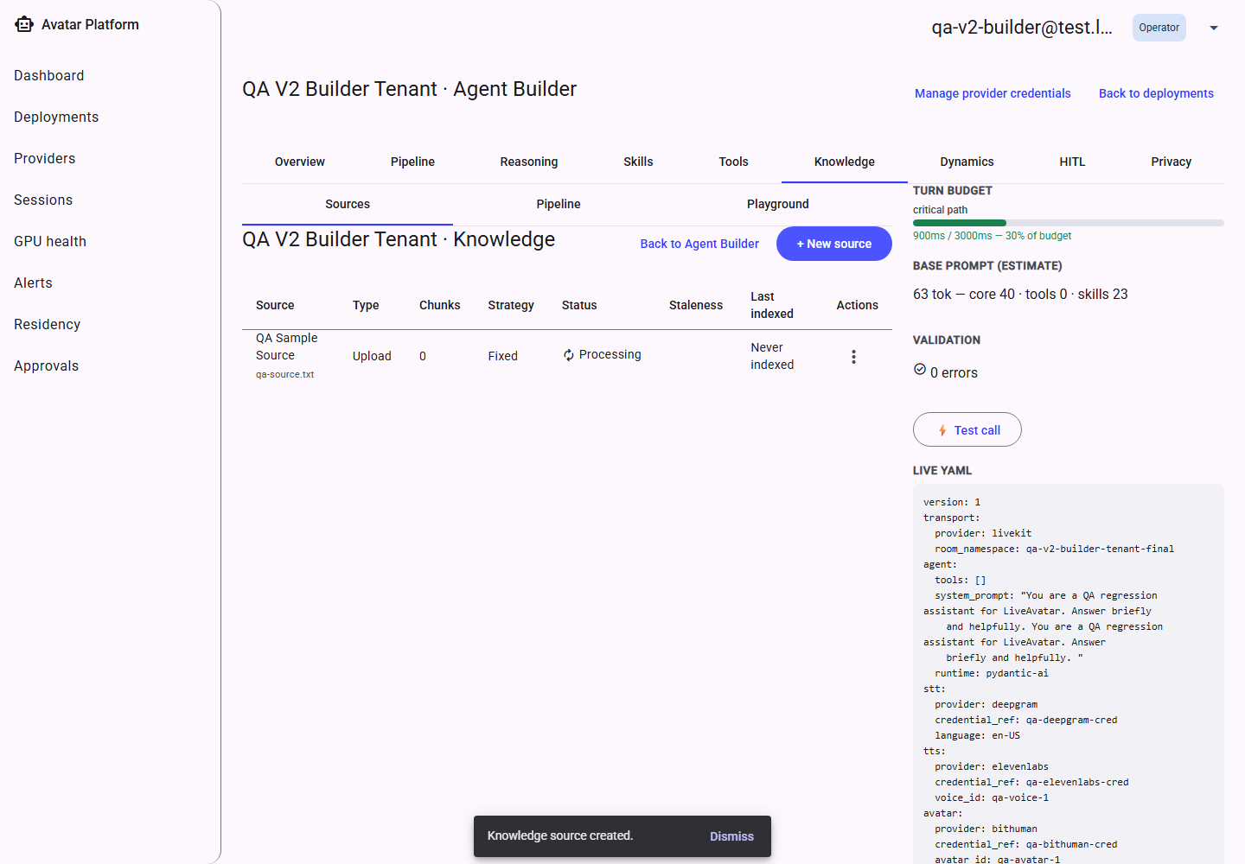
A source, uploaded and listed.
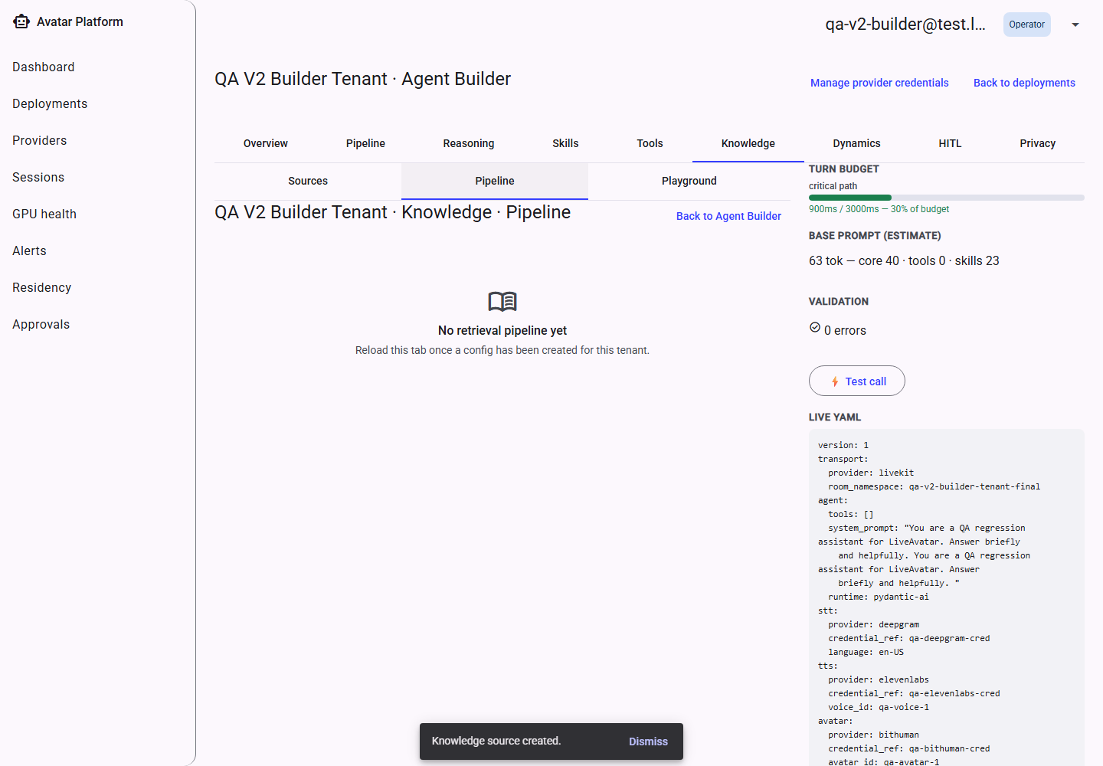
The retrieval Pipeline sub-tab.
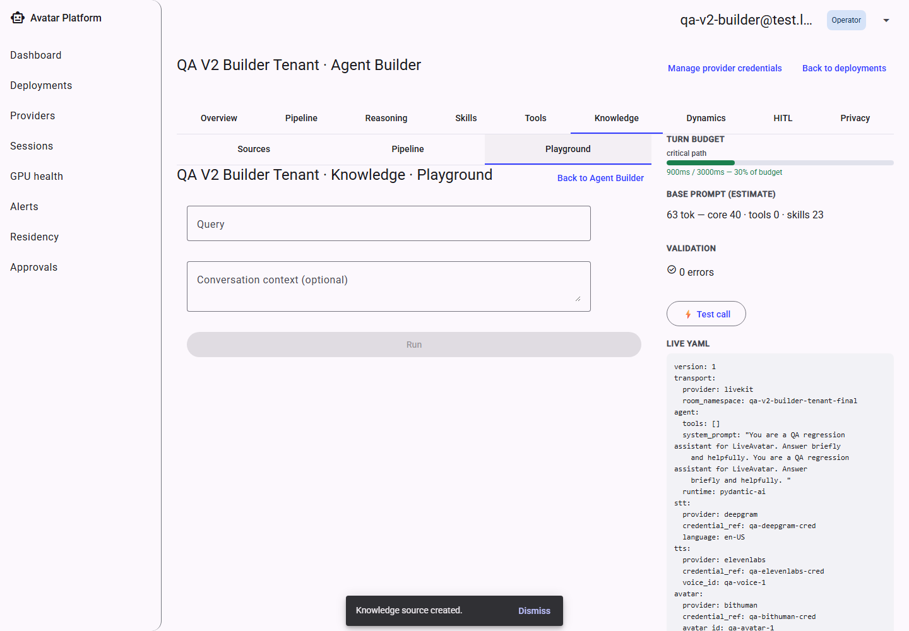
The Playground — test a query live.

11.7 Dynamics
Tunes the conversational “feel” of a call: barge-in sensitivity (how readily the agent lets a caller interrupt it), how long it waits in silence before re-prompting, how verbose its responses are, and hard per-turn limits on response length and duration.
All five settings are saved together and persist across a reload, as shown below.
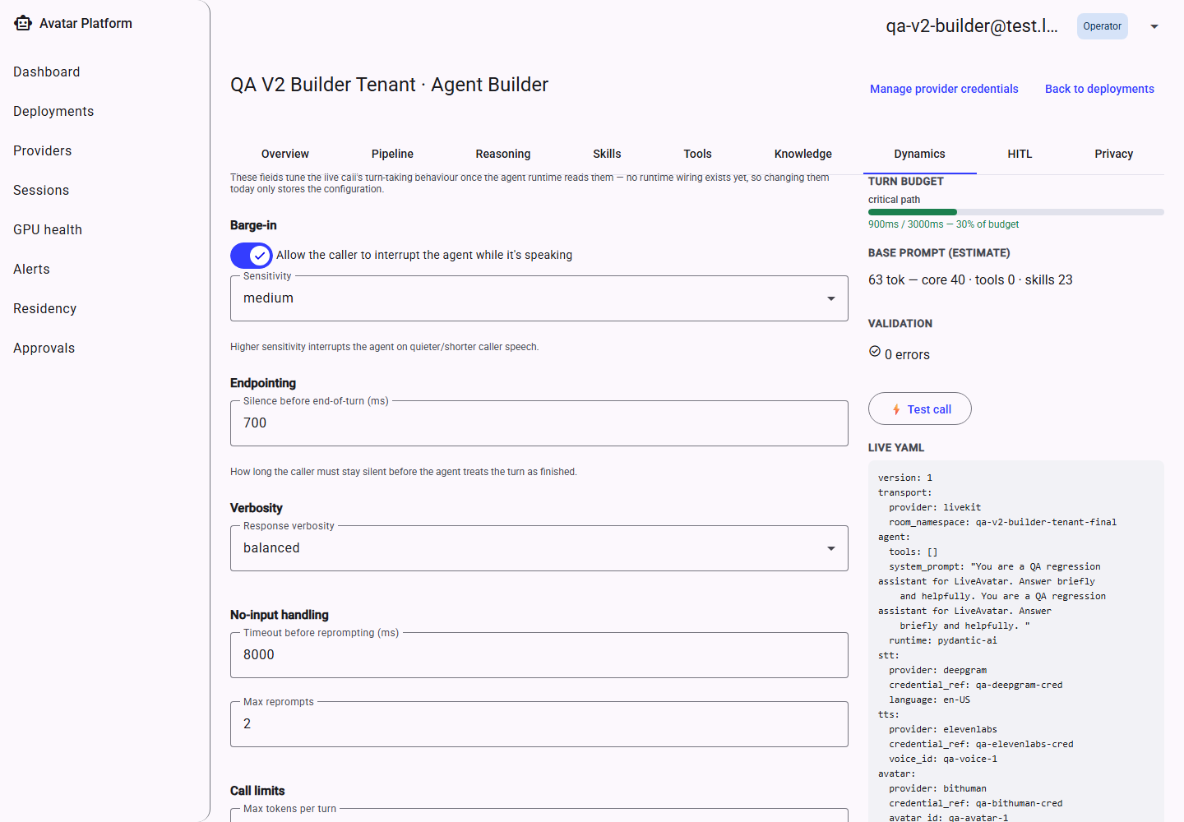
Dynamics — defaults.
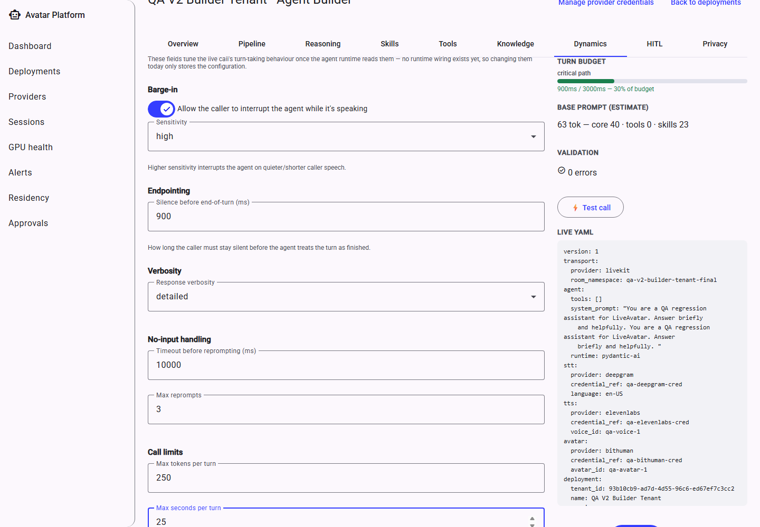
Dynamics, customized.
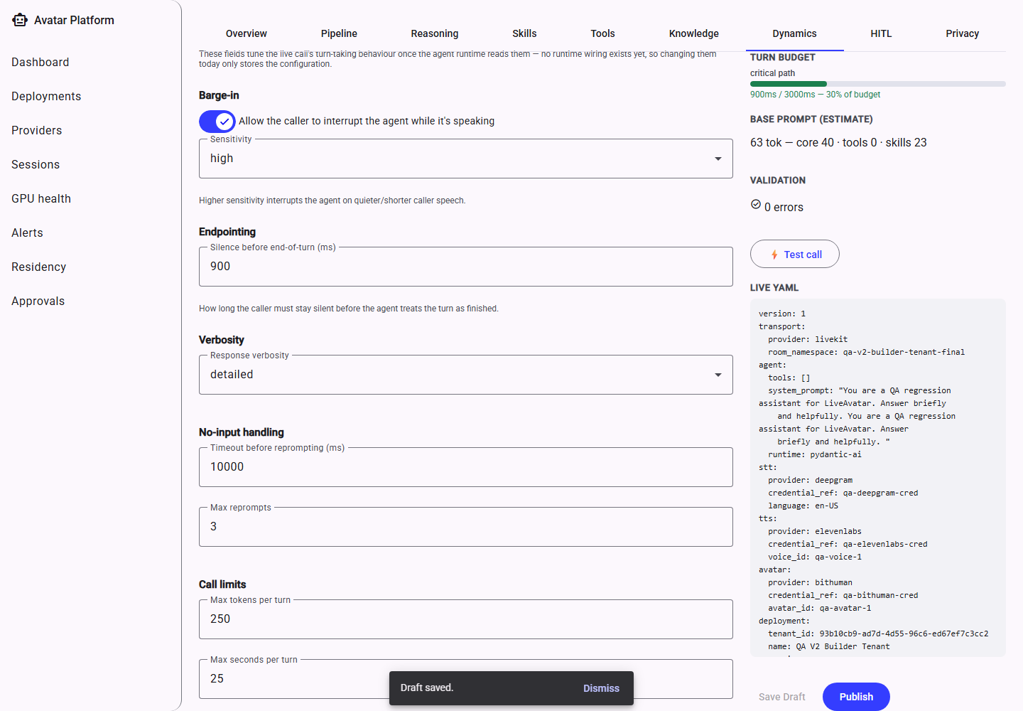
Saved.
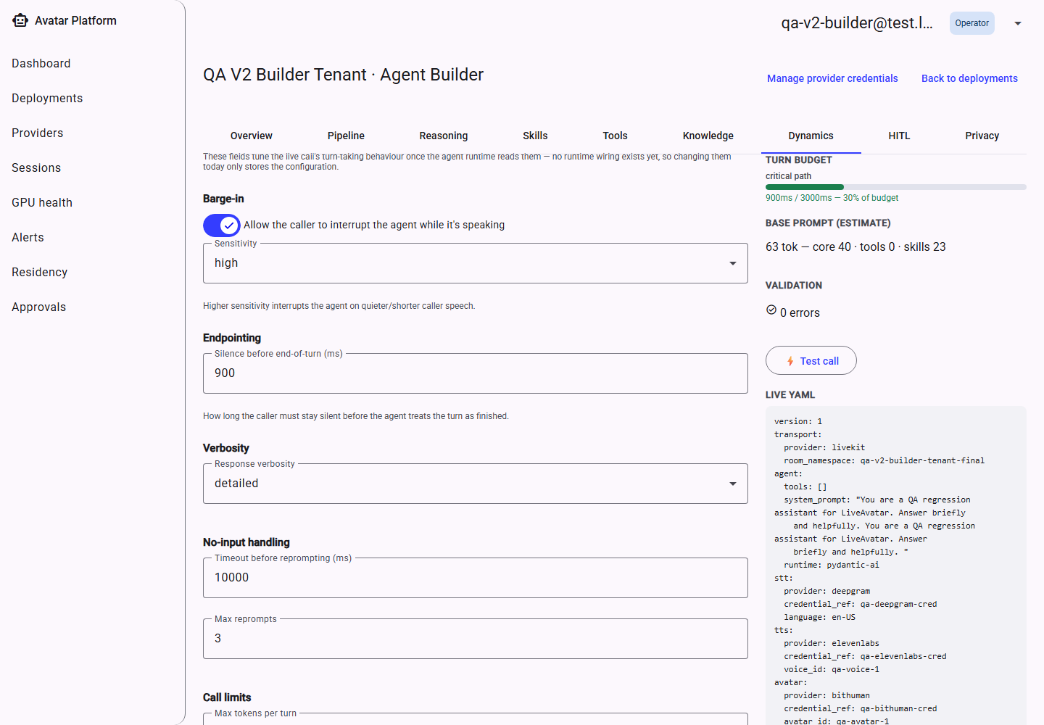
Values still correct after a page reload.

11.8 HITL (Human-in-the-Loop)
Defines the approval gates referenced elsewhere in the configuration (for example, from a consequential Tool or a graph node): who reviews a pending decision (a Reviewer Group, with its own notification channels), how long the agent waits for a human response (SLA), what the agent tells the caller while it waits, and what happens if the SLA expires (auto-approve, auto-deny, escalate, or defer to an asynchronous follow-up after the call ends).
Two gate types (Whisper and Post-hoc review) are shown but disabled with an explicit “coming soon” reason — the platform is upfront about what is and isn't available yet rather than hiding the option entirely.
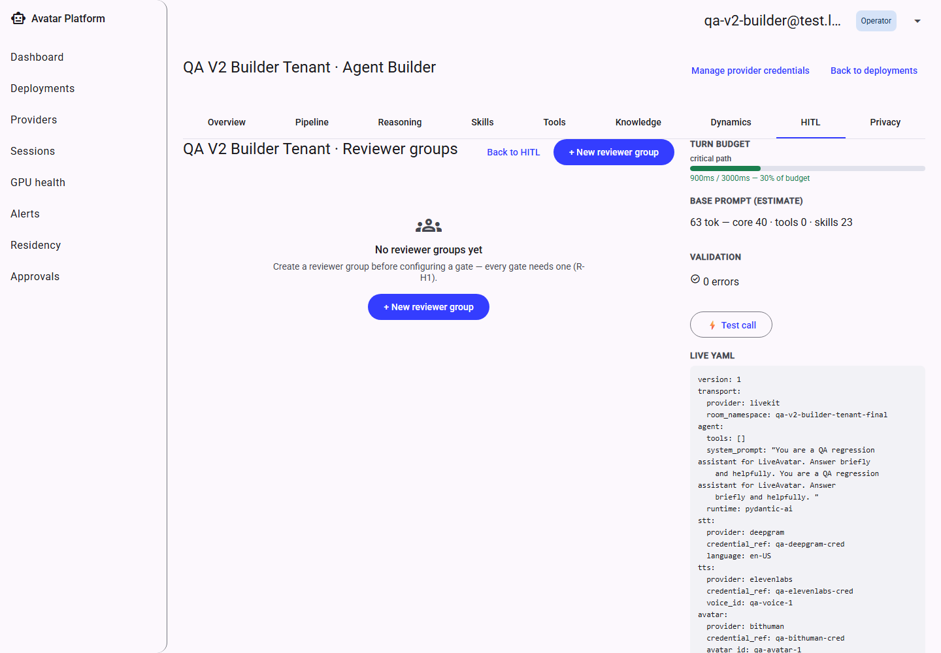
Reviewer groups — empty.
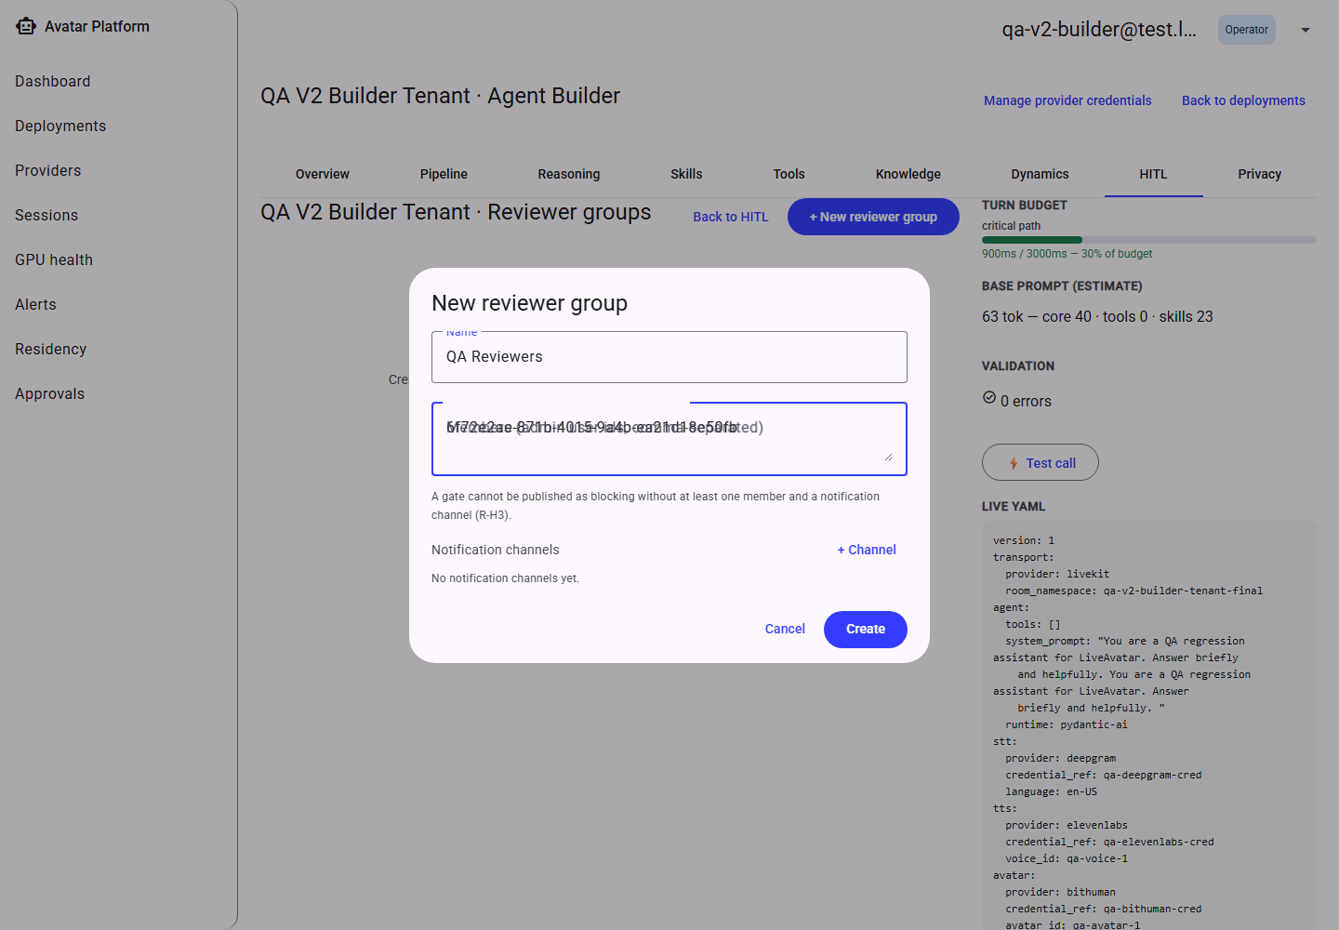
Creating a reviewer group.
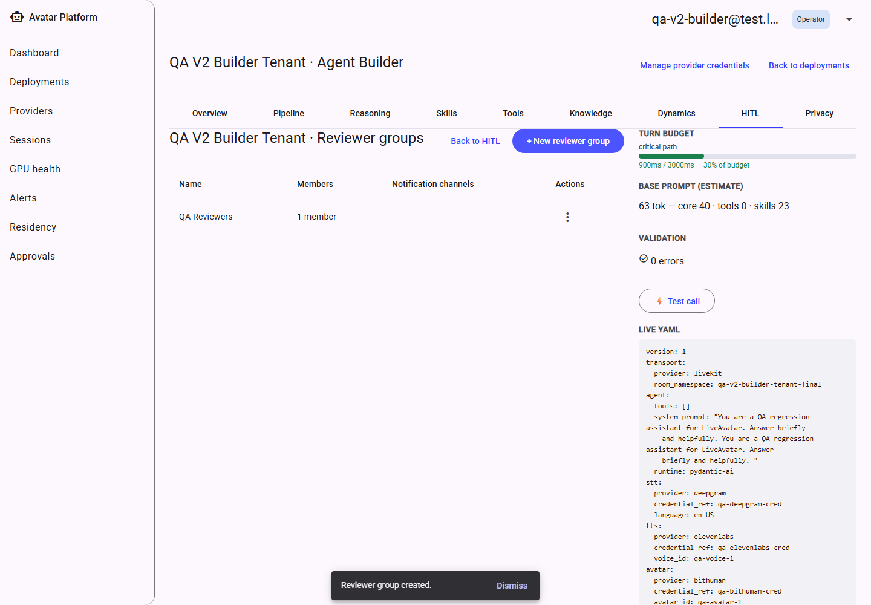
The group, created.
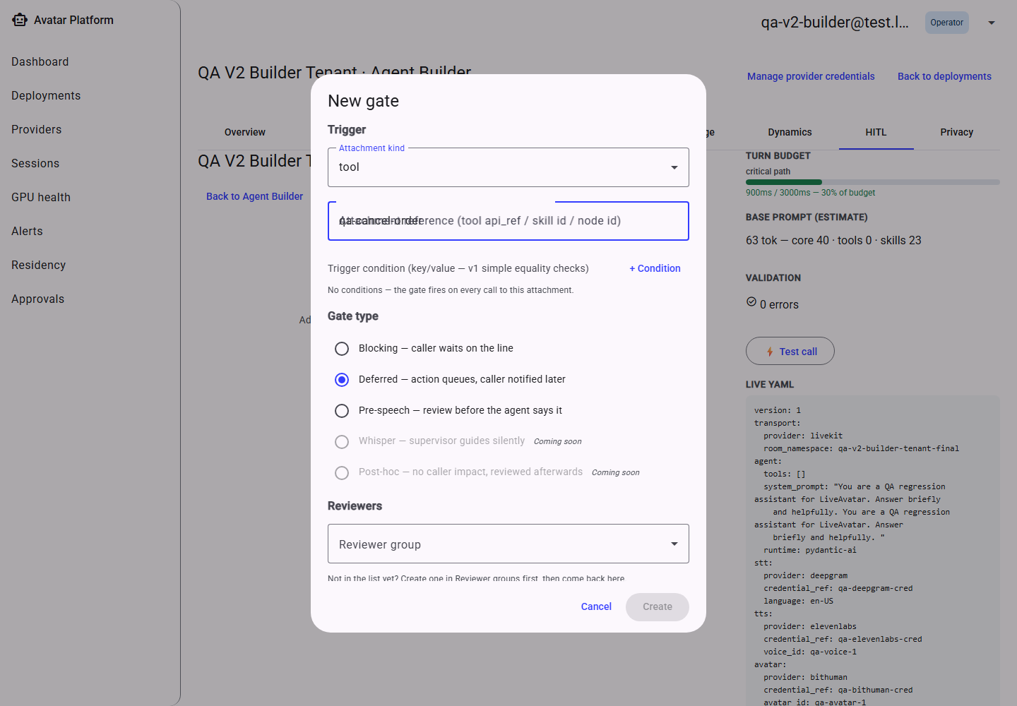
Gate types — two shown disabled with a reason.
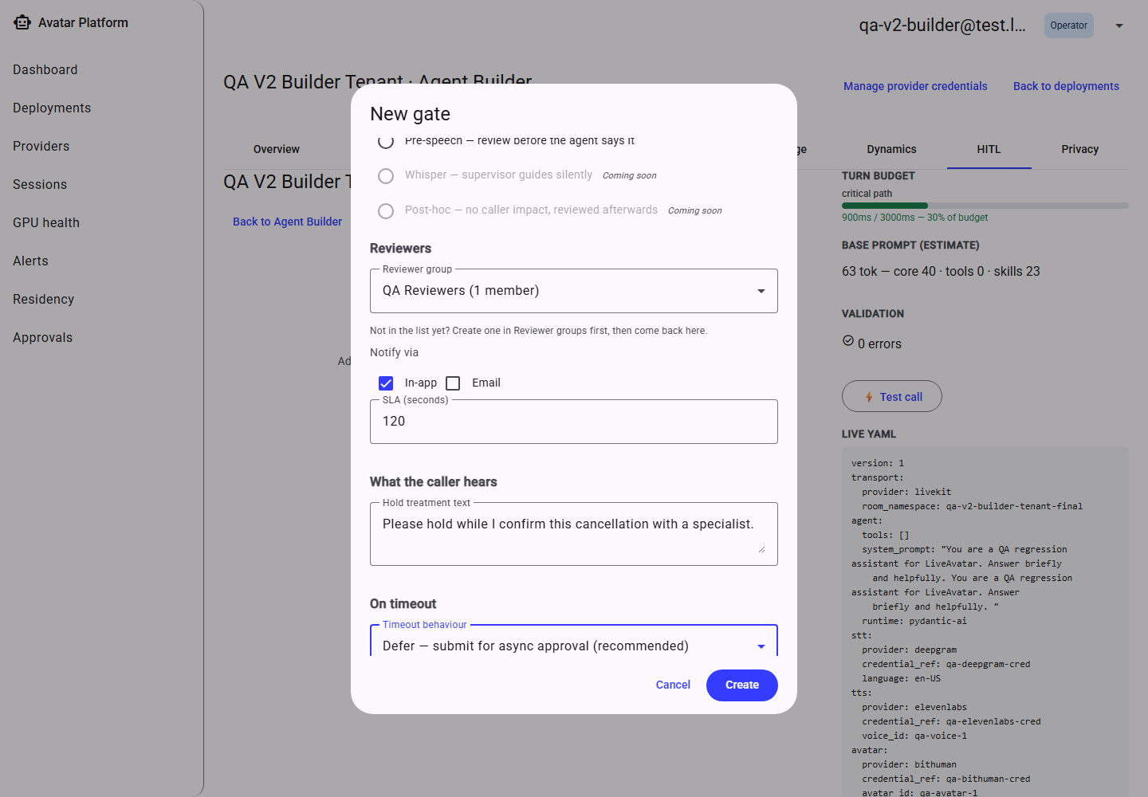
Configuring a gate.
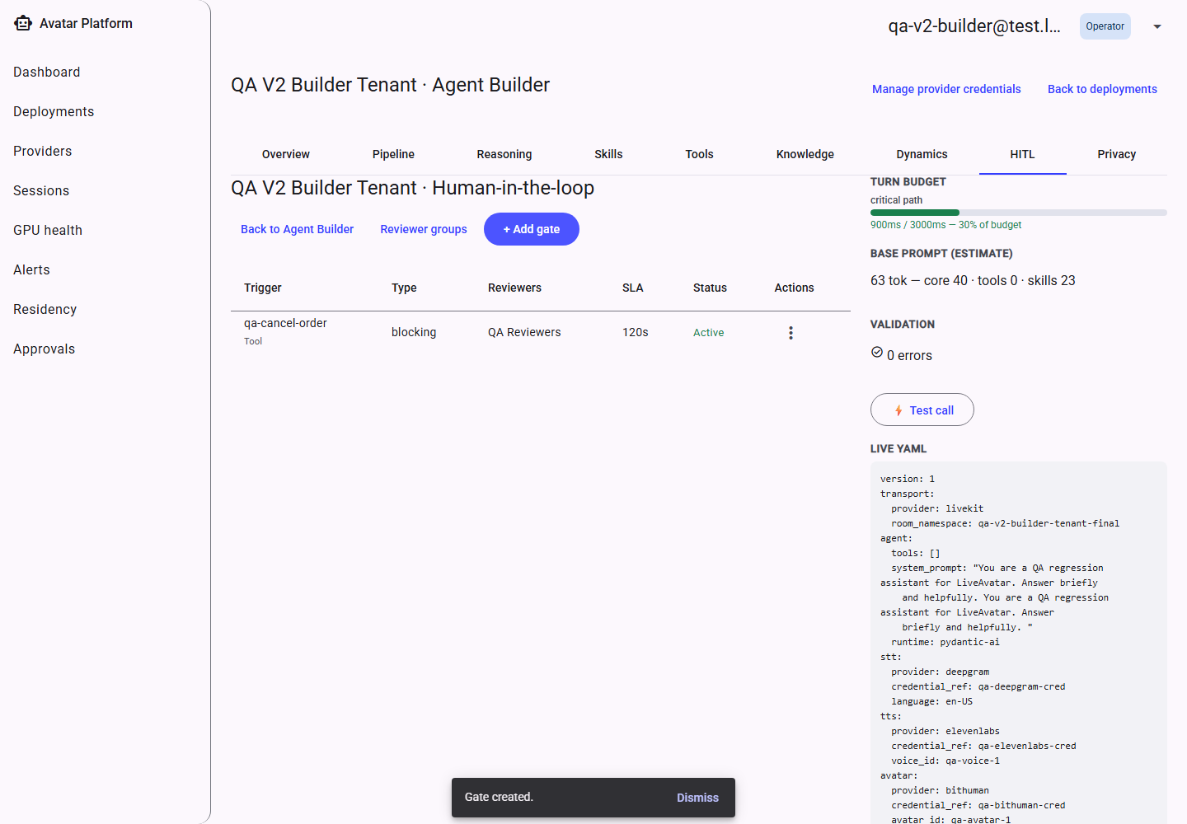
The gates list.

11.9 Privacy
Controls whether conversation content may reach a remote (non-self-hosted) LLM provider, how many days transcripts are retained before automatic deletion, and whether call recordings are captured at all.
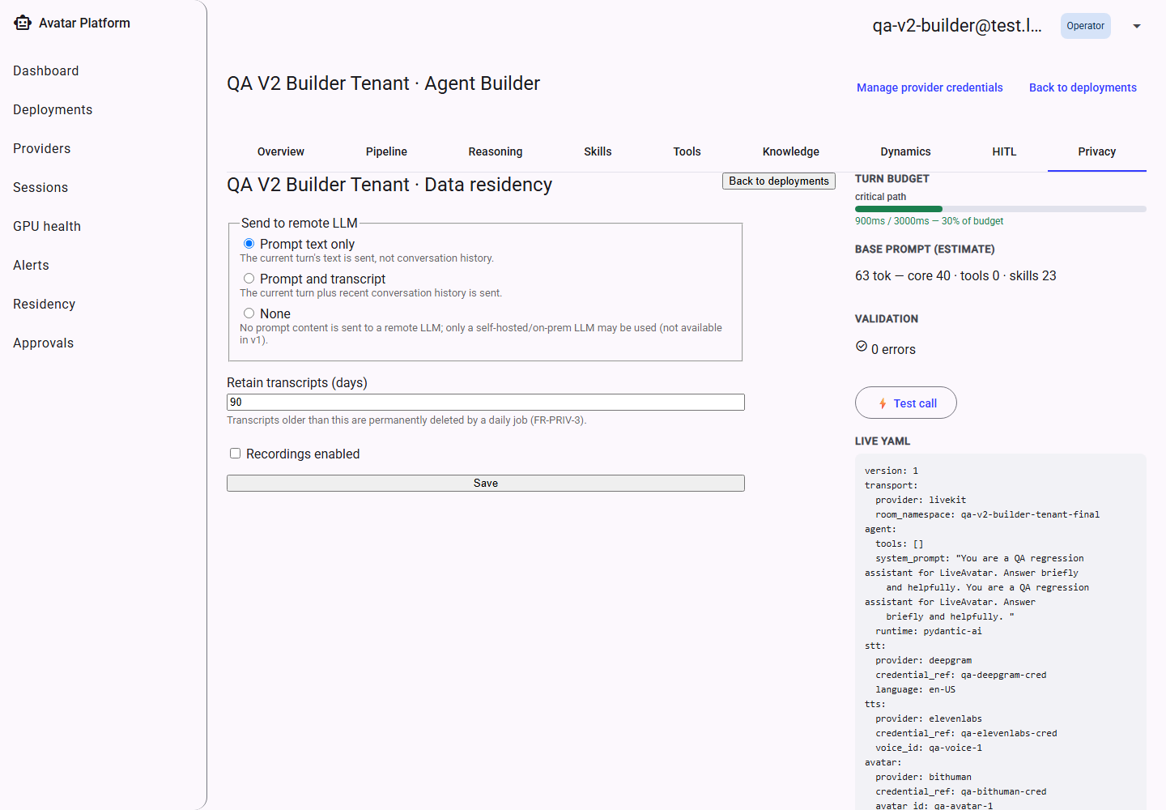
Privacy settings.
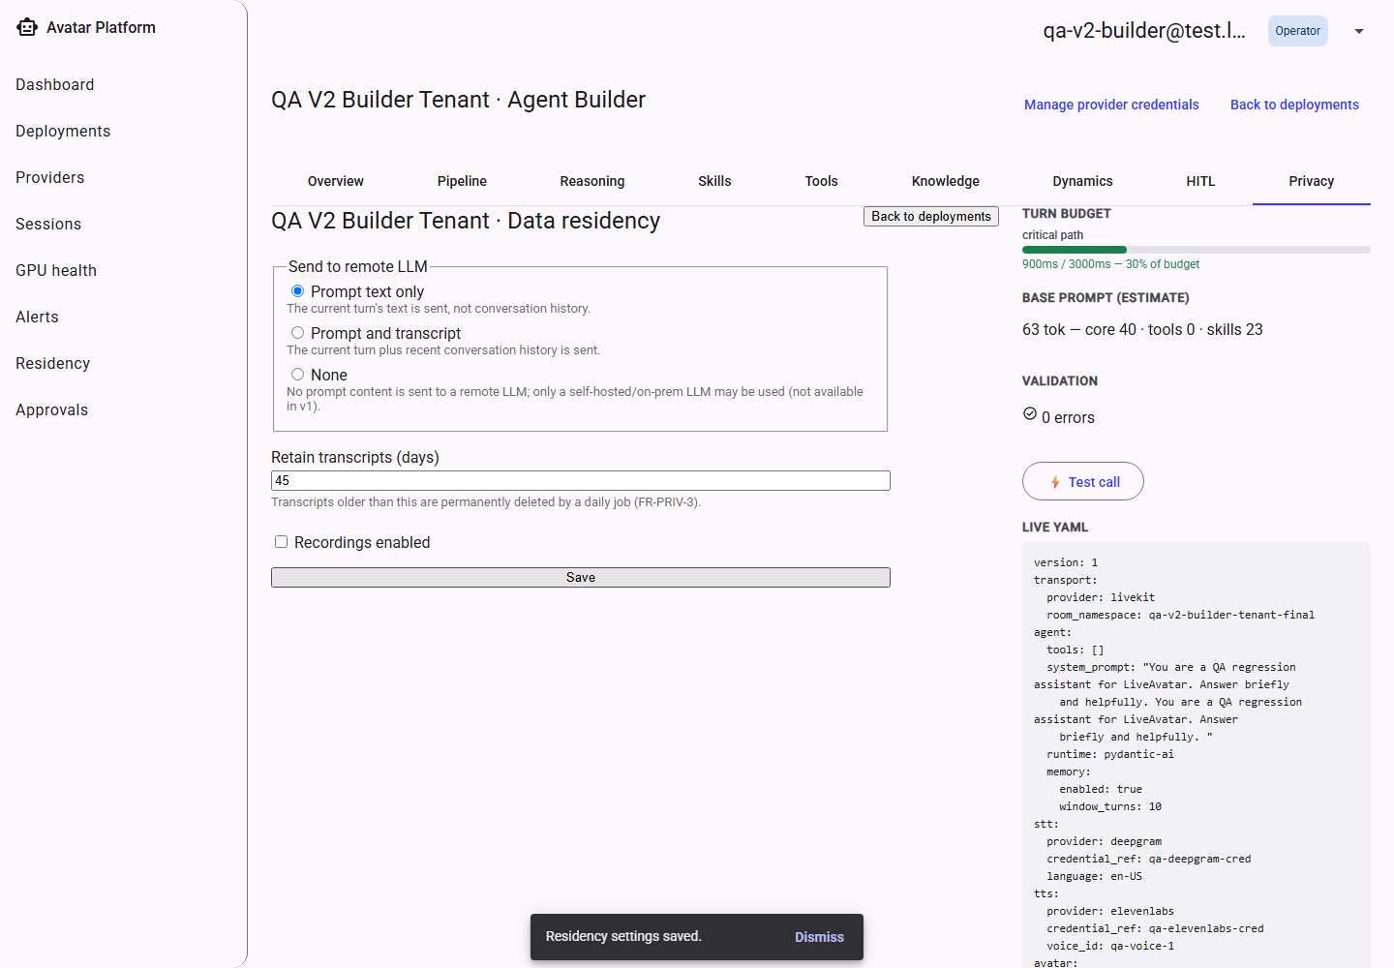
After saving a change.

11.10 Bookmarks From Older Versions
Earlier versions of the admin console had each of these tabs as its own separate page. Any old bookmark or link to one of those pages still works — it now redirects straight into the matching tab inside this shell.
An old direct link, redirected into the new shell.

Part 2 — Conversation Experience
This is the application a caller opens to talk to a configured avatar agent — typically reached via a link a tenant shares (e.g. https://call.yourcompany.com/t/<tenant-slug>), not something a caller logs into.

1. Precall
Before joining, a caller optionally enters a display name, chooses whether to turn their camera on, and grants microphone (and, if camera was turned on, camera) permission. If the agent isn't available right now — the tenant is paused, unknown, or its configuration isn't fully published — this screen says so clearly instead of letting the caller proceed into a broken call.
If microphone (or, with the camera turned on, microphone and camera) permission is denied, no such device exists on the caller's machine at all, or the connection to the calling infrastructure is temporarily unavailable, this screen shows the specific reason — worded differently for “you said no” versus “there's no microphone to say yes to”, since those need different next steps from the caller — and, where recoverable, a Retry button.
This app has no navigation of its own — a caller always arrives via a tenant-specific link (e.g. …/c/acme-support), never the bare app root. Opening the app with no tenant in the link shows a short explanatory dead-end rather than a blank page.
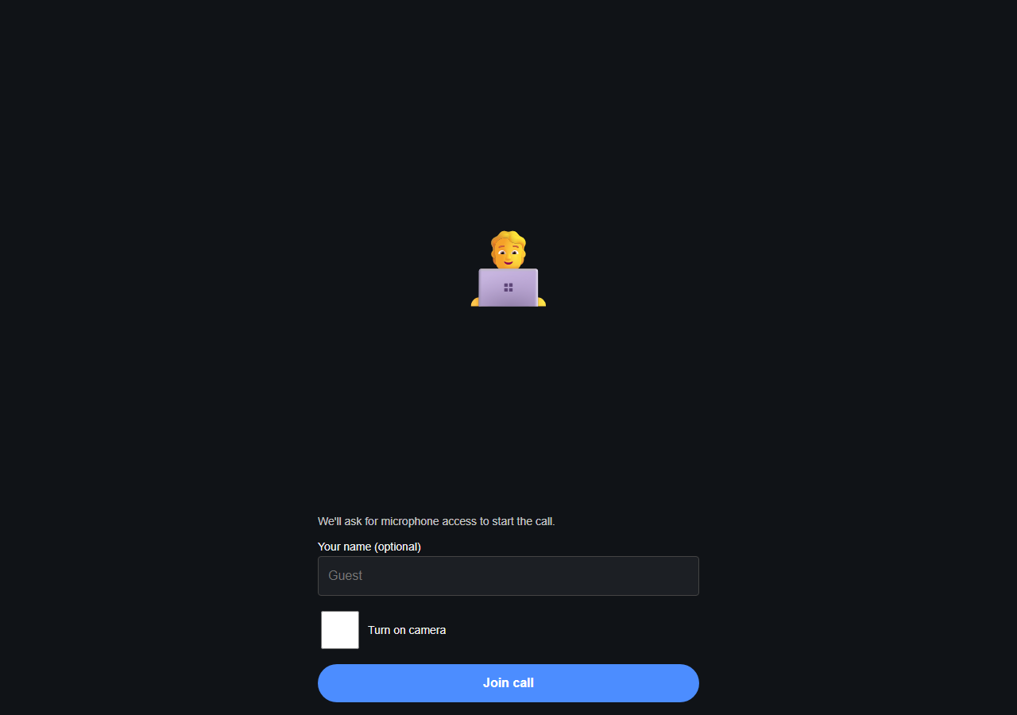
Precall — initial state.
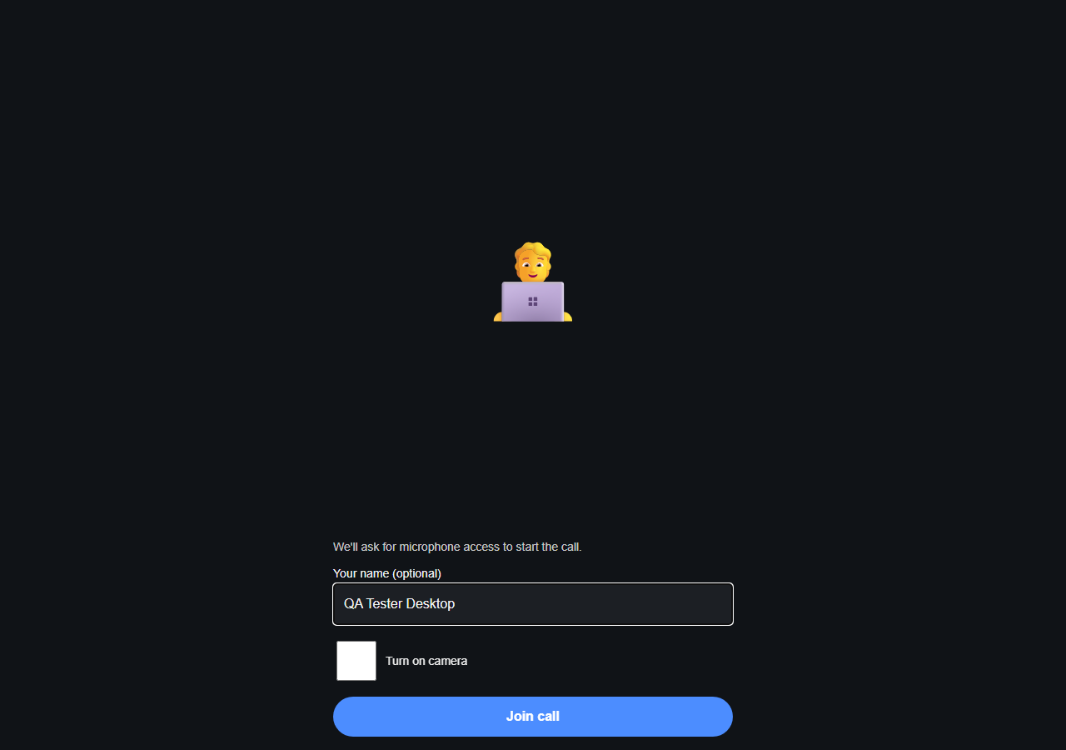
Precall — name entered, ready to join.
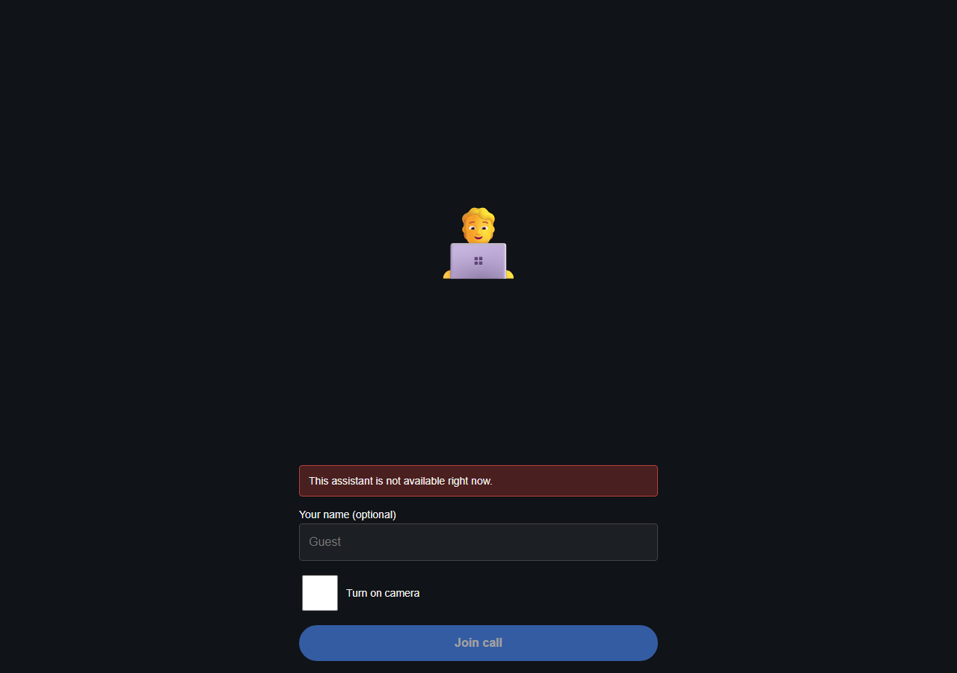
An unknown/invalid link.
The tenant is currently paused.
The tenant's agent isn't fully configured yet.
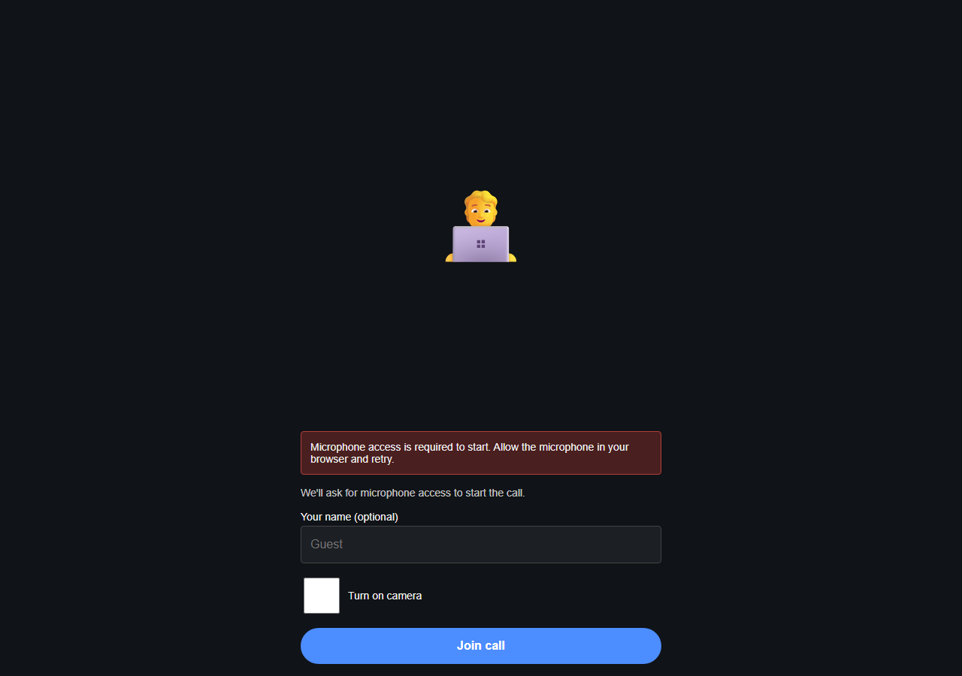
Microphone permission denied.
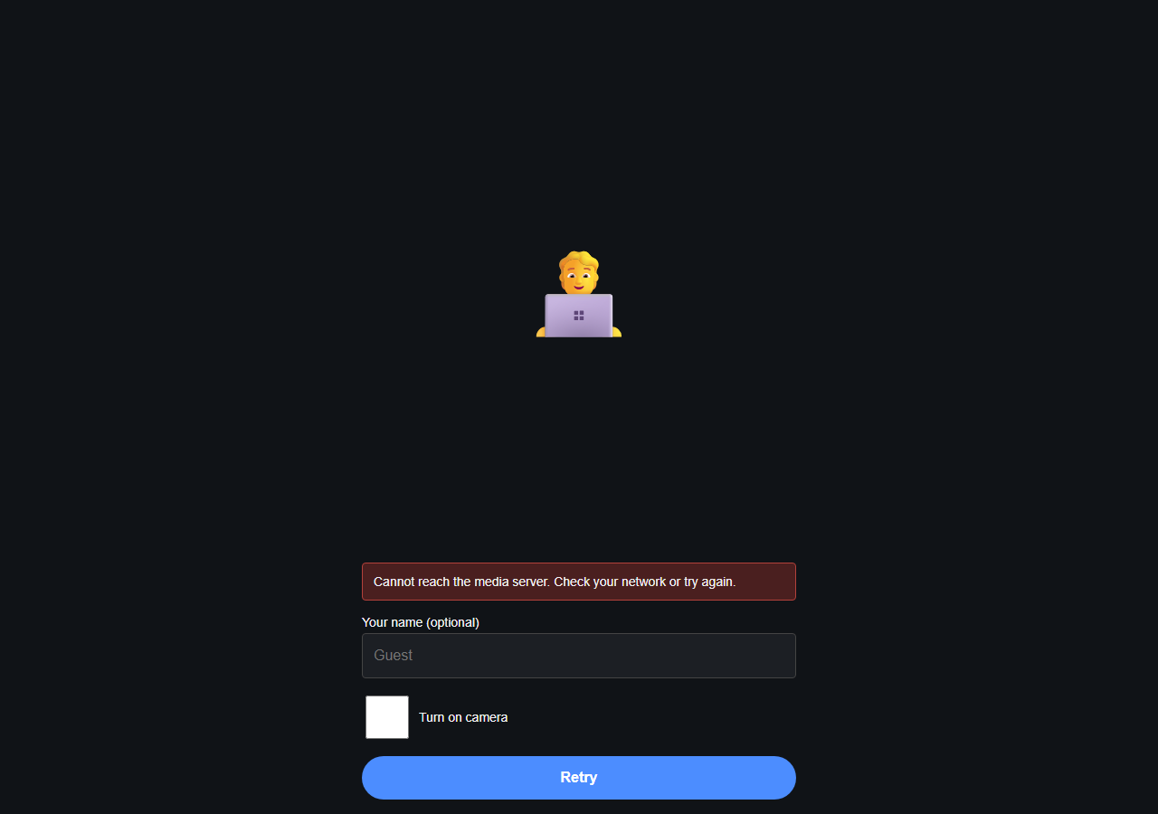
Calling infrastructure temporarily unavailable.
Recovered after pressing Retry.
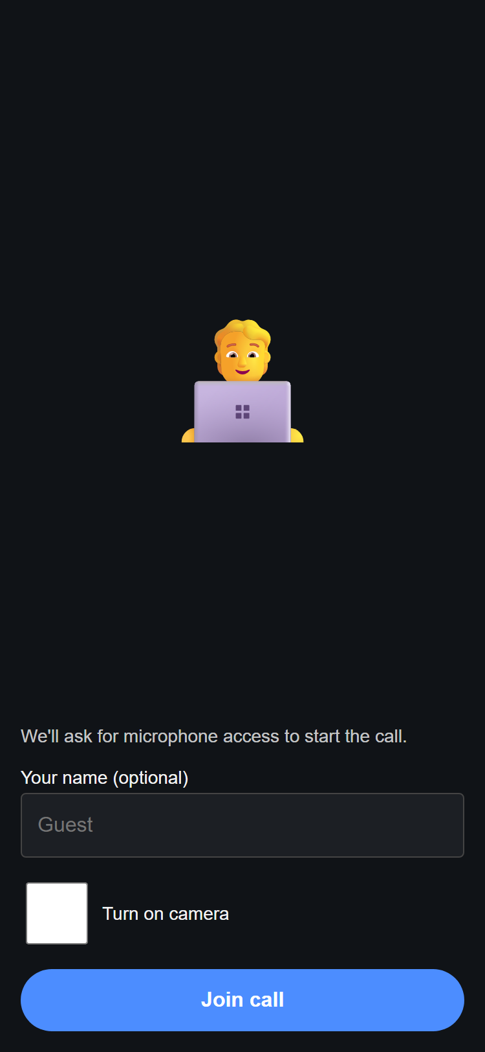
Precall on a phone-width screen.
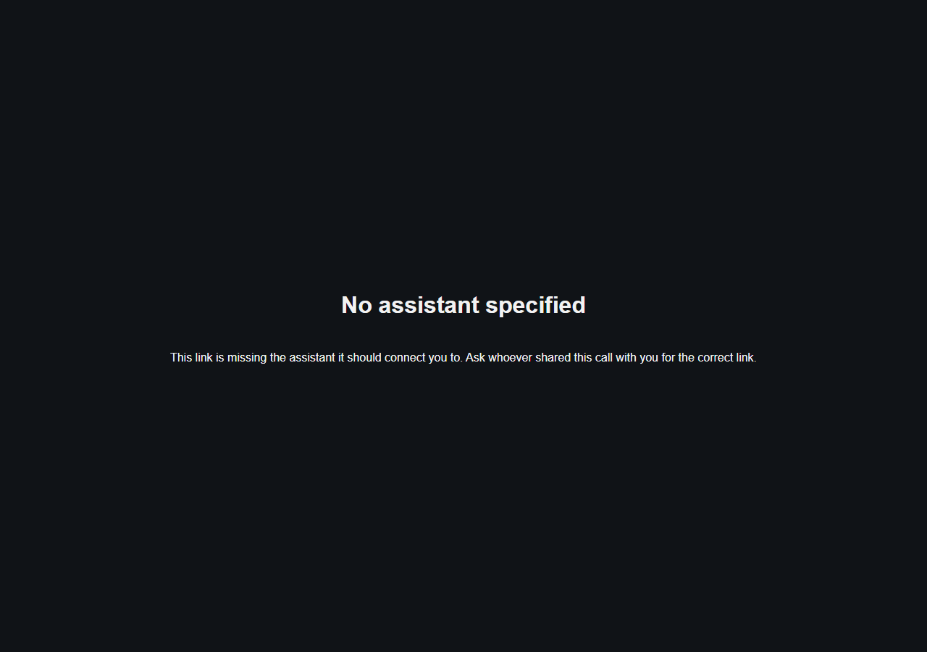
Opening the app with no tenant slug in the link.

2. During the Call
Once connected, the caller sees the avatar, can mute/unmute their microphone, toggle live captions, and end the call. If the agent's avatar hasn't attached yet, a short, clearly-worded waiting message appears rather than a blank screen; if live captions aren't available for this call, that is also stated plainly rather than showing an empty box.
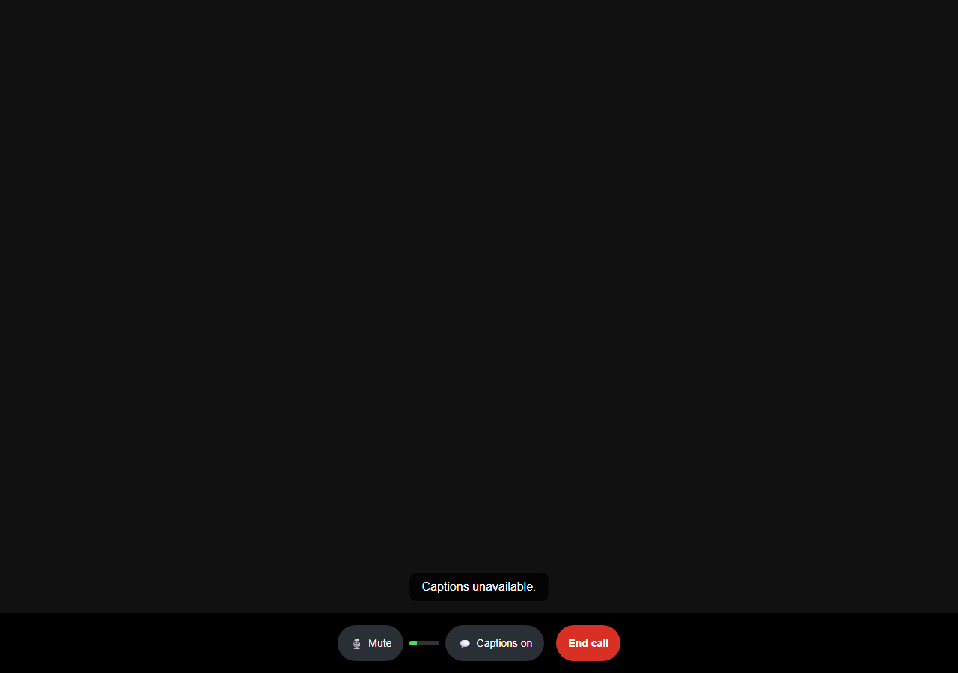
Call screen — connecting.
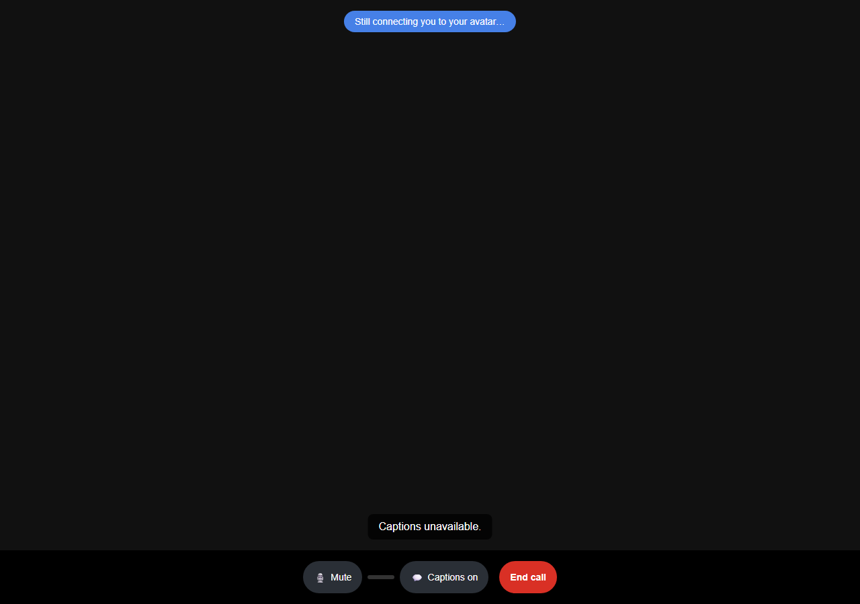
Connected, waiting for the avatar to attach.
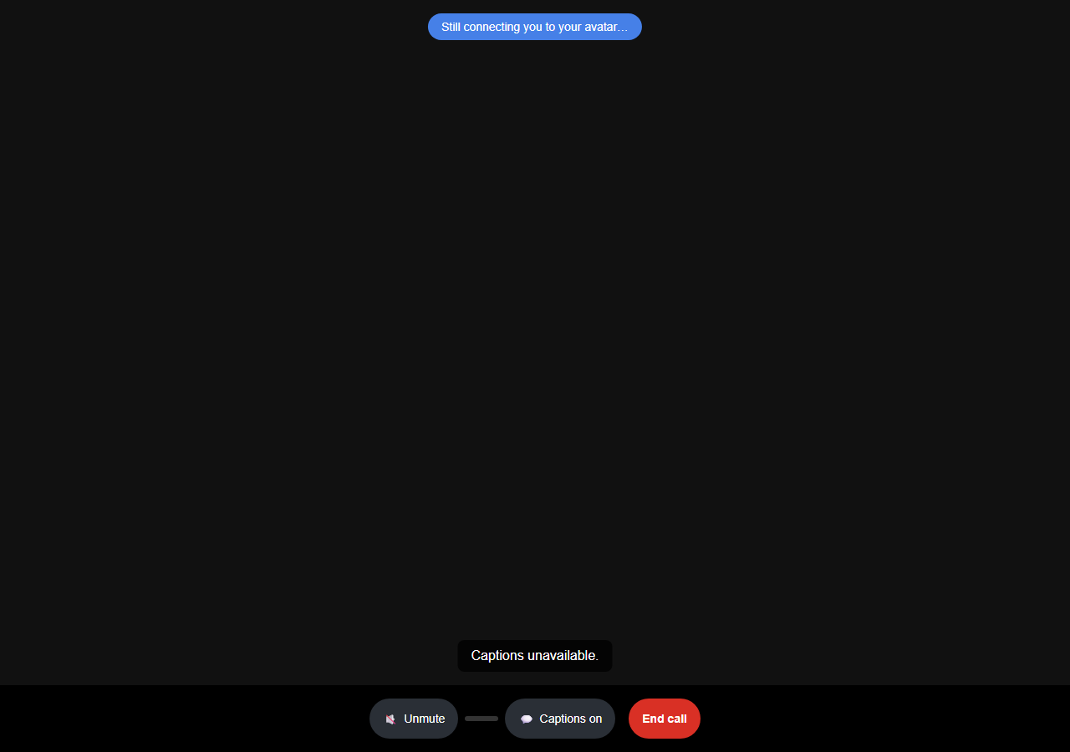
Microphone muted.
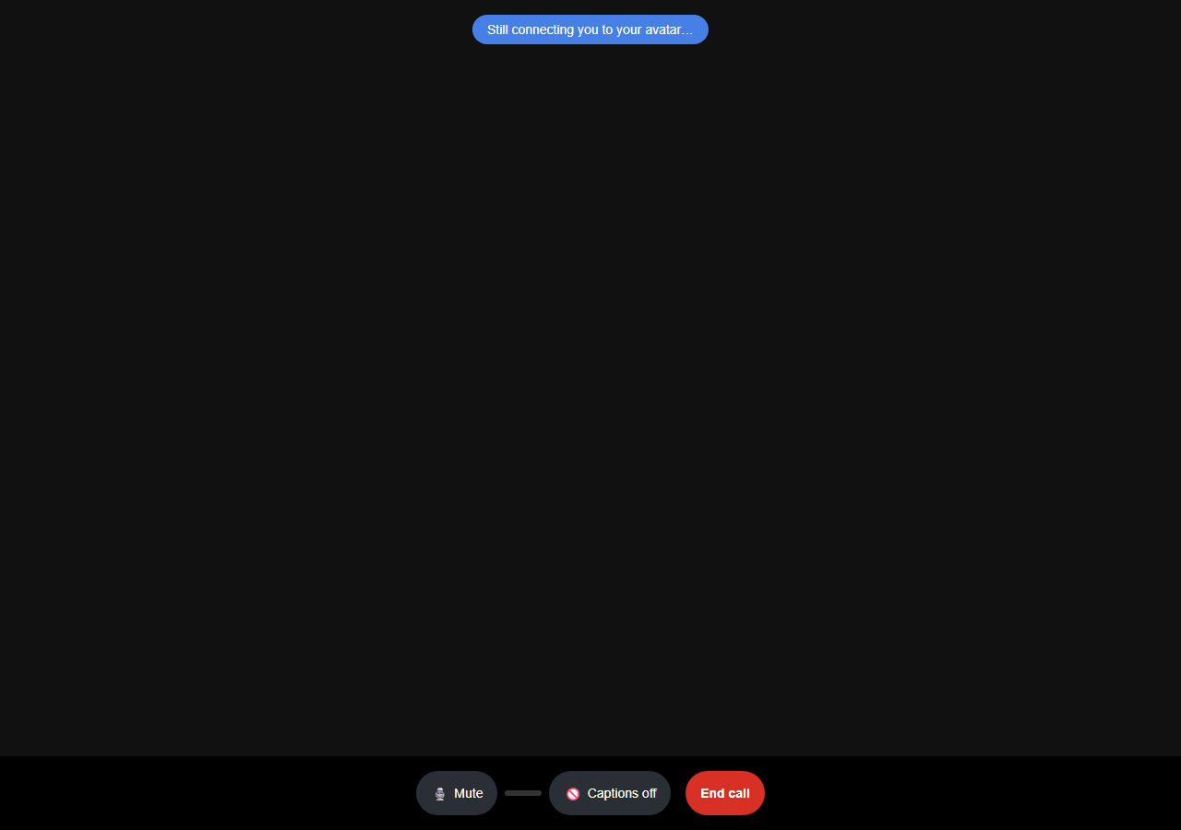
Captions unavailable for this call.

Call screen on a phone-width screen.

3. Approval Waits (Feature Preview)
When an agent's action requires a human reviewer's sign-off mid-call (Part 1, Section 9), the caller is told what is happening and roughly how long it may take, with a visible progress indicator — the call is never left in silence while waiting. If the decision is instead deferred to be resolved after the call ends, the caller is shown that outcome once it resolves.
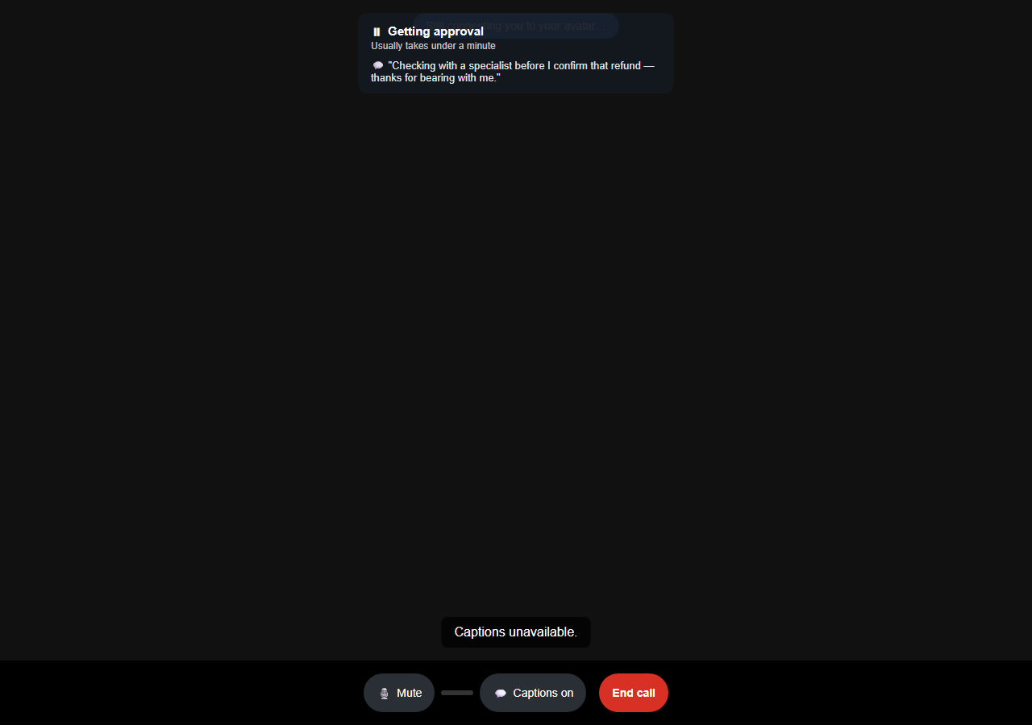
Waiting on a human reviewer's approval.
Feature preview: shown here using a simulated approval event for illustration; end-to-end triggering from a live call is completed in a follow-up release.
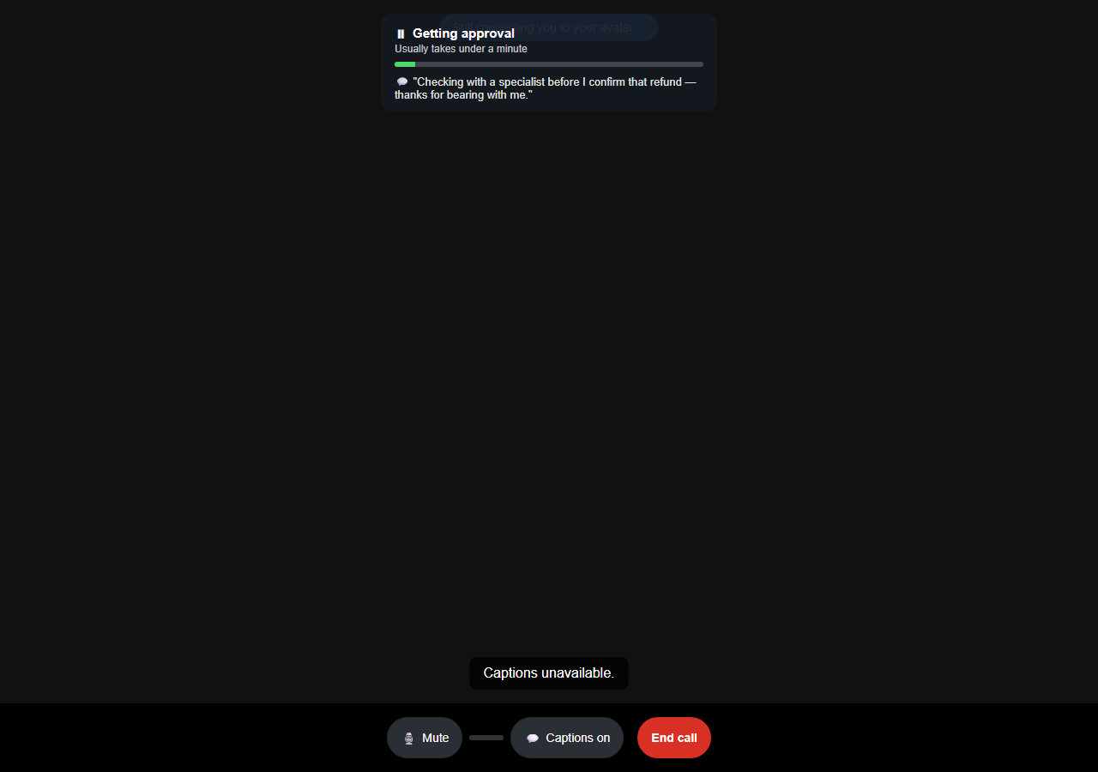
The wait, with elapsed-time progress.
The call resumes once approved.
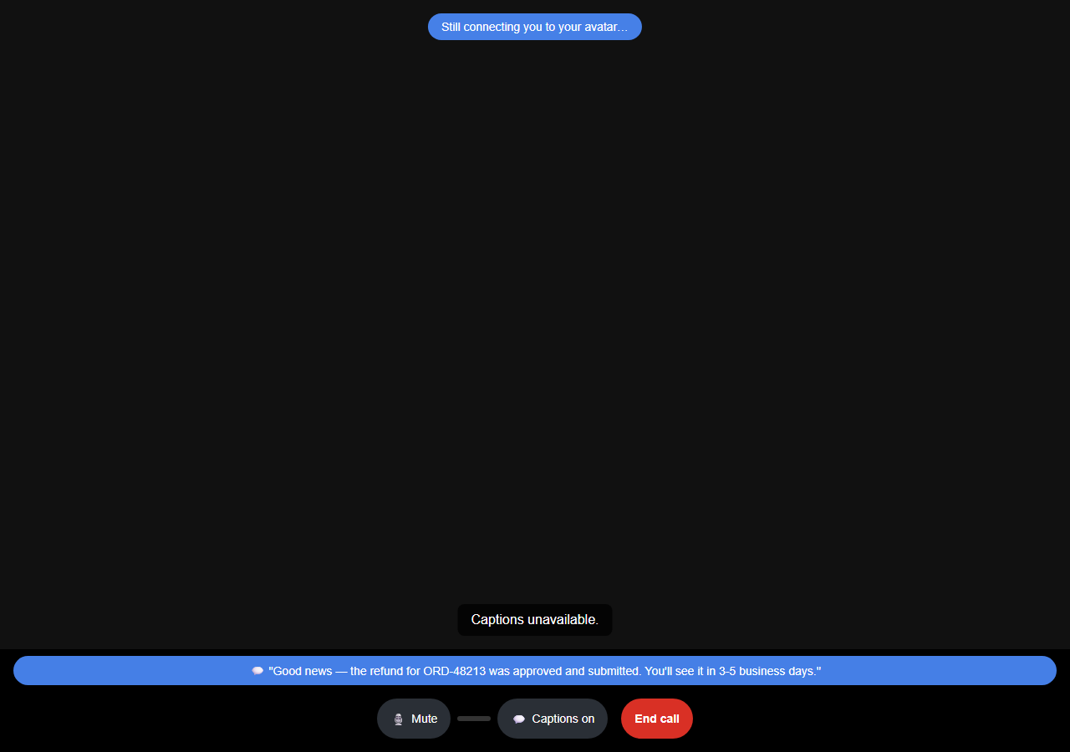
A deferred decision's outcome, once resolved.

4. After the Call — Summary & Feedback
After the call ends, the caller is taken to a summary of what was discussed, generated from the call's transcript, and can optionally leave a star rating and comment.
This page can be safely reloaded or revisited from the link sent to the caller — a submitted rating stays shown as submitted rather than re-presenting the form. An expired, forged, or already-used summary link shows a generic “no longer available” message rather than any call- or caller-specific detail.
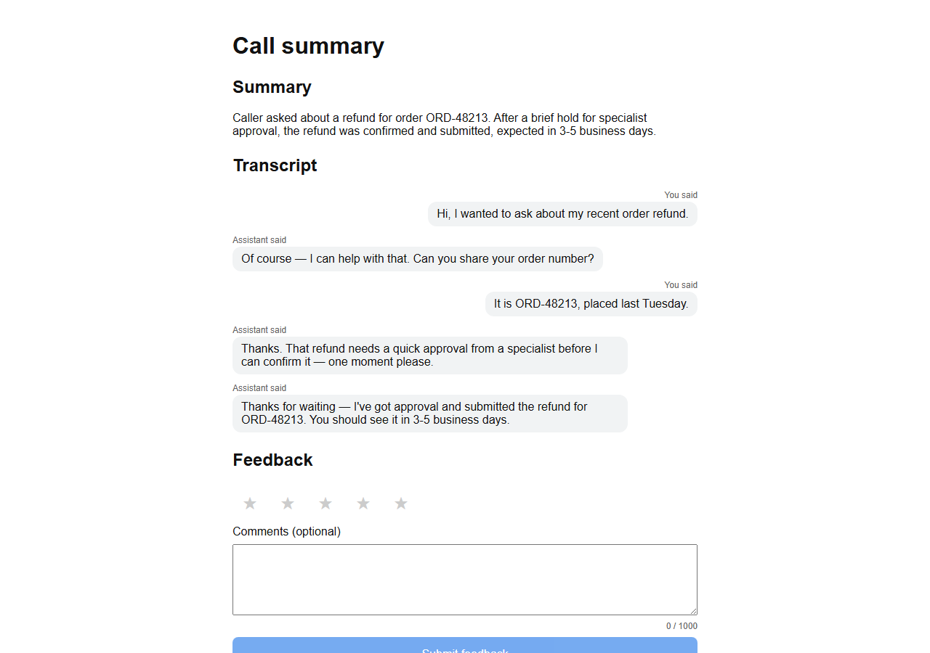
Call summary and transcript.
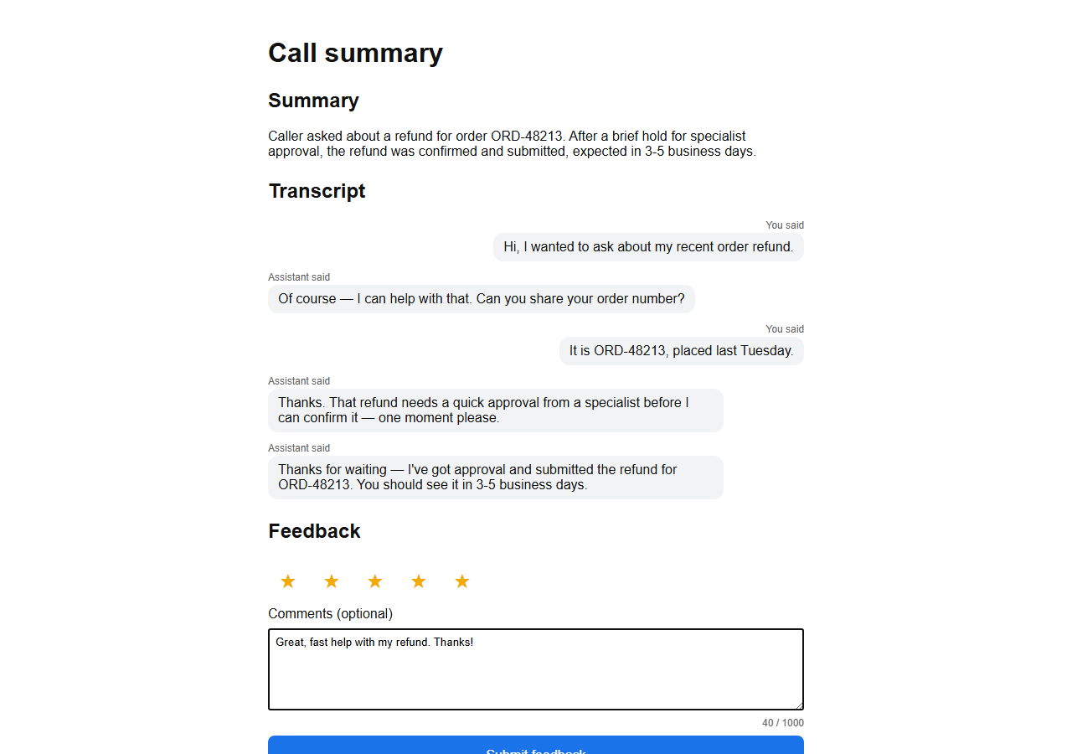
Leaving a rating and comment.
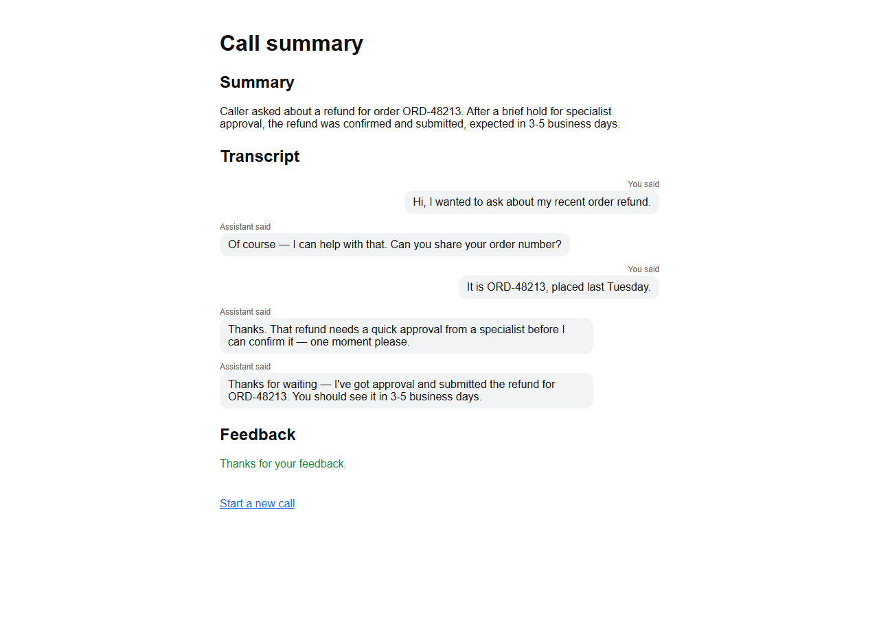
Feedback submitted.
Still shows as submitted after a page reload.

An invalid/forged summary link.
A summary link for a call that no longer exists.
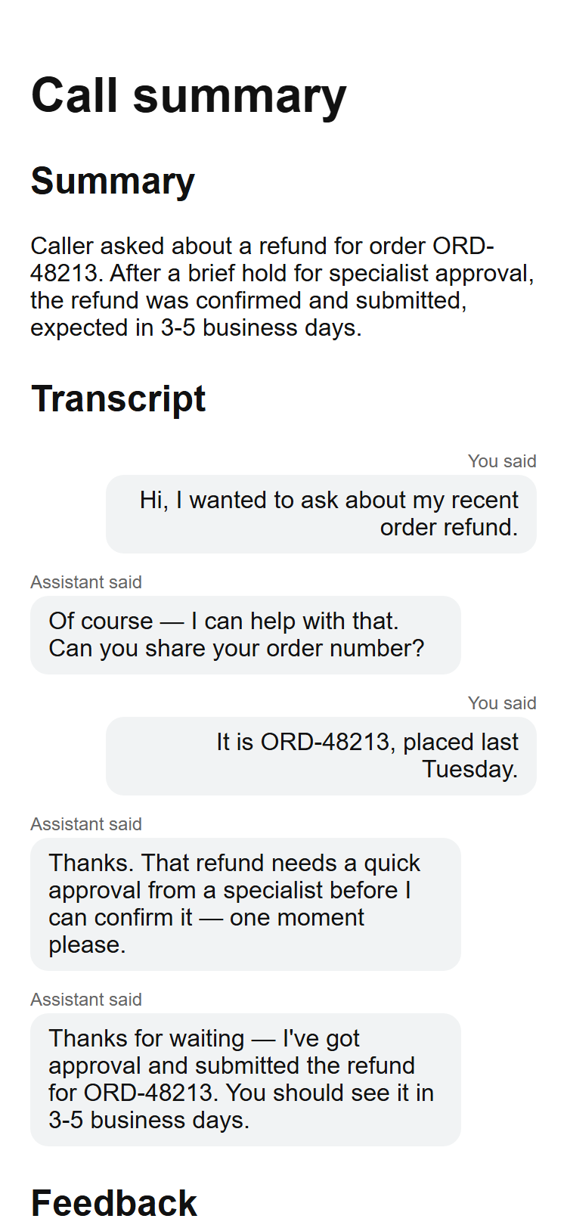
Summary on a phone-width screen.

Notes & Known Limitations
Every screen in this guide was exercised against a real, live deployment — including, for the deployment this guide was captured from, real vendor credentials for Deepgram (speech-to-text), OpenAI (reasoning), ElevenLabs (text-to-speech), and bitHuman (avatar rendering, from a local model file). A session against that deployment completes end-to-end (status “ended”, a generated summary) rather than failing, confirming the whole provider chain is wired correctly. A production deployment only needs its own real credentials in place of a sandbox's placeholders to reach this same fully-“Healthy” state.
- A fully-voiced, camera-on live call end to end (real captured microphone audio all the way through to rendered avatar video in a browser) was not captured in this guide — the browser used to drive these screenshots has no real microphone, and the automated browser-to-LiveKit media handshake used for testing does not reliably complete in every sandboxed environment. This is a testing-harness limitation, not a gap in the product's own provider wiring.
- The human-approval “waiting” and “deferred outcome” call screens (Part 2, Section 3) are fully built and shown here as a feature preview; the voice-agent-side wiring that triggers them from a real live call is completing in a follow-up release.
- The Agent Builder's Reasoning tab “Test call” feature (not pictured in this guide) is a deliberate structural simulation, not a live call — it checks that a graph's nodes are wired correctly without spending real vendor API calls or minutes on every edit. To hear a real, fully-voiced response, use the Conversation app itself (Part 2) against a published, fully-credentialed tenant.

