In All Pages make every feature has tooltip help to help user under stand every feature in the platform
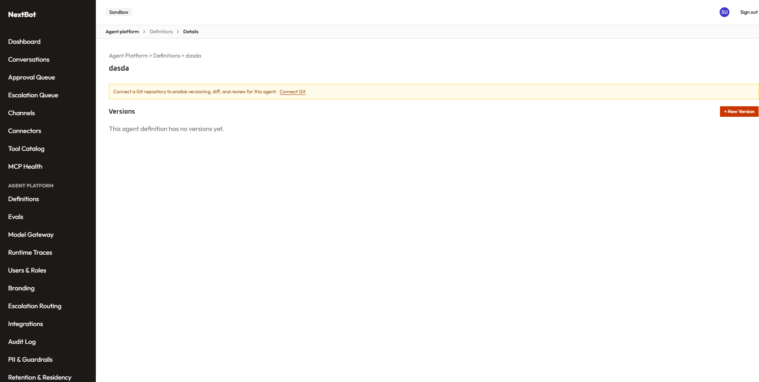
Comments:-
- Use shadcn menu instead of this custom one
- NextBot should has brand icon in top menu
- Add database storage for agent source as default and keep git as secondary
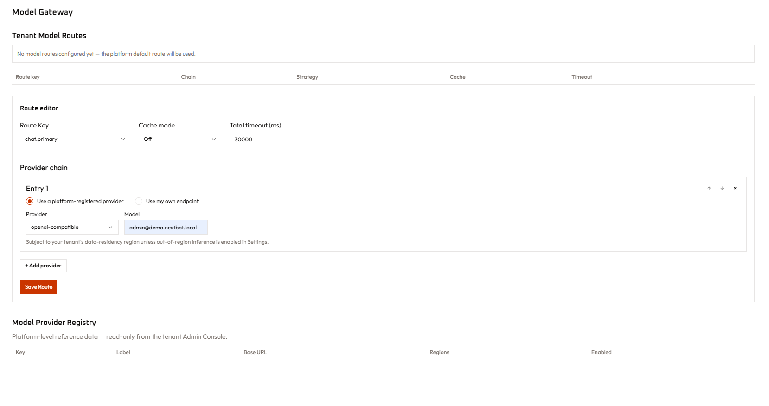
Comments :-
- Reorganize page and seed with proper data

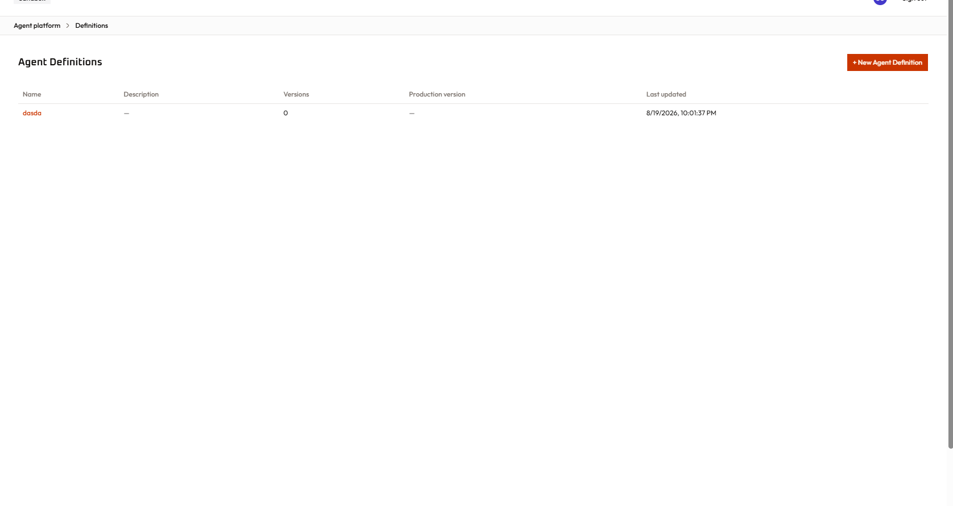
When edit show last version and able to browse older version , restore , and publish with sand box testing
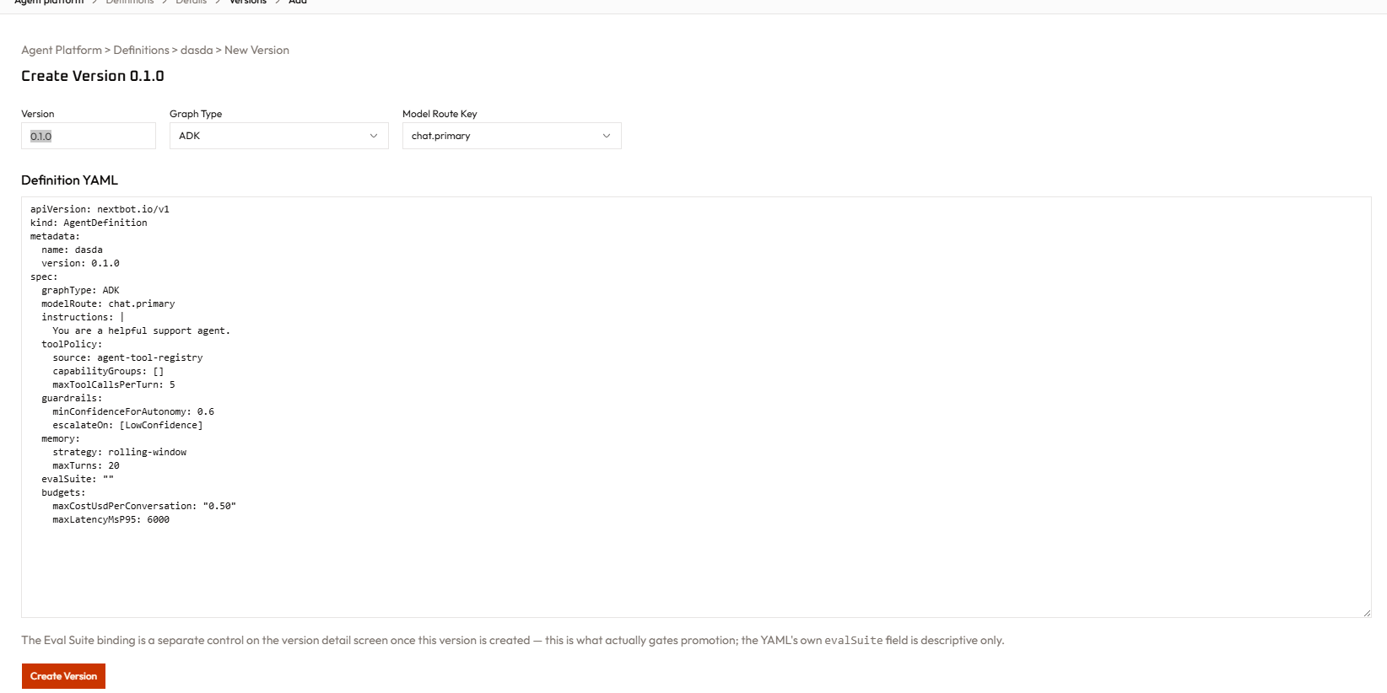
In this page make agent design studio so the user can build agent in deign mode or text base mode

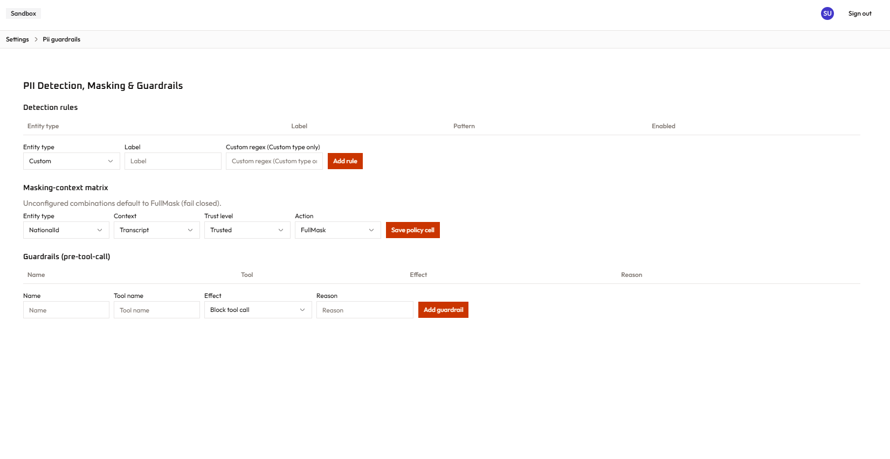
Enhance UX of this page

Add one page for settings and include all setting related pages

Connector Alert Configuration , Retention & Residency

And remove un needed pages or that doesn’t add business value

**add interface to enroll mcp’s and AI plugins and use them in agent design studio

**add sandbox to test agent before publish

**seed one working agent and give test page for web channel wediget

**don’t use any custom componenet and only use shadcn compoenents only

