NextBot Screen Reference
Table of Contents
NextBot — Screen Reference 1
1. Authentication 1
2. Day-to-day operations (Admin Console) 4
3. Agent Platform — building and running agents 15
4. Settings 23
5. Platform Manager console — cross-tenant operator surface 31
6. The customer-facing widget 35

NextBot — Screen Reference
A screen-by-screen guide to every page in the NextBot platform: the Admin Console (tenant-facing), the Platform Manager console (cross-tenant operator surface), the customer-facing widget, and the authentication screens shared by all of them. For each screen: what it’s for, what a user can do on it, and the logic/rules that govern it. Screenshots below are from a live, seeded instance of the platform.
Sidebar/module names in parentheses refer to the permission module that gates the screen (Read/Write/None per role) — every screen fails closed: a role with no access sees a “you don’t have access” state on a direct link, not an empty page or a crash.

1. Authentication

Login (/login)
Tenant slug + email + password. On success, if the account has TOTP MFA enabled, a second screen asks for the 6-digit code (with a “trust this device” option and backup codes as a fallback). Distinct error states for a wrong password, a locked-out account (too many attempts), and an account with zero assigned roles — each says something different so a user isn’t left guessing.
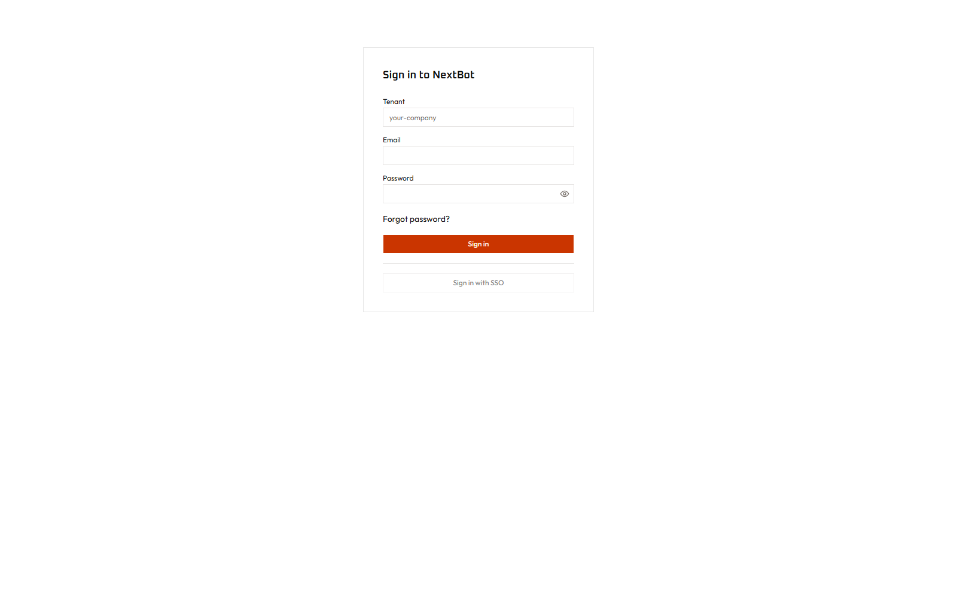
Login

Forgot password (/forgot-password)
Email-only reset request. Deliberately gives the same “if an account exists” response whether or not the address is real, so the form can’t be used to enumerate registered emails.

Forgot password

Platform Manager login (/internal/ops/login)
A separate, unrelated login for the cross-tenant operator console (see §5) — an operator token, not a tenant account. Gated additionally by an IP allowlist. This page and every page under it is designed to be byte-for-byte indistinguishable from a genuinely missing page to anyone who isn’t both on the allowlist and holding a valid token — see §5 for why.
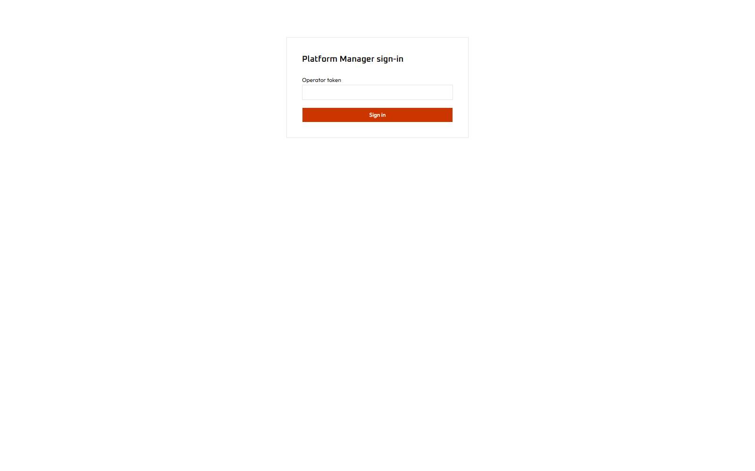
Platform Manager login

2. Day-to-day operations (Admin Console)

Dashboard (/dashboard) — module: reporting
Landing page after login. High-level tenant metrics (conversation volume, escalation rate, tool-call activity) at a glance.
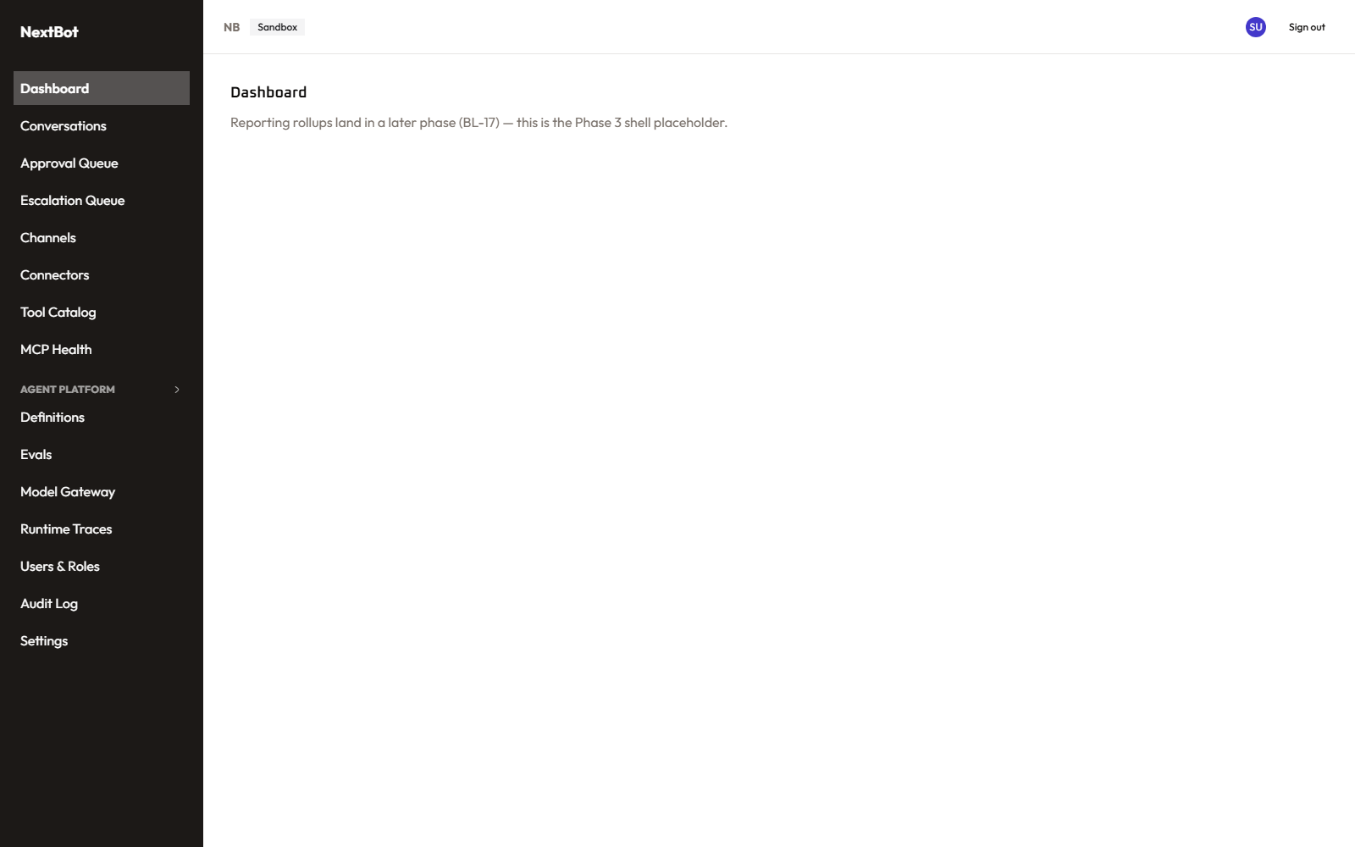
Dashboard

Conversations (/conversations, /conversations/[id]) — module: conversations
The list of every conversation the tenant’s agents have had, filterable by status, recognized task/intent, language, and date range. Opening one shows the full transcript, the agent’s reasoning trace (collapsible, so the transcript itself stays readable), and any tool calls it made along the way with their arguments/results.
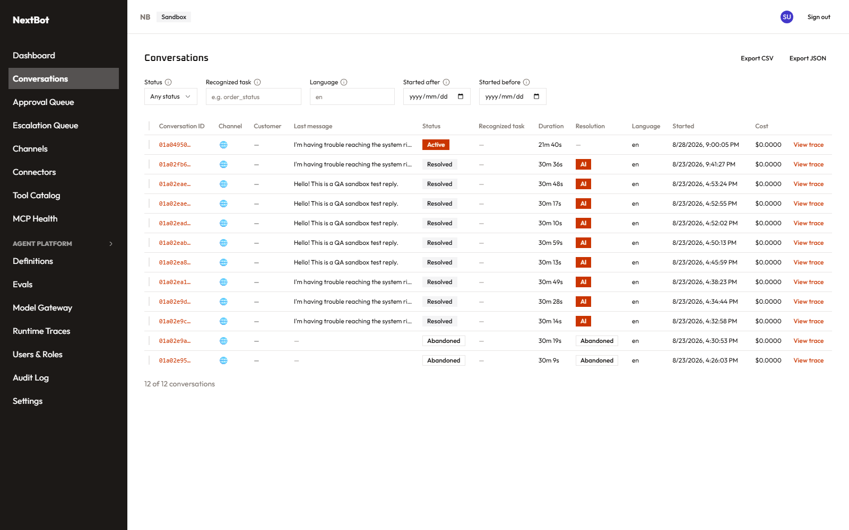
Conversations list
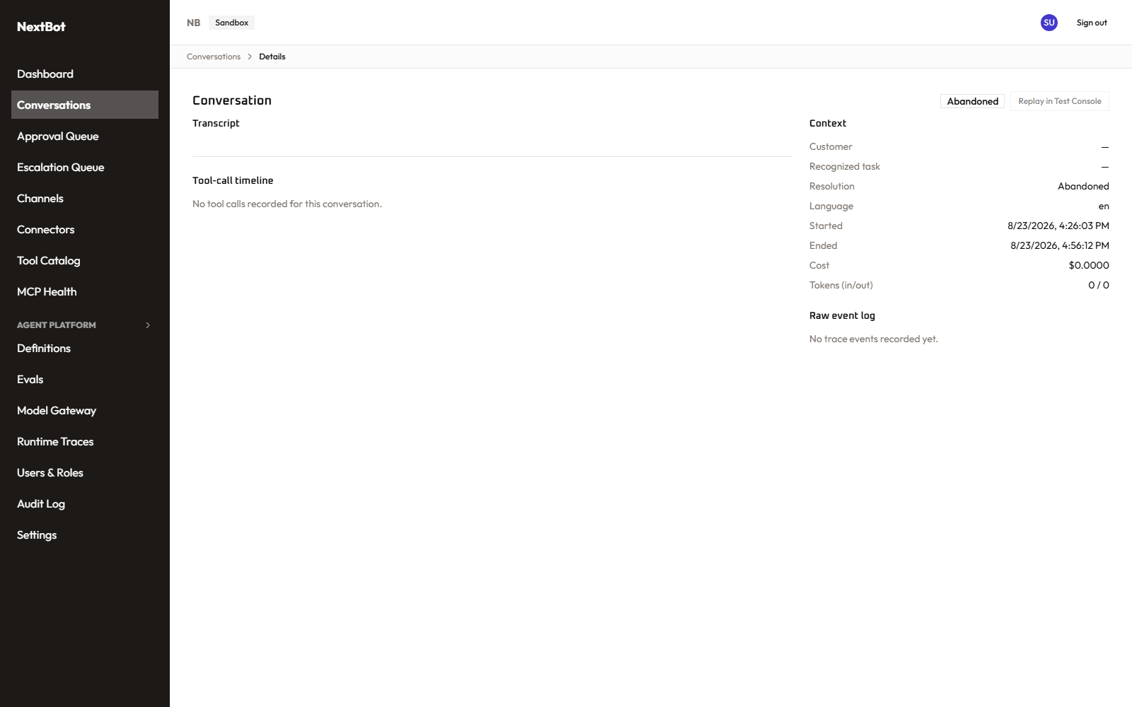
Conversation detail

Approval Queue (/approvals) — module: approval_queue
Tool calls an agent wants to make that are classified as high-risk (Tier-3) sit here pending a human decision — approve or deny, with an optional note. This is the human checkpoint in the tool-tiering system: Tier-1 calls run automatically, Tier-2 calls are logged, Tier-3 calls stop here until a person signs off.
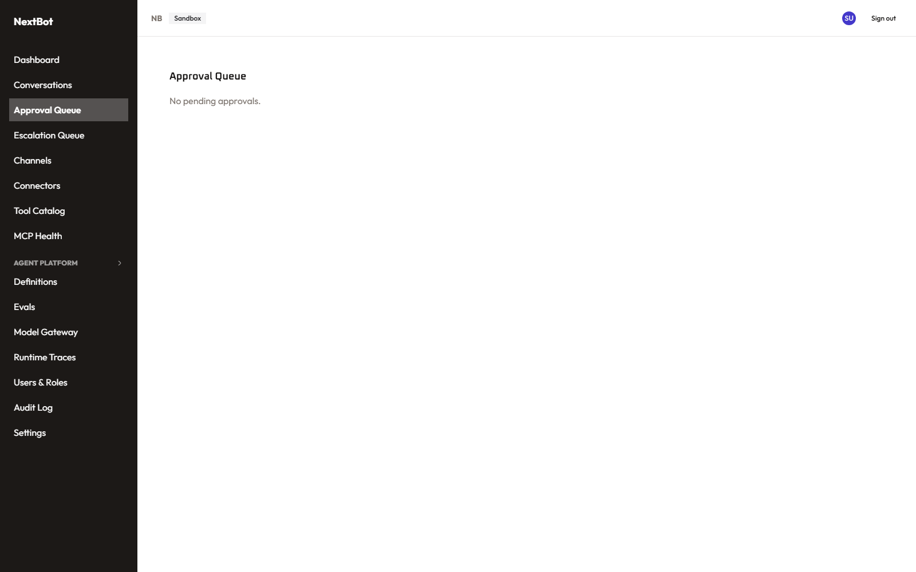
Approval Queue

Escalation Queue (/escalations, /escalations/[id]) — module: escalations
Conversations an agent handed off to a human (low confidence, an explicit customer request, or a guardrail trip) land here. Opening one is a live takeover panel: send a message directly to the customer, see the same reasoning/tool-call history the agent had, and either resolve the escalation or hand it back to the bot.
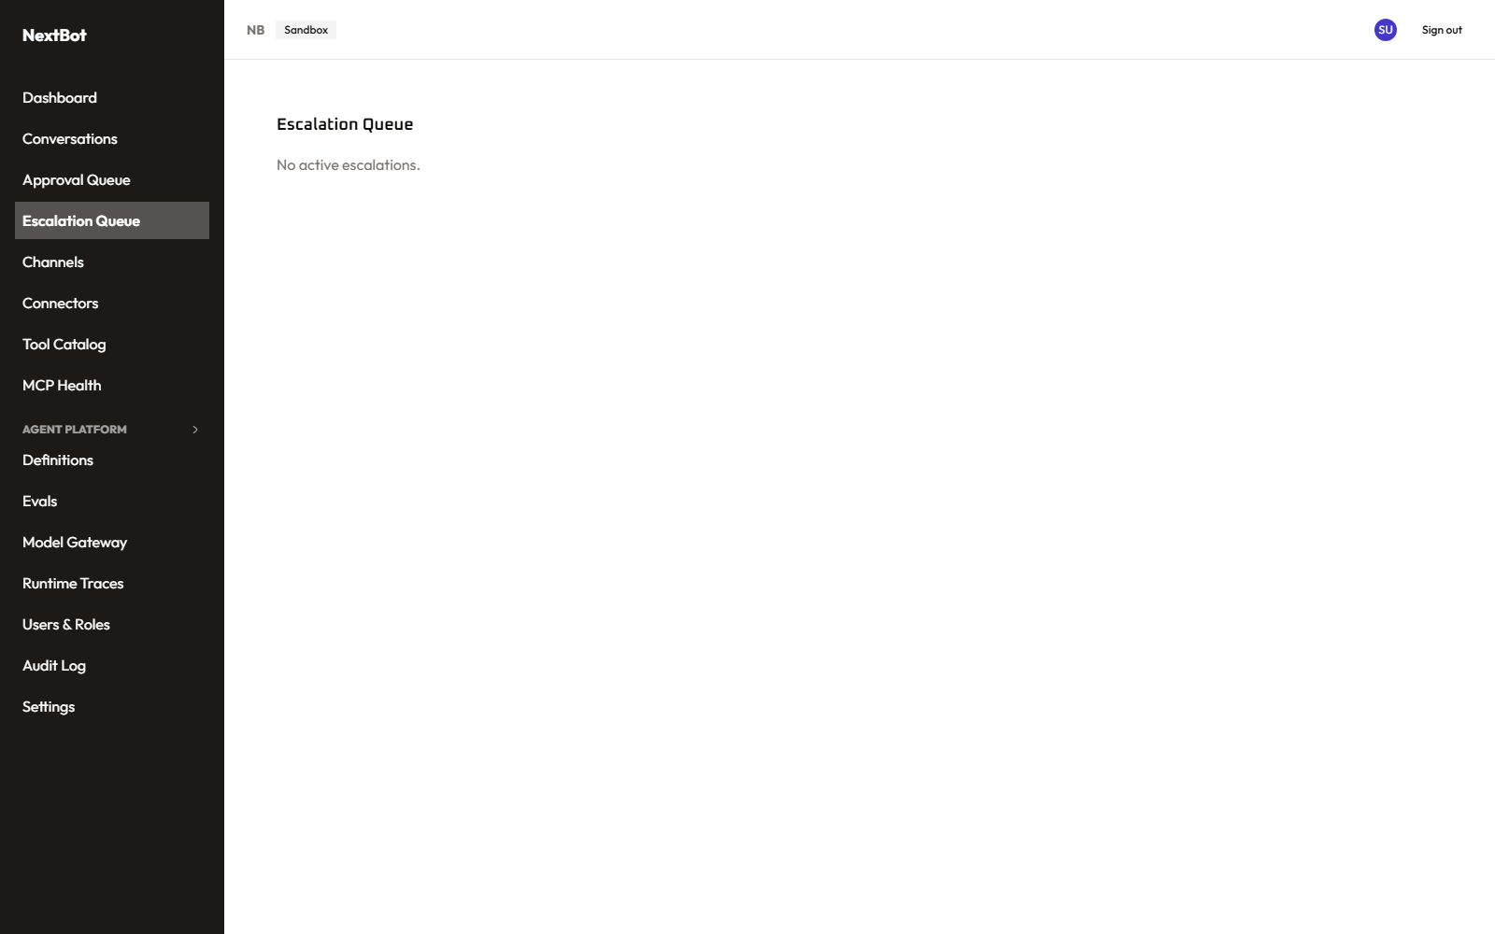
Escalation Queue

Channels (/channels, /channels/new) — module: channels
Where a tenant’s customer-facing entry points live — currently a Web Widget channel type and a WhatsApp Business channel type, added via a type-picker → type-specific setup flow. Each channel’s detail page (WhatsApp’s, specifically) lets you configure the Meta/WABA connection, webhook, and consent settings, and every mutating control disables itself for a Read-only viewer rather than hiding — so a viewer can see the full configuration without being able to change it.
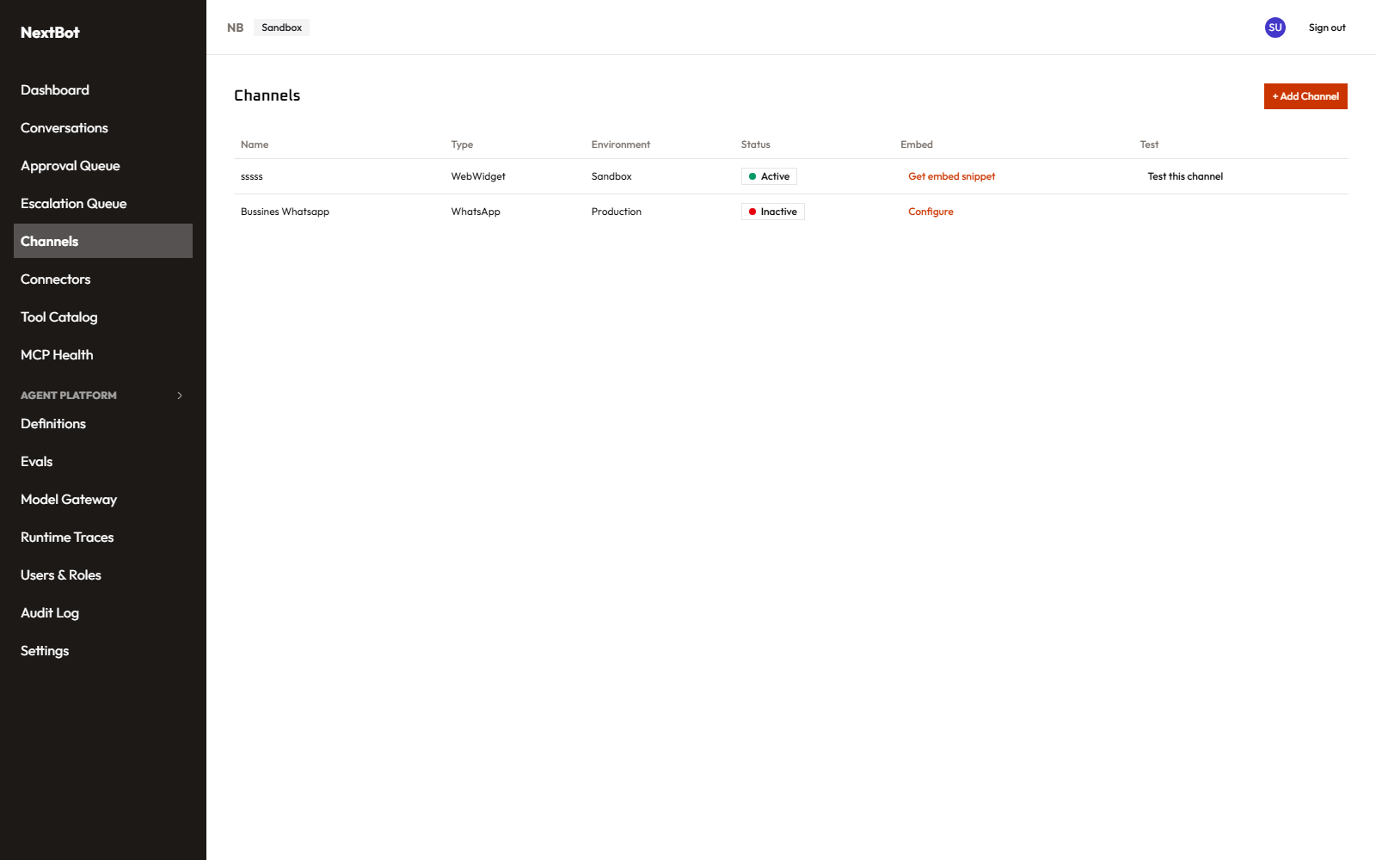
Channels list
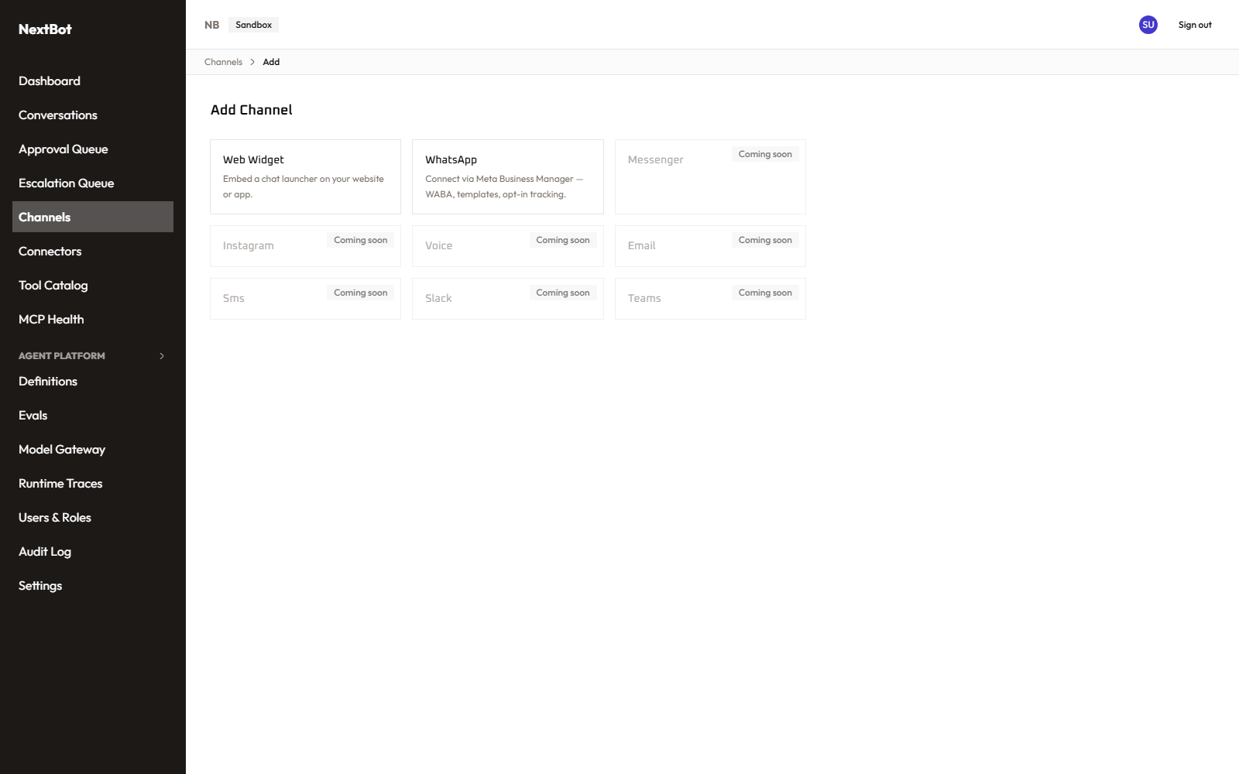
Add channel

Channel test (/channels/[channelId]/test)
A live, real chat panel embedded right in the console, running the channel’s actual currently-deployed Production agent version — the same experience a real customer would get, useful for confirming a channel actually works without opening a separate browser tab to the public widget URL.

Connectors (/connectors, /connectors/new, /connectors/[id]) — module: connectors
An MCP connector is a backend system (a CRM, a ticketing system, an internal API — or, per the newly-seeded examples, a knowledge-graph Memory server, a web-Fetch server, Azure DevOps, or Microsoft 365) that exposes tools an agent can call. Adding one is a form: name, description, backend type, environment, transport (streamable HTTP or a gateway-mediated stdio process), endpoint URL, and an authentication method with the credential itself stored in the encrypted credential vault, never shown back in plaintext once saved. Its detail page shows live health status.
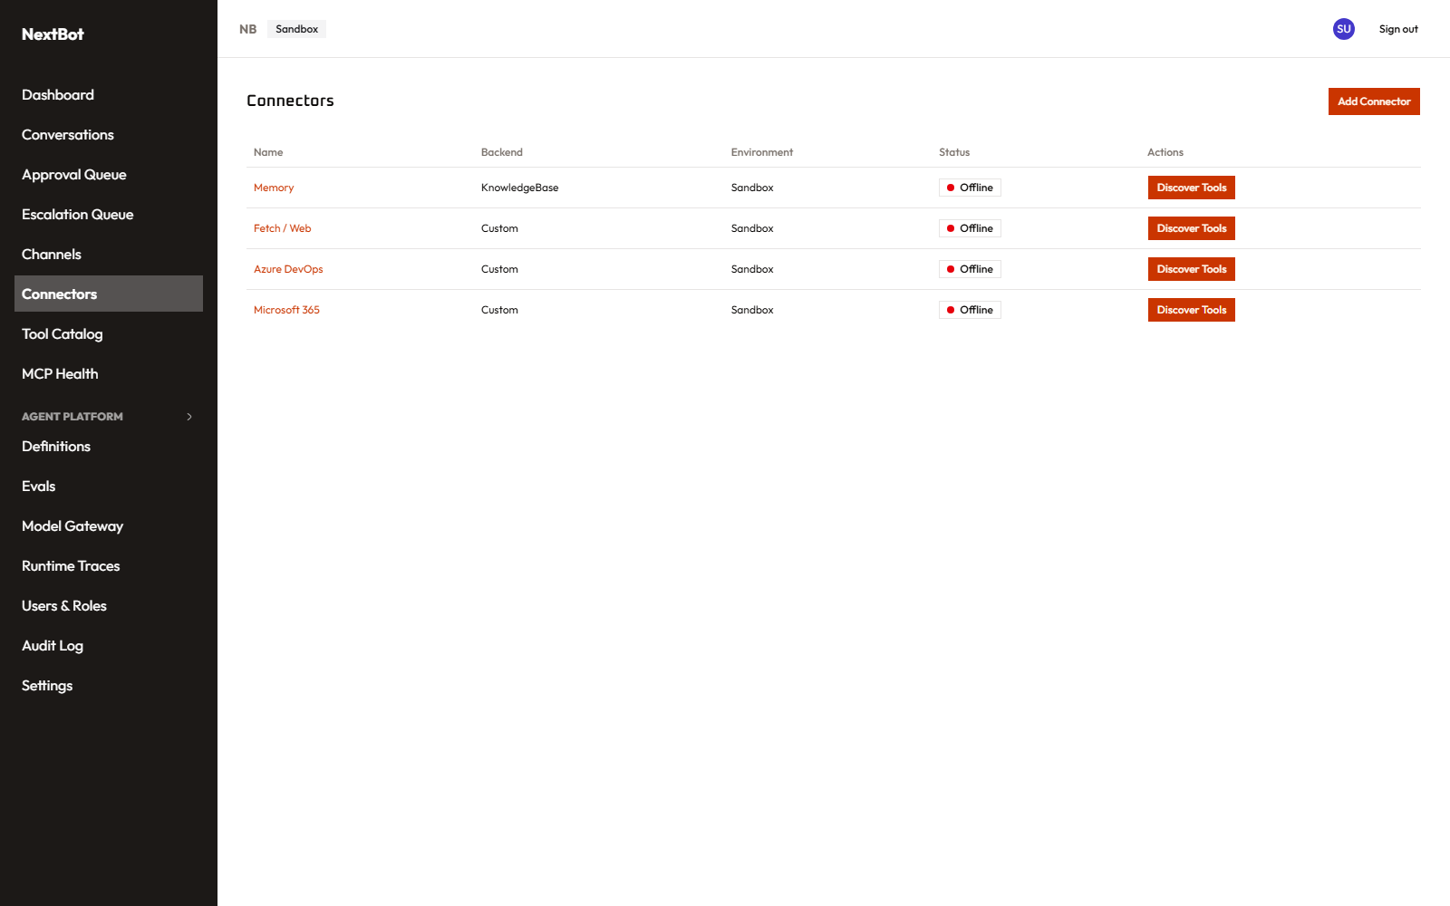
Connectors list
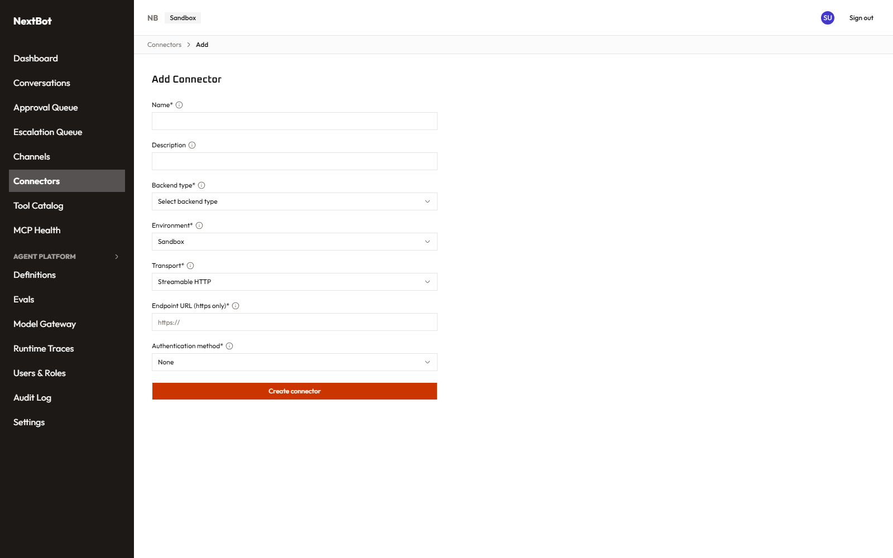
Add connector
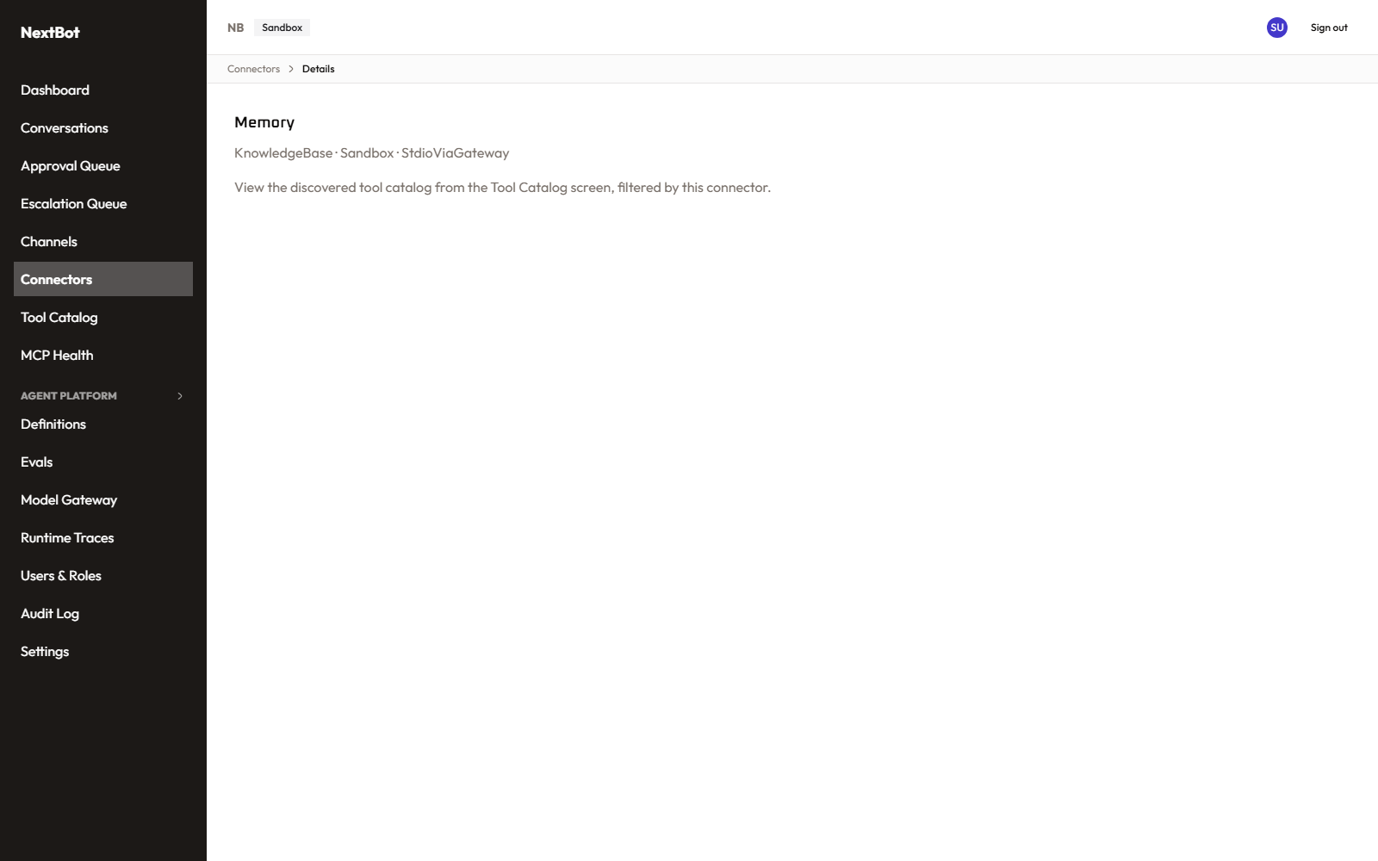
Connector detail

Tool Catalog (/tools, /tools/[id]/permissions) — module: tool_permissions
Every tool discovered across every connector, in one searchable list, tagged with its read/write classification and its approval tier (auto/logged/human-approval-required). Two controls sit behind a different permission module (agent_tool_config) than the list itself: whether a tool is visible to agents at all, and its priority weight when several tools could serve the same request — so a viewer with Read on the catalog but not on tool configuration can see everything and change nothing. Each tool’s own permissions page lets you write explicit allow/deny rules scoped by tool, connector, or backend type, with a “simulate” preview of what a given rule set would actually decide.
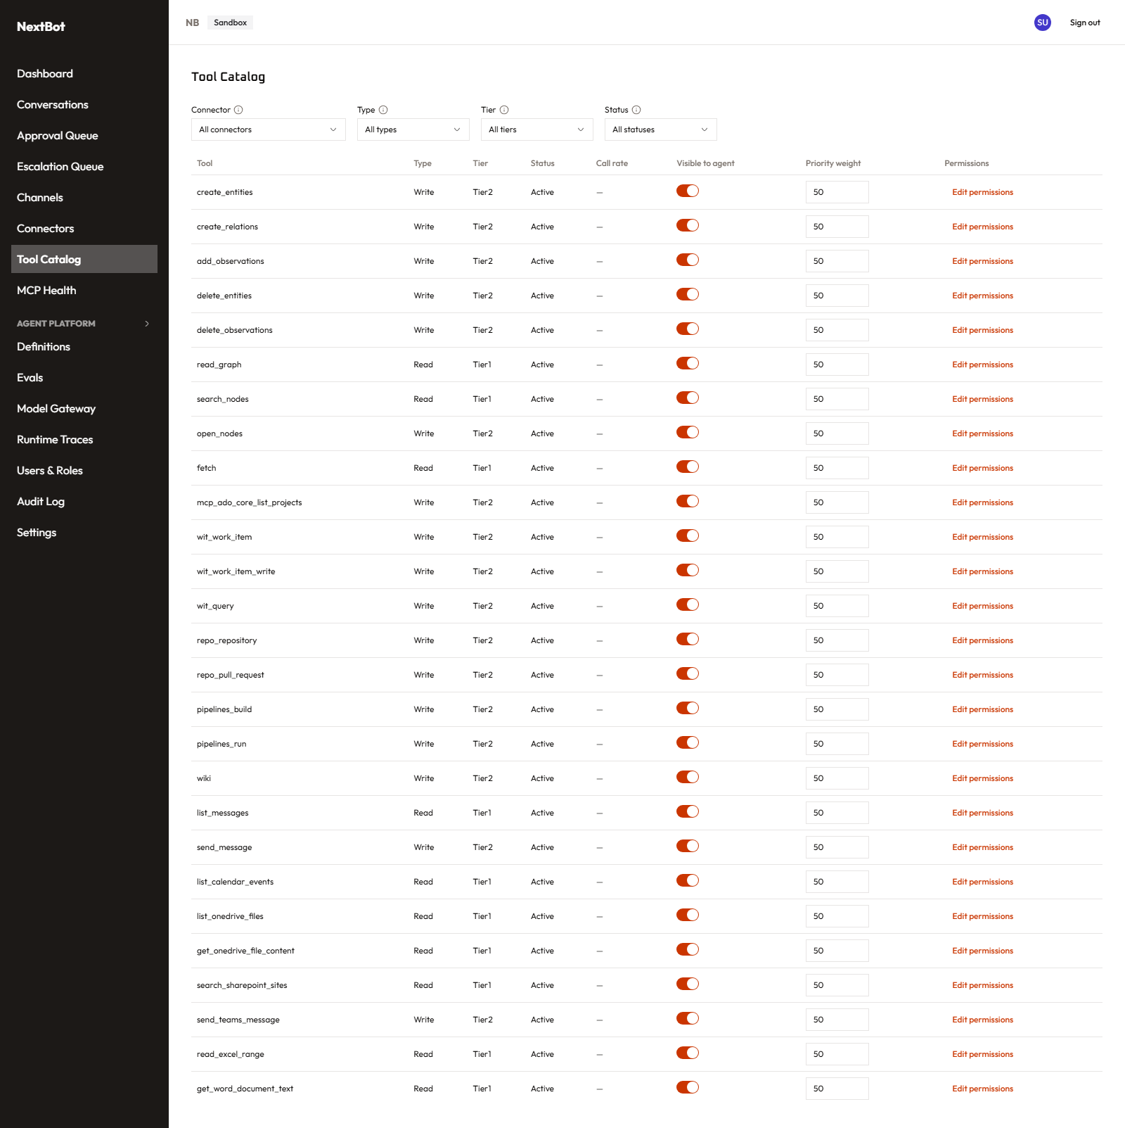
Tool Catalog
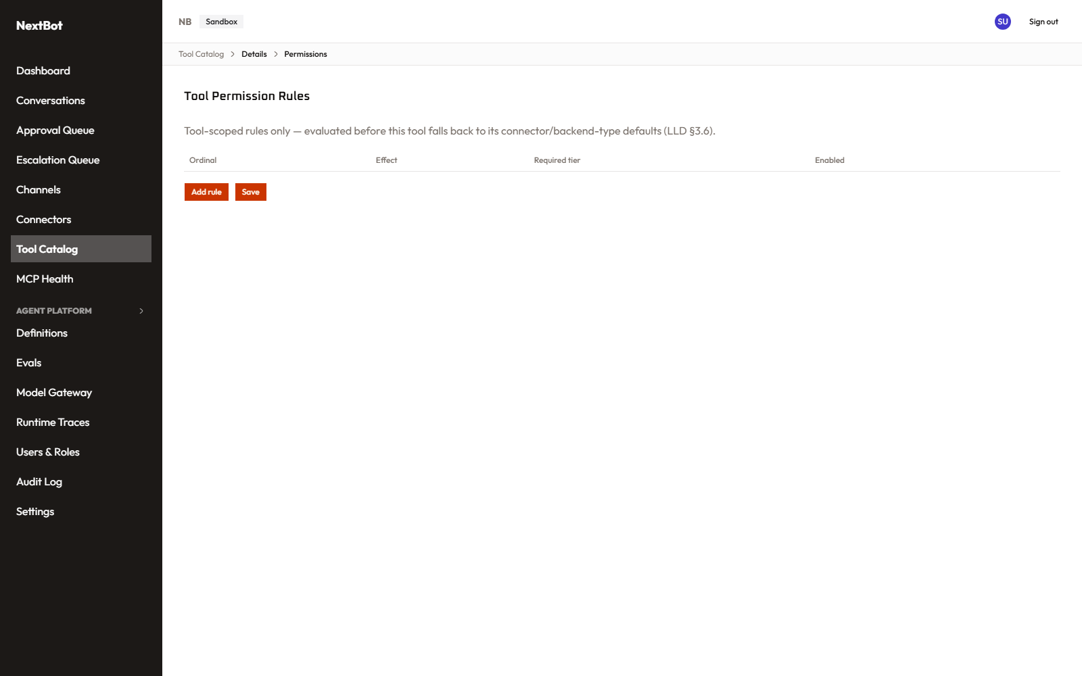
Tool permission rules

MCP Health (/mcp-health) — module: connectors
Two tabs. Health: live status per connector/tool, latency, and recent error history — the operational view for “is anything broken right now.” Alert Configuration: per-connector/tool alert rules (a threshold, a destination, and for email destinations a target address) — this used to be its own separate page (/settings/connector-alerts) but was folded in here as a tab, since alert configuration is really part of health monitoring, not a tenant-wide setting; the old URL still works, it just redirects here.
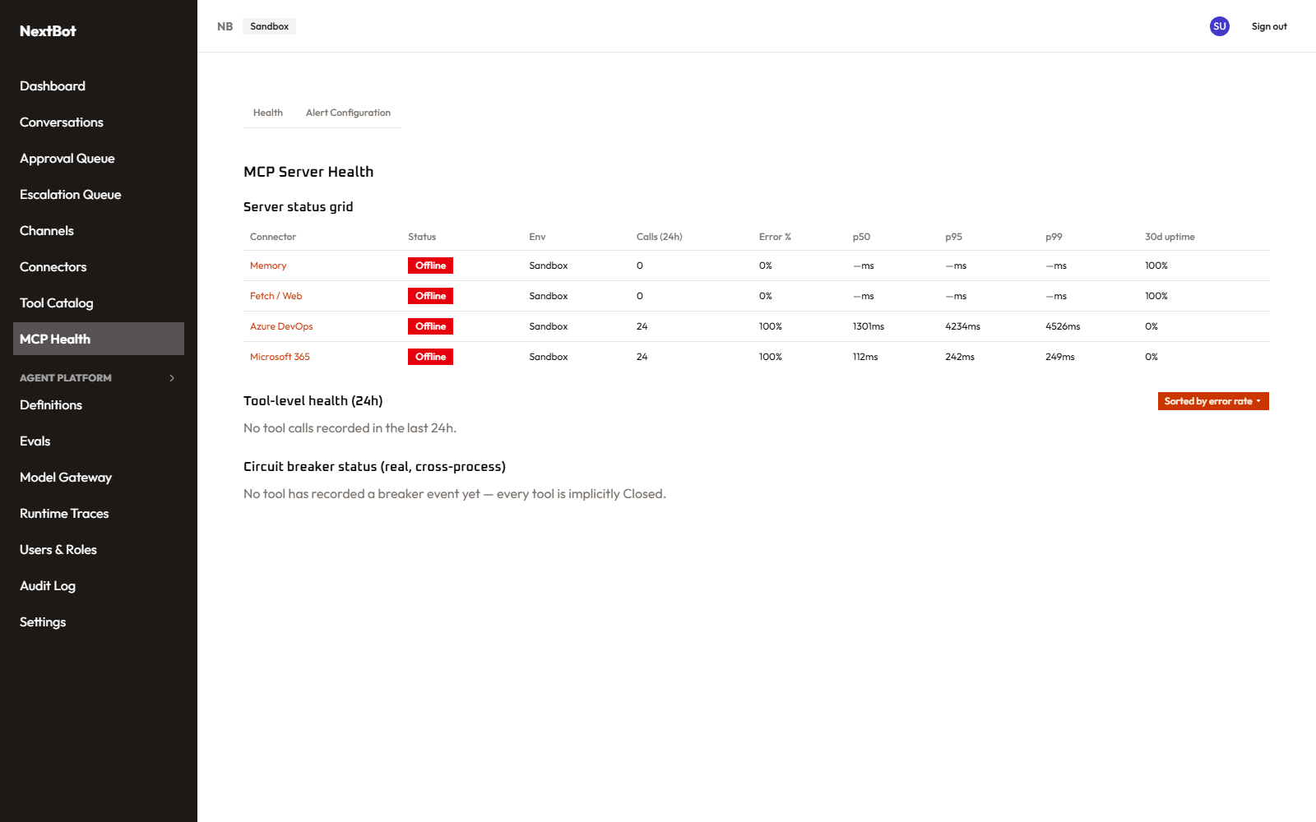
MCP Health — Health tab
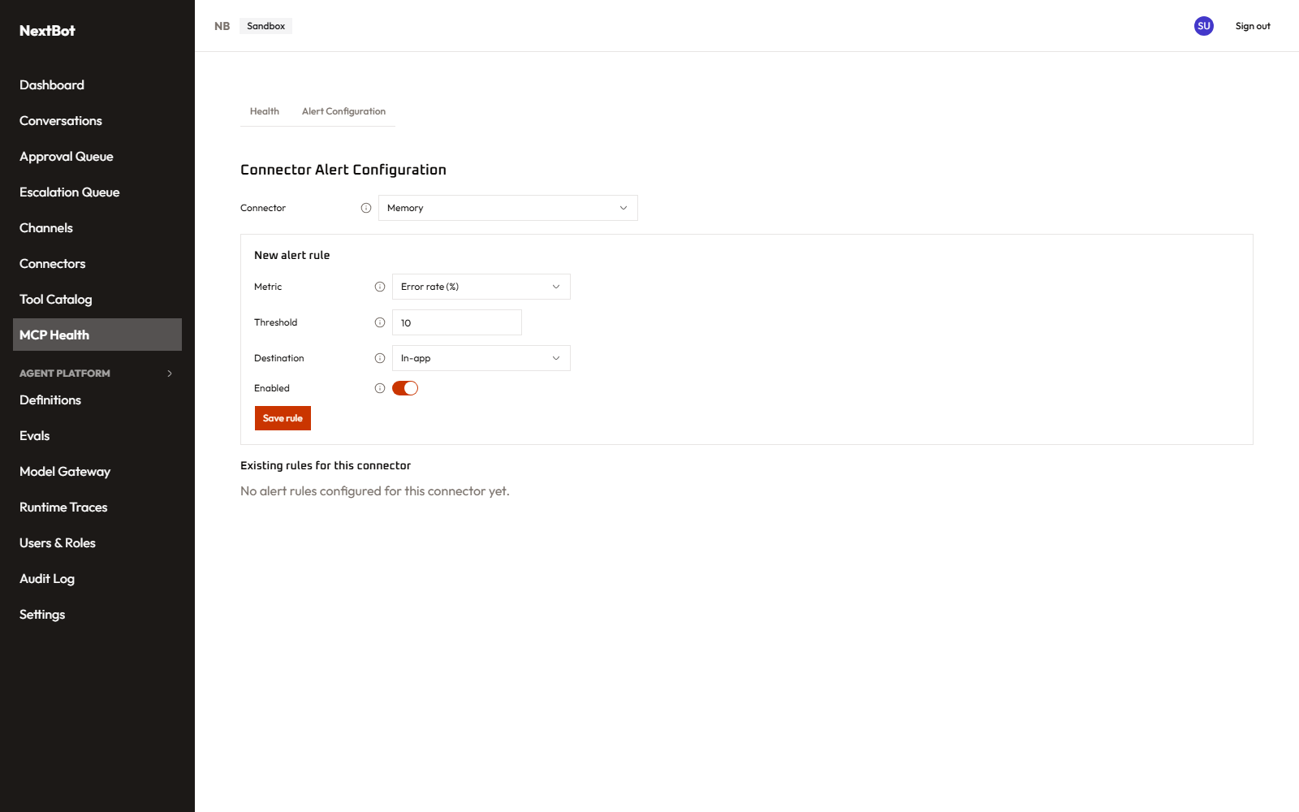
MCP Health — Alert Configuration tab

3. Agent Platform — building and running agents
Everything in this section shares one sidebar group (“Agent Platform”) and one permission module (agent_platform).

Definitions (/agent-platform/definitions, /agent-platform/definitions/[id])
An agent definition is the named, versioned “thing” a channel actually talks to — think of it as the agent’s identity, with a history of versions underneath it. The list shows every definition, its version count, and which version (if any) is live in Production. A definition’s detail page lists every version with its status (Draft → EvalGated → HumanReview → Approved → Production → Deprecated), whether it has a linked Git commit/PR, and row actions: open it, compare two versions, promote one, or Restore an old version — which creates a brand-new version pre-filled with that old one’s content (versions themselves are immutable and never mutated; restoring is “author a new version from an old one,” not a rollback).
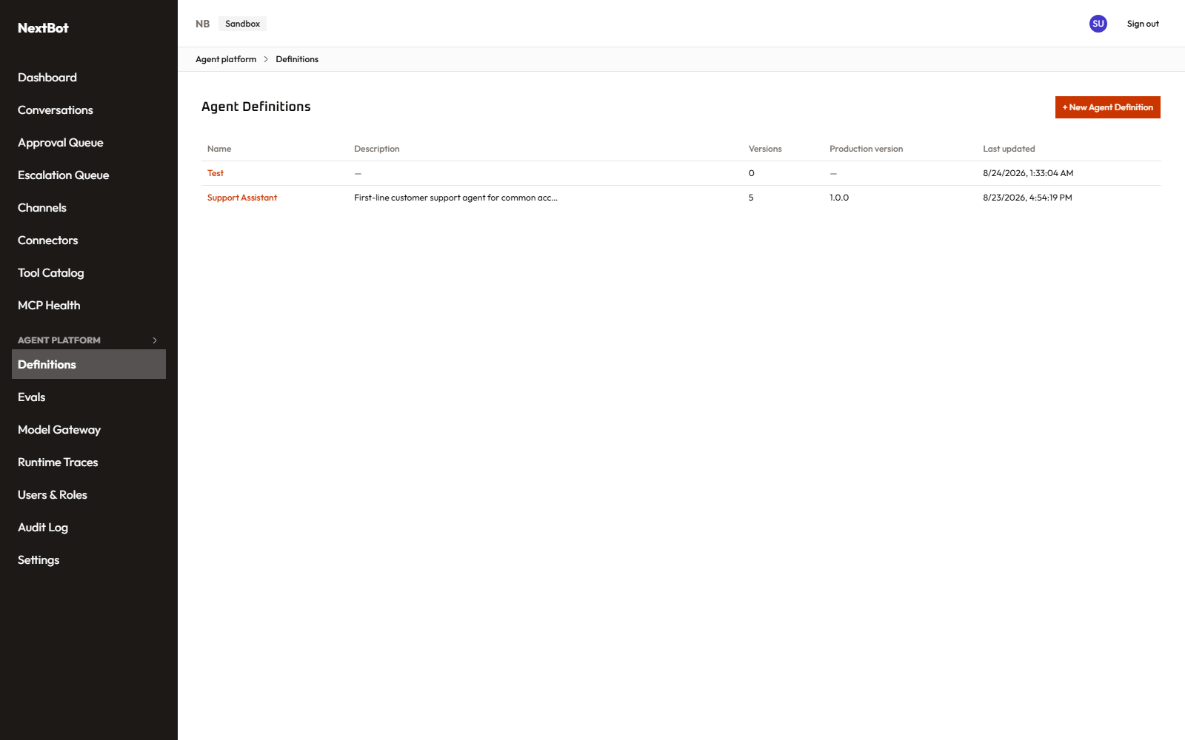
Agent Definitions list
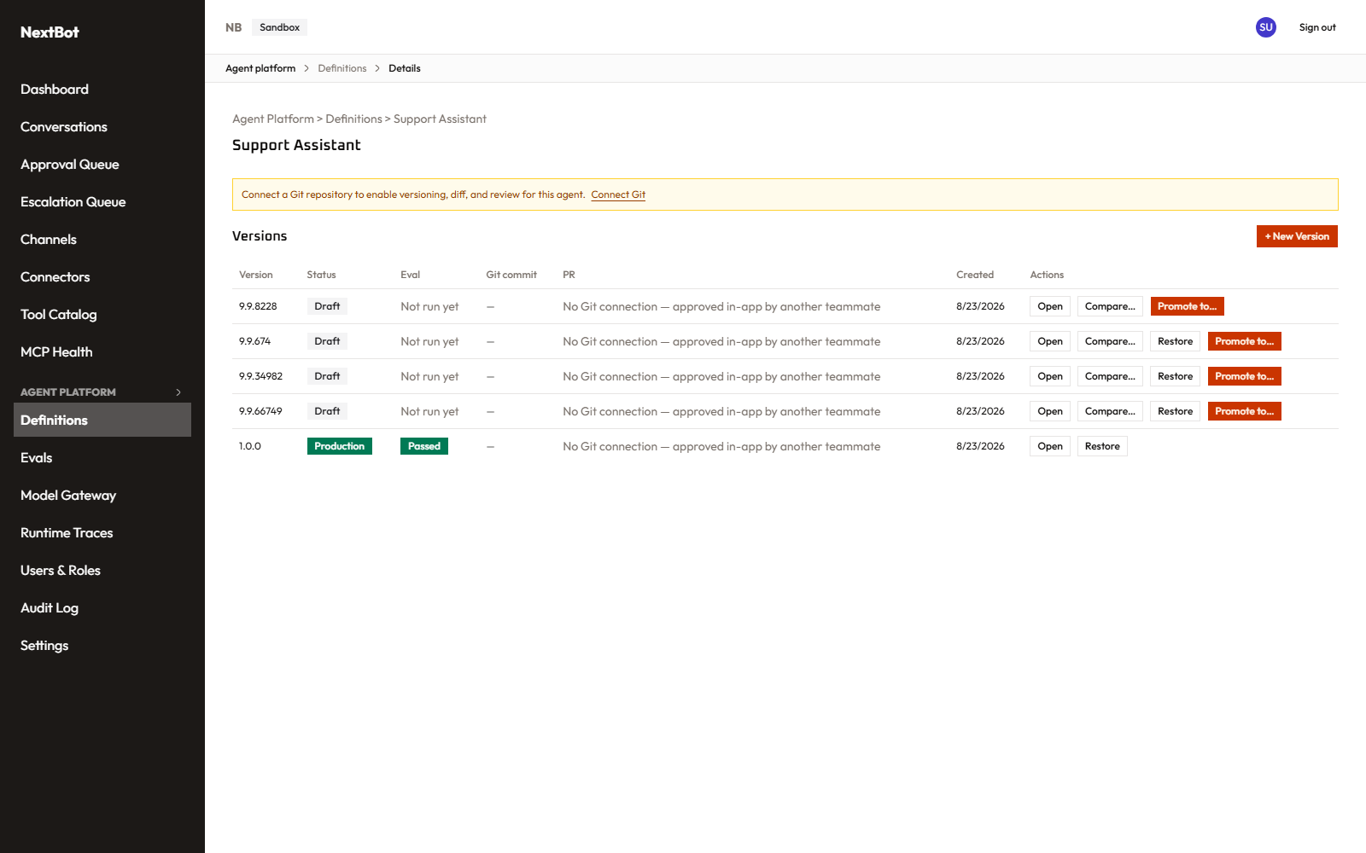
Agent Definition detail

Create/edit a version (/agent-platform/definitions/[id]/versions/new)
This is where an agent’s actual behavior gets authored, in one of two interchangeable modes: - Text mode: a raw YAML editor for the full definition (model route, system instructions, tool policy, guardrails, memory strategy, eval suite, cost/latency budgets). - Design mode: the identical content as a real structured form — a section per concern, including a real picker for which Tool Registry capability groups (e.g. “Knowledge & Web,” “DevOps & Code”) this version’s tool calls are scoped to, instead of hand-typing group names.
Switching tabs re-derives one representation from the other, so either mode can be used to build the same version and the YAML underneath is always what actually gets validated and saved — Design mode is a friendlier way to produce it, not a separate system. A version can be created and edited entirely without ever connecting a Git repository (Git sync, when connected, is a bonus for diff/PR review — never a requirement to make progress).
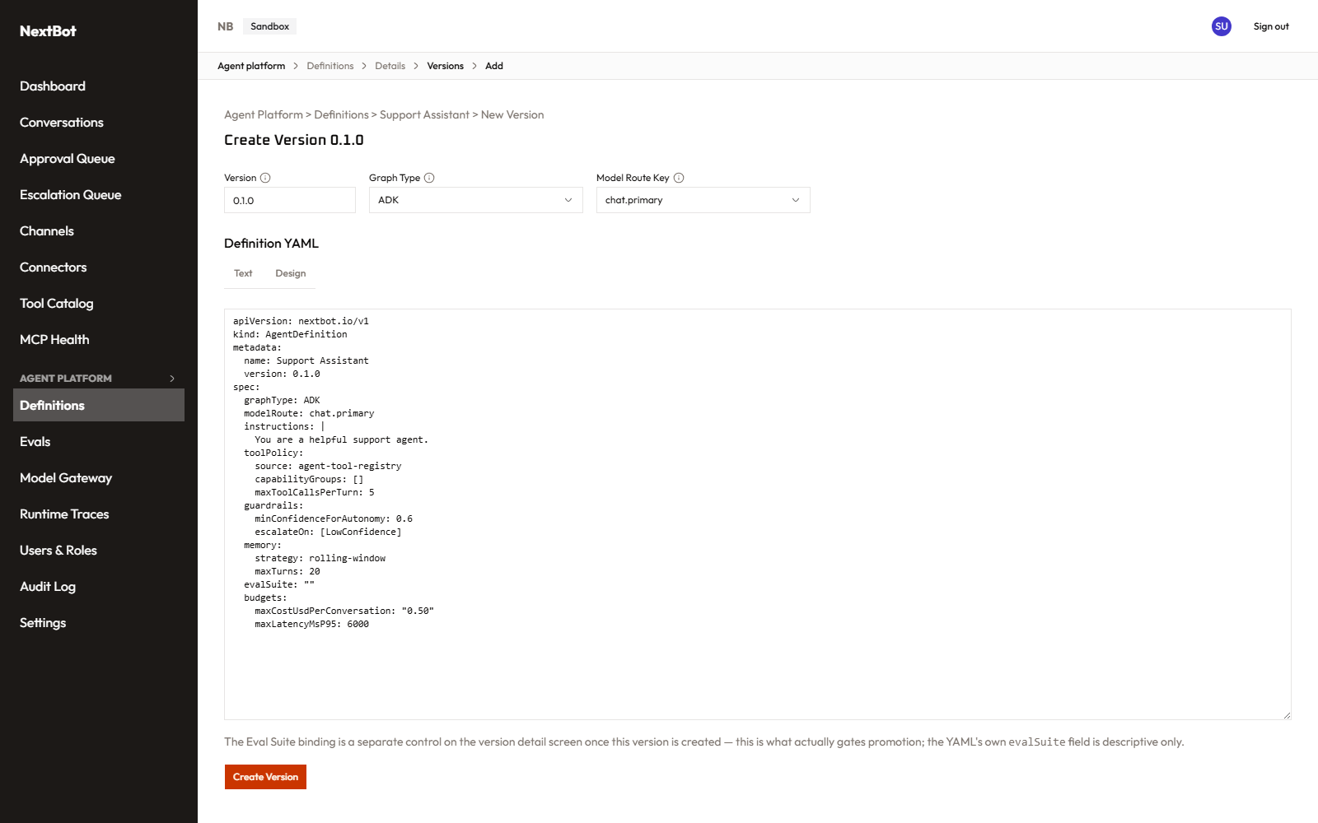
Create version — Text mode
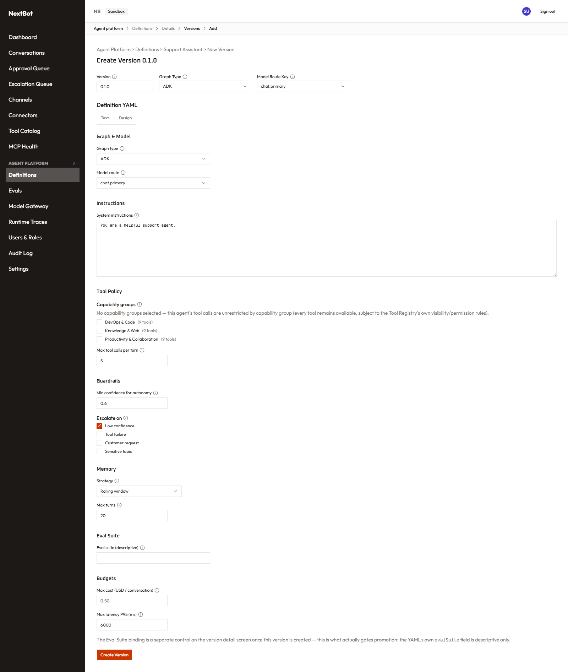
Create version — Design mode

Promoting a version (Definitions detail page)
Moving a version through Draft → … → Production requires, at the last step: (1) a passing eval-suite run, (2) approval from someone other than whoever created the version (an in-app reviewer≠author check — this stands in for Git PR review when no Git repo is connected, and is enforced either way), and (3) at least one completed sandbox test conversation against that exact version (see below) — so nothing reaches real customers without both a second pair of eyes and a real conversation having actually been tried against it. Promoting a follow-up version for an agent that’s already live in Production correctly replaces the prior deployment rather than trying to run two at once.

Version detail (/agent-platform/versions/[versionId])
Three tabs on one version: Overview (the read-only YAML — versions never change after creation, so this is always exactly what was saved), Eval (bind an eval suite, run it, see per-case pass/fail history), and Sandbox — a real, live chat panel running this exact version in an isolated test conversation, invisible to real customers and never resumable, which is both how a person manually tries a version before promoting it and the mechanism that satisfies the sandbox-test promotion gate above.
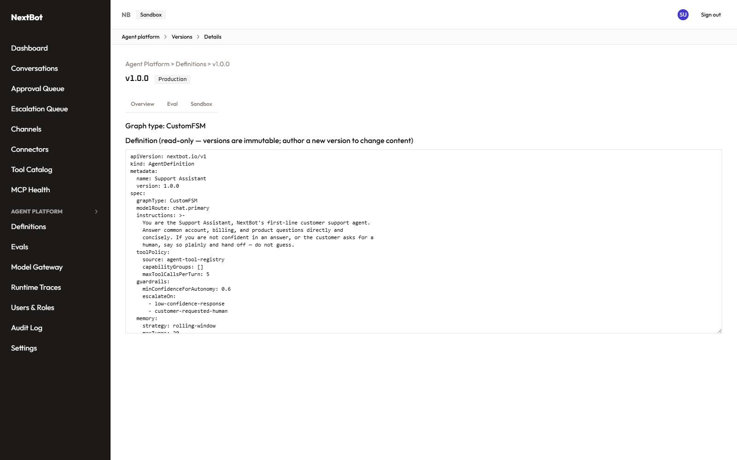
Version detail — Overview tab
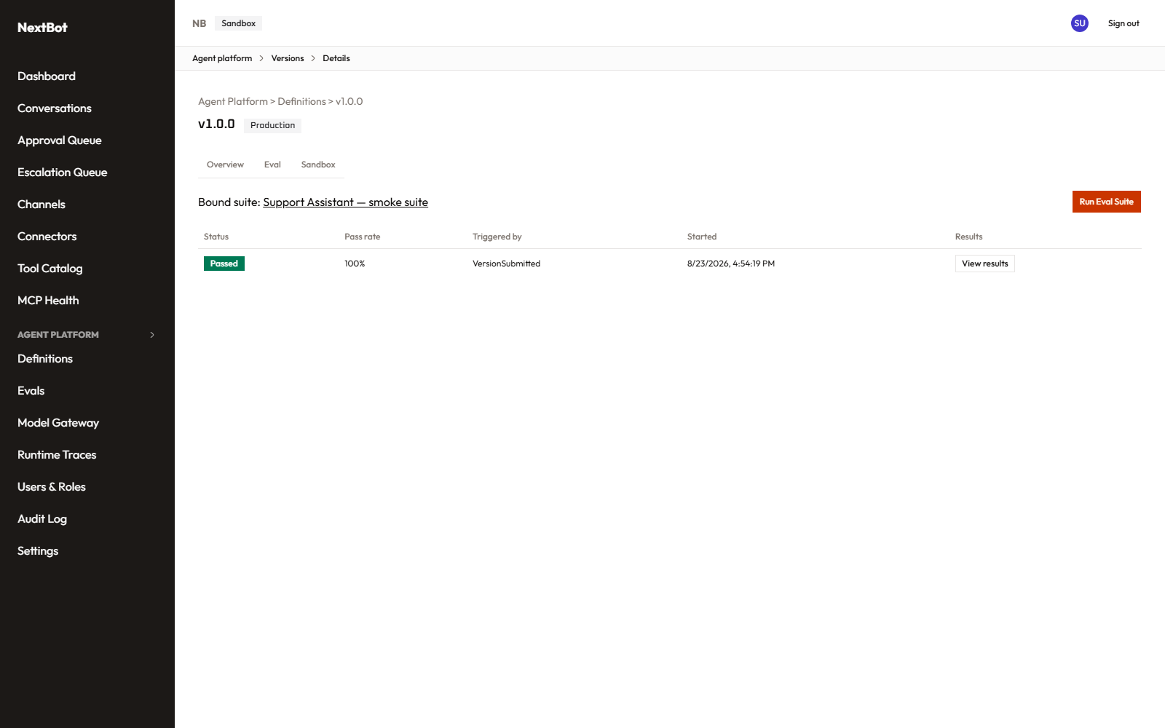
Version detail — Eval tab
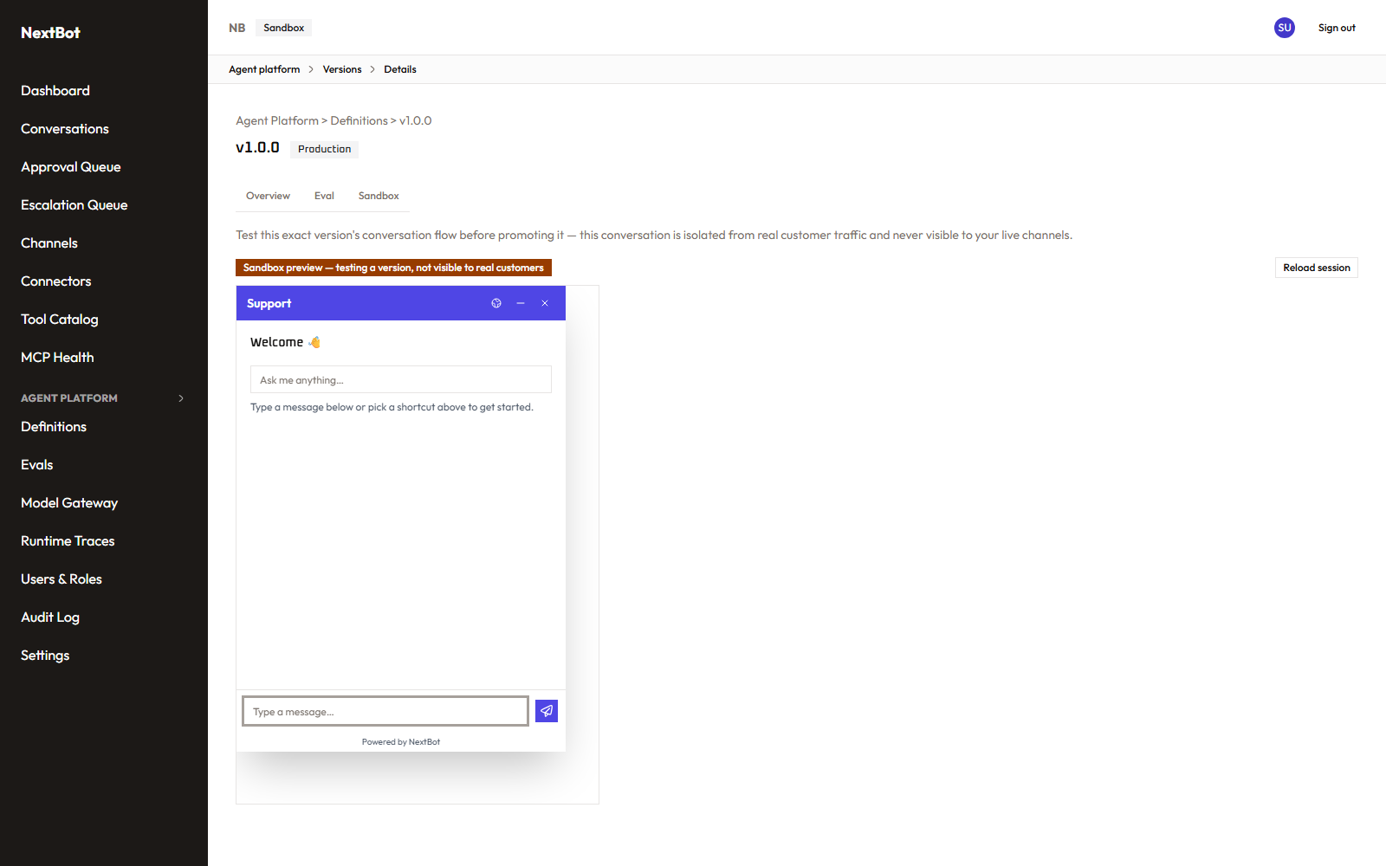
Version detail — Sandbox tab

Evals (/agent-platform/evals, /agent-platform/evals/[id])
An eval suite is a named set of test cases — each a scripted mini-conversation with an expected-response pattern, a pass threshold, and a cost/latency budget — used to mechanically check whether a version behaves as intended before a human ever looks at it. The detail page is where individual cases get authored and run.
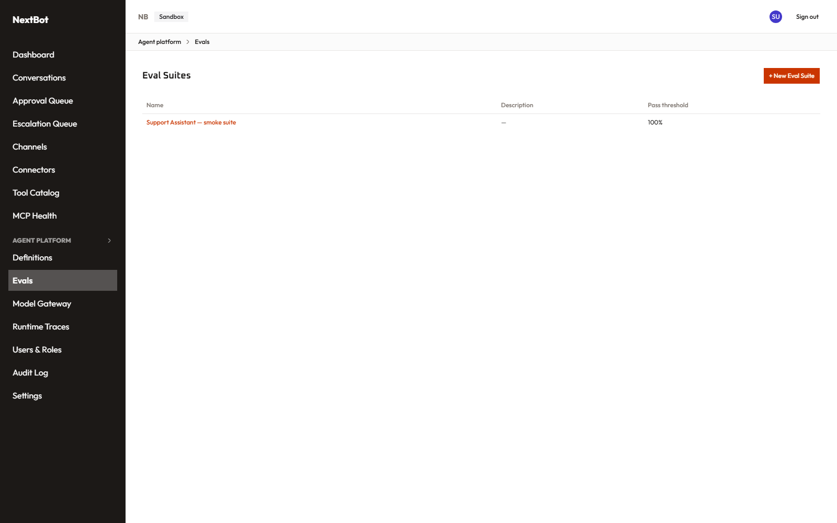
Eval Suites list

Model Gateway (/agent-platform/model-gateway)
Two tabs. Routes: the named model routes an agent’s modelRoute field points at (e.g. chat.primary) — each is a chain of one or more providers, either a platform-registered one or a “bring your own endpoint” with its own credential, plus cache mode and timeout settings; editing a route opens a side panel rather than an always-open form, to keep the list itself readable. Provider Registry: a read-only list of the platform-level providers available to route to. Model names typed here are lightly validated (no stray whitespace/@-shaped strings) to catch the obvious data-entry mistake of pasting the wrong thing into the field.
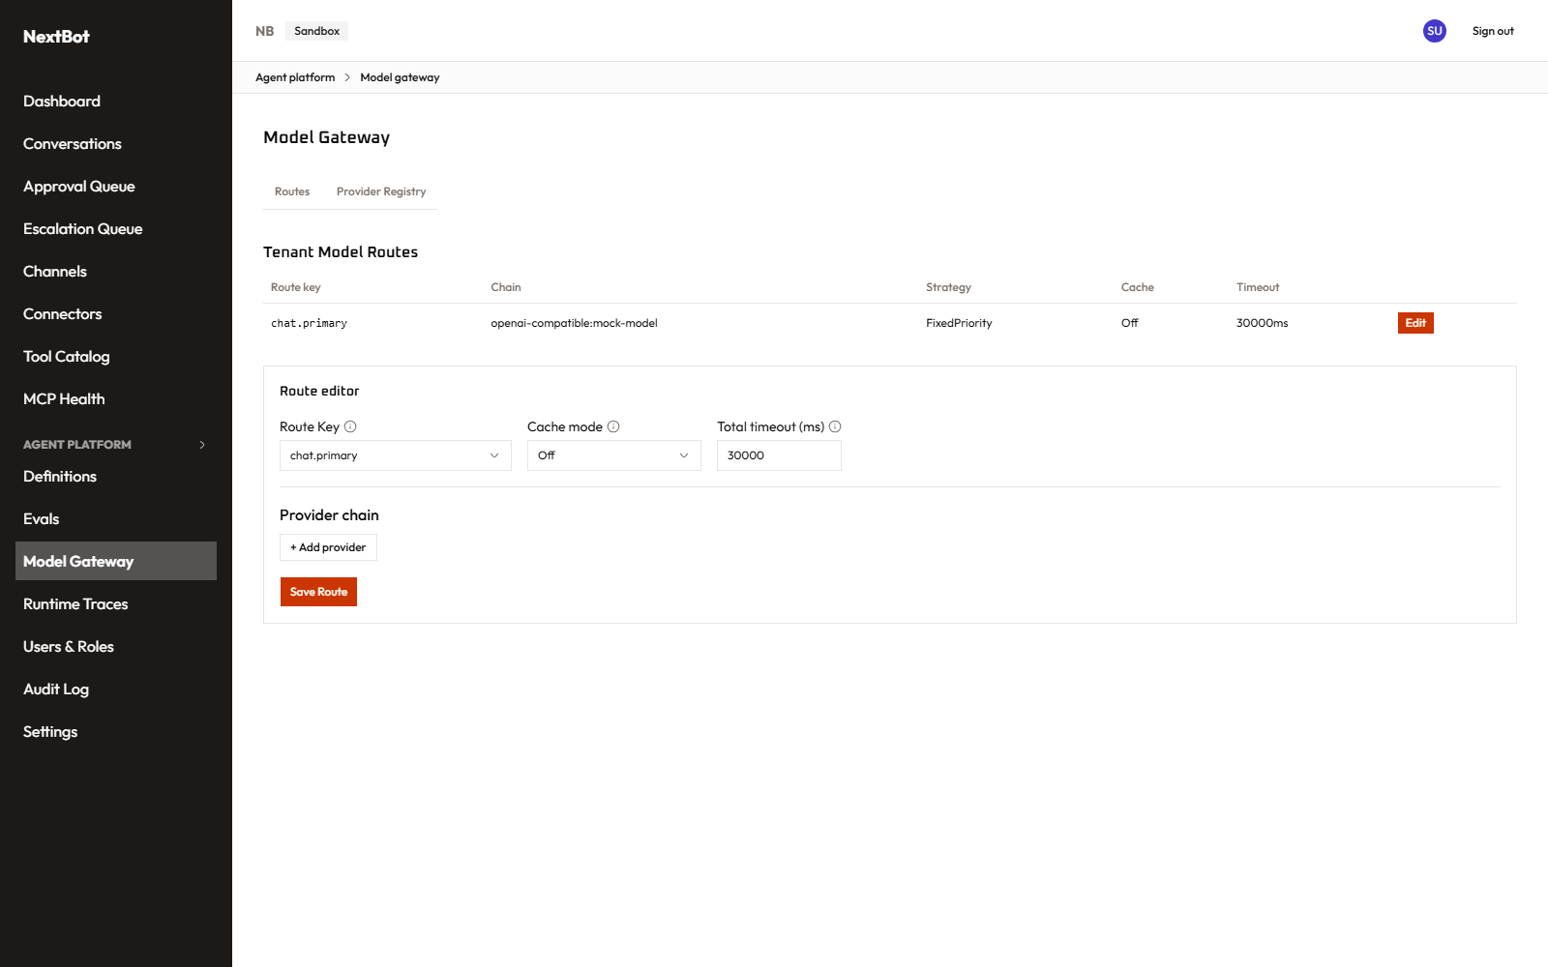
Model Gateway — Routes tab
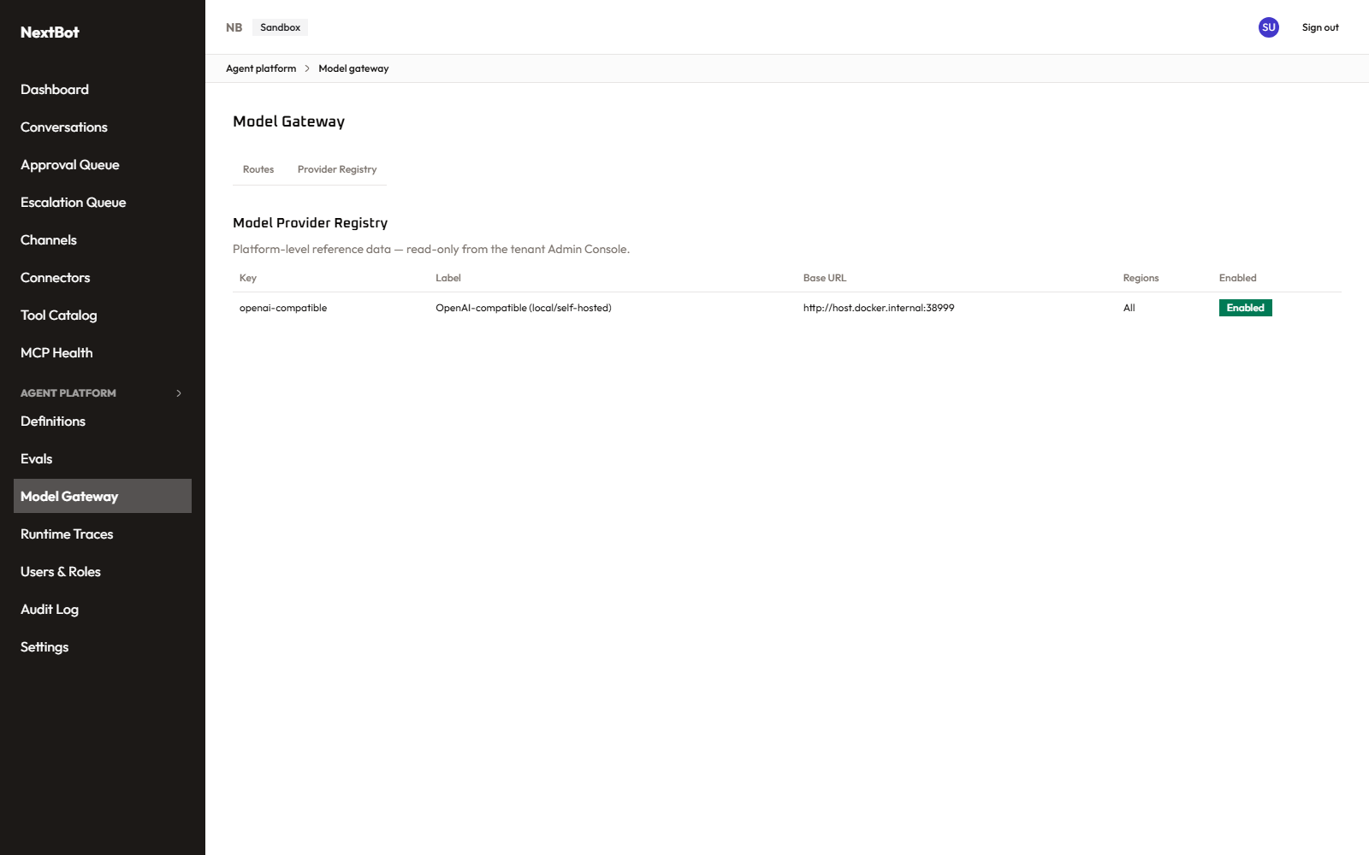
Model Gateway — Provider Registry tab

Runtime Traces (/agent-platform/traces)
A filterable log of real agent-run executions — which definition/version handled a given turn, how long it took, and what happened — useful for debugging a specific run after the fact rather than watching health in aggregate.
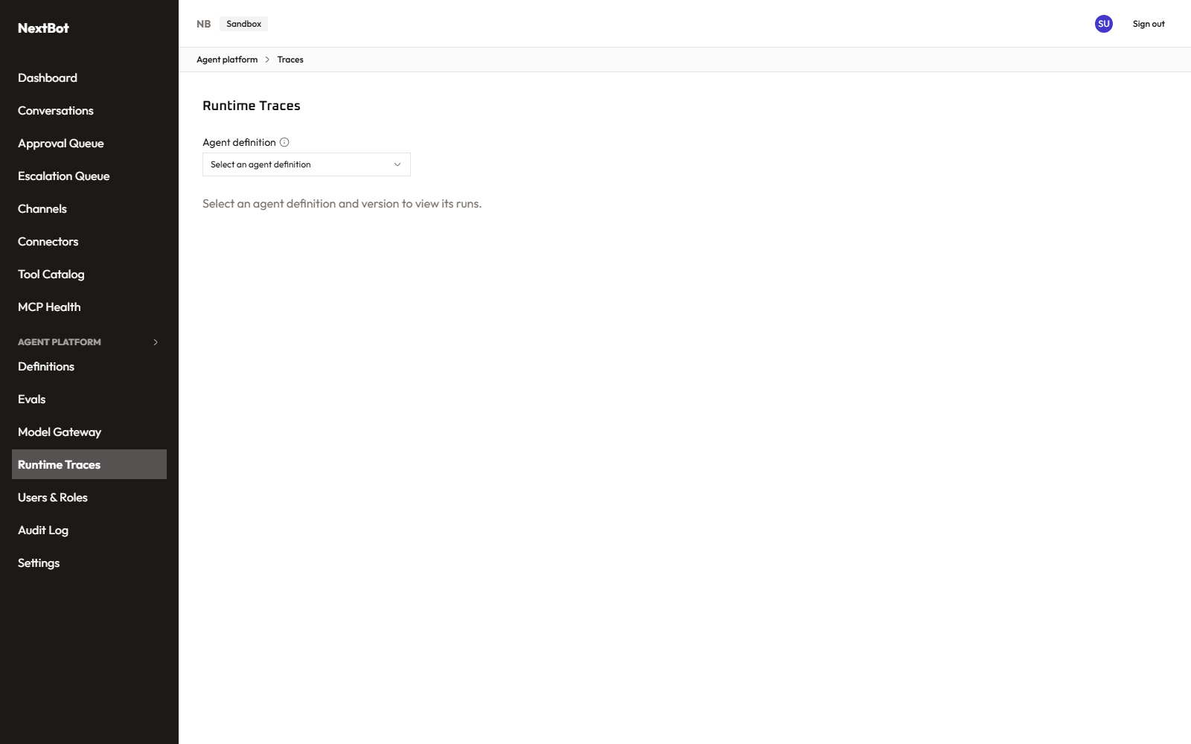
Runtime Traces

Diff (/agent-platform/diff)
Side-by-side comparison of two versions’ YAML — reached from a definition’s “Compare…” action, not from the sidebar directly. Only available when both versions have a real Git commit behind them (this is a genuine Git-provider diff API call, not a local text diff), since a version without one has nothing on the Git side to compare.

4. Settings

Settings hub (/settings)
A landing page of cards linking to every tenant-configuration screen below, added so there’s one obvious place to start rather than a flat list of unrelated sidebar entries. Each card only appears if the signed-in role can actually read that screen — same fail-closed rule as everywhere else, just applied per-card instead of per-nav-item. (Model Gateway isn’t listed here — it stays grouped under Agent Platform, since that’s where the underlying spec places it.)
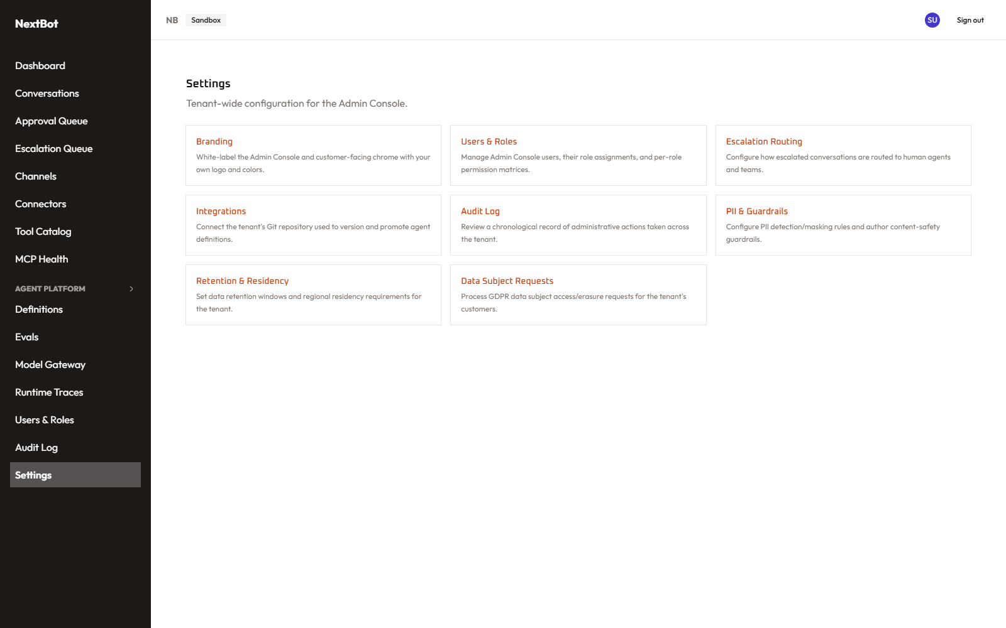
Settings hub

Branding (/settings/branding) — module: security_settings
Primary/secondary color, logo, favicon (auto-generated from the logo if none is supplied separately), and font. An optional “white-label” toggle extends the tenant’s colors into the Admin Console’s own top bar and sidebar chrome (scoped narrowly to those, not repainted across every button in the app) and onto the public login page for that tenant.
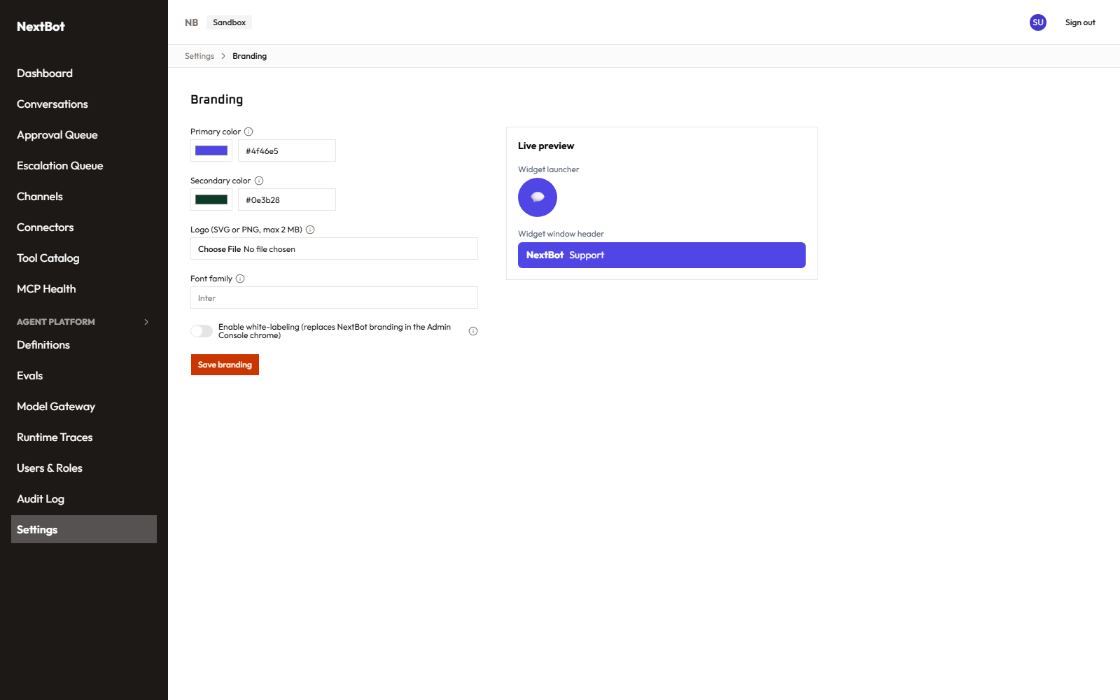
Branding settings

Escalation Routing (/settings/escalation-routing) — module: escalations
Rules mapping a recognized goal/channel combination to a specific queue, plus a fallback rule for anything that doesn’t match — this is what decides which team an escalated conversation lands in front of.
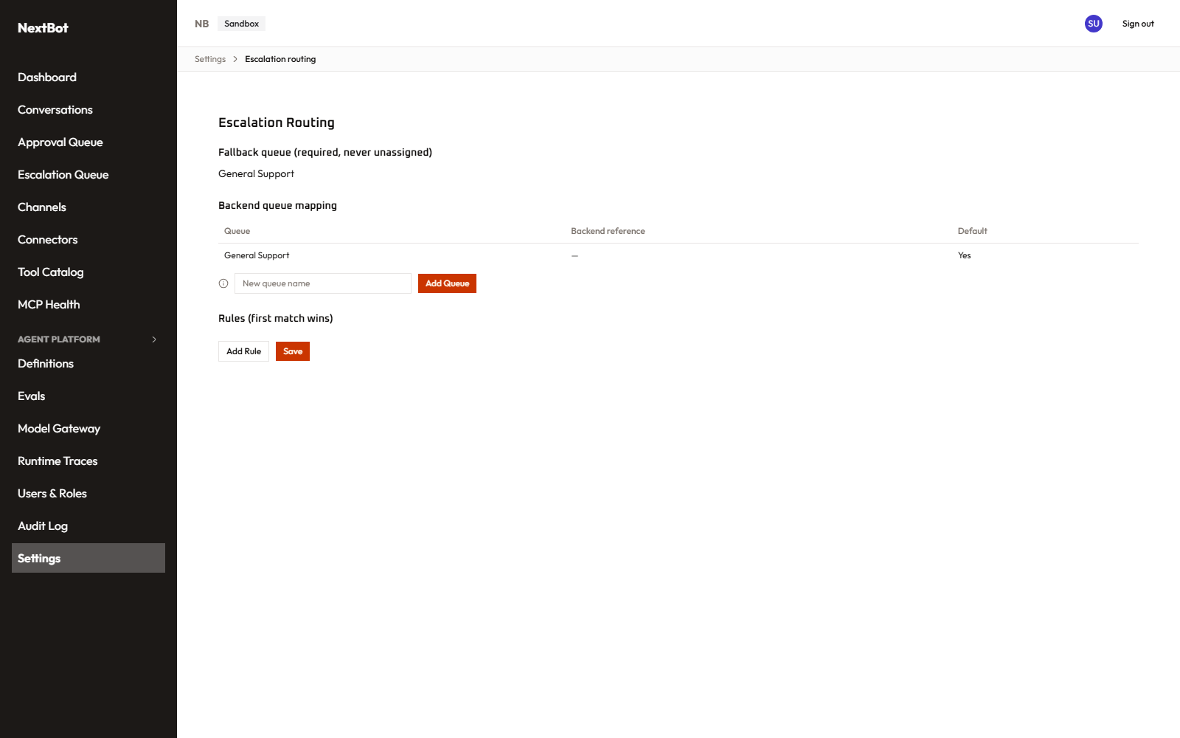
Escalation Routing settings

Integrations (/settings/integrations) — module: agent_platform
The tenant’s single Git connection (GitHub or GitLab), used for optional version sync/PR review in the Agent Platform. One connection per tenant, not per agent. Connecting is a real OAuth handshake; the callback screen (/settings/integrations/git-callback) completes it and shows a mandatory data-residency disclosure before the connection is finalized.
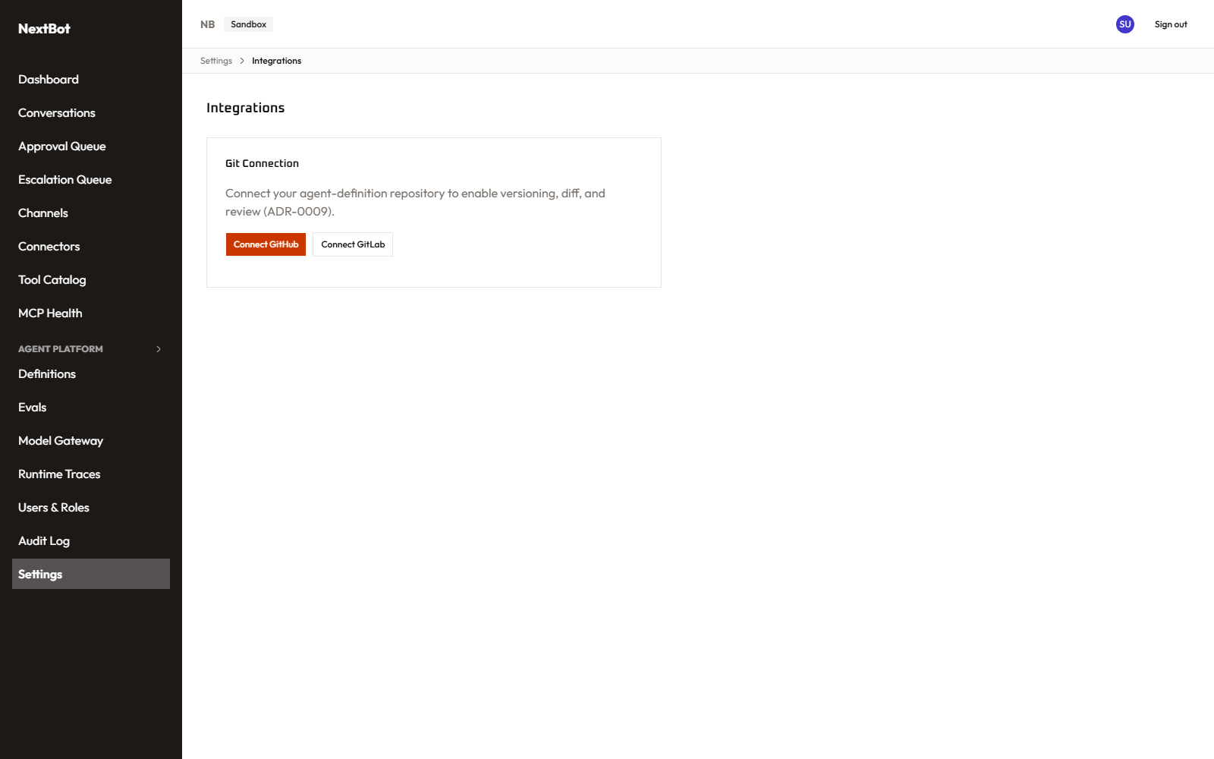
Integrations settings

PII & Guardrails (/settings/pii-guardrails) — module: security_settings
Three related configuration surfaces: detection rules (which PII entity types to recognize, including custom regex-based ones), a masking-context matrix (how to treat a given entity type in a given context/trust-level combination — unconfigured combinations default to full masking, fail-closed), and pre-tool-call guardrails that can block a specific tool call outright with a stated reason.
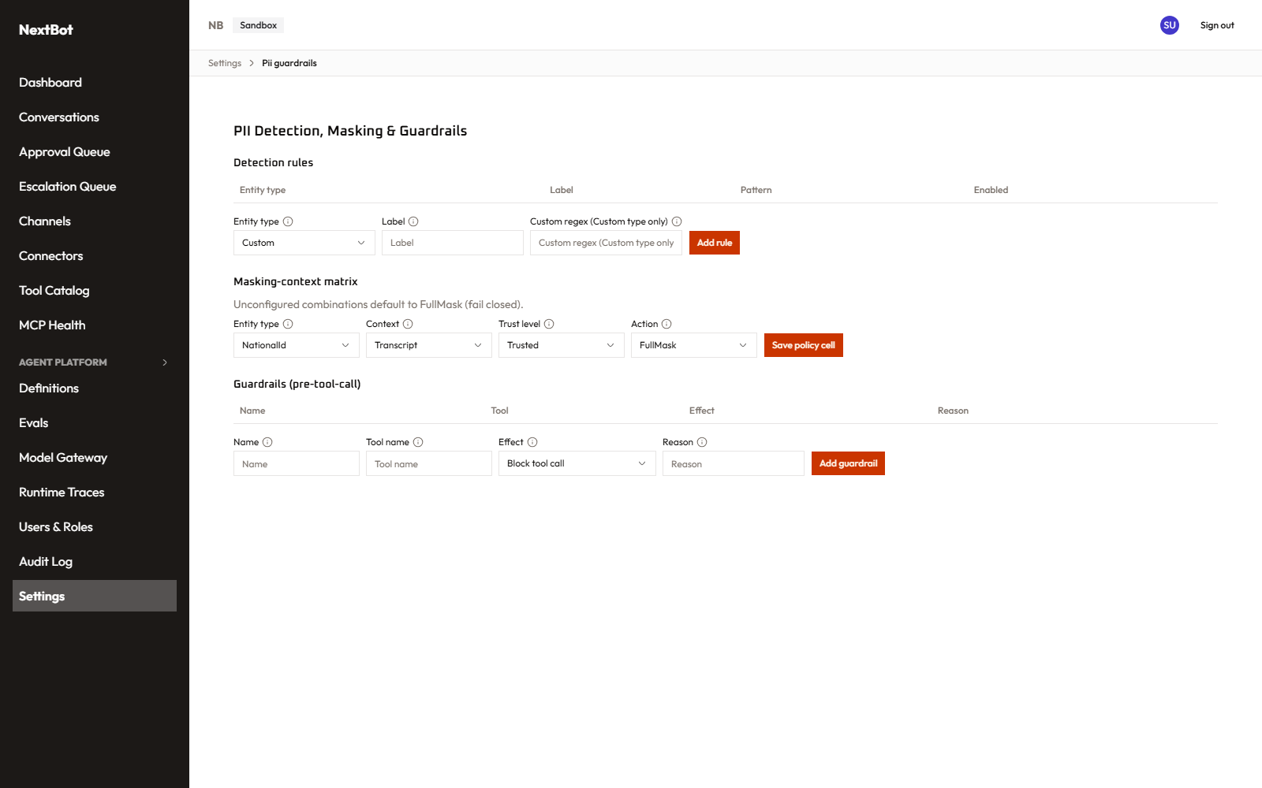
PII & Guardrails settings

Retention & Residency (/settings/data-policy) — module: security_settings
How long conversation data is kept before automatic purge, and which storage region the tenant’s data lives in (plus whether out-of-region inference is permitted for the AI subsystem).
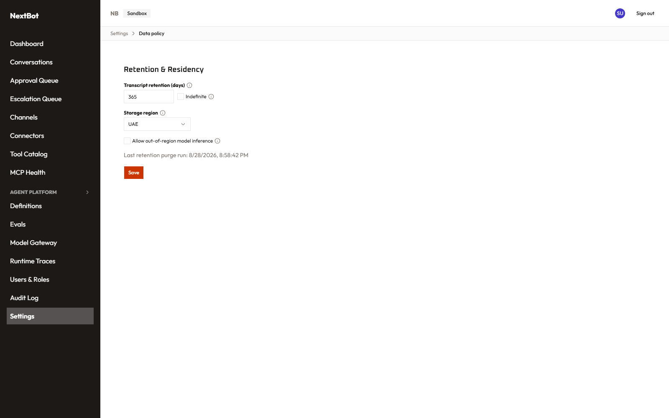
Retention & Residency settings

Data Subject Requests (/settings/dsr) — module: security_settings
The GDPR tool: look up everything stored about a given customer identifier and export or delete it.
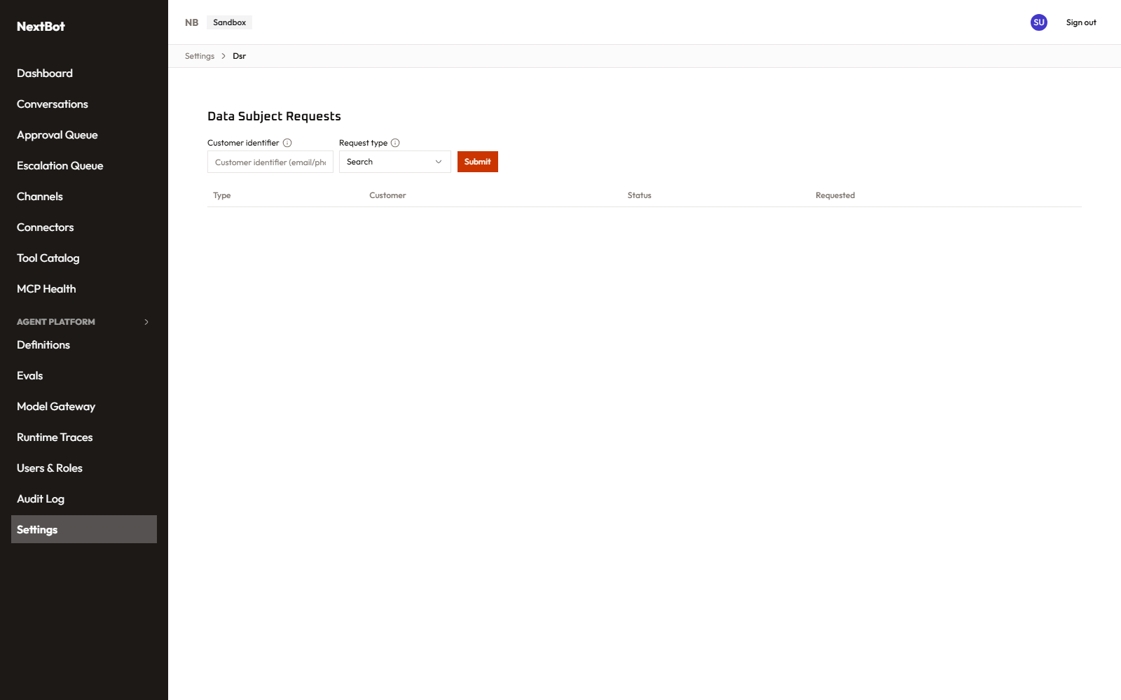
Data Subject Requests

Users & Roles (/roles) — module: users_roles
Every user in the tenant plus the role/permission-matrix editor. A Read-only viewer sees the full picture but every mutating control (invite a user, create/edit a role, change someone’s roles, reset MFA) is disabled rather than hidden, so it’s clear what exists without implying it can be changed.
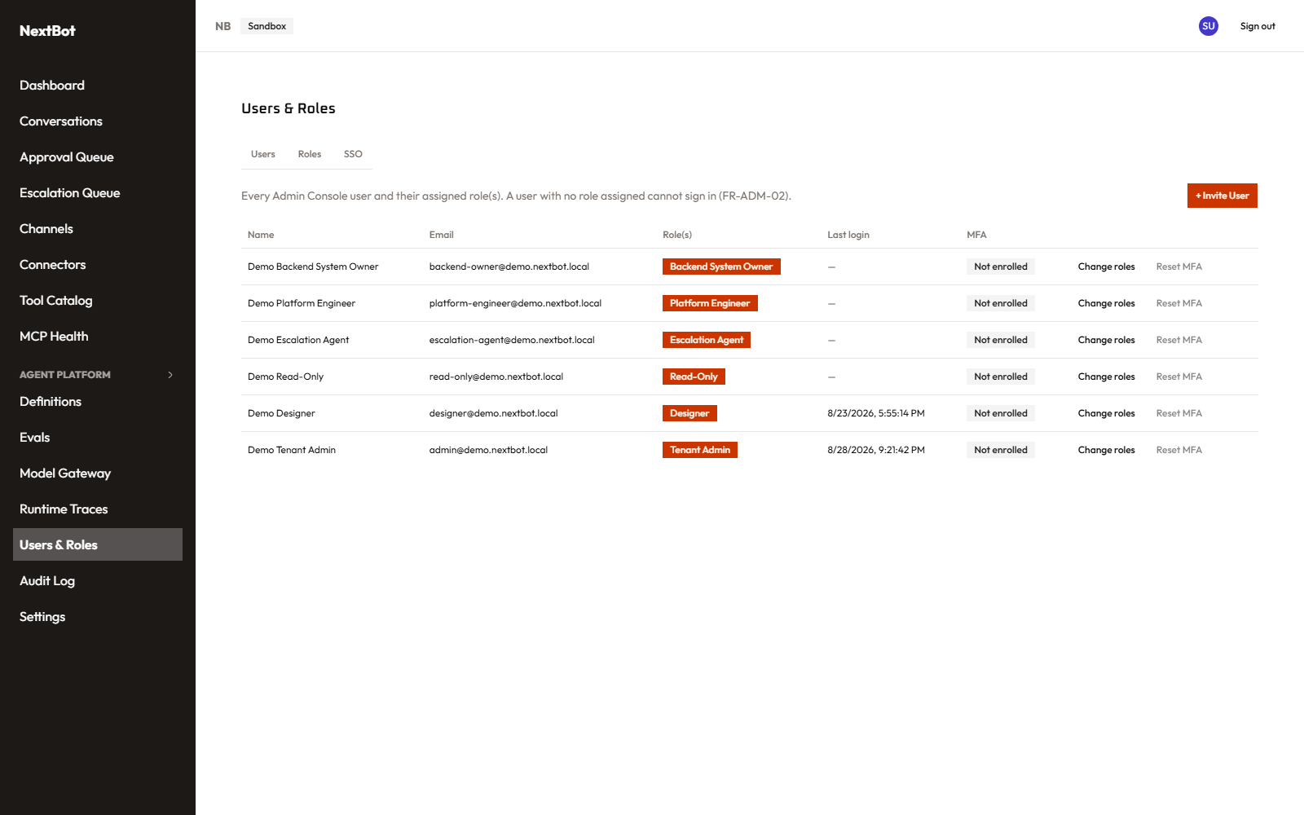
Users & Roles

Audit Log (/audit-log) — module: audit_log
A searchable record of administrative actions (logins, connector changes, permission edits, Tier-3 approval decisions, escalation claims, and more) with real actor attribution, filterable by actor/action type/target type/date/outcome.
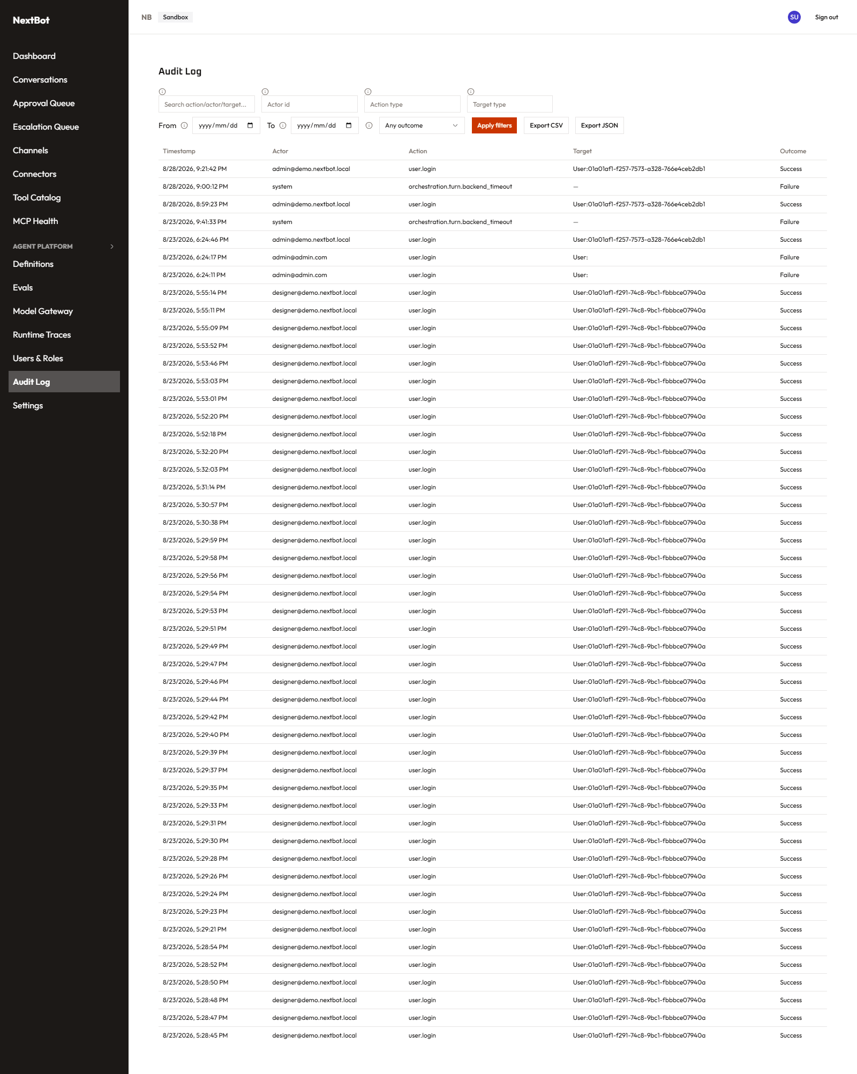
Audit Log

5. Platform Manager console — cross-tenant operator surface
A completely separate, internal-only console (public path /internal/ops/**, gated by an operator token + IP allowlist, not a tenant login) for whoever runs the NextBot platform itself, not any one tenant. Every page here is deliberately built so that a denied request — wrong token, disallowed IP, or the whole feature turned off — is byte-for-byte indistinguishable from that page genuinely not existing, so an outside observer can’t even confirm this console is there, let alone reachable.

Login (/internal/ops/login)
Operator token entry, rate-limited. (Screenshot in §1.)

Tenant List / Detail / Provisioning (.../tenants, .../tenants/[id], .../tenants/new)
Every tenant on the platform, its status, plan tier, and live quota usage at a glance. The detail page lets an operator change a tenant’s status, relabel its plan tier (without ever silently touching its quota), or explicitly re-seed its quota back to the tier’s current defaults — a separate, deliberate action, never a side effect of relabeling. Provisioning creates a brand-new tenant.
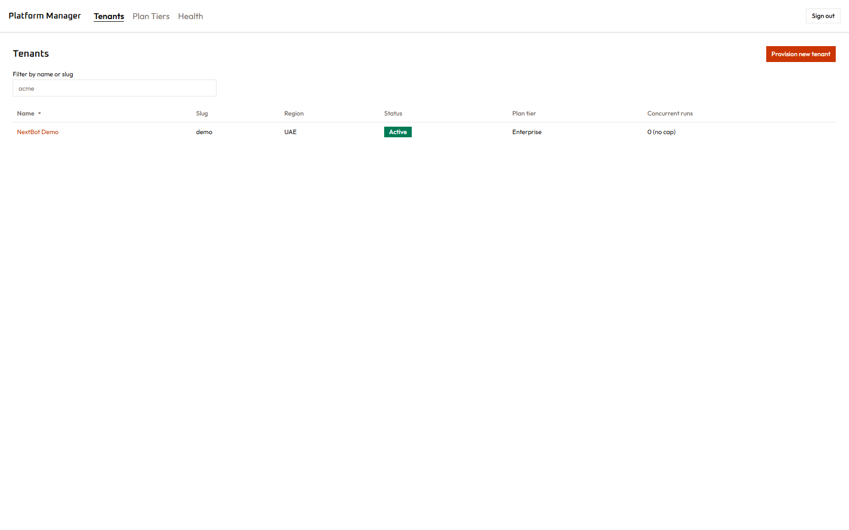
Platform Manager — Tenant List
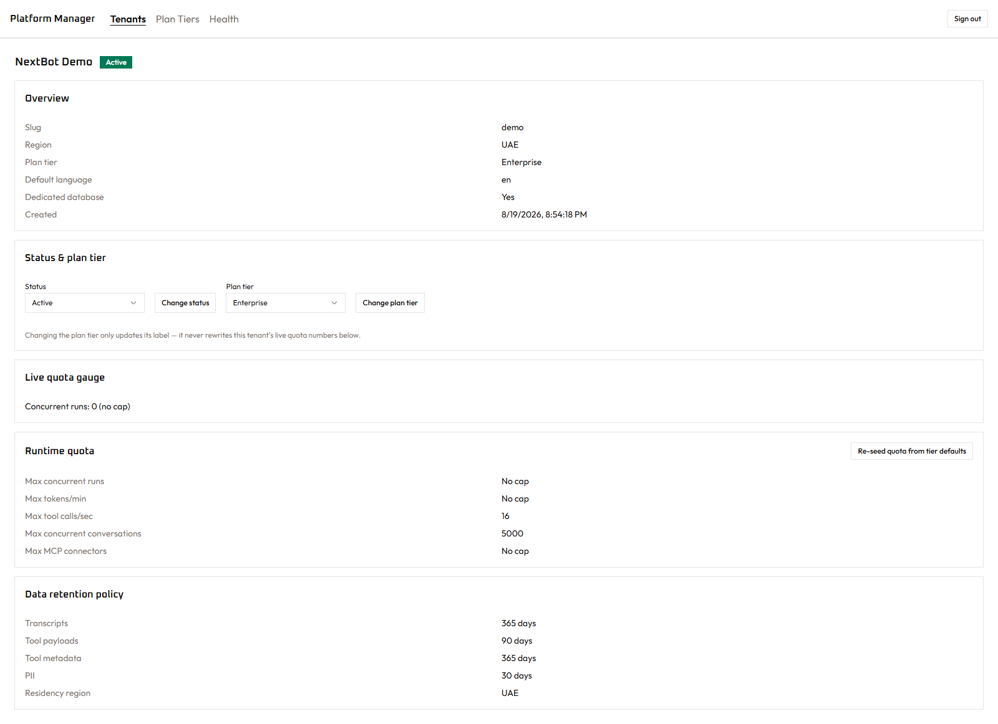
Platform Manager — Tenant Detail

Plan Tiers (.../plan-tiers)
Edit the quota defaults and descriptive feature notes for the Starter/Growth/ Enterprise tiers — these apply to newly-provisioned tenants going forward, never retroactively to an already-running tenant.
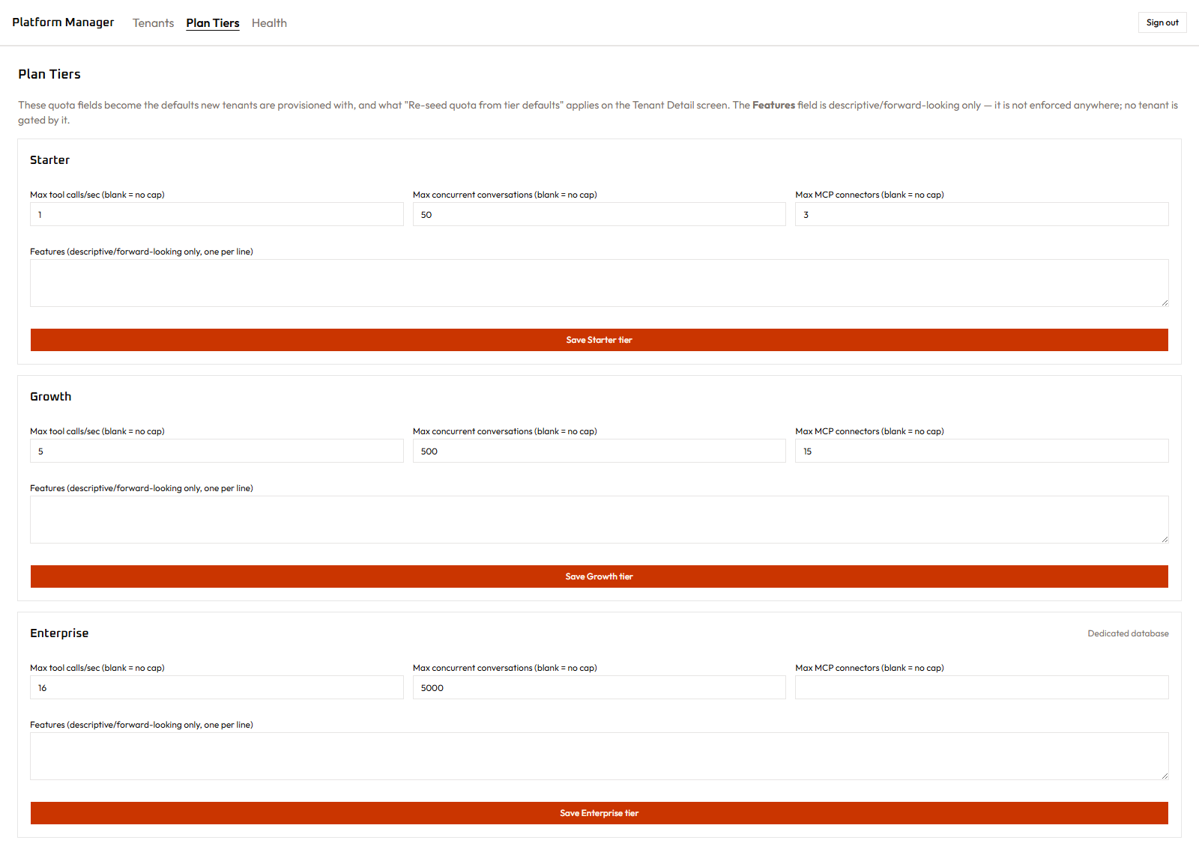
Platform Manager — Plan Tiers

Health (.../health)
A cross-tenant rollup of connector health — which tenants have a degraded or offline connector right now, worst-first — built specifically to expose only metadata (connector name, status, error class/count) and never any conversation content, per the operator’s need-to-know boundary.
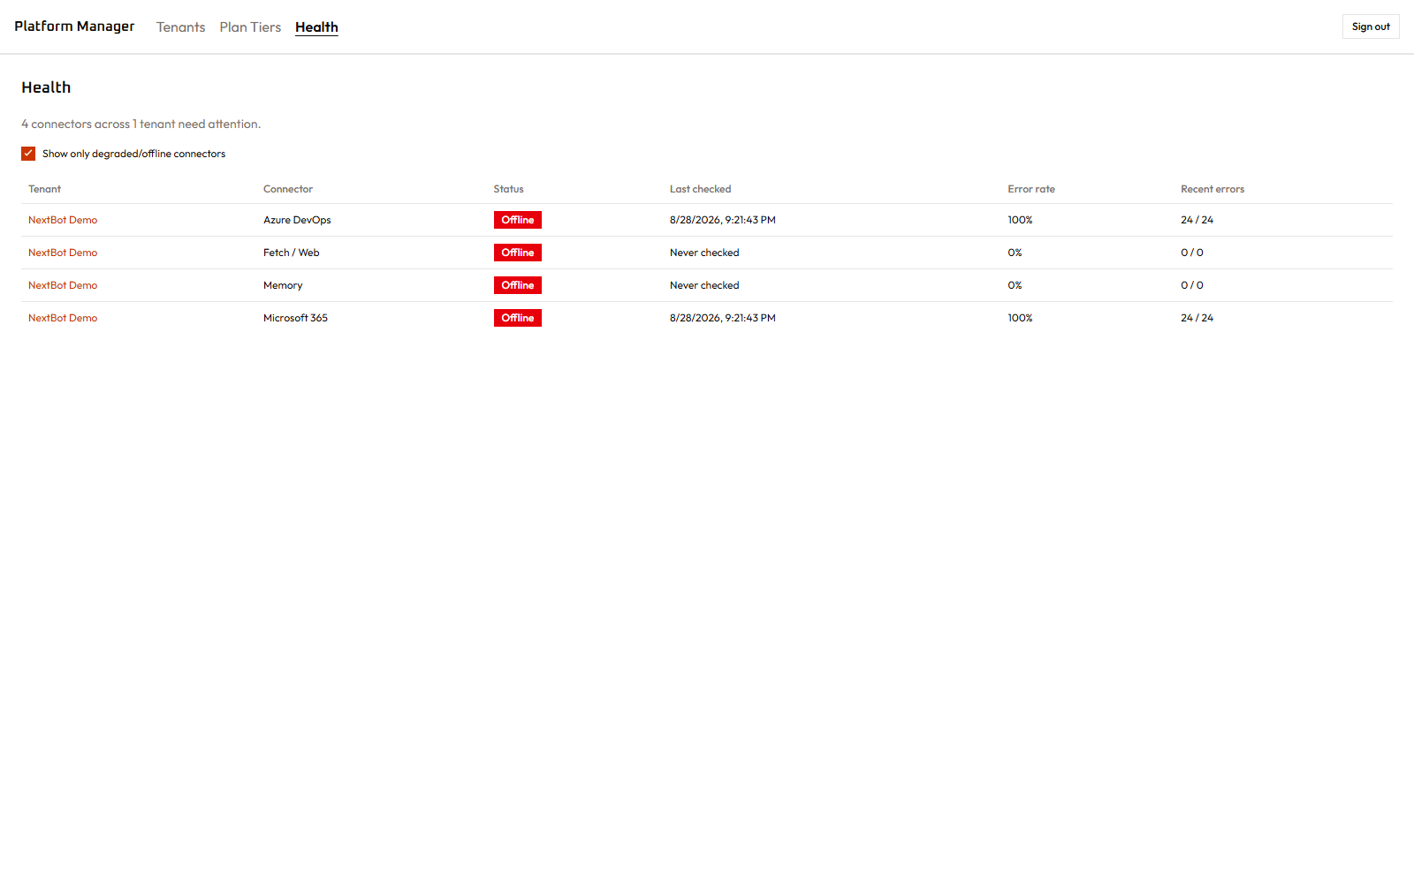
Platform Manager — Health rollup
Every mutation anywhere in this console writes to its own platform-level audit trail, separate from any tenant’s own audit log.

6. The customer-facing widget
Not an admin screen at all — the actual chat interface a tenant’s customers see, embedded via a <script> loader on the tenant’s own website. It’s a standalone application (not iframed admin-console code) specifically so its styling can never leak into or out of a customer’s page, and so it faithfully reflects exactly what a real customer would experience — the same reason it’s the thing reused, rather than a lighter mock-up, for both the “test this channel” and “sandbox preview a version” screens described above.

Widget launcher
(This screenshot shows the widget loaded standalone, outside its normal embedding context — the loader script normally supplies a full session handshake that only succeeds when embedded on a real page via <script>, so a bare, direct load like this correctly shows its “temporarily unavailable” state rather than a working chat. This is expected behavior for this specific way of viewing it, not a defect.)

