Assignment 5.2

**Automatic Garage Door Controller**

Introduction: -

* Finite state machine (FSM) is a major tool to implement **controllers** and **sequencers.**
* FSM has finite inputs, outputs and number of states. At each clock edge, combinational logic computes outputs and next state as function of inputs and present state.
* FSM has two types: -
  + Moore FSM (outputs change with the clock edge)
  + Mealy FSM (outputs change irrespective to clock edge)

Assignment: -

You have to implement an **automatic Garage Door Controller** that control both up and down motors.

**Block Interface: -**

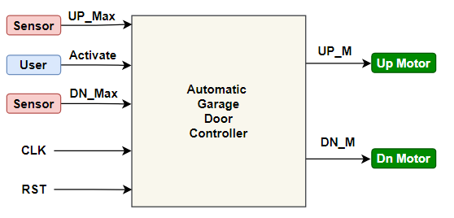

**Specifications: -**

* The **Controller** has 3 inputs: -
  + Activate push button (user) trigger the Up motor when the **Door** down and trigger the Down motor when the **Door** Up
  + UP_Max (Sensor) becomes high when the **Door** is completely open.
  + DN_Max (Sensor) becomes high when the **Door** is completely close.
  + Always the **Door** is completely close or completely open.
  + Finite state machine is initialized to IDLE state using **Asynchronous** reset

**States Diagram: -**

**IDLE state**: it is the default state & reset state of the finite state machine.

**Mv_Up State**: it is the state to enable the up motor to open the garage door

**Mv_Dn state:** it is the state to enable the down motor to close the garage door

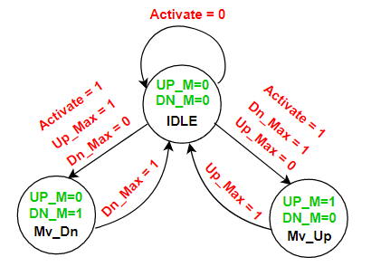

**Requirements: -**

1- Design a Moore Finite state machine that implement the above state diagram using Verilog language.

2- Write a testbench to validate your design using 50 MHz clock frequency.