**3.2. HAL**

**3.2.1. LED’S FLOWCHARTS**

Std_ReturnType LED_initialize(const led_t *led_ptr);

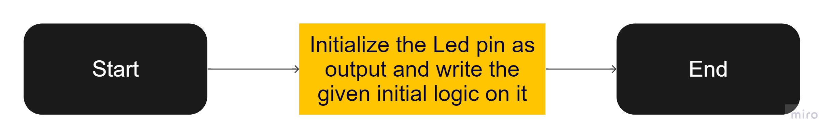

Std_ReturnType LED_turn_on(const led_t *led_ptr);

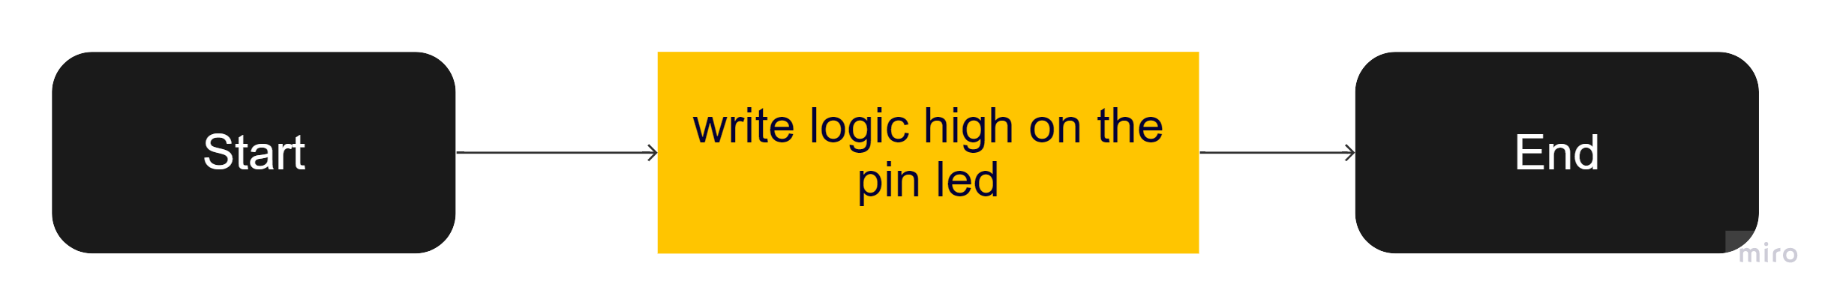

Std_ReturnType LED_turn_off (const led_t *led_ptr);

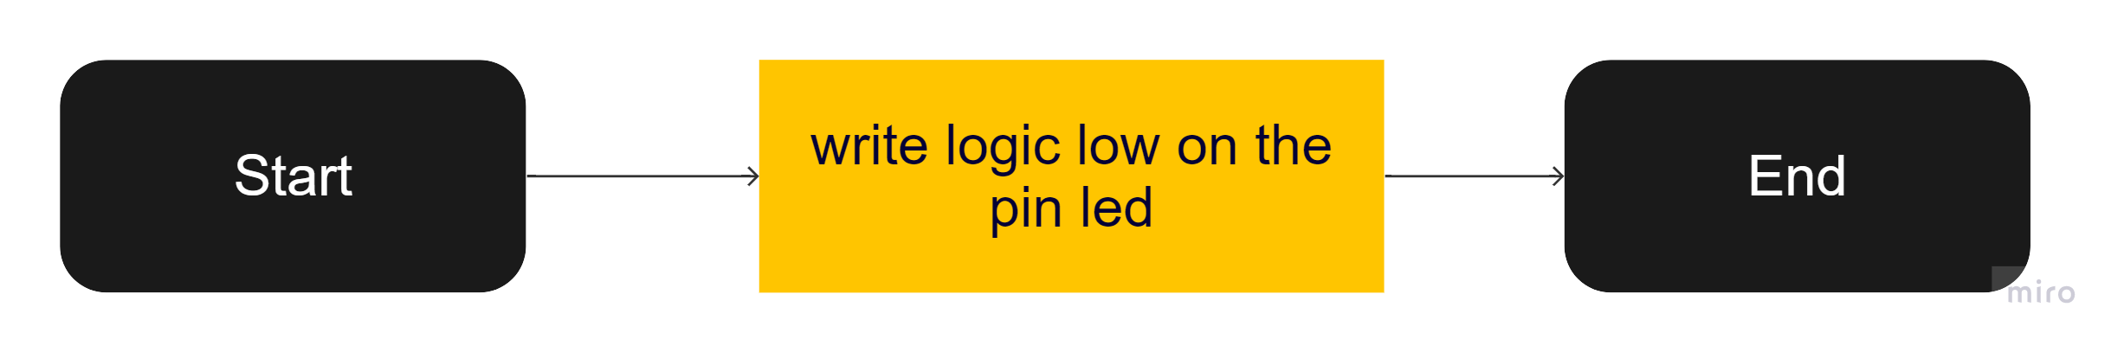Std_ReturnType LED_turn_toggle (const led_t *led_ptr);

