

Mohamed Hussein
Web Topologies CW2 Documentation

Contents
Mohamed Hussein Web Topologies CW2 Documentation 1
Tools 3
Part 1: Synthetic Network Modeling 4
Objective 4
Methodology 4
Analysis 4
Results 4
Part 2: Community Detection in Real-World Network 5
Dataset 5
Objective 5
Preprocessing 5
Algorithms 6
1. Louvain Algorithm 6
2. Label Propagation 6
Dashboard 6
Results 7
Louvain 7
Label Propagation 8
Comparison 9
Conclusion 9

This project explores the structural properties of different network models and performs community detection on real-world networks. It is divided into two parts:
- Part 1: Synthetic network modeling comparing the Barabási–Albert (BA) model against the Erdős–Rényi (ER) model, with a focus on degree distribution and scale-free properties.
- Part 2: Community detection on a real-world collaboration network using Louvain and Label Propagation algorithms, integrated in a user-friendly Streamlit dashboard.

Tools

- Python
- NetworkX
- Streamlit (for dashboard visualization)

Part 1: Synthetic Network Modeling
Objective
Simulate and analyze two types of networks:
- Barabási–Albert (BA): A scale-free network exhibiting power-law behavior.
- Erdős–Rényi (ER): A random graph with uniform edge probabilities.

Methodology
- BA Model:
  - Starts with m0m_0m0​ nodes.
  - Each new node attaches to mmm existing nodes with a probability proportional to their degree (preferential attachment).
- ER Model:
  - Constructed with the same number of nodes n, and edge probability ​ to match the average degree.

Analysis
- Degree Distribution:
  - For both models, the degree distribution P(k)P(k)P(k) is computed and normalized.
- Log–Log Plot:
  - BA shows a straight-line tail → confirms power-law
  - ER shows a binomial/Poisson-like distribution → no power-law.

Results
- BA Network: High-degree hubs, skewed distribution → scale-free.
- ER Network: No hubs, narrow distribution → not scale-free.
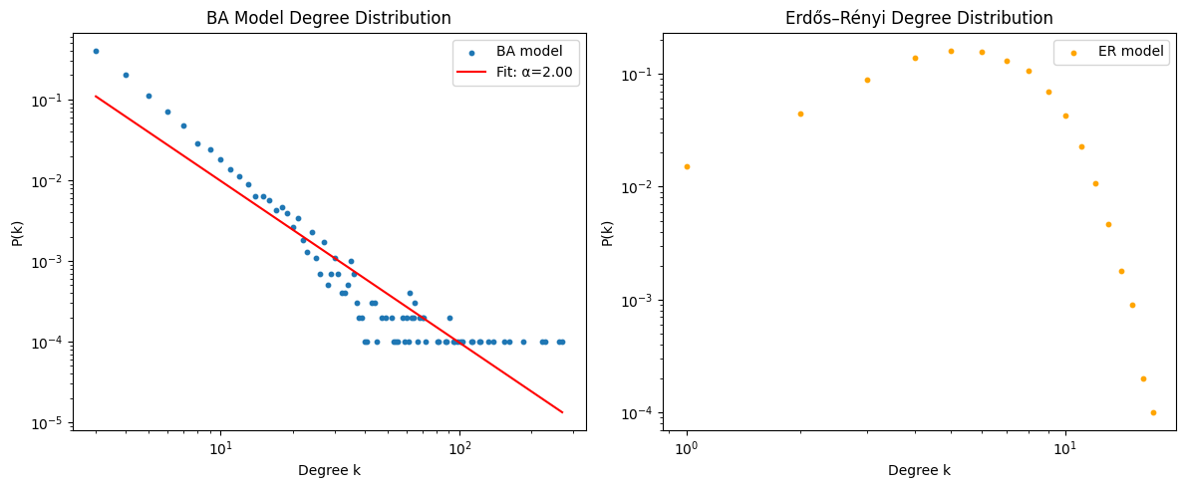

Part 2: Community Detection in Real-World Network

Dataset
- ca-GrQc (Collaboration graph from arXiv General Relativity):
  - Nodes = Authors
  - Edges = Co-authorships
  - Large, sparse, undirected graph
Objective
Detect and visualize communities within a real-world network.

Preprocessing
- Load graph from edge list
- Extract largest connected component
- Apply detection algorithms

Algorithms

1. Louvain Algorithm
- Unsupervised modularity-based optimization
- Output: Dense central cluster + satellite communities
- Pros: High-quality clusters, deterministic

2. Label Propagation
- Nodes iteratively adopt the most frequent label among neighbors
- Output: Many small communities, varied structure
- Pros: Fast and scalable
- Cons: Non-deterministic

Dashboard
- Implemented in Streamlit dashboard
- Allows user to:
  - Upload dataset
  - Select method
  - View interactive network visualization

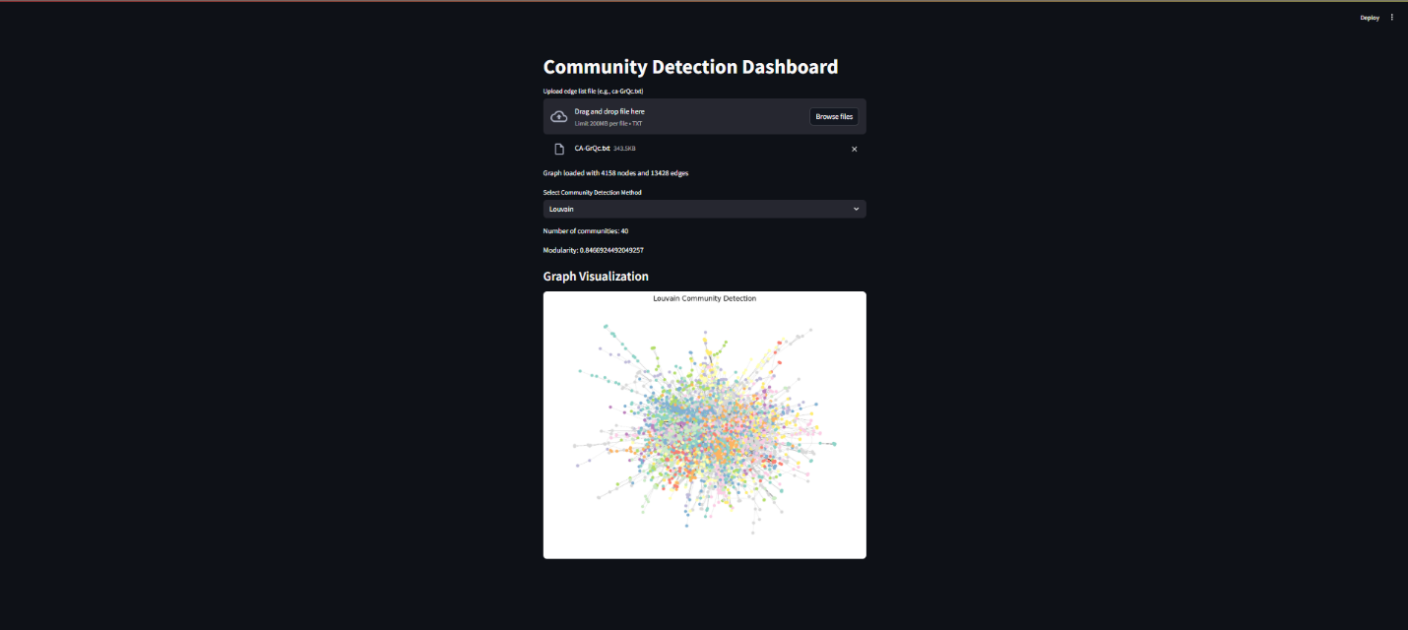

Results

Louvain
- Clear modular structure
- Central core + multiple research groups
- Optimized modularity

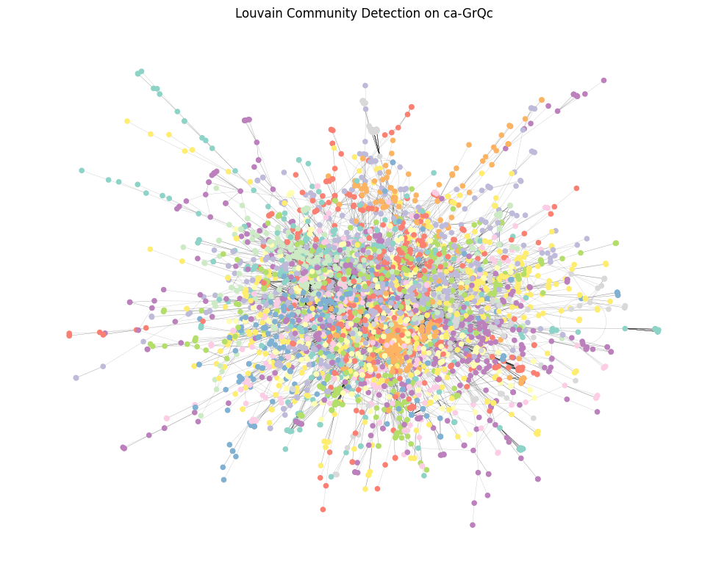

Label Propagation
- More fragmented
- Captures local clusters
- Sensitive to updating order

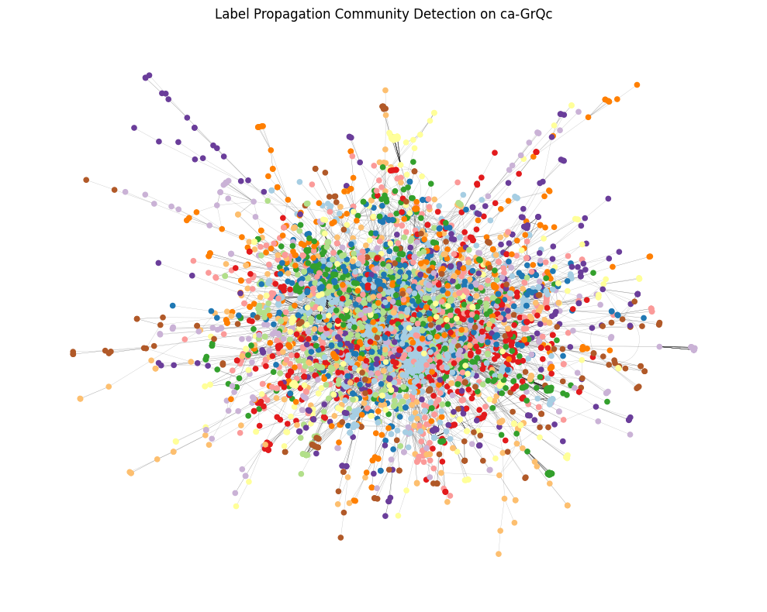

Comparison

Metric | Louvain | Label Propagation
Speed | Medium | Fast
Stability | High | Low
Interpretability | Excellent | Moderate
Modularity | Optimized | Suboptimal

Conclusion
The project highlights that network science links what research predicts with what data analysis finds. Modeling BA and ER graphs among synthetic networks teaches us essential facts about how network structures affect degree distribution, how well-connected nodes develop and what makes some nodes “hubs.” The BA model is able to show that in real systems such as social networks and citation graphs, only a small group of nodes connect to most nodes. Since this behavior is a hallmark of self-organizing systems, understanding it is essential for modeling disease spread, the spread of news and making sure infrastructure remains robust. At the same time, when we apply Louvain or Label Propagation on real networks like ca-GrQc collaboration, we find hidden structures that were not obvious in the original graphs. Louvain finds that scientific groups are tightly organized into clusters such as shared research teams or groups focusing on specific topics which indicate how information and teamwork move through scientific communities. They are interesting to academics and can also guide how companies choose what to recommend, how to manage operations and how rules are made online. The combination of modeling and empirical analysis gives the project a chance to evaluate research questions in theory and gain useful insight from examining real community data. This approach demonstrates the usefulness and adaptability of network analysis for research as well as for real-world use. Overall, this work proves how examining network layouts, and their behavior can benefit decisions, uncover concealed patterns and help design interlinked systems in domains like academia, social networks, telecommunications and others.

