

Pacman

Name
Mohamed Hussein
Ahmed El Keshawy

Contents
Environment 3
Motivation 3
Scenario 3
Obstacles 3
Agent 3
Algorithm 3
GUI 4
Implementation 5
References 12

Environment
The layout features a maze made of blue lines on a black background.
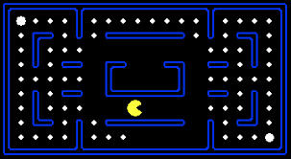

Motivation
The motivation for this game is to have Pacman achieve the highest score in the shortest time possible and making Pacman like a game of time which its aim to have the lowest time possible without ghosts.

Scenario
The Scenario here is for Pacman to move Up, down, left, right to eat the pellets in the shortest time possible or Pacman will have a time limit and he will have to get the highest score in that time.

Obstacles
Red: 5 Second Penalty
Purple: 10 Second Penalty
Orange: 50 score Deduction Penalty

Agent
The agent will be Pacman since the ghosts are absent, Pacman is the only active participant, making decisions and moving through the maze.

Algorithm
The algorithm we will be using is going to be Q-Learning. Q-learning is a model-free reinforcement learning algorithm that is used to learn the value of an action in a particular state.

GUI

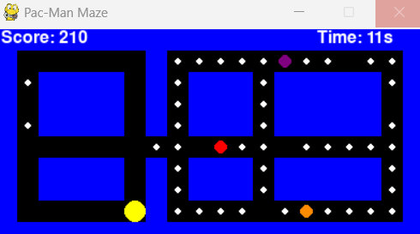

Implementation

Starting off with the imports we used numpy, pygame, sys and random imports
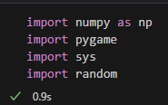

We defined the layout of the Pac-Man game maze as a list of strings but we will change that to a list lists, because in python you can’t modify a string in a specific position
Different elements in the maze-like walls (W), pellets (. ), and different obstacles (P, O, S) are represented by each character in the strings.

initialize_game()
It returns different game elements like the maze layout, and color definitions, it initializes the Pygame library and sets up the maze layout, window dimensions, and color settings.

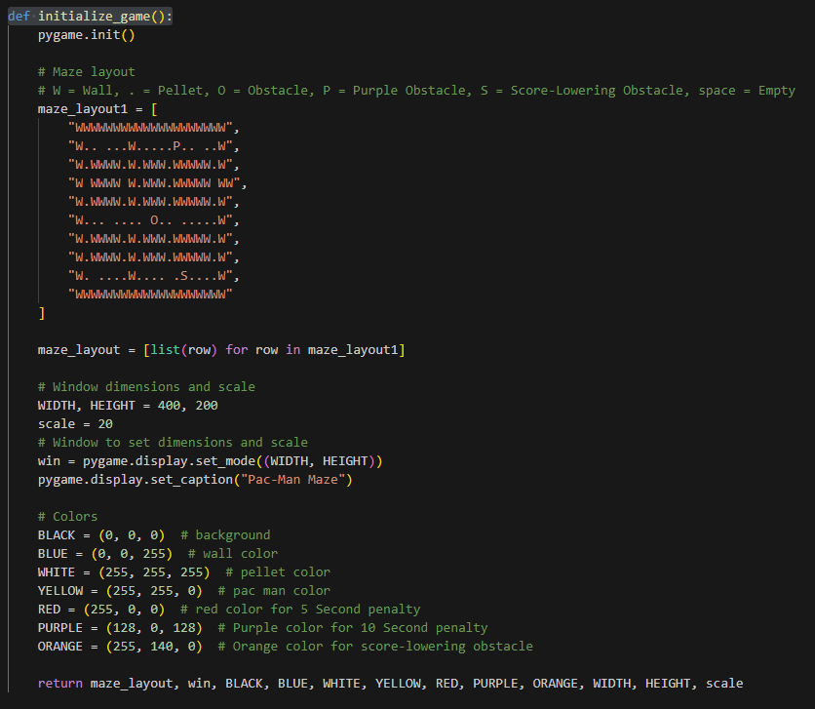
reset_game(original_Layout)

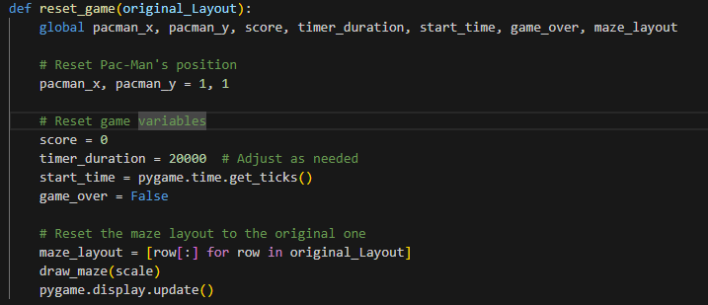
This Function resets the game's score, timer, and Pac-Man's starting position. It also recreates the maze according to its original design.

get_state_representation()
This Function flattens the layout of the maze and encodes the current state according to Pac-Man's position, the amount of time passed, and whether there are obstacles. The AI algorithm will most likely use this state representation to guide its decisions through the game.
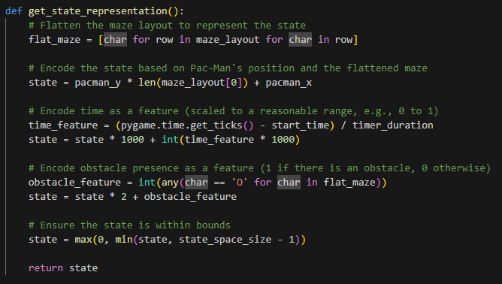

update_q_table (state, action, new_state, reward)
Reinforcement learning depends on the updating of Q-tables which are updated by this function. The learning rate is included in the Q-table update process which is based on the Q-learning formula.
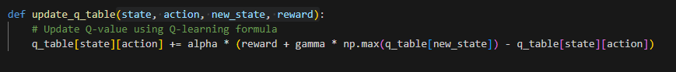

choose_action(state, epsilon)
Using an epsilon-greedy policy, this function chooses an action depending on the current state and an epsilon value. The epsilon-greedy algorithm is a popular strategy used in reinforcement learning by selecting between the most well-known action and a random action. It finds a balance between the two. The probability of selecting well-known action over random action is given by the "epsilon" parameter [1].
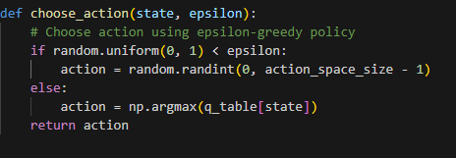

draw_maze(scale)
This Function causes the maze to render in the game window. Based on the characters in the maze layout, it draws walls, pellets and obstacles using Pygame functions. It also manages the timer color and time, score display and Pacman rendering.
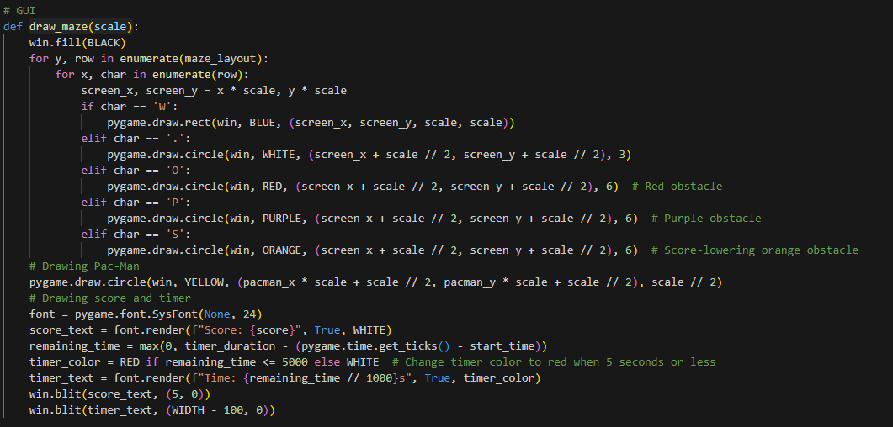

move_pacman(dx, dy)
This function updates Pac-Man's position based on dx and dy preventing Pacman to not move through walls and update the layout maze when Pacman eats the pellet or obstacles to remove them from the layout maze as well as putting the Penalties for the obstacles.

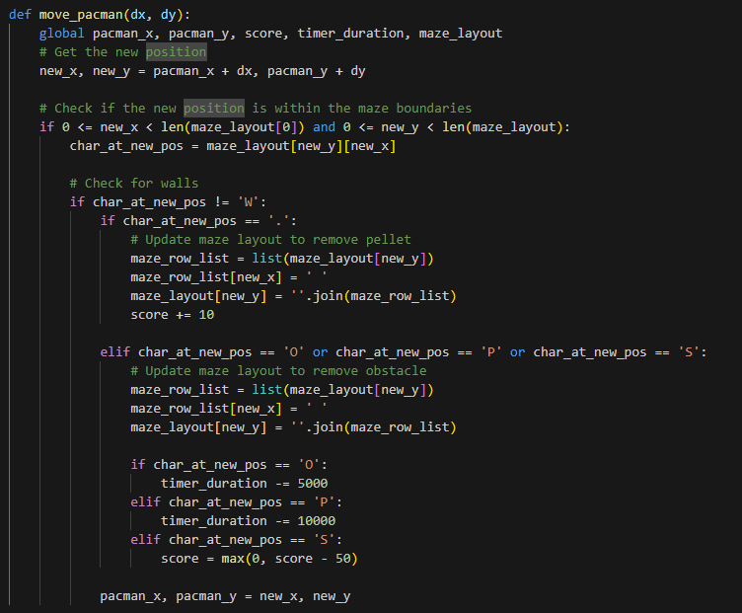

main_game_loop()
This is the main game loop. It runs continuously processing the AI decisions, rendering the maze, and updating the game state. After getting the current state, this function uses Q-Learning to determine what to do. The Function moves Pacman in that direction, modifies the Q-table, redraws the maze, resets the game and looks for the game-over condition.

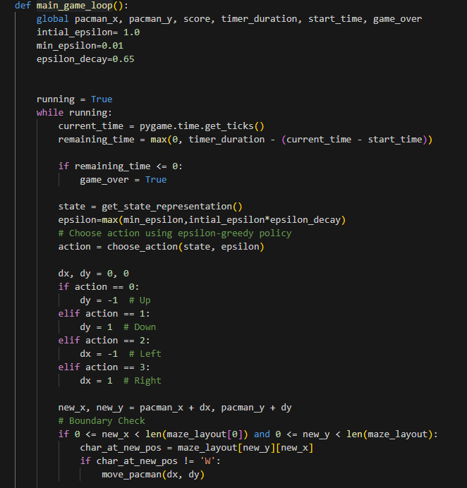
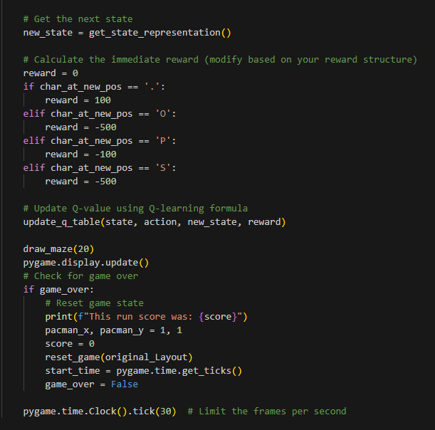
This code initializes the game and Q-Learning parameter and the Q-Table and calls the main_game_loop() function.

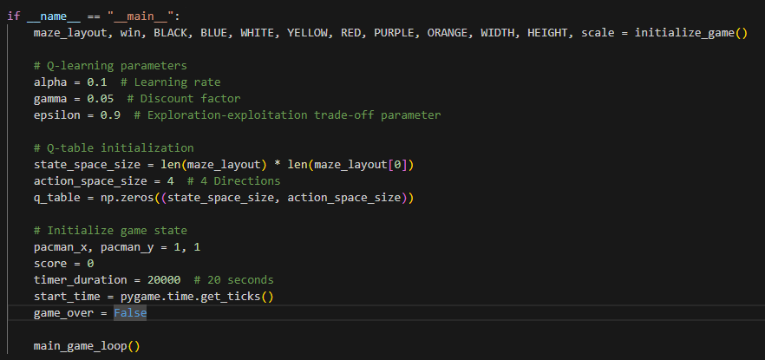

These were our best run scores.
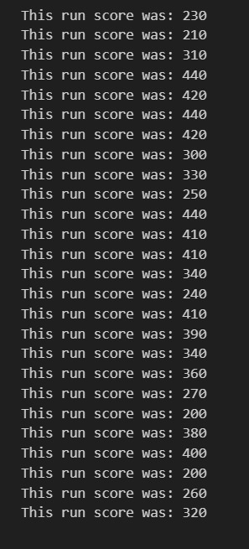

References

[1] “Epsilon-Greedy Algorithm in Reinforcement Learning,” GeeksforGeeks, May 01, 2020. https://www.geeksforgeeks.org/epsilon-greedy-algorithm-in-reinforcement-learning/ (accessed Jun. 18, 2020).

