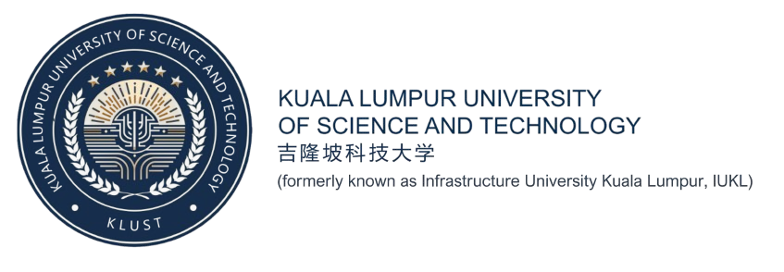

Operating System
Assignment 1 (15%) (73m)

Name | Mohamed Mohamed Hussein
ID | 251925403
Lecturer | HASLIN HASAN
Semester | Oct/Nov 2025
Date | 5/01/2026

Part one:
a) Make a timeline of OS from 1960 to the present according to the OS major family or category below
1. IBM Operating Systems (The Mainframe Era)
Timeline: 1960s – Present
In the early 1960s, computers were extremely large and expensive. They were called mainframes. The most famous company making these computers was IBM (International Business Machines). Before 1964, every computer IBM made was different. If a company bought a new, faster computer, they had to rewrite all their software from the beginning. This was a big problem because it cost a lot of money and time.
Everything changed in 1964. IBM introduced a new family of computers called the System/360. The most important part of this system was its operating system, called OS/360. This was a revolution in the computer world. For the first time, an operating system could run on many different computers, from small ones to huge ones. If a business grew and needed a bigger computer, they could keep their old software and it would still work. This idea is called "compatibility," and it is standard today, but it was new back then.
During this time, the operating system used something called Batch Processing. Users did not sit in front of a screen like we do today. Instead, they punched their programs onto paper cards. They gave a stack of these cards to an operator. The operator put the cards into the machine, and the OS/360 processed them one by one in a "batch."
As time passed, IBM operating systems became more advanced. In the 1970s, they introduced "virtual storage," which allowed computers to use more memory than they physically had. The OS/360 evolved into newer versions like MVS (Multiple Virtual Storage). Today, IBM still makes powerful mainframe operating systems called z/OS. These are used by big banks and insurance companies to process millions of transactions every second. Even though it started in the 1960s, the technology from IBM’s early operating systems is still the foundation of big business computing today.

2. UNIX (The Father of Modern OS)
Timeline: Late 1960s – Present
In the late 1960s, a group of researchers at AT&T Bell Labs wanted to create a better operating system. They were frustrated with complex systems that were hard to use. Two famous computer scientists, Ken Thompson and Dennis Ritchie, decided to build something simpler and more flexible. In 1969, they created UNIX.
UNIX was very different from IBM’s systems. First, it was designed to be small and efficient. Second, it introduced the idea of creating small tools that do one thing very well, which could be connected together. But the most important change happened in the early 1970s. Dennis Ritchie invented a new programming language called C. They rewrote the entire UNIX operating system using C. This made UNIX "portable." This means users could move the operating system to different types of computer hardware without rewriting the code. Before this, operating systems were stuck on one specific machine.
In the 1980s, UNIX became very popular in universities and for large servers. It was a "multi-user" and "multitasking" system. This means many people could use the same computer at the same time, and the computer could run many programs at once. Because UNIX was so good, different groups started making their own versions. The University of California, Berkeley, made a version called BSD (Berkeley Software Distribution).
However, UNIX was expensive and owned by big companies. This led to "UNIX wars" where different companies fought over the standard. Despite this, UNIX became the standard for the internet. Today, UNIX is the "grandfather" of almost all modern operating systems. Linux is a clone of UNIX, and Apple’s macOS is actually a version of UNIX. When you use a Mac or a Linux server, you are using technology that started with Ken Thompson and Dennis Ritchie in 1969.
UNIX also introduced the 'filesystem' structure that we use today, where files are organized in a hierarchy of directories and subdirectories like a tree. Its powerful command-line interface became the standard way for administrators to manage complex networks and servers efficiently. Even though the original code is very old, the philosophy of building small, modular programs that work together is still the golden rule for software developers. Therefore, learning UNIX concepts is still considered essential for anyone studying computer science or cybersecurity today.
3. Microsoft Windows (The Personal Computing Giant)
Timeline: 1980s – Present
The story of Windows begins in the early 1980s with a different operating system called MS-DOS (Microsoft Disk Operating System). MS-DOS was a text-based system (CLI). Users had to type commands like "dir" or "copy" on a black screen to make the computer work. It was not easy for normal people to use, but it was the standard for IBM Personal Computers.
Microsoft wanted to make computers easier, so they looked at the graphical systems developed by Xerox and Apple. In 1985, Microsoft released Windows 1.0. At first, it was not a real operating system. It was just a "shell" or a graphical layer that sat on top of MS-DOS. It allowed users to click on menus and use a mouse, but it was slow and simple.
The big explosion happened in 1995 with the release of Windows 95. This was a massive change. It introduced the "Start" button, the taskbar at the bottom of the screen, and the ability to easily plug in new hardware (Plug and Play). Windows 95 made personal computers extremely popular in homes and offices. Everyone wanted a PC because it was colorful and easy to navigate.
In the early 2000s, Microsoft moved away from the old MS-DOS foundation. They released Windows XP, which was built on a much stronger and more stable technology called the "NT kernel." Windows XP was very successful and people used it for many years. Since then, Windows has continued to evolve with Windows 7, Windows 10, and now Windows 11. Today, Windows is the most popular operating system for desktop and laptop computers in the world. It is famous for being compatible with almost all hardware and software, especially games and office applications.
In recent years, Windows has adapted to modern needs by integrating cloud services like OneDrive directly into the system, making it easier to save and share files online. Microsoft also introduced better support for touchscreens in Windows 10 and 11, allowing the OS to run smoothly on tablets and 2-in-1 laptops. The latest versions now focus heavily on security and productivity, offering new tools to help users organize their open windows efficiently. Looking to the future, Microsoft is beginning to add artificial intelligence features, ensuring Windows remains the central hub for both work and entertainment.

4. Open Source Operating Systems (Freedom to Share)
Timeline: 1990s – Present
For a long time, operating systems like Windows and UNIX were "proprietary." This means the code (the recipe for the software) was a secret. Users could not see how it worked or change it. In the 1980s, a man named Richard Stallman started a movement called the Free Software Foundation. He believed that software should be free for everyone to share and modify. He started building a free system called GNU, but it was missing one important piece: the kernel (the core of the OS).
In 1991, a student in Finland named Linus Torvalds created that missing piece. He wrote a small kernel called Linux. He put the code on the internet and told everyone, "This is just a hobby, it won't be big and professional." He was wrong. Because the code was open to the public, thousands of programmers from all over the world started helping him. They fixed bugs, added new features, and improved the speed. This was the birth of the Open Source operating system.
Linux combined with the GNU tools to become a full operating system. Companies started packaging Linux into easy-to-use versions called "distributions," such as Red Hat, Debian, and later Ubuntu. Unlike Windows, Linux was free to download and install.
Today, Open Source is incredibly powerful. While most people still use Windows on their home laptops, the Open Source Linux OS runs the entire internet. Almost all the servers for Google, Facebook, and Amazon run on Linux. It is preferred because it is secure, stable, and can be modified to do exactly what the user wants. The Open Source movement proved that people working together for free can build better software than big companies.
Furthermore, the open source revolution extended to mobile devices with the creation of Android, which uses the Linux kernel to power billions of smartphones worldwide. This flexibility allows developers to adapt the software for everything from tiny smart home devices to the world's most powerful supercomputers. By allowing anyone to inspect the code, open source systems offer unmatched transparency, ensuring that security flaws are found and fixed quickly. Ultimately, this collaborative model has become the backbone of modern innovation, proving that shared knowledge drives technology faster than secrecy.

5. Network Operating Systems (Connecting the World)
Timeline: 1980s – Present
Before the 1980s, personal computers were standalone machines. If you wanted to move a file from one computer to another, you had to save it on a floppy disk and walk over to the other computer. This was called "sneakernet." As offices bought more computers, they needed a way to connect them together so they could share printers and files. This created the need for a Network Operating System (NOS).
The king of Network Operating Systems in the 1980s and early 1990s was a system called Novell NetWare. NetWare was specialized software designed only to run on a server. It allowed many office computers to log in, share a hard drive, and print documents to a shared printer. It was very fast and reliable. For a long time, if you worked in an office, you probably used NetWare to save your work.
However, in the mid-1990s, the technology changed. Microsoft released Windows NT (New Technology). Unlike Novell, which was just for servers, Windows NT looked like normal Windows but had powerful networking tools built inside. It became easier for administrators to manage user accounts and security because they already knew how to use Windows.
Eventually, the idea of a separate "Network OS" disappeared. Today, networking is a standard part of every modern operating system. Windows Server and Linux are the main systems used for networking now. They handle huge tasks like cloud computing, hosting websites, and managing security for thousands of employees. We no longer buy a special "Network OS" because networking is now the most basic requirement for any operating system.
Modern network systems also focus heavily on cybersecurity, using advanced firewalls and encryption to protect sensitive company data from hackers. They allow employees to work from home by connecting securely to the office network through Virtual Private Networks (VPNs). Additionally, these systems now support virtualization, meaning one physical server can run many different virtual servers at the same time to save electricity and space. This evolution has made the network operating system the invisible but essential engine that keeps the global digital economy running 24/7.

6. Mobile Operating Systems (Computers in Our Pockets)
Timeline: 1990s – Present
The final major family is the Mobile Operating System. In the 1990s, businessmen started carrying small digital assistants called PDAs. These used simple systems like Palm OS or Windows Mobile. They required a small plastic stylus (pen) to tap on the screen. They were useful for calendars and contacts, but they were not good for the internet or media.
Later, phones started getting smarter. Symbian and BlackBerry OS became popular. BlackBerry was famous for email and its physical keyboard. It was the standard for business people. However, these systems were clunky and hard to use for fun things like browsing the web.
Everything changed in 2007 when Apple launched the iPhone with iOS. This was a revolution. iOS was designed for fingers, not a stylus. It had a "multi-touch" screen that let users zoom in on photos by pinching. It made the phone feel like a powerful computer. A year later, Google released Android, which is an open-source mobile OS based on Linux.
These two systems, iOS and Android, created the "App Store" economy. Before this, you could only use the software the phone came with. Now, users could download millions of apps for games, work, and social media. Today, Mobile OSs are the most used operating systems in the world. They handle complex tasks like voice recognition (Siri/Google Assistant), GPS navigation, and high-quality photography. They have transformed the phone from a communication tool into a supercomputer that fits in our pocket.
Furthermore, mobile operating systems are now expanding their reach beyond smartphones to power wearable technology like smartwatches and even the dashboard systems of modern cars. They are heavily investing in Artificial Intelligence to predict user needs and optimize battery life without relying solely on the cloud. The introduction of 5G networks has also allowed these systems to stream high-definition games and videos instantly, rivaling traditional desktop computers. As they continue to evolve, the line between a mobile phone and a full-fledged computer is disappearing, making them the central hub of our digital lives.

b) List the OS under the following category
1. CLI (Command Line Interface)
- MS-DOS
- UNIX Shells (e.g., Bourne shell or C shell)
2. GUI (Graphical User Interface)
- Microsoft Windows (e.g., Windows 10 or 11)
- Apple Mac OS X (Aqua interface)
3. Proprietary Operating Systems
- Microsoft Windows (Source code is closed and owned by Microsoft)
- Apple macOS (Source code is closed and owned by Apple)
4. Open Source Operating Systems
- GNU/Linux (Source code is free for anyone to use)
- BSD UNIX (Source code is available to the public)
c) Answer the following regarding CLI OS

What are the advantages of CLI over GUI?

1. Speed and Efficiency
The first major advantage of a Command Line Interface (CLI) is speed. For experienced users, typing a specific command is much faster than searching through many folders and menus in a GUI. For example, if a user wants to copy or delete a specific file, they can type one short line of text to do it instantly. This allows advanced users to manipulate files and execute programs very quickly without taking their hands off the keyboard.
2. Low System Resources
The second advantage is that CLI uses very little computer power. A Graphical User Interface (GUI) requires a lot of memory (RAM) and processing power to display colorful icons, windows, and mouse movements. Because CLI only uses simple text, it is very lightweight. This makes it perfect for slower computers or servers that need to save all their power for running important programs rather than drawing pretty graphics.

What are the advantages of GUI over CLI?

1. User-Friendly and Easy to Learn
The biggest advantage of a GUI is that it is user-friendly2. In a CLI, the user must memorize difficult commands and syntax to make the computer work. In a GUI, files and programs are represented by familiar icons3. A beginner can sit down and immediately understand how to open a folder or run a program just by clicking a mouse, without needing to learn a special computer language.
2. Visual Multitasking
Another advantage is visual multitasking. A GUI allows users to see multiple windows and programs open at the same time on one screen. You can easily drag and drop a file from one folder to another using the mouse4. This visual style makes it much easier to understand what is happening on the computer compared to a CLI, where you often can only see one stream of text at a time.
Which one do you think is better – CLI or GUI? Explain in one sentence.

Answer
I think the GUI is better for daily tasks because it is intuitive for everyone to use, but the CLI is better for IT professionals who need speed and direct control over the system.

Part Two
a) Pick what you think is the best OS (or one of the best) among them.
Answer = I have picked Microsoft Windows 10.
b) For the OS that you have picked at (a), describe THREE points what you think to be the best features of the OS.
1. Universal Software Compatibility
The strongest feature of Windows 10 is its incredible compatibility. Unlike other operating systems that might only run specific types of apps, Windows runs almost everything. Whether it is a high-end video game, a specialized engineering program, or a simple text editor, developers almost always build their software for Windows first. This makes it the "best" OS for students and professionals because you rarely have to worry if a program will work on your computer.
2. User-Friendly Interface (GUI)
Windows 10 refined the Graphical User Interface (GUI) to be perfect for both beginners and experts. It brought back the traditional "Start Menu" that people loved, but mixed it with modern "Tiles" for quick information. The interface is intuitive; users can easily find their files, change settings, or launch applications without needing to memorize complex commands. This balance between powerful features and ease of use is why it is the most popular desktop OS in the world.
3. Multitasking with Snap Assist
Windows 10 introduced a feature called "Snap Assist" which is excellent for productivity. It allows users to drag a window to the side of the screen, and it automatically snaps into place, taking up exactly half the screen. It then shows all your other open windows so you can fill the other half with one click. This makes working on two things at the same time—like writing an essay while reading a website—extremely fast and organized.
c) Describe THREE features you want the OS to have in the future.
- True Self-Healing Capabilities: I want the OS to be able to detect and fix its own problems instantly without bothering the user. If a driver crashes or a virus tries to attack, the OS should automatically isolate the problem and repair the corrupted files in the background without needing a "Blue Screen of Death" or a restart.
- Seamless Device Handoff: I would like the OS to allow me to move a running program from my computer to my phone or TV instantly. For example, if I am typing a Word document on my PC, I should be able to walk away and have that exact document appear on my phone screen immediately, without saving or closing anything.
- Voice-Controlled Navigation: In the future, I want to control the entire OS using natural voice conversation. Instead of clicking through five menus to change a setting, I want to just say, "Computer, organize my desktop and turn on dark mode," and the OS should understand and do it immediately.

Part Three
a. What are the four basic resources of an OS? (2 marks)
- The CPU (Processing Time) – The brain that does the work.
- Memory (RAM) – The space where running programs sit.
- I/O Devices – Things like the keyboard, mouse, and screen.
- Files (Storage) – The data saved on the hard disk.

b. OS is also known as __________?
It is known as a Resource Allocator (or sometimes a Control Program).

c. OS development sequence:
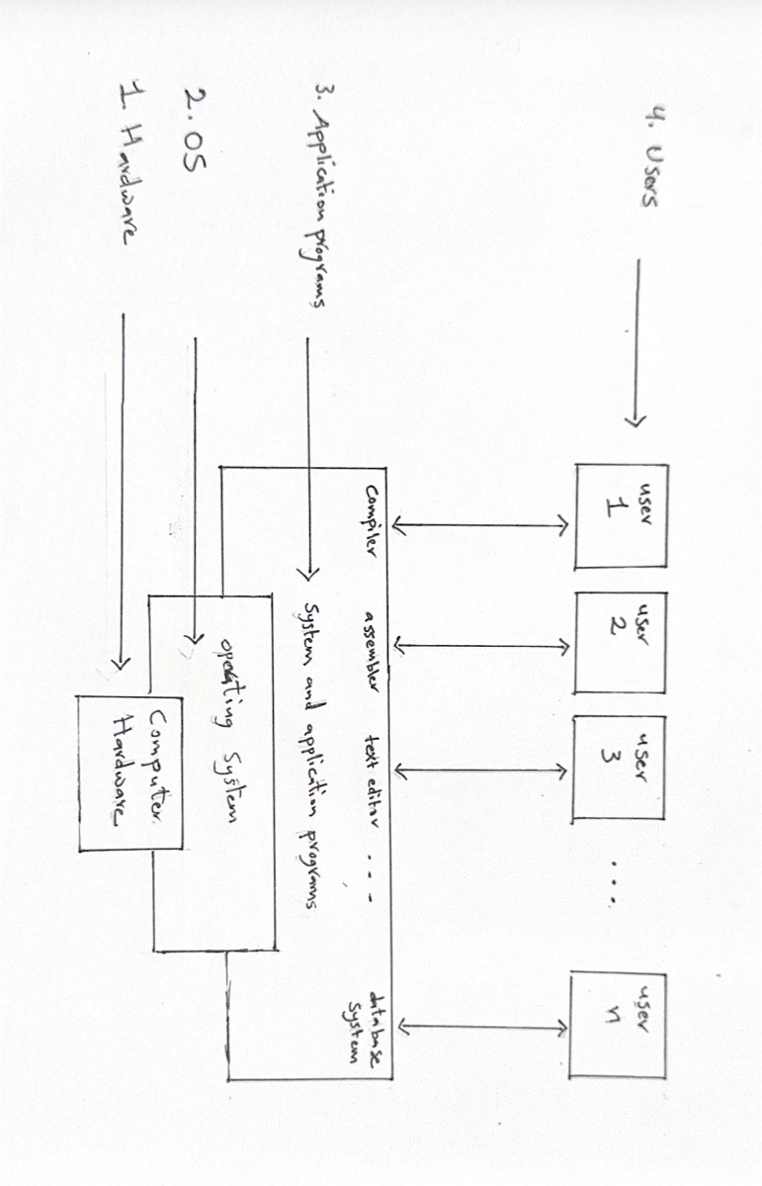
OS development can be described as starting with (i) no OS; to (ii) Batch Processing Systems; to Multiprogramming Systems and Time-Sharing Systems.

d. Illustrate the layers of a typical computer system (4 marks).
- Top Layer: Users (People using the computer)
- Second Layer: System and Application Programs (Compilers, Games, Word Processors)
- Third Layer: Operating System (The manager)
- Bottom Layer: Computer Hardware (CPU, RAM, Disk)

e. Explain the terms below (Focus on 1960s/History + Examples) (14 marks):
1. Batch Processing
In the 1960s, computers were too expensive to let users type slowly on them. Instead, users punched their programs onto cardboard cards. An operator collected these cards into a stack (a "batch") and fed them into the computer one by one. The computer processed the whole batch without stopping.
Example: The IBM 7094 was a famous mainframe used in the 1960s for batch processing scientific data.
2. Multiprogramming
Computers in the 1960s were very fast, but loading data from tapes was slow. To stop the CPU from waiting and doing nothing (being idle), engineers invented multiprogramming. This allowed the computer to hold several different jobs in its memory at once. When one job waited for data, the CPU instantly switched to work on the next job.
Example: The IBM OS/360 (released in 1964) was one of the first operating systems to use multiprogramming to stay busy.
3. Multiprocessing
This technology allows a computer system to have more than one CPU (Brain) inside it. In the 1960s, this was a very new and expensive idea. It allowed the computer to do two or more instructions at the exact same time, which made it much faster for complex calculations.
Example: The Burroughs B5000 (1961) was one of the first systems designed to use two processors working together.
4. Time-Sharing
In the late 1960s, people wanted to interact with computers directly. Time-sharing connected many simple terminals (screens/keyboards) to one big mainframe. The operating system switched between users so fast that every user felt like they had the computer to themselves, even though they were sharing it with 30 other people.
Example: CTSS (Compatible Time-Sharing System) at MIT in 1961 was the first system to prove this was possible.
5. Virtual Machine
A Virtual Machine (VM) is software that acts like a real computer. In the 1960s, IBM wanted to test new operating systems without buying new hardware. They wrote software that created a "fake" computer inside the real one. This allowed them to run multiple different operating systems on one machine at the same time.
Example: IBM CP-40 (1964) was the first system to create virtual machines, which later became the CP-67.
6. Cloud Computing
While modern "Cloud" (like Google Drive) is new, the idea started in the 1960s. It was called "Utility Computing." The idea was that computing power should be like electricity—you plug into a wall and get it from a massive central generator (mainframe) somewhere else, and you only pay for what you use.
Example: In 1963, J.C.R. Licklider described an "Intergalactic Computer Network" which was the first vision of today's cloud.
7. Artificial Intelligence (OS AI)
In the 1960s, AI was about trying to make computers solve logic puzzles or chat like humans. Operating Systems today use AI to manage resources, but in the 1960s, AI was just a program running on top of the OS to test if computers could "think."
Example: ELIZA (1966) was a famous program that could chat with users and pretend to be a psychotherapist.
f. Explain the terms below relating to computer and processor technology (12 marks):
- Vacuum tube:
These were used in the first computers (like ENIAC) to control electricity. They were like big glass lightbulbs that got very hot and burned out often.
- Transistor:
These replaced vacuum tubes in the second generation of computers. They were much smaller, cheaper, and did not get as hot, which made computers reliable.
- Integrated circuit (IC):
This technology fits thousands of transistors onto a small silicon chip. It made computers much smaller and faster in the third generation.
- Microchip:
Also called a microprocessor, this puts the whole CPU onto one single small chip. It is the brain inside all modern PCs and phones.
- Single processor chip:
This is a standard CPU that has only one "core" or brain. It can only process one instruction at a time, but it does it very quickly.
- Multicore processor chip:
This is a single chip that has two or more "cores" (brains) inside it. It allows the computer to do two or more things at the exact same time, like playing a game and recording video.

