Subject Code | CSC 2626
Subject Name | DISTRIBUTED & PARALLEL COMPUTING
Student Name & ID | Hussein Musab Abdi 251925406  Mohamed Mohamed Hussein 251925403  Sulayman Abdulkadir Yasin 251925462  Abdirahman Abdikarim Abdirisak 251925464  Mohamed Lukman Hassan 251925585
Assessment Number | Group Project
Assessment Title | Distributed Banking Transaction Simulator
We declare that all material in this assignment is our own work except where there is clear acknowledgement or reference to the work of others, and We have complied with and agreed to the University statement on Plagiarism and Academic Integrity.

Signature: Date: 21-Oct-2026
…………………….

Assessor’s feedback:

Assessor’s signature: | Date:
Contents
1 Introduction 4
1.1 Background 4
1.2 Problem statement 4
1.3 Objectives 4
1.4 Scope 4
1.5 Team roles 5
2 Background and literature review 5
2.1 Distributed and parallel computing 5
2.2 Clusters, MPI and job scheduling 5
2.3 Concurrency control: race conditions and locks 5
2.4 Deadlock 6
2.5 Replication and producer–consumer 6
2.6 Measuring performance 6
3 Methodology 6
3.1 Approach 6
3.2 Changes from the original plan 7
3.3 Functional requirements 7
3.4 Non-functional requirements 8
3.5 Tools 8
4 System design 8
4.1 Cluster architecture 8
4.2 Software architecture 9
4.3 Communication protocol 10
4.4 Concurrency and locking design 11
4.5 Data design 12
5 Implementation 12
5.1 Building the cluster 12
5.2 Banking system code 12
5.3 How the system is run 14
5.4 Requirement coverage 14
6 Testing and results 15
6.1 Summary of findings 15
6.2 Test environment 15
6.3 Cluster validation 16
6.3.1 Network performance 17
6.3.2 Parallel speed-up (Monte Carlo π, 40 million points) 17
6.4 Functional testing of the banking system 18
6.4.1 Automatic unit tests 18
6.4.2 System tests on the cluster 19
6.5 Race condition test 21
6.6 Deadlock test 22
6.7 Scalability benchmark 23
6.7.1 Throughput (transactions per second) 24
6.7.2 Response time (milliseconds) 25
7 Discussion 26
7.1 Analysis of the results 26
7.2 Requirements check 27
8 Problems encountered and how we solved them 27
9 Conclusion and future work 28
9.1 Conclusion 28
9.2 Limitations and future work 29
10 References 29
11 Appendices 30
Appendix A: Cluster configuration files 30
Appendix B: Source code 30

1 Introduction

1.1 Background
Real banks process thousands of transactions at the same moment from ATMs, mobile apps and branches. Each one reads and changes shared data: account balances. If two operations change the same account without coordination, money can be created or lost. This is the race condition taught in the module’s synchronization topics.
A banking system is a good test case for distributed and parallel computing because its correctness rule is simple to check: money is only moved, never created or destroyed except by deposits and withdrawals. This lets us prove that our concurrency design works, not just claim it.

1.2 Problem statement
A single-threaded bank server is safe but slow, because each customer waits for all the customers before them. A multi-threaded server is fast but unsafe without synchronization: two concurrent withdrawals can both read the same balance and both succeed, and two transfers in opposite directions can deadlock.
The project answers one question: how can a distributed bank server process many concurrent client transactions quickly while keeping every balance consistent and never deadlocking?

1.3 Objectives
- Build a client–server banking system in Python using TCP sockets and a JSON message protocol.
- Serve many clients at once with a thread pool.
- Protect shared account data with per-account locks, and avoid deadlock in transfers by always locking accounts in a fixed order.
- Show the problem the design solves: run the same workload with locking switched off and record the lost money.
- Generate realistic load with a parallel simulator that runs simulated customers on several machines.
- Measure throughput, response time and scalability, and compare three locking strategies: none, one global lock and per-account locks.
- Replicate the transaction log to a backup server on another machine.
- Build and validate a real computing cluster with shared storage, MPI and a job scheduler to run the system on.

1.4 Scope
In scope: a three-node cluster (VMware virtual machines); bank server, customer client, admin console, backup server and load simulator; account operations (open account, log in, balance, deposit, withdraw, transfer, mini statement); SQLite storage; testing and performance evaluation with charts.
Out of scope: real money or real bank data; a web or mobile interface; production security such as TLS (PINs are hashed, but this is a simulation); automatic failover to the backup server.

1.5 Team roles
Member | Role | Responsible for
Musab | Project lead and integration | Plan, protocol, integration, report editing
Abdirahman | Server and networking | Cluster network, socket server, thread pool, JSON protocol
Sulayman | Concurrency and transactions | Locks, transfer ordering, deadlock prevention, consistency check
Mohamed | Data and administration | SQLite storage, backup server and replication, admin console
Lukman | Client, simulator and performance | Customer client, MPI load simulator, benchmarks, charts

2 Background and literature review

2.1 Distributed and parallel computing
A distributed system is a collection of independent computers that appears to its users as a single coherent system (Tanenbaum & van Steen, 2017). The computers have their own memory and cooperate only by passing messages over a network, which brings benefits (sharing resources, adding machines to grow) and problems (partial failure, network delay, no shared clock) (Coulouris et al., 2012). Parallel computing runs parts of one task at the same time on several processors to finish it faster. Our project uses both: the bank is a distributed client–server system, and the load simulator is a parallel program spread across the cluster.

2.2 Clusters, MPI and job scheduling
A cluster is a group of computers connected by a network and managed as one resource. The Message Passing Interface (MPI) is the standard way to write programs for clusters: the same program runs as several processes (“ranks”), which coordinate through operations such as barrier, broadcast and gather (Gropp et al., 2014). We used Open MPI with mpi4py, the standard Python binding (Dalcin & Fang, 2021). Large clusters use a resource manager so that users submit jobs rather than choosing machines themselves; Slurm is the most widely used one and allocates nodes, starts jobs and queues them (Yoo et al., 2003).

2.3 Concurrency control: race conditions and locks
A race condition happens when the result of a program depends on the timing of threads that share data. The classic example is the read–modify–write update: two threads read the same balance, each change it, and the second write overwrites the first (Silberschatz et al., 2018). The standard fix is mutual exclusion, where a lock (mutex) allows only one thread at a time into the critical section. The size of what one lock protects, its granularity, is a trade-off: one global lock is simple but lets only one transaction run at a time, while one lock per data item allows independent work to run in parallel at the cost of more complexity (Gray & Reuter, 1993).

2.4 Deadlock
A deadlock is a state where a set of threads each wait for a resource held by another thread in the set, so none can continue. Coffman et al. (1971) showed it needs four conditions at once: mutual exclusion, hold and wait, no preemption and circular wait. Removing any one prevents deadlock. A transfer that locks two accounts can create a circular wait when two transfers run in opposite directions. Making every thread acquire locks in the same global order (here, by ascending account number) removes circular wait (Silberschatz et al., 2018).

2.5 Replication and producer–consumer
Keeping copies of data on more than one machine (replication) lets a system survive the loss of one machine (Coulouris et al., 2012). Our server sends each committed transaction to a backup server. To keep this slow network work out of the transaction path, we use the producer–consumer pattern: worker threads put entries in a queue, and a separate thread takes them out and sends them. The same pattern is used to write to SQLite, which allows only one writer at a time (SQLite, n.d.).

2.6 Measuring performance
We use the standard measures for parallel and concurrent systems. Throughput is the number of transactions completed per second. Response time (latency) is the time from sending a request to receiving the reply, reported as the mean, the median and the 95th percentile. Speed-up is the time with one process divided by the time with p processes, and efficiency is speed-up divided by p. Amdahl (1967) showed that the part of a program that cannot run in parallel, together with communication cost, limits the speed-up that more processors can give.

3 Methodology

3.1 Approach
We worked in short iterations, building the smallest working system first and adding one concurrency feature at a time, with a checkpoint at the end of each stage:
- Planning and requirements: proposal, requirements and team roles.
- Cluster set-up: three Ubuntu VMs, network, SSH, shared folder, MPI and Slurm, checked with checkpoints CP0–CP6.
- Core banking system: server, client and storage working for one customer.
- Concurrency and distribution: thread pool, three lock modes, ordered locking, backup server, admin console and MPI load simulator.
- Testing and performance: automatic tests, race and deadlock tests, benchmark of all lock modes, with screenshots as evidence (checkpoints BC1–BC7).
- Report and demonstration.

3.2 Changes from the original plan
Planned | What we did | Reason
Lab machines (HPE server and two PCs) on a wired switch | Three laptops, each running one Ubuntu VM in VMware, on Wi-Fi | The lab machines had no internet access to install software; the lecturer asked us to use our own laptops
Load simulator with Python multiprocessing on one machine | Simulator started with MPI (mpirun), processes on all three nodes, each running customer threads | Uses the cluster and the module’s MPI topic; gives real distributed load
pytest | Python’s built-in unittest | Nothing extra to install on the VMs
10–200 clients, 1–16 worker threads | 5–25 customers, 8 worker threads | The Wi-Fi network made larger runs very slow (see section 7)

3.3 Functional requirements
Priority uses MoSCoW: Must is needed for the core system; Should adds value if time allows. The last column shows the final status (details in section 5.4).
ID | Requirement | Priority | Status
FR1 | The server accepts many TCP client connections at the same time | Must | Met
FR2 | Each client is handled by a worker from a fixed-size thread pool, set at start-up | Must | Met
FR3 | Client and server exchange JSON messages, one per line, each with an operation and a request ID | Must | Met
FR4 | A customer logs in with account number and PIN; PINs are stored as salted hashes | Must | Met
FR5 | A customer can check the balance of their own account | Must | Met
FR6 | A customer can deposit a positive amount | Must | Met
FR7 | A customer can withdraw up to their balance; larger requests are refused | Must | Met
FR8 | A customer can transfer money; the transfer is all-or-nothing | Must | Met
FR9 | Every balance change holds the account’s lock; transfers lock both accounts in ascending order | Must | Met
FR10 | Every completed transaction is written to SQLite | Must | Met
FR11 | An administrator can open, freeze and unfreeze accounts | Must | Met
FR12 | An administrator can run a consistency check of the total money | Must | Met
FR13 | The load simulator runs many simulated customers in parallel and records each response time | Must | Met (MPI processes × threads)
FR14 | The server runs in three locking modes: none, global, per-account | Must | Met
FR15 | A customer can view their last 10 transactions | Should | Met
FR16 | A replicator thread sends each transaction to a backup server | Should | Met
FR17 | The admin console shows live statistics | Should | Met
FR18 | The simulator saves results as CSV and draws charts | Should | Met

3.4 Non-functional requirements
ID | Category | Requirement
NFR1 | Consistency | Total money is unchanged after any run in per-account and global modes
NFR2 | Deadlock freedom | No run hangs, including opposite-direction transfers between the same two accounts
NFR3 | Performance | Per-account mode is faster than global-lock mode with 20 or more clients
NFR4 | Response time | Median response under 100 ms
NFR5 | Scalability | Throughput measured for several client counts and thread-pool sizes
NFR6 | Reliability | A client that disconnects does not crash the server or leave an account locked
NFR7 | Durability | Committed transactions survive a server restart
NFR8 | Security | PINs are never stored in plain text; a customer cannot use another customer’s account
NFR9 | Maintainability | Code is split into modules with docstrings
NFR10 | Usability | Client menus need no training; errors are plain messages
The results against these requirements are in section 7.2.

3.5 Tools
Item | Used
Virtualisation | VMware Workstation Pro on three laptops
Operating system | Ubuntu 26.04 LTS (64-bit)
Language | Python 3.14 (standard library: socket, threading, concurrent.futures, queue, sqlite3, json, hashlib)
Cluster software | OpenSSH, NFS, Open MPI 5 with mpi4py, Slurm with Munge, ufw firewall
Analysis | matplotlib for charts, iperf3 and ping for the network

4 System design

4.1 Cluster architecture
The cluster has one head node and two compute nodes (Figure 1). Each runs in VMware on a different laptop. Every VM has a second network adapter (ens34) bridged to its laptop’s Wi-Fi, so all three VMs are on the same hotspot network as if they were separate physical computers.
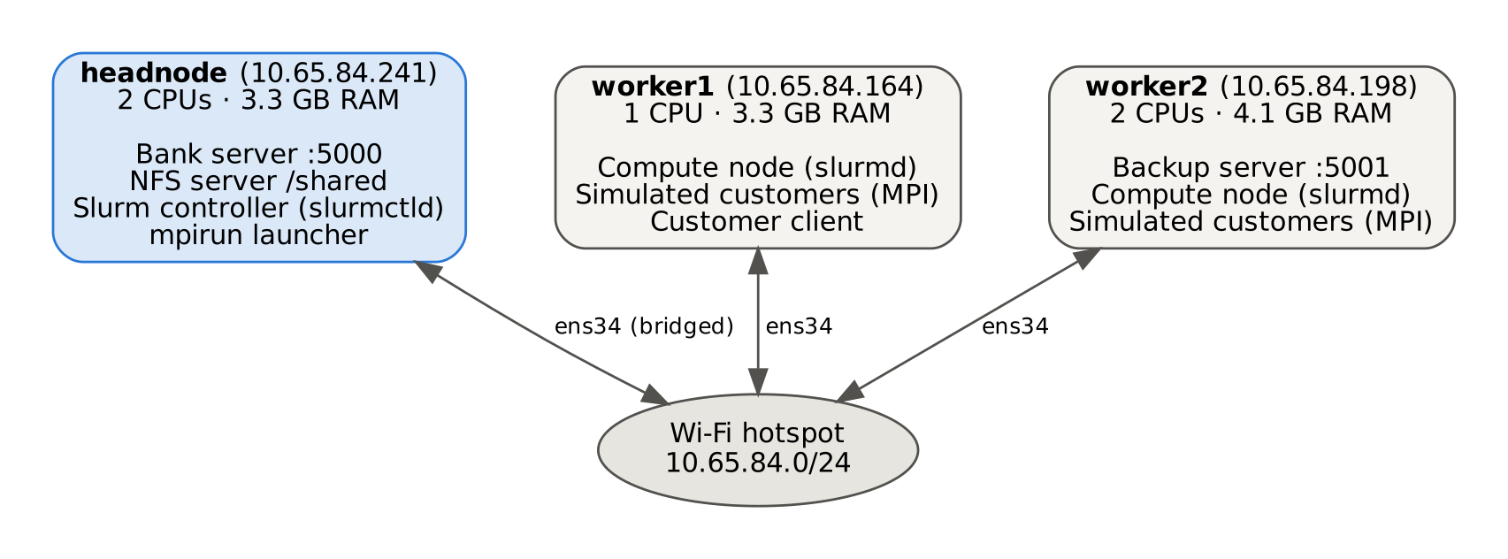
Figure 1: Cluster architecture — three VMs on three laptops, connected through the Wi-Fi hotspot
Node | Role | Services
headnode | Head node | NFS server (/shared), Slurm controller, bank server on port 5000, starts mpirun
worker1 | Compute node | Slurm daemon, simulated customers, customer client
worker2 | Compute node | Slurm daemon, simulated customers, backup server on port 5001
All nodes share the same user (mpiuser), reach each other by name through /etc/hosts, log in to each other with SSH keys (no password), and see the same /shared folder, so code copied once to the head node is available everywhere.

4.2 Software architecture
The banking system has five components (Figure 2). Customer clients, the admin console and the load simulator connect to the bank server over TCP. The server gives each connection to a worker thread from its pool. Workers lock the accounts they use, change the balances in memory and place the finished transaction in two queues: one for the database writer thread and one for the replicator thread, which sends batches to the backup server on worker2.
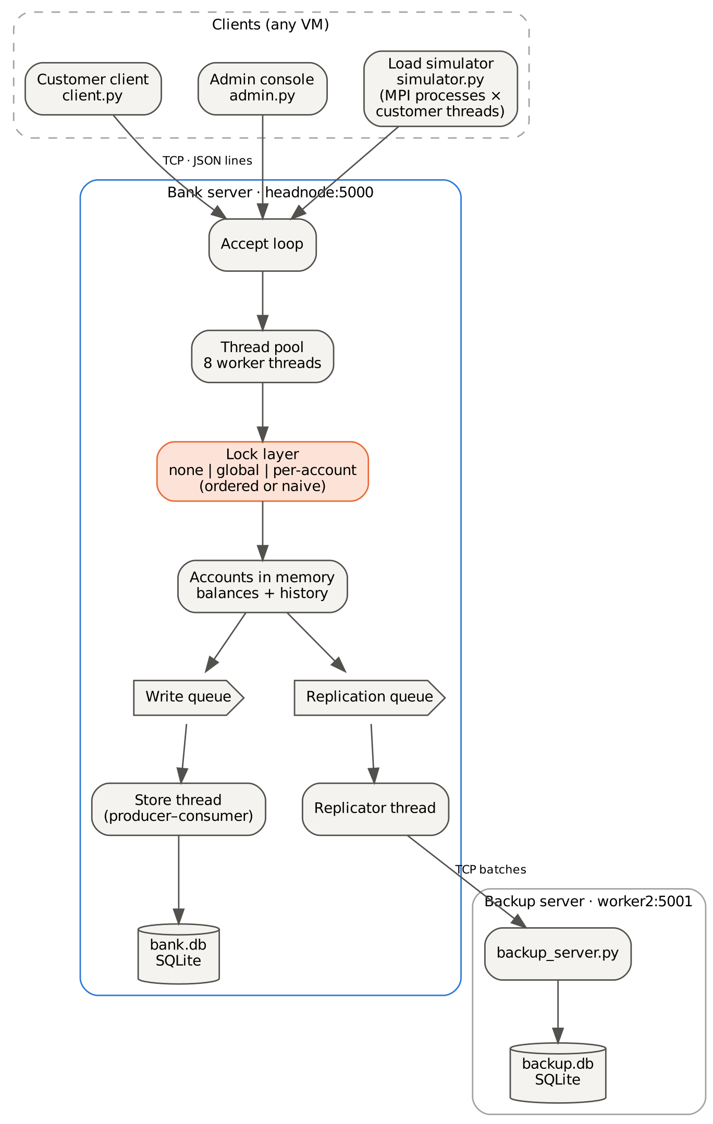
Figure 2: Software architecture of the banking system
Component | File | Runs on | Module concepts
Bank server | bank_server.py, bank_core.py | headnode | Sockets, client–server, thread pool, locks, deadlock prevention, producer–consumer
Backup server | backup_server.py | worker2 | Distributed storage, replication
Customer client | client.py | any node | Client–server, request–reply
Admin console | admin.py | headnode | Consistency check, live statistics
Load simulator | simulator.py | all nodes (MPI) | MPI processes, threads, performance measurement

4.3 Communication protocol
Every message is one JSON object on one line. A request has an id, an operation op and its fields; the reply repeats the id and has ok set to true or false.
Request : {"id": 7, "op": "deposit", "account": 12, "amount": 5000}
Reply : {"id": 7, "ok": true, "balance": 105000}
Error : {"id": 8, "ok": false, "error": "insufficient funds"}
Customer operations are login, balance, deposit, withdraw, transfer, statement and logout. Administrator operations (after admin_login) are init, create, freeze, list, check, stats and set_mode. Amounts are whole sen (cents) stored as integers, so there are no rounding errors.

4.4 Concurrency and locking design
The lock layer is where correctness is won or lost. The server supports three modes, which can be changed while it runs so that they can be compared on the same data:
Mode | How it works | Expected result
none | No locks | Fast, but races lose or create money
global | One lock for the whole bank | Always correct, but only one transaction at a time
account | One lock per account | Always correct, and transactions on different accounts run in parallel
A transfer needs two locks. In ordered mode (the default) the two accounts are always locked in ascending account-number order, which removes the circular wait needed for deadlock. Naive mode locks the sender first; it exists only to demonstrate deadlock. Every lock request has a 5-second timeout, so a deadlock is detected and the transfer is cancelled instead of hanging forever. Figure 3 shows the transfer algorithm.
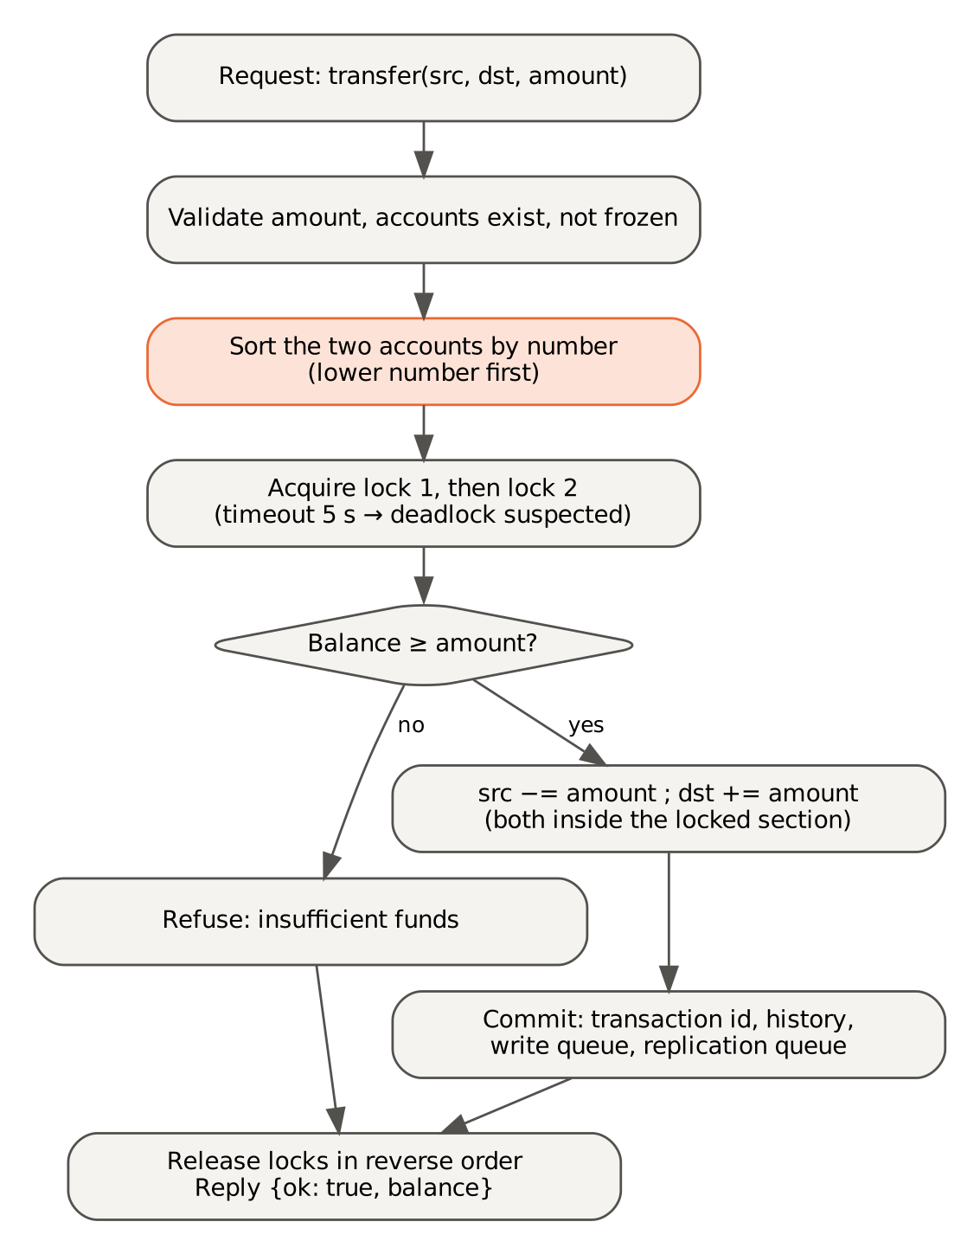
Figure 3: Transfer algorithm with ordered locking
To make races visible in testing, every operation reads the balance, waits 2 ms (a simulated processing time) and then writes the new value. Without a lock, another thread can change the balance during that gap.

4.5 Data design
Table | Columns | Stored on
accounts | number, balance, salt, pin_hash, frozen | headnode (bank.db)
transactions | txid, time, type, src, dst, amount, src_balance, dst_balance | headnode (bank.db)
transactions (copy) | the same, plus received time | worker2 (backup.db)
The consistency rule is: sum of all balances = starting total + deposits − withdrawals. The server keeps the expected total under its own lock, and the check operation compares it with the actual sum.

5 Implementation

5.1 Building the cluster
Step | What we did | Checkpoint
1 | Installed Ubuntu in VMware on each laptop; named the VMs headnode, worker1, worker2; created mpiuser on all | —
2 | Added a bridged adapter (ens34) to the laptop Wi-Fi; checked each VM can ping the others | CP0
3 | Added all three names and IP addresses to /etc/hosts | CP1
4 | Created an SSH key on headnode and copied it to every node with ssh-copy-id | CP2
5 | Exported /shared from headnode with NFS and mounted it on the workers; allowed the subnet in ufw | CP3
6 | Installed Open MPI and mpi4py; wrote /shared/hostfile (headnode 2 slots, worker1 1, worker2 2) | CP4
7 | Installed Munge (same key on all nodes) and Slurm; wrote slurm.conf with the three nodes | CP5
8 | Measured network speed (iperf3, ping) and MPI speed-up (π program) | CP6
MPI jobs are started with two extra options so that Open MPI uses only the bridged Wi-Fi adapter and IPv4:
mpirun --hostfile /shared/hostfile -np 5 \
--mca btl_tcp_if_include ens34 \
--mca btl_tcp_disable_family 6 \
python3 simulator.py ...

5.2 Banking system code
The code is about 1,700 lines of Python in /shared/bank.

File | Lines | Purpose
config.py | 63 | Settings: hosts, ports, workers, lock mode, delay, timeouts
protocol.py | 75 | JSON-lines messages over TCP
bank_core.py | 362 | Accounts, locks, deposit/withdraw/transfer, consistency check, SQLite writer thread
bank_server.py | 291 | TCP server, thread pool, request handling, replicator thread
backup_server.py | 113 | Receives and stores replicated transactions
client.py | 114 | Customer menu
admin.py | 139 | Admin commands: init, create, freeze, check, stats, watch, mode, backup
simulator.py | 245 | MPI load simulator and measurements
plot_results.py | 120 | Charts from the results CSV
test_bank.py | 167 | 14 automatic tests
The lock layer (bank_core.py) chooses the locks from the mode and, in ordered mode, sorts the accounts by number before locking them:
def _locked(self, *accs):
if self.mode == "none":
yield; return
if self.mode == "global":
with self.global_lock:
yield
return
if self.lock_order == "ordered":
# low number first
order = sorted(set(accs), key=lambda a: a.number)
else:
# naive: sender first
order = list(dict.fromkeys(accs))
held = []
try:
for acc in order:
if not acc.lock.acquire(timeout=config.LOCK_TIMEOUT):
raise DeadlockSuspected("possible deadlock")
held.append(acc)
yield
finally:
for acc in reversed(held):
acc.lock.release()
The transfer changes both balances inside the same locked section, so it is all-or-nothing:
def transfer(self, source, target, amount):
src, dst = self._get(source), self._get(target)
# both accounts, in a safe order
with self._locked(src, dst):
src_now, dst_now = src.balance, dst.balance
if src_now < amount:
raise BankError("insufficient funds")
# 2 ms simulated processing
self._work()
src.balance = src_now - amount
dst.balance = dst_now + amount
return self._commit("transfer", src, dst, amount, 0)
The server accepts connections and hands each one to the thread pool. A client that disconnects or sends bad data only ends its own session:
# 8 by default
pool = ThreadPoolExecutor(max_workers=args.workers)
while running:
sock, address = listener.accept()
pool.submit(self.handle_client, sock, address)
The load simulator uses MPI to coordinate processes on all nodes. Rank 0 prepares the bank, Barrier starts every process together, each process runs its customer threads, and gather collects all response times on rank 0, which calculates the results and runs the consistency check:
if RANK == 0 and args.init:
admin_call(host, port, "init", accounts=args.accounts, ...)
# everyone starts together
COMM.Barrier()
threads = [threading.Thread(target=customer, ...) for i in range(args.clients)]
...
# results to rank 0
everyone = COMM.gather(mine, root=0)

5.3 How the system is run
Where | Command
worker2 | python3 backup_server.py --db ~/backup.db
headnode | python3 bank_server.py --db ~/bank.db
headnode | python3 admin.py init --accounts 100 --balance 1000
any node | python3 client.py (account and PIN)
headnode | mpirun --hostfile /shared/hostfile -np 5 ... python3 simulator.py --clients 5 --ops 40 --init
headnode | bash benchmark.sh (all modes, 1–5 processes, then charts)

5.4 Requirement coverage
Requirement | Where it is implemented | Evidence
FR1, FR2 | ThreadPoolExecutor in bank_server.py | Figures 11, 15
FR3 | protocol.py | All client screenshots
FR4, NFR8 | hash_pin (salted SHA-256); server only lets a customer use their logged-in account | Figure 10 (test_pin)
FR5–FR8 | deposit, withdraw, transfer in bank_core.py | Figures 10, 13, 14
FR9, FR14 | _locked with three modes and ordered locking | Figures 16, 18
FR10, NFR7 | Store thread writes to bank.db; balances reload on restart | Section 6.4.2
FR11, FR12, FR17 | admin.py init/create/freeze/check/stats/watch | Figures 12, 16
FR13, FR18 | simulator.py (MPI) writes results.csv; plot_results.py | Figures 15, 19–22
FR15 | Last 10 transactions kept per account | Figure 10 (test_statement)
FR16 | Replicator thread and backup_server.py | Figure 14

6 Testing and results

6.1 Summary of findings
All tests were run on our three-VM cluster (headnode, worker1, worker2). The three main findings are:
- Locking is necessary for correctness. With no locking, the bank’s total was wrong in all six runs, by up to RM 601. With either locking scheme, it was correct in every run.
- Ordered locking prevents deadlock. The naive lock order caused 12 deadlock timeouts in 20 transfers; ordered locking caused none and finished in 0.063 s instead of 20 s.
- Per-account locks scale better than one global lock. On one machine they processed about 2.9× more transactions per second (1,074.6 vs 369.1). Across the cluster, the Wi-Fi network rather than the locks became the main limit.

6.2 Test environment
Item | Value
Host machines | 3 laptops, each running one VM in VMware Workstation Pro
Operating system | Ubuntu 26.04 LTS (64-bit) on all three VMs
headnode | 2 CPUs, about 3.3 GB RAM: bank server, Slurm controller, NFS server
worker1 | 1 CPU, about 3.3 GB RAM: compute node, load simulator
worker2 | 2 CPUs, about 4.1 GB RAM: compute node, backup server, load simulator
Network | VMs bridged to the laptops’ Wi-Fi; all on one hotspot (10.65.84.0/24)
Software | Python 3, Open MPI 5.0 with mpi4py, Slurm with Munge, NFS, SQLite
Bank server settings | Thread pool of 8 workers; 2 ms simulated processing time per transaction

6.3 Cluster validation
Before testing the bank, we checked each layer of the cluster with a checkpoint.
Checkpoint | Test | Result
CP0 | The three VMs reach each other by IP address | Passed
CP1 | Each VM reaches the others by name (/etc/hosts) | Passed
CP2 | headnode logs in to every node over SSH with no password | Passed
CP3 | A file written to /shared (NFS) is visible on all nodes | Passed
CP4 | One MPI job runs processes on all three VMs | Passed: 6 ranks on headnode, worker1 and worker2
CP5 | Slurm lists all nodes and runs a batch job | Passed: 3 nodes idle; batch job computed π = 3.141276 with 5 processes in 1.53 s
CP6 | Network and parallel performance measured | Passed: see sections 6.3.1 and 6.3.2
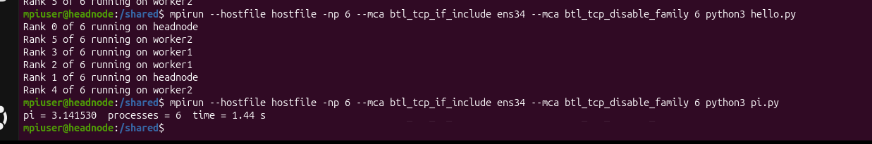
Figure 4: CP4 — one MPI job with 6 ranks running on headnode, worker1 and worker2
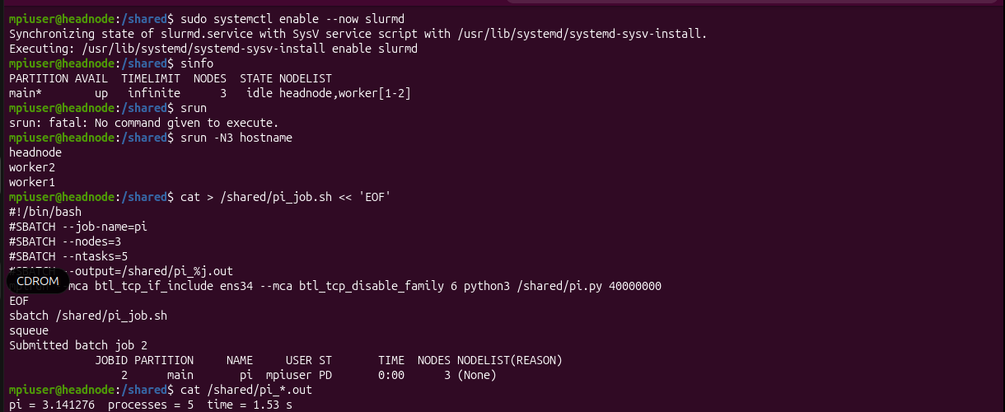
Figure 5: CP5 — Slurm shows 3 idle nodes, srun runs on all three, and the batch job computes π
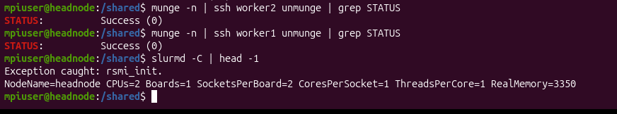
Figure 6: Munge authentication succeeds from headnode to both workers

6.3.1 Network performance
Measurement | headnode → worker1 | headnode → worker2
Bandwidth (iperf3, receiver, 10 s) | 15.5 Mbit/s | 14.7 Mbit/s
Retransmitted packets | 50 | 325
Average ping latency | 22.3 ms (20 pings)
The Wi-Fi link is far slower than a wired gigabit network, which normally gives 900+ Mbit/s and under 1 ms latency. The link to worker2 was the less stable one.
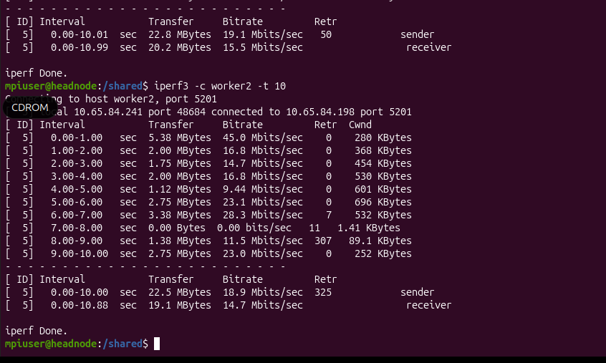
Figure 7: iperf3 bandwidth test from headnode to worker1 and worker2

6.3.2 Parallel speed-up (Monte Carlo π, 40 million points)
MPI processes | Machines used | Time (s) | Speed-up | Efficiency
1 | headnode | 6.14 | 1.00× | 100%
2 | headnode | 3.24 | 1.90× | 95%
3 | headnode, worker1 | 2.42 | 2.54× | 85%
4 | headnode, worker1, worker2 | 2.22 | 2.77× | 69%
5 | headnode, worker1, worker2 | 1.66 | 3.70× | 74%
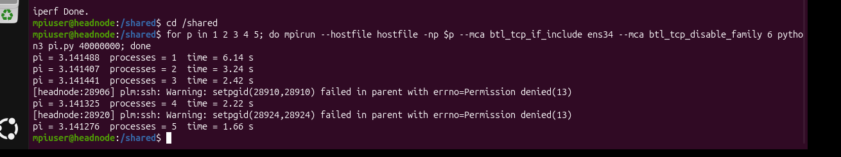
Figure 8: Monte Carlo π run with 1 to 5 MPI processes
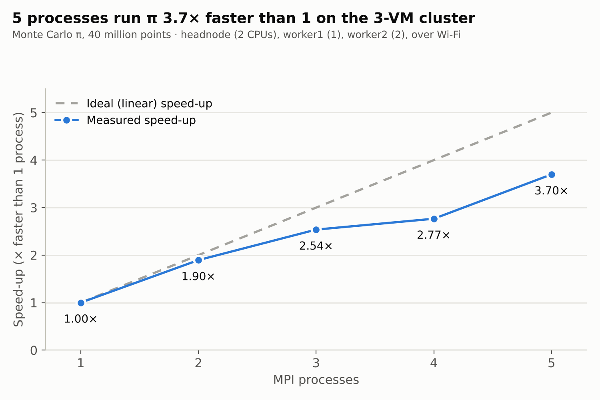
Figure 9: Parallel speed-up of the Monte Carlo π program
Speed-up = time with 1 process ÷ time with p processes; efficiency = speed-up ÷ p. The cluster gave a real 3.7× speed-up with 5 processes. Efficiency fell once processes ran on other machines, because results travel over the slow Wi-Fi link.

6.4 Functional testing of the banking system

6.4.1 Automatic unit tests
test_bank.py contains 14 automatic tests. All 14 passed on the cluster.
Group | What is tested | Result
Basic operations (9 tests) | Deposit, withdraw, transfer; refusing a withdrawal larger than the balance; all-or-nothing transfer; invalid amounts and accounts; frozen accounts; PIN check; mini statement keeps the last 10 entries | All passed
Concurrency (5 tests) | Per-account and global locks keep the total correct under 20 concurrent threads; no locking produces a wrong total; ordered locking never deadlocks; naive locking deadlocks | All passed
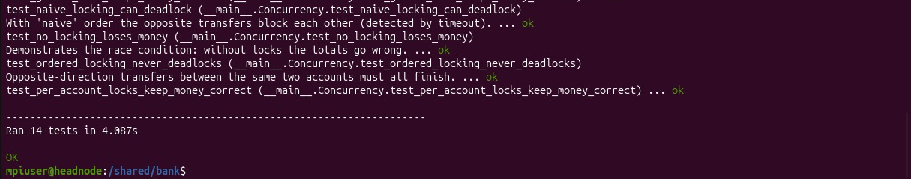
Figure 10: All 14 automatic tests pass on headnode

6.4.2 System tests on the cluster
Test | Steps | Expected result | Result
Servers start | Backup server on worker2, bank server on headnode | Both listening on ports 5001 and 5000 | Passed
Account set-up | admin.py init creates 100 accounts of RM 1,000 | Consistency check: no money lost | Passed
Remote customer | client.py on worker1 and worker2: log in, balance, deposit, transfer, mini statement | Correct balances on both sides | Passed
Replication | Backup server on worker2 receives committed transactions | Backup server running throughout | Passed: backup server active on worker2 (Figure 14)
Distributed load | 5 MPI processes × 5 customers = 25 customers on all three VMs, 20 accounts | All operations complete, no money lost | Passed: 408.0 tx/s, mean response 12.24 ms, difference RM 0.00
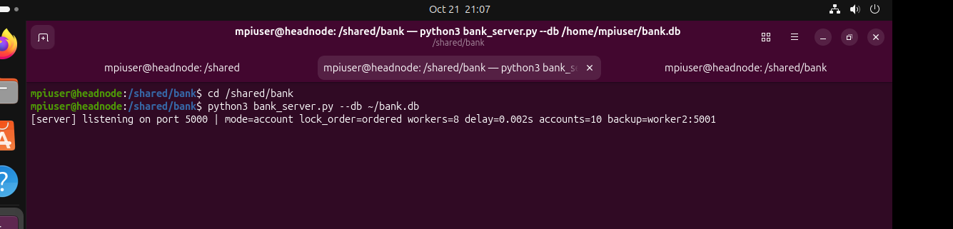
Figure 11: The bank server listening on port 5000 on headnode (per-account locks, 8 worker threads, backup on worker2)
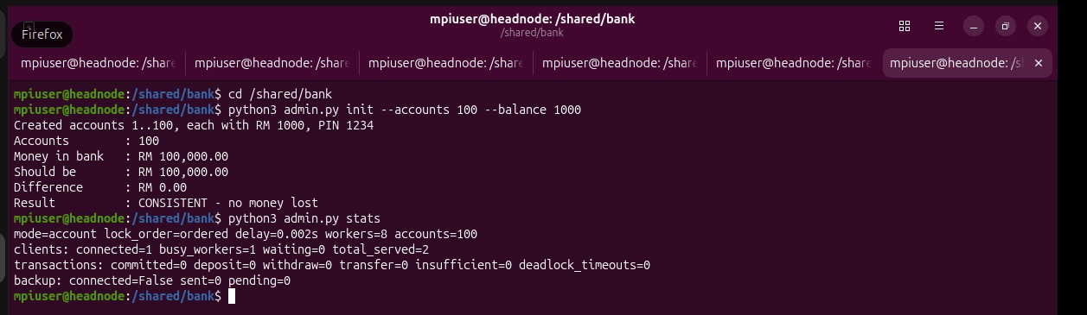
Figure 12: 100 accounts created and the consistency check passes. The backup shows connected=False because no transaction had been made yet.
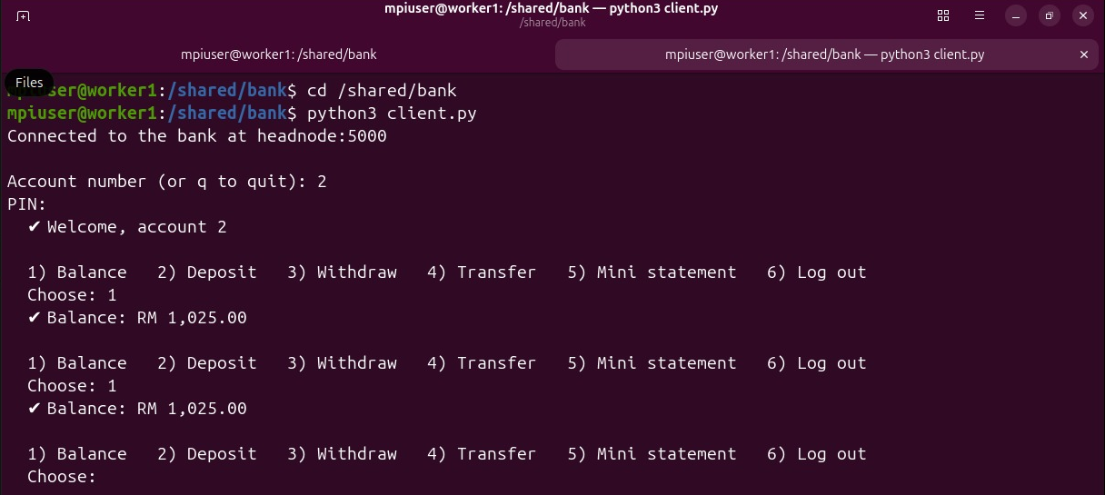
Figure 13: A customer on worker1 logs in to account 2, which shows RM 1,025.00 after receiving RM 25
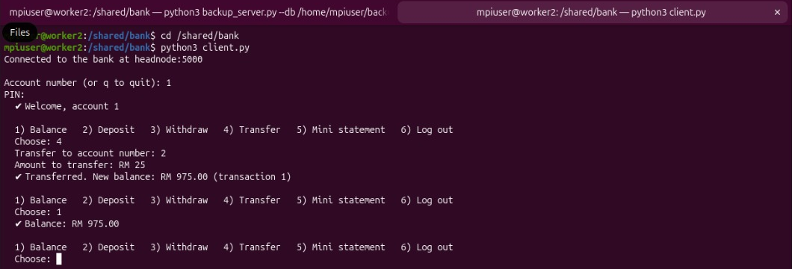
Figure 14: A customer on worker2 transfers RM 25 from account 1 to account 2; the first tab shows the backup server running on worker2
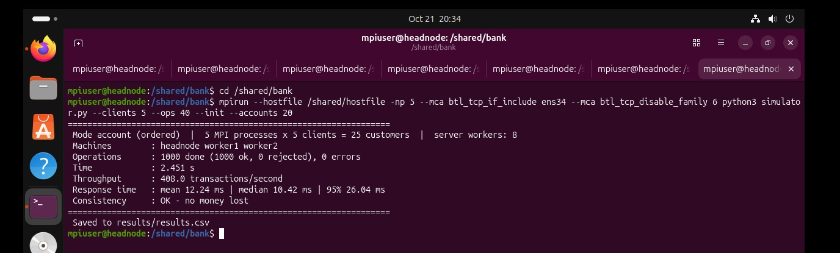
Figure 15: 25 simulated customers on all three VMs: 1,000 operations, 408.0 transactions per second, no money lost

6.5 Race condition test
Twenty-five customers ran at the same time against only 10 accounts, so many customers used the same account at once.
Lock mode | Throughput (tx/s) | Money difference | Result
No locking (--mode none) | 103.1 | −RM 221.00 (money lost) | Inconsistent
Per-account locks (--mode account) | 313.1 | RM 0.00 | Consistent
During the benchmark (section 6.7) the unlocked bank was also wrong in every one of its five runs, while both locked modes were correct in all ten of theirs.
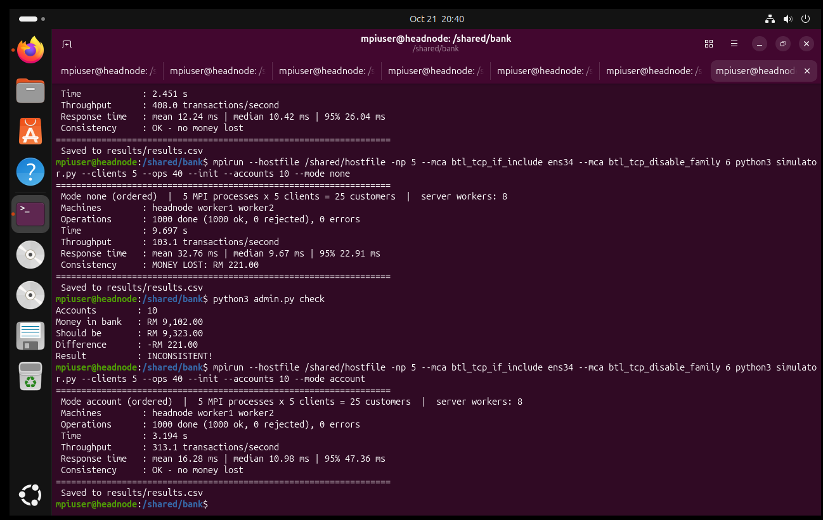
Figure 16: Race condition — with no locking RM 221.00 is lost and admin.py check reports INCONSISTENT; with per-account locks no money is lost
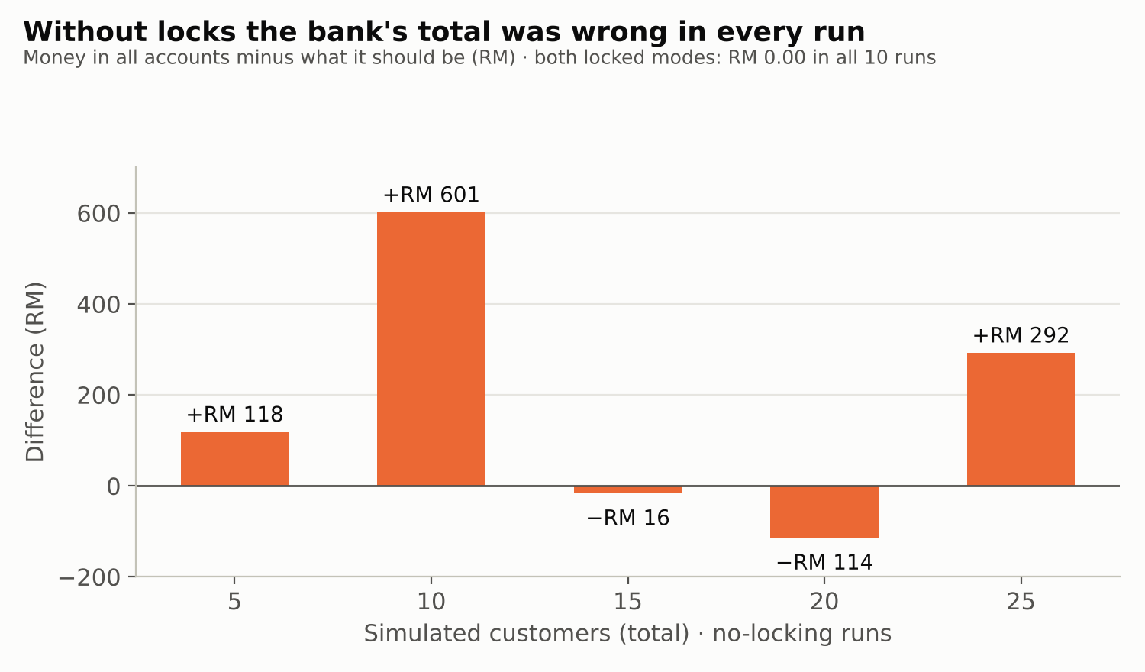
Figure 17: Money difference in the no-locking runs
Explanation. Without locks, two threads can read the same balance, each add or subtract their own amount, and write back. The second write overwrites the first, so one update is lost. Money can be lost or created depending on which update is overwritten, which is why the differences are both positive and negative. Locking makes the read–change–write sequence happen as one indivisible step for each account.

6.6 Deadlock test
Four customers each made five transfers between accounts 1 and 2 only, in both directions (the “ping-pong” pattern). This is the classic situation for a deadlock.
Lock order | Transfers completed | Deadlock timeouts | Time | Mean response time | Money
Naive (sender’s account first) | 8 of 20 | 12 | 20.03 s | 4,004 ms | Correct
Ordered (lower account number first) | 20 of 20 | 0 | 0.063 s | 10.8 ms | Correct
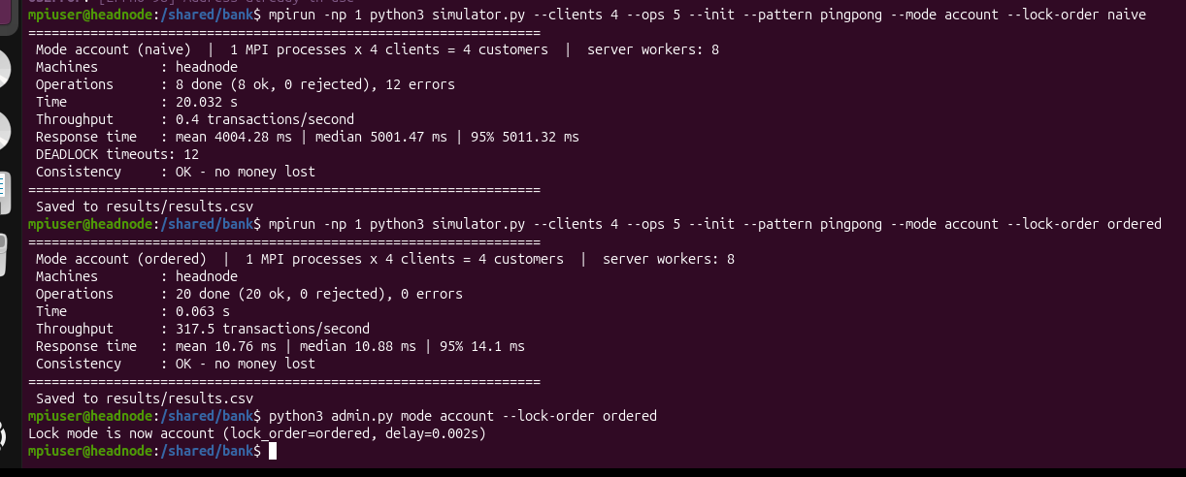
Figure 18: Deadlock test — naive order gives 12 deadlock timeouts in 20.03 s; ordered locking completes all 20 transfers in 0.063 s
Explanation. With the naive order, a transfer from 1 to 2 locks account 1 and waits for account 2, while a transfer from 2 to 1 locks account 2 and waits for account 1. Each waits for the other, which is a circular wait. Our server detects this with a 5-second timeout and cancels the transfer, so no money is lost, but 12 of 20 transfers failed. Ordered locking removes the circular wait, one of the four necessary conditions for deadlock, so every transfer completed about 300× faster.

6.7 Scalability benchmark
benchmark.sh ran each lock mode with 1 to 5 MPI processes, each process running 5 customer threads that each made 40 random operations (50% transfers, 20% deposits, 20% withdrawals, 10% balance checks) on 20 accounts. Processes 1–2 run on headnode; processes 3, 4 and 5 add worker1, worker2 and a second process on worker2.
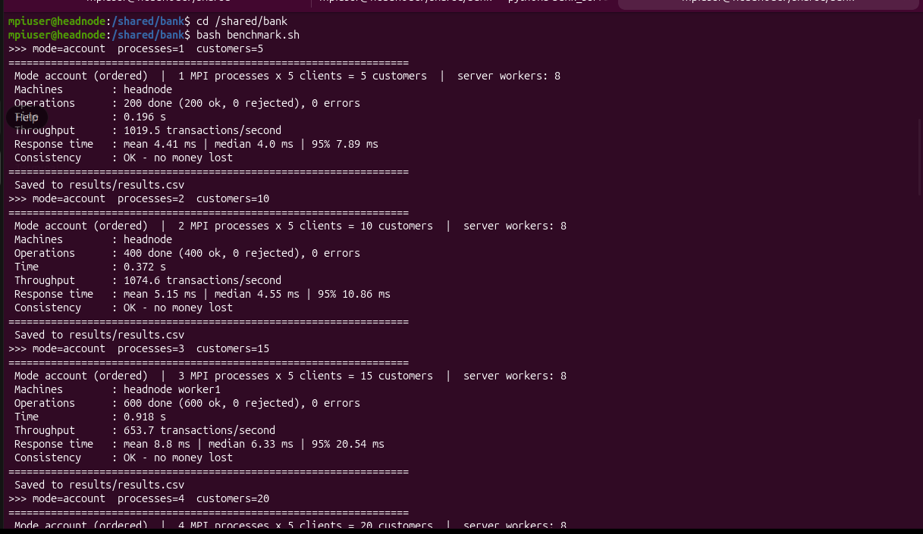
Figure 19: benchmark.sh running the per-account mode with 5, 10 and 15 customers
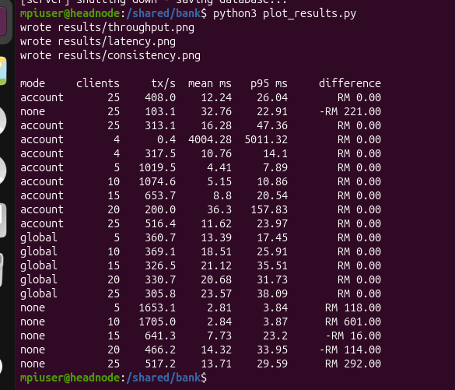
Figure 20: Results table printed by plot_results.py

6.7.1 Throughput (transactions per second)
Customers | Per-account locks | One global lock | No locking
5 | 1,019.5 | 360.7 | 1,653.1
10 | 1,074.6 | 369.1 | 1,705.0
15 | 653.7 | 326.5 | 641.3
20 | 200.0 | 330.7 | 466.2
25 | 516.4 | 305.8 | 517.2
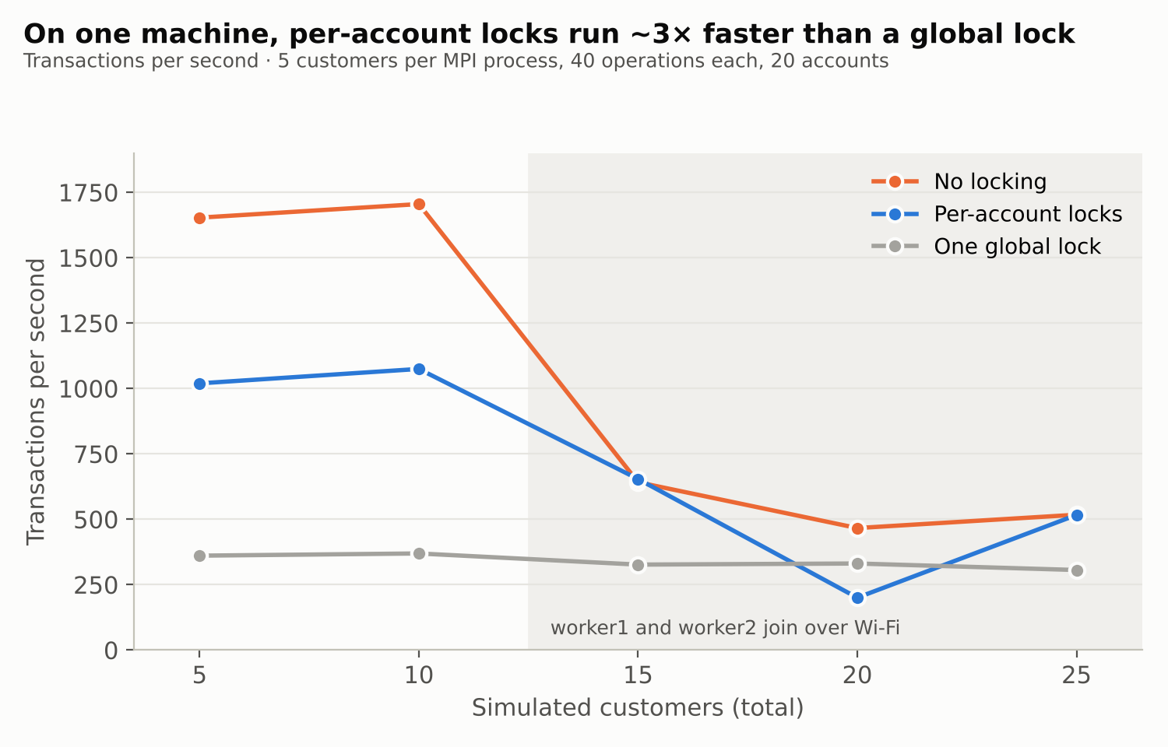
Figure 21: Throughput by lock mode

6.7.2 Response time (milliseconds)
Customers | Per-account mean / 95% | Global mean / 95% | No locking mean / 95%
5 | 4.41 / 7.89 | 13.39 / 17.45 | 2.81 / 3.84
10 | 5.15 / 10.86 | 18.51 / 25.91 | 2.84 / 3.87
15 | 8.80 / 20.54 | 21.12 / 35.51 | 7.73 / 23.20
20 | 36.30 / 157.83 | 20.68 / 31.73 | 14.32 / 33.95
25 | 11.62 / 23.97 | 23.57 / 38.09 | 13.71 / 29.59
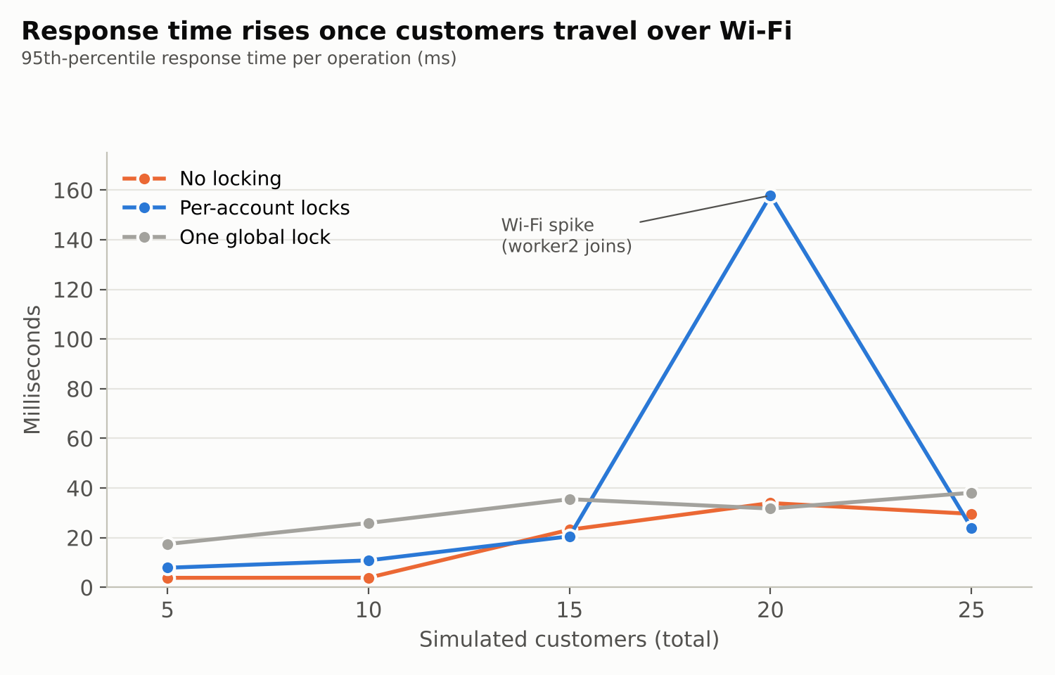
Figure 22: 95th-percentile response time by lock mode

7 Discussion

7.1 Analysis of the results
The global lock does not scale. Its throughput stayed between 305.8 and 369.1 tx/s whatever the number of customers. Only one transaction can run at a time, and each spends 2 ms in its critical section, so the theoretical maximum is 500 tx/s. Adding customers only makes them queue for the same lock, which is why its response time grew steadily from 13.39 ms to 23.57 ms.
Per-account locks allow real parallelism. Transactions on different accounts run at the same time, so with 5–10 customers on headnode the bank processed 2.8–2.9× more transactions than with the global lock, while staying correct.
No locking is fastest but useless. It was 1.6× faster than per-account locks on one machine, but the total was wrong in every run. A fast bank that loses money is not acceptable.
The network becomes the bottleneck across machines. From 15 customers onward, worker1 and worker2 joined, and every request from them crossed the Wi-Fi link (about 22 ms round trip, about 15 Mbit/s). Each customer waits for a reply before sending the next request, so network delay, not locking, limited throughput. As a result the per-account and no-locking modes fell to similar values (about 520–650 tx/s at 15 and 25 customers).
The 20-customer per-account result is probably a network outlier. Its throughput (200.0 tx/s) and 95th-percentile response (157.83 ms) are much worse than the 15- and 25-customer runs. This run was the first to include worker2, whose link showed 325 retransmissions in the network test. Because each configuration was run only once, we cannot rule out other causes; repeating the runs would confirm it.
Thread pool limit. The server has 8 worker threads, and each customer keeps one connection. Above 8 customers, the extra customers wait for a free thread, which adds to their response time.

7.2 Requirements check
Requirement | Target | Result
NFR1 Consistency | Total unchanged with locking | Met: RM 0.00 difference in every locked run
NFR2 Deadlock freedom | No hang with opposite transfers | Met: 0 deadlocks with ordered locking
NFR3 Performance | Per-account faster than global from 20 customers | Partly met: faster at 5, 10, 15 and 25 customers; slower at 20 (probable Wi-Fi outlier)
NFR4 Response time | Median under 100 ms | Met up to 25 customers (largest mean 36.30 ms); 50 customers not tested
NFR5 Scalability | Several pool sizes and client counts | Partly met: 5–25 customers tested; only one pool size (8) so far
NFR6 Reliability | Disconnecting clients do not crash the server | Met: the server kept running through all tests
NFR7 Durability | Balances survive a restart | Met: balances reloaded from bank.db after a restart
NFR8 Security | No plain-text PINs; no access to others’ accounts | Met: salted SHA-256 PIN hashes; the server refuses operations on any account except the logged-in one (test_pin passed)
NFR9 Maintainability | Modular, documented code | Met: 10 modules, each with a docstring explaining its purpose
NFR10 Usability | Menus need no training | Met: numbered client menu with plain messages such as “insufficient funds” (Figures 13 and 14)

8 Problems encountered and how we solved them
Building a real cluster brought several practical problems. The table lists them with their causes and fixes; each fix is now part of our set-up guide.
Problem | Cause | Solution
Lab machines had no internet access | Packages could not be installed | Moved the cluster to three laptops, each running an Ubuntu VM in VMware
headnode had no network address on its NAT adapter | VMware NAT adapter gave a 169.254 address | Added a second adapter bridged to the laptop’s Wi-Fi (ens34) on all three VMs
IP addresses changed after reconnecting | The hotspot gives new addresses | Updated /etc/hosts on every VM, and allowed both subnets in the firewall
mpirun hung | SSH still asked for a password | Ran ssh-copy-id from headnode to each worker
OpenMPI pairing warnings | It tried IPv6 and the NAT adapter | Added --mca btl_tcp_if_include ens34 --mca btl_tcp_disable_family 6
Munge “Rewound credential” and Slurm authentication errors | The VM clocks were different | Synchronised the clocks and restarted munge, slurmd and slurmctld
Simulator froze when run with plain python3 | Open MPI 5 starting a single-process runtime | Changed the simulator to use MPI only when started by mpirun
“Address already in use” / “Connection refused” | Server already running / server not started | Use the running server, or start bank_server.py before the clients
“No such file or directory” | Command run from /shared instead of /shared/bank | cd /shared/bank first
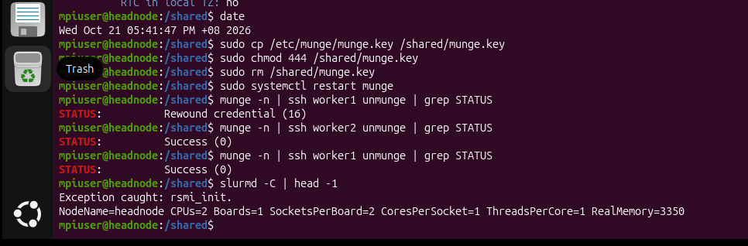
Figure 23: Munge rejected worker1 (“Rewound credential”) until the clocks were synchronised; afterwards both workers return Success
Figure 24: The simulator waiting forever when started without mpirun, before the fix

9 Conclusion and future work

9.1 Conclusion
The project met its main objectives. We built a working three-node cluster from laptops and virtual machines, with shared storage, passwordless SSH, MPI and the Slurm scheduler, and showed a real 3.7× speed-up on a parallel program. On it we ran a distributed bank in which customers on different machines use a multi-threaded server, every transaction is stored in SQLite and copied to a backup server on another node, and an MPI simulator creates load from all three nodes at once.
The experiments answered the project question. Without synchronization the bank lost or created money in every run, which is the race condition in practice. Locks fixed it completely: no money was lost in any locked run. Lock order matters as much as locks: the naive order deadlocked 12 times in 20 transfers, and ordered locking removed every deadlock and ran about 300 times faster. Lock granularity matters for speed: per-account locks served about 2.9 times as many transactions per second as one global lock, while staying just as correct. Finally, in a distributed system the network is part of the design; over Wi-Fi it, not the locks, became the main limit once customers ran on other machines.
The project applied the main topics of the module in one working system: processes and threads, thread pools, sockets and client–server communication, synchronization and mutual exclusion, deadlock prevention, producer–consumer queues, replication, MPI, cluster job scheduling and performance evaluation.

9.2 Limitations and future work
- Wi-Fi network. A wired gigabit switch would reduce latency from about 22 ms to under 1 ms and show the locking differences more clearly across machines.
- Single runs. Each configuration ran once; repeating each 3 times and averaging would reduce the effect of Wi-Fi spikes.
- Thread pool size. Testing 8, 16 and 32 workers would complete NFR5.
- Uneven VMs. worker1 had 1 CPU while the others had 2; equal VMs would give a fairer comparison.
- Reader–writer locking. Balance enquiries could share access while updates take exclusive access, improving read-heavy workloads.

10 References
Amdahl, G. M. (1967). Validity of the single processor approach to achieving large scale computing capabilities. In Proceedings of the AFIPS Spring Joint Computer Conference (Vol. 30, pp. 483–485). ACM.
Coffman, E. G., Elphick, M. J., & Shoshani, A. (1971). System deadlocks. ACM Computing Surveys, 3(2), 67–78.
Coulouris, G., Dollimore, J., Kindberg, T., & Blair, G. (2012). Distributed systems: Concepts and design (5th ed.). Pearson.
Dalcin, L., & Fang, Y.-L. L. (2021). mpi4py: Status update after 12 years of development. Computing in Science & Engineering, 23(4), 47–54.
Gray, J., & Reuter, A. (1993). Transaction processing: Concepts and techniques. Morgan Kaufmann.
Gropp, W., Lusk, E., & Skjellum, A. (2014). Using MPI: Portable parallel programming with the Message-Passing Interface (3rd ed.). MIT Press.
Open MPI Project. (n.d.). Open MPI documentation. https://www.open-mpi.org/doc/
Python Software Foundation. (n.d.). threading — Thread-based parallelism and concurrent.futures — Launching parallel tasks. https://docs.python.org/3/library/
Silberschatz, A., Galvin, P. B., & Gagne, G. (2018). Operating system concepts (10th ed.). Wiley.
SQLite. (n.d.). Write-ahead logging. https://www.sqlite.org/wal.html
Tanenbaum, A. S., & van Steen, M. (2017). Distributed systems (3rd ed.). Maarten van Steen.
Yoo, A. B., Jette, M. A., & Grondona, M. (2003). SLURM: Simple Linux utility for resource management. In Job Scheduling Strategies for Parallel Processing (LNCS 2862, pp. 44–60). Springer.

11 Appendices

Appendix A: Cluster configuration files
/etc/hosts (all three VMs)
10.65.84.241 headnode
10.65.84.164 worker1
10.65.84.198 worker2
/shared/hostfile (MPI)
headnode slots=2
worker1 slots=1
worker2 slots=2
Slurm node lines (/etc/slurm/slurm.conf, same file on all nodes)
NodeName=headnode CPUs=2 ... RealMemory=3350
NodeName=worker1 CPUs=1 ... RealMemory=3346
NodeName=worker2 CPUs=2 ... RealMemory=4100
PartitionName=main Nodes=ALL Default=YES MaxTime=INFINITE State=UP

Appendix B: Source code
The complete source code (bank.zip, 10 Python files, benchmark.sh, benchmark.sbatch and README.md) is submitted with this report.

