LAB 1 REPORT
Process and Thread Management
Distributed & Parallel Computing
Implementation using Java and Python

1. Introduction
This lab investigates process and thread management by implementing the same computational task using Java threads, Java processes, Python threads, and Python processes. The selected task is the summation of integers from 1 to 4,000,000. Using the same task in all four implementations makes it possible to observe differences in execution behavior and performance.

2. Objectives
- Understand the basic difference between a process and a thread.
- Create and manage multiple threads and processes in Java and Python.
- Divide one computational problem among four workers.
- Combine partial results to obtain one correct final result.
- Measure execution time and compare the four implementations.

3. Experimental Task
The program calculates the sum of all integers from 1 to 4,000,000. The workload is divided into four equal ranges so that four workers can perform the calculation.
Worker | Assigned Range
Worker 1 | 1 - 1,000,000
Worker 2 | 1,000,001 - 2,000,000
Worker 3 | 2,000,001 - 3,000,000
Worker 4 | 3,000,001 - 4,000,000
Each worker calculates a partial sum. After all workers finish, they combine the partial sums. The expected final result is 8,000,002,000,000.

4. Tools and Environment
Development environment: Visual Studio Code. Languages: Java and Python. The programs were executed locally on a Windows computer using the integrated terminal in VS Code.

5. Implementation

5.1 Java Multithreading
The Java thread implementation uses four SumWorker threads inside one Java process. Each thread receives a different numerical range and performs its summation independently. The start() method begins thread execution, while join() makes the main thread wait until all worker threads finish. The four partial sums are then added to obtain the final result.

5.2 Java Process Management
The Java process implementation uses ProcessBuilder to create four separate Java worker processes. Each child process calculates one range and prints its partial result. The main process reads the results, waits for the child processes to complete, and combines the values. This approach creates separate operating-system processes and therefore has additional process and JVM startup overhead.

5.3 Python Threading
The Python threading implementation uses the threading module. Four Thread objects execute the same calculation function with different ranges. The partial results are stored in a shared results list. The main thread calls join() for each worker before combining the results.

5.4 Python Multiprocessing
The Python multiprocessing implementation uses the multiprocessing module to create four separate processes. A multiprocessing Queue is used to return each partial sum to the main process. The if __name__ == "__main__" guard is used so that process creation works correctly on Windows.

6. Results
All four implementations produced the same correct final sum. The execution time changed slightly between runs, which is expected because operating-system scheduling, background activity, runtime startup, and available CPU resources can vary. For a stronger comparison, each program should be executed multiple times and the average time should be reported.
Implementation | Workers | Final Sum | Observed Time
Java Threads | 4 threads | 8,000,002,000,000 | ~0.0324 s
Java Processes | 4 processes | 8,000,002,000,000 | ~0.2404 s
Python Threads | 4 threads | 8,000,002,000,000 | ~0.3682 s
Python Processes | 4 processes | 8,000,002,000,000 | ~0.6055 s
Note: The times above are observed single-run values from the completed tests and are not treated as universal performance results. Repeated measurements should be averaged before making a final performance conclusion.

7. Discussion
The experiment demonstrates an important structural difference. Threads execute within the same process and share the process memory, whereas separate processes have independent memory spaces and require additional mechanisms to exchange results. In the Java experiment, the thread implementation completed faster than the separate-process implementation in the observed runs, partly because the process version starts additional JVM processes. In Python, the threading and multiprocessing versions also showed different timings. The small workload and startup overhead mean these values should be interpreted as observations from this lab rather than a general rule about which technique is always faster.
The order in which threads and processes printed their messages was not always sequential. This shows that concurrent workers are scheduled independently by the runtime and operating system; starting Worker 1 first does not guarantee that it will print or finish first.

8. Conclusion
Lab 1 successfully demonstrated process and thread management in both Java and Python. The same numerical task was divided among four workers using four different implementations. All implementations produced the correct total of 8,000,002,000,000, confirming that the workload was divided and combined correctly. The lab also showed that threads and processes have different creation, memory, communication, scheduling, and performance characteristics. Repeating the timing tests and using average execution times will provide a more reliable final performance comparison.

9. Evidence to Include Before Final Submission
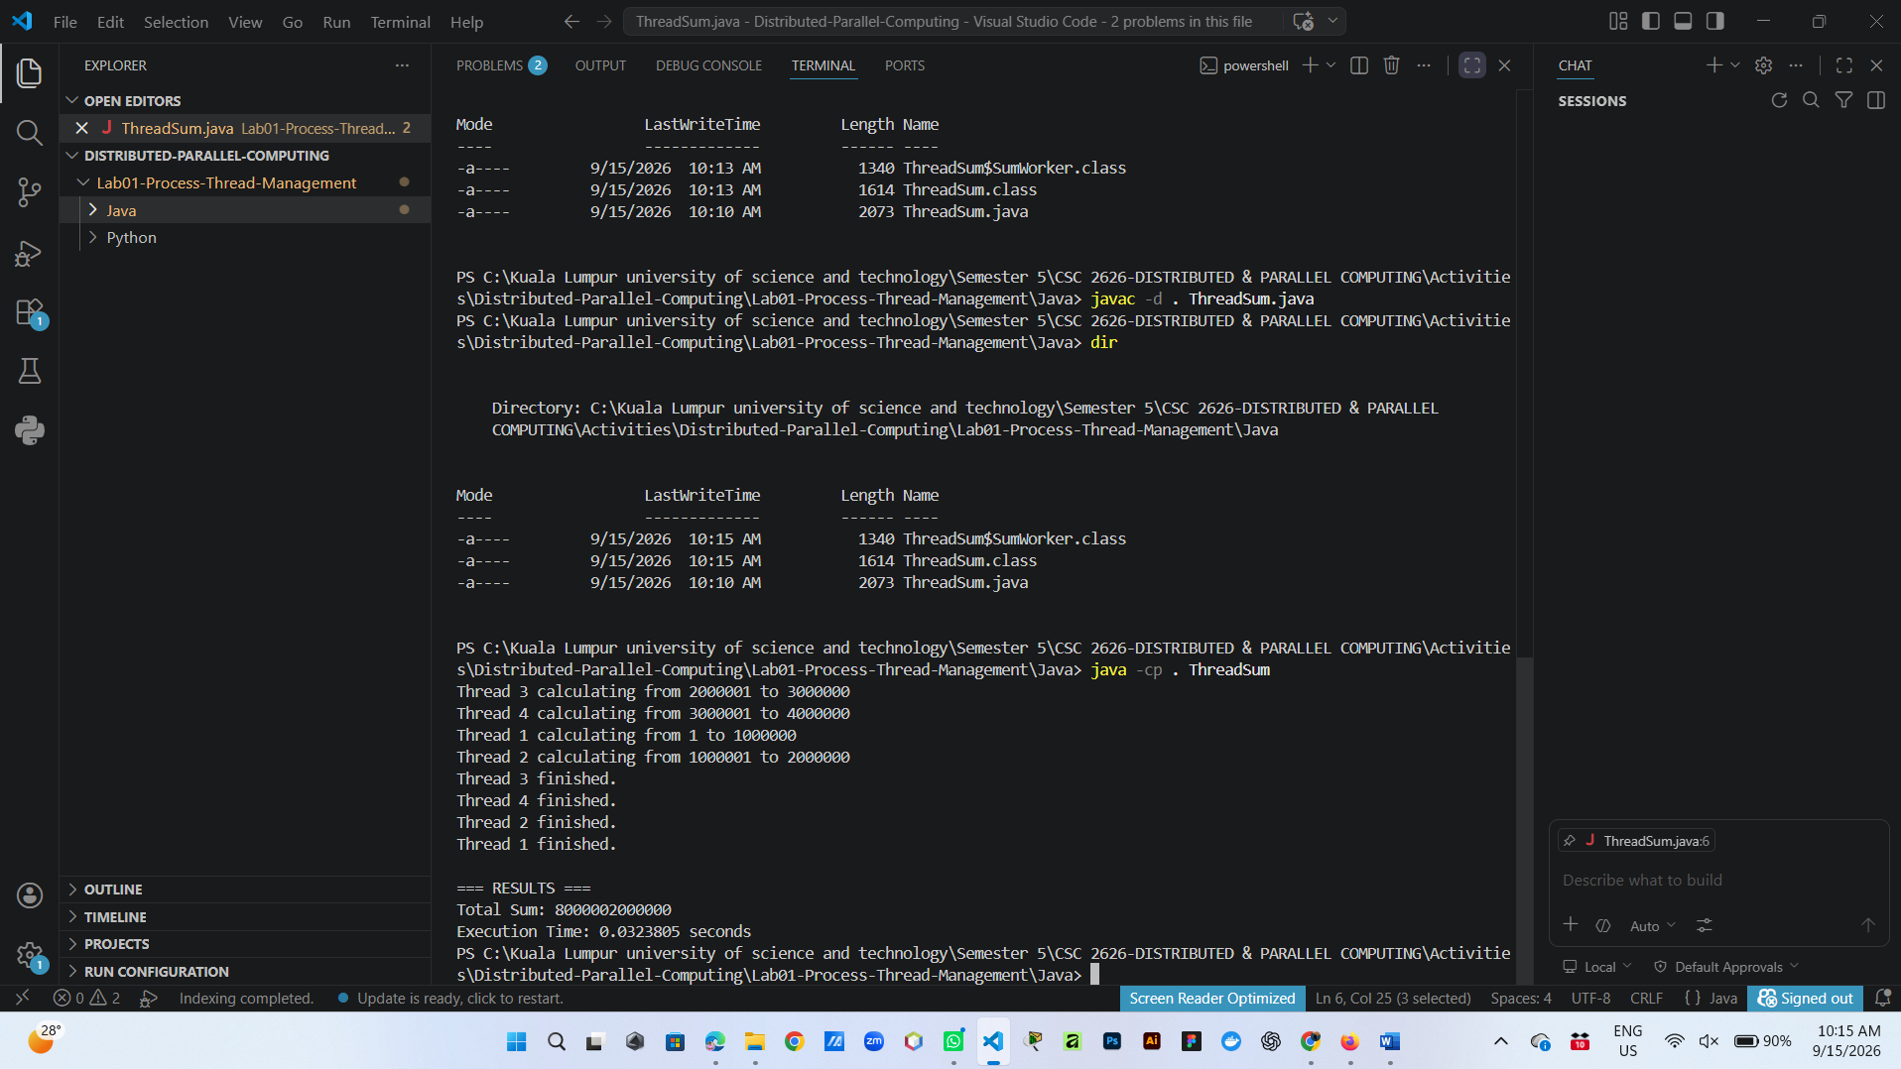
- Screenshot of Java ThreadSum execution.

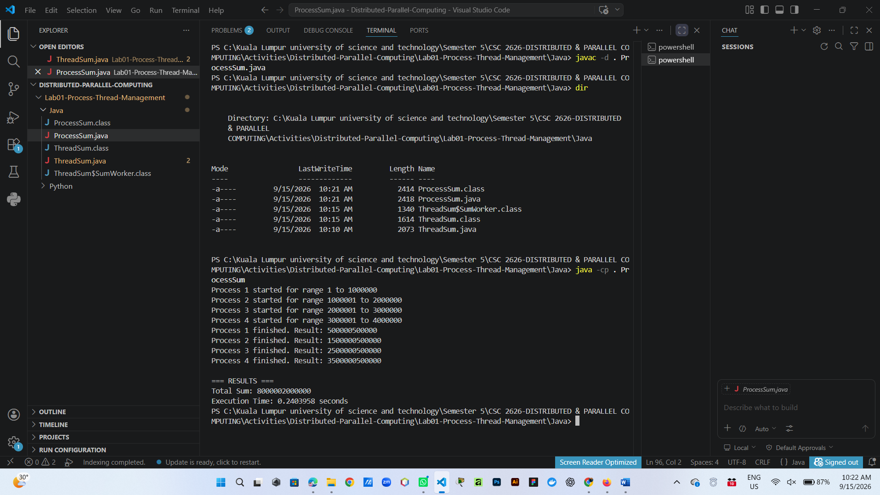
- Screenshot of Java ProcessSum execution.

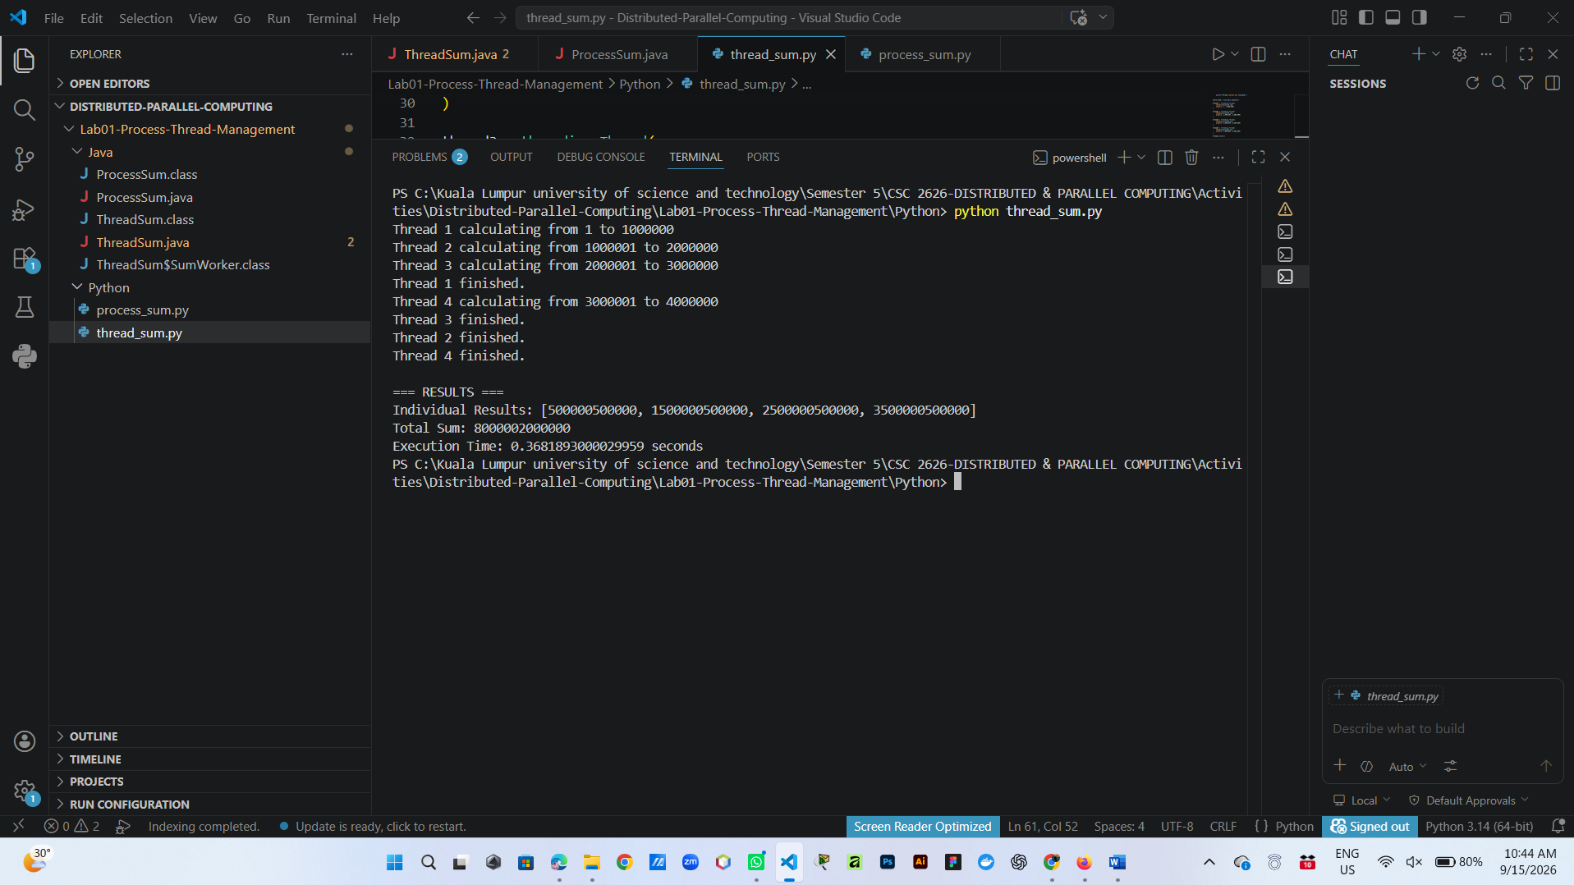
- Screenshot of Python thread_sum.py execution.

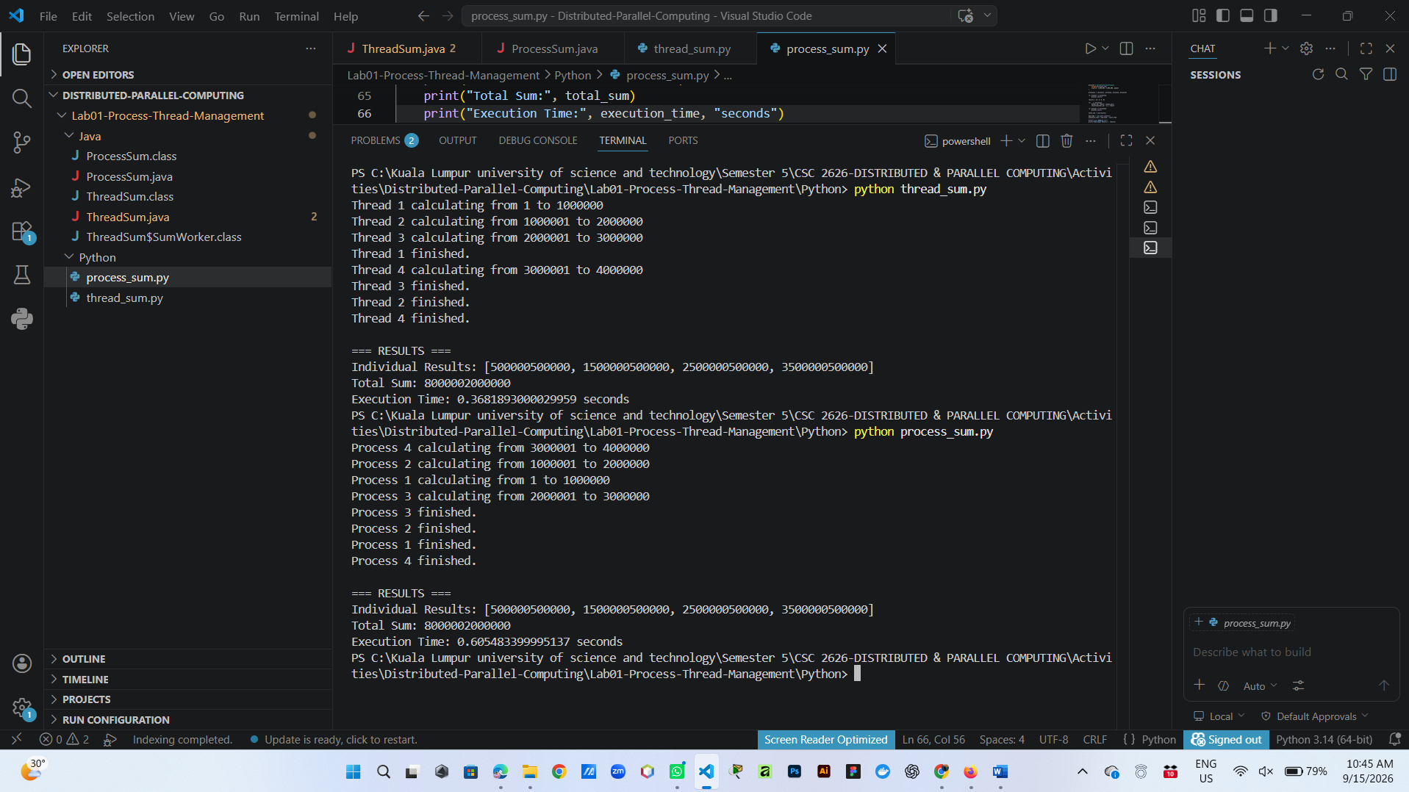
- Screenshot of Python process_sum.py execution.

- Three execution-time runs for each implementation and the calculated average.



