Mohamed ibrahim elhassanein ibrhaim

Student number 2021A0113

Date : 22 / 11 / 2024

Handwritten Digit Recognition Using TensorFlow

**Over-view**

1 - Introduction -------------------------

2 - Purpose of the Project ------------

3 - Problem Statement ----------------

4 -Tools and Technologies ------------

5 -Data Preparation --------------------

6 - making a model.h5 -----------------

7 - Training and Results ---------------

8 how to using this model ------------

9- Challenges Faced --------------------

10 -Conclusion --------------------------

11 - References -------------------------

1 - Introduction

What is Data Mining?

Data mining is the process of discovering patterns, correlations, anomalies, and useful information from large datasets using statistical and computational techniques.

It is a part of the larger process called Knowledge Discovery Databases (KDD), which involves selecting, preprocessing, transforming, and interpreting data.

The primary goal of data mining is to extract patterns from data that can be used for decision-making, predictions, and discovering trends.

2 - Purpose of the Project

The primary objective of this project is to recognize handwritten digits (0-9) with a high level of accuracy using deep learning techniques. Handwritten digit recognition is a classic problem in the field of computer vision and has practical applications such as:

- Postal code recognition in mail sorting.

- Bank check verification.

- Digitized document processing.

This project utilizes the MNIST dataset, which consists of labeled images of handwritten digits, to train and evaluate a machine learning model capable of performing this task.

#### **TensorFlow as the Chosen Framework**

TensorFlow, an open-source deep learning framework developed by Google, was chosen for this project because of its flexibility, scalability, and robust ecosystem. TensorFlow provides a high-level API, Keras, which simplifies the creation and training of deep learning models. Its ability to handle large-scale computations, efficient GPU/TPU support, and extensive community resources make it an ideal choice for implementing convolutional neural networks (CNNs) for image classification tasks like handwritten digit recognition.

3 . Problem Statement

ignificance of Handwritten Digit Recognition

Handwritten digit recognition is a fundamental problem in the field of computer vision, where the goal is to accurately identify digits (0-9) written by hand. This task is significant because it represents the ability of machines to understand and process human input in the form of natural, unstructured data—such as handwriting. Handwritten digit recognition is a key step towards creating systems that can interact with humans in a more intuitive way, similar to how humans read and interpret handwriting.

#### ****Common Applications****

Handwritten digit recognition has numerous practical applications across various industries, including:

1. **Postal Services:** Sorting handwritten mail based on zip codes or addresses, automating the mail sorting process.
2. **Banking:** Automating the processing of handwritten checks, reducing human error and improving the speed of transactions.
3. **Document Digitization:** Converting handwritten forms, surveys, and other documents into machine-readable formats, enabling efficient data storage and analysis.
4. **License Plate Recognition:** Recognizing handwritten vehicle registration numbers in traffic management systems.
5. **Medical Transcription:** Converting handwritten medical records into digital form for improved patient record management.
6. Tools and Technologies

TensorFlow, Python, Matplotlib,

1. Data Preparation

Go o this link to owmload

<https://www.kaggle.com/datasets/sagyamthapa/handwritten-math-symbols?select=dataset>

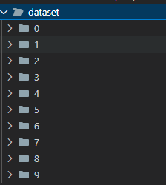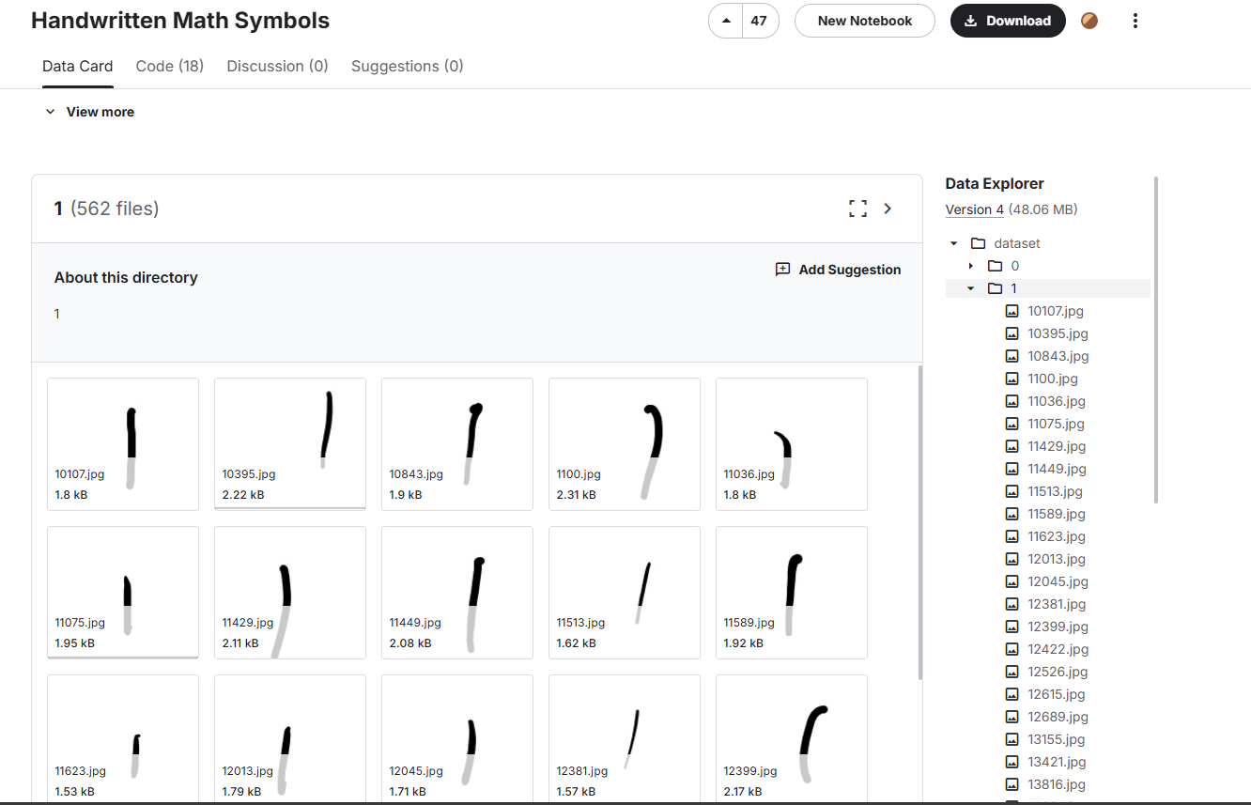

6 - making a model.h5

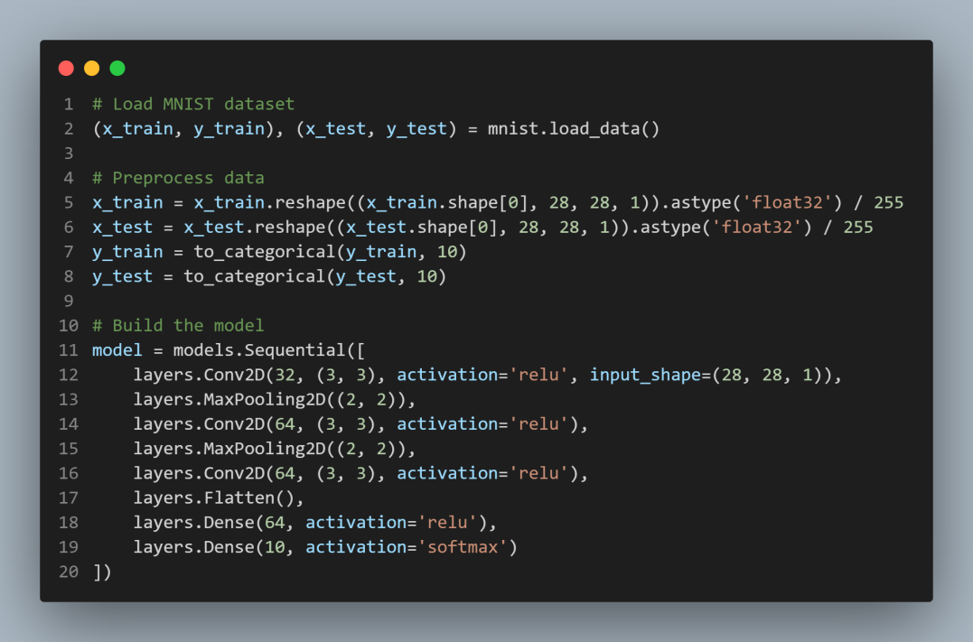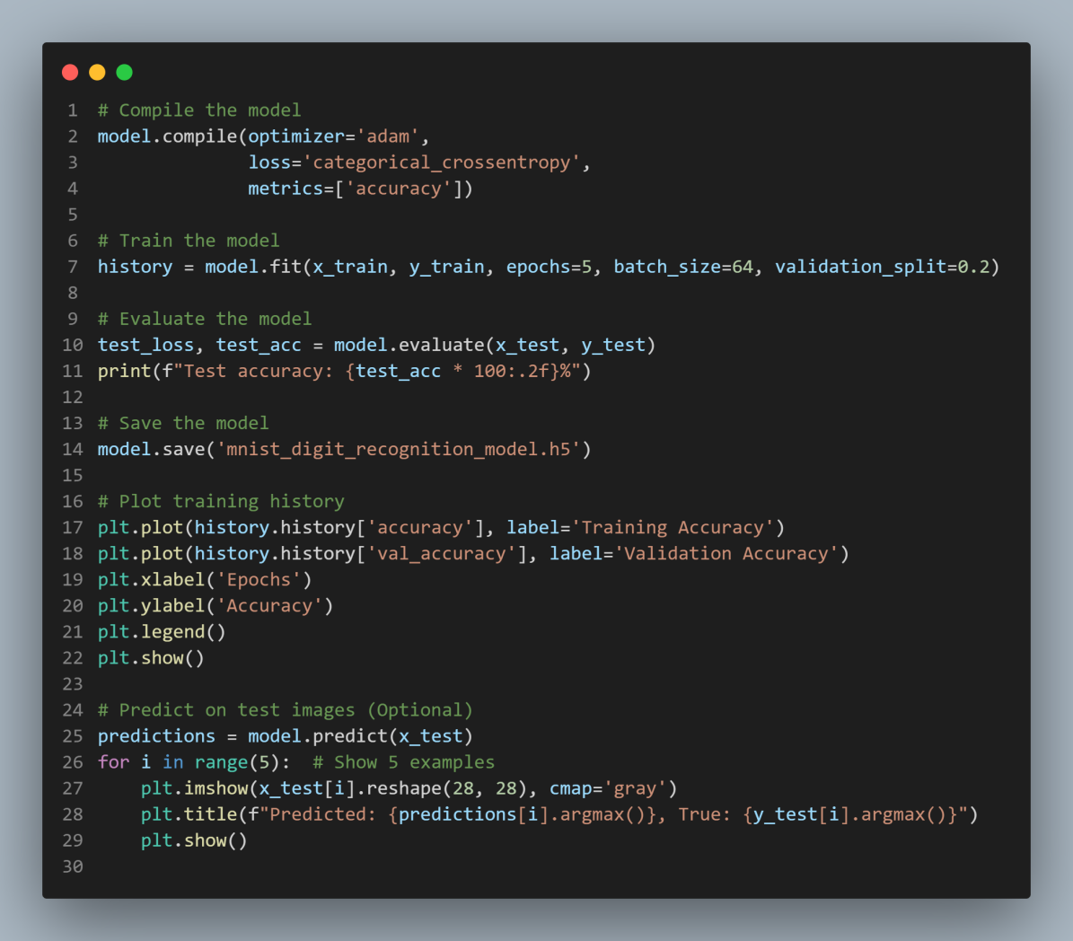

7 Training and Results

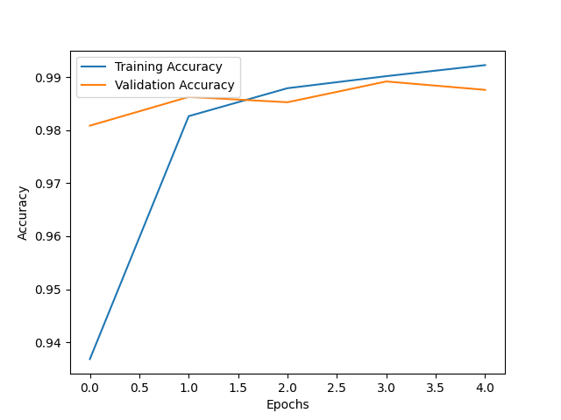

Blue Line

this to Indicates the training accuracy, which steadily increases as the model learns from the training data.

Orange Line:

Represents validation accuracy, which shows how well the model performs on unseen validation data during training.

Training Accuracy : The model achieves near-perfect accuracy (close to 99%)

8 how to using this model

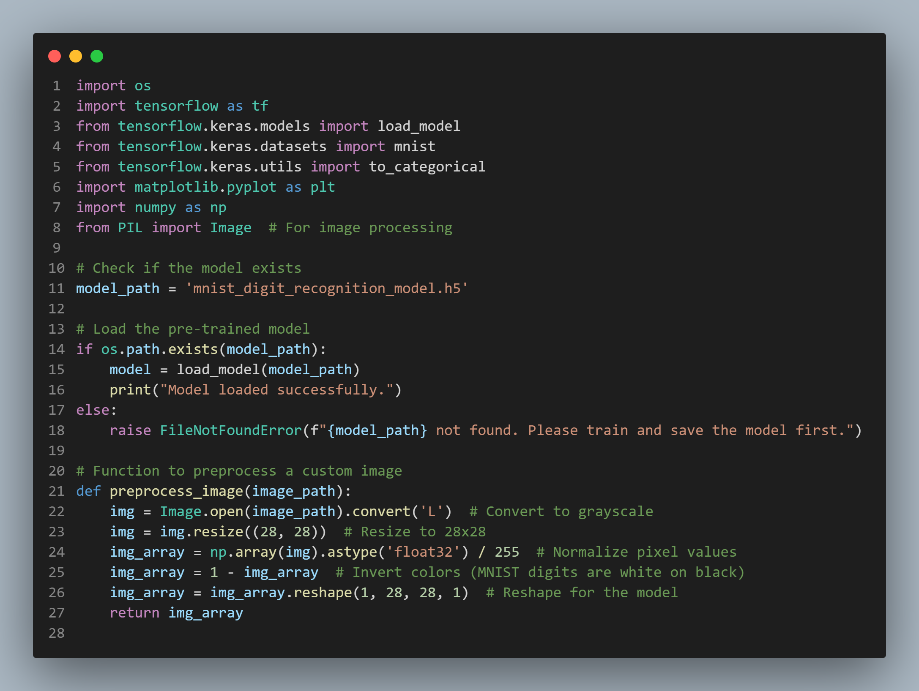

Reslut

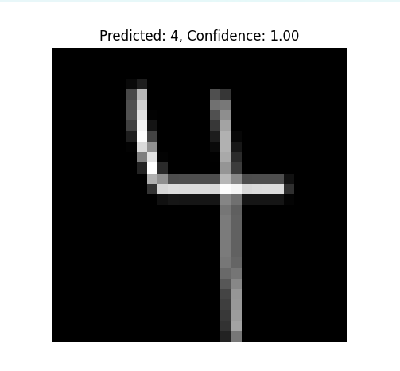

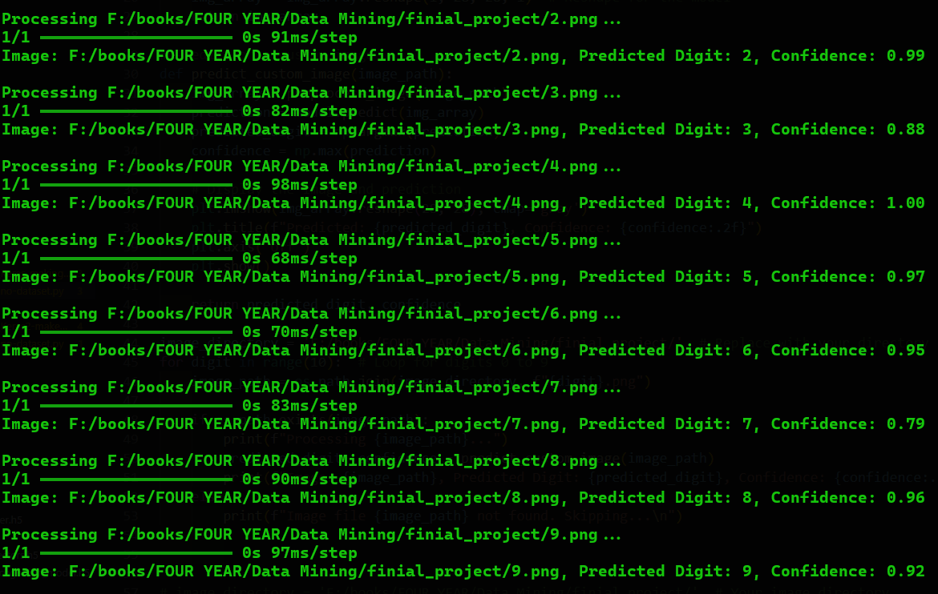

9- Challenges Faced

There was a library called PyTorch, but after searching and checking carefully, I found that this library is the best solution, and even the fastest.

While scikit-learn is a fantastic library for traditional machine learning, it is not optimized for deep learning tasks. It does not provide the flexibility and scalability needed for complex neural network architectures like Convolutional Neural Networks (CNNs), which are crucial for image recognition tasks.





1. **Conclusion**

**Project Achievements**

This project successfully developed a deep learning model for handwritten digit recognition using TensorFlow and convolutional neural networks (CNNs). The model achieved a high accuracy rate of over 98%, demonstrating its effectiveness in recognizing handwritten digits from the MNIST dataset. The training process was efficient, and the model showed strong generalization ability, as evidenced by the minimal gap between training and validation accuracy.

The project showcases the practical applicability of deep learning techniques in solving real- world problems, such as automating the recognition of handwritten digits. This model could be used in various industries for applications such as postal mail sorting, banking check verification, and document digitization, where the ability to process handwritten data quickly and accurately is crucial.

Future Scope

Although the model performs well on the MNIST dataset, there is still room for improvement and further development:

**Deploying on Mobile Devices:** The model can be optimized for mobile deployment, enabling real-time digit recognition in applications such as mobile banking or interactive forms. By converting the model to a format suitable for mobile platforms (e.g., TensorFlow Lite), it can be integrated into mobile apps for efficient use on smartphones and tablets.

**Improving Accuracy:** While the model has achieved high accuracy, it can be further improved by:

* 1. Expanding the dataset to include more diverse handwriting samples.
  2. Fine-tuning the model architecture (e.g., experimenting with deeper networks or different activation functions).
  3. Implementing data augmentation techniques to increase model robustness by introducing variations in the training data.

**Generalization to Other Datasets:** Extending the model to recognize handwritten characters beyond digits (e.g., letters, cursive handwriting) could broaden its applicability in different domains, such as education, healthcare, and automatic form processing.

11 References

<https://en.wikipedia.org/wiki/Data_mining>

<https://www.kaggle.com/datasets/sagyamthapa/handw>ritten-math-symbols?select=dataset

<https://www.techtarget.com/searchbusinessanalytics/definition/data-mining111t6>

<https://opencv.org/blog/pytorch-vs-tensorflow/>

<https://www.tensorflow.org/>

<https://scikit-learn.org/stable/>

<https://www.tensorflow.org/install>

<https://www.kaggle.com/datasets/sagyamthapa/handwritten-math-symbols>

<https://pytorch.org/tutorials/beginner/pytorch_with_examples.html>

<https://pypi.org/project/torch/>