Ayurvedic herbs which contain phytoestrogen
Shatavari(Asparagus racemosus)
Shatavari is one of the best herbs for women.It nourishes seven body tissues and vitalises reproductive system.Shatavari root is cooked in milk and consumed.Ayurveda lehya named Shathavari gulam contains Shatavari. Dosage is 1 tablespoon daily.
Vidarikand(Pueraria tuberosa)
Vidarikand is a large tuber which has rejuvenatory effects on both men and women.It helps to increase the good cholesterol or HDL.It nourishes all tissues and increases fertility.It pacifies vata and pitha factors.Tuber of Vidari is cooked in milk,dried and powdered.Vidaryadi lehyam in Ayurveda contains Vidari.
Dosage is 1 tablespoon daily.
Methika(Trigonella foenum graceum)
Fenugreek seeds or Methika is used in Indian cooking.In women it is used as uterine tonic.Fenugreek has antidiabetic properties as it slows down absorption of glucose from food.It balances vata and kapha factors and enhances pitta or metabolism.Methika is good remedy to cure hot flushes.
Soak 1 tablespoon of fenugreek seeds for 3 hours and cook in a cup of coconut milk.Jaggery or palmsugar may be added .Another option is to take 1 tsp freshly powdered fenugreek seeds with warm water in empty stomach.
Yashtimadhu(Glycerrhiza Glabra)
Yashtimadhu gives emotional stability and reduces hot flushes.It relieves constipation and painful urination.
Dosage:1 tsp of Yashtimadhu powder may be consumed with warm water or milk before breakfast.
Tila(Sesamum indicum)
Sesame seeds may be roasted and made into balls in palm sugar or jaggery syrup.
To make herbal tea 1 tsp of sesame seeds is boiled in 1 glass of water and taken in empty stomach.
Food containing Phytoestrogens
Miso paste,Flax seed,soy products,Mungbean sprouts,garlic,dried apricots,pistachios,dates,yam and green beans contain phytoestrogen.

12 Foods High in Estrogen for Balanced Hormones
If you’ve been told by your doctor that your estrogen levels are low, you can use these estrogen-rich foods to get you back to where you need to be. You can also use this list as a way to avoid foods high in estrogen if you have too much estrogen in your body.
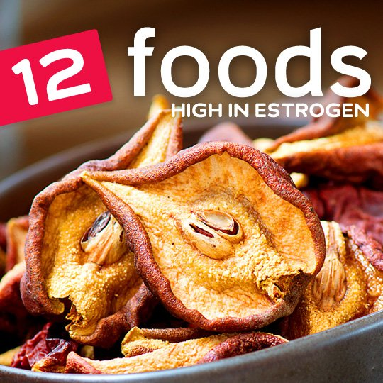
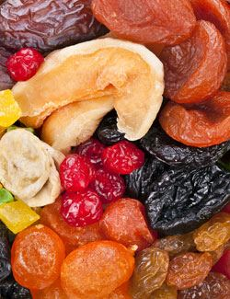
1. Dried Fruits
Dried fruit, especially dried apricots, dates, and prunes, can help balance your estrogen levels in a big way. They are also a healthy snack that can keep you away from the vending machine with a sweet and satisfying chewiness, as well as added fiber.
These dried fruits contain phytoestrogens, which will mimic the way estrogen is used by the body, helping to fill any shortages you may have in estrogen, and producing the same effect as if you had generated more estrogen in the body.
When eating dried fruit, remember that the drying process concentrates all parts of the fruit, so you’ll generally be getting more vitamins and nutrients from them, but you’ll also be getting more sugar, so it may take less dried fruit to make a serving than if it were fresh.
Tips for eating more: Dried fruits are best eaten in the spring, and the best fruit for estrogen are apricots, dates, and prunes.
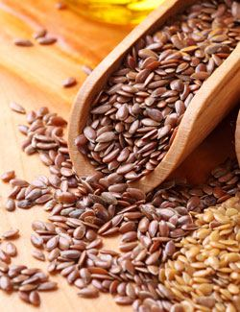
2. Flaxseed
Flaxseeds are the number one way to help get more estrogen into the body, and you can either eat them directly or add them to other foods, just be sure to add them to your diet if estrogen is a concern.
Flaxseeds are high in fiber, and will therefore help you feel full during and after a meal, and help a sluggish digestive system. They are often recommended for weight loss because of their fiber content, and can help lower cholesterol as well. That’s a lot of benefit from a little seed.
Flaxseeds are a fantastic source of omega-3s as well, but it’s the ALA form from plants, and not the same as you get from salmon and other animal sources. This form of omega-3 is helpful at keeping arteries from hardening, which can help prevent strokes and heart attacks and provide other heart healthy benefits.
Tips for eating more: Ground flaxseed is the best way to incorporate it into your cooking more. It basically disappears into soups and smoothies, and can be sprinkled onto a salad without noticing it’s there. Tip: Add the dressing to the salad first and the flaxseed will cling to it so you get some in each bite.
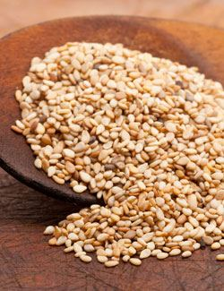
3. Sesame Seeds
Sesame seeds contain phytoestrogens, and you can also use sesame seed oil if that makes it easier, as they both contain lignans with possess the phytoestrogens.
Sesame seeds are loaded with fiber, and they are also a great source of minerals. Because of their small size you can easily add them to other foods that are lacking to help make up for some of that deficiency. For example, a tablespoon of sesame seeds is going to give you nearly a tenth of what you need each day for iron, magnesium, and calcium, as well as 4% of your total fiber.
Unfortunately the sesame seeds stuck to the bun of a Big Mac don’t qualify, you’ll want to sesame seeds by themselves or in conjunction with other healthy foods to reap their benefits.
Tips for eating more: Keep a supply of sesame seeds on hand for adding to soups or onto a salad. They also make a great crust for a chicken breast.
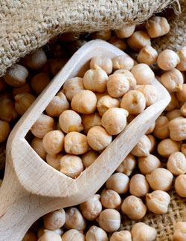
4. Chickpeas
Chickpeas are a natural source of phytoestrogen, which isn’t actually estrogen but does a good job of standing in for it.
The most common way chickpeas are prepared and eaten is in the form of hummus, but falafel is also a popular way to go. They don’t have much flavor of their own, so it’s important to mix them with other foods, spices, and seasonings to make them something you’ll enjoy eating.
Chickpeas are also high in fiber and protein, which makes them a great choice if you’re looking to reduce your meat consumption. They’ll help you feel full, and keep you feeling that way longer because of that combination of fiber and protein.
Tips for eating more: Hummus is perhaps the easiest way to eat more chickpeas, and is basically made from mashing up chickpeas and adding tahini and olive oil until the right consistency is achieved. Salt and pepper to taste.
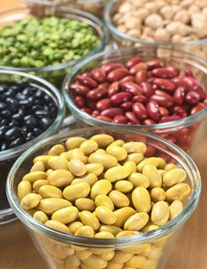
5. Beans
Beans have long been considered a healthy food thanks to their high fiber content and ability to lower cholesterol. They’re also a food that is relatively high in phytoestrogen, although they seldom get attention for this feature.
Because of their high fiber and protein content you’ll often see beans in a meatless main dish. They have a texture to them that helps fill you up, and they are digested slowly by the body, making them a good carbohydrate choice for diabetics or anyone looking to maintain healthy blood glucose levels.
You can choose your favorite bean, and chances are it will have a respectable amount of phytoestrogens in it to help you in your quest to balance your hormone levels.
Tips for eating more: Beans make a great side dish and are a staple food for many types of cuisine. You can add them to soups to thicken things up and add texture.
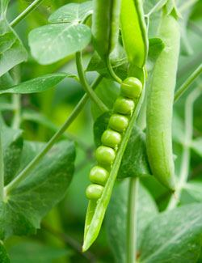
6. Peas
Peas are the perfect side dish if you’re looking for an estrogen boost. That’s because they are a source of phytoestrogens, much like many of the other foods featured here.
And like many foods on our list of estrogen foods, peas bring more to the table than just phytoestrogens. They contain minerals like magnesium, iron, and potassium, even pack some protein.
Peas are full of fiber and are a surprising source of Vitamin C. This means that you’ll be helping to boost your immune system in addition to getting an increase in your phytoestrogen numbers. The overall result is that you’ll be healthy overall with fewer symptoms associated with menopause and postmenopause.
Tips for eating more: Peas are typically thought of as a side dish, but can also factor into a casserole. They also taste great in soups and come in a few different forms to keep things interesting, like sugar snap peas and snow peas.
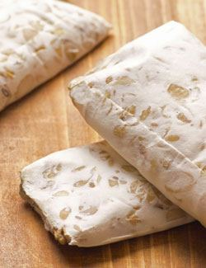
7. Tempeh
Tempeh is derived from soybeans and doesn’t lose its estrogen content during the process. It can be used to help treat menopausal symptoms if you’ve been told that you are not creating as much estrogen as you used to.
Tempeh is loaded with magnesium and iron, two important minerals that are sometimes hard to get enough of. This makes it a worthwhile food that you can feel good about eating, and that will help you feel satisfied long after the meal is finished.
Tempeh is a good source of protein and as such often stands in for meat in vegetarian and vegan dishes. It has a different texture than tofu, making it a better replacement depending on the meat you’re trying to do without.
Tips for eating more: Tempeh makes a great meat alternative, much the same as tofu only with a different texture and flavor. Sub this in for meat a few times a week and your estrogen level will benefit.
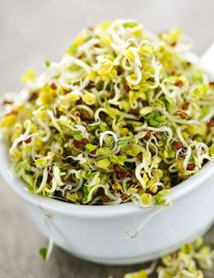
8. Alfalfa Sprouts
Alfalfa sprouts are one often overlooked way of improving your hormone levels because they contain phytonutrients, while being naturally low in calories and carbohydrates, making them an easy choice for an overall healthy diet.
One key to eating alfalfa sprouts is that they contain plant estrogens, which don’t have the side effects associated with other forms of estrogen supplementation.
You can help bring down cholesterol levels in your blood by eating alfalfa sprouts, and this is a great vegetable to eat during the spring months when everything is naturally sprouting in the world outside.
Tips for eating more: Alfalfa sprouts taste great as a salad topper, and also on a sandwich. Be sure to rinse off your sprouts in cold running water before eating, and eat them within a few days of purchase.
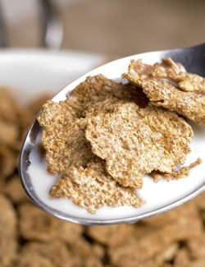
9. Bran Cereals
Bran is one source of phytoestrogens that comes with other health benefits which makes it worth adding to your diet.
Wheat bran has been documented as being a reliable way to increase the amount of phytoestrogens in the body, which can help balance hormones and reduce the symptoms associated with low estrogen levels.
You may already be familiar with bran as a health food due to the high amounts of fiber it contains. Bran muffins and bran cereals were part of the high fiber kick years ago and are still rather ubiquitous. You can benefit from the fiber they contain at the same time you’ll be upping your phytoestrogen levels.
Tips for eating more: Look for cereals made with bran. These will have bran in the title, like All-Bran, or will have a strong focus on fiber like with Fiber One.
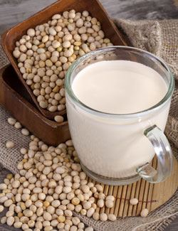
10. Soy Milk
Soy milk is derived from soy of course, and therefore gives the same benefits as tofu, tempeh, and soybeans in regards to the phytoestrogen it contains. It just happens to be in an easily consumed form, which makes it a great way to increase your estrogen numbers quickly and easily.
Drinking soy milk can help curb some of the symptoms associated with postmenopause by helping to restore some of the estrogen with the phytoestrogen present.
Soy milk is also a good source of calcium, just like cow’s milk. Manufacturers try to make it as enticing as possible for those looking to switch from cow’s milk to other forms of milk, so they fortify it and make it more nutritious to attract new buyers.
Tips for eating more: Replace cow’s milk with soy milk in cereals or when you drink it directly. You can also use soy milk in place of regular milk in your cooking and baking.
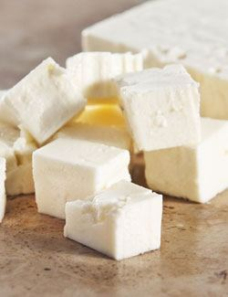
11. Tofu
Tofu is also a very good way to help the body balance its estrogen levels because of the isoflavones it contains, and the way these interact with estrogen receptors.
The high protein and iron content of tofu is why it’s been been used as a meat replacement by vegans and vegetarians for decades, and you don’t have to follow these diets in order to borrow from them in an effort to be healthier and get more estrogen.
Many times when you replace meat you’ll end up avoiding fat and cholesterol, so it’s a combination of getting the good things that tofu provides and avoiding some of the bad things that come with some types of meat.
Tips for eating more: Get into the habit of replacing a meat with tofu at least a few times a week. Start by designating one day to be meatless, and when that feels natural add another day and see how that feels. Compared to chicken and beef, tofu provides far more in the way of estrogen.
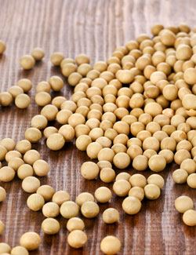
12. Soybeans
It’s not a surprise to see soybeans on our list because many other list makers are derived from soybeans, including tofu, tempeh, and soy milk.
Soybeans are off the charts when it comes to fiber and protein, and even a modest serving of them means you’re getting a chunk of your daily value covered. This means you can add them to a meal to help balance it out, especially if it is low in either protein or fiber.
As far as additional vitamins and minerals go, look to soybeans for a jump in your iron and magnesium levels, as well as higher calcium and potassium levels. There’s a lot going on when it comes to soybeans, and they deserve your consideration.
Tips for eating more: Eat edamame as a raw form of soybean that can be used as a snack or appetizer. Add cooked soybeans to a salad or put them in a soup. They do not have a strong flavor on their own, so they will get lost in the flavors that surround them.
Here is a list of the top ten estrogen rich foods which contain high levels of estrogen.

1. Flax seeds:
Flaxseeds are also commonly referred to as linseed. The phytoestrogens present in them are referred to as lignans. The seeds are generally ground and used in breads, cereals and salads to boost the absorption rate. Linseed has the most quantity of phytoestrogens: 379,380 mcg per 100 g. There are about 85.5 mg lignans in one ounce of linseed.

2. Tofu:
Tofu, also called bean curd is produced from soymilk and is high in phytoestrogens called isoflavones. Tofu is available in soft to firm varieties and may be used in soups and certain main courses. 3 ounces of tofu offers 20 mg of isoflavones or 27,150.1mcgof phytoestrogens per 100 g.
Ads by shopperzAd Options
[ Read: Uses of Calcium ]

3. Soybeans:
Soybeans are one of the richest sources of phytoestrogens. The intake of foods rich in estrogen like these is known to provide relief from the symptoms of menstrual cycle in women. Edamame are the pods which are produced by soy plant. These are a great choice for snack as they pack a nutritional punch. One cup contains 24 mg of isoflavone or 103,920 mcg of phytoestrogen per 100 g.

4. Soy yogurt:
Soy yogurt or bean curd yogurt is the yogurt made from soy milk. A cup of this yoghurt contains about21mg of isoflavones or 10,275 mcg of phytoestrogens per 100 g.
[ Read: Sources of Hemoglobin ]

5. Sesame seeds:
Sesame seeds also contain phytoestrogens known as lignans. These are used to make a wide variety of dishes and can also be sprinkled on top of certain appetizers. One ounce of sesame seeds contain 11.2 mg of lignans, or 8008.1mcg of phytoestrogens 100 g.Comparatively,sunflower seeds or helianthus seeds have less phytoestrogens, with 216mcg per 100g.

6. Multi-grain bread:
Whole grains like oats, barley, rye and wheat have phytoestrogens known as lignans. The number of units per weight depends on the concentration of the whole grains in the bread.
[ Read: Foods Rich in Sodium ]

7. Soymilk:
Soy milk is a beverage made from soy beans. It is rich in phytoestrogens called flavones. One cup of soy milk contains about 30 mg of flavones or 2,957.2 mcg phytoestrogens per 100 g.

8. Hummus:
Hummus is a type of food made using boiled and mashed chickpeas. It can be used as a dip or a spread. It provides 993 mcg of phytoestrogens per 100 g.

9. Garlic:
Garlic which belongs to the onion family is also a source of isoflavonoids with about603.3mcg of phytoestrogens per 100 g.It is one of ingredients which is widely used in cuisines the world over.

10. Dried apricots, dates and prunes:
Dried apricots are a far higher supply of phytoestrogens than natural apricots. Dried apricots contain 445.5 mcg of phytoestrogens per 100 g. Dried dates with 329.5 mg of isoflavoids per 100g and dried prunes with 177.5mcg per 100 g are also good sources of estrogen.
Eating a diet rich in the above mentioned products along with good quantities of fruits and vegetables would not only ensure a smooth transition into menopause for women, but also safeguard their overall health and well-being.
Foods Containing Natural Estrogens
Note: Those rich in isoflavones are underlined while those foods rich in glutamate are in bold.
Alfalfa
Animal flesh
Anise seed
Apples
Baker's yeast
Barley
Beets
Carrots
Cherries
Chickpeas (garbanzo beans)
Clover
Cowpeas (black- eyed peas)
Cucumbers
Dairy Foods***
Dates
Eggs
Eggplant
Fennel
Flaxseeds
Garlic
Hops
Licorice
Oats
Olive oil
Olives
Papaya
Parsley
Peas
Peppers
Plums
Pomegranates
Potatoes
Pumpkin
Red beans
Red clover
Rhubarb
Rice (relatively highin glutamate)
Sage
Sesame seeds
Soybean sprouts
Soybeans***
Sunflower seeds
Tomatoes
Wheat
Yams

