Requirement3
data: Vowel

Learning rate:

the best learning rate is : 0.1
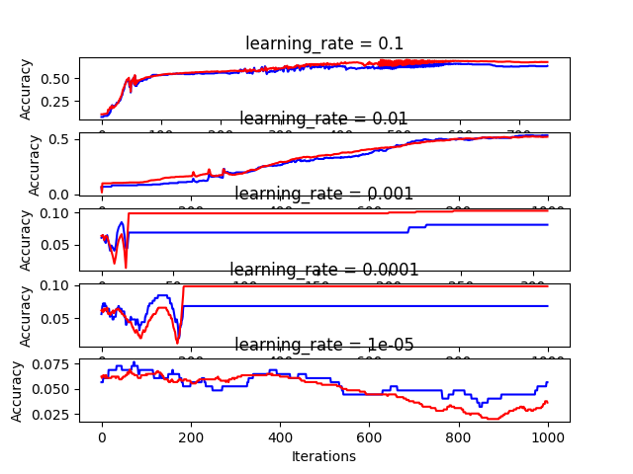

Result of this model:
test_accuracy: 0.64
train_accuracy: 0.686

Model best No of nodes:
6 nodes with :
test_accuracy: 0.67
train_accuracy: 0.745

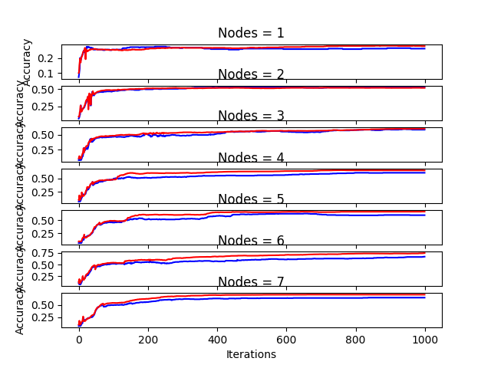

2LayerModel(6,4):
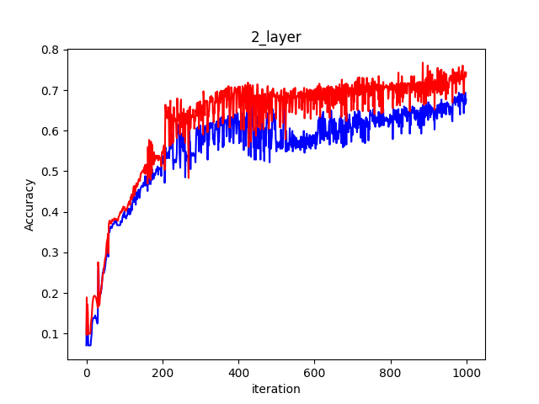
test_accuracy: 0.677
train_accuracy: 0.74

