ToledoMessage: A Post-Quantum Hybrid
End-to-End Encrypted Messaging Platform
Combining Classical and Post-Quantum Cryptography
for Secure Browser-Based Communication

Mohamed Khamis
University of Toledo, Department of Computer Science
Toledo, Ohio, United States
February 2026
ABSTRACT
This paper presents ToledoMessage, a novel secure messaging platform that implements a hybrid post-quantum end-to-end encryption (E2EE) system within a browser-based WebAssembly environment. The system combines the X3DH (Extended Triple Diffie-Hellman) key agreement protocol with the NIST-standardized ML-KEM-768 (formerly CRYSTALS-Kyber) key encapsulation mechanism, creating a hybrid classical/post-quantum key exchange that provides security against both current and future quantum computing threats. Message-level encryption employs the Double Ratchet protocol with AES-256-GCM authenticated encryption, providing forward secrecy and break-in recovery. Digital signatures use a hybrid Ed25519 + ML-DSA-65 (formerly Dilithium) scheme for authentication. The platform is implemented using Blazor WebAssembly for the client, ASP.NET Core with SignalR for real-time server communication, and BouncyCastle for cryptographic operations. The server operates under a zero-knowledge model, never accessing plaintext messages or private keys. We present the system architecture, cryptographic protocol details, security analysis, and a comparison with existing messaging platforms including Signal, WhatsApp, and Telegram.
Keywords: Post-Quantum Cryptography, End-to-End Encryption, Signal Protocol, X3DH, Double Ratchet, ML-KEM-768, Blazor WebAssembly, Hybrid Cryptography, Secure Messaging

1. Introduction
The proliferation of quantum computing poses an existential threat to the cryptographic foundations of modern secure communication. Current messaging applications such as Signal, WhatsApp, and iMessage rely on classical Diffie-Hellman key exchange and ECDSA signatures, which are vulnerable to Shor's algorithm on a sufficiently powerful quantum computer [1]. The National Institute of Standards and Technology (NIST) has recently standardized post-quantum cryptographic algorithms, including ML-KEM (Module-Lattice-Based Key Encapsulation Mechanism) and ML-DSA (Module-Lattice-Based Digital Signature Algorithm), marking a critical inflection point in the transition to quantum-resistant cryptography [2].
ToledoMessage addresses this challenge by implementing a hybrid cryptographic model that combines proven classical algorithms with NIST-standardized post-quantum primitives. The system's key contribution is the integration of ML-KEM-768 into the Signal Protocol's X3DH key agreement, creating a key exchange that requires an attacker to break both the classical X25519 Diffie-Hellman and the lattice-based ML-KEM to compromise a session. This hybrid approach provides defense-in-depth: if either primitive is found to be vulnerable, the other continues to protect communication security.
A second contribution is the deployment of this hybrid cryptographic stack within a browser environment using Blazor WebAssembly (WASM). All cryptographic operations—key generation, session management, encryption, and decryption—execute entirely in the client's browser sandbox, with the server operating under a strict zero-knowledge model. The server stores and routes only encrypted ciphertext, never accessing plaintext messages or private keys.

2. System Architecture

2.1 High-Level Overview
ToledoMessage follows a three-tier architecture consisting of: (1) a Blazor WebAssembly client running in the browser, (2) an ASP.NET Core server providing REST APIs and real-time SignalR communication, and (3) a SQL Server 2022 database for persistent storage. Figure 1 illustrates the overall system architecture.
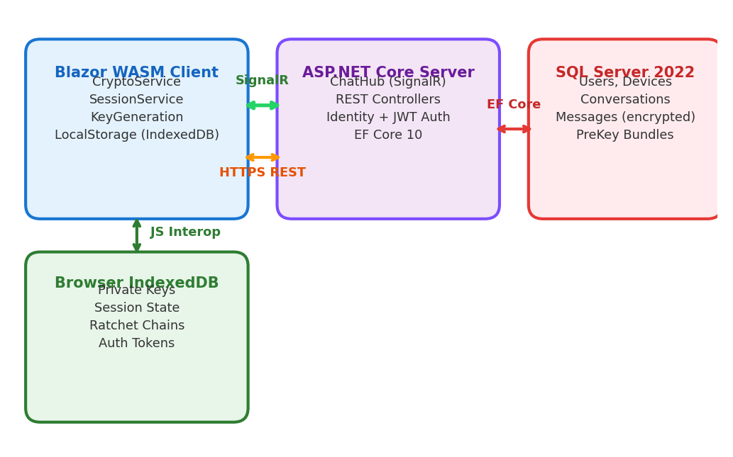
Figure 1: ToledoMessage system architecture.

2.2 Technology Stack
Component | Technology | Purpose
Client Runtime | Blazor WebAssembly (.NET 10) | Browser-based UI + crypto execution
Crypto Library | BouncyCastle 2.6.2 | X25519, ML-KEM-768, Ed25519, ML-DSA-65, AES-GCM
Server Framework | ASP.NET Core 10 | REST API endpoints + middleware
Real-Time | SignalR | WebSocket-based message delivery + events
Authentication | ASP.NET Core Identity + JWT | User registration, login, token issuance
ORM | Entity Framework Core 10 | Code First migrations, SQL Server provider
Database | SQL Server 2022 | Persistent storage (encrypted data only)
Client Storage | Browser IndexedDB | Private keys, session state, tokens
Table 1: Technology stack components and their roles.

3. Cryptographic Model

3.1 Hybrid X3DH Key Agreement
The Extended Triple Diffie-Hellman (X3DH) protocol, originally designed by Marlinspike and Perrin for the Signal Protocol [3], establishes a shared secret between two parties who may not be simultaneously online. ToledoMessage extends X3DH by incorporating ML-KEM-768 key encapsulation alongside the standard X25519 Diffie-Hellman exchanges.
Each device registers the following pre-key bundle with the server:
- Identity Key: Long-term Ed25519 public key (32 bytes) + ML-DSA-65 public key (1,952 bytes)
- Signed Pre-Key: Medium-term X25519 public key (32 bytes), signed with hybrid signature
- Kyber Pre-Key: ML-KEM-768 encapsulation key (1,184 bytes), signed with hybrid signature
- One-Time Pre-Keys: Batch of 10 ephemeral X25519 public keys (32 bytes each)
Algorithm 1: Hybrid X3DH Initiator (Alice)
function X3DH_Initiate(BobBundle):
1. Verify(BobBundle.signedPreKey, BobBundle.identityKey)
2. Verify(BobBundle.kyberPreKey, BobBundle.identityKey)
3. (eph_pub, eph_priv) = X25519.GenerateKeyPair()
4. DH1 = X25519(eph_priv, BobBundle.signedPreKey) // 32 bytes
5. DH2 = X25519(eph_priv, BobBundle.oneTimePreKey) // 32 bytes
6. (kem_ct, kem_ss) = ML-KEM-768.Encapsulate(BobBundle.kyberPreKey)
7. ikm = DH1 || DH2 || kem_ss
8. SK = HKDF-SHA256(ikm, info="ToledoMessage-X3DH-v1", len=64)
9. rootKey = SK[0:32], chainKey = SK[32:64]
return (rootKey, chainKey, eph_pub, kem_ct)
The critical security property of this hybrid scheme is that the shared secret SK depends on material from both the classical X25519 exchanges and the post-quantum ML-KEM-768 encapsulation. An attacker must break both X25519 (solving the elliptic curve discrete logarithm problem) and ML-KEM-768 (solving the Module-LWE problem) to recover the session keys.

3.2 Double Ratchet Protocol
After session establishment via X3DH, ToledoMessage employs the Double Ratchet algorithm [4] to derive unique encryption keys for each message. The protocol maintains three key chains:
- Root Chain: Updated via DH ratchet steps, producing new chain keys. Uses HKDF-SHA256 with the current root key as salt and a new DH shared secret as input key material.
- Sending Chain: Derives per-message keys for outgoing messages. Each step uses HMAC-SHA256 with the chain key to produce a message key and the next chain key.
- Receiving Chain: Symmetric to the sending chain, used for decrypting incoming messages. Maintains separate counters for out-of-order message handling.
Algorithm 2: Double Ratchet Message Encryption
function RatchetEncrypt(session, plaintext):
1. (session.sendChainKey, messageKey) = KDF_CK(session.sendChainKey)
2. session.sendMessageNumber += 1
3. nonce = SecureRandom(12 bytes)
4. ciphertext = AES-256-GCM.Encrypt(messageKey, nonce, plaintext)
5. SecureErase(messageKey) // Immediately delete after use
return (nonce || ciphertext || authTag)
This construction provides two critical security properties: (1) Forward Secrecy — compromise of the current session state does not reveal past message keys, as each chain key is immediately replaced after deriving a message key; (2) Break-in Recovery — if an attacker obtains the current session state, a new DH ratchet step (triggered by receiving a message with a new DH public key) establishes a fresh shared secret, healing the session.

3.3 AES-256-GCM Authenticated Encryption
Each message is encrypted using AES-256-GCM (Galois/Counter Mode), an AEAD (Authenticated Encryption with Associated Data) cipher. The implementation uses a 256-bit key derived from the Double Ratchet, a 96-bit random nonce generated per message, and produces a 128-bit authentication tag. The wire format is:
Wire Format
output = nonce(12 bytes) || ciphertext(variable) || authTag(16 bytes)
transport = Base64Encode(output)

3.4 Hybrid Digital Signatures
ToledoMessage employs a hybrid signature scheme combining Ed25519 (classical, 64-byte signatures) with ML-DSA-65 (post-quantum, 3,309-byte signatures). The HybridSigner class produces signatures by concatenating both: signature = Ed25519.Sign(m) || ML-DSA-65.Sign(m). Verification requires both components to pass independently, ensuring that the compromise of one scheme does not invalidate the authentication guarantee.
Property | Ed25519 | ML-DSA-65 | Hybrid (Combined)
Public Key Size | 32 bytes | 1,952 bytes | 1,984 bytes
Signature Size | 64 bytes | 3,309 bytes | 3,373 bytes
Security Basis | ECDLP | Module-LWE | Both (defense-in-depth)
Quantum Resistant | No | Yes (NIST Level 3) | Yes
Standard | RFC 8032 | FIPS 204 | Custom hybrid
Table 2: Comparison of signature scheme properties.

4. Post-Quantum Cryptographic Integration

4.1 ML-KEM-768 (CRYSTALS-Kyber)
ML-KEM-768 is a lattice-based Key Encapsulation Mechanism standardized by NIST in FIPS 203 [5]. It provides IND-CCA2 security based on the Module Learning With Errors (MLWE) problem. ToledoMessage integrates ML-KEM-768 at the X3DH key agreement stage via the MlKemKeyExchange class, which wraps BouncyCastle's ML-KEM implementation.
Parameter | Value
Algorithm | ML-KEM-768 (FIPS 203)
Security Level | NIST Level 3 (~192-bit classical equivalent)
Public Key Size | 1,184 bytes
Ciphertext Size | 1,088 bytes
Shared Secret Size | 32 bytes
Underlying Problem | Module-LWE (lattice-based)
Integration Point | X3DH step 6: KEM encapsulation against Kyber pre-key
Table 3: ML-KEM-768 parameters in ToledoMessage.

4.2 Hybrid Security Argument
The hybrid key agreement provides a "best of both worlds" security guarantee. Let SK = HKDF(DH1 || DH2 || kem_ss). An adversary attempting to recover SK must either: (a) solve the Computational Diffie-Hellman problem on Curve25519 to recover DH1 and DH2, and (b) solve the Module-LWE problem to recover kem_ss from the ML-KEM ciphertext. The HKDF construction ensures that even partial knowledge of the input key material does not reveal the derived key, provided at least one component remains secret [6].

5. End-to-End Message Flow
The complete lifecycle of a message in ToledoMessage involves the following steps:
- Step 1 - Session Establishment: If no active Double Ratchet session exists with the recipient, the sender's CryptoService initiates X3DH by fetching the recipient's pre-key bundle from the server.
- Step 2 - Key Derivation: The Double Ratchet derives a unique message key (MK) from the sending chain. The chain key is advanced, ensuring MK is never reused.
- Step 3 - Encryption: AeadCipher.Encrypt(MK, plaintext) produces the AES-256-GCM ciphertext with random nonce and authentication tag.
- Step 4 - Multi-Device Fan-Out: MessageEncryptionService repeats steps 2–3 for each of the recipient's registered devices, producing independent ciphertexts.
- Step 5 - Transport: Encrypted envelopes are sent via SignalR's ChatHub.SendMessage(). The server stores the ciphertext and routes it to connected devices.
- Step 6 - Delivery: The recipient's device receives the envelope via SignalR push, decrypts using its own Double Ratchet session, and displays the plaintext.
- Step 7 - Acknowledgment: Delivery and read receipts flow back through SignalR, updating message status (Sending → Sent → Delivered → Read).

6. Security Analysis

6.1 Threat Model
We consider an adversary with the following capabilities: (a) full control of the network (active man-in-the-middle), (b) ability to compromise the server and access all stored data, (c) access to a cryptographically relevant quantum computer (CRQC). Table 4 summarizes the security guarantees provided by ToledoMessage against each threat.
Threat | Mitigation | Status
Man-in-the-Middle | X3DH mutual auth + safety number verification | Mitigated
Server Compromise | E2EE: server sees only ciphertext | Mitigated
Past Key Compromise | Forward secrecy via Double Ratchet | Mitigated
Future Key Compromise | Break-in recovery via DH ratchet | Mitigated
Quantum Attack (keys) | ML-KEM-768 in X3DH key agreement | Mitigated
Quantum Attack (sigs) | ML-DSA-65 in hybrid signatures | Mitigated
Replay Attack | Random nonce + message counters | Mitigated
Device Theft | Keys in browser IndexedDB (session-bound) | Partial
Metadata Analysis | Server sees routing data (not content) | Acknowledged
Table 4: Threat model and mitigations.

7. Comparison with Existing Systems
Feature | ToledoMessage | Signal | WhatsApp | Telegram | iMessage
E2EE by Default | Yes | Yes | Yes | No* | Yes
Post-Quantum KEM | ML-KEM-768 | PQXDH** | No | No | PQ3**
PQ Signatures | ML-DSA-65 | No | No | No | No
Forward Secrecy | Yes | Yes | Yes | Yes* | Yes
Open Source Crypto | Yes | Yes | No | No | No
Safety Numbers | Yes | Yes | Yes | No | No
Multi-Device E2EE | Yes | Partial | Partial | No | Yes
Disappearing Msgs | Yes | Yes | Yes | Yes | No
Browser Client | Yes (WASM) | No | No | Yes | No
Key Agreement | Hybrid X3DH | X3DH | X3DH | DH | ECIES
Symmetric Cipher | AES-256-GCM | AES-256-CBC | AES-256-GCM | AES-256-IGE | AES-CTR
Table 5: Feature comparison. *Telegram requires manual opt-in for secret chats. **Signal's PQXDH and Apple's PQ3 are recent additions (2023–2024) using different PQ schemes.
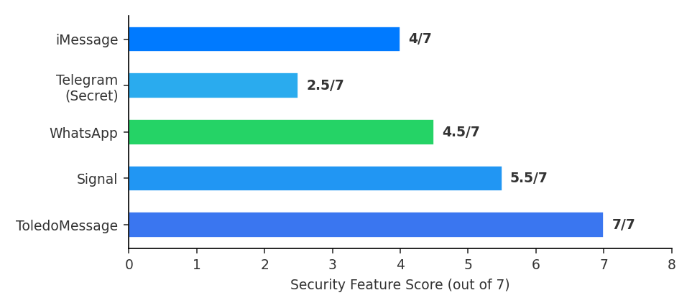
Figure 2: Aggregate security feature comparison.

8. Implementation Details

8.1 Client-Side Services
The Blazor WebAssembly client implements the following key services, all running entirely within the browser's WASM sandbox:
Service | Responsibility
CryptoService | Orchestrates X3DH initiation, session establishment, encrypt/decrypt operations
SessionService | Manages Double Ratchet state per peer device (root key, chain keys, counters)
KeyGenerationService | Generates identity keys (Ed25519+ML-DSA), signed pre-keys, Kyber pre-keys, OTP keys
MessageEncryptionService | Multi-device fan-out: encrypts for all of recipient's registered devices
LocalStorageService | Encrypted IndexedDB storage via JS Interop for keys and session state
FingerprintService | Computes SHA-256 safety numbers from identity keys for verification
PreKeyReplenishmentService | Monitors and auto-replenishes one-time pre-keys when count drops low
SignalRService | WebSocket connection management, event subscription, message transport
ThemeService | Persists and applies user-selected UI theme via localStorage
Table 6: Client-side service architecture.

8.2 Database Schema
The SQL Server database stores user accounts, device registrations (with public keys only), conversations, participants, and encrypted messages. The schema uses decimal primary keys with precision 20 and scale 0, UTC timestamps, and cascading deletes for referential integrity. Critically, the database never contains private keys or plaintext message content—only ciphertext blobs and public cryptographic material.

8.3 Test Coverage
The cryptographic layer is validated by 65 unit tests covering X25519 key exchange, ML-KEM-768 encapsulation/decapsulation, Ed25519 and ML-DSA-65 signing/verification, hybrid signatures, X3DH protocol flow, Double Ratchet session management, and AES-256-GCM encryption/decryption. All tests pass consistently across the test suite.

9. Conclusion
ToledoMessage demonstrates that hybrid post-quantum end-to-end encryption is feasible within a browser-based environment. By integrating ML-KEM-768 into the X3DH key agreement and ML-DSA-65 into the signature scheme, the system provides quantum-resistant security without sacrificing the proven guarantees of classical cryptography. The Double Ratchet protocol ensures forward secrecy and break-in recovery at the per-message level, while the zero-knowledge server architecture ensures that even a fully compromised server cannot access message content.
Future work includes: (1) formal security proofs using tools such as ProVerif or Tamarin, (2) mobile native applications using .NET MAUI, (3) encrypted file and media transfer, (4) voice and video calling with SRTP encryption, (5) multi-device synchronization using the Sesame protocol, and (6) decentralized federation following the Matrix protocol model.

References
[1] P. Shor, "Algorithms for quantum computation: discrete logarithms and factoring," Proc. 35th FOCS, IEEE, 1994.
[2] NIST, "Post-Quantum Cryptography Standardization," FIPS 203, FIPS 204, FIPS 205, 2024.
[3] M. Marlinspike and T. Perrin, "The X3DH Key Agreement Protocol," Signal Foundation, 2016.
[4] T. Perrin and M. Marlinspike, "The Double Ratchet Algorithm," Signal Foundation, 2016.
[5] NIST, "Module-Lattice-Based Key-Encapsulation Mechanism Standard," FIPS 203, August 2024.
[6] H. Krawczyk, "Cryptographic Extraction and Key Derivation: The HKDF Scheme," Proc. CRYPTO 2010, Springer.
[7] D. J. Bernstein et al., "Post-Quantum Cryptography," Nature, vol. 549, 2017.
[8] Signal Foundation, "Signal Protocol Technical Documentation," signal.org/docs, 2023.

