**1.0 Strategy**

We will examine pictures of plant roots (as depicted in Figure 1) captured using a confocal laser microscope. We will describe methods to sample the image's color space, decrease image noise, use thresholding conditions, and transform the image into a binary image. Our aim is to investigate a potential software solution for extracting areas of nuclei as a binary image.

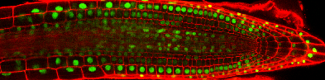

(a) Stack Ninja 1 (b) Stack Ninja 2

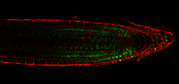

(c) Stack Ninja 3

***Figure 1: Test Samples***

**2.0 Color space conversion**

By looking at the images in Figure 1, we can conclude that it’s a Colored image that have a bright green color at the nuclei od the cell, to detect them, there are different color space conversion that can be used such as grey scale method for converting the image to HSV and extract Hue Channel. After repetitive explorations, I’ve found that the grey scale method results in better and clearer output than HSV.

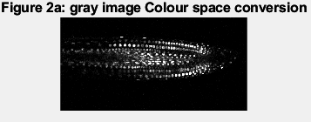 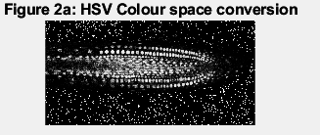

*Figure 2: shows comparison of color space conversion obtained from hue channel of grey space method (right) and HSV (left)*

Referring to Fig.2, it can be observed that (Fig. 2 left) has less noise as it only contains only the shades of grey rather than colors, this means that an image has only one color channel which reduces the amount of information that needs to be processed. And it can be noticed that (Fig. 2 right) has higher contrast level than (Fig. 2 right).

However, in (Fig. 2 right) Despite having more noise, (Fig. 2 Right) demonstrates better  
representation of the detected cell nuclei especially on the left and right regions of the image  
when compared to (Fig. 1 left). Besides, (Fig. 1 right) offers a better clarity to all the detected  
nuclei.

*Figure 3: shows comparison of final results using the Grey space (left) and HSV (right).*

The results that came from grey space method was more accurate than from using HSV. Therefore, this paper suggests the usage of grey scale color space in the color conversion method.

**3.0 Noise reduction**