**1.0 Strategy**

We will examine pictures of plant roots (as depicted in Figure 1) captured using a confocal laser microscope. We will describe methods to sample the image's color space, decrease image noise, use thresholding conditions, and transform the image into a binary image. Our aim is to investigate a potential software solution for extracting areas of nuclei as a binary image.

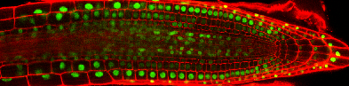

*(a) Stack Ninja 1 (b) Stack Ninja 2*

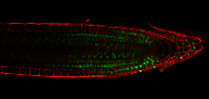

*(c) Stack Ninja 3*

***Figure 1: Test Samples***

**2.0 Color space conversion**

By looking at the images in Figure 1, we can conclude that it’s a Colored image that have a bright green color at the nuclei od the cell, to detect them, there are different color space conversion that can be used such as extracting the green channel form the nuclei or extracting the hue channel from HSV color space. After repetitive explorations, the extraction of hue channel from HSV color space has resulted in a clearer output when compared to the extraction of green channel from RGB.

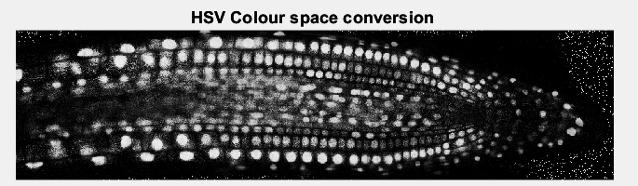

1. *Result from StackNinja1*

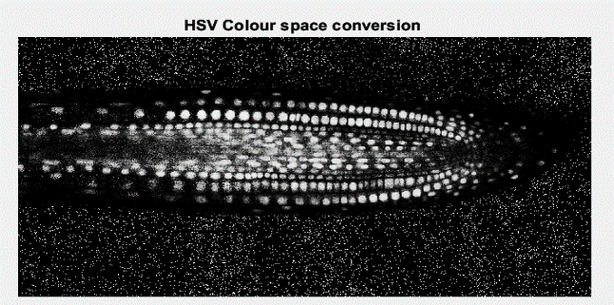

1. *Result from StackNinja2*

1. *Result from StackNinja3*

***Figure 2: comparison of color space conversion obtained from HSV and green color channel.***

Referring to Fig.2, (Fig. 2 right) has less noise as it only contains only the shades of green color only, this means that an image has only one-color channel which reduces the amount of information that needs to be processed.

However, it can be observed that in (Fig. 2 left) Despite having more noise, (Fig. 2 left) demonstrates better representation of the detected cell nuclei especially on the left and right regions of the image when compared to (Fig. 1 right). Besides, (Fig. 1 left) offers a better clarity to all the detected nuclei. This approach gave more accurate result than using the green color extraction method, its only disadvantage was that it had a lot of noises, but it was resolved using median filter noise reduction.

**3.0 Noise reduction**

As shown in the results received form the HSV color conversion, it can be notices that the image is noisy specially at the surroundings and the center of the plant root. To solve these issues, several noise reduction algorithms have been implemented, such as: Median Filtering, Gaussian Filtering, Average Filtering and Anisotropic

1. *Noise reduction result from StackNinja1*

*(b) Noise reduction result from StackNinja2*

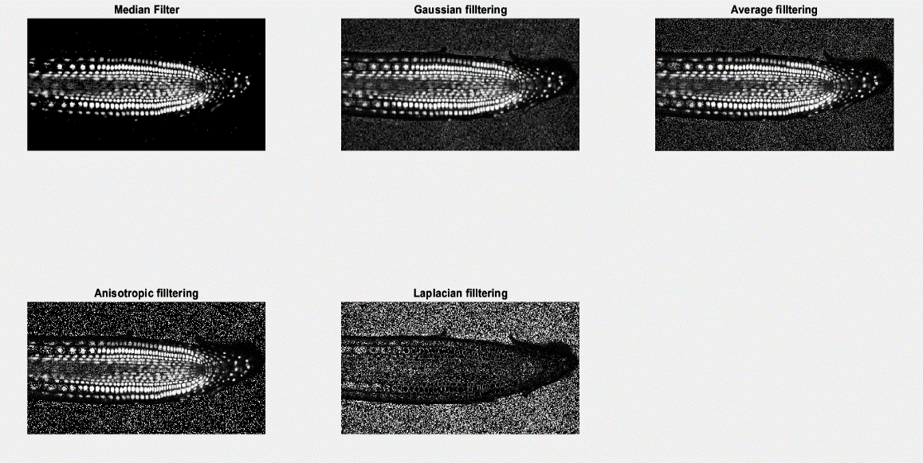

*(c) Noise reduction result from StackNinja3*

***Figure 3: comparison of five different noise reduction methods. (Top-left: Median filter, Top-center: Gaussian filter with a sigma value of 2.0, Top-Right: Average filter with a neighborhood size of 2x2, Bottom-Left: Anisotropic filter, Bottom-Center: Laplacian filter).***

From the comparison above, it is evident that the most successful noise reduction method among the five tested is shown in Figure 2 (Top-left). The results demonstrate that Median Filtering has outperformed the other methods and has effectively reduced most of the 'salt' noise in the plant root's surroundings. Median filter is a non-linear digital filtering technique it works by replacing each pixel value in the image with the median of its neighboring pixels. Median filtering preserves edges and fine details in the image, unlike other filters such as mean or Gaussian filters, which can blur edges and details. However, Gaussian, and average filters are better at removing Gaussian noise which is why they didn’t give a better outcome in our case. Furthermore, Median filtering does not require any parameters to be set, while Gaussian and average filters require the selection of a filter kernel size and standard deviation or weighting factors, respectively. So, it was difficult to find a parameter that would give a clear output with all the three images.