
CA1 · DATA AND APPLICATION SECURITY
Threat Modelling and Vulnerability Assessment of a Cloud-Hosted Application
Target: OWASP Juice Shop on a Microsoft Azure virtual machine
Student Full Name | Mohamed Louai Merdji
Student Number | 2026197
Module Title | Data and Application Security
Assessment Title | Threat modelling and vulnerability assessment of a cloud-hosted application
Lecturer / Supervisor | Dr. Matt Lemon
Assessment Due Date | Thursday, 15 October 2026 at 11:59 pm
Date of Submission | 15 October 2026
GitHub repository (all evidence): github.com/mohamedlouaimerdji-cloud/ca1-threat-model

1. Introduction and scope
The focus of this study is OWASP Juice Shop, an intentionally vulnerable web application designed for security testing (OWASP, n.d.a). It was deployed using Docker (image digest sha256:73c53fbf442e…) on an Azure virtual machine (vm-juiceshop, Ubuntu 24.04) within my student’s personal subscription. The container is bound to the loopback interface (127.0.0.1:3000), so the application is reachable only through a key-authenticated SSH tunnel. No continuous compliance testing system or third-party services were evaluated.

1.1 Authorisation statement
The target of this assessment is an instance of OWASP Juice Shop that I installed and deployed myself, on infrastructure I own and control (my personal Azure subscription). I am its only user, and I am therefore the owner granting permission for this testing.
Dr Matt Lemon, the module lecturer, confirmed by email on Monday 5 October 2026 that this email is to be treated as my authorisation. He instructed that the container must not be exposed to the internet or to the college network and must be bound to localhost only. I complied with this instruction: the container is bound to 127.0.0.1:3000 and was reached only through a key-authenticated SSH tunnel (Section 2). The assessment was not carried out against any CCT system or third-party service.

2. System description and trust boundaries

2.1 Components
Table 1: System components and their security-relevant configuration.
Component | Technology | Notes
Browser / client | Angular SPA | Runs in the tester's browser; communicates over HTTP/REST and Socket.IO.
App server | Node.js / Express | Serves the API and handles authentication (JWT) and business logic.
Data store | SQLite (default) | File-based database bundled inside the container.
Container runtime | Docker Community Engine | Single container, non-root user (UID 65532), default capabilities.
Cloud / platform layer | Azure IaaS VM | IAM: SSH key-only login, single account.  Networking: one public IP; one NSG with a single inbound rule (TCP/22, one IP) and default deny.  Storage: OS disk only.  Firewall: NSG only, no WAF or reverse proxy.

2.2 Trust boundaries
Four trust boundaries were modelled using the Microsoft Threat Modeling Tool (Microsoft, n.d.) and are shown in Figure 1 (evidence/diagrams/trust-boundaries.png).
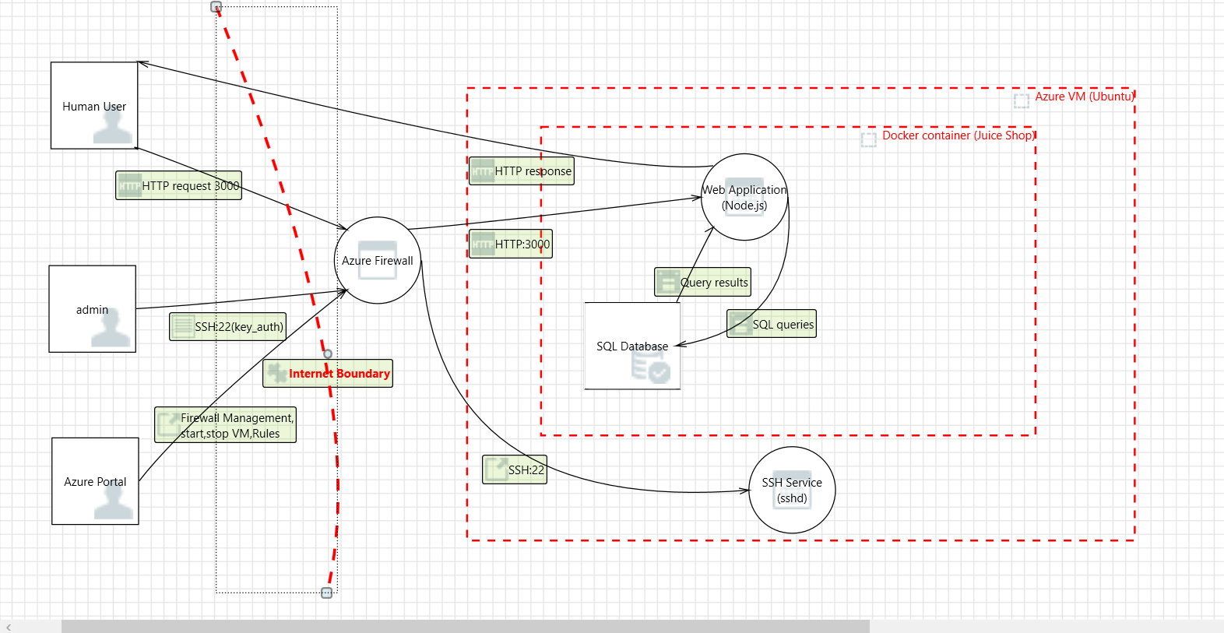
Figure 1: Trust boundary diagram produced with the Microsoft Threat Modeling Tool (as modelled, before port 3000 was closed).
Note: the diagram shows a direct HTTP:3000 path from the Azure Firewall into the application to illustrate how a user interacts with it. This path does not reflect the final deployment: port 3000 is not exposed on the VM's public interface. It is bound to 127.0.0.1:3000 (localhost only) and reachable solely through an authenticated SSH tunnel, as stated in Section 1. The open port shown in the model was closed after the diagram was produced.
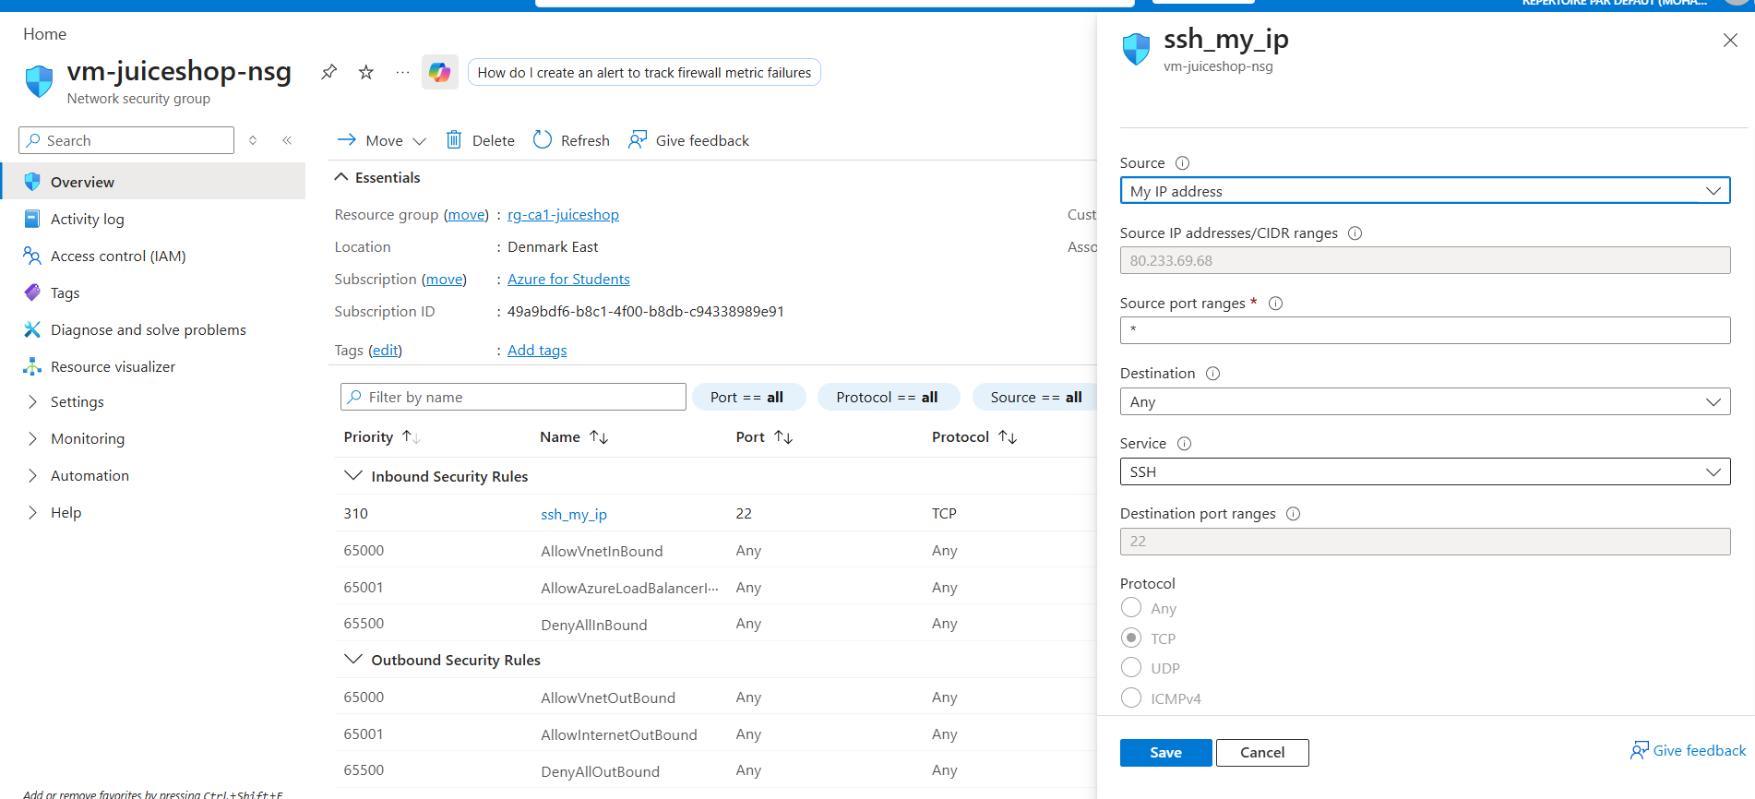
Figure: Azure portal network security controls (after the closure)
(
Table 2: Trust boundaries identified in the model.
ID | Boundary | Description
TB1 | Internet / User | The public internet and the tester's own machine, versus the Azure NSG, which is the only firewall/edge control in front of the VM. No reverse proxy or WAF sits here.
TB2 | Edge ↔ Application | The VM's network stack, versus the Juice Shop container. Crossed only through the SSH tunnel binding to 127.0.0.1:3000; the container is not otherwise reachable from the VM's network interface.
TB3 | Application ↔ Data store (weak) | The Node.js/Express app server, versus the SQLite database file. Both run inside the same container process and filesystem, so this boundary is weak: there is no separate database service, authentication, or network control between them.
TB4 | Container ↔ Host / platform control plane | The Juice Shop container, versus the Docker engine and the underlying Ubuntu host it runs on. Crossed if a container escape or privilege escalation occurs (relevant to the CIS Docker Benchmark findings in Section 5).

3. Threat model
I applied the STRIDE framework (Spoofing, Tampering, Repudiation, Information disclosure, Denial of service and Elevation of privilege) to the four identified trust boundaries. The Microsoft Threat Modeling Tool generated 65 candidate threats across these boundaries, which I then triaged manually. Fifty-two were dismissed: nine were already neutralised by existing controls such as localhost-only binding and key-only SSH, and 43 were not applicable to this specific deployment. The remaining 13 required direct investigation because the automated output corresponded to risks I had not yet verified (see evidence/diagrams/threat_triage_all_65.csv for full details, and Figures 2 and 3).
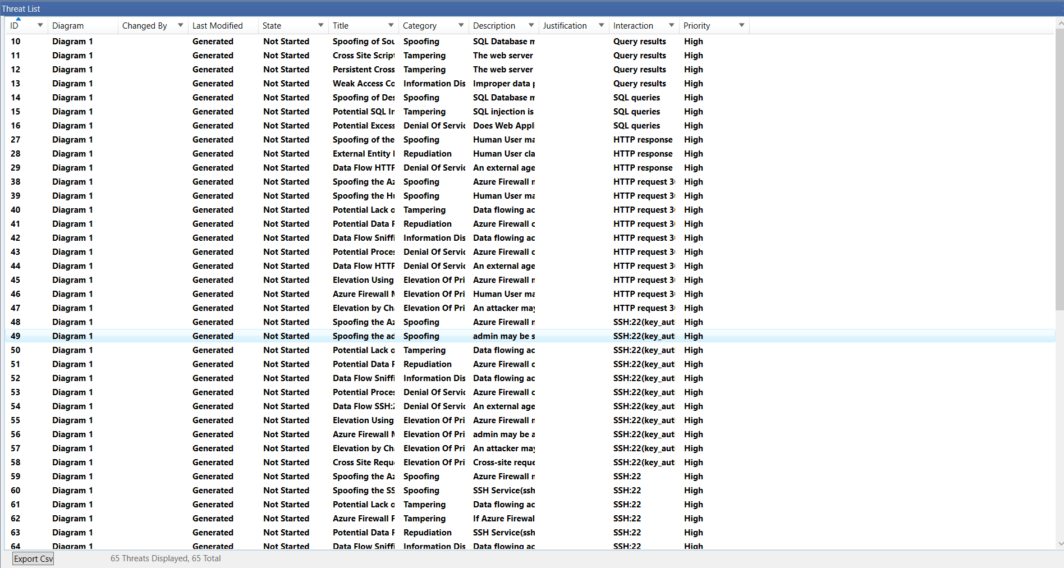
Figure 2: Threat triage of the 65 tool-generated threats (extract 1 of 2).
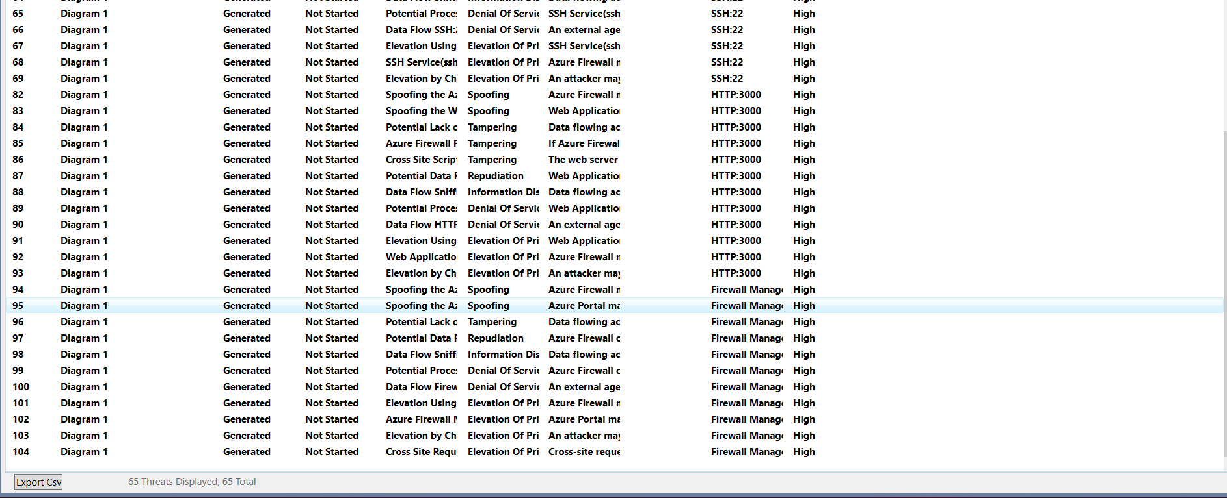
Figure 3: Threat triage of the 65 tool-generated threats (extract 2 of 2).
Beyond the tool's output, I manually added three threats (M1–M3) to account for specifics that the generic templates missed:
- M1 addresses a default NSG rule that initially permitted SSH from any source. This was self-remediated before testing began by replacing it with a single-IP rule.
- M2 covers container isolation at TB4, specifically the risk of escalation from the Juice Shop container to the Docker host, a concern heightened by hardening gaps such as the lack of capability drops and a writable root filesystem (Section 4).
- M3 identifies a Cross-Site Request Forgery (CSRF) vulnerability arising from the absence of a SameSite cookie attribute, confirmed in Section 6 (finding F2). It allows state-changing requests to be forged from other origins while a user is authenticated.

3.1 Most critical finding
The most critical finding was a SQL injection at the login endpoint, the only threat confirmed through direct exploitation rather than inference. Submitting 'or 1=1-- as the username with any password yields an authenticated administrator session without valid credentials. This vulnerability crosses TB2 and TB3 simultaneously, defeating application-level access control without requiring any network-layer weakness at TB1, where the NSG and SSH tunnel controls remain intact. It is documented in Figure 4 (sqli_login_bypass.png) and scored at CVSS 9.1 (Critical) in Section 6; this bypass represents the highest risk identified in the model.
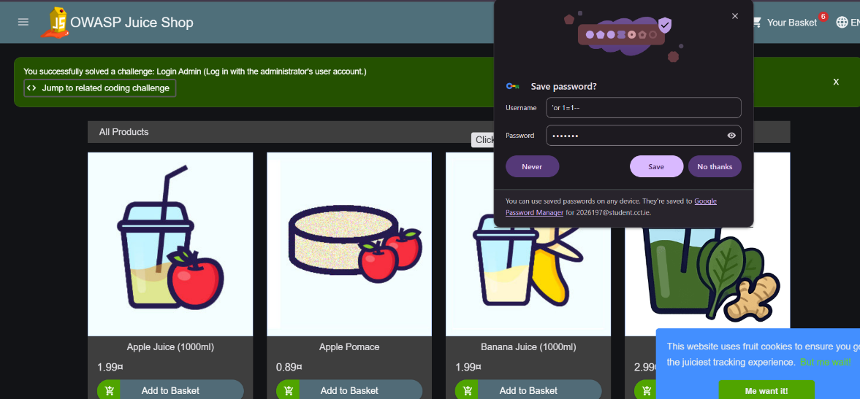
Figure 4: SQL injection login bypass: administrator session obtained without valid credentials.

4. Critical appraisal of existing controls
Table 3: Assessment of the security controls present in the deployment.
Control | Present? | What it defends | Limitation in this deployment
NSG firewall | Yes | Blocks unsolicited inbound traffic. | Restricted to one source IP for SSH only; breaks whenever the ISP-assigned IP changes, and outbound traffic is unrestricted.
SSH key-only authentication | Yes | Prevents password brute-forcing of the host. | Single account, no further host-level access control layer.
Localhost-only container binding | Yes | Prevents direct internet access to the vulnerable app. | Depends entirely on the SSH tunnel; any misconfiguration of the bind would expose the app directly.
Container isolation | Partial | Limits the blast radius of a container compromise. | Non-root user is correctly set, but default Linux capabilities are kept, the root filesystem is writable, and no memory limit is set (CIS Docker Benchmark 5.11, 5.13, 5.26).
TLS / HTTPS | No | Would encrypt data in transit. | Login and session data travel in plaintext (Section 6, finding F3).
WAF / reverse proxy | No | Would filter malicious requests such as the SQL injection payload used in Section 3. | Absent entirely; the NSG filters by network address only, not by request content.
Logging and monitoring | Minimal | Would detect malicious activity. | Only default container logs exist; no centralised logging and no alerting, so the exploitation in Section 3 would leave no actionable trace.

Taken together, the controls that are present (NSG, SSH hardening, localhost-only binding) address the network perimeter effectively for this lab context, but none of them would have prevented, detected, or alerted on the SQL injection authentication bypass. That attack never needed to defeat the network perimeter: it exploited a flaw inside the application logic that perimeter controls cannot see. Network-layer hardening was prioritised during deployment, while application-layer and monitoring controls were not.

5. Vulnerability assessment against OWASP and CIS

5.1 OWASP Top 10 mapping
The edition used was OWASP Top 10:2025 (OWASP, 2025), confirmed on the official website rather than from memory. The findings fell into six categories:
- A01 Broken Access Control and A05 Injection, both directly confirmed by the SQL injection authentication bypass.
- A02 Security Misconfiguration, covering the missing security headers and the permissive container defaults.
- A03 Software Supply Chain Failures, informed by the Trivy dependency scan.
- A04 Cryptographic Failures, owing to the lack of TLS.
- A09 Security Logging and Alerting Failures, identified during the review of controls in Section 4 rather than by any scanning tool, since none of the tools used could check for the presence of logging.
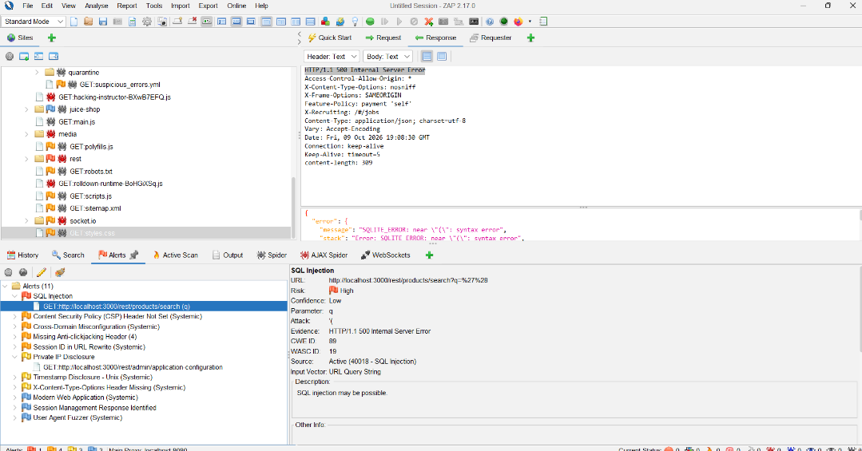
Figure 5: OWASP ZAP alerts for the Juice Shop instance, including the SQL injection alert on the product search endpoint.

5.2 CIS Docker Benchmark
The Docker Bench for Security (Docker, n.d.) was used to assess CIS Docker Benchmark v1.6.0 (CIS, n.d.) against the running container. This is the benchmark version the tool implements; later benchmark releases exist and their control numbering may differ. Table 4 summarises the controls most relevant to this deployment: three passed directly and three returned a WARN.
Table 4: Docker Bench results for the controls most relevant to this deployment.
Control | Requirement | Result
4.1 | Container runs as a non-root user | PASS
5.4 | Kernel capabilities are restricted (see note below) | PASS
5.5 | No privileged containers | PASS
5.11 | Memory limits are set | WARN
5.13 | Root filesystem is mounted read-only | WARN
5.14 | Incoming traffic is bound to a specific host interface | PASS
5.26 | Container is restricted from acquiring additional privileges | WARN

One result deserves particular attention. Control 5.4 returned a PASS because no additional capabilities had been added, yet docker inspect shows that no capabilities had been explicitly removed either. The benchmark's simple pass/fail system cannot distinguish between “nothing extra has been added” and “reduced to the minimum required”, and therefore overstates the actual degree of hardening of the container.
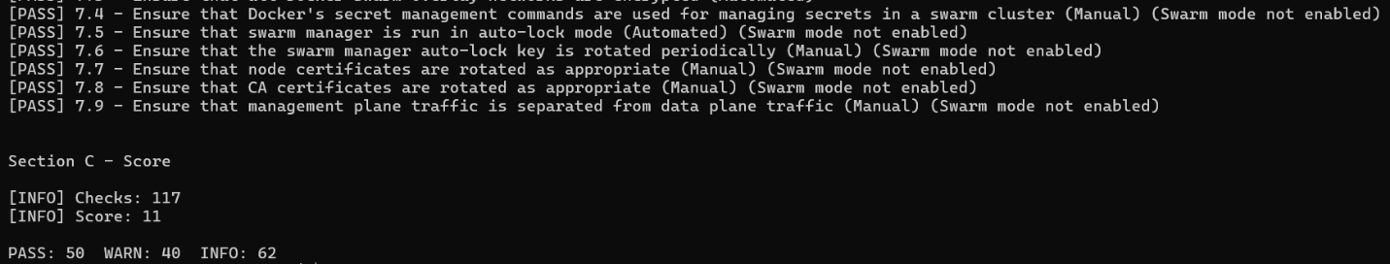
Figure 6: Docker Bench for Security output for the running container.
Because of the time constraints of the assignment, a full automated scan of the Azure platform and Ubuntu host layers was beyond scope. Instead, platform-level settings were checked manually against the published CIS Azure Foundations and CIS Ubuntu Linux Benchmark controls (restricted SSH source, and key-only authentication, which also disables password logins). This limited manual examination is stated here as an explicit scope restriction rather than being left unmentioned.

5.3 Critical assessment of the standards
Both standards work adequately as checklists for infrastructure-level hardening, but neither can identify flaws in application logic. The SQL injection bypass, the most serious issue found in this evaluation, could not have been detected by the automated checks of either standard alone; it needed manual testing guided by the OWASP category list, not by a CIS control or an automated scan.
The scanner output also has to be interpreted rather than accepted at face value. The 175 Trivy findings used to inform A03 include a number of packages that the application code never reaches, so unless they are assessed for reachability and severity (the process carried out in Section 6), the raw figures would overstate the true level of exposure.

6. Prioritised findings with CVSS scoring and justification
Six findings were scored using CVSS v3.1 (FIRST, 2019) via the official calculator (FIRST, n.d.). The SQL injection authentication bypass (F1) is the only finding confirmed by direct exploitation. The remainder were identified through automated scanning (OWASP ZAP (OWASP, n.d.b) for F2–F4; Trivy (Aqua Security, n.d.) for F6) or manual configuration review (F5), and are scored accordingly. Finding IDs reflect order of discovery and are used throughout this report; Table 5 lists them by rank.
Table 5: Findings ranked by CVSS v3.1 base score.
Rank | ID | Finding | CVSS vector | Score | Severity
1 | F1 | SQL Injection – Authentication Bypass (CWE-89) | AV:N/AC:L/PR:N/UI:N/S:U/C:H/I:H/A:N | 9.1 | Critical
2 | F2 | Insecure Session Token Storage (CWE-614/311) | AV:N/AC:H/PR:N/UI:N/S:U/C:H/I:H/A:N | 7.4 | High
3 | F6 | CVE-2026-19481, @fastify/busboy Denial of Service | AV:N/AC:L/PR:N/UI:N/S:U/C:N/I:N/A:H | 7.5 | High
4 | F3 | Missing Transport Layer Encryption (CWE-319) | AV:A/AC:H/PR:N/UI:N/S:U/C:H/I:L/A:N | 5.9 | Medium
5 | F4 | Unauthenticated Information Disclosure (CWE-200) | AV:N/AC:L/PR:N/UI:N/S:U/C:L/I:N/A:N | 5.3 | Medium
6 | F5 | Insecure Container Configuration | AV:L/AC:H/PR:L/UI:N/S:U/C:L/I:L/A:L | 4.5 | Medium

6.1 Per-finding scoring justification
Each score below follows from the specific CVSS v3.1 metrics chosen, not only the final number.

Rank 1 · F1 – SQL Injection Authentication Bypass: 9.1 Critical
Vector: AV:N/AC:L/PR:N/UI:N/S:U/C:H/I:H/A:N
Reached through the public login form with no credentials and no user interaction needed (AV:N/AC:L/PR:N/UI:N). The exploit grants a full administrator session, so Confidentiality and Integrity are both High; Availability is None because the exploit does not crash or deny the service.
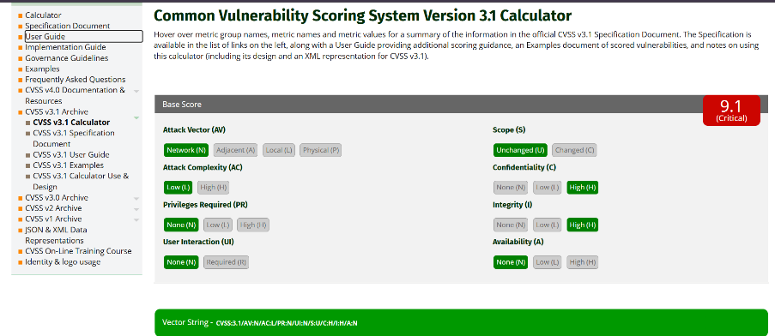
Figure 7: FIRST CVSS v3.1 calculator: F1 scored 9.1 (Critical).

Rank 2 · F2 – Insecure Session Token Storage: 7.4 High
Vector: AV:N/AC:H/PR:N/UI:N/S:U/C:H/I:H/A:N
The missing cookie flags are themselves reachable over the network with no privileges, but actually stealing the token needs one extra step, such as network interception or a working script injection, so Attack Complexity is rated High rather than Low. Once stolen, the token gives full account control (C:H/I:H).
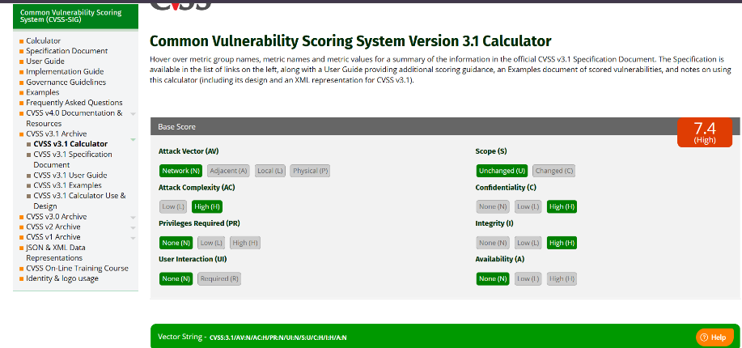
Figure 8: FIRST CVSS v3.1 calculator: F2 scored 7.4 (High).

Rank 3 · F6 – CVE-2026-19481, @fastify/busboy Denial of Service: 7.5 High
Vector: AV:N/AC:L/PR:N/UI:N/S:U/C:N/I:N/A:H
Vector taken directly from the NVD listing (NVD, 2026) rather than estimated. A single crafted request from anywhere on the network with no login (AV:N/AC:L/PR:N) crashes the Node.js process, so only Availability is affected (A:H), with no data read or changed (C:N/I:N).
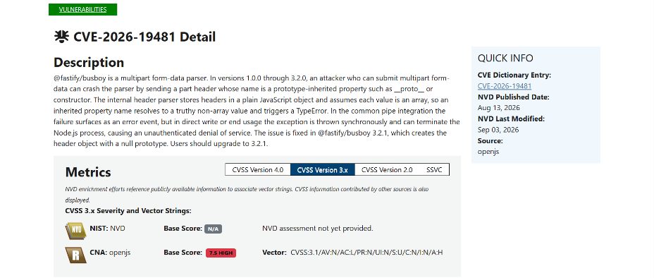
Figure 9: NVD listing for CVE-2026-19481 showing the published CVSS v3.1 vector and score.

Rank 4 · F3 – Missing Transport Layer Encryption: 5.9 Medium
Vector: AV:A/AC:H/PR:N/UI:N/S:U/C:H/I:L/A:N
Exploiting the plaintext traffic realistically needs a position on the same network path (AV:A) and an active interception setup (AC:H), not a simple remote request. Once intercepted, credentials and the session token are fully exposed (C:H), but no direct tampering beyond that was demonstrated (I:L).
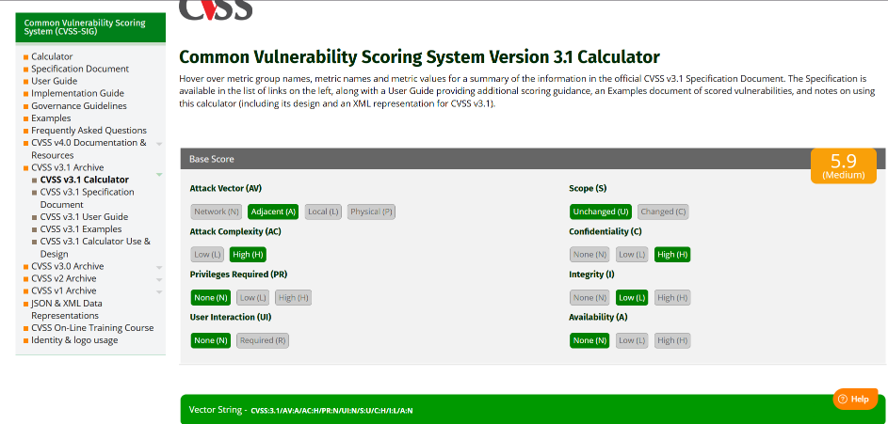
Figure 10: FIRST CVSS v3.1 calculator: F3 scored 5.9 (Medium).

Rank 5 · F4 – Unauthenticated Information Disclosure: 5.3 Medium
Vector: AV:N/AC:L/PR:N/UI:N/S:U/C:L/I:N/A:N
The configuration endpoint is reachable directly with no login (AV:N/AC:L/PR:N), but it only exposes internal IP addresses and configuration detail rather than user data, so Confidentiality is scored Low and Integrity and Availability are unaffected.
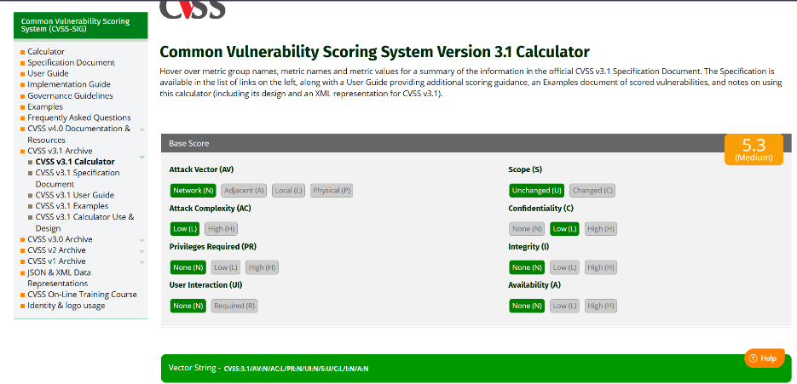
Figure 11: FIRST CVSS v3.1 calculator: F4 scored 5.3 (Medium).

Rank 6 · F5 – Insecure Container Configuration: 4.5 Medium
Vector: AV:L/AC:H/PR:L/UI:N/S:U/C:L/I:L/A:L
These hardening gaps only matter to an attacker already running code inside the container (AV:L/PR:L), and need a further escape or abuse technique on top of that (AC:H). The extra damage they would allow beyond an existing application-level compromise is limited, so each impact metric is scored Low.
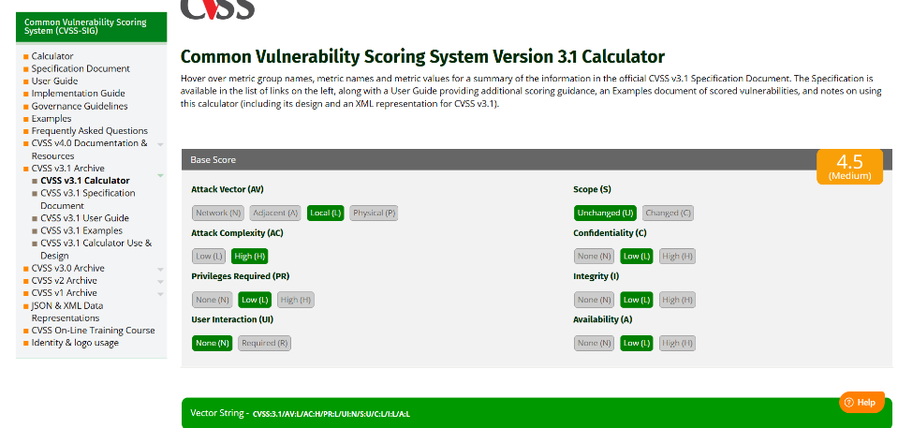
Figure 12: FIRST CVSS v3.1 calculator: F5 scored 4.5 (Medium).

6.2 Contextual justification
CVSS base scores describe the vulnerability in the product rather than its exposure in this lab, and the two must be kept distinct.
F1 scores 9.1 because the score assumes the application is deployed openly. In the actual deployment it can be reached only via an authenticated SSH tunnel from a single IP address, which reduces the likelihood of exploitation in the real world at this time without affecting the severity of the underlying flaw. The same applies to F3: the absence of TLS is a Medium-severity finding by itself, but because the SSH tunnel used for testing encrypts the channel the assessor employed, the exposure actually exercised during testing is lower than the score alone suggests.
The 7.5 score for F6 is also instructive. Had it been hand-estimated rather than taken from NVD, an availability-only vector would plausibly have scored below my estimate for F3 (expected 5.5–6.0, confirmed 5.9), when in fact it ranks above it. This is direct evidence for using the FIRST calculator and published NVD scores rather than hand-estimated vectors. F6 is also qualitatively different from the other findings: its vector (C:N/I:N/A:H) has only an availability impact, so a crafted request can take the application offline but does not disclose or alter any data, whereas F1, F2 and F3 all directly affect confidentiality.

7. Conclusion
This assessment found that the network-layer controls applied to this deployment (NSG restriction, SSH hardening, localhost-only binding) are effective for their intended purpose, but that the application layer behind them contains a critical, exploitable flaw: a SQL injection authentication bypass, CVSS 9.1. No perimeter control can address it, because it does not depend on network access at all once the tunnel is established.
The three highest-priority recommendations arising from this work are:
- Remediate the SQL injection through parameterised queries at the application layer, since this is the single highest-impact finding.
- Add the HttpOnly, Secure and SameSite attributes to the session cookie and enable TLS, which together close F2 and F3.
- Apply the CIS Docker Benchmark's WARN-level container hardening recommendations (read-only root filesystem, memory limits, capability restriction) as defence-in-depth, even though none of them is independently exploitable in this assessment.
Two further, lower-priority actions follow from the remaining findings: update @fastify/busboy to a patched release to close F6 (CVE-2026-19481), and restrict access to the unauthenticated configuration endpoint to close F4.
The combination of automated scanning, standards-based assessment, and manual verification used throughout this report was necessary precisely because no single method identified all of the findings on its own.

8. References
Anthropic (2025) Claude [Large language model]. Available at: https://claude.ai (Accessed: 15 October 2026).
Aqua Security (n.d.) Trivy. Available at: https://github.com/aquasecurity/trivy (Accessed: 8 October 2026).
CIS (Center for Internet Security) (n.d.) CIS Docker Benchmark v1.6.0. Available at: https://www.cisecurity.org/benchmark/docker (Accessed: 9 October 2026).
Dakan, R. and Feller, J. (2025) The AI Fluency Framework. Anthropic. Available at: https://www-cdn.anthropic.com/b383cf6baddbfc72fdf8b0ed533a518e2872d531.pdf (Accessed: 15 October 2026).
Docker (n.d.) docker-bench-security. Available at: https://github.com/docker/docker-bench-security (Accessed: 8 October 2026).
FIRST (Forum of Incident Response and Security Teams) (2019) Common Vulnerability Scoring System version 3.1: Specification Document. Available at: https://www.first.org/cvss/v3.1/specification-document (Accessed: 11 October 2026).
FIRST (Forum of Incident Response and Security Teams) (n.d.) Common Vulnerability Scoring System Version 3.1 Calculator. Available at: https://www.first.org/cvss/calculator/3.1 (Accessed: 11 October 2026).
Microsoft (n.d.) Microsoft Threat Modeling Tool. Available at: https://learn.microsoft.com/en-us/azure/security/develop/threat-modeling-tool (Accessed: 7 October 2026).
NVD (National Vulnerability Database) (2026) CVE-2026-19481 Detail. Available at: https://nvd.nist.gov/vuln/detail/CVE-2026-19481 (Accessed: 11 October 2026).
OWASP (2025) OWASP Top 10:2025. Available at: https://top10.owasp.org/2025/ (Accessed: 9 October 2026).
OWASP (n.d.a) OWASP Juice Shop. Available at: https://owasp.org/www-project-juice-shop/ (Accessed: 5 October 2026).
OWASP (n.d.b) OWASP ZAP (Zed Attack Proxy). Available at: https://www.zaproxy.org/ (Accessed: 9 October 2026).

Appendix A: AI Fluency declaration
Claude (Anthropic, 2025) was used throughout this assignment as a working aid, in the following ways:
- Explaining tools and commands (Trivy, Docker Bench for Security, OWASP ZAP, CVSS scoring) in plain language before they were run, including what each flag does and why.
- Drafting the structure and wording of the supporting documents (docs/00–docs/05), the trust boundary diagram description, and this report, from evidence, scan output and findings that the student generated.
- Reviewing evidence against the assessment criteria, for example, cross-checking CIS Docker Benchmark control IDs cited in draft text against the student's own docker-bench-bash.txt output, and correcting IDs that were initially wrong.
- Looking up current external facts, such as the current OWASP Top 10 edition and CIS Docker Benchmark version, rather than relying on possibly outdated prior knowledge.
All scans, exploitation attempts (including the SQL injection login bypass), screenshots, and CVSS calculator entries were performed directly by the student, against the student's own authorised deployment. No AI tool accessed the target system, ran commands against it, or scored a CVSS vector without the student independently confirming the result on the official FIRST calculator or NVD listing. A full, dated log of AI use throughout the assignment is maintained in docs/06-ai-fluency-log.md, submitted alongside this report as required by the assignment brief.

A.1 Reflection using the AI Fluency Framework
This declaration follows the AI Fluency Framework (Dakan and Feller, 2025), covering delegation, description, discernment and diligence.
Delegation. I used Claude to explain each tool before I ran it (Trivy, Docker Bench for Security, OWASP ZAP, the FIRST CVSS calculator), to rework the wording and structure of this report around evidence I generated, to check CIS Docker Benchmark control IDs I cited against my own docker-bench-bash.txt output, and to look up the current OWASP Top 10 edition rather than rely on memory. I did not use it to design the attack: the SQL injection login bypass, every scan, and every piece of evidence in this report came from commands and tests I ran myself, against my own authorised deployment.
Description. My verbatim prompts and Claude's corresponding output are recorded in docs/06-ai-fluency-log.md, submitted alongside this report. In general, I gave Claude a specific, checkable task tied to evidence I already had, for example asking it to correct CIS control IDs against my own docker-bench-bash.txt output, rather than open-ended requests for it to invent findings, so each prompt had a concrete, verifiable answer I could check myself.
Discernment. Claude's first draft of the CIS Docker Benchmark control IDs in my notes was wrong: it wrote them from memory rather than from my evidence, and I had to check my own docker-bench-bash.txt output and get it corrected. Its early hand-estimated CVSS vector for the TLS finding undershot what the official calculator gave once I actually scored it, and when I looked up the real published CVSS score for CVE-2026-19481 on NVD myself, it came out higher than Claude's own hand-estimate for a different finding. That gap between guessed and verified scores is why I confirmed every CVSS score on the official FIRST calculator or NVD listing myself, rather than accepting any AI-generated number as final.
Diligence. Claude (Anthropic, 2025) was the only AI tool used in this assignment. Everything I supplied to it was my own: terminal output, screenshots and scan results from a deployment I own and am solely authorised to test (Section 1), never any other person's data or a CCT or third-party system, so no personal or restricted data was involved. Claims Claude made that I relied on, such as the current OWASP Top 10 edition, the CIS Docker Benchmark version, and the CVSS score for CVE-2026-19481, were each checked by me directly against the real OWASP, CIS and NVD pages before I included them in this report, rather than trusting Claude's word alone.

