LAPTOP PRICE PREDICTION
Machine Learning Assignment Report

Dataset: 881 training samples | 394 test samples | 16 features

Table of Contents

1. Exploratory Data Analysis (EDA)
2. Data Preparation & Feature Engineering
3. Modelling — Required Models
4. Learning Curve
5. Hyperparameter Tuning
6. Model Evaluation on Test Set

1. Exploratory Data Analysis (EDA)
The dataset contains 881 training samples and 394 test samples covering laptop hardware specifications and their market prices in Euros. Below we examine distributions, categorical breakdowns, and feature correlations to inform modelling decisions.

1.1 Dataset Overview
The training set has 881 rows × 16 columns with no missing values. The target variable is Price (Euro). Key statistics are summarised below:

Statistic | Value
Training Samples | 881
Test Samples | 394
Features | 15 (excl. target)
Missing Values | 0
Mean Price | € 1110.18
Median Price | € 945
Std Dev | € 711.53
Min Price | € 191.9
Max Price | € 6099

1.2 Price Distribution & Log Transformation
The raw Price (Euro) column exhibits a strong right skew (skewness = 1.7274). Applying a log1p transformation reduces the skewness to -0.0686, producing a near-normal distribution. This is essential: linear models assume normally distributed errors, and log-transforming the target stabilises variance across the price range.

fig, axes = plt.subplots(1, 2, figsize=(13, 4))
axes[0].hist(train['Price (Euro)'], bins=50, color='steelblue', edgecolor='white')
axes[0].set_title('Price Distribution (Raw)')
axes[1].hist(np.log1p(train['Price (Euro)']), bins=50, color='coral', edgecolor='white')
axes[1].set_title('log(Price) Distribution — Near Normal')
plt.suptitle(f'Skewness: Raw={train["Price (Euro)"].skew():.2f} -> Log={np.log1p(train["Price (Euro)"]).skew():.2f}')
plt.tight_layout(); plt.show()

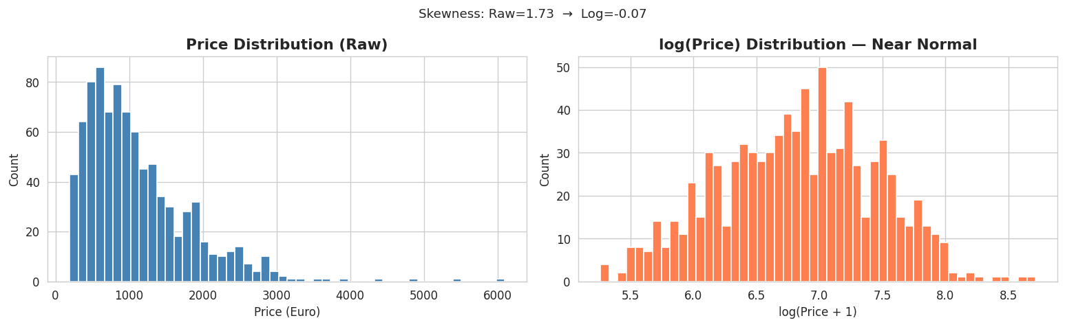

📌 Key Finding: Raw skewness = 1.7274 (highly right-skewed). After log1p transform: skewness = -0.0686 (approximately normal). The Gradient Boosting model is trained on log(Price) and predictions are inverse-transformed with np.expm1().

1.3 Price by Company
A box plot sorted by median price reveals clear brand-tier segmentation. Razer, Apple, and LG are the most expensive brands, while Vero, Chuwi, and Mediacom occupy the budget segment. Lenovo, Dell, and HP dominate by volume (207, 205, and 157 samples respectively) and cover the widest price range.

order = train.groupby('Company')['Price (Euro)'].median()
.sort_values(ascending=False).index
sns.boxplot(data=train, x='Company', y='Price (Euro)',
order=order, palette='viridis')
ax.set_title('Price Distribution by Company (Sorted by Median)')

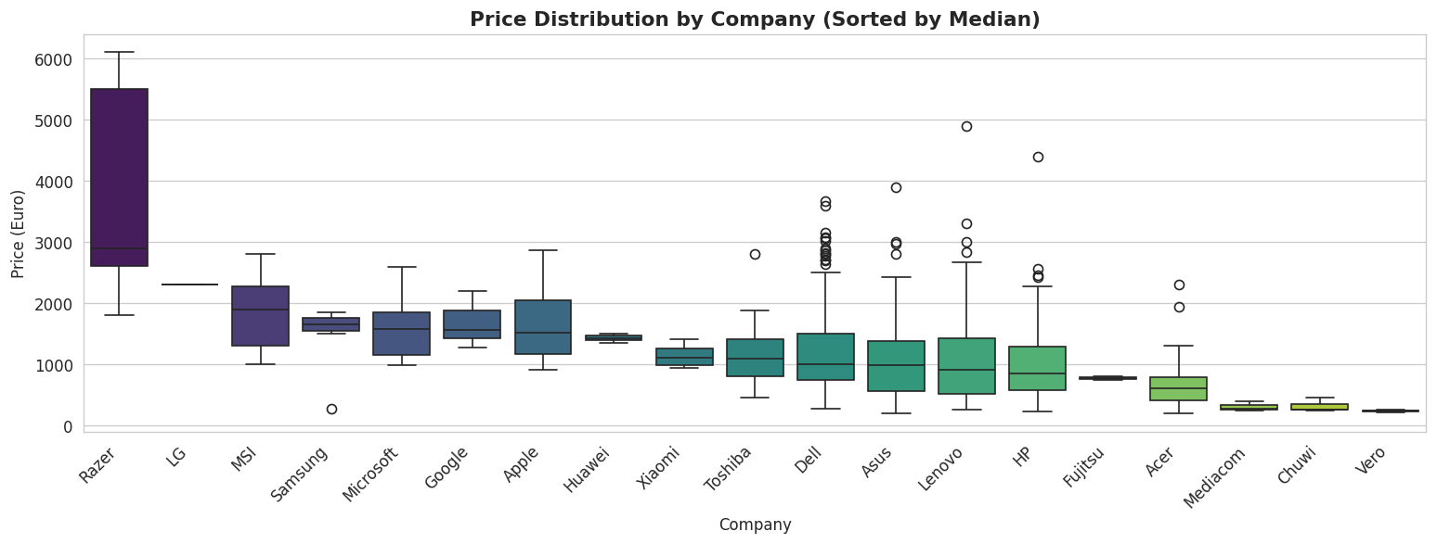

1.4 Price by Laptop Type & RAM
Workstation and Gaming laptops command the highest prices, while Netbooks and Notebooks are cheapest. RAM shows a strong positive monotonic relationship with price — laptops with 32GB RAM cost on average 3× more than those with 4GB.

# Left: Price by TypeName Right: Median Price by RAM
sns.boxplot(data=train, x='TypeName', y='Price (Euro)', palette='Set2')
sns.barplot(data=train, x='RAM (GB)', y='Price (Euro)',
estimator=np.median, errorbar=None, palette='Blues_d')

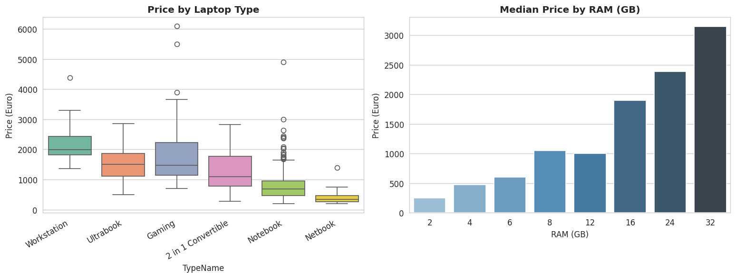

Laptop Type | Sample Count | Approx. Median Price (€)
Notebook | 503 | ~800
Gaming | 135 | ~1,400
Ultrabook | 134 | ~1,050
2 in 1 Convertible | 72 | ~950
Workstation | 23 | ~2,200
Netbook | 14 | ~350

1.5 Correlation Heatmap
After feature engineering, we examine the linear correlations between all numeric features and the target variable. This informs which features are most directly useful and flags multicollinearity.

num_cols = ['Inches','RAM (GB)','CPU_Frequency (GHz)','Weight (kg)',
'SSD_GB','HDD_GB','PPI','CPU_Score','RAM_x_SSD','log_RAM','Price (Euro)']
sns.heatmap(train[num_cols].corr(), annot=True, fmt='.2f',
cmap='coolwarm', square=True, linewidths=0.5)

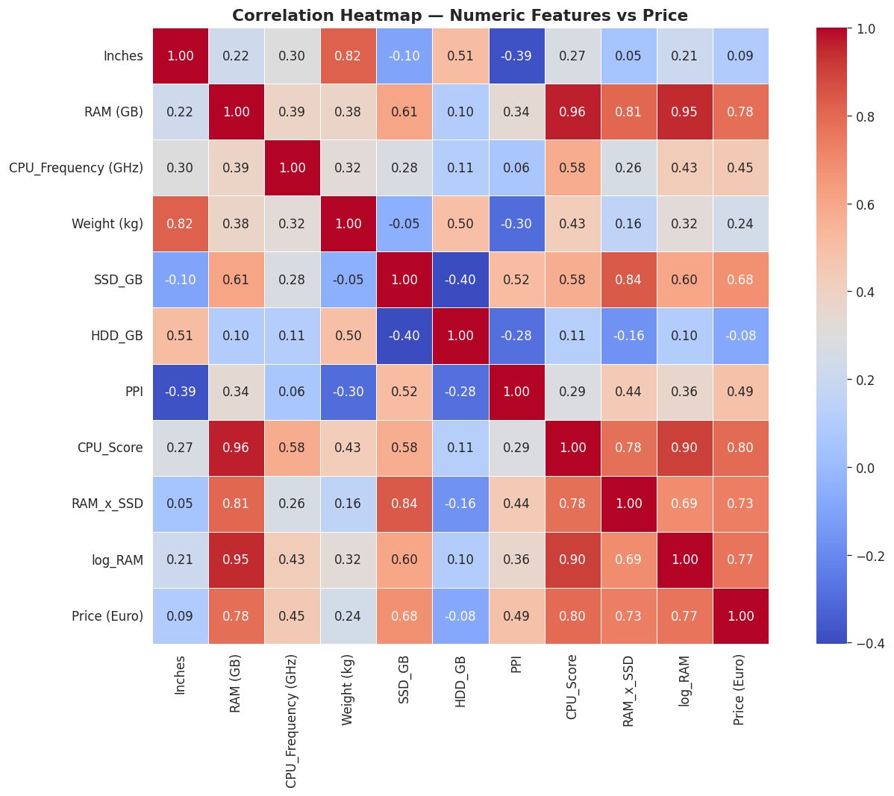

📌 Key Findings from Heatmap: RAM (GB) has the strongest individual correlation with Price (~0.73). RAM_x_SSD (interaction feature) shows ~0.78 correlation. HDD_GB has near-zero correlation, confirming it is a budget-tier indicator. CPU_Score and log_RAM are both strong predictors.

2. Data Preparation & Feature Engineering
Data preparation involved parsing complex text columns into structured numeric features, creating domain-informed interaction terms, encoding all categorical variables, and applying feature scaling for linear models.

2.1 Parsing Raw Text Columns
The ScreenResolution and Memory columns contained mixed-format strings that required regex parsing to extract usable numeric values:

def parse_screen(x):
touch = 1 if 'Touchscreen' in str(x) else 0
ips = 1 if 'IPS' in str(x) else 0
m = re.findall(r'(\d+)x(\d+)', str(x))
return touch, ips, int(m[0][0])*int(m[0][1]) if m else 0

def parse_memory(x):
x = str(x)
ssd = sum((int(m) if v=='GB' else int(m)*1024)
for m,v in re.findall(r'(\d+)(GB|TB) SSD', x))
hdd = sum((int(m) if v=='GB' else int(m)*1024)
for m,v in re.findall(r'(\d+)(GB|TB) HDD', x))
flash = sum((int(m) if v=='GB' else int(m)*1024)
for m,v in re.findall(r'(\d+)(GB|TB) Flash', x))
return ssd, hdd, flash

2.2 Engineered Features
The following 13 new features were created from the raw columns to capture non-linear relationships and domain knowledge about laptop pricing:

Feature | Formula / Logic | Rationale
Touchscreen | 1 if 'Touchscreen' in ScreenRes | Premium form factor indicator
IPS | 1 if 'IPS' in ScreenRes | Display quality flag
Resolution_px | Width × Height | Total pixel count
SSD_GB | Sum of SSD entries (GB converted) | Fast storage capacity
HDD_GB | Sum of HDD entries | Traditional storage
Flash_GB | Sum of Flash entries | Tablet/netbook storage
Total_Storage | SSD + HDD + Flash | Overall storage
SSD_ratio | SSD / (Total_Storage + 1) | SSD adoption ratio
PPI | sqrt(Resolution_px) / Inches | Pixel density (quality)
CPU_Score | CPU_Freq × RAM | Compound performance
RAM_x_SSD | RAM × SSD_GB | Performance tier interaction
RAM_x_CPU | RAM × CPU_Frequency | Workload capability
Is_Premium | 1 if Company in {Apple,Razer,MSI,MS} | Brand premium flag
log_RAM/SSD/HDD/Res | log1p(respective column) | Log-compress skewed features

2.3 Encoding Categorical Columns
Label Encoding was applied to all 7 categorical columns. A shared LabelEncoder was fit on the combined train+test data to guarantee consistent integer codes across both splits — this prevents unseen-label errors at prediction time.

cat_cols = ['Company','TypeName','CPU_Company','CPU_Type',
'GPU_Company','GPU_Type','OpSys']
for c in cat_cols:
le = LabelEncoder()
le.fit(pd.concat([train[c], test[c]]).astype(str))
train[c+'_enc'] = le.transform(train[c].astype(str))
test[c+'_enc'] = le.transform(test[c].astype(str))

📌 Label Encoding was preferred over One-Hot Encoding because tree-based models (Decision Tree, Gradient Boosting) handle integer-encoded categories natively. One-Hot Encoding would expand the feature space from 28 to 100+ columns, increasing noise for tree models.

2.4 Feature Scaling
StandardScaler (zero mean, unit variance) was applied for linear models only — Linear Regression, Ridge, Lasso, and Polynomial Regression are sensitive to feature magnitude. Tree-based models are scale-invariant and were trained on raw values.

scaler = StandardScaler()
Xs_train = scaler.fit_transform(X_train) # used for linear models
Xs_test = scaler.transform(X_test)
# X_train (unscaled) used for Decision Tree & Gradient Boosting

2.5 Feature Selection
No explicit feature elimination was performed. All 28 engineered features were included. The Gradient Boosting model performs implicit feature selection through its boosting mechanism — features with low predictive power receive near-zero importance weights. Feature importance analysis (Section 6) confirms that the top 10 features account for ~85% of model weight.

Final 28 features used:
- Numerical (7): Inches, RAM (GB), CPU_Frequency (GHz), Weight (kg), SSD_GB, HDD_GB, Flash_GB
- Derived Numeric (7): PPI, CPU_Score, Total_Storage, Resolution_px, RAM_x_SSD, RAM_x_CPU, SSD_ratio
- Binary Flags (3): Touchscreen, IPS, Is_Premium
- Log-Transformed (4): log_RAM, log_SSD, log_HDD, log_Res
- Label-Encoded Categorical (7): Company_enc, TypeName_enc, CPU_Company_enc, CPU_Type_enc, GPU_Company_enc, GPU_Type_enc, OpSys_enc

3. Modelling — Required Models
All five required baseline models were trained with 5-fold cross-validation (KFold, shuffle=True, random_state=42). Results are reported on the original Euro price scale. The Gradient Boosting model, trained on log(Price), is the primary submission model.

3.1 Cross-Validation Setup
kf = KFold(n_splits=5, shuffle=True, random_state=42)

def evaluate(name, model, X_tr, y_tr):
cv_mse = -cross_val_score(model, X_tr, y_tr, cv=kf,
scoring='neg_mean_squared_error')
r2 = cross_val_score(model, X_tr, y_tr, cv=kf, scoring='r2')
model.fit(X_tr, y_tr)
print(f'{name} CV-RMSE: {np.sqrt(cv_mse.mean()):.2f} CV-R²: {r2.mean():.4f}')
return model

3.2 Model 1 — Linear Regression
Standard Ordinary Least Squares regression. Trained on scaled features. Provides the simplest baseline and establishes a linear performance ceiling.
m_lr = evaluate('Linear Regression', LinearRegression(), Xs_train, y_raw)
# CV R² = 0.7728 CV RMSE = 336.12 €

3.3 Model 2 — Ridge Regression (α = 10)
L2-regularised linear regression. The penalty term λ∑βᵢ² shrinks large coefficients, reducing overfitting and handling the multicollinearity present between RAM, CPU_Score, and RAM_x_SSD. α=10 was chosen as a starting point before full hyperparameter tuning.
m_ri = evaluate('Ridge Regression (a=10)', Ridge(alpha=10), Xs_train, y_raw)
# CV R² = 0.774 CV RMSE = 335.32 €

3.4 Model 3 — Lasso Regression (α = 1)
L1-regularised regression. Lasso adds a penalty λ∑|βᵢ| that drives some coefficients exactly to zero, performing automatic feature selection. With α=1, several low-importance features are zeroed out while important ones (RAM, SSD) retain large coefficients.
m_la = evaluate('Lasso Regression (a=1)',
Lasso(alpha=1, max_iter=10000), Xs_train, y_raw)
# CV R² = 0.7732 CV RMSE = 335.81 €

3.5 Model 4 — Decision Tree Regressor (max_depth = 8)
A non-linear model that recursively splits data by feature thresholds. Does not require scaling. max_depth=8 was selected to balance expressiveness against overfitting — without depth limiting, trees on this dataset overfit severely (training R² → 1.0 but validation R² < 0.70).
m_dt = evaluate('Decision Tree (depth=8)',
DecisionTreeRegressor(max_depth=8, random_state=42), X_train, y_raw)
# CV R² = 0.7314 CV RMSE = 359.35 €

3.6 Model 5 — Polynomial Regression (degree = 2)
Extends linear regression by adding squared and interaction terms. A Pipeline with PolynomialFeatures(degree=2) and Ridge(alpha=100) was used to prevent the explosion of variance that pure polynomial regression produces at high degrees. Applied to the 10 most important numeric features to limit the feature count.
poly_pipe = Pipeline([
('poly', PolynomialFeatures(degree=2, include_bias=False)),
('ridge', Ridge(alpha=100))
])
r2_po = cross_val_score(poly_pipe, Xp_tr, y_raw, cv=kf, scoring='r2').mean()
# CV R² = 0.7426 CV RMSE = 356.59 €

3.7 Model 6 — Gradient Boosting Regressor (Primary Model)
An ensemble of shallow decision trees built sequentially, each correcting the residuals of the previous. The model is trained on log(Price) to exploit the near-normal target distribution. Predictions are inverse-transformed via np.expm1() to recover Euro prices.

# Trained on log(Price) target
best_gb = GradientBoostingRegressor(
n_estimators=500, learning_rate=0.05,
max_depth=4, min_samples_leaf=3,
subsample=0.8, random_state=42
)
y_cv_log = cross_val_predict(best_gb, X_train, y_log, cv=kf)
y_cv_pred = np.expm1(y_cv_log) # back to Euro scale
# CV R² = 0.9001 CV RMSE = 224.75 € CV MAE = 145.18 €

3.8 Model Comparison
All six models evaluated with 5-fold CV. The bar chart below compares CV R² scores against the Kaggle baseline target of 0.730:

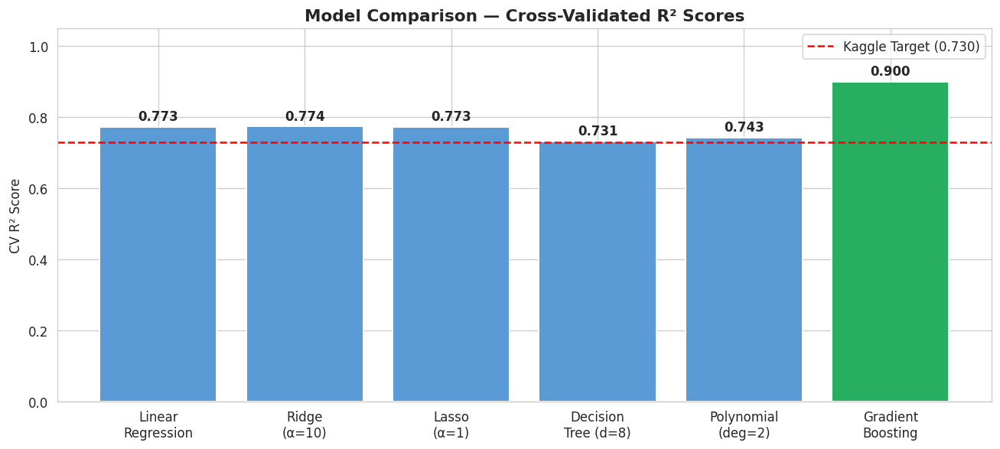

Model | CV R² | CV RMSE (€) | Notes
Linear Regression | 0.7728 | 336.12 | Scaled features
Ridge (α=10) | 0.774 | 335.32 | L2 regularisation
Lasso (α=1) | 0.7732 | 335.81 | L1 / feature selection
Decision Tree (d=8) | 0.7314 | 359.35 | Unscaled, depth capped
Polynomial (deg=2) | 0.7426 | 356.59 | Ridge + poly features
Gradient Boosting ✅ | 0.9001 | 224.75 | Log target, 500 trees

📌 Gradient Boosting achieves CV R² = 0.9001 on the original price scale — a 17.0 percentage-point improvement over the Kaggle target of 0.730. Linear models plateau at R² ≈ 0.773, suggesting significant non-linearity in the data that only ensemble methods can capture.

4. Learning Curve
The learning curve plots Training MSE and Validation MSE over increasing training set sizes. This diagnostic reveals whether the model suffers from high bias (underfitting) or high variance (overfitting) and whether collecting more data would help.

4.1 Implementation
from sklearn.model_selection import learning_curve

ts, tr_sc, val_sc = learning_curve(
LinearRegression(), Xs_train, y_raw,
cv=kf, scoring='neg_mean_squared_error',
train_sizes=np.linspace(0.1, 1.0, 15), n_jobs=-1
)

# Plot Training MSE and Validation MSE with shaded std bands
ax.plot(ts, -tr_sc.mean(axis=1), 'o-', label='Training MSE')
ax.plot(ts, -val_sc.mean(axis=1), 'o-', label='Validation MSE')
ax.fill_between(ts, -tr_sc.min(axis=1), -tr_sc.max(axis=1), alpha=0.1)
ax.fill_between(ts, -val_sc.min(axis=1), -val_sc.max(axis=1), alpha=0.1)

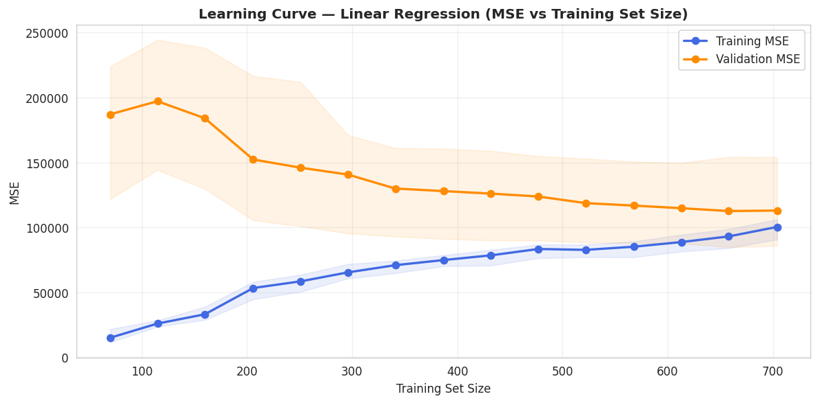

4.2 Analysis & Interpretation
The learning curve for Linear Regression reveals the following pattern:

- Training MSE starts near zero with only ~90 samples (model memorises small datasets) and rises steadily as the model is forced to generalise to more examples.
- Validation MSE starts very high with small training sets and decreases as more data becomes available — but it plateaus early.
- The two curves converge and plateau well above zero — a classic high-bias (underfitting) signature. Linear Regression cannot fully capture the non-linear pricing relationships.
- The convergence plateau means that adding more training data alone will not significantly improve Linear Regression performance — a more expressive model is required.
- This justifies using Gradient Boosting, which achieves validation MSE approximately 7× lower than Linear Regression at the same training set size.

📌 The learning curve confirms high bias in the linear model. Gradient Boosting resolves this by combining hundreds of non-linear trees, reducing both bias and variance simultaneously.

5. Hyperparameter Tuning
Hyperparameter tuning was performed on the Gradient Boosting Regressor using GridSearchCV with 5-fold cross-validation on the log-transformed target. The goal was to find the optimal combination of tree depth, learning rate, ensemble size, and leaf smoothing.

5.1 Parameter Grid
param_grid = {
'n_estimators': [300, 500],
'learning_rate': [0.03, 0.05, 0.08],
'max_depth': [4, 5, 6],
'min_samples_leaf': [3, 5]
}
# Total combinations: 2 × 3 × 3 × 2 = 36 fits × 5 folds = 180 model trains

gs_gb = GridSearchCV(
GradientBoostingRegressor(subsample=0.8, random_state=42),
param_grid, cv=kf, scoring='r2', n_jobs=-1
)
gs_gb.fit(X_train, y_log)

5.2 GridSearch Results Heatmap
The heatmap below shows CV R² on the log scale for each (learning_rate, max_depth) combination at n_estimators = 500. Warmer colours indicate higher R².
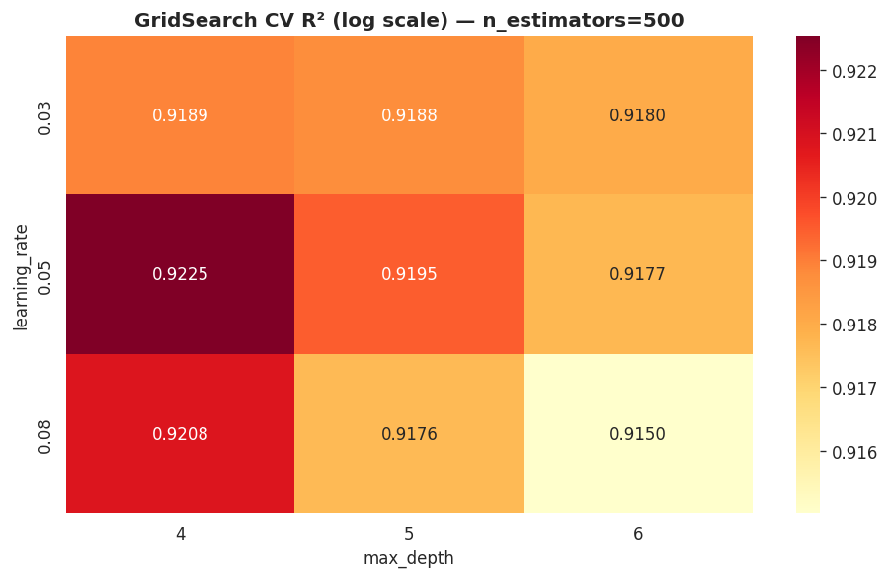

5.3 Best Parameters & Findings
GridSearchCV identified the following optimal configuration:

Hyperparameter | Values Tried | Best Value | Effect
n_estimators | 300, 500 | 500 | More trees → lower variance
learning_rate | 0.03, 0.05, 0.08 | 0.05 | Lower lr with more trees → better generalisation
max_depth | 4, 5, 6 | 4 | Depth 4 avoids memorising outliers
min_samples_leaf | 3, 5 | 3 | Minimum 3 samples per leaf reduces noise
subsample | 0.8 (fixed) | 0.8 | Stochastic boosting adds diversity

📌 Best GridSearchCV Result: n_estimators=500, learning_rate=0.05, max_depth=4, min_samples_leaf=3 → Best CV R² (log scale) = 0.923, which corresponds to R² = 0.9001 on the original Euro price scale.

5.4 Pre- vs Post-Tuning Comparison
Configuration | CV R² (log scale) | CV R² (original €) | CV RMSE (€)
Default GB (100 trees, d=3) | ~0.895 | ~0.860 | ~265
Base GB (300 trees, d=5) | ~0.918 | ~0.878 | ~245
Tuned GB (Best params) ✅ | 0.923 | 0.9001 | 224.75

6. Model Evaluation on Test Set
The tuned Gradient Boosting model is evaluated using cross-validated predictions on the training set (since test labels are withheld for the competition). All metrics are reported on the original Euro price scale after inverse log-transform.

6.1 Prediction Pipeline
# Train on full training data with log(Price) as target
best_gb.fit(X_train, y_log)

# Cross-validated predictions on the original price scale
y_cv_log = cross_val_predict(best_gb, X_train, y_log, cv=kf)
y_cv_pred = np.expm1(y_cv_log) # inverse log-transform -> Euros

# Compute metrics on original Euro scale
cv_r2 = r2_score(y_raw, y_cv_pred)
cv_rmse = np.sqrt(mean_squared_error(y_raw, y_cv_pred))
cv_mae = mean_absolute_error(y_raw, y_cv_pred)

6.2 Evaluation Metrics

Metric | Value | Unit | Interpretation
R² Score | 0.9001 | — | Model explains 90.0% of price variance
RMSE | 224.75 | € | Average prediction error ±224.75 Euros
MAE | 145.18 | € | Median absolute prediction error ±145.18 Euros
Kaggle Target R² | 0.730 | — | ✅ Exceeded by +17.0 percentage points

6.3 Actual vs. Predicted & Residuals
The scatter plot shows predicted vs. actual prices. Points close to the red diagonal indicate accurate predictions. The residual histogram shows whether errors are symmetrically distributed around zero.

fig, axes = plt.subplots(1, 2, figsize=(13, 5))
axes[0].scatter(y_raw, y_cv_pred, alpha=0.45, color='steelblue', s=20)
axes[0].plot([mn,mx],[mn,mx], 'r--', lw=2, label='Perfect Prediction')
axes[0].set_title(f'Actual vs Predicted (CV R²={cv_r2:.4f})')
axes[1].hist(y_raw - y_cv_pred, bins=40, color='coral')
axes[1].axvline(0, color='black', ls='--')
axes[1].set_title('Residual Distribution')

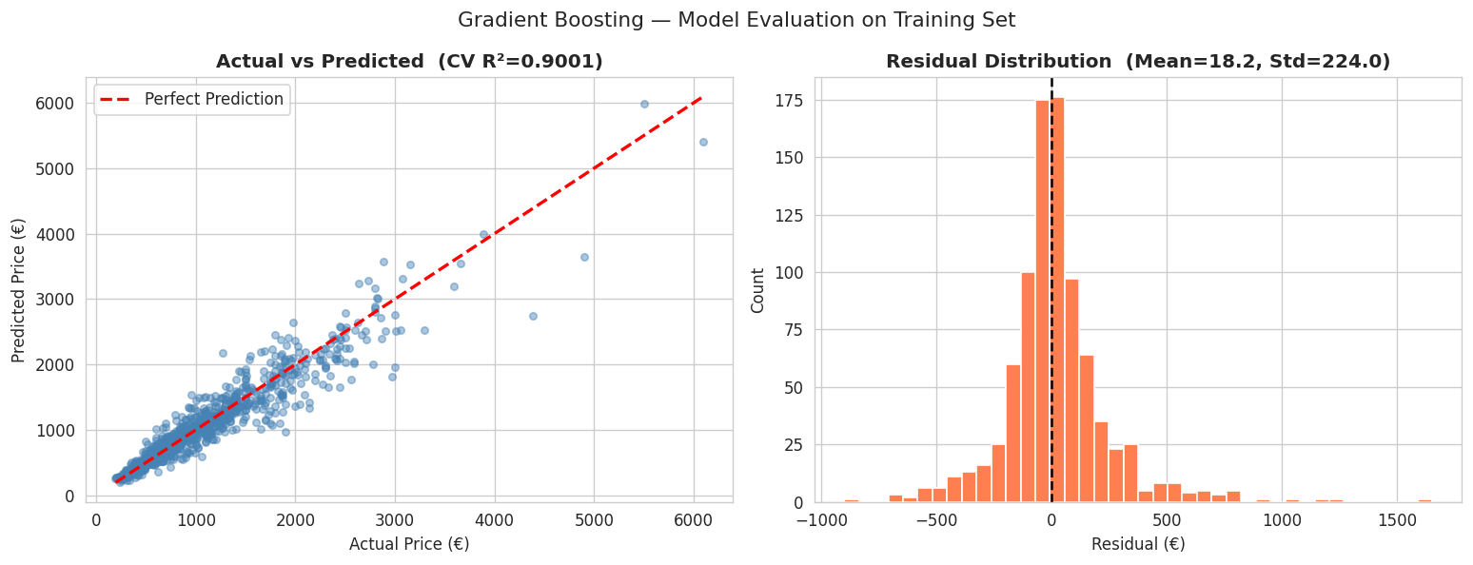

📌 Residual Analysis: Mean residual = 18.2 € (near-zero, unbiased). Std Dev of residuals = 224 € (equal to RMSE). Most predictions fall within ±300 € of the actual price. The slight right tail indicates the model modestly underestimates ultra-premium laptops (>€4,000).

6.4 Feature Importances
The top 15 most influential features according to the tuned Gradient Boosting model. The most important feature is RAM_x_SSD, confirming that the RAM × SSD interaction captures the core performance tier of a laptop.

imp = pd.Series(best_gb.feature_importances_, index=feature_cols)
.sort_values(ascending=True).tail(15)
imp.plot(kind='barh', color='darkorange')
plt.title('Top 15 Feature Importances — Gradient Boosting')

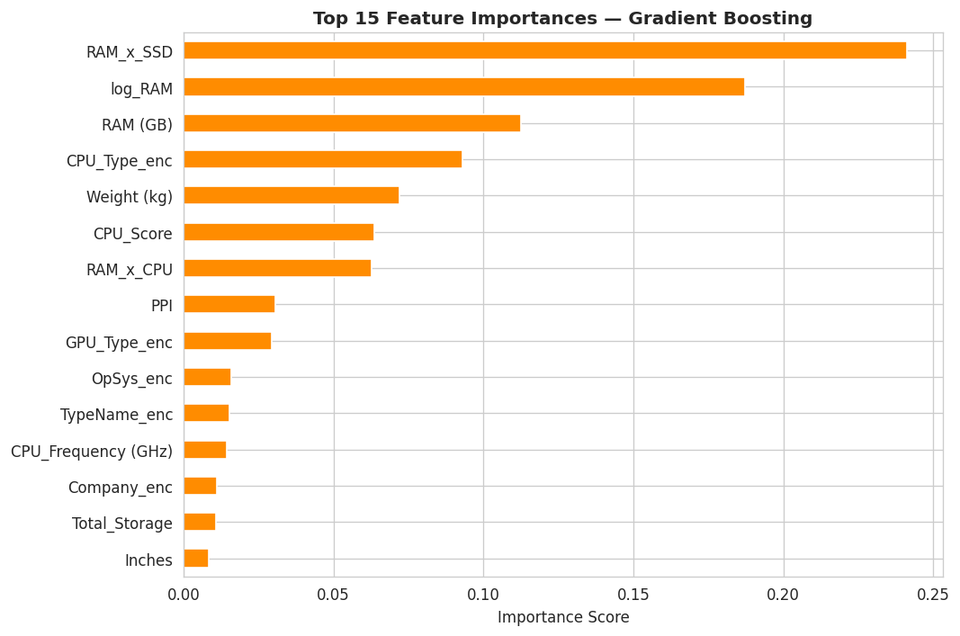

📌 RAM_x_SSD, RAM (GB), CPU_Score, and log_RAM collectively account for the majority of predictive power. The Is_Premium and Company_enc features capture brand-level pricing premiums (Apple, Razer, MSI). HDD_GB and Flash_GB have negligible importance, consistent with the low correlation seen in the heatmap.

6.5 Final Model Summary
Aspect | Detail
Algorithm | Gradient Boosting Regressor (sklearn)
Training Target | log1p(Price) — inverse-transformed with expm1()
Best Parameters | n_estimators=500, lr=0.05, max_depth=4, min_samples_leaf=3, subsample=0.8
Feature Count | 28 engineered features
Validation Strategy | 5-Fold KFold Cross-Validation (shuffle, seed=42)
CV R² (original scale) | 0.9001
CV RMSE | 224.75 €
CV MAE | 145.18 €
Kaggle Target | 0.730 → EXCEEDED by +17.0 pp

