LEASTPRIV DASHBOARD
SOFTWARE REQUIREMENTS SPECIFICATION
CloudForge One Day Hackathon | Team: MiniCoders | Version 1.0 | 15 October 2026

1. Purpose
Provide a dashboard that demonstrates AWS least-privilege enforcement using real AWS API calls. The restricted identity must list and read objects from one test S3 bucket; upload, delete, and IAM-user creation attempts must be denied by AWS.

2. Scope
IN SCOPE | OUT OF SCOPE
• Six predefined live permission tests  • Temporary STS credentials  • Actual AWS result and error display  • Restricted-role policy display  • JSON evidence export and audit evidence | • Production workloads  • Automated IAM remediation  • AI/ML analytics  • Tests beyond the six defined actions

3. Architecture
Request flow: Browser dashboard → AWS Lambda Function URL → AWS STS AssumeRole → S3/IAM authorization. AWS CloudTrail supplies independent audit evidence for selected events.
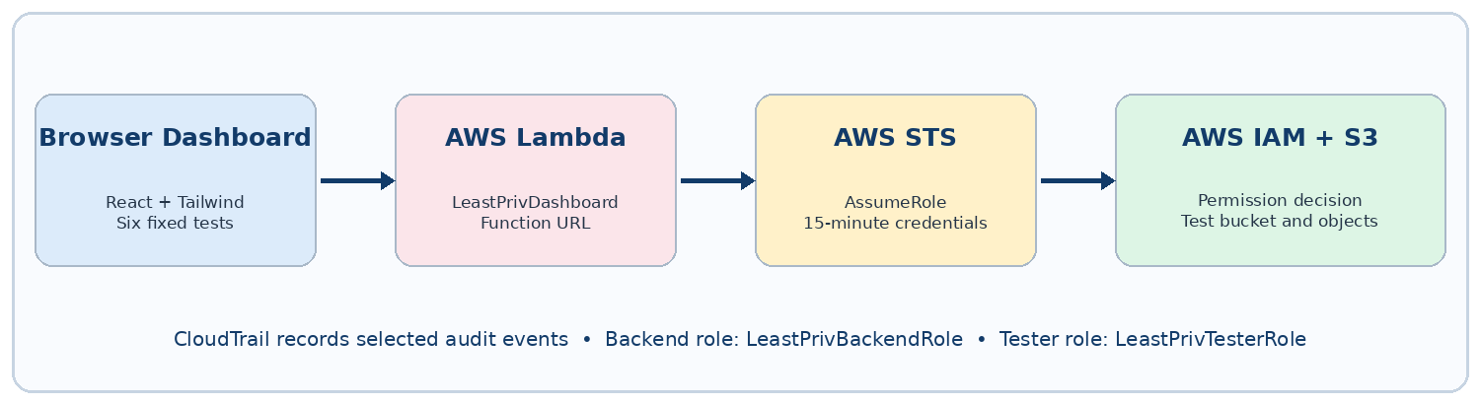
Figure 1. Runtime architecture of the live least-privilege demo.
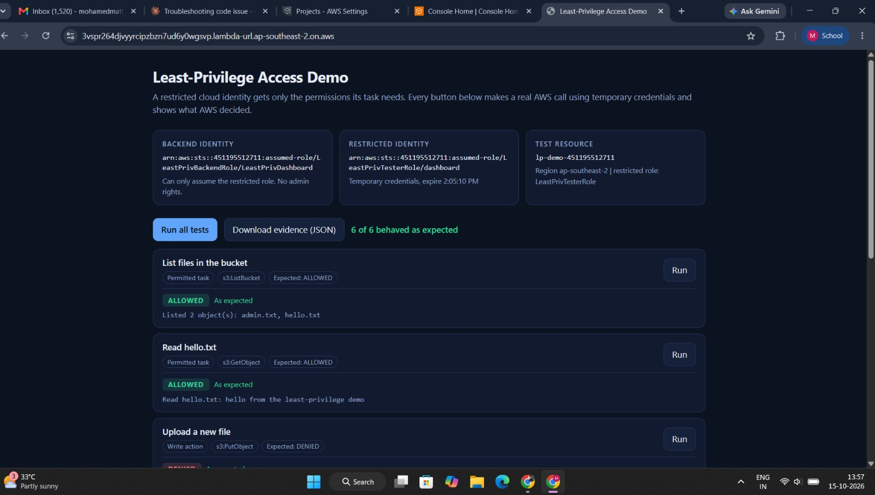
Figure 2. Implemented Least-Privilege Access Demo dashboard showing 6 of 6 permission tests behaving as expected.

4. AWS Resources and Access Rules
RESOURCE | REQUIRED CONFIGURATION
Administrator role | AccountFullAccessRole; used to demonstrate privileged actions in the controlled test account.
Backend role | LeastPrivBackendRole; may assume the tester role, read its policy, and write its own logs. No administrator permissions.
Restricted role | LeastPrivTesterRole; assumed by the backend for all six permission tests.
Tester policy | ReadOneBucketOnly: s3:ListBucket on the test bucket and s3:GetObject on objects in that bucket only; no wildcard actions and no Resource: "*".
S3 bucket | lp-demo-451195512711; test objects include admin.txt and hello.txt.
Region | ap-southeast-2 (Sydney).
Credentials | AWS STS temporary session, 900 seconds; no long-lived access keys stored in the application.

5. Functional Requirements
ID | REQUIREMENT | PRIORITY
FR-01 | Display six predefined tests with individual Run controls and a Run All Tests control. | Must
FR-02 | Use the Lambda Function URL as the backend endpoint. | Must
FR-03 | Assume LeastPrivTesterRole using AWS STS temporary credentials. | Must
FR-04 | List objects in the test bucket and show the real AWS response. | Must
FR-05 | Read hello.txt and display its content. | Must
FR-06 | Attempt upload, file deletion, bucket deletion, and IAM-user creation; display AWS AccessDenied responses. | Must
FR-07 | Display the restricted role's permission policy and raw AWS error messages. | Must
FR-08 | Show each test's expected result, actual result, and whether they match. | Must
FR-09 | Export test outcomes as a downloadable JSON evidence file. | Should

6. Test Cases and Expected Results
ID | ACTION | PERMISSION / API | EXPECTED
TC-01 | List bucket objects | s3:ListBucket | ALLOWED
TC-02 | Read hello.txt | s3:GetObject | ALLOWED
TC-03 | Upload a file | s3:PutObject | DENIED — AccessDenied
TC-04 | Delete a file | s3:DeleteObject | DENIED — AccessDenied
TC-05 | Delete the bucket | s3:DeleteBucket | DENIED — AccessDenied
TC-06 | Create an IAM user | iam:CreateUser | DENIED — AccessDenied
Acceptance criterion: 6/6 tests must match expected outcomes. Access decisions must come from AWS, not from simulated frontend logic.

7. Security and Audit Requirements
- Use separate administrator, backend, and restricted roles; the backend must not run with administrator permissions.
- Restrict the tester role trust policy to the explicitly approved role principals.
- Use 900-second STS sessions; do not store long-lived access keys in Lambda environment variables or application code.
- The Function URL may trigger only the six fixed test actions; it must not accept arbitrary AWS actions or resource names from users.
- Capture CloudTrail evidence for successful AssumeRole and denied DeleteBucket and CreateUser events.
- Show real AWS errors and keep JSON results/screenshots as demo evidence.

8. Acceptance Evidence and Cleanup
EVIDENCE | CLEANUP
• Dashboard screenshot showing policy and 6/6 results  • Downloaded JSON evidence  • CloudShell comparison of administrator and restricted identity  • CloudTrail events for AssumeRole success and the two denials  • Output confirming no IAM users or long-lived keys in Lambda configuration | Run cleanup_all.sh after the demo. Remove the Lambda function, test roles and policies, S3 bucket and objects, and any unused hackathon test user/credentials. Verify that each temporary resource is gone.

9. Future Enhancements (Optional)
Permission boundary, MFA for administrator-role assumption, alerts for repeated AccessDenied events, and AWS_IAM authentication for the Function URL before production use.

