The Read me file

Name: Mohamed Razziq Meah

Student ID: 12406369

CSY1018 – Website Development

Live URL: https://mohamedmeah.github.io/csy1018-assign1/

I have implemented HTML5 Elements.

I have implemented 5 Rules within CSS.

I have incorporated google web fonts.

I have not correctly optimised the layout for the website. I have not collaborated with anyone except for in class where general topics were discussed. I spent roughly two weeks preparing for this assignment; roughly three hours a day.

I have made regular commits through GitHub.

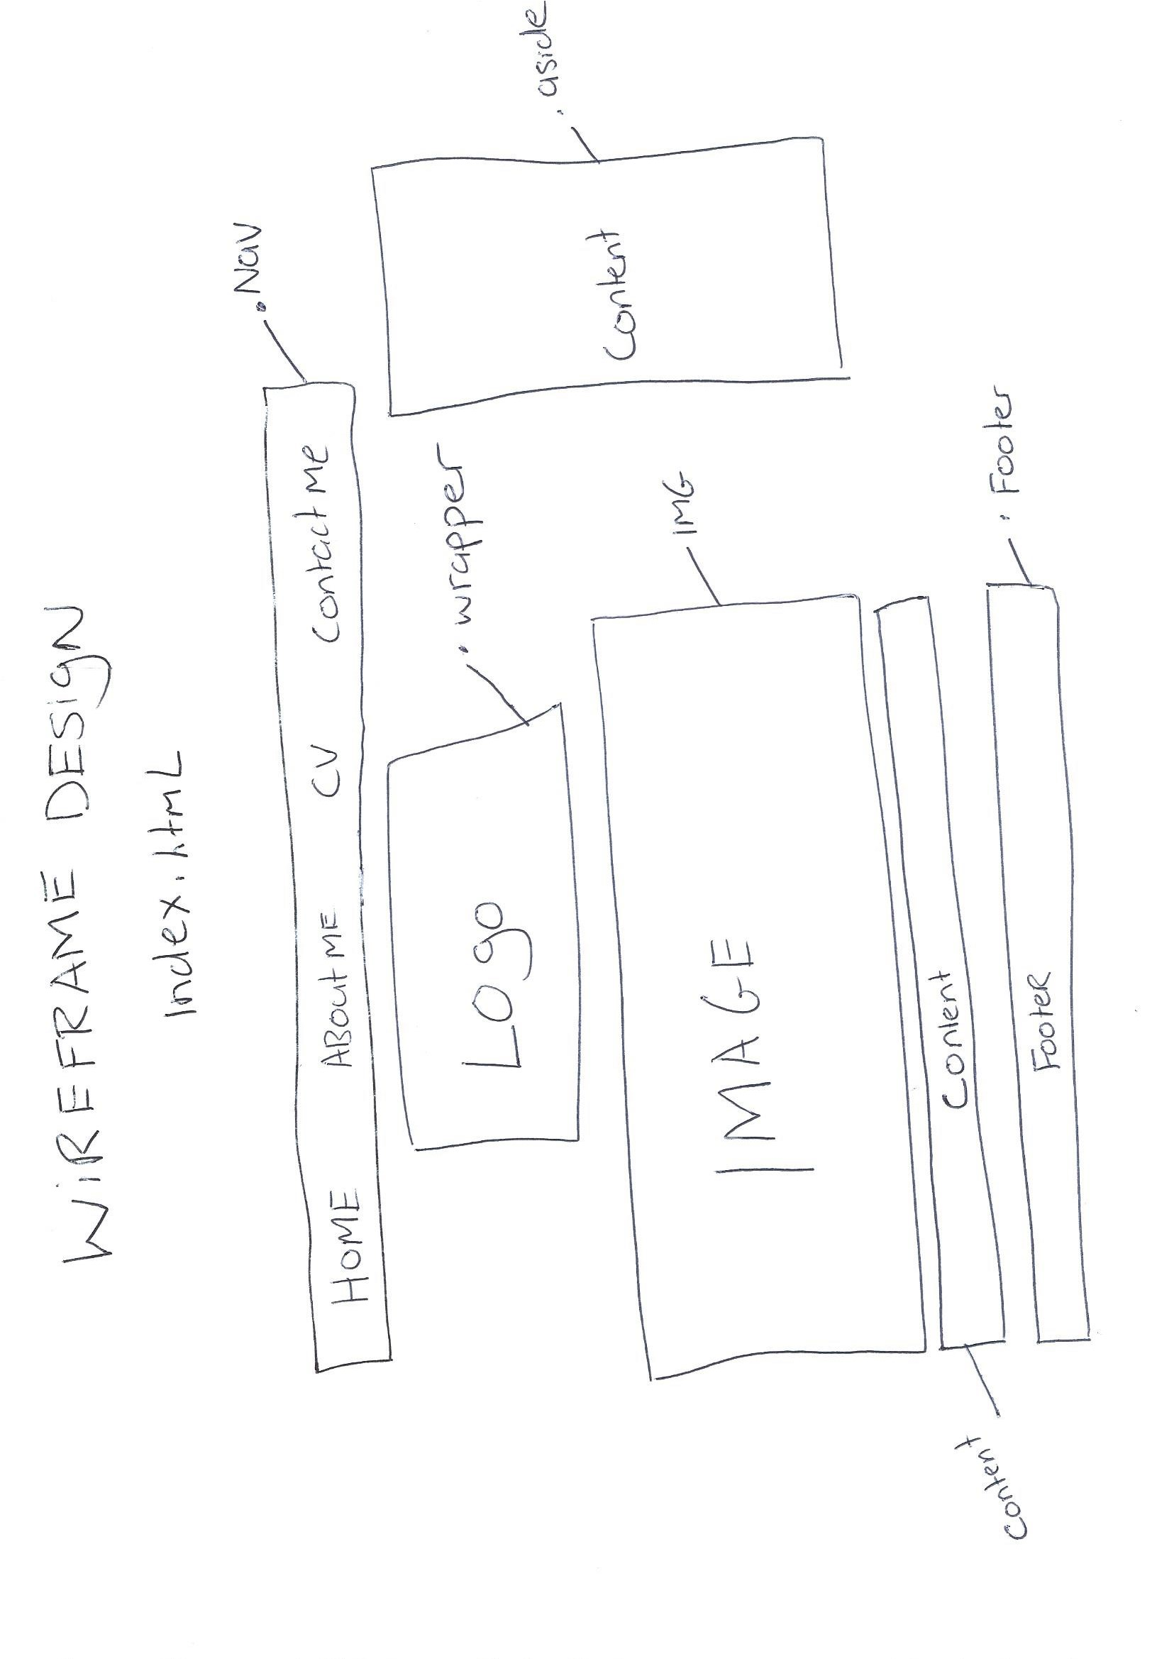

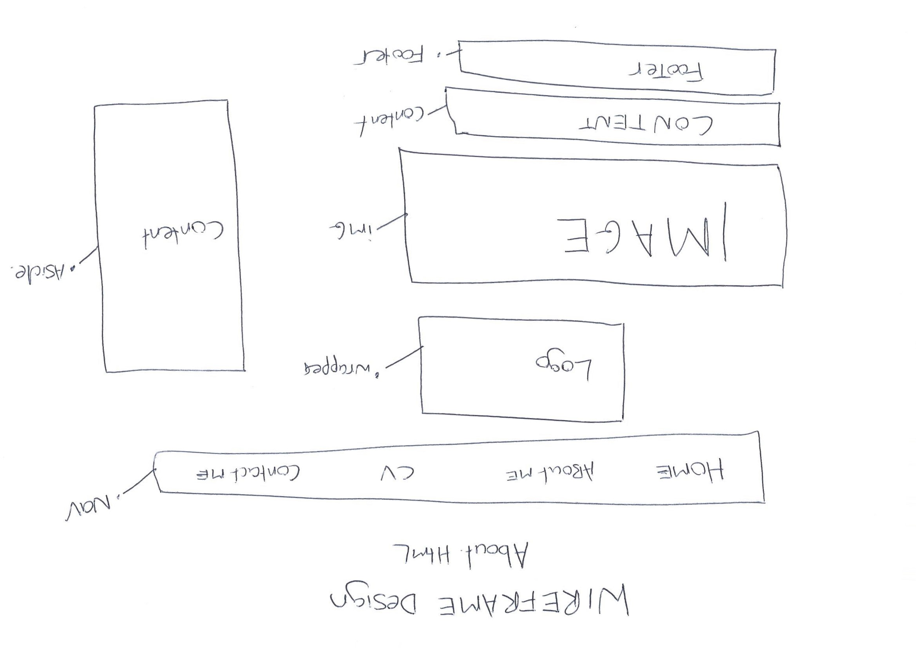

」

H

