Customer Churn Analysis
IBM Telco — Customer & Network Services
An End-to-End Data Analysis Project
Prepared by: Mohamed Mostafa Hassan Afify
NTI — Creativa · Data Analysis & Freelancing
Tools: Python · SQL Server · Tableau
July 2026

Contents
1. Project Overview
2. Data Source & Database Setup (SQL Server)
3. Methodology & Steps (Python Notebook)
4. Data Problems & How They Were Solved
5. SQL Data Storytelling & Insights
6. Tableau Dashboards & Design Decisions
7. Key Insights & Recommendations
8. Conclusion

1. Project Overview
This project analyses customer churn for a telecommunications provider operating in California. The goal is to understand who is leaving, why they are leaving, and where, and then to turn those findings into concrete business recommendations. The work covers the full data-analysis pipeline: from raw relational tables, through cleaning and preprocessing, to SQL-based storytelling and an interactive Tableau dashboard suite.

What I did
- Integrated five separate relational tables (demographics, location, population, services, status) into one clean analytical dataset of 7,043 customers.
- Loaded and stored the data in a SQL Server database, defined the relationships, and wrote a set of storytelling queries to extract insights.
- Performed a full EDA, cleaning and preprocessing workflow in Python (pandas, scikit-learn, seaborn), reserved for a later machine-learning model.
- Built four connected Tableau dashboards plus a Tableau Story that walks through the analysis from problem to solution.
- Compiled this document and a presentation deck as the final deliverables.
A note on the data: the dataset is IBM's public sample "Telco Customer Churn" data. The company it describes is a fictional California-based telecom, so "IBM" here refers to the source of the sample data, not to the operator being analysed.

2. Data Source & Database Setup (SQL Server)
The five raw tables were imported into a SQL Server database named IBM_Telco using SQL Server Management Studio (SSMS). After importing, primary and foreign keys were defined so the tables could be related correctly:
- The four customer-level tables — demographics, location, services and status — are linked on Customer_ID (one row per customer in each).
- The population table sits at Zip-Code level, so it links to the location table through Zip_Code rather than directly to customers.
The resulting schema is shown below. It forms a star/snowflake shape with the customer as the centre and population as a dimension attached through location.
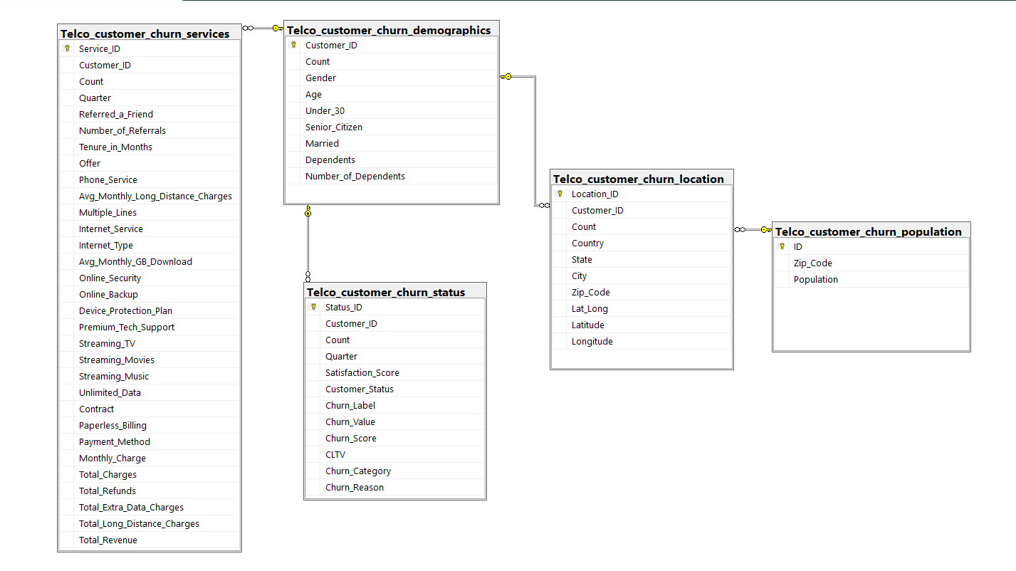
Figure 1 — SQL Server database diagram: the five related tables and their keys.

3. Methodology & Steps (Python Notebook)
All cleaning and preprocessing was done in a Python notebook, organised as a clear, repeatable pipeline. The main stages are described below.

3.1 Data integration
The four customer tables were merged on Customer_ID, and the population table was joined on Zip_Code using left joins. Constant metadata columns that carry no information (Count, Quarter, Country, State, Lat_Long) were removed before merging to keep the table clean and avoid duplicate columns. The result is a single table of 7,043 customers.

3.2 Cleaning & missing values
Missing values were handled with intent rather than blindly, because in this dataset an empty value usually carries meaning:
- Offer → 'No Offer', and Internet_Type → 'No Internet Service' (the customer simply had no promo / no internet).
- Churn_Category / Churn_Reason → 'No Churn' (only populated for customers who left).
- Financial columns → 0, and Population → median for the few zip codes with no match.
Money columns that SQL/Excel had stored as text (with blank spaces for new customers) were converted to numbers first, so they could be analysed correctly.

3.3 Handling noisy data — outliers
Continuous numeric columns were checked for outliers using box plots, then treated with IQR capping (winsorisation). A guard was added to skip any column whose IQR equals zero, so that mostly-zero columns such as Total Refunds are not accidentally flattened to a single value. The before/after box plots below show the effect — extreme values (most visibly in Population) are pulled in without deleting any rows.
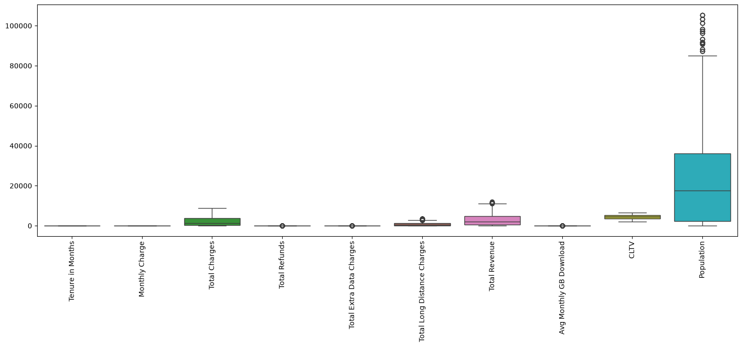
Figure 2 — Box plots of continuous features before IQR capping.
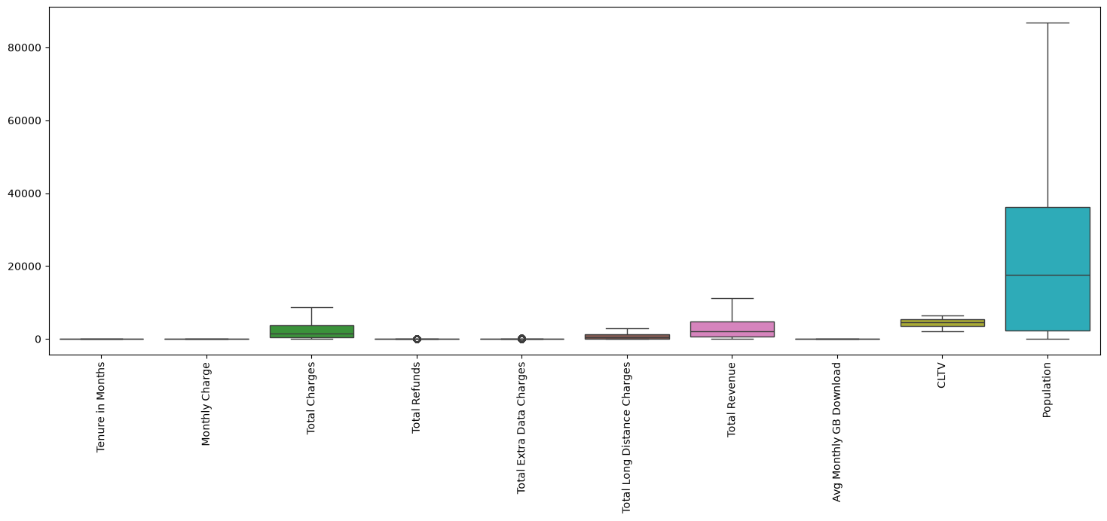
Figure 3 — The same features after IQR capping; extreme outliers are contained.

3.4 Handling noisy data — skewness
Several financial and usage columns were strongly right-skewed. For each one I compared the distribution before and after a log1p transformation. The log clearly reduces skewness — for example Number of Referrals drops from 1.45 to 0.84, and Total Long Distance Charges from 1.13 to −1.11. In this preprocessing notebook the data is kept on its original (linear) scale to stay readable for the SQL and Tableau work; the final decision on whether to log-transform is left to the modelling stage, since tree-based models do not need it while linear / distance-based models would benefit.
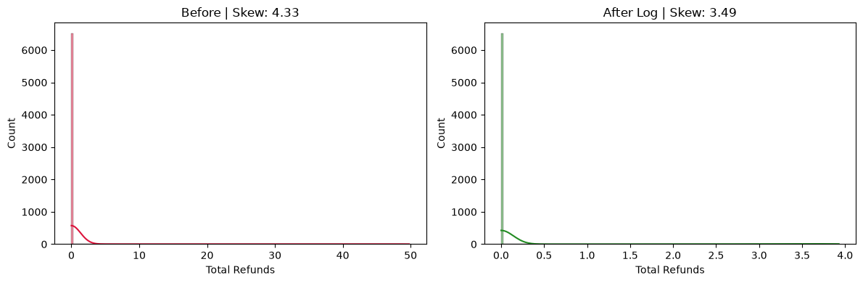
Figure 4 — Total Refunds: before vs after log (skew 4.33 → 3.49).
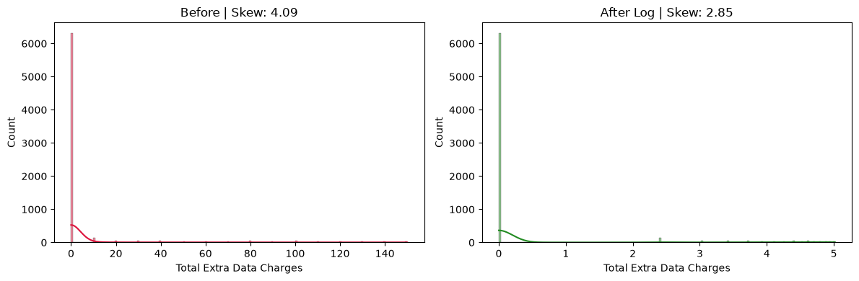
Figure 5 — Total Extra Data Charges: before vs after log (skew 4.09 → 2.85).
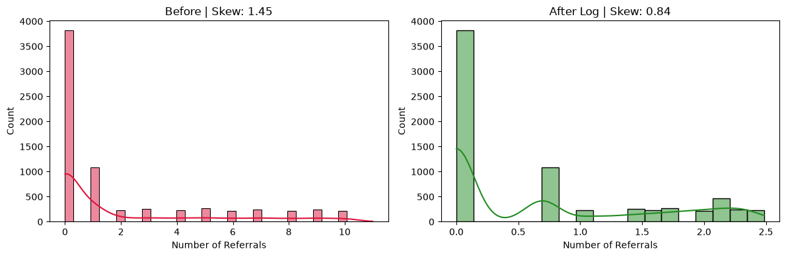
Figure 6 — Number of Referrals: before vs after log (skew 1.45 → 0.84).
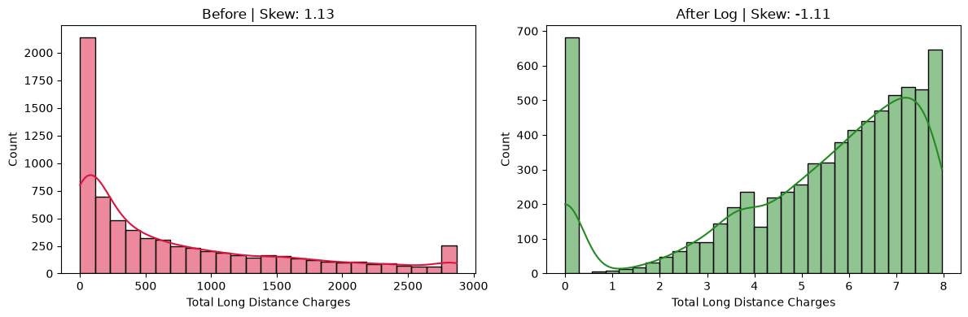
Figure 7 — Total Long Distance Charges: before vs after log (skew 1.13 → −1.11).

3.5 Feature engineering
Four business-driven features were added: Total_Services_Subscribed (how many add-on services the customer takes), Net_Revenue (revenue minus refunds), Cost_Per_Service (monthly charge per service) and GB_Per_Tenure_Month (data usage per month of tenure).

3.6 Correlation analysis
A correlation matrix was computed to understand relationships between features and to detect multicollinearity. Highly-correlated pairs (|r| ≥ 0.85) were identified so that one of each redundant pair could be dropped — for example Net_Revenue is almost identical to Total_Revenue (0.97). The heatmap also confirms sensible signals, such as the negative relationship between Satisfaction Score and Churn.
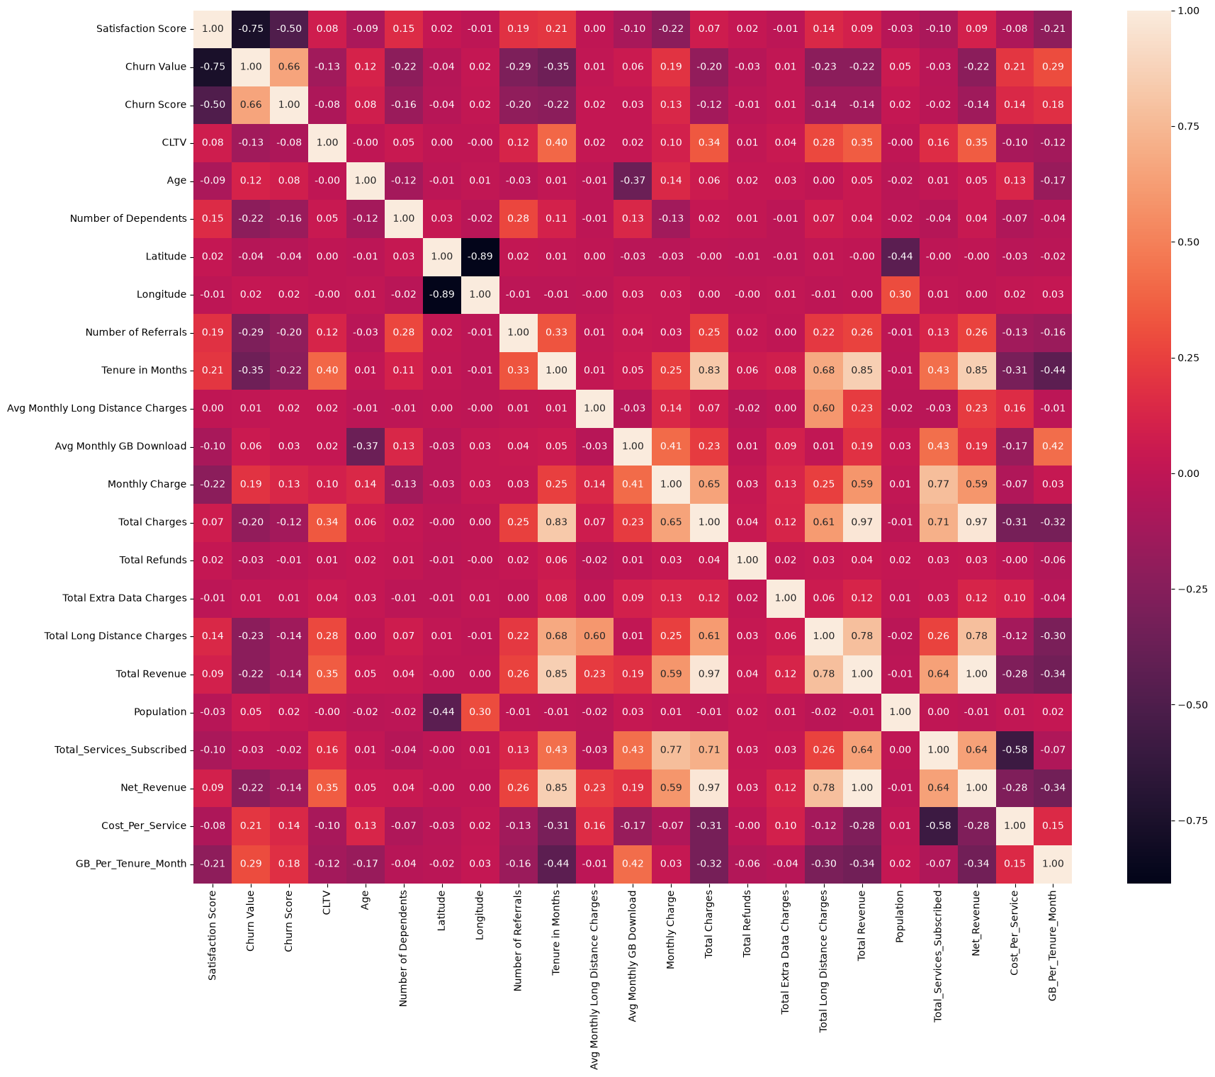
Figure 8 — Correlation heatmap of the numeric features (including the engineered ones).

3.7 Encoding, split & normalization
Categorical columns were one-hot encoded. Identifier, leakage and near-constant columns were removed. The data was then split 80/20 with stratification on the target to preserve the churn ratio, and finally MinMax-scaled — fitting the scaler on the training set only and applying it to the test set to avoid data leakage.

4. Data Problems & How They Were Solved
The table below summarises the main problems found in the raw data, how each was solved, and — most importantly — the reasoning behind each decision.
Problem in the data | How I solved it | Why (the reasoning behind it)
Data was spread across 5 separate tables | Merged the four customer tables on Customer_ID and joined Population on Zip_Code (left joins) | The tables share keys; a single analytical table is needed. Population is at zip level, so it joins through Location, not directly to customers.
Total_Charges was stored as text with blank spaces for brand-new customers | Converted with pd.to_numeric(errors='coerce'), then filled the resulting nulls with 0 | A blank means a new customer with no accumulated charges yet, i.e. a genuine 0, not a missing value.
Offer (~55%) and Internet_Type (~22%) had many missing values | Filled with meaningful labels: 'No Offer' and 'No Internet Service' instead of the mode | Missing here is informative (no promo / no internet). A category keeps that signal; the mode would distort the real distribution.
Churn_Category and Churn_Reason were ~73% empty | Filled with 'No Churn' | These fields are only populated for customers who churned, so empty means the customer stayed.
IQR capping could zero-out sparse columns (Total_Refunds, Total_Extra_Data_Charges, where Q1 = Q3 = 0) | Added a guard that skips any column whose IQR = 0 | Capping to a [0, 0] range would collapse the whole column to a single value and destroy its information.
Several financial / usage columns were heavily right-skewed | Analysed skewness and visualised the effect of a log1p transform (before vs after); kept the linear scale in this notebook | Interpretability for SQL and Tableau matters, and tree models do not need it. The final transform decision is deferred to the modelling stage.
Data-leakage columns (Churn_Label, Customer_Status, Churn_Score, Churn_Category/Reason) | Dropped before modelling and kept Churn_Value as the single target | These are known only because the outcome is known; keeping them would inflate model accuracy unrealistically.
Multicollinearity (e.g. Total_Revenue and Net_Revenue = 0.97, Tenure and Total_Charges = 0.83) | Dropped one column from each highly-correlated pair (|r| >= 0.85) | Redundant features add noise and instability to a model without adding new information.
High-cardinality / identifier columns (Customer_ID, City) unsuitable for encoding | Dropped before one-hot encoding | One-hot encoding a column with thousands of unique values would explode the number of columns.
Near-constant columns (a single value in >= 85% of rows, e.g. Phone_Service) | Dropped in a dedicated step | Columns with almost no variance carry little signal and only inflate the feature space.
Risk of data leakage from scaling before splitting | Split first, then fit the MinMax scaler on the training set only and applied it to the test set | Fitting the scaler on all rows leaks test-set statistics into training and gives an over-optimistic evaluation.

5. SQL Data Storytelling & Insights
Using the SQL Server database, I wrote a set of queries organised as a story in five themes: an overview of churn, who is churning, where they are, why they leave, and the relationship between satisfaction, value and churn. The most important findings were:
- Overall churn is 26.5% — 1,869 of 7,043 customers left, representing roughly $7.8M in lost customer lifetime value.
- Contract type is the strongest driver — month-to-month customers churn at 45.8%, versus only 2.5% on two-year contracts.
- The first year is critical — 47.4% of customers in their first 12 months churn, falling to 9.5% after four years.
- Fiber-optic customers are the most at risk — 40.7% churn, and they make up 66% of all churners.
- Competition is the number-one reason — 45% of churn falls under the "Competitor" category.
- Lack of protection increases churn — customers with no Online Security and no Tech Support churn at 33.4%, versus 9% for those with both.
- Churners pay more and are less satisfied — average monthly charge $74 vs $63, and average satisfaction 1.7 vs 3.8 (out of 5).
- Geography matters — San Diego has the highest churn among major cities at 64.9%.

6. Tableau Dashboards & Design Decisions

6.1 Connecting and relating the tables
Tableau was connected directly to the SQL Server database. The tables were combined using Tableau Relationships (rather than physical joins), which preserves each table's level of detail and prevents row duplication. Demographics acts as the central table, related to location, services and status on Customer_ID, while population relates to location on Zip_Code — mirroring the database schema exactly.
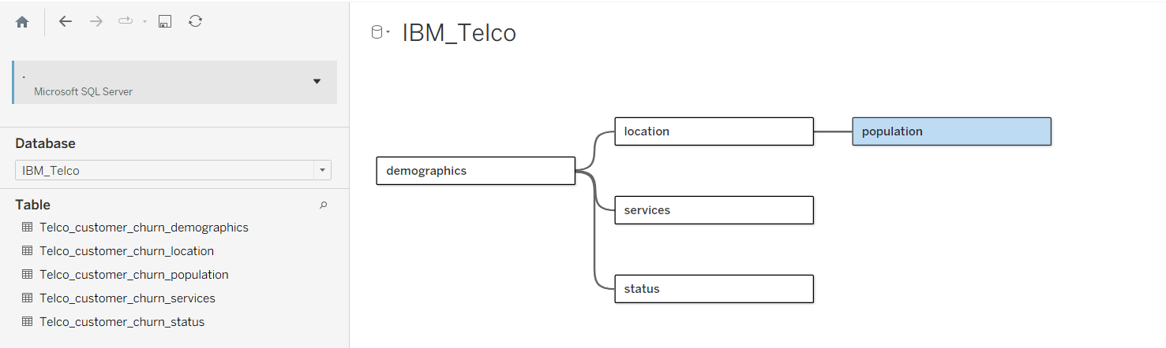
Figure 9 — The relationship model built inside Tableau.

6.2 Dashboards
Four connected dashboards were built, arranged deliberately as a narrative so that anyone opening the workbook is walked from the problem to the solution:
- Overview — headline KPIs and a Churn Risk Matrix (contract × tenure) that instantly shows where risk concentrates.
- Why They Churn — the drivers: contract, internet type, payment method and the security/support bundle.
- Where They Churn — a California map plus the top churn cities and population density.
- Insights & Recommendations — five findings, each paired with a recommendation and expected impact.

6.3 Design decisions
- Tool choice: Tableau was chosen over Power BI (both are permitted by the project brief) for its greater flexibility in layout and visual design, and because it made building a portfolio-quality, creative dashboard easier.
- Colour system: IBM's Carbon palette — a dark navy structure, IBM blue as the brand accent, and IBM red for churn/risk. A blue-to-red diverging scale encodes churn severity, so risk can be read instantly by colour.
- Consistency & branding: a custom left sidebar with the IBM logo, navigation buttons and a repeated footer credit unifies all pages.
- Interactivity: navigation buttons move between dashboards, and filters let the viewer explore by contract, tenure, internet type and payment method.
- Storytelling: a Tableau Story ties the four dashboards into a guided sequence for the presentation.

7. Key Insights & Recommendations
Each recommendation is tied directly to a finding from the analysis:
1. Month-to-month contracts drive churn (45.8% vs 2.5% on two-year).
Recommendation: Offer incentives to move customers onto longer contracts.
2. The first year is the danger zone (47.4% churn in the first 12 months).
Recommendation: Launch a structured 90-day onboarding and proactive-support programme.
3. Competition is the #1 reason (45% of churn).
Recommendation: Review fiber pricing and introduce targeted retention offers.
4. Fiber users are high-value and high-risk (40.7% churn, 66% of churners).
Recommendation: Improve fiber quality and price, and monitor satisfaction closely.
5. No security or support means higher churn (33.4% vs 9%).
Recommendation: Bundle security and support add-ons at a discounted rate to increase stickiness.

8. Conclusion
This project delivers a complete, end-to-end analysis of customer churn: the data was integrated from five tables, cleaned and preprocessed with careful, well-reasoned decisions, explored through SQL storytelling, and communicated through an interactive, professionally-designed Tableau dashboard suite. The analysis shows that churn is concentrated among month-to-month, first-year, fiber-optic customers with higher bills and less commitment, and that it is driven mainly by competition and price. The recommendations translate these findings into practical actions the business can take to reduce churn and protect revenue.

