

**Faculty of engineering - Shoubra Benha University**

|  |  |
| --- | --- |
| **Department** | **Engineering Mathematics and Physics** |
| **Division** |  |
| **Academic Year** | **2019-2020** |
| **Course name** | **Computer** |
| **Course code** | **ECE001** |

**Title: -**

**Build a website on recent computer engineering on programming language** 

By:

|  |  |  |  |
| --- | --- | --- | --- |
|  | Name | Edu mail | B.N |
| 1 | **محمد نبيل محمود زكى** | **Muhammed195905@feng.bu.edu.eg** | **813** |

## Approved by:

|  |  |
| --- | --- |
| Examiners committee | Signature |
| **Dr. Ahmed Bayoumi** |  |
| **Dr. Shady Elmashad** |  |
| **Dr. Abdelhamid Attaby** |  |
|  |  |
|  |  |

**Project link :** <https://github.com/mohamednabil11/html-project>

**Website link :** <https://mohamednabil11.github.io/html-project/>

# Abstract

Computer programming is a way of giving computers instructions about what they should do next. These instructions are known as code, and computer programmers write code to solve problems or perform a task. The end goal is to create something: that could mean anything from a web page, or a piece of software, or even just a pretty picture. That’s why computer programming is often described as a mix between art and science; it’s technical and analytical, yet creative at the same time.

# Table of contents

Divide your research into sections or subjects, mention each section first page at this table

|  |  |
| --- | --- |
| **Subject / section** | **Page** |
| Introduction | 4 |
| Literature Review | 5 |
| Results and discussion | 8 |
| Conclusions | 9 |
|  |  |
|  |  |

**Introduction**

A **programming language** is a formal language comprising a set of instructions that produce various kinds of output. Programming languages are used in computer programming to implement algorithms. Most programming languages consist of instructions for computers. There are programmable machines that use a set of specific instructions, rather than general programming languages. Early ones preceded the invention of the digital computer, the first probably being the automatic flute player described in the 9th century by the brothers Musa in Baghdad, during the Islamic Golden Age. Since the early 1800s, programs have been used to direct the behavior of machines such as Jacquard looms, music boxes and player pianos. The programs for these machines (such as a player piano's scrolls) did not produce different behavior in response to different inputs or conditions.

Thousands of different programming languages have been created, and more are being created every year. Many programming languages are written in an imperative form (i.e., as a sequence of operations to perform) while other languages use the declarative form (i.e. the desired result is specified, not how to achieve it). The description of a programming language is usually split into the two components of syntax (form) and semantics (meaning). Some languages are defined by a specification document (for example, the C programming language is specified by an ISO Standard) while other languages (such as Perl) have a dominant implementation that is treated as a reference. Some languages have both, with the basic language defined by a standard and extensions taken from the dominant implementation being common.

# Literature Review

# I have been researching about programming laguges and as an application I have used what I learnt in programming in a website to apply this knowledge, this website contains 5 pages and in this section of report I will preview some shanpshots from website pages and its source code.

# Main page

# 

# 

# Comparison page :

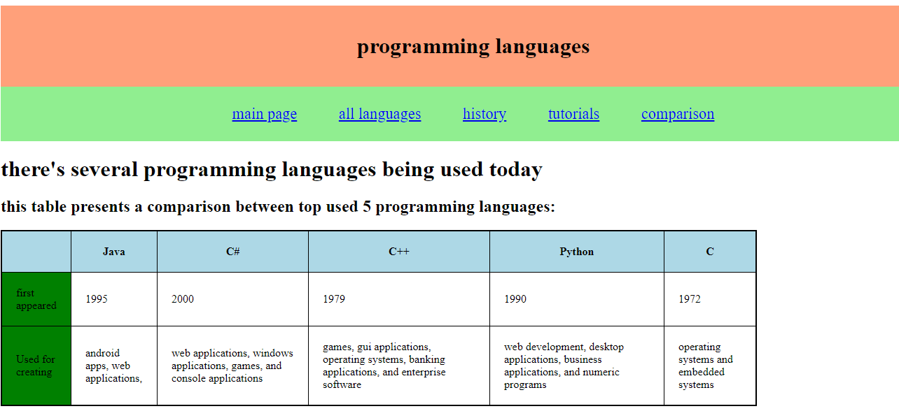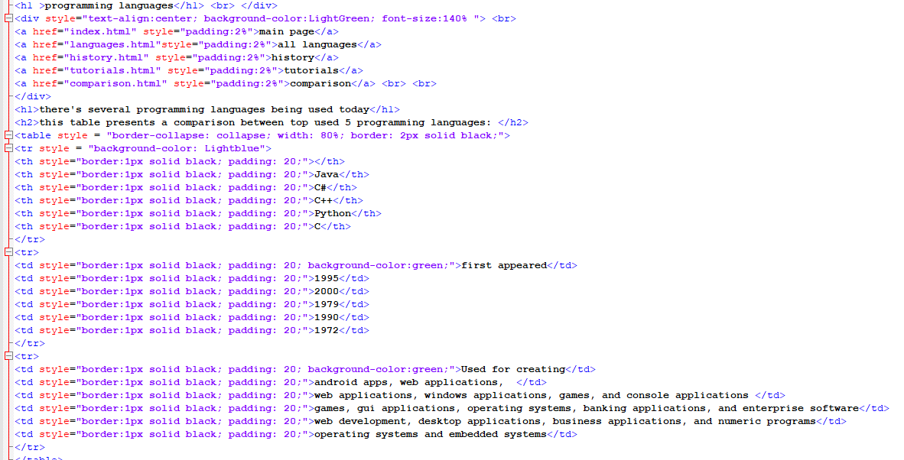

# History :

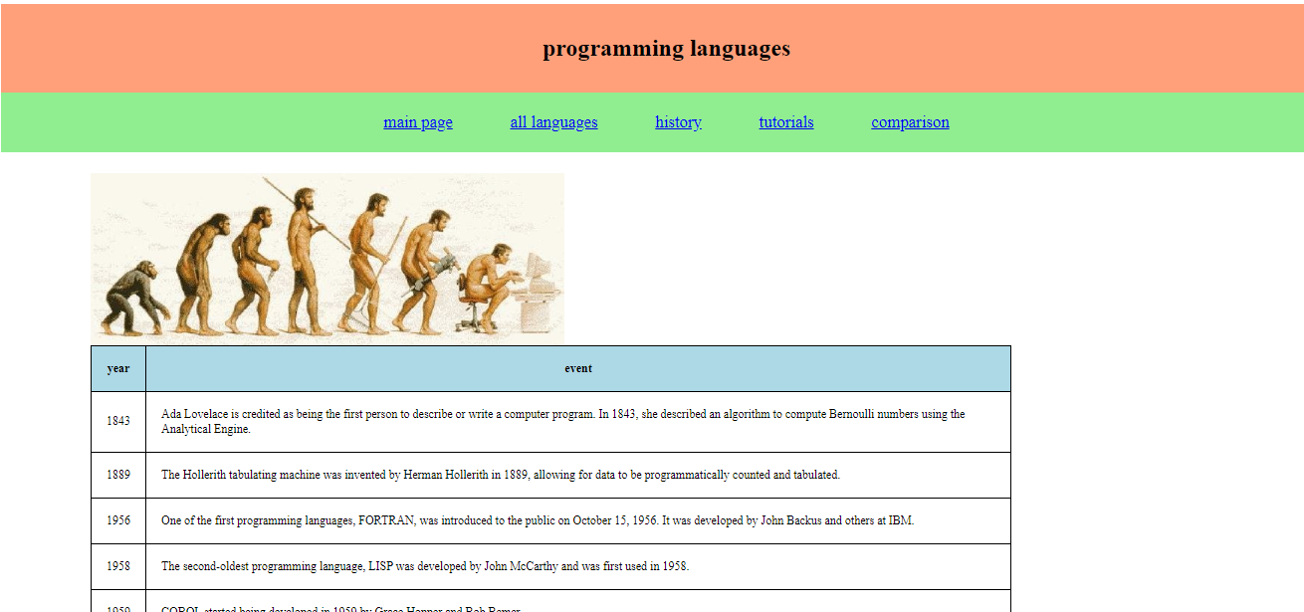

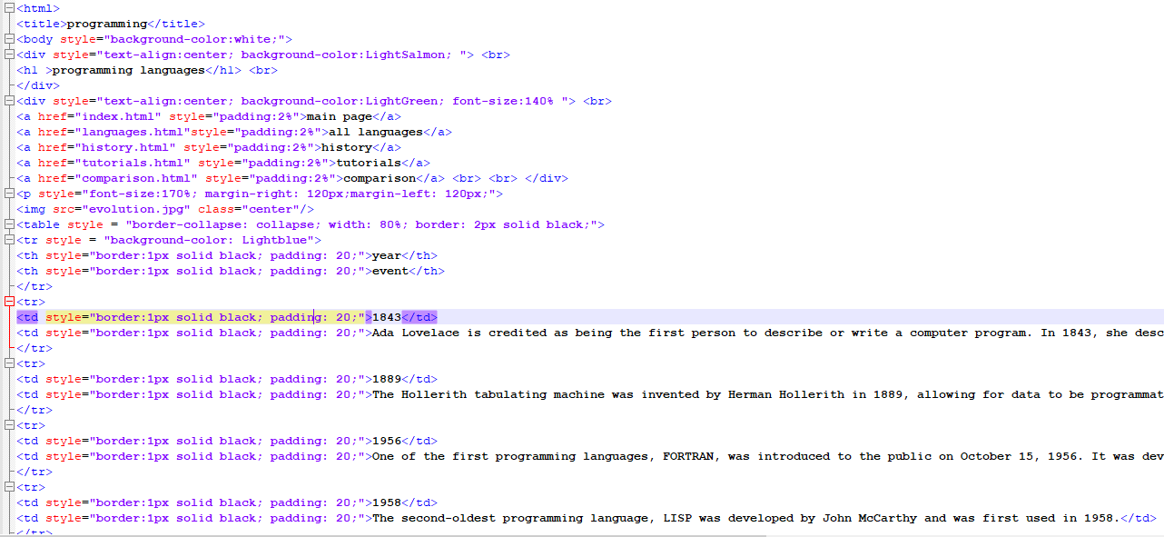

# Results and discussion

A program is a set of instructions given to a computer to perform a specific operation. or computer is a computational device which is used to process the data under the control of a computer program. While executing the program, raw data is processed into a desired output format. These computer programs are written in a programming language which are high level languages. High level languages are nearly human languages which are more complex then the computer understandable language which are called machine language, or low level language. Like we have different languages to communicate with each other, likewise, we have different languages like C, C++, C#, Java, python, etc to communicate with the computers. The computer only understands binary language (the language of 0’s and 1’s) also called machine-understandable language or low-level language but the programs we are going to write are in a high-level language which is almost similar to human language.

The piece of code given below performs a basic task of printing “hello world! I am learning programming” on the console screen.

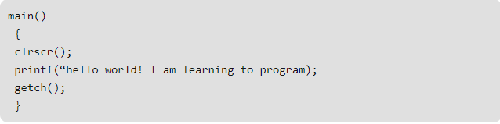

The main() is a standard function that you will always include in any program that you are going to create. The clrscr() function is used to see only the current output on the screen while the printf () function helps us to print the desired output on the screen. Also, getch() is a function that accepts any character input from the keyboard.

# Conclusions

Programming Languages are important for software technologies. It is a basic one, without it programming could not do a thing about software. It is a key factor to every software. There are different types of programming languages that are currently trendy like : python, c++, java and web languages as HTML,CSS and javascript. these languages and more other languages are being used to shape our digital world today by building impressive applications and softwares.