CURRICULUM VITAE
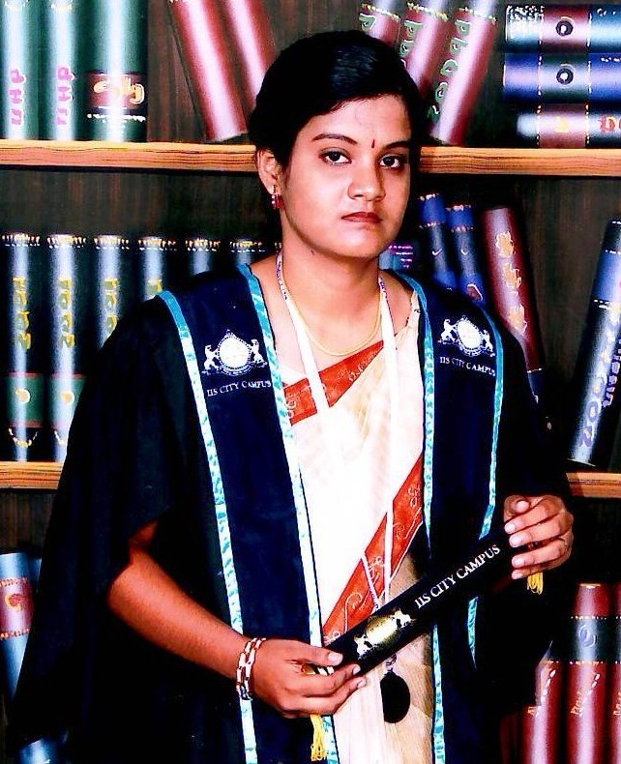

I am searching for a job related with IT and Management wise job. And I am eager to work hard to participate in the growth of the organization and also to develop the professional approach myself. I can work with a team with dedication

Personal details

- Name in full : Thadchayani Santhiraratnam
- Gender : Female
- Address
Permanent Residence:
Kerneady Lane,
Thirunelvely,
Jaffna
Present Residence : No 60,Quarry Road,
Dehiwala,
Colombo.
- Telephone : 021 - 222 - 4891
- NIC No : 928053725V
- Mobile : 077 - 6458221
- Email : thadchayani31@gmail.com
- Date Of Birth : 31 ^{st} October 1992
- Civil status : Single

Educational qualification

- Higher National Diploma in Software Development at IIS City Campus, Jaffna
(2012 - 2014)
Subject | Grade
Employability skills and professional development | Distinction
Data analysis and design | Distinction
Data structures and algorithms | Distinction
Distributed software application | Distinction
IT support for end users | Distinction
Human and computer interface | Distinction
Web Application -Project development and implementation [(Students’ Information Providers)] | Merit
Mathematics for software development | Merit
System analysis and design | Merit
Office Solutions Development | Merit
Java programming | Merit
Computer systems | Merit
Management in IT | Merit
Business skills for e-commerce | Merit
Quality systems in IT | Merit
Web applications development | Pass
Software application testing | Pass
Networking technologies | Pass
Procedural programming | Pass
.net programming | Pass

- G.C.E Advance Level at Chundikuli Girls' College, Jaffna
(2011)
- Diploma in PC Application at DMI Computer Education, Jaffna
(2008)
- G.C.E Ordinary Level at Chundikuli Girls' College, Jaffna
(2008)
Subjects | Grade
App.Tam.Literature | B
Tamil Language & Literature | C
Mathematics | C
Hinduism | C
Entrepreneurship Education | C
Science | C
History | C
Health and physical education | S
English | S
Professional qualification

- Following Bachelor of Information Technology at MIS BIT Campus, Jaffna, SriLanka.
- Higher National Diploma in Software Development at IIS City Campus, Jaffna
(2012 - 2014)
Other skills

- I can work with team spirit
- I can do presentation
- I can work dedicated with a team
- I am good in Designing and Programming (Specially PHP,CSS,HTML)
- Typing in English and Tamil

Linguistic Skills (Very Good, Good Elementary)
Language

Write

Understand

Speak

Read
Tamil
English
Sinhala

Very Good
Good

Very Good
Good

Very Good
Good

Very Good
Very Good

Experiences

EXPERIENCES

Designation : Lecturer In PC Application and Graphic Designing
Station : MIS BIT Campus
Period : 11th of September 2012 - Now
Duties & Responsibilities
- Designing and implementing new methods of teaching to reflect changes in research
- Designing, preparing and developing teaching materials
- Supporting students through a advisor role

Extracurricular activities

- I participated as a member in the LEO club of Chundikuli Girls' College
- I was a member of Sports Committee at Chundikuli Girls' College
- I was a member of Science Union at Chundikuli Girls' College
- I participated Chundikuli Giirls College cultural events
- I participated most IIS City Campus cultural events including dramas, debates, poems

Referees

Referees
Name & Designation
Official address
TP No
077-6669228

0212220288
0775677359

Lion.Dr.Y.Thiyagarajah MJF

Mr.R.Kumaran

MEDI ADIS CLINIC,
Dispensary & Surgery,
Point Pedro Road,
Muththiraichanthi,
Nallur,Jaffna.

Chief executive officer,
MIS BIT Campus,
#26,Brown Road,
Jaffna.

I hereby declare that all the information furnished above is true to the best of my knowledge and belief. I assure you that if I’m given opportunity, I will do my duties regarding to the best of my ability.

Yours Faith fully, Date
30/04/2014
(S.Thadchayani)

