CURRICULUM VITAE
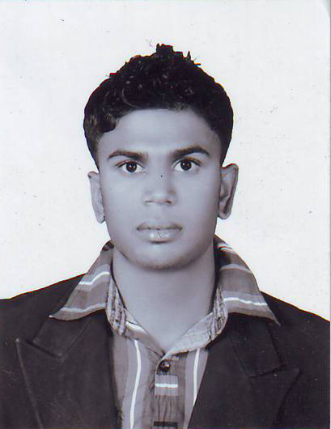
J..M.L.KASUN
Daragala, palley elle, Welimada,
E-Mail: lakshitha1211@gmail.com
071-3737000 / 057-2244403

Personal Details
Name in full  Date of Birth | :  : | Jothimuni Lakshitha kasun Jothimuni.  11th December 1992
Age  Civil Status | :  : | 21 Years.  Single.
Gender | : | Male
Ethnicity | : | Sinhala
NIC. No. | : | 923461523v
Contact No : 071-3737000/0757606938
Postal Addres : Daragala, Palley elle, Welimada

Educational Qualifications

B/Vijaya Vidiyalaya,Welimada
G.C.E O/L Exam, December 2008 INDEX No-82350906
•BUDDHISM A •HISTORY B
•LANG. & LIT (S) C •ARTS S
•ENGLISH S •CITI.EDUCATION C
•MATHEMATICS C •HEA. & PHY.EDU B
•SCIENSE S
B/ Welimada Central College, Welimada
G.C.E A/L August 2012 INDEX No-5934737
•Economics C
•Business Studies C
•Accounting S
•General English S

Work experience
• State Timber Corporation – Keppetipola Complex
Working as an Accounts trainee for one year.
- Preparation Monthly VAT Report, Cash Flow & Bank Reconciliation.
- Making Credit Sale Controlling Account.
- Entering Account Receivable invoice to the System (ACCPAC).
- Entering Cash Book & Salary Journals to the System (ACCPAC).
- Making Transfer In & Out Document of Transmission Poles, Sleepers. Elephant Poles & Logs for Reconciliation.

Other Qualifications
- Completed a Certificate Course In English At The Easiest Way.
- Ability to work with MS Office Package (MS Word, Excel, Power Point, Access & Familiar with Internet & E-mail.

Extra Activities
- A member of School prefect Board
- A Head prefect of dhamma School prefect Board.
- Committee member of school Commerce Association. .
- Member of school Cricket team.

Communication & other Key Skills
- Group Presentations, Report Writing, Capable of speaking Sinhala and English language.
- Made effective contribution as a team member on assignments & presentations in the School.

Non-Related Referees
- D.A.J Sarrojani.
H.R Manager,
Rain Were PVT LTD,
Biyagama,
Contact No: Mobil - 071-2618000
Office-011-2465165

- Mr. Channa Kannangara
Head of commerce section.
Central College.
Welimada.
Contact No: Mobil-072-3404207
Office-057-2245234

∙Here by certify the above particular given by me are true & accurate to the best of my knowledge.

………………………… …………………………
J.M Lakshitha kasun Date

