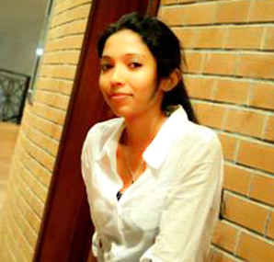

CURRICULUM VITAE

Mayurindi Karunarathne

OBJECTIVE
To initiate my career in Media field & to develop my skills while contributing to the organization at my best.

CORE COMPETENCIES
- Performs Well Under Pressure  - Computer Skills  - Presentation skills  - Interpersonal skills | - Advanced Communication  - Outstanding Leadership  - Organization skills  - Time Management

PERSONAL DETAILS
Name in Full Karunarathne Mudalige Narmada Mayurindi
Date of Birth 28th of August 1990
Age Age 24
Contact Number +94 77 0215009 , +94 413405124
Email address mayurindimudalige@yahoo.com
N.I.C No 907410447v
Gender Female
Nationality Sri Lankan
Civil Status Single

SPECIAL ACHIEVEMENTS
I was selected to participate in the International Student Week held in Ilmenau , Germany as one of the three students who were selected from Sri Lanka and participated in the work group “Film” in 2013

I have been selected to take part in the 2nd largest International Student Conference in Europe (ISWI) and the largest in Germany , which is going to be held in June 2015, as one of the 270 international students who have been selected, out of 3000 applicants all over the world.

ACADEMIC QUALIFICATIONS
Bachelor’s Degree in Mass Media

University : University of Colombo, Sri Palee Campus, Faculty of Mass Media
Specialization : Television
Status : Completed and Graduation Pending
National Diploma in Television Program Production

University : University of Vocational Technology (UNIVOTEC)
Specialization : Television Program Production
Status : Completed

Visharadha- Part 1 (Completed)

Institute : Bhathkande Sangeet Vidyapith, Lucknow, India
Specialization : Vocals
Status : Part 1 - Completed

EDUCATIONAL QUALIFICATIONS
School Education
School Attended : St. Mary’s Convent – Matara
Period : From 1996 to 2009

Examinations Passed
G.C.E. Ordinary Levels : 2006
G.C.E. Advanced Levels : 2009 (In Arts Stream)

CO-CURRICULAR ACTIVITIES

In Unversity of Colombo
I have completed projects in following subjects
- Public relations
- Development communication
- Media management

I have written scripts for the Advertisement produced for Childrens’ Day 2011 and for Song visuals, & Short films.

I worked in a University Tele drama production project as an Audio Administrator

In St. Mary’s Convent- Matara.

I was a student of St’Mary’s Convent, Matara, from grade one to G.C.E (A/L) and have taken part and obtained certificates and awards for the following while doing my studies.

- I have done a practical project of biological , sociological and psychological effects of music in 2008
- I was a junior Prefect in 2006 and a Senior Prefect in 2008
- I was placed First in Singing in Matara District, organized by Sri Lanka Rupavahini Corprration, in 2004,
- I was placed as the Best Singer in School level in2005
- I have participated in all island Debating competition organized by the Richmond College and Mahinda College, Galle, and was placed 2nd in Matara District inter school debating competition organized by YMCA
- I was a member of the Mass Media Association and Eastern Music Association and Sinhala lietarary, English Litereary and IT associations.
- An active member of the Eastern Band for two years.
- Was placed in poetry writing in Sinhala for the Sinhala Day in School level.
- Was seconed in dictation and took part in recitation held for the English day competitions
- I have taken part in Atheletics for the inter – house sports meet.
- I have obtained a Distinction for the Australian National Chemistry
Quiz in 2006

TRAININGS & WORKSHOPS ATTENDED

University Inplant training
Completed the 7 months of training period in production field at, Sirasa TV, Stein Studios, Rathmalana.

Children Skills development program
Conducted by Journalist Mr. Ediwin Ariyadasa and Ms. Rathna Pushpakumari in 2006

Prefects Training Program
Organized by YMCA International Academy- Matara in 2008

“From chaos to community :introduction to kingian nonviolence (101)”
Presented at the university of Colombo ,Sriplaee campus,
Organized by the national peace council of srilanka,communities without boundaries international, Inc, and press, cultural and educational affairs, U.S.Embassy, Colombo in 2011

Computer Literacy

Have a fair knowledge of MS Office Applications, and Edtiting

LANGUAGE PROFICIENCY

Posses the ability to Read, write and speak English and Sinhala Fluently .

Completed upper intermediate – II in FCE Preparation at English and More European Eductation Centre

WORK EXPERIENCE
Position : Teacher
Institute : St. Mary’s Convent - Matara
Period : 2010

Position : Assitant English Teacher (for Young learner’s Classes)
Institute : European education centre
Period : 2010

Position : Volunteer- Social Working Projects
Institute : Little Blue Elephant Organization (Joined with Finland government )
Period : 2013

Position : Media Coordinator
Institute : Union for International Community Development (non profit
organization)
Period : 2015 (present)

NON RELATED REFERENCES

Mr.Ajith Jayawardhana
Career Guidance Counsellor
University of Colombo
Colombo 03.
Tel: + 94 (0) 77 3516994
E mail: ajith@cgu.cmb.ac.lk

Ms. Margaretha Rutgers
English and More, European Education Center
EEC 62/4
Rahula Road,
Matara
Tel: +94 (0) 77 5588444 / +94 (0) 41 2222817
E mail:marga45@gmail.com

Mrs. Sakunthala Gregory
Retierd teacher (1975/2013)
Prefects incharge / Sectional head
St’ Mary’s Convent , Matara
Instructor – Social Etiquette
Tel: +94 (0) 0776111515

DECLARATION
I do hereby certify that the above particulars given by me are true and accurate for the best of my knowledge.
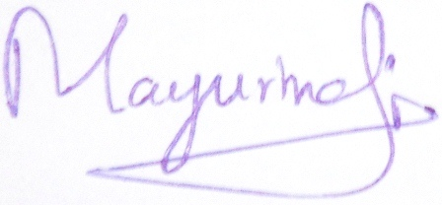

25.01.2014
Date Signature of Applicant

