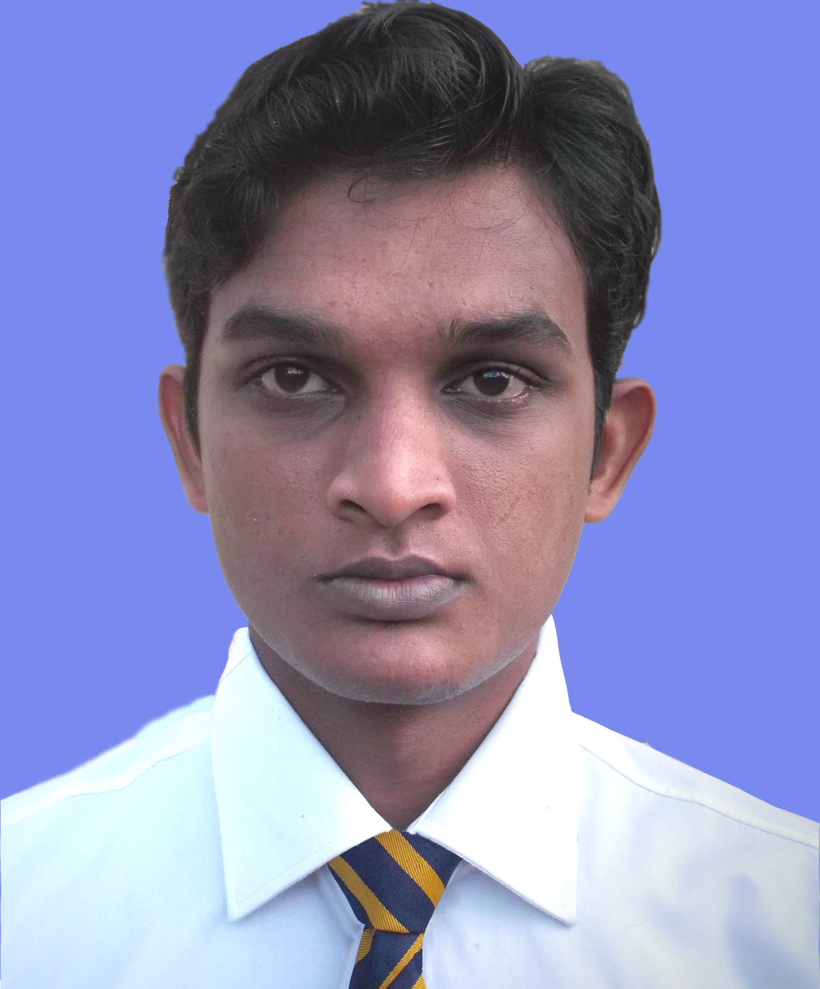
Sachithra Piyatissa
Kahatawaththa road,
Bohingamuwa,
Kuliyapitiya.
Tel: 071-5960636
e-mail: sachithramaduranga@gmail.com

PERSONAL PROFILE:

A final year science undergraduate with good knowledge. Reliable, trustworthy, highly focused and hard working. Able to work well both in a team environment as well as using own initiative.

EDUCATIONAL QUALIFICATIONS:

2013 –2016 BSc. (expected) in Science at University of Colombo.

Subjects studied: Chemistry, Zoology, Plant science, Environment
science, Environmental physics

2002 – 2010 Royal College, Colombo 7.

GCE A Levels: Chemistry [A], Physics [B], Biology [B].

GCE O Levels: Mathematics [A], Science [A], Buddhism [A],
English [A], Social studies [A], Business studies [A],
History [A], Music [A], Health [A], Sinhala [B]

EXTRA-CURRICULAR ACTIVITIES:
Vice president of the science faculty art forum in 2015.

COMPUTER SKILLS:
Microsoft word, PowerPoint, excel
Multimedia and graphic designing

PERSONAL DETAILS:
Full name : Hitihamillage Sachithra Maduranga Prabhash Piyatissa
Gender : Male
Date of Birth : 17th June 1991

Marital Status: Single
Nationality : Sri Lankan

INTERESTS:

Writing poems, Video editing, Traveling

References:

Professor Wipula B. Yapa. A.M.A.B Amarakoon.
Professor in zoology, BSc. Engineering(hons)
Head of the department, Section head-Maintenance,
Department of Zoology, Haycarb PLC,
University of Colombo, Katana road,
Colombo 3. Badalgama.

Tel: +94112503399 Tel: +94312269219
+94714406282

Email: head@zoology.cmb.ac.lk Email: aba@haycarb.com
wipula@gmail.com

I hereby attest that the above information is true & correct according to the best of my knowledge.

