KOTHASAN  KOGULAN  # 16/27,8TH LANE,  VAPPAN KULAM,MANNER ROAD,  VAVUNIYA.  Sri Lanka.  Date of birth:  1992.11.02  N.I.C. #  923071296V  +94 77 77 35009  Kkothasan2@gmail.com  www.facebook.com/V.K.GOBI  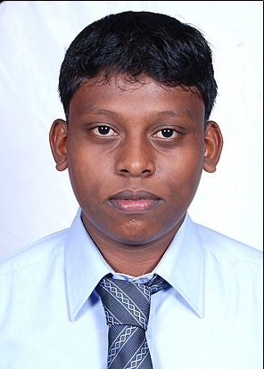 | SUMMARY  An adaptable, conscientious, enthusiastic and self-motivated applicant with the knowledge of advance level , interested in pursuing my future career in Banking field, now seeking a challenging and rewarding opportunity in order complete my role towards advancement of Banking field  EXPERIENCE  TRAINEE MARKETING EXECUTIVE, CITIZENS DEVELOPMENT BUSINESS FINANCE PLC. (CDB) VAVUNIYA  VavuniYA, Sri Lanka — 2013  I worked as Trainee Marketing Executive at the office. Vavuniya Citizens Development Business Finance PLC. (CDB) between 09.01. 2013 to 20.03.2013.  DIALOG AXIATA PLC. { ABANS OFFICE AUTOMMATION (PVT) LTD.}  MULLAITIVU & VAVUNIYA, Sri Lanka — 2013  I have been working as Front Line Officer (FLO) at Customer service- mullaitivu and vavuniya between 2013.03.21 and now.  Key Responsibilities  - Customer service.  EDUCATION  School: V/ Vavvuniya Tamil Madya Maha Vidyalayam  PROFESSIONAL QUALIFICATIONS:  Other Experience/ Activities  OTHER QUALIFICATIONS:  - Was a prefect in school.  - Was a member of road traffic team in school.  - Was a player in a Basket Ball team and batmen tan.  - Sri lanka youth clube member.  - Ability to do photo editing, graphic and web designing  OTHER SKILLS:  - Possess a driving license for light vehicles and motorbike (AB)  - Can speak Sinhala normally  - Effective communication skills  - Effective interpersonal skills  PERSONAL QUALITIES:  - Hard working, reliable and trustworthy  REFERENCES  I do hereby confirm that the above said particulars are true and correct to the best of my knowledge.  ………………… 2014.06.07  (K.KOGULAN) Date
  Year | Qualification | Results
  2012 | GCE (A/L)  (Commerce stream) | Index No.: 6225853  Economics S  Business studies S  Accounting C  Common General Test 42
  2008 | GCE (O/L) | Index No.: 82761582
  Mathematics C
  Tamil C
  Health Science A
  Social Studies & History C
  Science S
  Religion A
  Tamil Literature C
  Entreprenrurship Education C
  English S
  Year | Qualification | Results | Institution
  2009 | Diploma in ICT Application. | Introduction End user Applications: A  Language & Communications: A+  Web Designing: A+  Object Orient Programming  With Visual Basic.Net: A+  Fundamentals of ICT ( FICT 1): A  Project Work: A+ | IDM Computer  Studies (Pvt.) Ltd.  Vavuniya
  2011 | Certified Computer Accountant Using Tally.9 | Overall grade: A | Computer Software College.  (CSC)
  MR.Thavarajay Kamalan,  Sports officer,  Vavuniya District.,  vavuniya.  E-mail:  Phone: +94776139000 | Mr.S.Sivakaran  Guidance counselor,  V/V.T.M.M.V.,  Kandy Road,  Vavuniya. Sri Lanka.  E-mail: sivaharan2011@gmail.com  Phone: +94772018757

