Name: Pasan Bagye Jeewaka Illege

Address: 3/301, Field View, Nalagasdeniya, Hikkaduwa.

Mobile: 0777120147

Email: pasanbagye@ymail.com
Dear Sir
I am following a Bachelor of Science degree in Management Information System, from the University College Dublin at National School of Business Management (NSBM) now I am in my last year and I feel that my background makes me a good fit for a trainee position.
Due to the lack of experience I would like to apply for a training position at your company where I could utilize my background to improve my knowledge that I have acquired during the past years and I am very interested in doing training at a successful company such as yours.
I am available for contact at anytime you desire.
Thanks for your time and consideration.
Yours Faithfully
Pasan Bagye
pasan

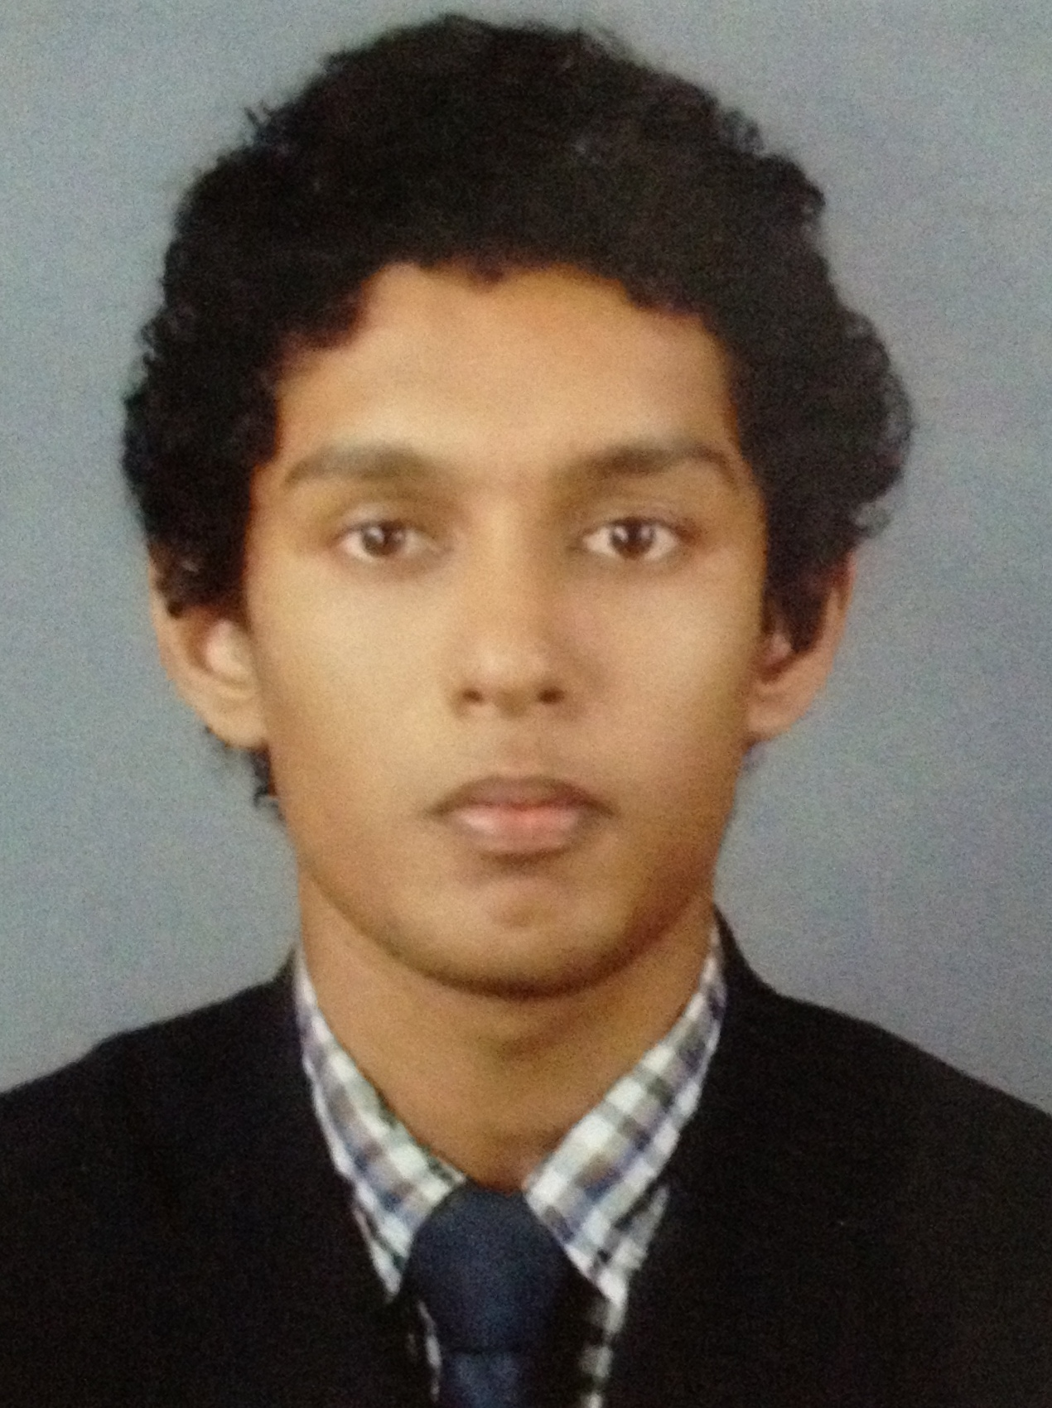
Name: Pasan Bagye Jeewaka Illege

Address: 3/301, Field View, Nalagasdeniya, Hikkaduwa.

Mobile: 0777120147

Email: pasanbagye@ymail.com

Personal Profile

I am an energetic, positive and self motivated individual. I have strong technical skills as well as excellent interpersonal skills. I am eager to be challenged in order to grow and improve my communication and professional IT skills.

Career Objective

To enhance my capabilities and qualifications so that I have the opportunity to prove myself as a competent employee.

Education and Training

2012 – 2013 Successfully completed Higher Diploma in Computer Based Information Systems (HDCBIS)
NIBM, Galle.

Subjects Covered

- Management Practices
- Software Engineering
- Data Structures and Algorithms
- Computer Networks
- Advanced Database Management Systems
- Computer Architecture
- Object Oriented Programming and Design I
- Agile Software Development Practices
- Software Quality Assurance
- Data Warehousing and Data Mining
- Object Oriented Programming and Design II
- Business Statistics for Information Technology
- Data processing
- Operational research

2011 – 2012 Successfully completed Diploma in Computer System Design (DCSD)
NIBM, Galle.

Subjects Covered
- Introduction to Computer Science.
- Quantitative Techniques for Computing.
- Data Structures and C Language.
- Computer Technology.
- OOP with C++.
- Database Management Systems.
- Computer Architecture.
- Internet Technology.
- System Software.
- Programming in Visual Basic.NET.
- Programming in JAVA.
- Business Information Systems.
- Systems Analysis and Design.
- Systems Design Project.
2009 – 2011 GCE A/L Examination – Math Stream
Dharmasoka College, Ambalangoda
2 Passes including English

2005– 2008 GCE O/L Examination
Dharmasoka College, Ambalangoda
All 9 subjects passed including grade “B” for Mathematics and English

2011 Advanced Certificate in English from National Institute of Business Management
Status Distinction

Projects Involved At the University

Online Doctor Channeling System

Developed an online Doctor channeling system which will be capable of performing doctor channeling online and generate all monthly reports and bills.

Technology -: Visual Basic.NET.MY SQL server 2008

Static Web site For Garment Shop

Design a static website for Harsha Tailors for publish their clothing items and tailor works.

Technology -: Dreamweaver

Hotel management System

Develop a hotel management system for 6 degrees north beach villa for maintain their stocks and generate the bills and monthly report for the management.

Technology -: Java, MY SQL server

Skills
Technical:
▪ Languages
Visual Basic.NET, C++, and C language and also familiar with java
▪ Database
MYSQL, MS Access, MS SQL Server
▪ Operating Systems
MS Dos, Windows7/ XP
▪ Web Developing
PHP, HTML, XML
▪ System Design
UML, DFD

Interpersonal:
  - Working in a group and a team player
  - Verbal and writing skills
  - Problem solving, Decision making skills and Negotiation

Personal Details

Date of Birth | :31/10/1992
Nationality | : Sri Lankan
Gender | : Male
NIC | :923051309V
Civil Status | : Single

References

Mr. Thepul Ginige.
Post : Lecture, Colombo Campus.
Address : 94,Cumaratunga Munidasa Mawatha,Colombo.
Tel : 0714803326
Email : Thepulg2003@yahoo.com

Ms. Uthpala Pramudini Athukorala

Post : Course Director,

Address : National Institute of Business Management 132, Pettigalawatta, Matara Road, Galle.

Tel : 091-5636363
E-mail : epramudini@gmail.com

