Dear Sir,

Here I am sending my cv with reference to the advertisement published in Sunday Observer, Please through my particulars.
Thanking You.

G.G.Hikkaduwage

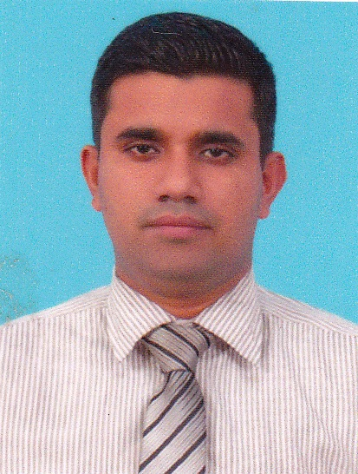.

PROFESSIONAL EXPERIENCE
I was employed under Central Finance Company PLC since 2004 to 2006 as an Audit Trainee.
I was employed at Central Finance Company PLC –Nugegoda Branch as a Customer Service Officer cum Accounts Officer 2006-2012
I was employed as a Snr Customer Service Officer for Fixed Deposits and Savings Department at Central Finance PLC -Homagama Branch.2012-2014
I have a working experience of 10 Years in the same company.
I have worked at Nippon Services BPO (Pvt) Ltd Ratmalana as an accounts assistant Sep 2014- Dec 2014. (3Months)

Responsibilities and Duties of the position
- Handling the Walking customers for Fixed Deposits & Savings
- Promoting Savings & Fixed Deposits
- Cross Selling Of Fixed Deposits & Savings.
- Visiting Customers for Canvass Fixed Deposits& Savings.
- Handling all the related activities for Fixed Deposits & Savings.
- Handling Western Union Money Transfer Service.
- Preparation of Bank Reconciliation Statements.
- Preparing Statistics and cash flow for the management
- Have an Individual Customer Base for Savings & Fixed Deposits
- Expose to Hire Purchase/Leasing
- Working as a Customer Service Officer at CF Homagama Branch.
- Able to Work in a team Under Pressure

PROFESSIONAL QUALIFICATION

- Successfully Completed AAT Foundation & Intermediate.
- Successfully Completed a Diploma in English Course at Sri Jinarathana Vocational Institute.
- Successfully Completed a Certificate Course in Spoken English.
- Successfully Completed a Certificate Course in Windows Based Application Course at AAT Centre.

EXTRA CURRICULLAR ACTIVITIES
- Member Of a School A School Athletic Squad
- Assistant Coordinator of the School Commerce Society

EDUCATIONAL QUALIFICATION

- G.C.E.Advanced Level Examination – 2002( Prince Of Wales College,Moratuwa)
Accounting – S Economics S, Business Studies – C
- G.C.E.Ordinary Level Examination – 1998 (Prince Of Wales College,Moratuwa)
Passed with five distinctions and three credit passes.

OBJECTIVES
Exercising my skills knowledge in a dynamic & challenge able working environment while supporting.
To achieve greater success by working in a well established organization and improve my career life.

PERSONAL PROFILE
Name with initials : G.G.HIKKADUWAGE
Name denoted by initials : GIWANTHA GAYAN HIKKADUWAGE
Date of birth : 18th of April 1982
Age : 32 years old
Nationality : Sri Lank an
Gender : Male
Civil states : Single
NIC No : 821094224V
Contact : 0094071-7663714 Residential0094011-2622266
E-Mail : giwathagh@gmail.com
Address : No.3/1, 2nd Lane, Ratmalana,Sri Lanka.

NON RELATED REFEREES

Mr. H.K. Amarasinghe Mr. Gamini Yapa
AGM (Internal Audit) Senior Manager (Micro Finance)
Central Finance Company PLC Central Finance Company PLC.
No.270, Vauxhall Street, Union Place, No.312, High Level Rd,
Colombo 02 Sri Lanka Colombo 06.Sri Lanka
Tel.00940112304698 Tel.0094077587094

Date 15.02.2015

.

