CURRICULUM VITAE

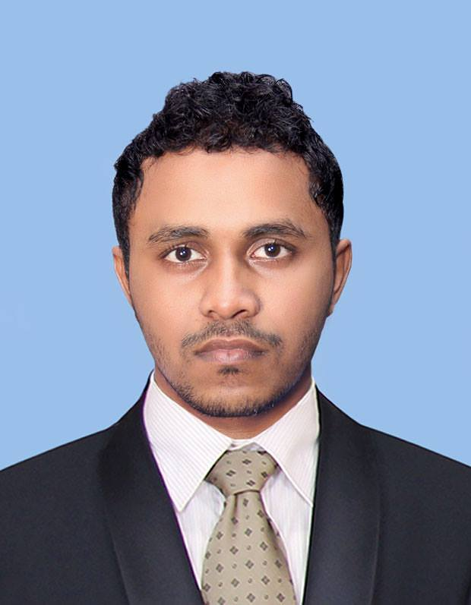

PERSONAL DETAILS

- Full Name : Shehan Pramuditha Wijesinghe
- Name with Initials : S.P.Wijesinghe
- Address : No:623,Dikhena,Uragasmanhandiya.
- Date of Birth : 15th January 1993
- Gender : Male
- Civil Status : Single
- Nationality : Sri Lankan
- School Attended : Karandeniya Central College
- Mobile : 0712158343
- Email : shehanpramu20@gmail.com

EDUCATIONAL QUALIFICATIONS

Passed G.C.E. Ordinary Level Examination (2008)

Index No: 80821200

Subject | Grade
Health & Physical Education | A
Buddhism | A
History | B
Geography | B
Sinhala Language & Literature | B
Science | C
Mathematics | C
Music | C
English | S
English (2011) (Index No:11278358) | C

Passed G.C.E. Advanced Level Examination (2012)

Index No: 4715969

Subject | Grade
Accounting | S
Business Studies | C
Economics | C

OTHER QUALIFICATIONS
I’m Studying Business Management External Degree in University of Kelaniya

EXTRA CURRICULAR ACTIVITIES

- Played for the School Cricket Team.
- Played for the Galle District Cricket U17 Team
- Played for the Southern Province U17/U19 Cricket Team
- Played for the Old Dharmapalian’s Sports Club,Pannipitiya 2013/14

NON RELATED REFEREES

(1) Mr.P.H.R.G.Gunawardana,
Principle (G/Kaluwalagoda Kanitu Viduhala)
Kerewa,
Karandeniya.
Tel: 0779745000

(2) Mrs.A.A.D.L.Nadeeshani
Public Management Assistant
Ministry of Public Administration and Home Affairs.
Independence Square,
Colombo 07
Tel: 0772171259

I hereby attest that the above information is true & correct according to the best of my knowledge.
[Signature & Date]
…………………….
S.P.Wijesinghe

