CURRICULUM VITAE
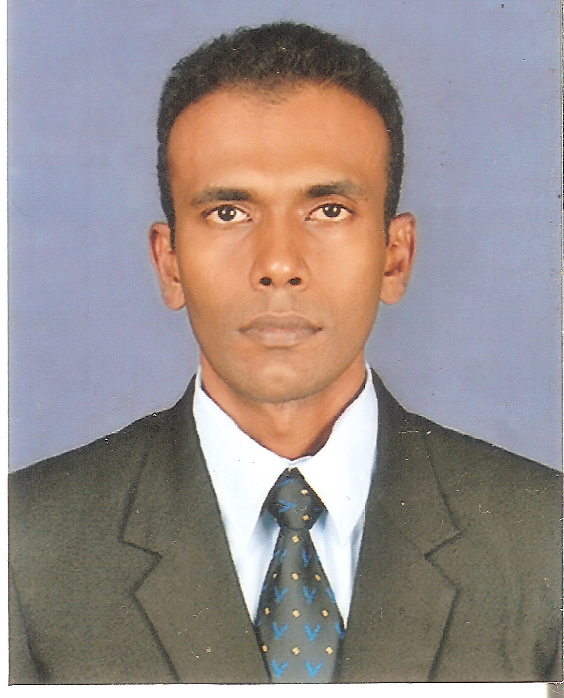
A.A.D. JALITHA CHAMILKA
No. 144 , Borella Road,
Depanama
Pannipitiya.
011-2849436,0774288462
jalithac@hotmail.com
JOB OBJECTIVES & CAREER GOALS :

To obtain an accounting position where I will be able to contribute my skill, knowledge and experience to a company that will give me an opportunity to develop my career.
EMPLOYMENT EXPERIENCE :
:

Accounts Executive (Promote) 2010 - 2014
Accounts Clerk 2007 - 2010
B.P.Morawaka & Sons (Pvt) Ltd. Kottawa
( Indigenous Pharmaceuticals & Herbal Beverage Drink Of Morawaka Medito )
Selected accomplishments:
Accountancy
Preparation of Financial Statements. ( Balance Sheet, Profit & Loss Accounts, Trial Balance )
Involving Company All Audit Activities & Tax Interviews
Maintenance of Ledger Accounts. ( Manual & Computerized )
Maintenance of Cash Book & Bank Reconciliations.
Preparation of Payment Vouchers & Cheques.
Involving in Annual Stock Verification.
Maintenance of Sales Day Books, Stock Books & Debtors Ledgers.

Management
Involving in all Management Activities at Superb Motor Service

Human Resource Management
Preparation of Salaries, Gratuity, EPF & ETF.
Recruitment Schedule Handling.

Sales

Involving Sales Promotion, Exhibition & Social Service Activities.

Accounts Clerk 2004-2006 (1 Year 7 Months)
Sunil Siriwaradana & Sons Ltd
Ambatale,Mulleriyawa New Town

Selected accomplishments:
Accountancy
Preparation of Final Accounts
Preparation of Ledgers, Cash Books, Bank Reconciliations
Preparation of Bar Accounts
PROFESSIONAL QUALIFICATIONS:

Institute of Chartered Accountants of Sri Lanka

CAB II Examination Results Index No
Accounting Application and Taxation 66 4876
Information Management 53 4876
Audit and Assurance 50 4612
Business Communication II C 6037
CAB I Examination Results Index No
Introduction to financial Accounting A 129
Introduction to Decision Marking Techniques B 129
Introduction to Business C 129
Business Communication I C 3902
B.Sc. Business Administration General (External) Degree
University of Sri Jayewardenepura
Successfully Completed the 1st year examination in 2009 September
Successfully Completed the 2nd year examination in 2010 November
3rd Year - Completed
Operational Research B ( 2010 January )
Small Business Management c ( 2010 January )
Operational Management c ( 2010 January )
3rd Year -Pending Result 2014 February Exam
International Business Studies
Management Information System
Business Policy & Strategic Management
COMPUTER LITERACY:

Following Diploma in Computerized Accounting under Esoft Computer Studies (Pvt ) Ltd.

Quick Book, Sage , MYOB, Peachtree

Diploma Computer Programming & System Design Under Employment Research & Training Institute Ministry of Labour Relations & Foreign Employment

Proficiency in the following Microsoft Office packages under Institute of Charted Accountants of Sri Lanka

MS Word 2010 MS Access 2010
MS Excel 2010 MS PowerPoint 2010
ACADEMIC QUALIFICATION:

Higher Education:

G.C.E. (A/L) Examination – 2001
Business Studies A
Accountancy B
Economics C

Secondary Education :

G.C.E. (O/L) Examination – 1997
Passed with 02 distinctions and 05 credits.
LANGUAGE LITERACY :

Foundation English Course - Successfully Completed
Sri Jinaratana Academy Colombo -02.

EXTRA CURRICULUM ACTIVITIES:

Representative of the School National Saving Bank

Member of School Volleyball team

Active member of the School Broadcasting Unit & School Traffic Unit

Member of Commerce Society, Buddhist Society, Sinhala Society, Astronomical Society
SKILLS / ABILITIES:

Excellent Computer Skills
Ability to successful Team / Independent work
Hard Working
Keen to Learn

PERSONAL INFORMATION:

Name in Full : Angampitiya Arachchige Don Jalitha Chamilka
Address : No 144, Borella Road, Depanama, Pannipitiya.
Date of Birth : 22nd January 1982
Sex : Male
Civil Status : Unmarried
School Attended :President’s Collage, Maharagama
NON – RELATED REFEREES:

Mr. Anil Kuragama
Senior Executive.
DHL Keells (Pvt) Ltd.
No.374,Negombo Road,
Seeduwa.
Tele : 094-777-269133
094-11-4366600

Mr. Kumudu Morawaka
Vice President.
HSBC Securities Service Centers
HSBC Bank
Rajagriya.
Tele : 094-718-135874

I hear by certify that the above particulars are true and Accurate to the best of my knowledge and belief.

……………………………………………… ………………………………………………
(J.C.Angamipitiya) Date

