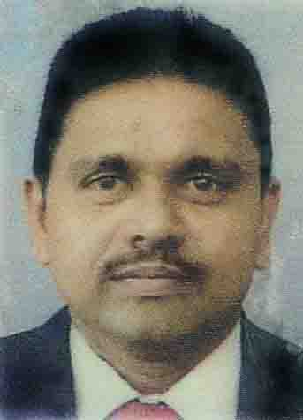

Jude Thaddeus Dass

B-43/G4, N.H.S. Mobile : +94 773184605
Colombo – 10, Phone (Res) : +94 114873889
Sri Lanka. E-mail : judetdass@gmail.com

______________________________________________________________

Career Goals : Seeking a position in an Organization that will benefit from my sincerity, commitment, initiative, capabilities and contributions ultimately qualifying for advancement and increase in decision making responsibilities.

Professional Experience

Manager – Administration (9th February 2005 to date)

Qualitea Ceylon (Pvt) Ltd
14, Station Road, Wattala, Sri Lanka

“Qualitea” Ceylon (Pvt) Ltd is an ISO 9001:2000 certified leading Tea Exporter in Sri Lanka. Our brands Qualitea, Shere Tea and Genex Tea are sold in over 40 countries worldwide.

- Manage and monitor the performance of the administration staff to achieve the company objectives.
- Ensure that proper training is in place to upgrade the knowledge required to maintain professional standard.
- Designing and implementation of systems, policies and procedures to facilitate internal controls to achieve goals.
- Recruitment, conducting initial interviews and performing all other HR related functions
- Liaising, Monitoring and handling Security, Janitorial, telecommunication and other service providers.
- Responsible for renewal and monitoring trade mark related work.
- Staff Attendance, Leave Entitlements, Pay roll related activities.
- General Correspondence, general administration functions.

________________________________________________________________________

HR & Administration Controller (October 1997 to November 2004)

Trans Maldivian Airways Pvt Ltd (TMA)
Hululle Airport
Rep. of Maldives

TMA is a Domestic Sea Plane operators formerly known as “Hummingbird Helicopters (Pvt)
operating Helicopter Services in the Republic of Maldives, managed by a Company in the
United Kingdom.

- Performed all HR and administrative related duties.
- Maintaining Aircraft Spares stock.
- Imports of Aircraft spares and all other necessary items to carry out the operations.
- Liaise with government departments, Ministries.
- Recruitment of Pilots, Engineers and all other Expatriates and Local staff.
- Arranging Accommodation facilities for Pilots and Engineers.
- Arranging Air travels and liaising with Airlines and Travel Agents
- Maintaining Fixed Assets Register
- Preparation of Pay roll.
- General Correspondence.
________________________________________________________________________
Accountant (April 1996 to September 1997)

Dimms Incorporated,
Rep. of Maldives

Dimms is a leading Maldivian owned Trading Company dealing with furniture & Hardware related items and the sole agents for Canon products in the Maldives.

- Handling and performing all accounting functions including preparation of final accounts.
- Introduced Quick Books accounting package

__________________________________________________________________________

Accountant (February 1995 to March 1996)

Neo Columbus Air Tour Pvt Ltd,
Consistory Building, Colombo – 11.

_________________________________________________________________________

Accountant (April 1989 to April 1994)

Makunudu Club, Rep. of Maldives

Makunudu is a star class Resort hotel owned and managed by a Company in Switzerland and a member of Swiss chain of hotels “Relais & Chateaux”.

- Handling and performing all accounting functions including preparation of final accounts.
- Front office activities.
- Imports of Food & Beverage from other countries.
- Staff Recruitment activities
- Handling and controlling petty cash of the Hotel

________________________________________________________________________
Auditor (December 1985 to March 1989)

Saverimuttu & Co.,
Chartered Accountants,
Rep. of Maldives.

_____________________________________________________________________
Debtors Control Clerk (1984 to December 1985)

Contracts & Supplies,
Baseline Road,
Colombo – 9

Educational Qualification

G.C.E. (A/L) (Bio Science) – August 1983
St. Joseph's College
Colombo – 10.

G.C.E. (O/L) - December 1980
St. Joseph's College
Colombo – 10

- Skills and Competencies

- Strong analytical skills.

- Excellent Teamwork and Interpersonal skills.

- Good communication skill.

- Possessing an excellent leadership skill.

- Flexibility.

- Well- motivated and hard working.

- Quickly adjustable to any type of Environment.

- Confident to work independently.

- Computer Skills – Microsoft office package, MYOB

________________________________________________________________________________

Personal Information

Nationality : Sri Lankan

Gender : Male

Date of Birth : November 20, 1964

Marital Status : Married

Religion : Roman Catholic

Languages : Tamil, English, Sinhala & Dhivehi (Maldivian)

Health : Excellent

Hobby : Listening to music

________________________________________________________________________

References
: Mr. Ajith Abeyawardena
Project Manager - ERP
151/11A, 1s Lane, Campus Road,
Rattanapitiya,
Borlesgamuwa

Mr. Darrel Herft
Director - Operations
Qualitea Ceylon (Pvt) Ltd.,
14, Station Road, Wattala.
Mobile – 0777 751094

Signature: Date: 4th June 2015

