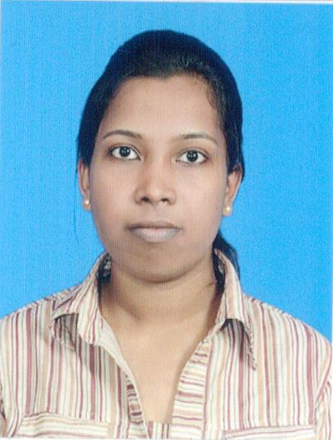
BIODATA:-PAVITHRA GEORGE

PERSONAL DETAILS
- Full Name :- Pavithra George
- Permanent Address :- No.131/65F, Jampettah Street, Colombo 13, Sri Lanka.
- Telephone Number :- +94776226040
- Email :- pavithrageorge1@gmail.com
- Date Of Birth :- 18th May 1995
- Nationality :- Sri Lankan
- Schools attended :- C/St. Anne’s Girl’s Maha Vidyalayam.

PROFFESIONAL QUALIFICATIONS
- Successfully completed certificate course in MS office

EDUCATIONAL QUALIFICATIONS
- Passed GCE (O level) Examination with 4A’s 3B’s and 2C’s(2011)
Subject Grade
Maths A
Science B
Tamil A
Religion A
History C
Commerce B
English C
Tamil l.t B
Health A

- Got 2C’s and 1S in GCE (A level) Examinations(2014)
Subject Grade
Business study C
Economic C
General English S

COMMUNICATION
- Good oral & written communication skills in English and Tamil.

QUALIFICATIONS IN EXTRA CURRICULAR ACTIVITIES
- Participated and got places in Essay & Speech Competitions
- Board member of school LEO club
- Secretary of Tamil Union Society
- Act as a Prefect during 2012-2014

CAREER OBJECTIVE:-
- I would like to engage myself where my skills would be greatly enhanced for my own professional growth

NON-RELATED REFREE S

- Rev. Sister Mary Mable Fernando Pulle,
Principal,
C/St Anne’s Girls Maha Vidyalayam,
Colombo 13.
Tel: 011 2342646

- Mr. Niroshan Croos,
Finance Executive,
John Keells Holdings,
89, Galle Road,
Colombo 03.
Tel: 075 5272195

