Dear Sir/Madam

After reading your advertisement and giving serious consideration to your specific needs, I have determined that my experience in Food and Beverage make me the perfect candidate. As my resume will indicate, I have spent the past 5 years directly involved in almost every aspect of a service.

My Responsibilities Involve:
• Responsible for the preparation of food & beverages and cash register transactions.
•Maintain the standards of quality service, product and cleanliness.
•Prepare & serve food & beverage.
•Prepare restaurant for operations.
•General cleaning of work areas.
•Cashiering.
•Delight guests each & every time.
•Taking orders, serving customers and cleaning up after customers leave.
Thank you for your time and consideration.

CURRICULUM VITAE

Prashan Marianayagam
Email Address :prashanmaria@yahoo.com
Contact No:0112855381/0779612481 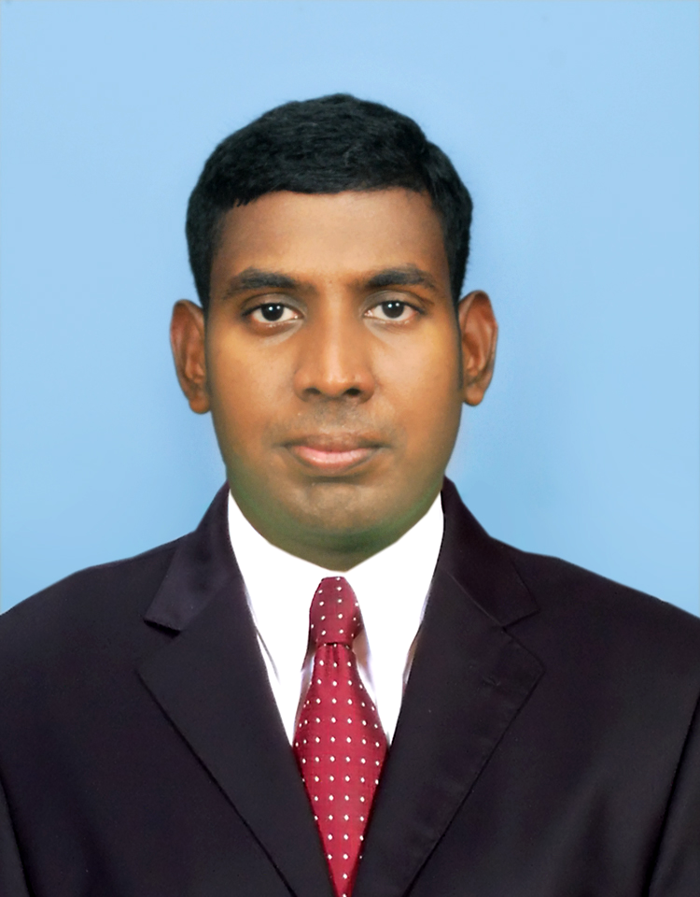
Objective:

I am an enthusiast individual having an inquiring mind and eagle eye for details, would like to apply my present knowledge in the firm, which I would be working In a Challenging and rewarding job position with a progressive Service and hospitality based organization that will utilize my talents and abilities to the maximum potential.

Skills & Strength

- Developed good working relations with Superiors & Sub-ordinates
- Participated in various Seminars, Hospitality & customer service training
- Rated for excellent customer service
- Having positive attitude
- Dedicated in Achieving Higher standard in Hospitality service
- Strong analytical, decision making and problem solving skills Strongly believe in team work
- Willing to work in multi cultured environment
- High proficiency in Hospitality Industry as Food & Beverage International Cookery, Chinese Cookery, Pastry &Bakery,Morrocan cookery, Italian Cookery.

Academic Qualifications:
Educated at St Peter’s College, Colombo-04 (GCE Ordinary Level-2004-Sri Lanka)

Professional Qualification:

Hotel School Course at Lanka International Hotel School Rajagiriya. Sri Lanka.
Basic Hygiene Training. Part 01,02
Computer Literate

Extra Curricular Activities:

Participated in Annual Inter-House Hockey/Basketball(1999-2002)
Active Member of Tamil Literacy Union
College Library Society.

Experience:

TAJ SAMUDRA-COLOMBO, SRI LANKA
WATEREDGE-BATTARAMULA- SRI LANKA
FIVE STAR HOTELS AND RESTAURTANTS IN COLOMBO WORKING AS: TRAINEE COOK AND WAITER 2005-2007.
Atlas Hospitality- PREOPENING STAFF 2008-2010.
MADIANT JUMERIAH DUBAI 2012
LENORTE PARIS QATAR 2014 .

Achievement:

Preopening Staff of Tanjia Restaurant
Employee Of The Month
Crossing Training In DoorMan

Personal Details:

NAME PRASHAN MARIANAYAGAM

DATE OF BIRTH 16/09/1987

SEX MALE

MARITAL STATUS MARRIED

NATIONALITY SRI LANKAN

PASSPORT N1925023 (07/06/2007-07/06/2017)

RELIGION CHRISTIAN

LANGUAGES KNOWN ENGLISH, TAMIL,SINHALES,HINDI

HOBBIES READING HOSPITALITY MAGAZINES,WRITING
LYRICS,PLAYING FOOTBALL & CRICKET.

Permanent Address 95/13A GODAGAMAGE WATTA,
GODAGAMA SOUTH,GODAGAMA

DECLARATION- I hereby confirm that details furnished by me are true and correct to the best of my Knowledge, and in the event me being selected for the position considered, I assure you that I would perform my duties to the best of my abilities to meet my superiors requirements.

Prashan Marianayagam

Non Related Referees
Brayn law Mary Jones
0503712764 0561018724
Dubai Dubai

