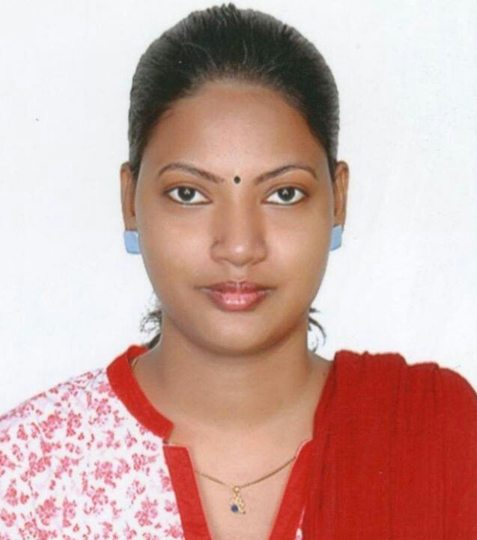
RESUME

J. JEYASHALINI

No. 7/3, 6th Lane, Mobile: 075 90 75 933
Veppankulam, Email: jjeyashalini@gmail.com
Vavuniya.
Sri Lanka.

Career Objective

To be a part of the organization where I can utilize my technical skills and leadership abilities in the most proficient manner.

Academic Qualification

MA. Tourism | Tamilnadu University (Chennai)
BCA | Tamilnadu University. (Chennai)
12th Standard | Dr. Nirmala Girls Hr. Sec. School (Chennai
Personal Profile

Name | JEYASHALINI
Date of birth | 22.01.1990
Father’s Name | S. Jeyabalan
Gender | Female
Marital Status | Spinster
Nationality | Sri Lanka
Religion | Christian
Languages known | Tamil & English ( To Read, Write, Speak)
Work Experience

6 Years | Senior Travel Consultant  Kumaar Holidays  Chennai.
1 Year | Administration  Computer Informatics  Ramanathapuram,  India.

Professional Training

 | Tailoring
 | Typewriting

Software Skills

- MS Office skills
- C Language
- C++ Language
- Photoshop
- CorelDraw
- In design
- HTML
- JavaScript

Leisure Interests

- Reading
- Writing poems
- Listening to songs
- Cooking

Declaration

I am confident of my ability to work in team. I hereby declare that the information furnished above is true to the best of my knowledge.

Place : Vavuniya Signature

Date : (J. JEYASHALINI)

