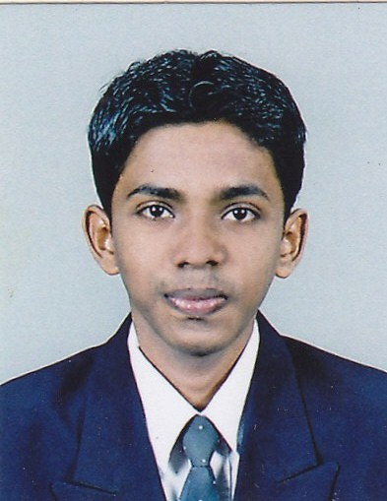
CURRICULUM VITAE
PERSONAL DETAILS

- Name In Full : Rameen Mohamed Sajith
- Sex : Male
- Date of Birth : April 14th1993.
- Civil Status : Single
- Address : 52/01, jumma masjid mw, periyamulla, negombo,
Sir lanka.
- Nationality : Sri Lankan Moor.
- N I C No : 931050338 v
- School Attended : Al – Hilal Central College at Negombo.
- Telephone no : 0757581090
- Home no : 0776749757
- E-mail Address : mssajith22@gmail.com

EDUCATIONAL QUALIFICATIONS

- G.C.E Ordinary Level – ( 2009 ) 1A,1C,6S

(NATIONAL CERTIFICATE ENGINEERING CRAFT PRACTICE) ELECTRONICS (NVQ-03) full time two year course, SRI LANKA COLLEGE OF TECHNOLOGY-COLOMBO in 2011 to 2012.
1st year results
Subjects Results
- ELECTRONICS(THEORY) CREDIT
- ELECTRONICS(PRACTICAL) MERIT
- MATHEMATICS DISTINCTION
- ENGINEERIG SCIENCE CECREDIT
- TECHNICAL DRAWING CREDIT
- COMMUNICATION SKILLS CREDIT
- USE OF COMPUTERS CREDIT

Other qualification

- Successfully Completed Certificate Course of Microsoft office at Zonal Education Computer Resource Centre in 2010.
- Successfully completed certificate course in PC
HARDWARE ENGINEERING
- Participated of Art Competition Conducted by – OPED 2006
- Radio, TV And Allied Equipment Repairer (NVQ-3)

PROFESSIONAL EXPERIENCE

- Training Technician in Sri Lanka Telecom

- CCTV Technician
Ever Focus LS (PVT) LTD.
Negombo.

Responsibilities

Maintained tools and equipment to ensure good working conditions.
Repaired CCTV cameras on site.
Changed parts and components which broke down and replaced with new parts.
Positioned correctly CCTV cameras in the site for proper recording and assured all areas in the facility is covered.
Assured that CCTV in the facility are running in good working conditions.

NON RELATED REFEREES:

Mr.M.SHAFI RAHEEM Mr.M.M.M. GAZZALY-SLPS
Member of provincial council, Principal
Western Province, Al-Hilal Central College Negombo. Negombo.

I do hereby declare that the above-mentioned particulars are true and accurate to the best of my knowledge
…………………
DATE ……………….
R.M.SAJITH

