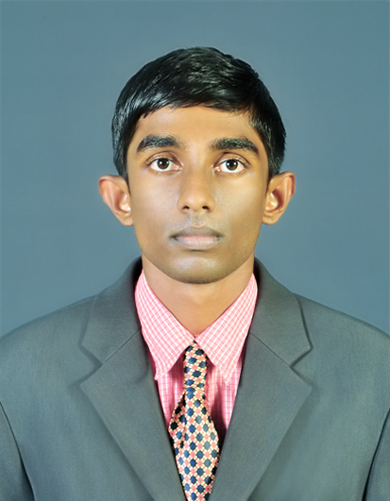
H.L.S. SANDARUWAN
Polmandiya, Hettiyawala west,
Kirinda, Puhulwella.
Mobile: +94 716778081
Home: +94 413412362
E-mail:sureshsandaruwan9@gmail.com

PROFILE

I am a highly flexible and hardworking, young fresh graduate at Faculty of Management, University of Ruhuna who has self-confidence to work on own initiative an as a part of a team. Self-motivated with an outgoing personality and dedicated to work in punctuality with proven leadership, self-determination, innovativeness and Computer literacy with communication skills. I am capable enough to work under pressurized conditions.

EDUCATIONAL QULIFICATION

University of Ruhuna (2011 – Present)
Degree of Bachelor of Business Administration (Accounting specialization area)

MR/Puhulwella Central Collage (2006-2010)
GCE Advanced Level 2010 (index no 4935390)
Three A s Commerce Stream

GCE Ordinary Level 2007 (index no 71543490)
6 A s, 1 B with 3C s

PROFESSIONAL QULIFICATION

- Completed CAB II stage (old syllabus) of the Institute of Chartered Accountants of Sri Lanka (ICASL) (index no 001454180)

- Cost Accounting
- Financial Accounting & Taxation
- Business Information Technology
- Business English II
- Audit & Assurance

- Diploma in computerized Accounting (Londontec city Campus Matara)

- Quick Book 2010
- Peachtree
- Sage Line 11

- MYOB 17
- Tally 9 With ERP
- Accpac

OTHER QULIFICATION

- I have successfully completed pre orientation program (POP) including English skills and Information technology in OUSL in Matara.
- I followed four months English course in institute of ROYAL. (kirinda puhulwella)
- I have successfully completed Six Month English language Course. Organized by The Ministry of Sports, Youth affairs in Southern Provincial council.
- Successfully completed Certificate Course in Tamil Language conducted by Ruhuna University of Sri Lanka
- Have successfully completed Microsoft Office Course in ICASL
- Have followed Sage Accounting Package conducted by University of Ruhuna

EXTRA CURRICULAR ACTIVITIES

- I participated three weeks leadership and positive thinking Program in Alpitiya police training school
- Member of school prefect board -2006/2007
- 2 year experience as a teacher in Dhamma School.

COMPUTER LITERACY

Excellent hands of experience in computer application in MS office (2007&2010) packages (MS Word, MS Excel, MS Power Point and MS Access) and internet & E- mail and also Hardware

LANGUAGE PROFICIENTLY
 | Reading | Writing | Speaking
Sinhala | Excellent | Excellent | Excellent
English | Moderate | Moderate | Moderate

PERSONAL DETAILS
- Full Name : Hewa Lokuge Suresh Sandaruwan
- Permanent Address: “Polmandiya”, Hettiyawala west, Kirinda, Puhulwella.
- National ID Number : 911620634V
- Date Of Birth : 10th June 1991
- Sex : Male
- Civil State : Single
- School Attended : MR/Puhulwella Central Collage
- Nationality : Sri Lankan
- Religion : Buddhism

NON-RELATED REFEREES
Mr.S.I.D Jayasinghe  Technical Officer  University of Ruhuna  Matara  M - 0711030967  E - sithararuh@gmail.com | Mr. Rasika Wijesooriya  Accountant,  Puttalam Salt Limited,  Kalpitiya Road, Palavi, Puttalam.  M - 071-5917730  T - 032-2269491  E - rasikawijesooriya@outlook.com

I do hereby declare that all the information provided above is true and accurate to the best of my knowledge.
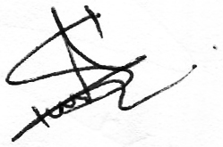
………………………. …………………………
Date Signature

