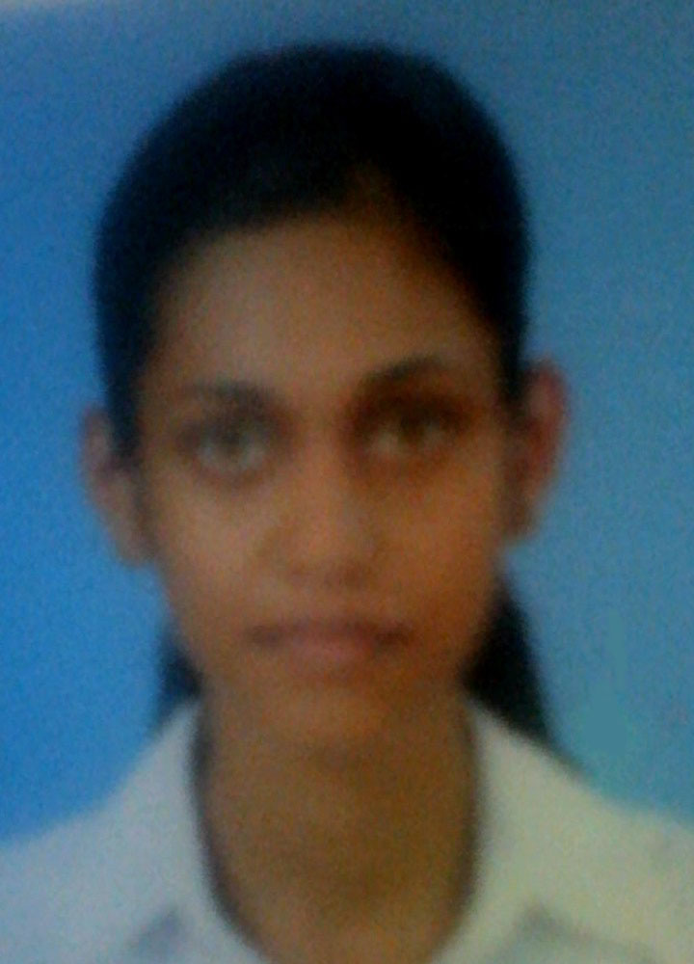
KANDALAMA KANKANAMALAGE CHAMALI MALSHA HAPUARACHCHI

Address: 54/A, Home : 033- 5689958
Pirisyala,
Ambepussa, Mobile : 071-7410550
Sri Lanka E-mail : chamalimalsha92@gmail.com

PROFILE

Name with initials: K.K.C.M Hapuarachchi

Date of Birth: 9th Feb 1992

Gender: Female Civil Status: Single National ID number: 925402354V Nationality: Sri Lankan Religion: Buddhist
EDUCATION

School Attended: Bandaranayke Central Collage
Veyangoda

G.C.E Ordinary Level Examination (2008)

Mathematics: A Science: B Sinhala: A English: B History: A Buddhism: A Agriculture & Food Technology B Business Studies and Accounts: C Sinhala Literature: A Development Studies: B

G.C.E Advance Level Examination (2012)

Accounting: A

Business Studies: A

Economics: B

TERTIARY EDUCATION

I Passed NVQ Level 3 – Application Assistant Examination
I Followed a Course Diploma in Computer Science in National Computer Project

PROFESSIONAL EDUCATION

Diploma in Computer Based Accounting
1st semester examination (2013-October)
Computer Based Accounting A+
Introduction to Programming & Database Systems A+
Introduction to Computer Applications B+
Multimedia Tools for Presentations B-

LANGUAGE PROFICIENCY & PERSONAL STRENGTH

Good written and verbal presentation skills in English and Sinhala. And also capable of working with team members and accepting supervision. Also aware of the professional ethics and disciplines.

PERSONAL ACHEIVEMENTS

• A member of the school Sinhala Literary & English Literary Society
• Involved with the school girl guiding team

REFEREES

W.K.I.Waragoda, D.L.A.K.Dissanayake
Head of Commerce Section, Managing Director,
Bandaranayake Central Collage, Beetaacom Multimedia & Computer Studies
Veyangoda. Mirigama
Tel- 0332289950 Tel- 0332274015

I do hereby certify that the above particulars furnished by me in this application are true and accurate to the best of my knowledge.

Name: Malsha Hapuarachchi

