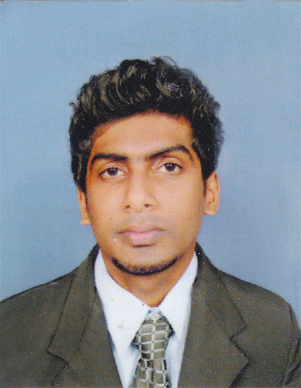

A.G.S SANDARUWAN
”141/B”,
Peragasgodalla,
Beralapanathara,
Contact No.0712072402
e-mail: sajithsandaruwan50@yahoo.com

Career Objective

To be an effective, hard working, knowledgeable and experienced person.

My Qualifications

- Professional Qualifications

- Following Higher national diploma in management from Advance technological institute.(ATI)
- Following certificate in Bank & Finance Level (CBF) Of IBSL (Passed two subject and following other four subject).
- Completed an English course.
- Primary & secondary education
- G.C.E. Advanced Level Examination (2014)

Subjects Grades
Accounting C
Business Studies C
Economics C
General English F
General test 60

- G.C.E. Ord. Level Examination (2010) 2As,1Bs,4C,1S

Subjects Grades

Buddhism A
Health & phy.Edu. A
Sinhala B
Science C
Mathematics C
History C
Business & account studies C
English S

Leadership & Other achievements

- Leadership training from ”International center the training of rural leaders”.

- A member of the School prefect board.

- Participated to Southern provincial volley ball competition.

- Member of Old boy association of Vocational Training Authority.

Key Skills

- Languages

English : Familiar with in reading, writing and speaking
Sinhala : Fluent in reading, writing and speaking

- . Computer Skills

Familiar with MS office 2007 & 2010

Personal Data

Full Name : Aranwala gamage Sajith sandaruwan
Date of Birth : 17th February 1994
School Attended : MR/ Morawaka National School
Civil Status : Single
Sex : Male
NIC No : 940482232V
Nationality : Sri Lankan
E-mail : sajithsandaruwan50@yahoo.com

Non Related Referees

Mr.Subash dilruks
Teacher of morawaka national school,

“Morawaka Road”,
paragala ,
Morawaka.
Contact No:071-8433955

Thank you.
Yours faithfully,

I hereby certify that the above mentioned details are true & correct to the best of my knowledge.

Thank you.
Yours faithfully
A.G.S SANDARUWAN
Date:04-01-2016

